PRECISION ONCOLOGY ANALYSIS
Manual Analysis Report
Clinical, pathological, molecular and outcome patterns in 82 cancer patients
Scope. Descriptive, pattern-finding analysis of the combined patient workbook, with interpretation of each chart. This draft was produced on the sample (fake) dataset; numbers will change when the real workbook is run.

1. Dataset and data quality
The workbook holds 82 unique patients after cleaning. Each patient has demographics, pathology, staging, treatment, baseline laboratory values (cycle 1), biomarker results, imaging narrative and survival status. A genomics sheet supplies sequencing text for a subset.
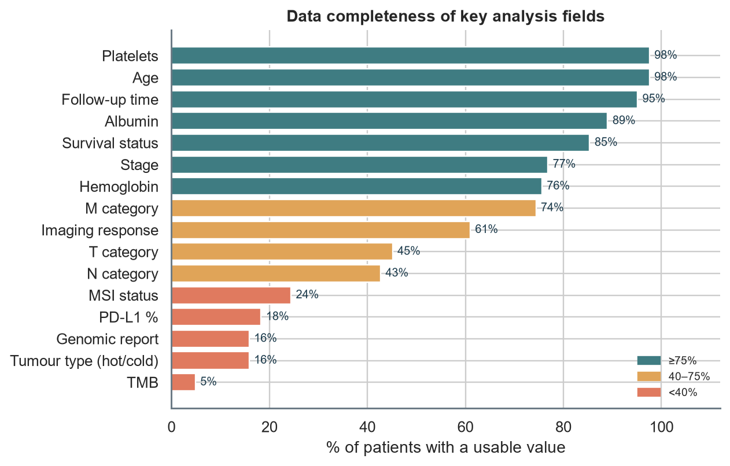
Figure 1. Share of patients with a usable value for each key field.
How to read it: Bars show how many patients have each field filled in and interpretable. Red bars (<40%) mark fields too sparse for firm conclusions.
- Staging: 77% of patients have a recorded stage (14 more were inferred as stage IV from M1 status).
- Response: only 61% have an imaging response that could be read from the report text.
- Molecular data: gene-level genomic results exist for 13 patients (16%); PD-L1 percentage for 15.
Cleaning actions recorded by the pipeline:
- Patient names removed and scrubbed from free text; 5 notes contained a name that was masked.
- Duplicate patient IDs collapsed to the most complete record.
- Lab values with mixed units (e.g. cells/µL, lakh/cmm, ×10³) standardised; implausible values set to missing.
- Dates in Excel-serial, dd/mm/yyyy and written-month formats parsed; dates after the record's entry time discarded.

2. Who are the patients?
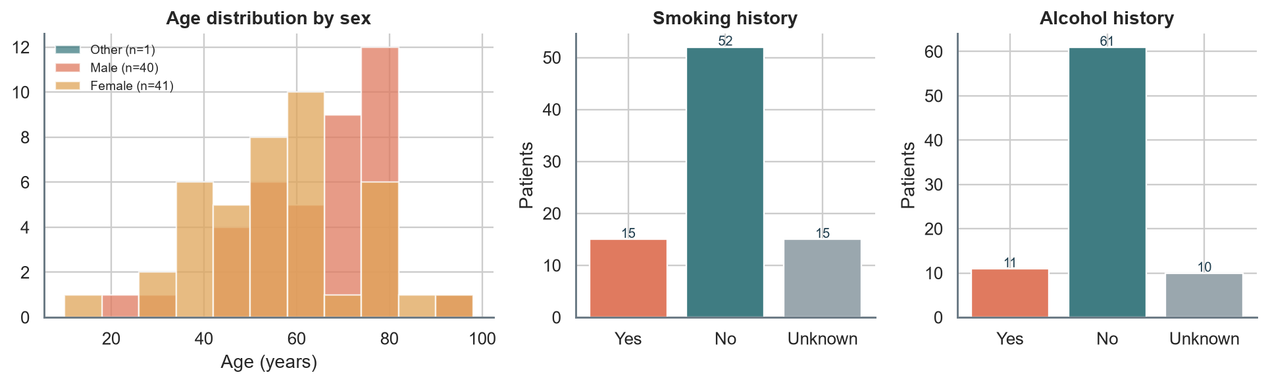
Figure 2. Age distribution by sex, with smoking and alcohol history.
Pattern: Median age is 62 years (range 16–96); 40 men and 41 women. 18% report a smoking history and 13% alcohol use.
Interpretation: the wide age range suggests a mixed cohort rather than a single disease population, so subgroup comparisons should be made within cancer site.

3. Cancer type and stage
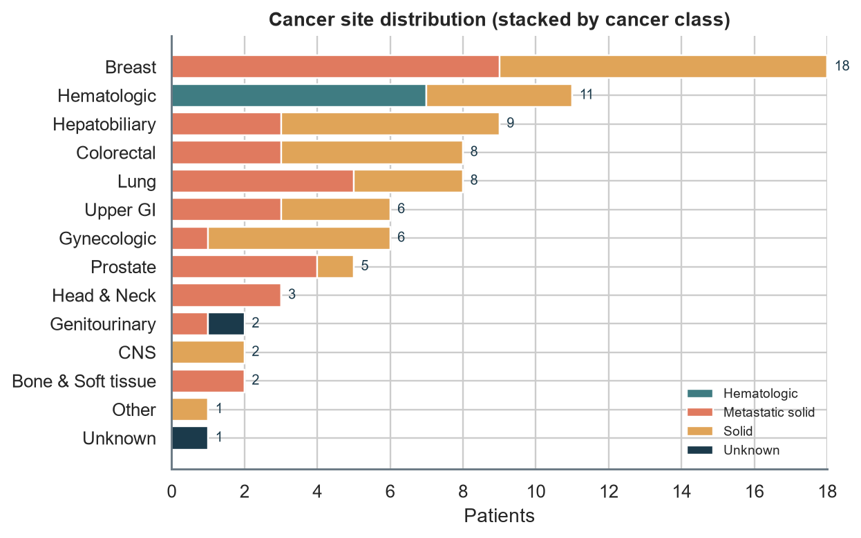
Figure 3. Patients by cancer site group, stacked by cancer class.
Pattern: The most common site groups are Breast (18), Hematologic (11), Hepatobiliary (9). 34 patients are classified as metastatic solid disease and 7 as hematologic cancers.
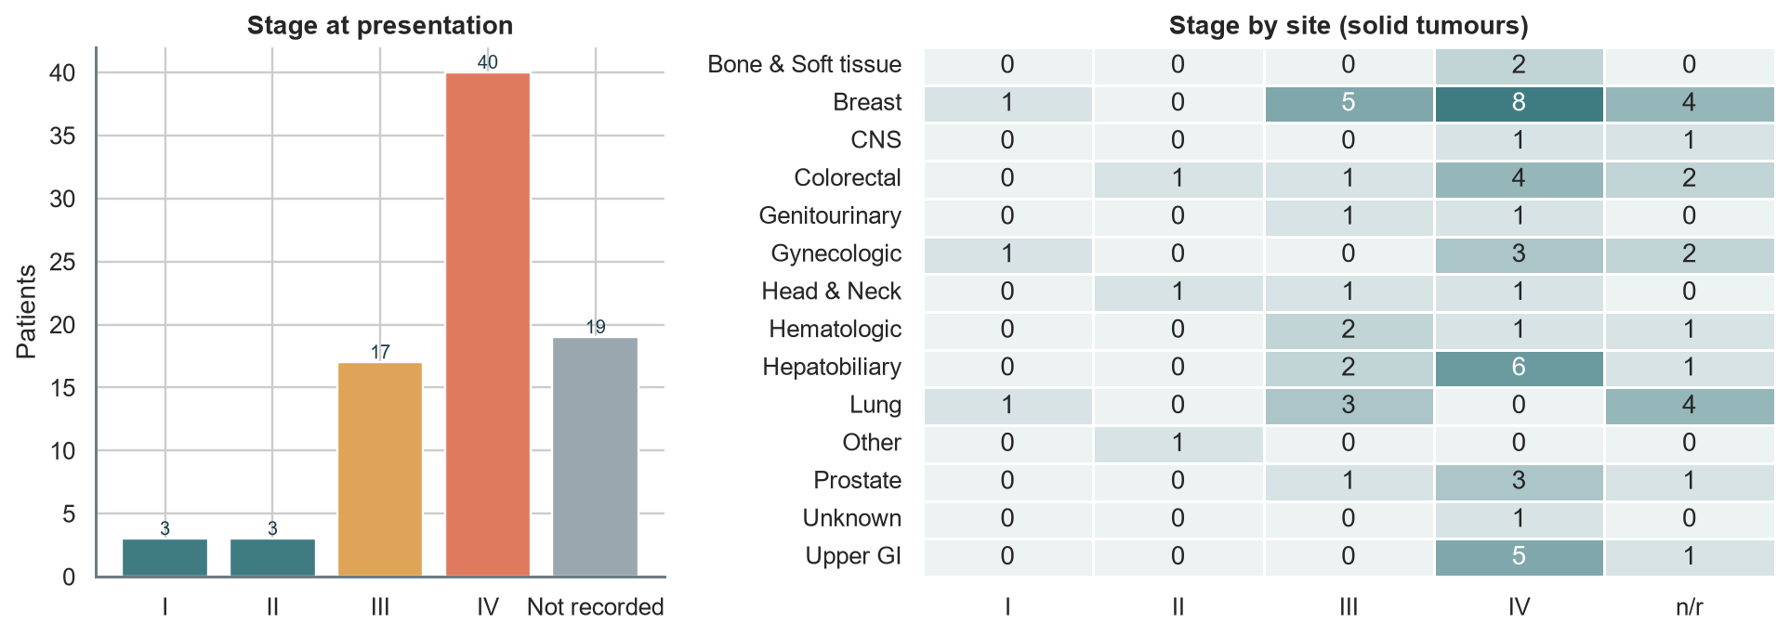
Figure 4. Stage distribution and stage by site (solid tumours).
Pattern: Among patients with a known stage, 63% are stage IV, so the cohort is skewed toward advanced disease. A large 'not recorded' group means stage-based comparisons cover only part of the cohort.

4. Treatment patterns
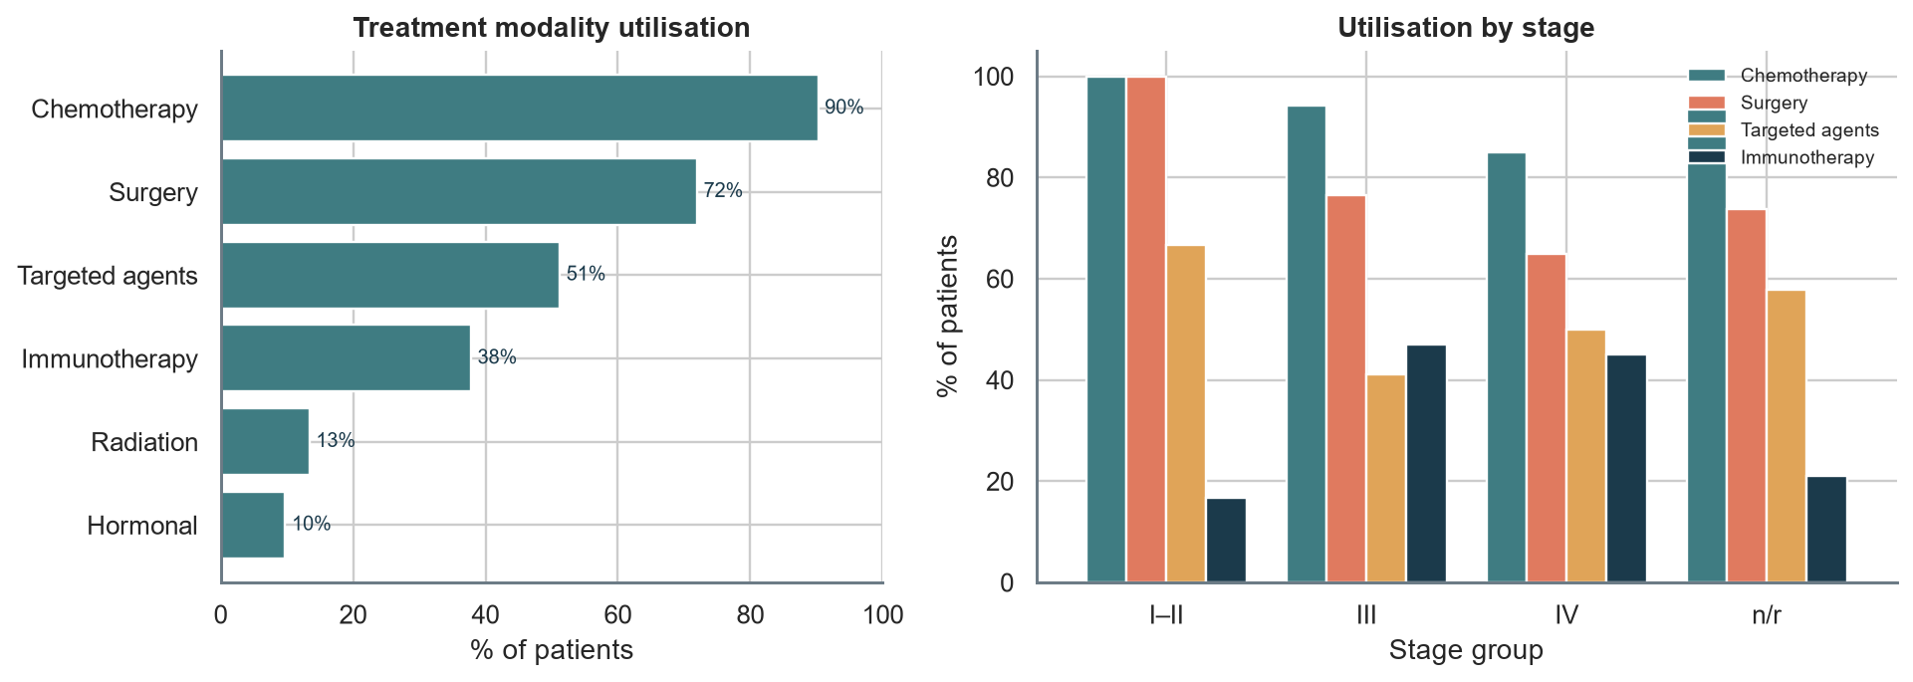
Figure 5. Treatment modality utilisation overall and by stage group.
Pattern: Chemotherapy is the most used modality (90%), followed by immunotherapy (38%), surgery (72%) and radiation (13%).
Table 1. Most frequent treatment combinations (as recorded).
Treatment combination | Patients | Share
Chemotherapy + Surgery | 32 | 39%
Chemotherapy + Immunotherapy + Surgery | 8 | 10%
Chemotherapy + Immunotherapy | 8 | 10%
Chemotherapy | 8 | 10%
Chemotherapy + Radiation + Surgery | 5 | 6%
Chemotherapy + Hormonal Therapy + Surgery | 3 | 4%
Surgery | 3 | 4%
Chemotherapy + Hormonal Therapy + Radiation + Surgery | 3 | 4%

5. Response to treatment
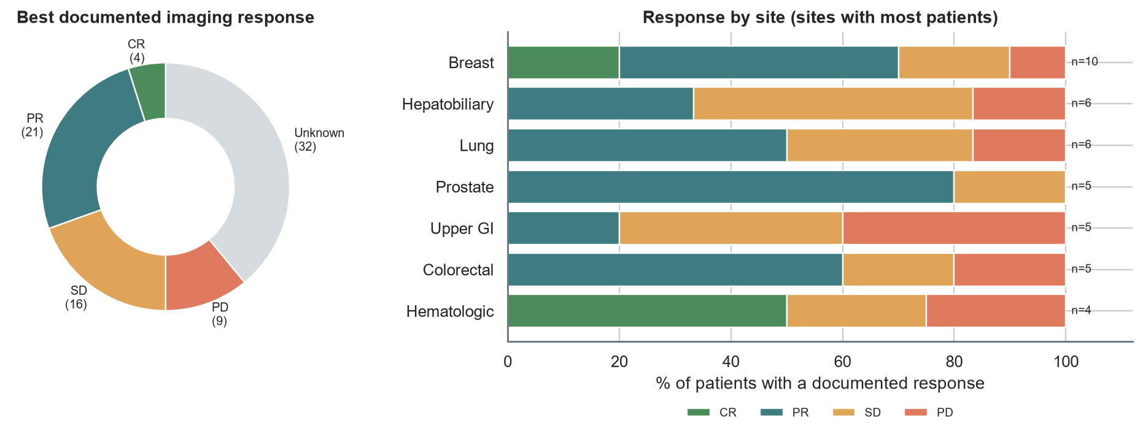
Figure 6. Best imaging response documented in the report text, overall and by site.
Pattern: Of 50 patients with a readable response, 25 (50%) showed a complete or partial response; 33 patients have at least one report describing progression.
Interpretation: response is inferred from keywords in imaging narratives (e.g. 'reduction in size', 'new lesion'), so it approximates RECIST rather than replacing it. Response labels should be hand-checked on a sample before they are quoted.

6. Molecular and biomarker landscape
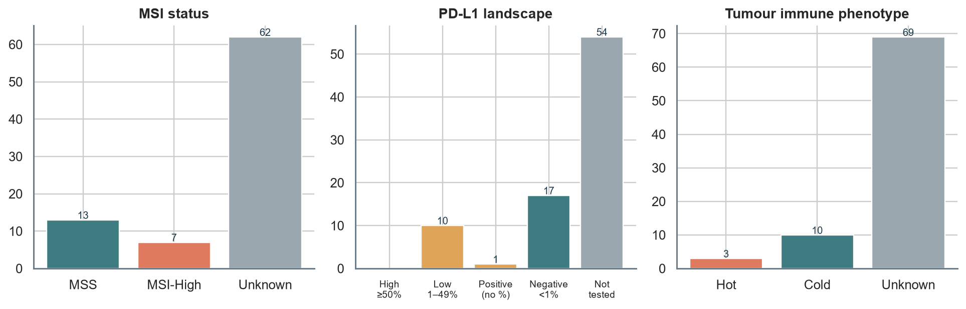
Figure 7. MSI status, PD-L1 expression and tumour immune phenotype.
Pattern: MSI status is available for 20 patients, of whom 7 are MSI-high. PD-L1 was tested in 28 patients (12 positive; 0 with ≥50% where a percentage was recorded). Tumours are labelled hot in 3 and cold in 10 patients.
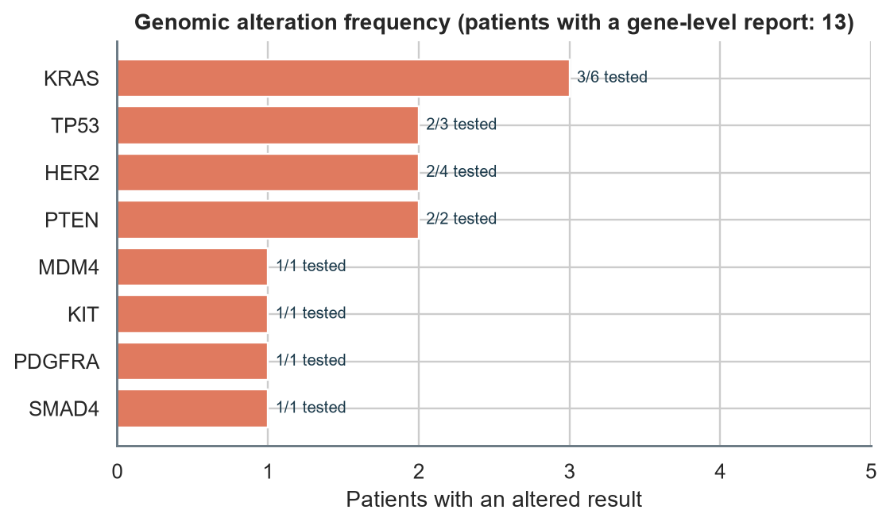
Figure 8. Genes with an altered result among patients that have a gene-level report.
Interpretation: with so few sequenced patients, frequencies are indicative only; the sequencing column also holds non-genomic reports (IHC, flow cytometry), which the pipeline deliberately does not count as genomic tests.

7. Survival status and follow-up
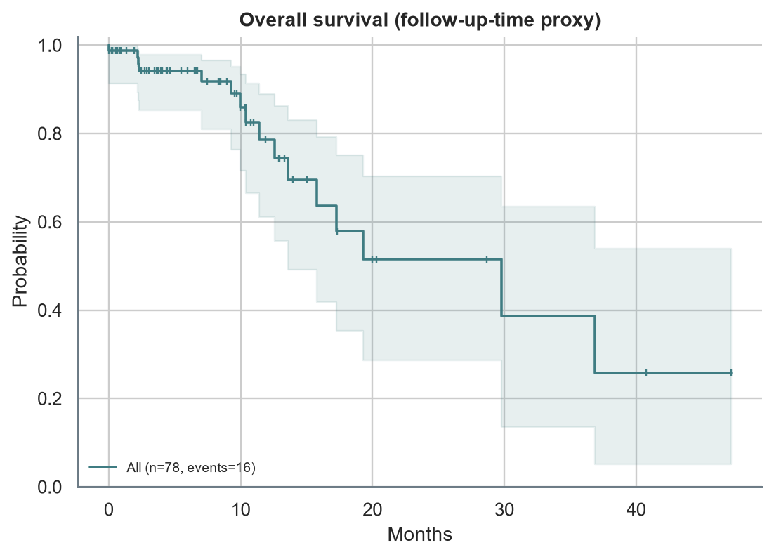
Figure 9. Kaplan–Meier estimate for all patients with usable follow-up.
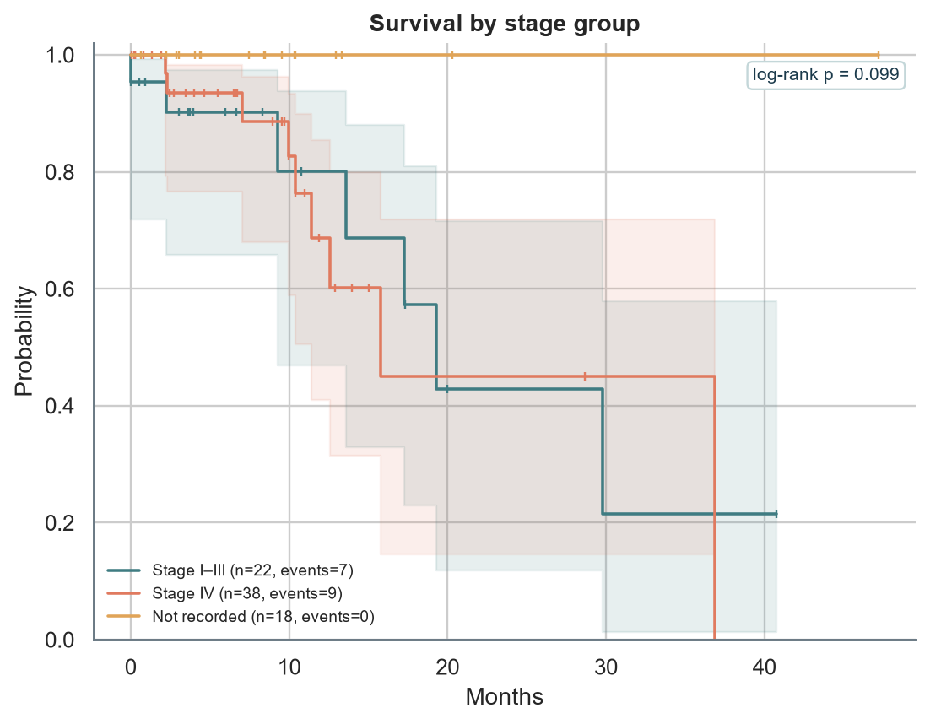
Figure 10. Survival by stage group (log-rank test).
Pattern: 54 patients are recorded as living, 16 deceased and 12 'not known'. Median follow-up is 6.9 months. Stage-group log-rank p = 0.10.
Caution. The sheet has no death date or last-contact date, so survival time is the span between the first dated treatment/imaging entry and the last dated entry. Treat curves as exploratory until true dates are available.

8. Key patterns and interpretations
- Stage mix. 63% of staged patients are stage IV; findings therefore mostly describe advanced disease.
- Treatment intensity. Chemotherapy appears in 90% of patients; most patients receive it, usually combined with another modality.
- Immunotherapy and biomarker testing. 38% received immunotherapy while PD-L1 percentage is recorded for 18%; testing appears to lag prescribing.
- Response data. 39% of patients have no response that can be read from text; a structured response field would unlock much more analysis.
- Molecular data. 20 patients carry at least one biomarker with an approved-therapy association at gene level (to be verified at variant level).

9. Limitations and next steps
- Single-centre, small sample; subgroup results are hypothesis-generating.
- Free-text parsing (stage, response, genes) is rule-based; validate on a hand-reviewed sample.
- Add structured death date, last-contact date, RECIST response and variant-level genomics to the data entry form.
- Replace proxy survival with true time-to-event once dates are captured.

