SEM PRACTICAL EXAM SHALINI R

DATA WAREHOUSING AND DATA MINING 18BCS091

U18CSI6203L

23.06.2021

1. Download a sample dataset from any Repository. List the attributes and its type in a word Doc.

**dataset:**<https://www.kaggle.com/manugupta/road-accidents-in-india>

This dataset contains the information of road accidents in Indian state and time of accident (0-3 hour, 3-6 hour ..)this information is obtained from the Ministry of Road Transport and Highways,Govt of India.

The main goal is to find some good patterns in the data set to help reduce accidents in India.

**Attribute and its type:**

1. Nominal attribute -STATE/UT
2. Numerical attribute -YEAR ,0-3 hrs. (Night),3-6 hrs. (Night), 6-9 hrs (Day),9-12 hrs (Day),12-15 hrs (Day),15-18 hrs (Day),18-21 hrs (Night),21-24 hrs (Night),Total.

2. Create a random dataset of 30 elements with x and y variables using random function between 30 to 80 integers for x and 60 to 100 integers for y. Apply K- means clustering to cluster the data into 2 clusters. Plot the graph and display the result. Use Tkinter GUI to Display the Results

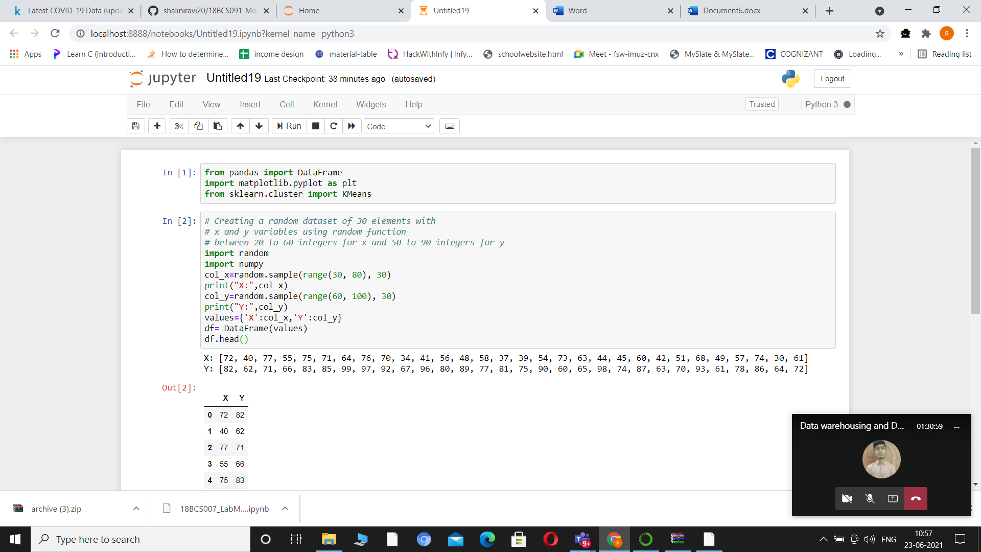

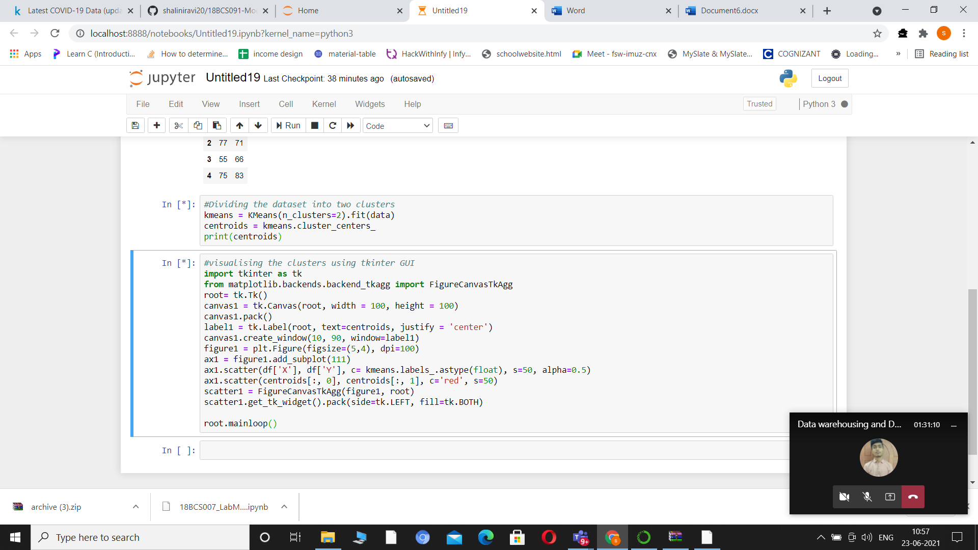

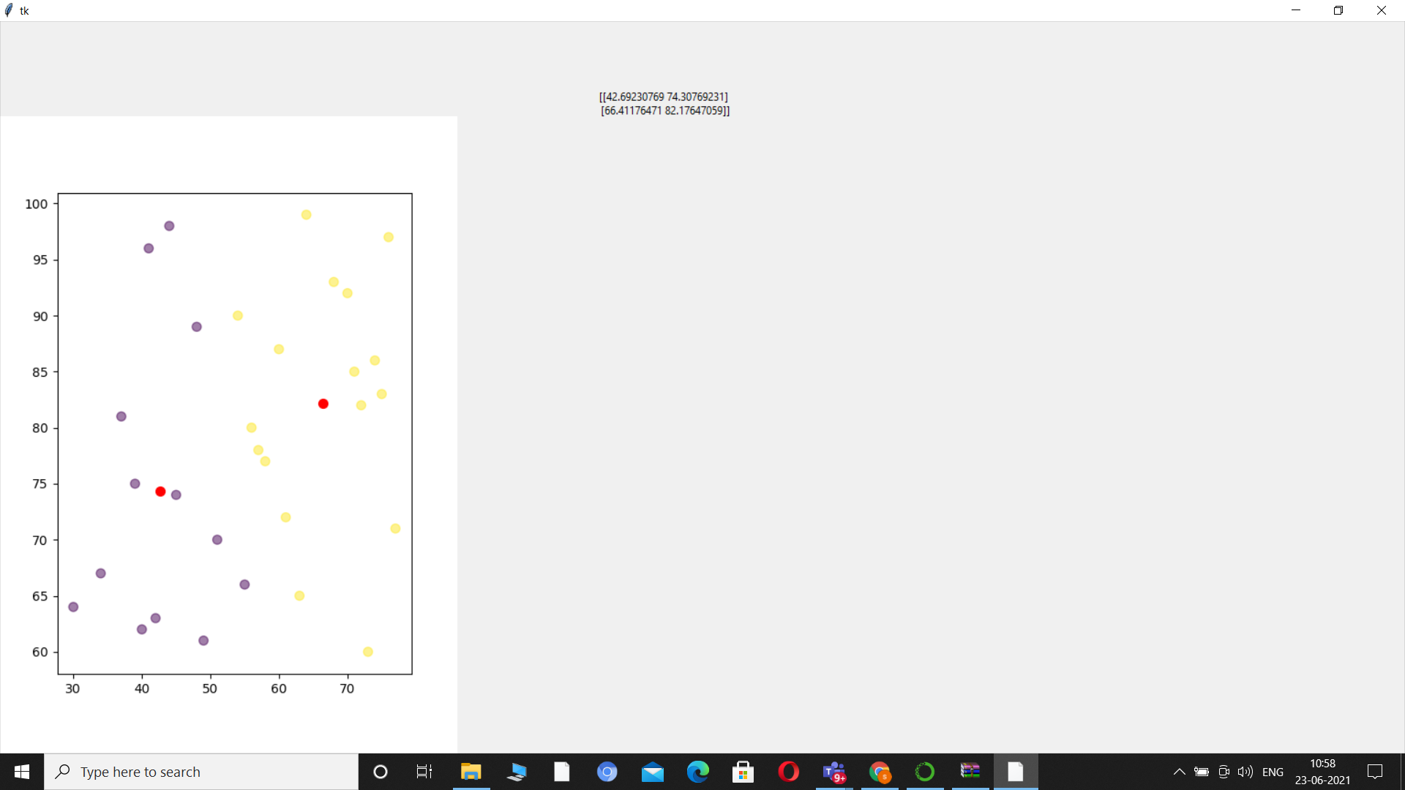

3. Upload in your github account. Provide the link for access.

<https://github.com/shaliniravi20/18BCS091-SEM_PRACTICAL/upload/main>