**Shalini Chilumula**

**700756190**

**NEURAL NETWORKS AND DEEP LEARNING**

**ASSIGNMENT -1**

**Github link :** [**https://github.com/shalinireddy0456/Assesment1.git**](https://github.com/shalinireddy0456/Assesment1.git)

**Write a python program for the following:**

**– Input the string “Python” as a list of characters from console, delete at least 2 characters, reverse the resultant string and print it.**

**Sample input:**

**python**

**Sample output:**

**ntyp**

**– Take two numbers from user and perform at least 4 arithmetic operations on them. Code:**

# Input two numbers from the user

num1 = float(input("Enter the first number: "))

num2 = float(input("Enter the second number: "))

# Perform arithmetic operations

addition_result = num1 + num2

subtraction_result = num1 - num2

multiplication_result = num1 * num2

# Check if num2 is not zero to avoid division by zero

if num2 != 0:

division_result = num1 / num2

print(f"Division result: {division_result}")

else:

print("Cannot perform division as the second number is zero.")

# Print the results of the arithmetic operations

print(f"Addition result: {addition_result}")

print(f"Subtraction result: {subtraction_result}")

print(f"Multiplication result: {multiplication_result}")

**Output:**

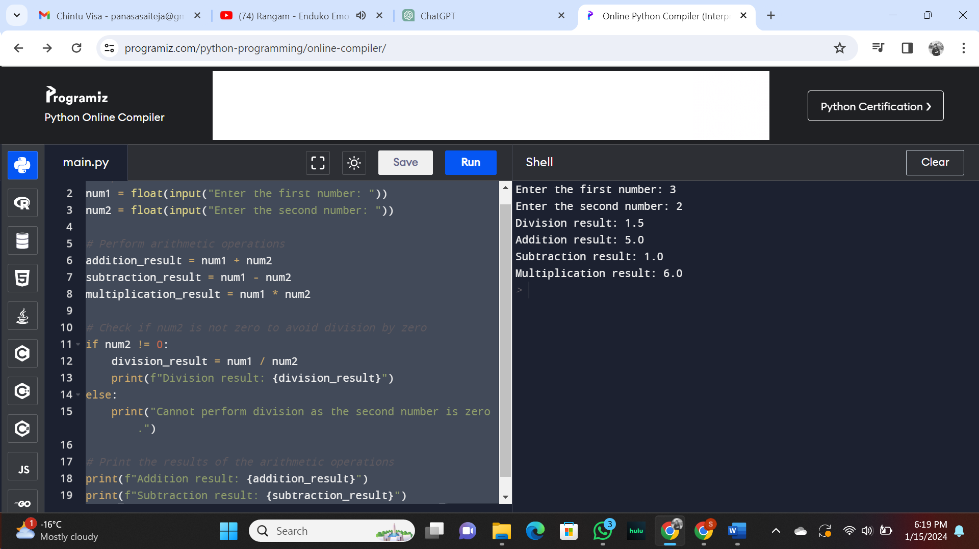

1. **Write a program that accepts a sentence and replace each occurrence of ‘python’ with ‘pythons’.**

**Sample input:**

**I love playing with python**

**Sample output:**

**I love playing with pythons**

**Code:**

# Input a sentence

input_sentence = input("Enter a sentence: ")

# Replace 'python' with 'pythons'

replaced_sentence = input_sentence.replace('python', 'pythons')

# Print the replaced sentence

print("Replaced Sentence:", replaced_sentence)

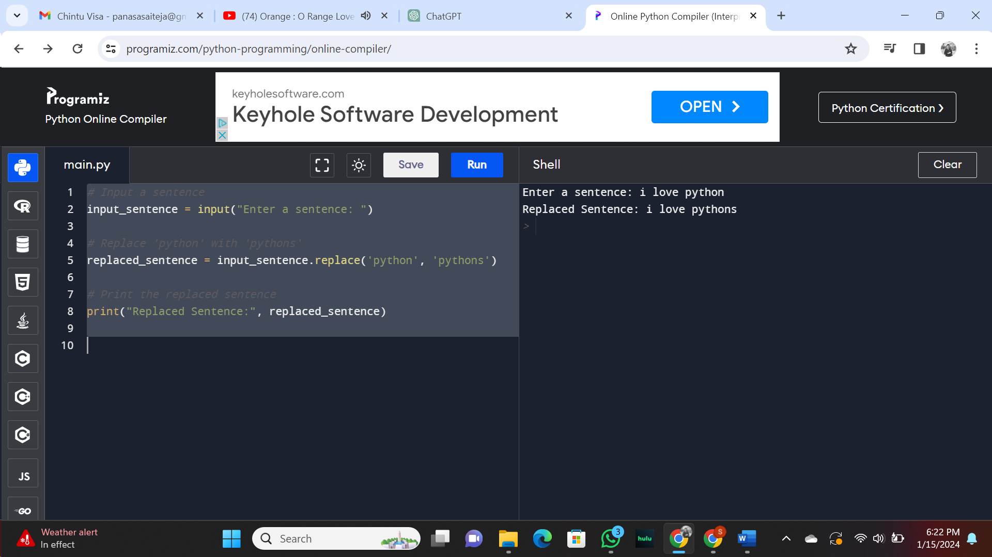

**3.Use the if statement conditions to write a program to print the letter grade based on an input class score. Use the grading scheme we are using in this class.**

**Code:**

# Input the class score from the user

class_score = float(input("Enter the class score: "))

# Determining the grade based on the grading scheme used in the class

if class_score >= 90 and class_score<=100:

grade = 'A'

elif class_score >= 80 and class_score<90 : grade = 'B'

elif class_score >= 70 and class_score<80: grade = 'C'

elif class_score >= 60 and class_score<70: grade = 'D'

elif class_score <60: grade = 'F'

else:

grade = 'WrongScore' # Print the grade

print("Grade:", grade)

Output

