COVER PAGE

BANKING DATA ANALYSIS DASHBOARD USING MICROSOFT EXCEL & SQL

Submitted By:
Shalini shenthilkumar

Tools Used:
Microsoft Excel
MySQL

Year:
2026

Acknowledgement

I would like to express my sincere gratitude to my guide, faculty members, and everyone who supported me during the completion of this project. This project helped me improve my skills in Microsoft Excel, SQL, and Data Analysis.

Table of Contents

1. Introduction
2. Objectives
3. Tools Used
4. Dataset Description
5. Data Cleaning
6. Customer Analysis
7. Transaction Analysis
8. Loan Analysis
9. Branch Analysis
10. Dashboard
11. SQL Queries12. Business Insights
13. Conclusion
14. Future Scope

Introduction

The Banking Data Analysis Dashboard is designed to analyze customer, transaction, loan, and branch data using Microsoft Excel and SQL. The objective is to convert raw banking data into meaningful business insights through dashboards, charts, and SQL queries.

Objectives

- Analyze customer information.
- Monitor transaction trends.
- Evaluate loan approval status.
- Compare branch performance.
- Build an interactive dashboard.
- Generate business insights.

Tools Used

Tool | Purpose
Microsoft Excel | Data Cleaning & Dashboard
SQL | Data Analysis
Pivot Tables | Summarization
Pivot Charts | Visualization
Slicers | Interactive Dashboard

Dataset Description

Sheet | Description

customers | Customer details

transactions | Transaction data

loan | Loan information

branches | Branch details

Data Cleaning

- Removed duplicate records.
- Checked missing values.
- Formatted dates.
- Standardized text values.
- Verified numerical columns.

Customer Analysis

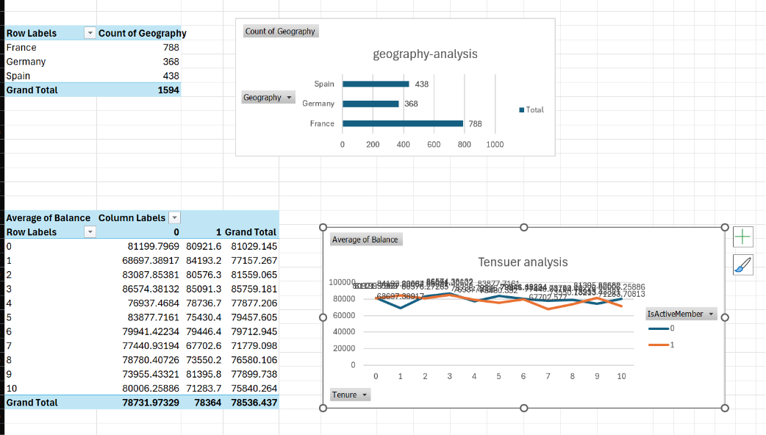

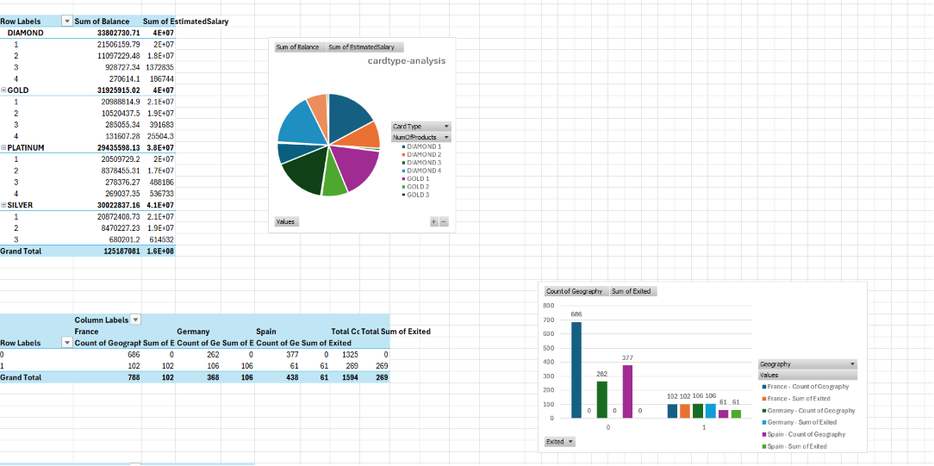
Transaction Analysis

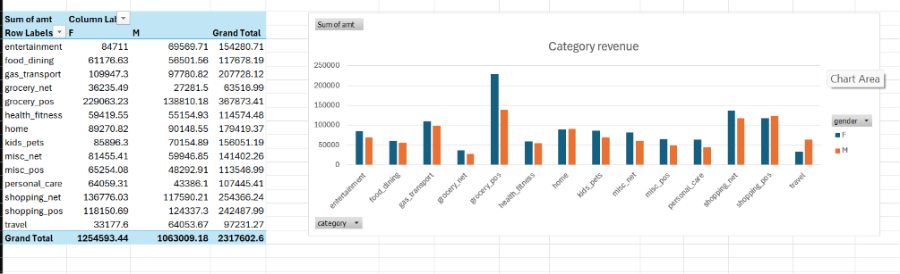

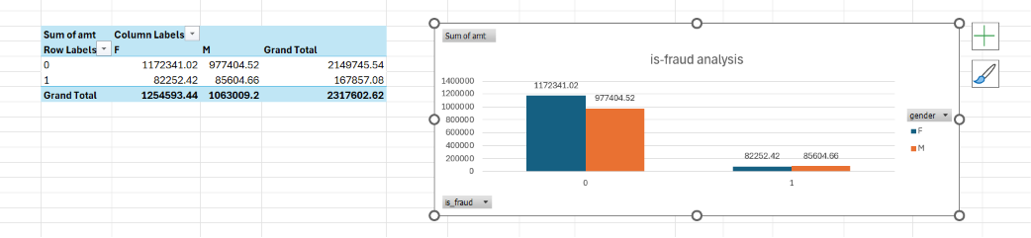

Loan Analysis

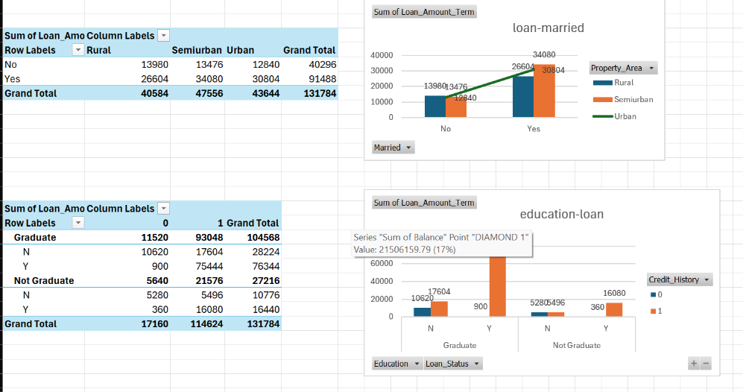

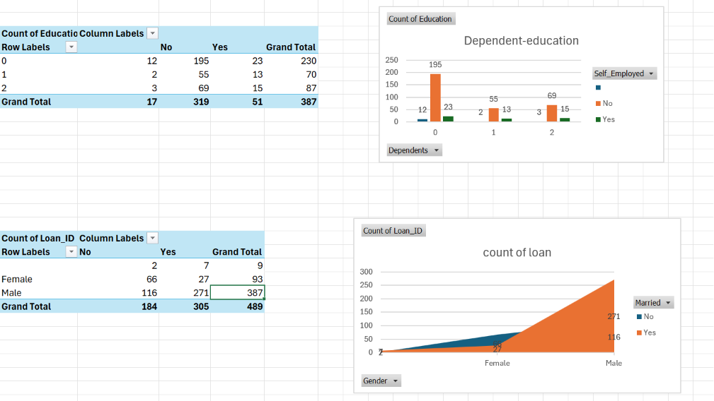
Dashboard

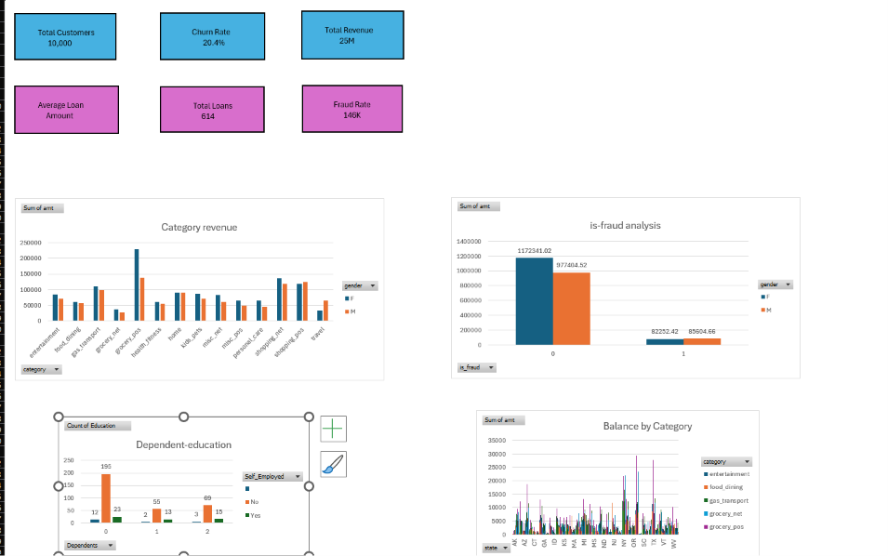

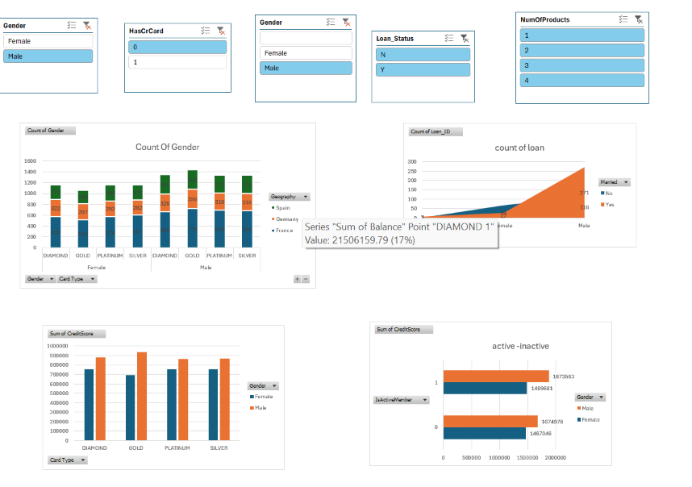
SQL Queries

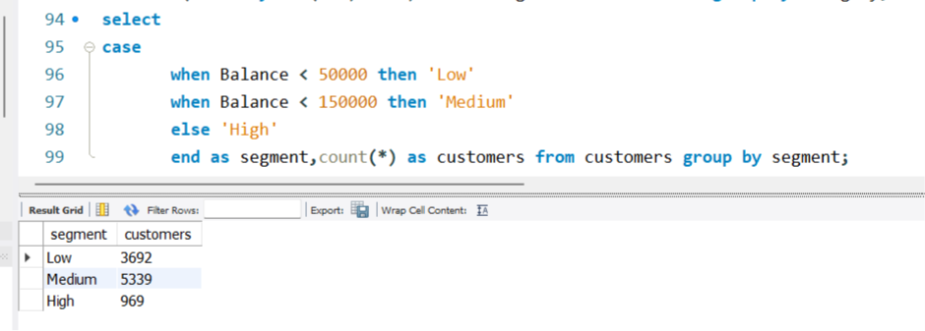

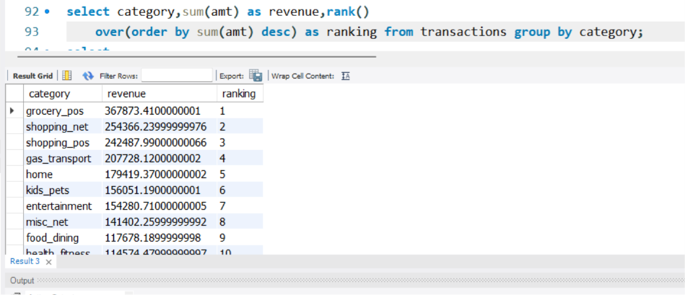

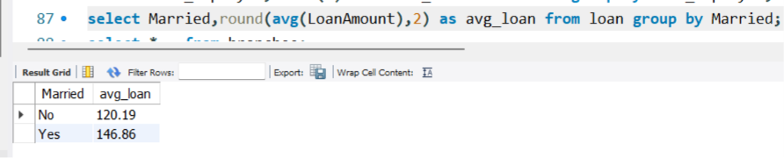

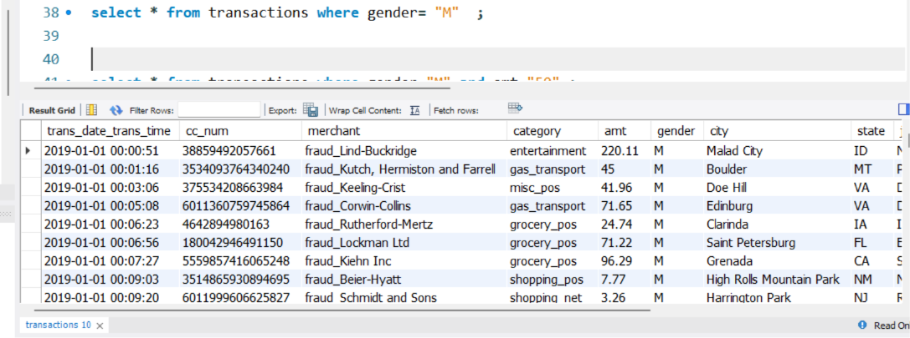

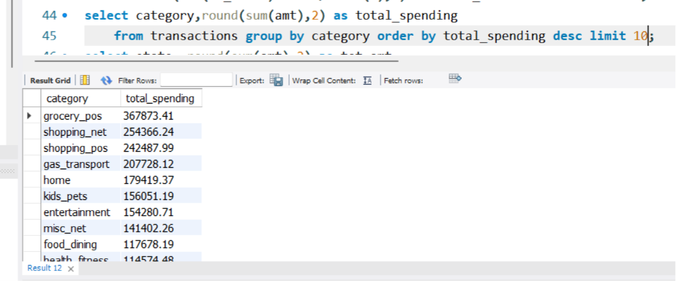

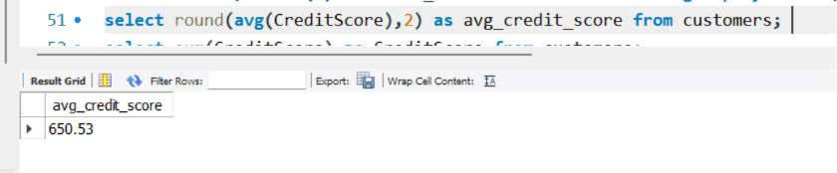
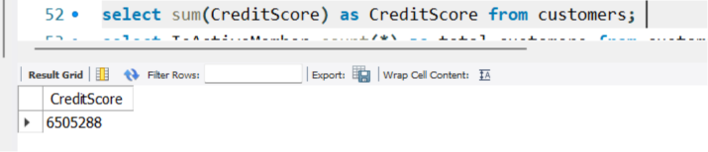
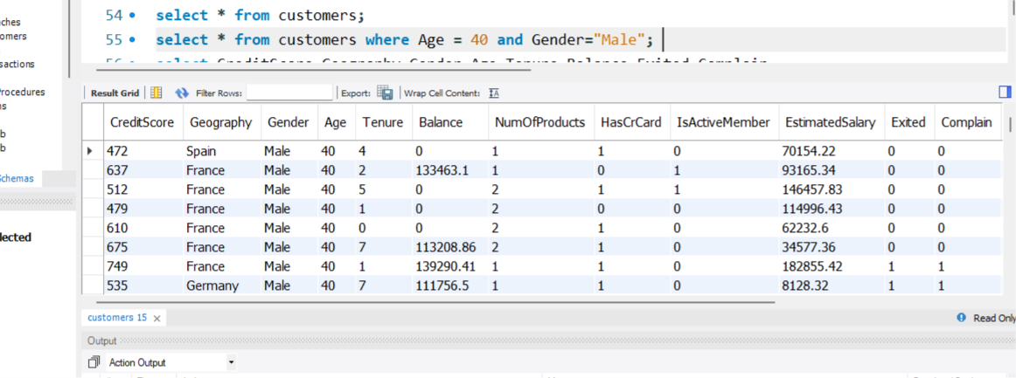

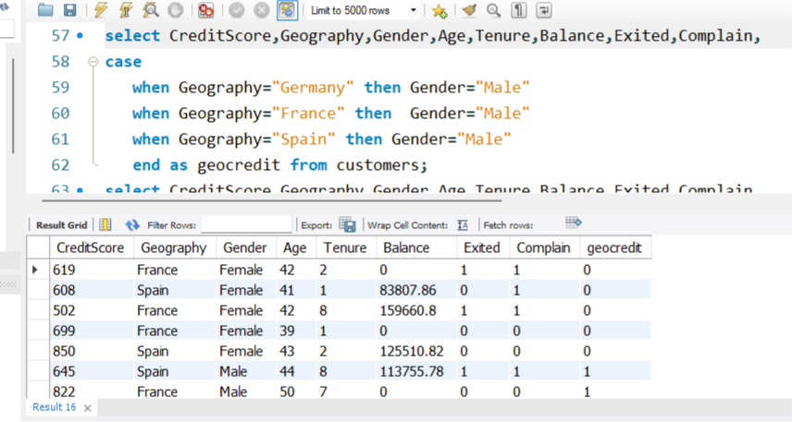

Business Insights

- France has the highest number of customers.
- Female customers maintain a higher average balance.
- Savings accounts are the most common account type.
- Loan approval rate is high for graduates.
- Transactions are highest in shopping-related categories.

Conclusion

This project successfully analyzed banking customer, transaction, loan, and branch data using Microsoft Excel and SQL. The interactive dashboard provides meaningful business insights that support better decision-making.

Future Scope

- Power BI Dashboard
- Python Automations
- Machine Learning
- Customer Churn Prediction
- Real-time Banking Analytics

