**FitFlex: Your Personal Fitness Companion**

**Overview**

FitFlex is a personal fitness companion application designed to help users track their workouts, monitor their nutrition, and offer recommendations based on fitness goals. The app will allow users to input data such as their workout routine, daily calorie intake, and preferred fitness goals (e.g., weight loss, muscle gain, general fitness).

**Features**

* **User Profile Management**:

Create and manage user profiles, including age, weight, height, and fitness goals.

* **Workout Tracking**:

Log workouts with details (exercise type, sets, reps, duration, etc.).

* **Meal Tracking**:

Record daily meals and their nutritional information (calories, macronutrients).

* **Progress Tracking**:

Visualize progress over time, including weight, strength, and body measurements.

* **Recommendations Engine**:

Receive workout and meal suggestions based on goals.

**Tech Stack**

* **Frontend**: React.js (for the user interface)
* **Backend**: Node.js with Express
* **Database**: MongoDB (for storing user data)
* **Authentication**: JWT-based Authentication
* **API**: RESTful API for communication between frontend and backend
* **Data visualization**: Chart.js (for showing progress)

**Coding**

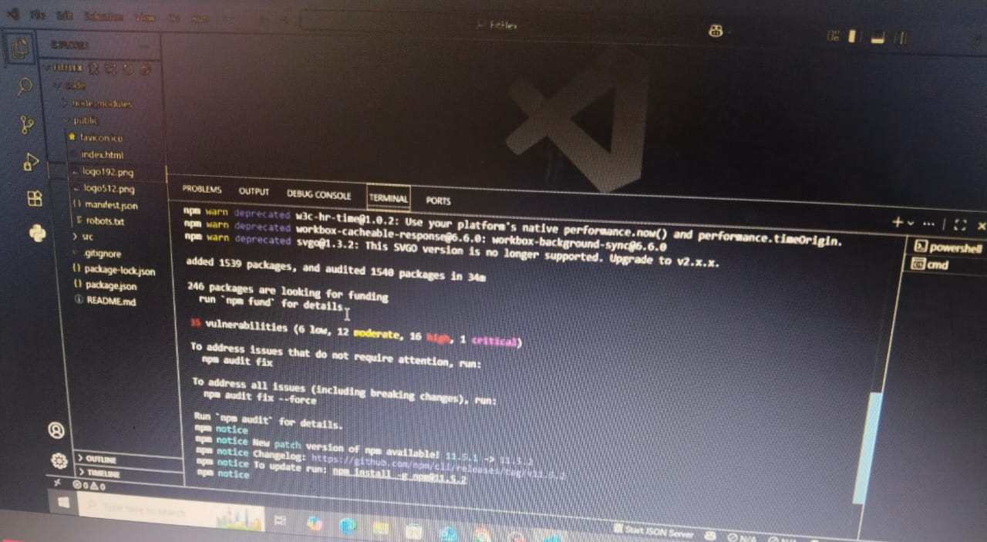

**Output**

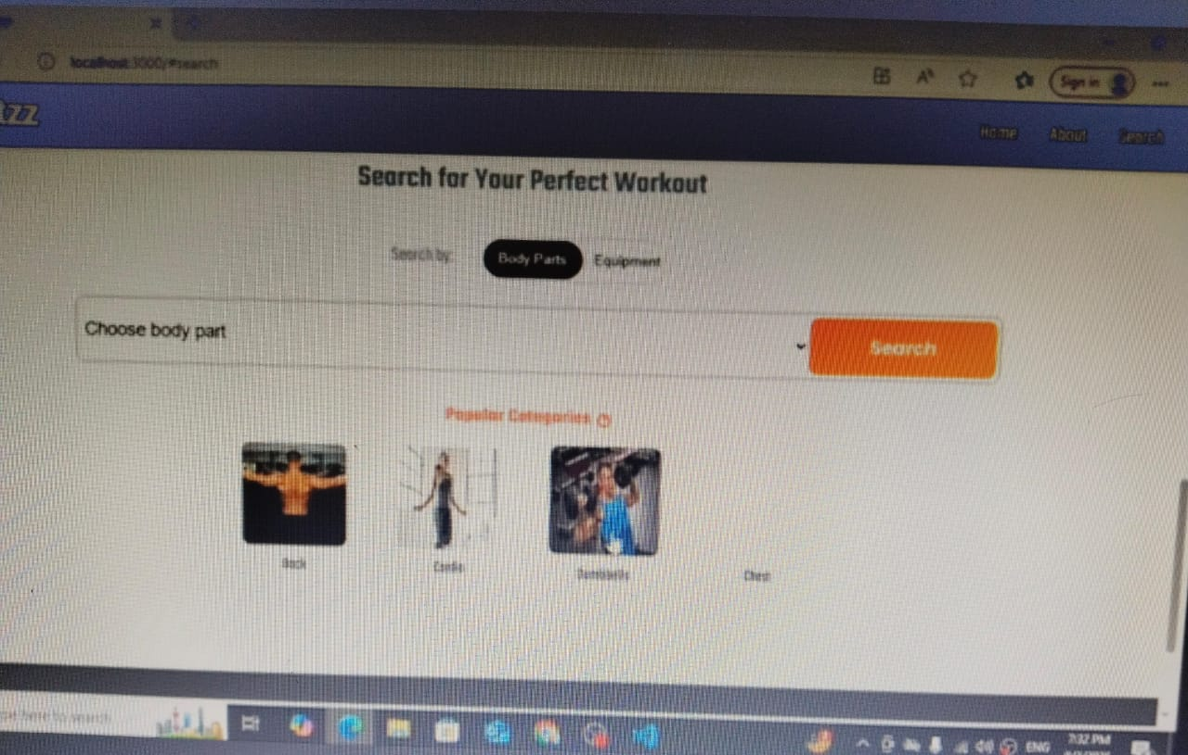

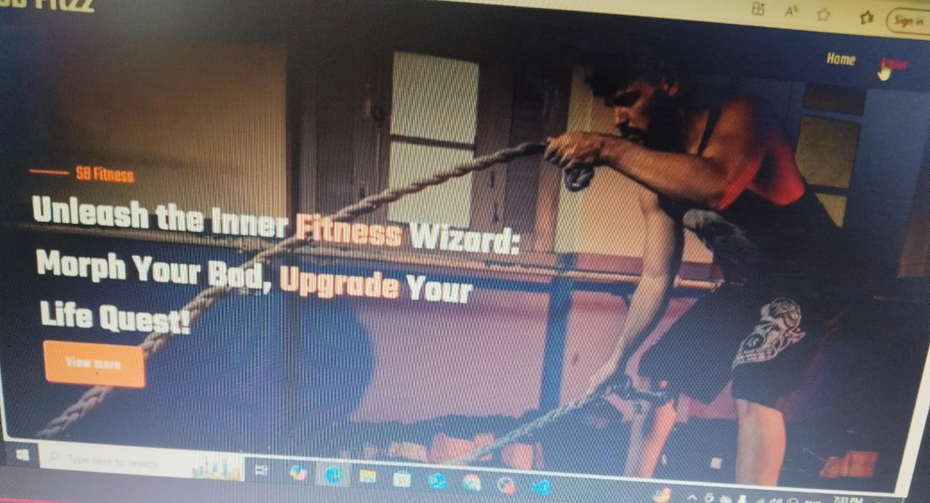

**Conclusion**

FitFlex is an all-in-one fitness companion that helps users track their physical activity, nutrition, and progress while giving them insights and recommendations based on their fitness goals. It leverages modern technologies to provide an intuitive and effective way of staying fit and healthy.