SIMATS ENGINEERING

ASSESSMENT TOOL 2

COURSE NAME: Database Management Systems COURSE CODE: CSA05

COURSE OUTCOME COVERED

CO2: Apply the relational model, relational algebra, SQL query structures, and views to solve database querying and data manipulation problems. (BL3, BL6)

Activity Tool : Scenario-Based Task (Medium) Assessment Tool Weightage: 20%

QUESTIONS
Q.N  o | Question | Bloom's Level
1 | A university stores student and course data in a single table. Analyze the structure and identify normalization issues, then redesign it up to 3NF | . BL4 – Analyze
2 | A company database contains employee and department details. Design appropriate SQL queries to retrieve employees working in multiple departments and justify your approach | . BL6 – Create
3 | Given a relation with multiple functional dependencies, determine the candidate keys and check whether the relation satisfies BCNF. If not, decompose it. | BL5 – Evaluate
4 | A banking system requires secure data access. Design views and constraints to ensure data security and integrity for different types of users. | BL6 – Create
5 | A sales database contains redundant data leading to anomalies. Analyze the schema and apply normalization up to 3NF or BCNF to eliminate redundancy. | BL4 – Analyze
6 | Given a dataset of customers and orders, write SQL queries using joins and subqueries to retrieve meaningful information such as frequent customers. | BL3 – Apply
7 | A relation contains multi-valued dependencies. Analyze the structure and decompose it into 4NF, explaining the reasoning. | BL4 – Analyze

8 | A database designer used improper constraints, leading to inconsistent data. Evaluate the schema and suggest appropriate integrity constraints. | BL5 – Evaluate
9 | For a given relational schema, analyze the presence of join dependencies and decompose it into 5NF to remove redundancy. | BL6 – Create
10 | A system uses inefficient SQL queries for data retrieval. Analyze the queries and optimize them using joins, indexing concepts, or query restructuring. | BL5 – Evaluate

Code of Conduct:

I V.Shalini (192525373) (Name / Reg No) certify that this submission is my original work and that I have adhered to the guidelines specified for this assessment. I understand that any violation of academic integrity rules will result in disciplinary action.

Signature of the student:
V.Shalini

RUBRICS FOR CALCULATION:

Criteria | Level 4 (Exemplary) | Level 3 (Proficient) | Level 2 (Developing) | Level 1 (Beginning)
Understandin g of Scenario | Demonstrates clear and complete understanding of the scenario and context | Shows good understanding with minor gaps | Partial understanding  ; misses key aspects | Misinterprets or fails to understand the scenario
Identification of Key Issues | Accurately identifies all relevant issues and factors involved | Identifies most key issues with minor omissions | Identifies limited issues; some irrelevant points | Unable to identify key issues
Application of Concepts | Applies appropriate concepts effectively to address the  scenario | Applies concepts with minor errors | Limited or partially correct application | Unable to apply relevant concepts
Decision Making | Makes well-reasoned,  logical decisions with strong rationale | Makes reasonable decisions with some justification | Makes weak decisions with limited justification | No clear decisions made or rationale provided
Clarity of Response | Response is clear, structured, and logically  presented | Generally clear with minor issues | Somewhat unclear or poorly structured | Disorganized and difficult to understand

1.A university stores student and course data in a single table. Analyze the structure and identify normalization issues, then redesign it up to 3NF
Aim
To analyze an unnormalized university database, identify normalization problems, and redesign the database up to Third Normal Form (3NF) to eliminate redundancy and improve data integrity.

Unnormalized Table (UNF)
StudentID | StudentName | Department | CourseID | CourseName | Faculty | Grade
101 | Asha | CSE | C101 | DBMS | Ravi | A
101 | Asha | CSE | C102 | Java | Anil | B+
102 | Rahul | ECE | C101 | DBMS | Ravi | B
103 | Priya | CSE | C103 | Python | Meena | A+
103 | Priya | CSE | C102 | Java | Anil | A

Problems in the Unnormalized Table
- Student information is repeated for every course.
- Course details are repeated for every student.
- Data redundancy increases storage space.
- Updating student or course details requires multiple changes.
- Deleting a student's last course may remove important course information.
- Inserting a new course without a student is difficult.

First Normal Form (1NF)
Rule
- Each column contains only atomic (single) values.
- No repeating groups.
1NF Table
StudentID | StudentName | Department | CourseID | CourseName | Faculty | Grade
101 | Asha | CSE | C101 | DBMS | Ravi | A
101 | Asha | CSE | C102 | Java | Anil | B+
102 | Rahul | ECE | C101 | DBMS | Ravi | B
103 | Priya | CSE | C103 | Python | Meena | A+
103 | Priya | CSE | C102 | Java | Anil | A
Observation
- Atomic values are maintained.
- Data redundancy still exists.

Second Normal Form (2NF)
Rule
- Must satisfy 1NF.
- Remove partial dependency by separating student and course details.
STUDENT
StudentID | StudentName | Department
101 | Asha | CSE
102 | Rahul | ECE
103 | Priya | CSE

COURSE
CourseID | CourseName | Faculty
C101 | DBMS | Ravi
C102 | Java | Anil
C103 | Python | Meena

ENROLLMENT
StudentID | CourseID | Grade
101 | C101 | A
101 | C102 | B+
102 | C101 | B
103 | C103 | A+
103 | C102 | A

Observation
- Partial dependencies are removed.
- Student and course details are stored separately.

Third Normal Form (3NF)
Rule
- Must satisfy 2NF.
- Remove transitive dependencies.
- Each non-key attribute depends only on the primary key.
STUDENT
StudentID | StudentName | Department
101 | Asha | CSE
102 | Rahul | ECE
103 | Priya | CSE

COURSE
CourseID | CourseName | Faculty
C101 | DBMS | Ravi
C102 | Java | Anil
C103 | Python | Meena

ENROLLMENT
StudentID | CourseID | Grade
101 | C101 | A
101 | C102 | B+
102 | C101 | B
103 | C103 | A+
103 | C102 | A

Benefits of 3NF
- Eliminates data redundancy.
- Reduces data inconsistency.
- Improves data integrity.
- Prevents update anomalies.
- Prevents insertion anomalies.
- Prevents deletion anomalies.
- Makes the database easier to maintain.
Comparison of Normal Forms
Normal Form | Improvement
UNF | Contains repeated data and redundancy
1NF | Removes repeating groups and ensures atomic values
2NF | Removes partial dependency by separating related data
3NF | Removes transitive dependency and improves data integrity

Conclusion
Normalization organizes data into well-structured tables to reduce redundancy and improve consistency. The original university table contains repeated student and course information, leading to update, insertion, and deletion anomalies. By converting the database from UNF to 1NF, 2NF, and finally 3NF, the data is separated into Student, Course, and Enrollment tables. This redesign improves data integrity, minimizes duplication, and makes the database easier to maintain and manage.

2.A company database contains employee and department details. Design appropriate SQL queries to retrieve employees working in multiple departments and justify your approach
Aim
To design SQL queries that retrieve employees working in multiple departments using grouping and aggregation techniques, and justify the chosen approach.

Database Tables
EMPLOYEE
EmployeeID | EmployeeName | DepartmentID
101 | John | D01
101 | John | D02
102 | Alice | D01
103 | David | D03
104 | Sophia | D02
104 | Sophia | D03
105 | Michael | D01

DEPARTMENT
DepartmentID | DepartmentName
D01 | HR
D02 | Finance
D03 | IT

Retrieve Employees Working in Multiple Departments
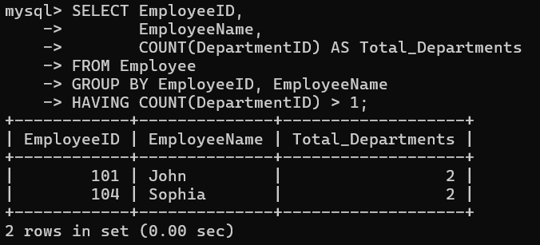
Display Employee Name with Department
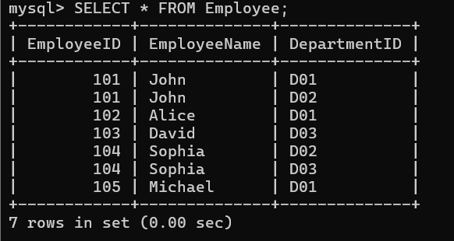
Retrieve Employees Working in More Than One Department with Department Details
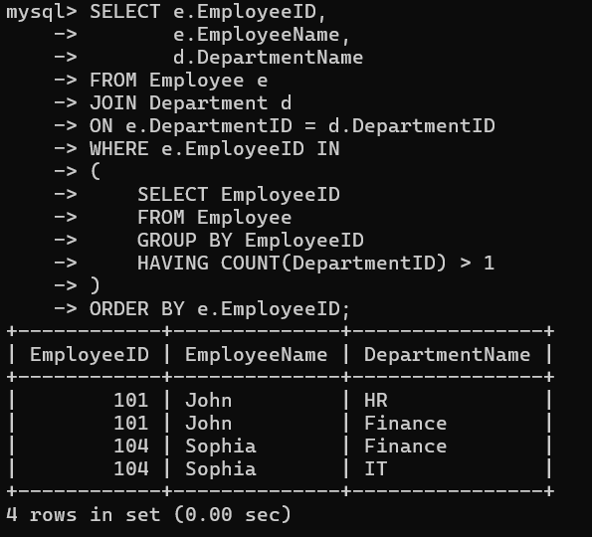
Advantages
- Retrieves employees assigned to multiple departments accurately.
- Uses aggregate functions for efficient analysis.
- JOIN improves readability by combining related tables.
- Suitable for large organizational databases.
- Easy to maintain and modify.
- Helps management identify employees handling multiple responsibilities.

Conclusion
The SQL solution uses GROUP BY, COUNT(), HAVING, JOIN, and a subquery to identify employees working in multiple departments. The combination of these SQL features provides an efficient and organized way to retrieve employee and department information. This approach is suitable for real-world company databases where employees may be assigned to more than one department and supports effective reporting and decision-making.

3.Given a relation with multiple functional dependencies, determine the candidate keys and check whether the relation satisfies BCNF. If not, decompose it.

Aim
To determine the candidate key of a relation using functional dependencies, verify whether the relation satisfies Boyce-Codd Normal Form (BCNF), and decompose it if necessary.

Relation
EMPLOYEE
EmpID | EmpName | DeptID | DeptName | Manager
101 | John | D01 | HR | Ravi
102 | Alice | D02 | Finance | Kiran
103 | David | D03 | IT | Anil
104 | Sophia | D02 | Finance | Kiran
105 | Michael | D01 | HR | Ravi

Functional Dependencies
- EmpID → EmpName, DeptID
- DeptID → DeptName, Manager

Candidate Key
Since EmpID uniquely identifies every employee, the candidate key is:
EmpID

Checking BCNF
A relation is in BCNF if every determinant is a candidate key.
Functional Dependency 1
EmpID → EmpName, DeptID
- EmpID is a candidate key.
- Satisfied.
Functional Dependency 2
DeptID → DeptName, Manager
- DeptID is not a candidate key.
- BCNF is violated.

Reason for Violation
The department details (DeptName and Manager) depend only on DeptID, not on the whole relation. Therefore, the relation contains redundancy and does not satisfy BCNF.

BCNF Decomposition
EMPLOYEE
EmpID | EmpName | DeptID
101 | John | D01
102 | Alice | D02
103 | David | D03
104 | Sophia | D02
105 | Michael | D01

DEPARTMENT
DeptID | DeptName | Manager
D01 | HR | Ravi
D02 | Finance | Kiran
D03 | IT | Anil

Advantages of BCNF Decomposition
- Eliminates data redundancy.
- Prevents update anomalies.
- Prevents insertion anomalies.
- Prevents deletion anomalies.
- Improves data consistency.
- Makes database maintenance easier.
- Ensures every determinant is a candidate key.

Comparison
Before BCNF | After BCNF
Employee and department data stored together | Employee and department data stored separately
Repeated department information | No repeated department information
Data redundancy exists | Redundancy removed
Higher chance of anomalies | Anomalies eliminated
Difficult to maintain | Easy to maintain

Conclusion
The given relation does not satisfy BCNF because the functional dependency DeptID → DeptName, Manager violates the BCNF rule, as DeptID is not a candidate key. By decomposing the relation into EMPLOYEE(EmpID, EmpName, DeptID) and DEPARTMENT(DeptID, DeptName, Manager), redundancy is removed, data integrity is improved, and the database becomes easier to manage.

4.A banking system requires secure data access. Design views and constraints to ensure data security and integrity for different types of users.

Aim
To design SQL Views and Constraints that provide secure data access and maintain data integrity for different types of users in a banking system.

BANK Table
AccountNo | CustomerName | Branch | Balance | AccountType
1001 | Ramesh | Hyderabad | 50000 | Savings
1002 | Sita | Vijayawada | 75000 | Current
1003 | Rahul | Hyderabad | 62000 | Savings
1004 | Anita | Visakhapatnam | 90000 | Current
1005 | Kiran | Guntur | 45000 | Savings

Customer View
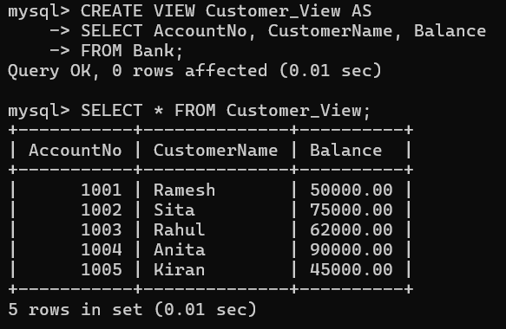
Branch Manager View
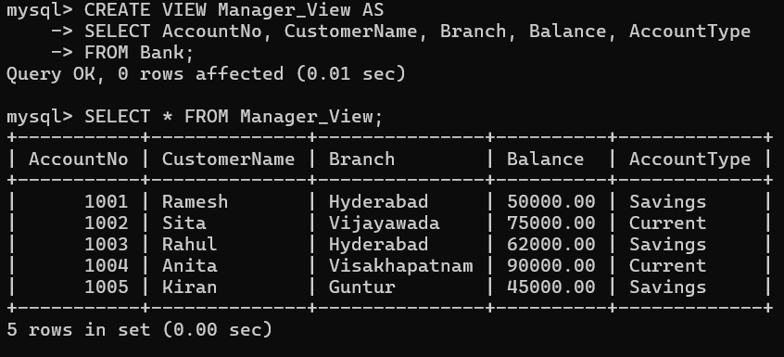

Constraints Used
Constraint | Purpose
PRIMARY KEY | Ensures each account has a unique Account Number.
NOT NULL | Prevents empty values for important fields.
CHECK (Balance >= 0) | Prevents negative account balances.
CHECK (AccountType IN ('Savings','Current')) | Allows only valid account types.

Security Features
- Views restrict users from accessing confidential information.
- Customers can view only their account details.
- Managers can access branch-related account information.
- Constraints prevent invalid or inconsistent data from being stored.
- Primary Key ensures each account is uniquely identified.

Advantages
- Improves database security.
- Prevents unauthorized access.
- Maintains data integrity.
- Reduces data redundancy.
- Simplifies data retrieval.
- Ensures accurate banking records.
- Makes database management easier.

Conclusion
Views and constraints provide a secure and reliable banking database system. Views allow different users to access only the information they are authorized to see, while constraints enforce valid and consistent data. Together, they improve security, data integrity, and efficient database management, making them essential features in modern banking applications.

5.A sales database contains redundant data leading to anomalies. Analyze the schema and apply normalization up to 3NF or BCNF to eliminate redundancy.

Aim
To analyze a sales database containing redundant data, identify normalization issues, and apply normalization up to Third Normal Form (3NF) to eliminate redundancy and improve data integrity.

Unnormalized Sales Table (UNF)
OrderID | CustomerID | CustomerName | ProductID | ProductName | Supplier | Quantity
1001 | C101 | Ramesh | P101 | Laptop | Dell | 2
1001 | C101 | Ramesh | P102 | Mouse | Logitech | 1
1002 | C102 | Sita | P101 | Laptop | Dell | 1
1003 | C103 | Rahul | P103 | Keyboard | HP | 3
1003 | C103 | Rahul | P104 | Monitor | Samsung | 2

Problems in the Existing Schema
- Customer details are repeated for every order.
- Product details are repeated for every purchase.
- Data redundancy increases storage.
- Updating customer or product information requires multiple changes.
- Deleting an order may remove important customer or product information.
- Inserting a new product without an order is difficult.

First Normal Form (1NF)
Rule
- Each column should contain atomic values.
- No repeating groups.
1NF Table

OrderID | CustomerID | ProductID | Quantity
1001 | C101 | P101 | 2
1001 | C101 | P102 | 1
1002 | C102 | P101 | 1
1003 | C103 | P103 | 3
1003 | C103 | P104 | 2

Observation
- Atomic values are maintained.
- Data redundancy still exists.

Second Normal Form (2NF)
Rule
- Must satisfy 1NF.
- Remove partial dependencies.
CUSTOMER
CustomerID | CustomerName
C101 | Ramesh
C102 | Sita
C103 | Rahul

PRODUCT
ProductID | ProductName | Supplier
P101 | Laptop | Dell
P102 | Mouse | Logitech
P103 | Keyboard | HP
P104 | Monitor | Samsung

SALES
OrderID | CustomerID | ProductID | Quantity
1001 | C101 | P101 | 2
1001 | C101 | P102 | 1
1002 | C102 | P101 | 1
1003 | C103 | P103 | 3
1003 | C103 | P104 | 2

Third Normal Form (3NF)
Rule
- Must satisfy 2NF.
- Remove transitive dependencies.

CUSTOMER
CustomerID | CustomerName
C101 | Ramesh
C102 | Sita
C103 | Rahul

PRODUCT
ProductID | ProductName | Supplier
P101 | Laptop | Dell
P102 | Mouse | Logitech
P103 | Keyboard | HP
P104 | Monitor | Samsung

ORDERS
OrderID | CustomerID
1001 | C101
1002 | C102
1003 | C103

ORDER_DETAILS
OrderID | ProductID | Quantity
1001 | P101 | 2
1001 | P102 | 1
1002 | P101 | 1
1003 | P103 | 3
1003 | P104 | 2

Analysis of Normalization
Normal Form | Improvement
UNF | Contains repeated customer and product data
1NF | Removes repeating groups and stores atomic values
2NF | Separates customer and product information to remove partial dependency
3NF | Separates order information from order details, removing transitive dependency and redundancy

Advantages of Normalization
- Eliminates data redundancy.
- Reduces update anomalies.
- Prevents insertion anomalies.
- Prevents deletion anomalies.
- Improves data consistency.
- Enhances database integrity.
- Simplifies database maintenance.
- Improves storage efficiency.

Conclusion
The original sales database contains redundant customer and product information, which leads to update, insertion, and deletion anomalies. By applying 1NF, 2NF, and 3NF, the database is reorganized into separate CUSTOMER, PRODUCT, ORDERS, and ORDER_DETAILS tables. This normalization eliminates redundancy, improves data integrity, reduces anomalies, and results in a more efficient and maintainable database design suitable for real-world sales management systems.

6.Given a dataset of customers and orders, write SQL queries using joins and subqueries to retrieve meaningful information such as frequent customers.

Aim
To retrieve meaningful information from customer and order data using JOINs and subqueries, such as identifying frequent customers and analyzing customer purchases.

Database Tables

CUSTOMER
CustomerID | CustomerName | City
101 | Ramesh | Hyderabad
102 | Sita | Vijayawada
103 | Rahul | Guntur
104 | Anita | Visakhapatnam
105 | Kiran | Hyderabad

ORDERS
OrderID | CustomerID | Product | Amount
1001 | 101 | Laptop | 50000
1002 | 101 | Mouse | 1000
1003 | 102 | Keyboard | 2000
1004 | 103 | Laptop | 50000
1005 | 103 | Monitor | 12000
1006 | 103 | Mouse | 1000
1007 | 104 | Printer | 15000
1008 | 105 | Laptop | 50000
1009 | 105 | Keyboard | 2000

Display Customer Details with Their Orders (JOIN)
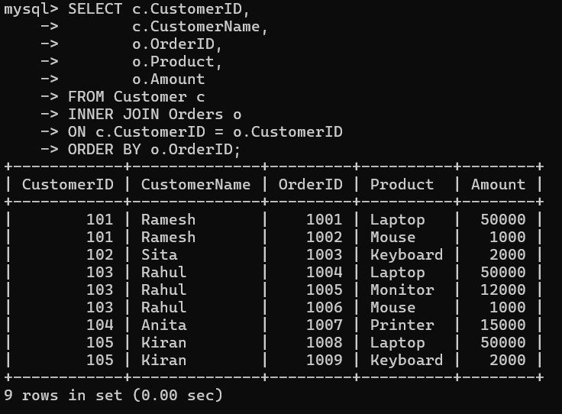
Find Frequent Customers (More Than One Order)
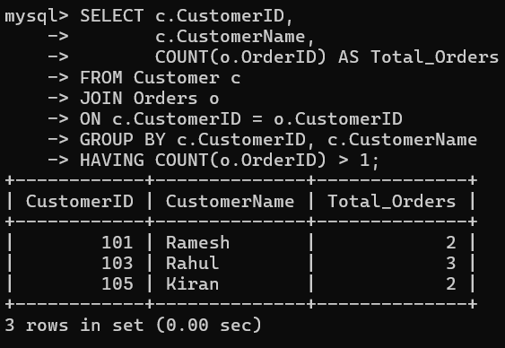

Display Customers Whose Total Purchase Amount is Greater Than ₹50,000 (Subquery)

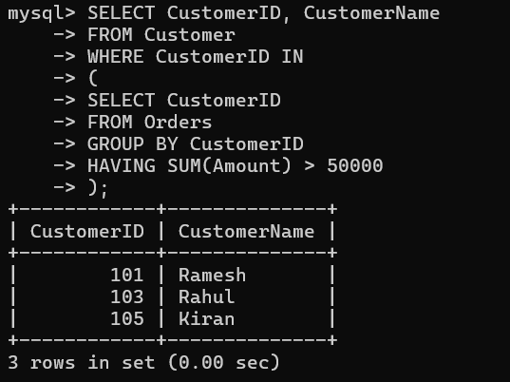

Display the Customer Who Placed the Highest Number of Orders

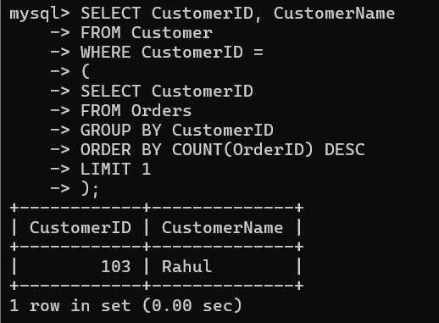

Display Total Purchase Amount of Each Customer
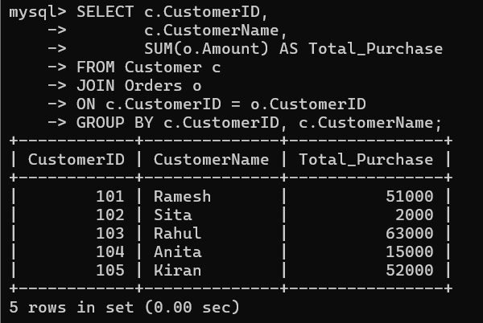
Advantages
- Identifies frequent customers.
- Calculates customer purchase totals.
- Retrieves related data efficiently.
- Supports business reporting and sales analysis.
- Improves customer relationship management.
- Helps identify valuable customers.

Conclusion
Using JOINs and subqueries, customer and order information can be analyzed effectively to identify frequent customers, calculate total purchases, and retrieve meaningful business insights. These SQL techniques are widely used in sales and e-commerce systems to support customer analysis, reporting, and informed decision-making.

7.A relation contains multi-valued dependencies. Analyze the structure and decompose it into 4NF, explaining the reasoning.

Aim
To analyze a relation containing multi-valued dependencies (MVDs) and decompose it into Fourth Normal Form (4NF) to eliminate redundancy and improve data integrity.

Given Relation
STUDENT
StudentID | StudentName | Course | Hobby
101 | Asha | DBMS | Music
101 | Asha | DBMS | Dance
101 | Asha | Java | Music
101 | Asha | Java | Dance
102 | Rahul | Python | Cricket
102 | Rahul | Python | Reading

Analysis of the Relation
A student can enroll in multiple courses and also have multiple hobbies.
The Course and Hobby attributes are independent of each other, which creates multi-valued dependencies.
Multi-Valued Dependencies
StudentID →→ Course
StudentID →→ Hobby
Because of these multi-valued dependencies, unnecessary combinations of courses and hobbies are stored, resulting in redundant data.

Problems in the Existing Relation
- Data redundancy increases.
- Multiple records store the same student information.
- Update anomalies may occur.
- Insertion anomalies may occur.
- Deletion anomalies may occur.
- Extra storage space is required.

Why the Relation is Not in 4NF
A relation is in Fourth Normal Form (4NF) if there are no non-trivial multi-valued dependencies.

Since:
StudentID →→ Course
StudentID →→ Hobby
the relation does not satisfy 4NF.

4NF Decomposition

STUDENT_COURSE
StudentID | Course
101 | DBMS
101 | Java
102 | Python

STUDENT_HOBBY
StudentID | Hobby
101 | Music
101 | Dance
102 | Cricket
102 | Reading

Advantages of 4NF Decomposition
- Eliminates multi-valued dependencies.
- Removes unnecessary duplicate records.
- Reduces data redundancy.
- Prevents update anomalies.
- Prevents insertion anomalies.
- Prevents deletion anomalies.
- Improves database consistency.
- Makes the database easier to maintain.

Comparison Before and After 4NF
Before 4NF | After 4NF
Course and Hobby stored together | Stored in separate tables
Redundant records | No redundant records
Multi-valued dependencies exist | Multi-valued dependencies removed
Higher storage requirement | Reduced storage
Difficult to maintain | Easy to maintain

Reason for Decomposition
The original relation stores independent information (courses and hobbies) together, creating unnecessary combinations of data. By separating the relation into STUDENT_COURSE and STUDENT_HOBBY, each table stores only one multi-valued dependency. This removes redundancy, improves data integrity, and satisfies the requirements of Fourth Normal Form (4NF).

Conclusion
The given relation contains multi-valued dependencies, making it unsuitable for 4NF. By decomposing the relation into STUDENT_COURSE and STUDENT_HOBBY, the database eliminates redundancy and anomalies while improving consistency and maintainability. The decomposed design satisfies Fourth Normal Form (4NF) and is more efficient for managing independent multi-valued attributes.

8.A database designer used improper constraints, leading to inconsistent data. Evaluate the schema and suggest appropriate integrity constraints.

Aim
To evaluate a database schema with improper constraints and suggest appropriate integrity constraints to ensure data consistency and integrity.

Existing Table (Without Proper Constraints)
EMPLOYEE
EmployeeID | EmployeeName | Department | Salary | Email
101 | John | HR | 50000 | john@gmail.com
102 | Alice | Finance | -10000 | alice@gmail.com
101 | David | IT | 60000 | david@gmail.com
104 | Sophia | NULL | 45000 | NULL

Problems in the Schema
- Duplicate EmployeeID values.
- Negative salary values.
- NULL values in mandatory fields.
- No validation for employee details.
- Data inconsistency due to missing constraints.
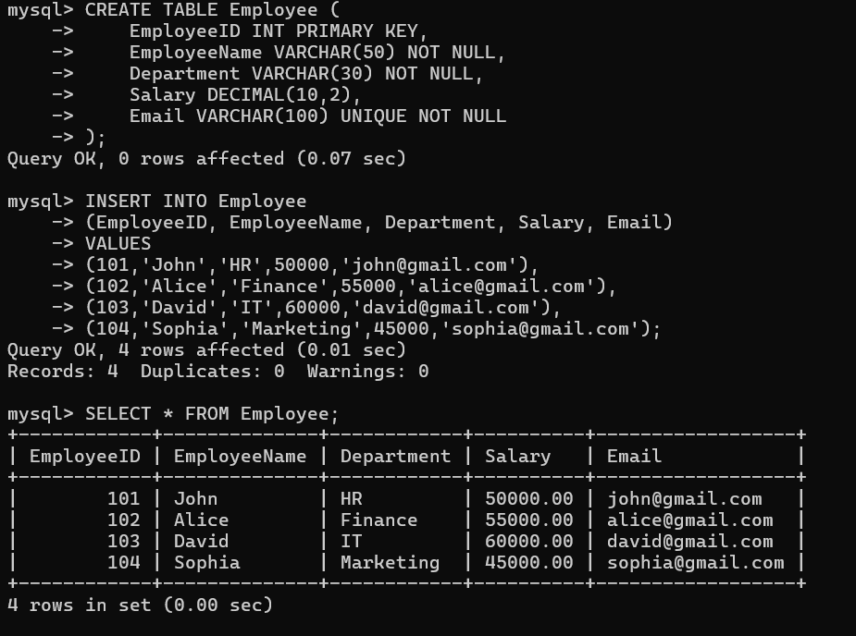

Advantages
- Eliminates duplicate records.
- Prevents invalid salary entries.
- Ensures mandatory information is provided.
- Improves data consistency.
- Maintains database integrity.
- Reduces update and insertion errors.
- Makes the database reliable and easy to maintain.

Conclusion
The original schema lacks proper integrity constraints, resulting in duplicate records, invalid values, and missing data. By applying PRIMARY KEY, NOT NULL, CHECK, and UNIQUE constraints, the database becomes more secure, consistent, and reliable. These integrity constraints help maintain accurate data and improve the overall quality of the database system.

9.For a given relational schema, analyze the presence of join dependencies and decompose it into 5NF to remove redundancy.

Aim
To analyze a relational schema for join dependencies and decompose it into Fifth Normal Form (5NF) to eliminate redundancy and improve data consistency.

Given Relation
SUPPLY
SupplierID | PartID | ProjectID
S1 | P1 | J1
S1 | P2 | J1
S2 | P1 | J1
S2 | P2 | J2
S3 | P3 | J2

Analysis of the Relation
The relation stores information about:
- Suppliers supplying parts.
- Parts used in projects.
- Suppliers working on projects.
The three attributes are related through join dependencies. Storing all information in one table may cause redundancy.

Join Dependency
The relation can be represented as:
SUPPLY (SupplierID, PartID, ProjectID)
Join Dependency:
SUPPLY = SP ⋈ SJ ⋈ PJ
where
- SP (SupplierID, PartID) – Supplier supplies a part.
- SJ (SupplierID, ProjectID) – Supplier works on a project.
- PJ (PartID, ProjectID) – Part is used in a project.
Since the relation can be reconstructed by joining these smaller relations, it contains a join dependency.

Why the Relation is Not in 5NF
- Supplier, Part, and Project information are stored together.
- Data redundancy exists.
- Repeated combinations increase storage.
- Insert, update, and delete anomalies may occur.

Decomposition into 5NF
SUPPLIER_PART (SP)
SupplierID | PartID
S1 | P1
S1 | P2
S2 | P1
S2 | P2
S3 | P3

SUPPLIER_PROJECT (SJ)
SupplierID | ProjectID
S1 | J1
S2 | J1
S2 | J2
S3 | J2

PART_PROJECT (PJ)
PartID | ProjectID
P1 | J1
P2 | J1
P2 | J2
P3 | J2

Verification
The original SUPPLY relation can be reconstructed by joining:
SUPPLIER_PART
⋈
SUPPLIER_PROJECT
⋈
PART_PROJECT
No information is lost after decomposition.

Advantages of 5NF
- Eliminates join redundancy.
- Removes unnecessary duplicate data.
- Prevents update anomalies.
- Prevents insertion anomalies.
- Prevents deletion anomalies.
- Improves data consistency.
- Makes database maintenance easier.
- Supports efficient database design.

Comparison
Before 5NF | After 5NF
Supplier, Part, and Project stored together | Stored in three separate relations
Join dependency exists | Join dependency removed
Higher redundancy | Redundancy eliminated
Difficult to maintain | Easy to maintain
More anomalies | Fewer anomalies

Conclusion
The given relation contains join dependencies, resulting in redundant data and possible anomalies. By decomposing the relation into SUPPLIER_PART, SUPPLIER_PROJECT, and PART_PROJECT, the schema satisfies Fifth Normal Form (5NF). This decomposition removes redundancy, preserves all information, and ensures an efficient, consistent, and maintainable database design.

10.A system uses inefficient SQL queries for data retrieval. Analyze the queries and optimize them using joins, indexing concepts, or query restructuring.

Aim
To analyze inefficient SQL queries and optimize them using JOINs, indexing concepts, and query restructuring for improved performance.

Database Tables
CUSTOMER
CustomerID | CustomerName | City
101 | Ramesh | Hyderabad
102 | Sita | Vijayawada
103 | Rahul | Guntur
104 | Anita | Visakhapatnam
105 | Kiran | Hyderabad

ORDERS
OrderID | CustomerID | Product | Amount
1001 | 101 | Laptop | 50000
1002 | 101 | Mouse | 1000
1003 | 102 | Keyboard | 2000
1004 | 103 | Laptop | 50000
1005 | 103 | Monitor | 12000
1006 | 104 | Printer | 15000
1007 | 105 | Laptop | 50000

Inefficient Query (Using Subquery)
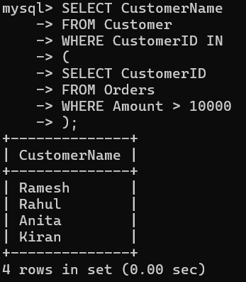

Optimized Query (Using JOIN)
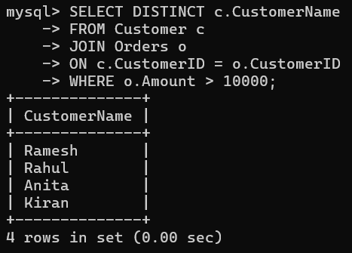

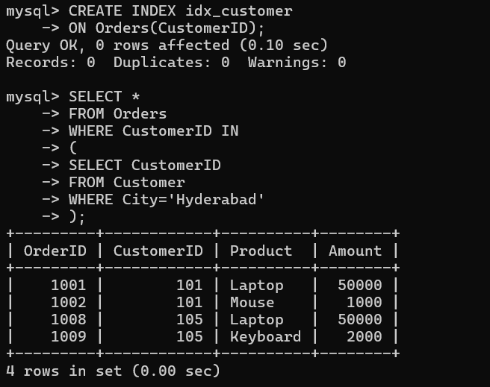

Performance Comparison
Technique | Benefit
JOIN | Faster retrieval from related tables
INDEX | Speeds up searching and joins
Query Restructuring | Reduces unnecessary subqueries
DISTINCT | Removes duplicate results

Advantages
- Faster query execution.
- Reduced execution time.
- Better use of database indexes.
- Improved performance for large datasets.
- Easier query maintenance.
- Efficient retrieval of related data.

Conclusion
The original SQL queries were inefficient because they relied on subqueries for data retrieval. By replacing subqueries with JOINs, creating an index on frequently searched columns, and restructuring the queries, the database performs more efficiently. These optimization techniques reduce execution time, improve scalability, and enhance overall database performance, making them suitable for real-world applications.

