SIMATS ENGINEERING
ASSESSMENT TOOL 3

COURSE NAME: Database Management Systems
COURSE CODE: CSA05

COURSE OUTCOME COVERED

CO4: Design database solutions incorporating file organization, indexing, and hashing techniques to optimize data storage and retrieval efficiency. (BL3, BL4)

Activity Tool : Comparative Analysis (Low)
Assessment Tool Weightage: 10%

QUESTIONS
Q.No | Question | Bloom's Level
1 | Compare sequential file organization and heap file organization in terms of data insertion, deletion, and retrieval efficiency. | Bloom’s Level: 4 – Analyze
2 | Differentiate between clustered indexing and non-clustered indexing with suitable database examples. | Bloom’s Level: 4 – Analyze
3 | Compare primary indexing and secondary indexing based on storage requirements and search performance. | Bloom’s Level: 4 – Analyze
4 | Analyze the differences between static hashing and dynamic hashing in database systems. | Bloom’s Level: 4 – Analyze
5 | Compare B-Tree indexing and B+ Tree indexing for large-scale database applications. | Bloom’s Level: 4 – Analyze
6 | Differentiate linear hashing and extendible hashing in terms of bucket management and scalability. | Bloom’s Level: 4 – Analyze
7 | Compare dense indexing and sparse indexing with respect to memory usage and access speed. | Bloom’s Level: 4 – Analyze
8 | Analyze the advantages and limitations of indexed sequential file organization versus direct file organization. | Bloom’s Level: 4 – Analyze
9 | Compare single-level indexing and multi-level indexing for efficient database retrieval operations. | Bloom’s Level: 4 – Analyze
10 | Evaluate the performance of hashing techniques and indexing techniques for exact-match and range queries in databases. | Bloom’s Level: 5 – Evaluate

Code of Conduct:

I V.Shalini(192525373) (Name / Reg No) certify that this submission is my original work and that I have adhered to the guidelines specified for this assessment.
I understand that any violation of academic integrity rules will result in disciplinary action.

Signature of the student:
V.Shalini

RUBRICS FOR CALCULATION:

Criteria | Weightage (%) | Level 4 (Exemplary) | Level 3 (Proficient) | Level 2 (Developing) | Level 1 (Beginning)
Scope of Items | 20% | Selects highly relevant items with clear scope and justification | Selects appropriate items with minor gaps | Selection is limited or partially relevant | Items are unclear or not relevant
Comparison Depth | 25% | Provides detailed and comprehensive comparison across multiple aspects | Provides adequate comparison with some depth | Limited comparison with few aspects | Very minimal or no comparison
Use of Evidence | 20% | Supports comparison with accurate data, examples, or references | Uses some supporting evidence with minor gaps | Limited or weak supporting evidence | No supporting evidence provided
Critical Thinking | 20% | Demonstrates strong critical thinking with clear interpretation and reasoning | Shows reasonable interpretation with minor gaps | Basic interpretation; lacks depth | No meaningful interpretation
Clarity of Presentation | 15% | Well-organized, clear, and logically structured presentation | Generally clear with minor issues | Somewhat unclear or poorly structured | Disorganized and difficult to understand

1.Compare sequential file organization and heap file organization in terms of data insertion, deletion, and retrieval efficiency.
Sequential File Organization
In sequential file organization, records are stored in a specific order, usually according to a primary key or another search key.
Example: Student records stored according to Student_ID: 101, 102, 103, 104.

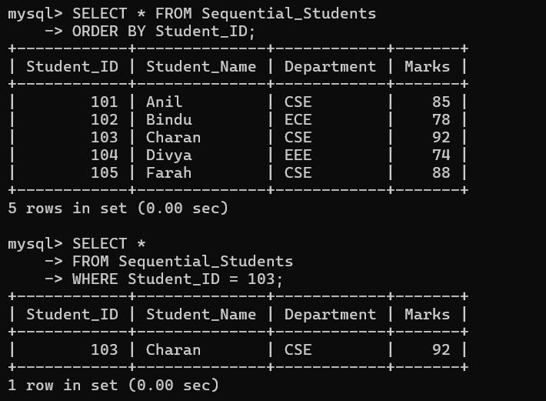
Heap File Organization
In heap file organization, records are stored in any available space without maintaining a particular order.
Example: New student records are simply added wherever free space is available.
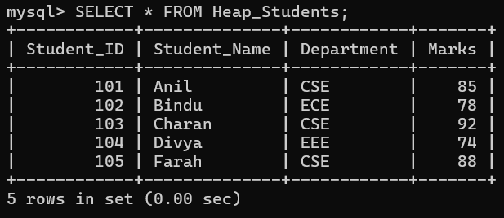
Feature | Sequential File | Heap File
Insertion | Slow because correct position must be found | Fast because record can be added at the end/free space
Deletion | More complex because order must be maintained | Easy; record can simply be marked/deleted
Retrieval | Very efficient for sequential/range searches | Slow for searches because records may be anywhere
Ordering | Records are ordered | Records are unordered
Searching | Faster for ordered data | Usually requires linear search
Maintenance | More maintenance required | Less maintenance
Range Queries | Very efficient | Less efficient
Storage | May require reorganization | Simple storage

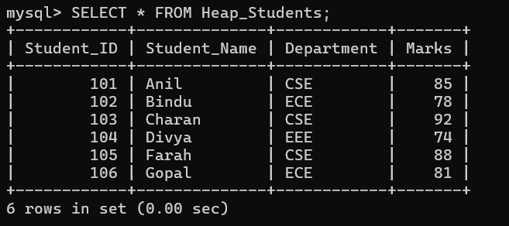
Advantages of Sequential Organization
- Efficient for sequential processing.
- Good for range queries.
- Records can be accessed in sorted order.
- Useful for reports and batch processing.
Limitations
- Insertion can be expensive.
- Deletion may create empty spaces.
- Periodic reorganization may be required.
Advantages of Heap Organization
- Very fast insertion.
- Simple implementation.
- Suitable when records are frequently inserted.
- Deletion is relatively simple.

Limitations
- Searching is slow without an index.
- Range queries are inefficient.
- Records are not stored in any particular order.
Conclusion
Heap files are better for frequent insertions, while sequential files are better for ordered retrieval and range queries.

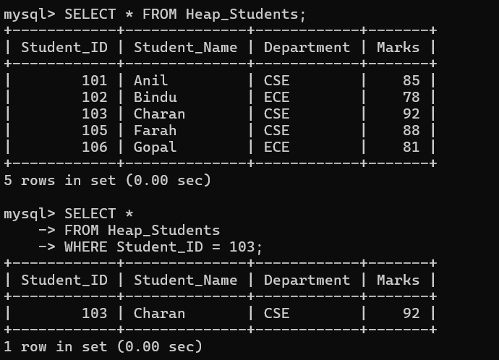
2.Differentiate between clustered indexing and non-clustered indexing with suitable database examples.
Clustered Indexing
A clustered index determines the physical order in which records are stored in a table. The table data is arranged according to the indexed column.
Example:
A student table is physically arranged according to:
Student_ID → 101, 102, 103, 104, 105
If Student_ID is clustered, records are stored in this order.
Non-Clustered Indexing
A non-clustered index is a separate structure containing indexed values and pointers to the actual records. The physical order of records does not change.

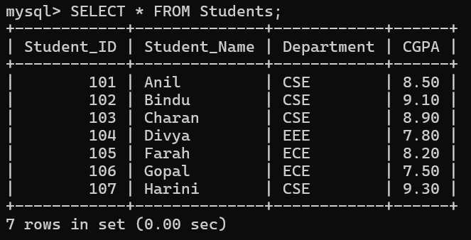Comparison
Feature | Clustered Index | Non-Clustered Index
Data order | Determines physical order | Does not determine physical order
Number | Usually limited to one per table | Multiple can be created
Storage | Closely associated with table data | Requires separate index storage
Retrieval | Very fast for ranges | Fast for specific searches
Range Queries | Excellent | Good
Insertions | Can be slower | Generally easier
Sorting | Data is already ordered | Additional sorting may be required
Example | Index on Student_ID | Index on Student_Name



Example

Suppose:
STUDENT
Student_ID Name
101 Ravi
102 Priya
103 Arun
104 Sita
A clustered index on Student_ID stores the records according to Student_ID.
A non-clustered index on Name may contain:
Arun → Record 103
Priya → Record 102
Ravi → Record 101
Sita → Record 104

Advantages of Clustered Index
- Fast sequential access.
- Excellent for range queries.
- Reduces disk I/O for ordered retrieval.
Advantages of Non-Clustered Index
- Multiple indexes can be created.
- Useful for different search conditions.
- Does not change the physical table arrangement.
Conclusion
Clustered indexing is suitable for range and ordered searches, whereas non-clustered indexing is useful when different columns need independent search indexes.

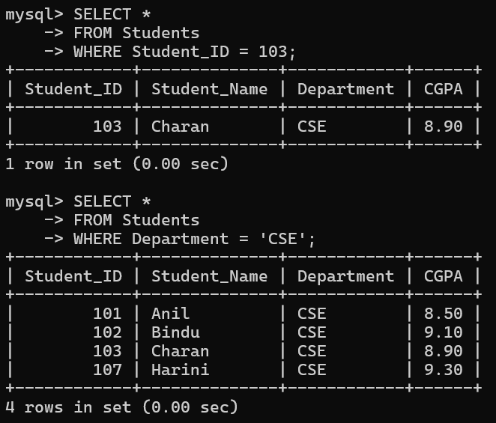
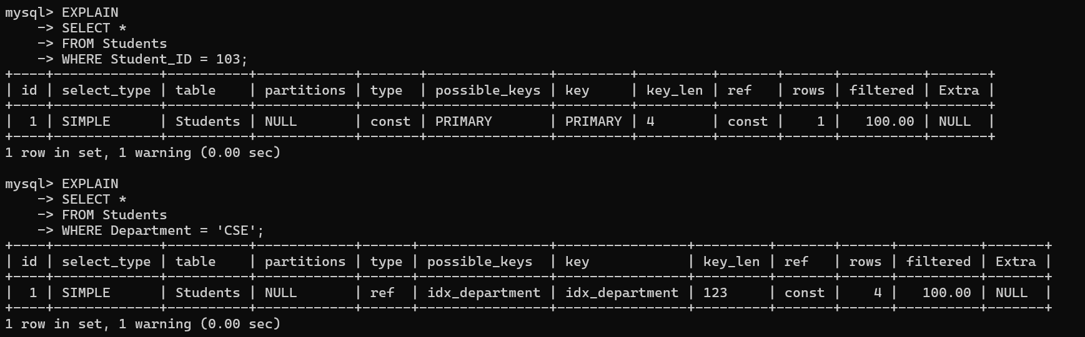
3. Compare primary indexing and secondary indexing based on storage requirements and search performance.
Primary Indexing
Primary indexing is created on a field that determines the ordering of records, generally a primary key.
Example: Student_ID.
Records may be:
101 → Arun
102 → Ravi
103 → Priya
104 → Sita
The index points to blocks containing these records.
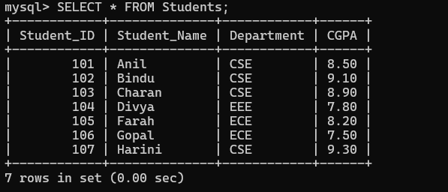
Secondary Indexing
Secondary indexing is created on a field that does not determine the physical ordering of records.
Example: Student_Name, Department, or City.
Comparison
Feature | Primary Index | Secondary Index
Based on | Primary/order field | Non-ordering field
Data ordering | Records are ordered | Records need not be ordered
Index size | Usually smaller | Usually larger
Search | Very efficient | Efficient
Storage | Less storage | More storage
Duplicate values | Generally unique | Can have duplicates
Range search | Very efficient | Depends on index
Example | Student_ID | Student_Name

Storage Requirements
Primary indexes are often sparse, so one index entry may represent one block. Therefore, they require comparatively less storage.
Secondary indexes are commonly dense, meaning more index entries are required. Therefore, they consume more storage.

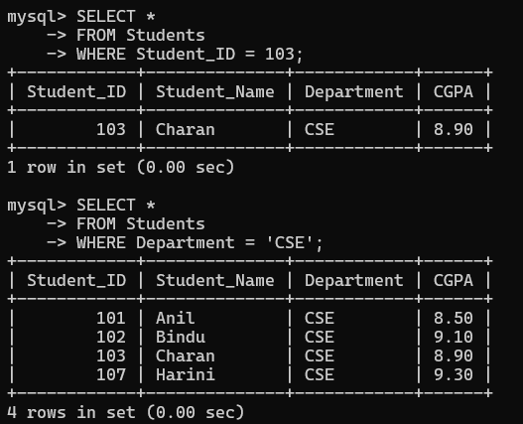
Search Performance
Both indexes improve search performance compared with a full table scan.
Primary indexes are particularly efficient when searching using the ordering field.
Secondary indexes are useful when users frequently search using other attributes.
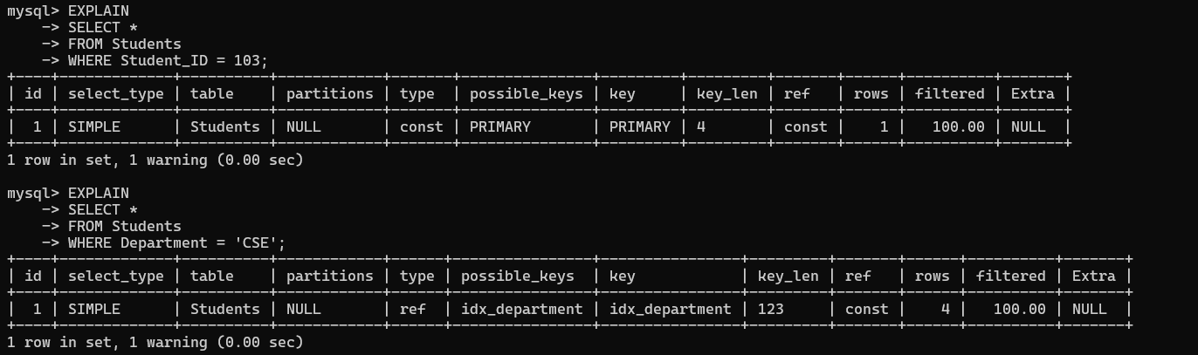
Conclusion
Primary indexes generally require less storage and provide efficient ordered access, while secondary indexes require more storage but provide additional search paths.

4. Analyze the differences between static hashing and dynamic hashing in database systems.
Hashing uses a hash function to determine the bucket where a record should be stored.
Example:
h(Student_ID) = Student_ID MOD 10
For Student_ID 105:
105 MOD 10 = 5
So the record is stored in bucket 5.

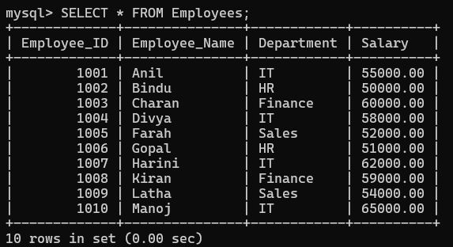
Static Hashing
In static hashing, the number of buckets is fixed when the file is created.
Advantages
- Simple implementation.
- Fast exact-match retrieval.
- Easy to understand and maintain.
- Good for databases with relatively stable data size.
Limitations
- Performance decreases when the file grows.
- Overflow buckets may be required.
- Too many empty buckets may waste storage.
- Reorganization may be necessary.

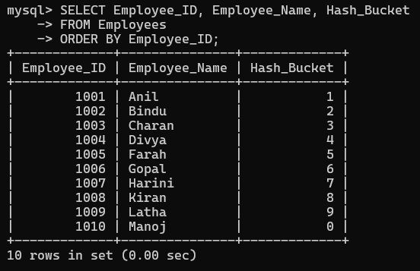

Dynamic Hashing
Dynamic hashing allows the number of buckets to increase or decrease as the database changes.
Examples include:
- Extendible hashing
- Linear hashing
Advantages
- Handles database growth efficiently.
- Reduces overflow problems.
- Better storage utilization.
- Does not require complete reorganization.
Limitations
- More complex.
- Additional metadata may be required.
- Bucket splitting can introduce overhead.

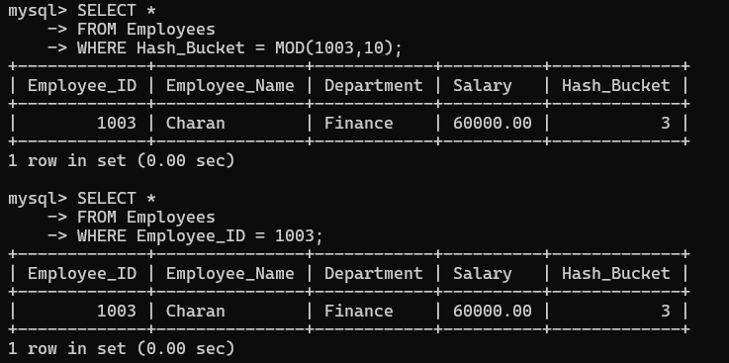

Comparison
Feature | Static Hashing | Dynamic Hashing
Number of buckets | Fixed | Can change
Growth handling | Poor | Excellent
Overflow | More likely | Reduced
Implementation | Simple | Complex
Scalability | Limited | High
Storage utilization | May be inefficient | Better
Reorganization | May be required | Usually avoided
Best use | Stable data | Frequently changing data

Conclusion
Static hashing is suitable for stable databases, while dynamic hashing is better for large and growing databases.

5. Compare B-Tree indexing and B+ Tree indexing for large-scale database applications.
B-Trees and B+ Trees are balanced tree structures widely used for database indexing.
B-Tree
In a B-Tree, both internal nodes and leaf nodes can contain keys and actual record pointers.
Example:
[50]
/ \
[20,30] [60,70]
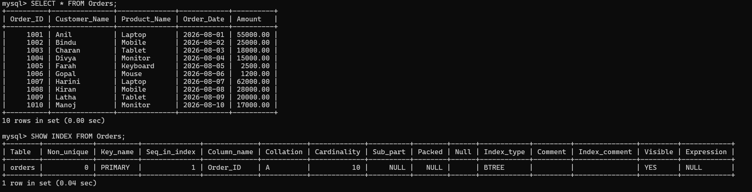
B+ Tree
In a B+ Tree, internal nodes contain only keys and pointers to child nodes. Actual record pointers are stored at the leaf level.
The leaf nodes are usually linked:
[10,20] → [30,40] → [50,60] → [70,80]

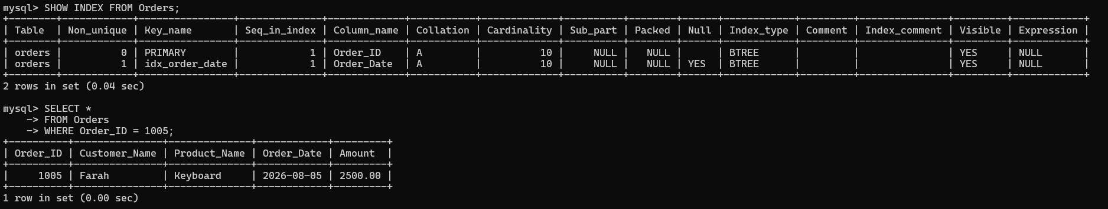Comparison
Feature | B-Tree | B+ Tree
Data pointers | Internal and leaf nodes | Mainly leaf nodes
Leaf nodes linked | Usually no | Yes
Range queries | Good | Excellent
Sequential access | Less efficient | Very efficient
Tree height | Can be slightly larger | Usually smaller
Fan-out | Lower | Higher
Search | Fast | Fast
Database usage | Less common | Very common

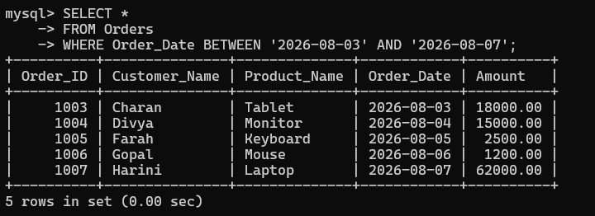Advantages of B+ Tree
- High fan-out reduces tree height.
- Efficient disk access.
- Excellent range searching.
- Sequential traversal is easy.
- Leaf nodes are linked.
- Suitable for large databases.

Example
Query:
SELECT * FROM Student
WHERE Student_ID BETWEEN 100 AND 200;
A B+ Tree can efficiently locate the first value and then follow linked leaf nodes to retrieve the remaining values. 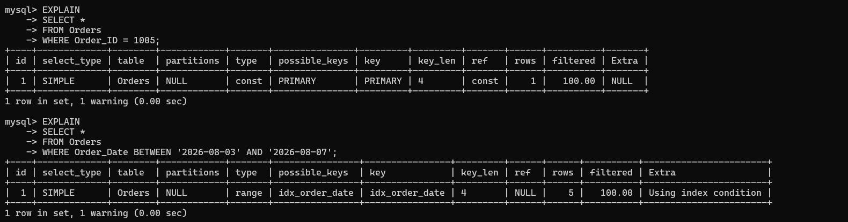
Conclusion
For large-scale database applications, B+ Trees are generally preferred because they provide efficient exact searches, range searches, and sequential access.

6. Differentiate linear hashing and extendible hashing in terms of bucket management and scalability.
Both are dynamic hashing techniques.
Linear Hashing
Linear hashing expands the hash file gradually by splitting buckets one at a time.
It does not require a large directory.
Features
- Buckets split progressively.
- Growth occurs gradually.
- Simple bucket management.
- Suitable for continuously growing databases.

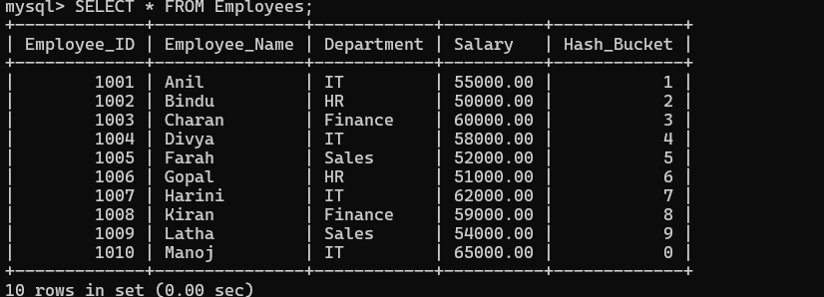
Extendible Hashing
Extendible hashing uses a directory containing pointers to buckets.
The directory uses hash bits to identify the correct bucket.
Example:
Directory
00 → Bucket A
01 → Bucket B
10 → Bucket C
11 → Bucket D
When a bucket becomes full, it can be split, and the directory may also grow.

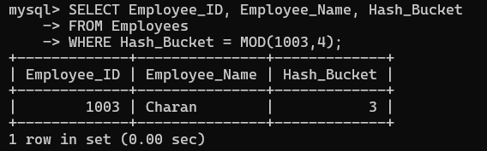
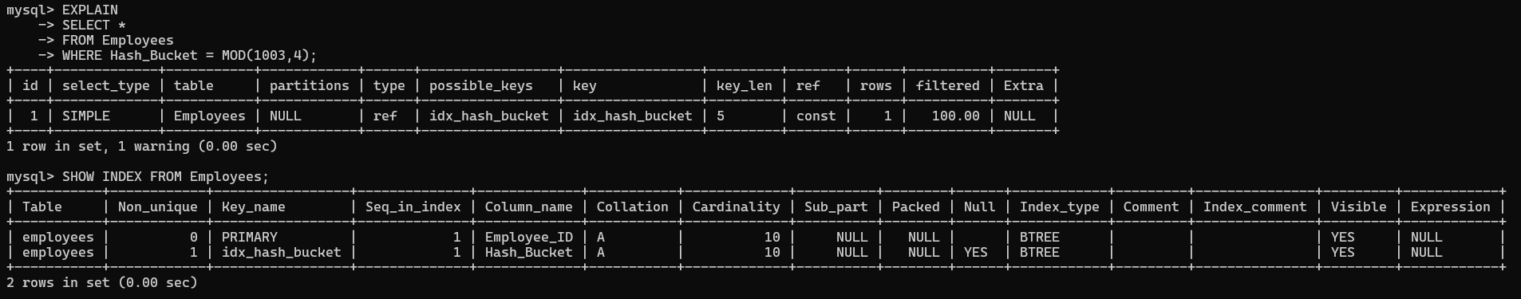
Comparison
Feature | Linear Hashing | Extendible Hashing
Directory | No large directory | Uses directory
Growth | Gradual | Bucket/directory splitting
Bucket splitting | One at a time | Based on hash prefixes
Memory | Lower directory overhead | More directory memory
Scalability | Good | Excellent
Implementation | Simpler | More complex
Overflow handling | Controlled gradually | Bucket splitting reduces overflow
Access | Direct hashing | Directory lookup + bucket access

Conclusion
Linear hashing provides simple and gradual expansion, while extendible hashing provides flexible bucket management and very fast access using a directory.

7. Compare dense indexing and sparse indexing with respect to memory usage and access speed.
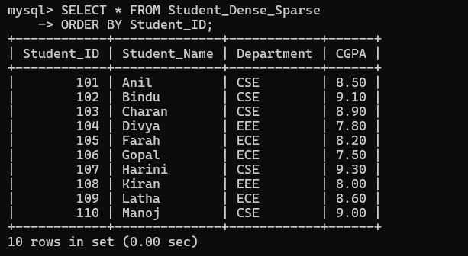
Dense Indexing
A dense index contains an index entry for every search-key value or record.
Example:
101 → Record 1
102 → Record 2
103 → Record 3
104 → Record 4
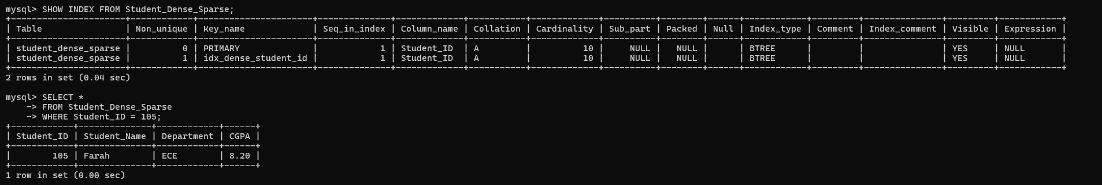
Advantages
- Very fast searching.
- Direct access to records.
- Suitable for secondary indexes.
Disadvantages
- Requires more memory.
- Index takes more storage space.
- Insertions and deletions require more index maintenance.
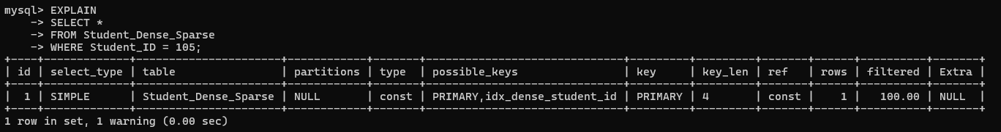
Sparse Indexing
A sparse index contains entries for only some search-key values, often one entry per data block.
Example:
101 → Block 1
201 → Block 2
301 → Block 3
Advantages
- Requires less storage.
- Lower maintenance cost.
- Suitable for ordered files.
Disadvantages
- Search can be slightly slower.
- Data file must generally be ordered.
- Additional search inside the block may be required.
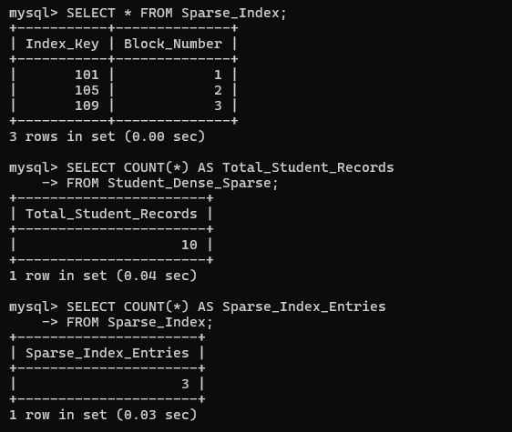

Comparison
Feature | Dense Index | Sparse Index
Entries | More | Fewer
Memory | High | Low
Search speed | Very fast | Slightly slower
Storage | High | Low
Maintenance | Higher | Lower
Suitable for | Secondary indexes | Ordered/sequential files
Conclusion
Dense indexing provides faster access but consumes more memory, while sparse indexing saves storage but may require additional searching.

8. Analyze the advantages and limitations of indexed sequential file organization versus direct file organization.
Indexed Sequential File Organization
Records are stored sequentially according to a key, and an index is maintained to locate records quickly.
It combines:
- Sequential access
- Indexed access
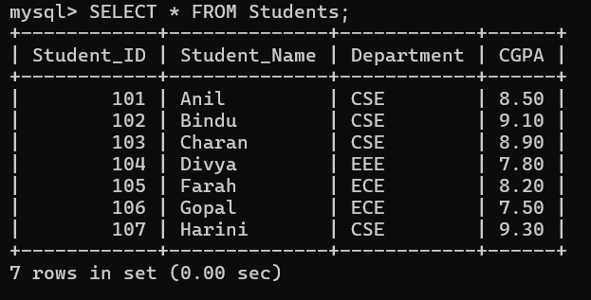
Example:
Index
100 → Block 1
200 → Block 2
300 → Block 3

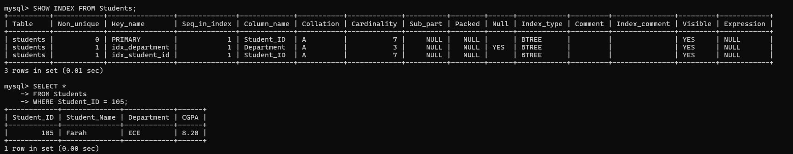
Advantages
- Supports both sequential and direct access.
- Good for range queries.
- Faster searching than simple sequential files.
- Suitable for large ordered files.
Limitations
- Index requires additional storage.
- Index must be maintained.
- Insertions and deletions may require overflow areas.
- Periodic reorganization may be needed.

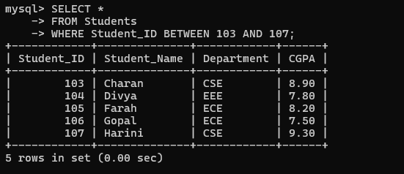
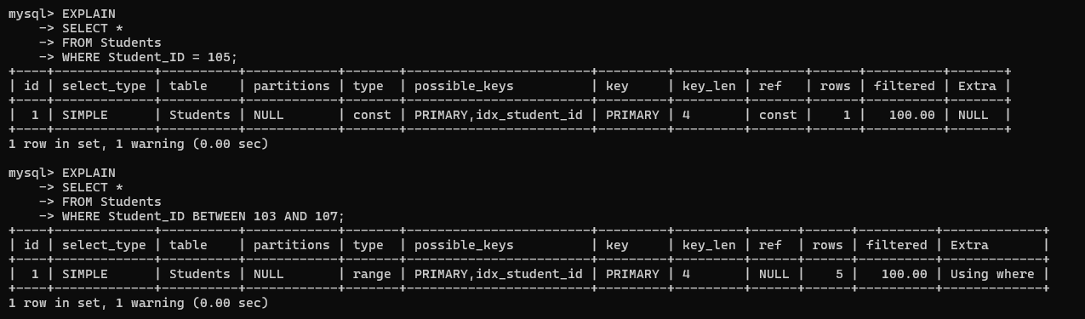

Comparison
Feature | Indexed Sequential | Direct
Access | Sequential + direct | Direct
Exact search | Fast | Very fast
Range search | Excellent | Poor
Sequential processing | Excellent | Less suitable
Storage | Index required | Hash/address structure
Complexity | Moderate | Moderate
Best use | Reports and range queries | Transaction processing

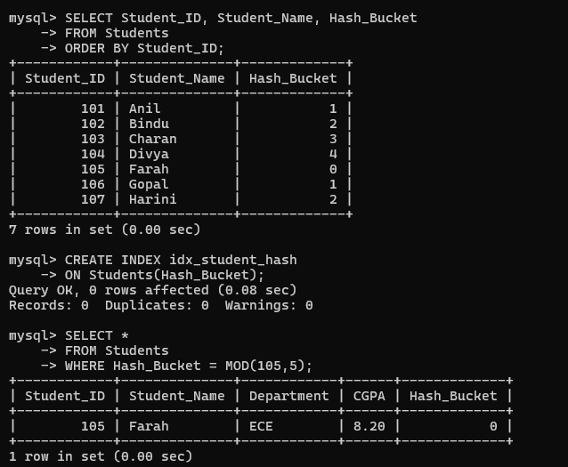
Conclusion
Indexed sequential organization is better for both sequential and range access, while direct organization is better for fast exact-match retrieval.

9. Compare single-level indexing and multi-level indexing for efficient database retrieval operations.
Single-Level Indexing
A single index is created over the data file.
Example:
Index → Data Blocks
If the index becomes very large, searching the index itself can become expensive.
Advantages
- Simple.
- Easy to implement.
- Suitable for smaller databases.
- Requires less management.
Limitations
- Large index may require many disk accesses.
- Search becomes slower as the index grows.
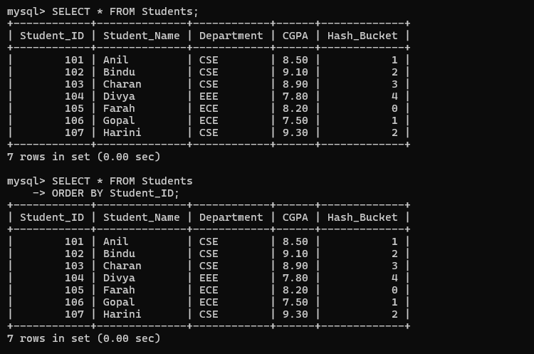
Multi-Level Indexing
In multi-level indexing, an index is created over another index.
Example:
Level 2 Index
↓
Level 1 Index
↓
Data Blocks
The higher-level index helps locate the lower-level index quickly.
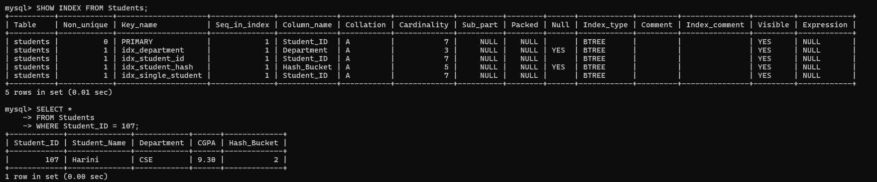
Advantages
- Reduces disk accesses.
- Efficient for large files.
- Faster searching.
- Reduces the amount of index scanned at each level.
Limitations
- More complex.
- Requires additional storage.
- Index levels must be maintained when data changes.
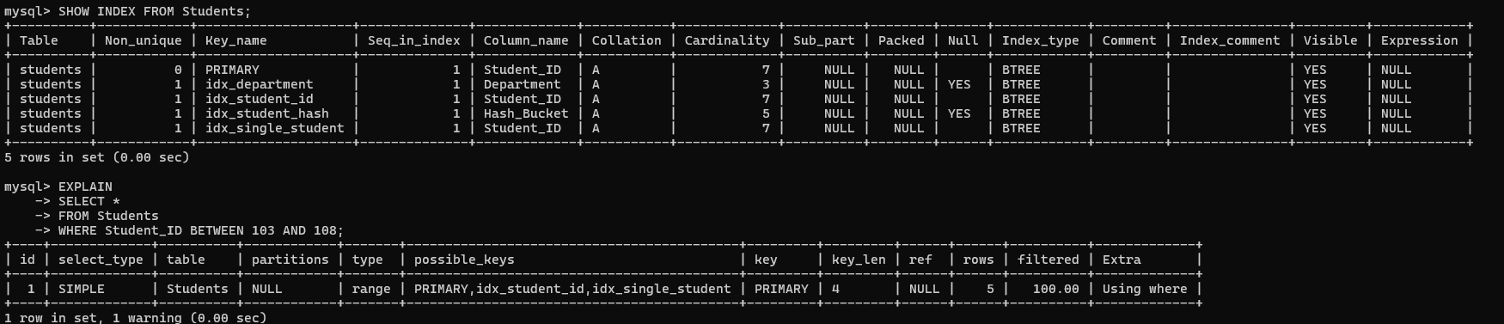
Comparison
Feature | Single-Level | Multi-Level
Number of levels | One | Multiple
Search speed | Good | Very good
Large files | Less suitable | Highly suitable
Disk accesses | More for large indexes | Fewer
Complexity | Simple | Higher
Storage | Lower | Higher
Scalability | Limited | Excellent
Conclusion
Single-level indexing is suitable for small databases, whereas multi-level indexing is more efficient for large databases.

10. Evaluate the performance of hashing techniques and indexing techniques for exact-match and range queries in databases.

Hashing and indexing are both important database access techniques, but they are suitable for different types of queries.
Exact-Match Query
An exact-match query searches for one specific value.
Example:
SELECT * FROM Student
WHERE Student_ID = 105;

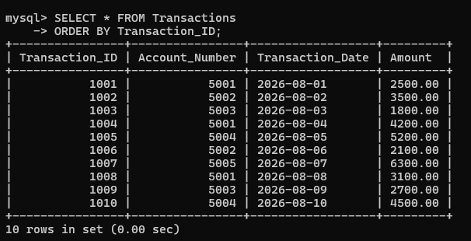
Hashing
Hashing is highly efficient for exact-match queries.
The hash function directly determines the bucket containing the record.
h(105) → Bucket 5
Therefore, the database can quickly locate the record.
Indexing
Indexes such as B+ Trees can also efficiently locate an exact value, but hashing can often provide more direct access for equality searches.

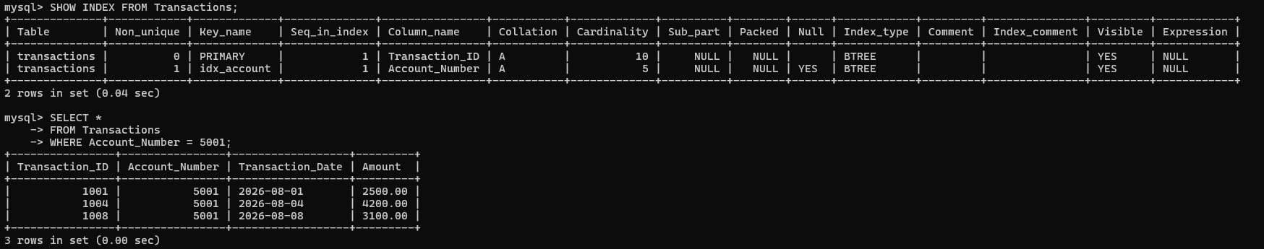
Range Query
A range query searches for values between two limits.
Example:
SELECT * FROM Student
WHERE Student_ID BETWEEN 100 AND 200;

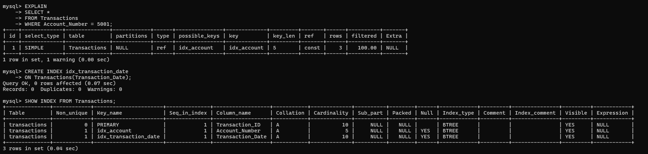
Hashing
Hashing is not suitable for range queries because records with nearby values can be placed in completely different buckets.
For example:
100 → Bucket 7
101 → Bucket 2
102 → Bucket 9
Therefore, finding all values from 100 to 200 is inefficient.

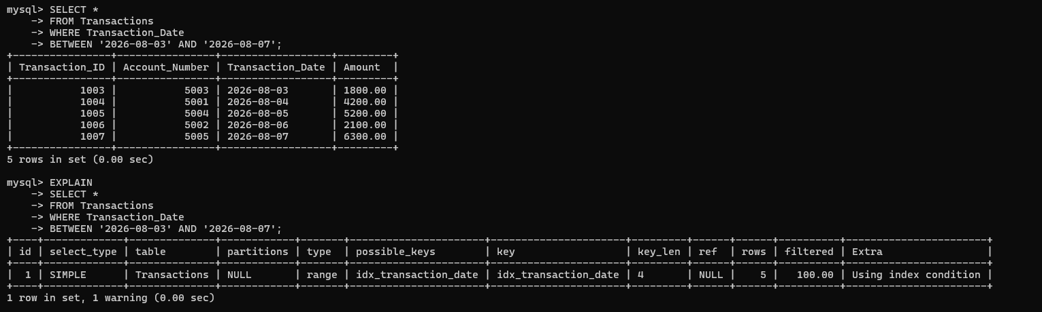
B+ Tree Indexing
B+ Trees are highly efficient for range queries because their leaf nodes are ordered and linked.
Example:
[100,110] → [120,130] → [140,150] → [160,170]
Once the first value is found, the database can move through linked leaf nodes.
Comparison
Query Type | Hashing | Indexing
Exact match | Excellent | Excellent
Range query | Poor | Excellent
Ordered retrieval | Poor | Excellent
Equality search | Very fast | Fast
Sequential access | Poor | Good
Storage | Bucket-based | Index structure
Best example | ID = 105 | ID BETWEEN 100 AND 200

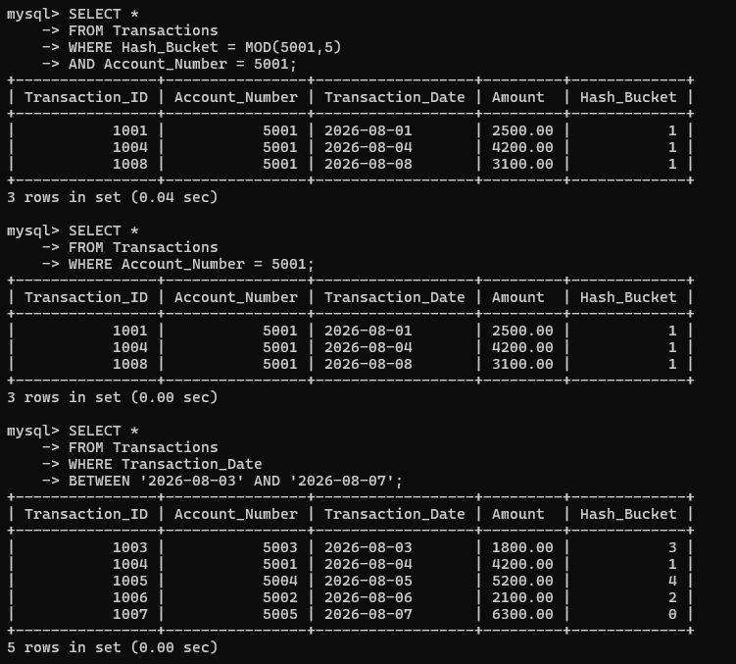
Overall Evaluation
Hashing is best for exact-match queries, especially when the application frequently searches for one particular key.
B+ Tree indexing is better for range queries, sorting, ordered retrieval, and both exact and range searches.
Final Conclusion
Requirement | Best Technique
Exact-match search | Hashing
Range search | B+ Tree Indexing
Sorted retrieval | B+ Tree
Sequential access | B+ Tree / Indexed Sequential
Frequently changing data | Dynamic Hashing
Large-scale database | B+ Tree / Dynamic Hashing
Therefore, no single technique is best for every query. Hashing provides excellent performance for equality searches, whereas indexing—especially B+ Tree indexing—is more versatile and performs much better for range and ordered queries.

