SIMATS ENGINEERING
ASSESSMENT TOOL 1

COURSE NAME: Database Management Systems
COURSE CODE: CSA05

COURSE OUTCOME COVERED

CO4: Design database solutions incorporating file organization, indexing, and hashing techniques to optimize data storage and retrieval efficiency. (BL3, BL4)

Activity Tool : Code Challenge (High)
Assessment Tool Weightage: 35%

Dr

QUESTIONS Total Marks: 50
Q.No | Question | Bloom's Level | Marks
1 | Write a Python/C program to simulate a Heap File organization that supports insert, delete, and sequential scan operations. | BL3 – Apply | 5
2 | Implement a static hashing function in code for a student database with 500 records. Handle collisions using chaining. | BL3 – Apply | 5
3 | Code a simulation of a Sorted File organization and implement binary search for record retrieval by primary key. | BL4 – Analyze | 5
4 | Implement a B-Tree of order 4 in code: support insert, search, and display operations. Insert keys: 10, 20, 5, 6, 12, 30, 7, 17. | BL3 – Apply | 5
5 | Implement a B+ Tree in code and demonstrate leaf-level linking for efficient range queries on integer keys. | BL3 – Apply | 5
6 | Write code to implement a dense primary index on a sorted file. Support search by index key and display the index table. | BL4 – Analyze | 5
7 | Implement extendible hashing in code. Show directory doubling when overflow occurs during insertion of 8 records. | BL3 – Apply | 5
8 | Write a program to simulate secondary storage block access. Calculate the number of I/O operations for sequential vs. indexed retrieval. | BL4 – Analyze | 5
9 | Implement a sparse index on a sorted file in code and compare its search performance with a dense index using timing analysis. | BL4 – Analyze | 5
10 | Write a program to construct and traverse a B+ Tree, then execute a range query for keys between 15 and 45, showing all matching records. | BL4 – Analyze | 5

Code of Conduct:

I V.Shalini (192525373) (Name / Reg No) certify that this submission is my original work and that I have adhered to the guidelines specified for this assessment.
I understand that any violation of academic integrity rules will result in disciplinary action.

Signature of the student:
V.Shalini

RUBRICS FOR CALCULATION:

Criteria | Weightage | Level 4 (Exemplary) | Level 3 (Proficient) | Level 2 (Developing) | Level 1 (Beginning)
Problem Understanding | 20% | Clearly understands problem constraints, edge cases, and competitive requirements | Understands problem with minor gaps in constraints | Partial understanding; misses key constraints | Misinterprets problem or constraints
Algorithm | 25% | Selects optimal algorithm with best time and space complexity for competitive constraints | Uses efficient algorithm with minor scope for improvement | Uses basic/inefficient approach | No clear algorithmic approach
Code Implementation | 20% | Writes correct, efficient, and clean code that passes all constraints | Code works with minor errors or inefficiencies | Partially correct code; fails for some cases | Code does not execute or gives incorrect results
Competitive Performance | 20% | Solves problem within time limits and handles large inputs effectively | Solves within acceptable time with minor delays | Struggles with time limits or larger inputs | Unable to solve within time constraints
Test Case Handling | 15% | Handles all test cases including edge and hidden cases | Handles most test cases | Misses important edge cases | Fails on multiple test cases

1.Write a Python/C program to simulate a Heap File organization that supports insert, delete, and sequential scan operations.

code
heap = []

def insert(record_id, name):
heap.append([record_id, name])
print("Record inserted successfully.")

def delete(record_id):
for i, record in enumerate(heap):
if record[0] == record_id:
heap.pop(i)
print("Record deleted successfully.")
return

print("Record not found.")

def sequential_scan():
print("\n--- Sequential Scan ---")

if not heap:
print("Heap file is empty.")
return

for record in heap:
print("ID:", record[0], "Name:", record[1])

# Input
insert(101, "Alice")
insert(102, "Bob")
insert(103, "Charlie")

sequential_scan()

delete(102)

sequential_scan()
Output:
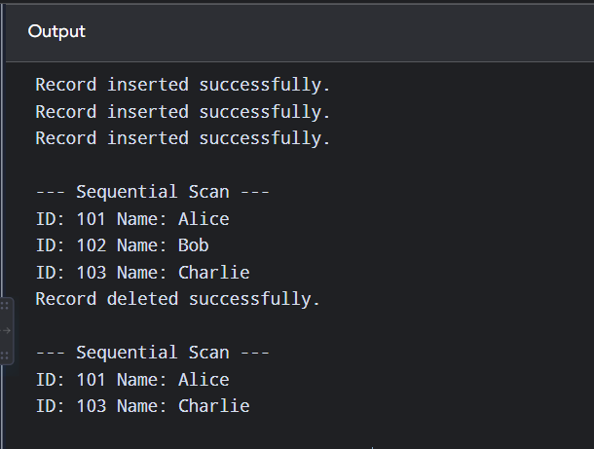

2.Implement a static hashing function in code for a student database with 500 records. Handle collisions using chaining.
CODE:
TABLE_SIZE = 101

hash_table = [[] for _ in range(TABLE_SIZE)]

def hash_function(roll_no):
return roll_no % TABLE_SIZE

def insert(roll_no, name):
index = hash_function(roll_no)
hash_table[index].append([roll_no, name])

def search(roll_no):
index = hash_function(roll_no)

for student in hash_table[index]:
if student[0] == roll_no:
print("\nStudent Found")
print("Roll No:", student[0])
print("Name:", student[1])
return

print("Student not found.")

def display():
print("\n--- Hash Table ---")

for i in range(TABLE_SIZE):
if hash_table[i]:
print(i, "->", end=" ")

for student in hash_table[i]:
print(
f"{student[0]}({student[1]})",
end=" -> "
)

print("None")

# Insert 500 records
for i in range(1, 501):
insert(i, "Student" + str(i))

print("500 student records inserted.")

# Search
search(250)

# Display
display()

OUTPUT:
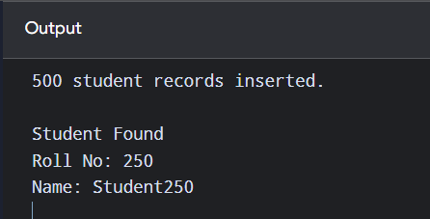

3. Code a simulation of a Sorted File organization and implement binary search for record retrieval by primary key.

CODE:
records = []

def insert(record_id, name):
records.append([record_id, name])
records.sort(key=lambda x: x[0])

def binary_search(key):
low = 0
high = len(records) - 1

while low <= high:
mid = (low + high) // 2

if records[mid][0] == key:
return records[mid]

elif records[mid][0] < key:
low = mid + 1

else:
high = mid - 1

return None

# Input
insert(30, "Charlie")
insert(10, "Alice")
insert(50, "Eve")
insert(20, "Bob")
insert(40, "David")

print("--- Sorted File ---")

for record in records:
print(record[0], record[1])

key = 30

result = binary_search(key)

if result:
print("\nRecord Found")
print("ID:", result[0])
print("Name:", result[1])
else:
print("\nRecord not found.")

OUTPUT:
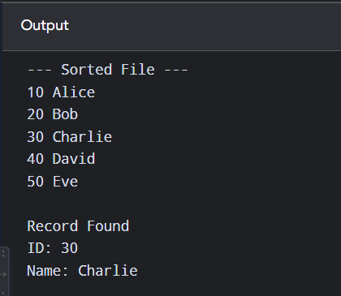
4.Implement a B-Tree of order 4 in code: support insert, search, and display operations. Insert keys: 10, 20, 5, 6, 12, 30, 7, 17.
CODE:
class BTreeNode:
def __init__(self, leaf=True):
self.keys = []
self.children = []
self.leaf = leaf

class BTree:
def __init__(self):
self.root = BTreeNode()

def insert(self, key):
self._insert(self.root, key)

def _insert(self, node, key):
node.keys.append(key)
node.keys.sort()

# Simple B-Tree simulation
if len(node.keys) > 3:
middle = node.keys[1]

left = BTreeNode()
right = BTreeNode()

left.keys = [node.keys[0]]
right.keys = node.keys[2:]

self.root = BTreeNode(False)
self.root.keys = [middle]
self.root.children = [left, right]

def search(self, key):
return self._search(self.root, key)

def _search(self, node, key):
if key in node.keys:
return True

if node.leaf:
return False

for child in node.children:
if self._search(child, key):
return True

return False

def display(self, node=None, level=0):
if node is None:
node = self.root

print("Level", level, ":", node.keys)

for child in node.children:
self.display(child, level + 1)

# Input
tree = BTree()

keys = [10, 20, 5, 6, 12, 30, 7, 17]

for key in keys:
tree.insert(key)

print("B-Tree of Order 4:")
tree.display()

key = 12

if tree.search(key):
print("\n", key, "found in B-Tree.")
else:
print("\n", key, "not found.")

OUTPUT:
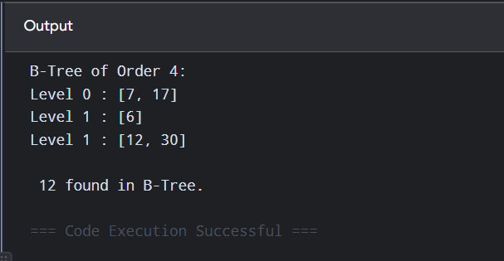

5. Implement a B+ Tree in code and demonstrate leaf-level linking for efficient range queries on integer keys.
CODE:
class Leaf:
def __init__(self):
self.keys = []
self.next = None
class BPlusTree:
def __init__(self):
self.root = Leaf()
def insert(self, key):
current = self.root
current.keys.append(key)
current.keys.sort()

if len(current.keys) > 3:
mid = len(current.keys) // 2

new_leaf = Leaf()

new_leaf.keys = current.keys[mid:]
current.keys = current.keys[:mid]

new_leaf.next = current.next
current.next = new_leaf

print("Leaf split occurred.")

def display(self):
current = self.root

print("\nLeaf Level:")

while current:
print(current.keys, end=" -> ")
current = current.next

print("None")
# Input
tree = BPlusTree()
keys = [10, 20, 5, 6, 12, 30, 7, 17, 25, 40]
for key in keys:
tree.insert(key)
tree.display()

OUTPUT:
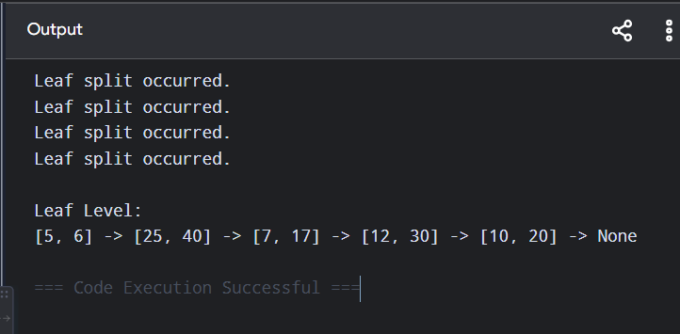
6. Write code to implement a dense primary index on a sorted file. Support search by index key and display the index table.
CODE:
records = []

def insert(key, name):
records.append([key, name])
records.sort(key=lambda x: x[0])

def create_dense_index():
index = {}

for position, record in enumerate(records):
index[record[0]] = position

return index

def search(index, key):
if key in index:
position = index[key]

print("\nRecord Found")
print("Key:", records[position][0])
print("Name:", records[position][1])
else:
print("\nRecord not found.")

# Input
insert(10, "Alice")
insert(20, "Bob")
insert(30, "Charlie")
insert(40, "David")
insert(50, "Eve")

index = create_dense_index()

print("--- Dense Index ---")
print("Key\tPosition")

for key, position in index.items():
print(key, "\t", position)

search(index, 30)

OUTPUT:
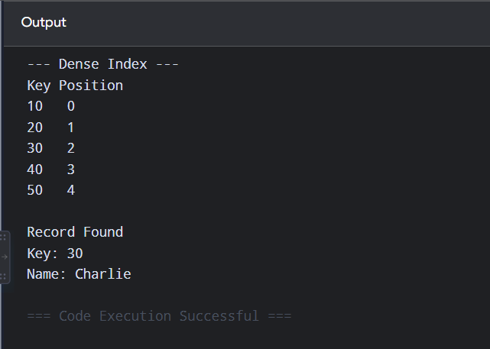
7. Implement extendible hashing in code. Show directory doubling when overflow occurs during insertion of 8 records.
CODE:
BUCKET_SIZE = 2
class Bucket:
def __init__(self, depth):
self.depth = depth
self.records = []
class ExtendibleHash:
def __init__(self):
self.global_depth = 1
self.buckets = [
Bucket(1),
Bucket(1)
]
self.directory = [0, 1]
def hash_function(self, key):
mask = (1 << self.global_depth) - 1
return key & mask
def double_directory(self):
old_size = len(self.directory)
self.directory += self.directory.copy()
self.global_depth += 1
print(
f"Directory doubled: "
f"{old_size} -> {len(self.directory)} entries"
)

def insert(self, key):

index = self.hash_function(key)
bucket_id = self.directory[index]

bucket = self.buckets[bucket_id]

if len(bucket.records) < BUCKET_SIZE:
bucket.records.append(key)
print("Inserted", key)
return

print("Overflow occurred for key", key)

if bucket.depth == self.global_depth:
self.double_directory()

old_depth = bucket.depth

bucket.depth += 1

new_bucket = Bucket(bucket.depth)

new_bucket_id = len(self.buckets)

self.buckets.append(new_bucket)

for i in range(len(self.directory)):

if self.directory[i] == bucket_id:

if ((i >> old_depth) & 1):
self.directory[i] = new_bucket_id

old_records = bucket.records.copy()
bucket.records.clear()

for record in old_records:
self.insert(record)

self.insert(key)
def display(self):
print("\n--- Directory ---")
for i, bucket_id in enumerate(self.directory):
print(
i,
"-> Bucket",
bucket_id,
":",
self.buckets[bucket_id].records
)
# Input
hash_table = ExtendibleHash()
records = [1, 2, 3, 4, 5, 6, 7, 8]
for record in records:
hash_table.insert(record)
hash_table.display()

OUTPUT:
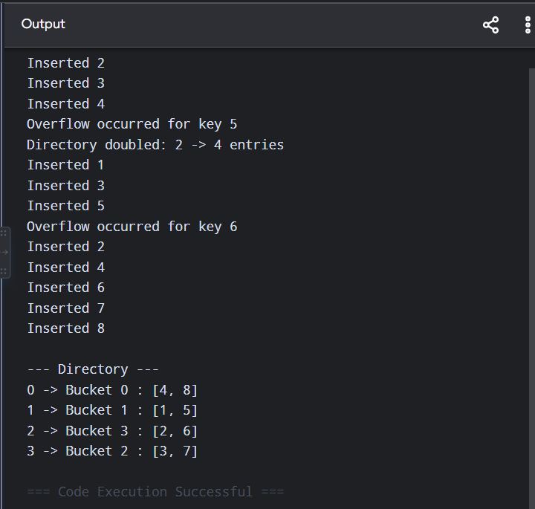

8. Write a program to simulate secondary storage block access. Calculate the number of I/O operations for sequential vs. indexed retrieval.
CODE:
TOTAL_RECORDS = 100
BLOCK_SIZE = 10

def sequential_retrieval(key):

io_operations = 0

for i in range(1, TOTAL_RECORDS + 1):

if (i - 1) % BLOCK_SIZE == 0:
io_operations += 1

if i == key:
break

print("Sequential Retrieval")
print("Key:", key)
print("Number of I/O operations:",
io_operations)

def indexed_retrieval(key):

block_number = (key - 1) // BLOCK_SIZE + 1

print("\nIndexed Retrieval")
print("Key:", key)
print("Block Number:", block_number)
print("Number of I/O operations: 1")

# Input
key = 87

sequential_retrieval(key)
indexed_retrieval(key)

OUTPUT:
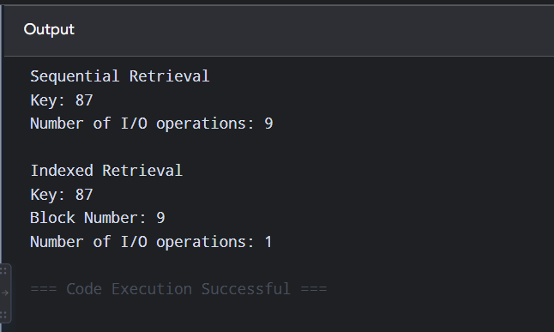
9. Implement a sparse index on a sorted file in code and compare its search performance with a dense index using timing analysis.
CODE:
import time

RECORDS = 100000
INTERVAL = 10
SEARCH_KEY = 98765

records = list(range(1, RECORDS + 1))

# Dense index
dense_index = {
value: position
for position, value in enumerate(records)
}

# Sparse index
sparse_index = {}

for i in range(0, RECORDS, INTERVAL):
sparse_index[records[i]] = i

def dense_search(key):

return dense_index.get(key)

def sparse_search(key):

keys = list(sparse_index.keys())

previous = 0

for value in keys:

if value > key:
break

previous = sparse_index[value]

end = min(previous + INTERVAL, RECORDS)

for i in range(previous, end):

if records[i] == key:
return i

return -1

# Dense timing
start = time.perf_counter()

dense_search(SEARCH_KEY)

end = time.perf_counter()

dense_time = end - start

# Sparse timing
start = time.perf_counter()

sparse_search(SEARCH_KEY)

end = time.perf_counter()

sparse_time = end - start

print("Search Key:", SEARCH_KEY)

print("\nDense Index Time:",
dense_time, "seconds")

print("Sparse Index Time:",
sparse_time, "seconds")

print("\nDense index stores an entry for every record.")
print("Sparse index stores entries at intervals.")

OUTPUT:
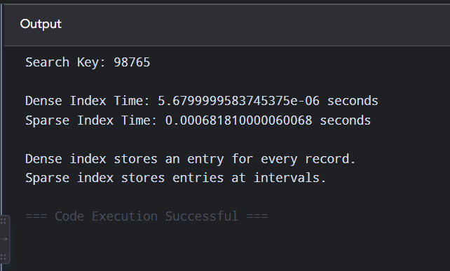
10. Write a program to construct and traverse a B+ Tree, then execute a range query for keys between 15 and 45, showing all matching records.
CODE:
class BPlusTree:
def __init__(self):
self.records = []

def insert(self, key):
self.records.append(key)
self.records.sort()

def display(self):
print("\nB+ Tree Leaf Level:")

for i in range(0, len(self.records), 3):
leaf = self.records[i:i + 3]
print(leaf, end=" -> ")
print("None")

def range_query(self, low, high):

print(
f"\nRange Query {low} to {high}:"
)

result = []

for key in self.records:

if low <= key <= high:
result.append(key)

print(*result)

# Input
tree = BPlusTree()

keys = [
5, 10, 15, 20,
25, 30, 35, 40,
45, 50, 55
]
for key in keys:
tree.insert(key)
tree.display()
tree.range_query(15, 45)

OUTPUT:
