SIMATS ENGINEERING
ASSESSMENT TOOL 2

COURSE NAME: Database Management Systems
COURSE CODE: CSA05

COURSE OUTCOME COVERED

CO4: Design database solutions incorporating file organization, indexing, and hashing techniques to optimize data storage and retrieval efficiency. (BL3, BL4)

Activity Tool : Industry Problem Solving Task (Medium)
Assessment Tool Weightage: 35%

Dr

QUESTIONS Total Marks: 50
Q.No | Question | Bloom's Level | Marks
1 | An e-commerce company needs to store 10 million product records. Recommend a file organization strategy and justify your choice with cost analysis. | BL4 – Analyze | 5
2 | A banking system requires fast retrieval of transactions by account number and date range. Design an indexing strategy with appropriate index types. | BL4 – Analyze | 5
3 | A healthcare system stores patient records accessed both by PatientID and by doctor name. Design a multi-level indexing solution. | BL4 – Analyze | 5
4 | A logistics company needs to efficiently handle dynamic insertions and deletions of shipment records. Analyze whether B-Tree or B+ Tree is more suitable. | BL4 – Analyze | 5
5 | Design a hashing scheme for an HR system with 5000 employees. Evaluate static hashing vs. extendible hashing for your scenario. | BL3 – Apply | 5
6 | An airline reservation system must support point queries by flight number and range queries by date. Propose a combined index structure. | BL4 – Analyze | 5
7 | For a university student database, design the file organization and secondary indexing to support fast queries by department and CGPA range. | BL4 – Analyze | 5
8 | Analyze the disk block utilization for Heap, Sorted, and Hashed file organizations given 100,000 records with 50 bytes each and 4KB blocks. | BL4 – Analyze | 5
9 | A social media platform needs to index 500 million posts by user_id, timestamp, and hashtag. Design a composite indexing strategy. | BL4 – Analyze | 5
10 | Compare the performance (insert, delete, search time) of Heap File, Sorted File, and Hashed File for a supermarket billing system with 1 million daily transactions. | BL4 – Analyze | 5

Code of Conduct:

I V.Shalini(192525373) (Name / Reg No) certify that this submission is my original work and that I have adhered to the guidelines specified for this assessment.
I understand that any violation of academic integrity rules will result in disciplinary action.

Signature of the student:
V.Shalini

RUBRICS FOR CALCULATION:

Criteria | Weightage | Level 4 – Exemplary | Level 3 – Proficient | Level 2 – Developing | Level 1 – Beginning
Criteria | Weightage | Level 4 – Exemplary | Level 3 – Proficient | Level 2 – Developing | Level 1 – Beginning
Understanding of Industry Problem | 20% | Comprehensive understanding of real-world problem and constraints | Good understanding with minor gaps in requirements | Basic understanding; some requirements unclear | Poor understanding; misinterprets problem context
Application of Engineering Concepts | 25% | Applies advanced and relevant concepts effectively to solve the problem | Applies appropriate concepts with minor errors | Limited application of concepts | Incorrect or no application of concepts
Solution Design | 25% | Innovative, practical, and feasible solution aligned with industry standards | Logical and feasible solution with minor gaps | Basic solution with limited feasibility | Unclear or impractical solution
Use of Tools | 15% | Effective use of modern tools, technologies, and real data | Appropriate use of tools with correct implementation | Limited or inconsistent use of tools | Minimal or incorrect use of tools
Analysis | 10% | Thorough analysis with validated results and performance evaluation | Good analysis with reasonable validation | Basic analysis with limited validation | Poor or no analysis
Professionalism | 5% | Highly professional, well-documented, and clearly presented work | Good documentation and presentation | Basic documentation with some gaps | Poor documentation and presentation

1.An e-commerce company needs to store 10 million product records. Recommend a file organization strategy and justify your choice with cost analysis.

GIVEN;
• Number of records = 10 million
• Record type = Product
• Important attributes = Product ID, Product Name, Category, Price
• Frequent operations = Search, insert, update and delete
• Large data volume requires efficient disk access.
• Searching the entire file for every request would be expensive.

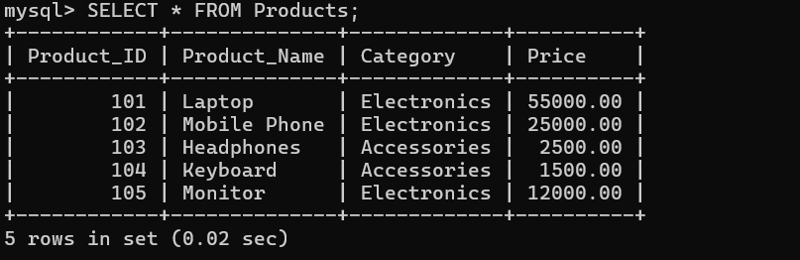

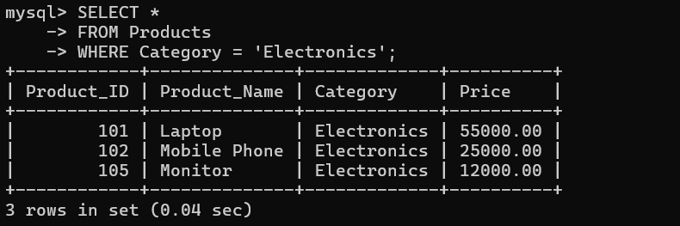

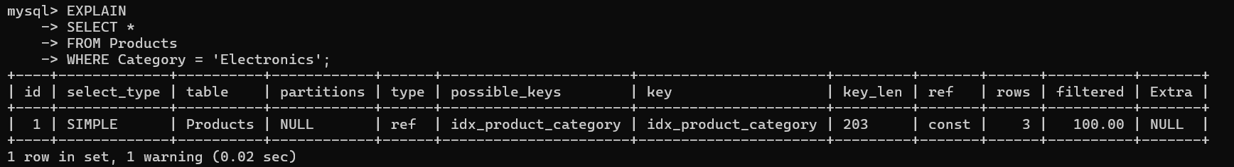

Cost Analysis
Without an index, MySQL may need to scan a large number of records to find matching products. With an index, the search can navigate through the index rather than scanning the complete table.

Operation | Without Index | With Index
Product search | High cost | Lower cost
Category search | Sequential scan | Indexed search
Insert | Lower | Slightly higher due to index maintenance
Storage | Lower | Additional index storage

Conclusion
For 10 million product records, an indexed organization with B+ Tree-based indexes is preferable because it provides faster searching at the cost of additional storage and index-maintenance overhead.

2. A banking system requires fast retrieval of transactions by account number and date range. Design an indexing strategy with appropriate index types.

Objective
To design and analyze an indexing strategy for a banking transaction database so that transactions can be retrieved efficiently using Account Number and Date Range.

Given Information
- The system stores banking transactions.
- Each transaction has a unique transaction ID.
- Transactions need to be searched using Account Number.
- Transactions also need to be retrieved for a particular date range.
- Since banking databases can contain millions of transactions, sequential scanning can be expensive.
- A composite B+ Tree index is suitable for this requirement.

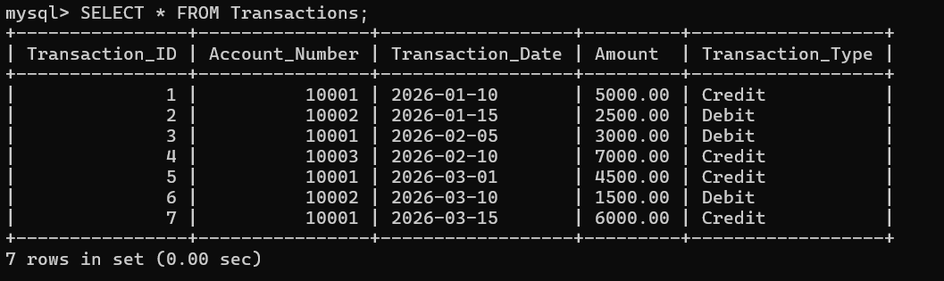

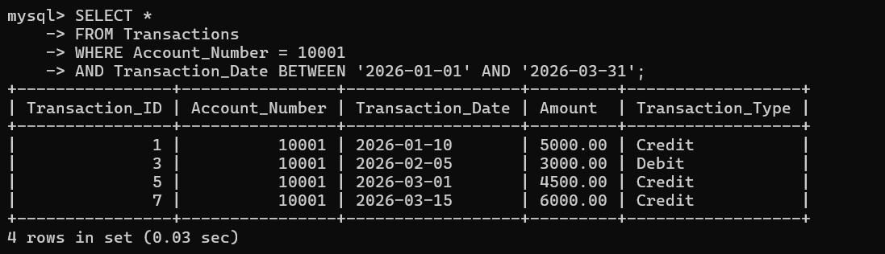

COST ANALYSIS:
Without an index, MySQL may need to examine many transaction records to find the required account and date range.
With the composite index, MySQL can navigate the index to locate the required account and then efficiently process the date range.
The index does require additional storage, and every insertion or deletion requires the index to be maintained. However, for a banking system with a large number of transactions, the improvement in retrieval performance is more important.

Operation | Without Index | With Composite Index
Account search | High | Low
Date range search | High | Low
Account + date search | High | Very efficient
Insert | Simple | Slightly higher
Delete | Simple | Slightly higher
Storage | Lower | Higher
Maintenance | Low | Moderate

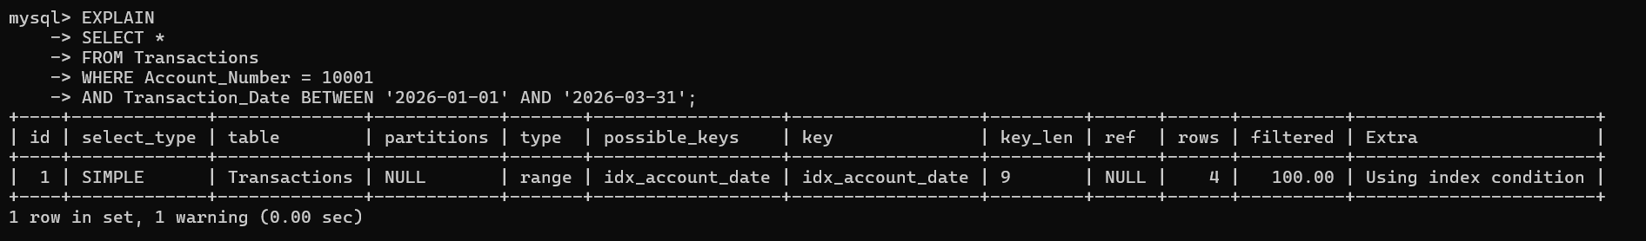

Conclusion
A composite B+ Tree index on (Account_Number, Transaction_Date) is recommended for the banking system. It provides efficient retrieval of transactions for a specific account and a specified date range. Although it requires additional storage and index-maintenance overhead, the reduction in search cost makes it appropriate for a large banking transaction database.

3. A healthcare system stores patient records accessed both by PatientID and by doctor name. Design a multi-level indexing solution.
Objective
To design an indexing strategy that provides fast retrieval of patient records using both PatientID and Doctor Name.
The healthcare database may contain a very large number of patient records. Searching the complete table for every request would increase the number of disk accesses and reduce performance. Therefore, primary and secondary indexes are required.

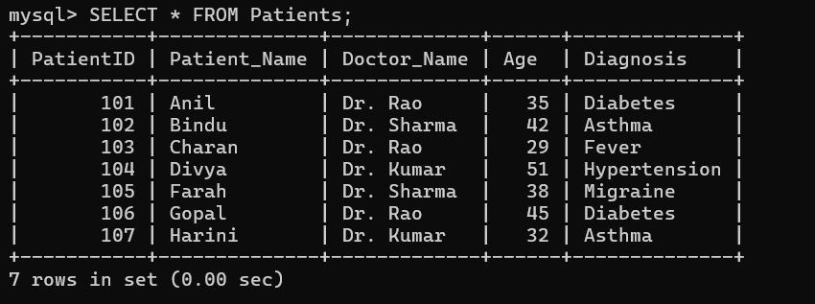

Cost Analysis
The healthcare system requires two different access paths.
The primary index on PatientID provides efficient direct access to an individual patient's record. Since PatientID is unique, it is suitable as the primary key.
The secondary index on Doctor_Name provides an additional access path for finding all patients associated with a particular doctor.

Operation | Without Index | With Index
Search by PatientID | Slow for large table | Very fast
Search by Doctor Name | Table scan | Faster
Insert | Simple | Slightly more overhead
Delete | Simple | Index must be updated
Storage | Lower | Additional index storage
Large database | Less efficient | More efficient

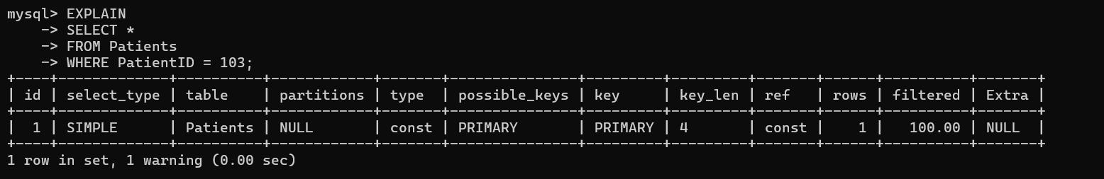

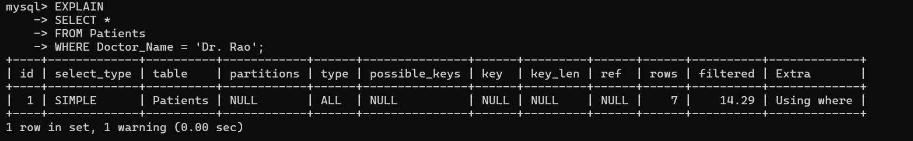

Conclusion
A multi-level indexing solution consisting of a primary index on PatientID and a secondary B+ Tree index on Doctor_Name is suitable for the healthcare system. The primary index provides fast retrieval of individual patients, while the secondary index supports efficient retrieval of all patients associated with a doctor.

4. A logistics company needs to efficiently handle dynamic insertions and deletions of shipment records. Analyze whether B-Tree or B+ Tree is more suitable.

Cost Analysis
B-Tree
B-Tree stores keys and records/pointers at different levels of the tree. Searching can sometimes finish at an internal node.
B+ Tree
B+ Tree stores actual record pointers at the leaf level and keeps leaf nodes linked. This makes sequential and range access efficient.
For a logistics system, shipment records are continuously inserted and deleted, and the system may also need searches based on tracking number and date.
B+ Tree maintains a balanced structure after insertions and deletions, so the tree remains efficient as the number of shipment records increases.

Why B+ Tree Is Better
For this logistics application, B+ Tree is more suitable than B-Tree because:
- It provides efficient search.
- It supports dynamic insertion and deletion.
- It maintains balanced tree height.
- Linked leaf nodes provide efficient sequential access.
- It performs very well for range queries.
- It reduces disk I/O because each internal node can contain many keys.
- It is widely used for database indexes.

Feature | B-Tree | B+ Tree
Search | Fast | Very fast
Insertion | Efficient | Efficient
Deletion | Efficient | Efficient
Range Queries | Good | Excellent
Sequential Access | Good | Excellent
Leaf Nodes Linked | Usually No | Yes
Database Usage | Less common | Very common
Disk-based databases | Good | Excellent

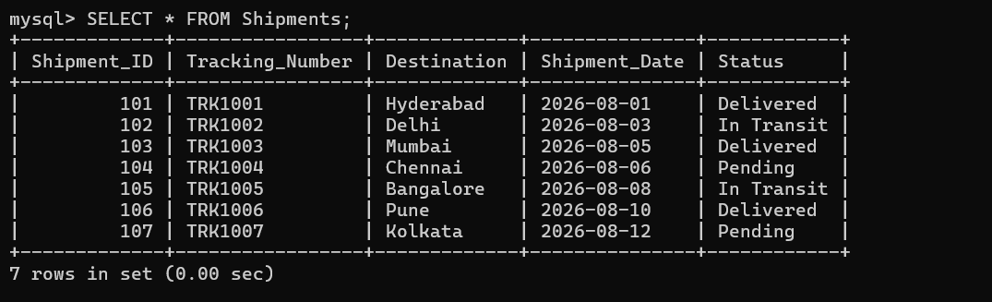

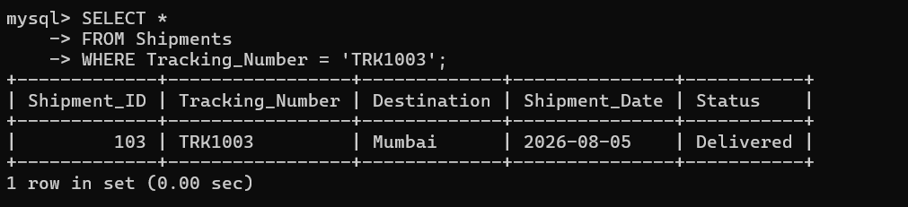

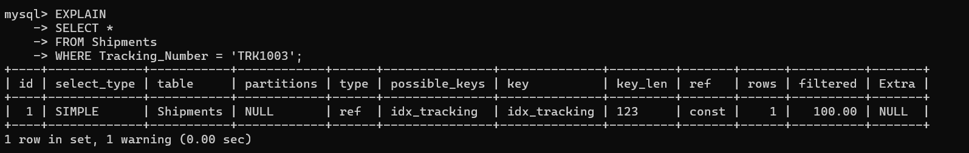

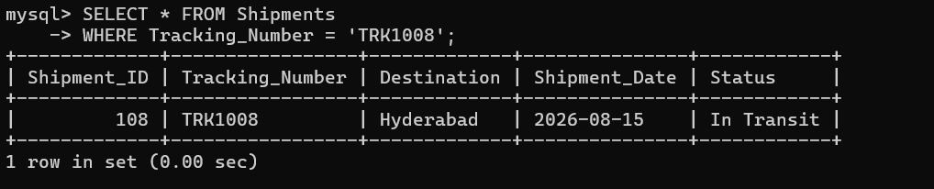

Conclusion
B+ Tree is the preferred choice for the logistics system. Although both B-Tree and B+ Tree support efficient insertion, deletion, and search, B+ Tree provides better performance for database workloads because its linked leaf nodes make sequential and range access efficient. MySQL's InnoDB indexes use B+ Tree-like structures, making a MySQL index on Tracking_Number an appropriate implementation for this requirement.

5. Design a hashing scheme for an HR system with 5000 employees. Evaluate static hashing vs. extendible hashing for your scenario.
Introduction
Hashing is a technique used to store and retrieve records quickly. In an HR system, every employee has a unique employee_id. We can use this employee ID as the hashing key.
Hash Function
A simple hashing function is:
Hash value = employee_id MOD 100
For example:
Employee ID = 1025
1025 MOD 100 = 25
Therefore, employee 1025 will be assigned to bucket 25.
Static Hashing
In static hashing, the number of buckets is fixed.
For 5,000 employees, we can create 100 buckets.
Average records per bucket
= 5000 / 100
= 50 employees

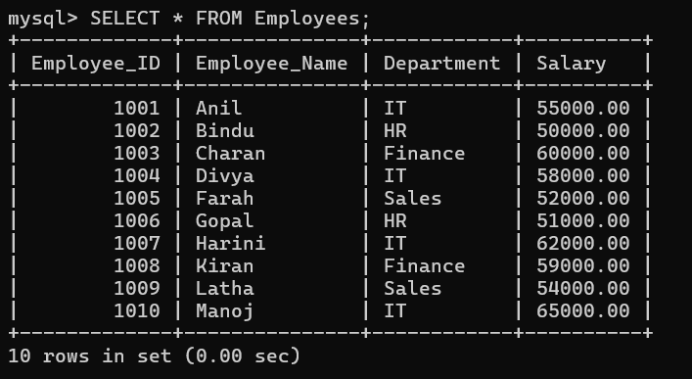

Extendible Hashing
Extendible hashing allows the number of buckets to increase when more records are added.
When a bucket becomes full:
Bucket full
↓
Bucket split
↓
Records redistributed
↓
New bucket created

Advantages:
- Dynamically grows.
- Reduces overflow.
- Suitable for large databases.
- Better when employee records continuously increase.

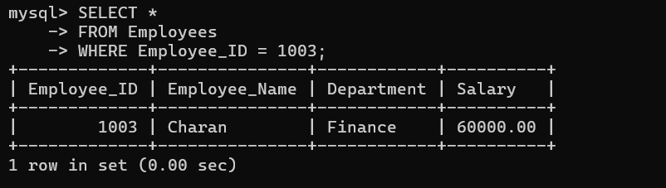
Advantages:
- Simple to implement.
- Fast for exact employee searches.
- Easy to understand.
- Good when employee numbers do not change significantly.
Disadvantages:
- Fixed number of buckets.
- Overflow can occur.
- Performance may decrease when the employee count increases.

Comparison
Factor | Static Hashing | Extendible Hashing
Buckets | Fixed | Dynamic
Growth | Difficult | Easy
Overflow | More likely | Less likely
Complexity | Low | Higher
Performance | Good | Very good
Suitable for HR | Yes | Yes

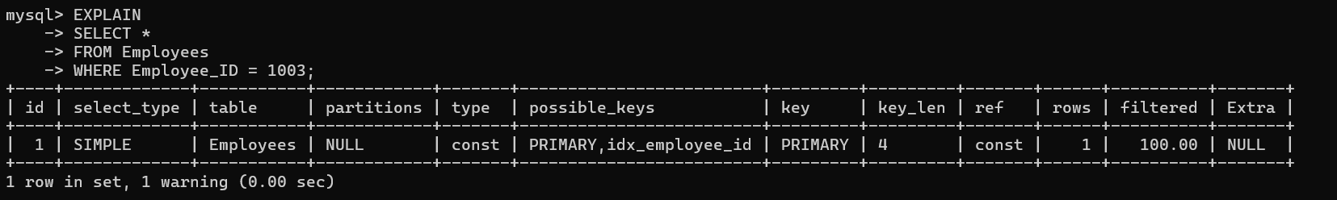

Conclusion
For 5,000 employees, static hashing is sufficient if the number of employees is stable. If the company is growing rapidly, extendible hashing is better.

6. An airline reservation system must support point queries by flight number and range queries by date. Propose a combined index structure.

An airline reservation system needs two types of queries:
- Point query: Search for a particular flight number.
- Range query: Search flights between two dates.
For example, searching AI101 is a point query, while searching flights from August 1 to August 31 is a range query.
In MySQL InnoDB, B+ Tree indexes are commonly used. A B+ Tree index supports both equality and range searches efficiently.

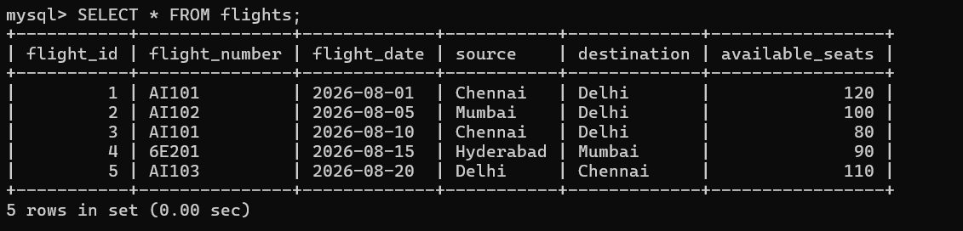

A good design is to create:
- Index on flight_number
- Index on flight_date
- Composite index on (flight_number, flight_date)
The composite index is useful when both flight number and date are used in the same query.

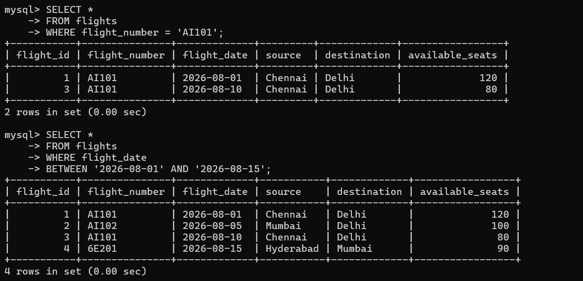

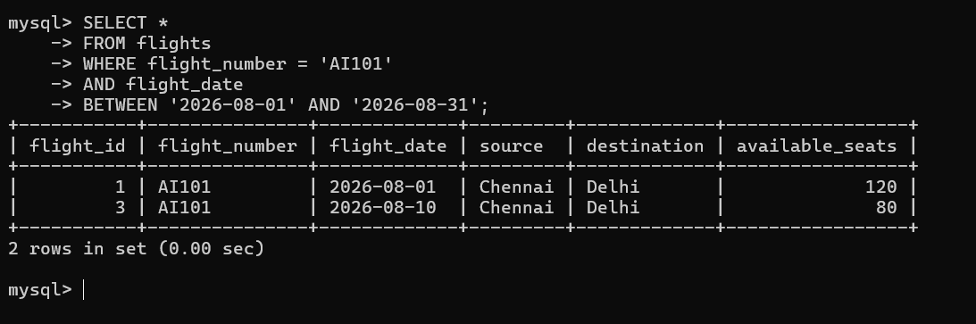

Advantages of Indexing
- Reduces the time required to search records.
- Avoids unnecessary full-table scans.
- Improves point-query performance.
- Improves date-range queries.
- Composite indexes improve queries involving multiple columns.
- Suitable for large airline reservation databases.
Conclusion
The airline system can use B+ Tree indexes in MySQL. The flight_number index supports point searches, while the flight_date index supports range searches. The composite (flight_number, flight_date) index supports queries using both fields.

7. For a university student database, design the file organization and secondary indexing to support fast queries by department and CGPA range.

A university database contains student information such as student ID, name, department and CGPA.
The system should quickly answer:
- Find all students in a particular department.
- Find students whose CGPA is within a given range.
- Find students from a particular department whose CGPA is within a range.
For this purpose, we use secondary indexes.
A composite index on (department, cgpa) is especially useful when both department and CGPA are used in the query.
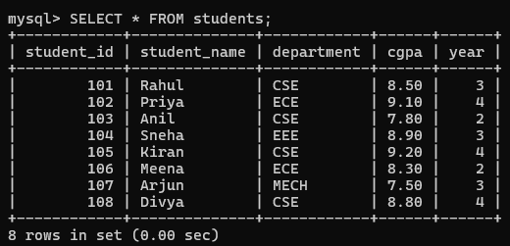

Advantages
- Faster department searches.
- Faster CGPA range searches.
- Reduces unnecessary table scanning.
- Improves query performance.
- Composite indexes support multiple-column queries.
- Suitable for large university databases.

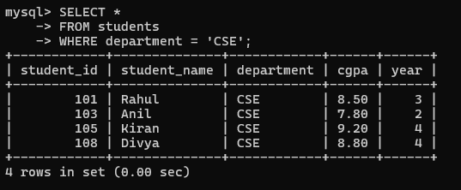

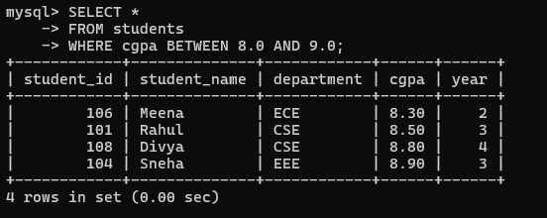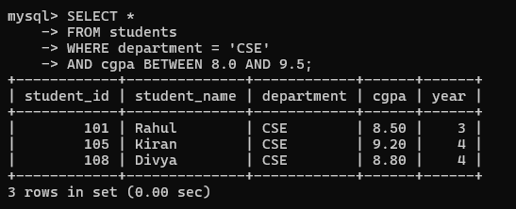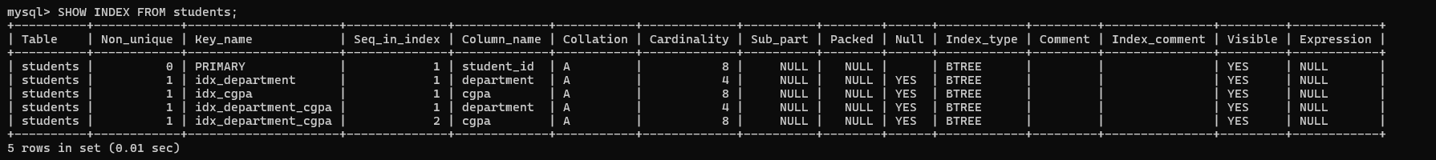
Conclusion
The university database uses InnoDB with primary and secondary B+ Tree indexes. The department index provides fast department searches, the CGPA index supports CGPA range queries, and the composite (department, cgpa) index improves queries that use both conditions.

8. Analyze the disk block utilization for Heap, Sorted, and Hashed file organizations given 100,000 records with 50 bytes each and 4KB blocks.

Introduction
File organization describes how records are stored in a database. The three common types are Heap File, Sorted File, and Hashed File.
Given:
- Number of records = 100,000
- Record size = 50 bytes
- Block size = 4 KB

Calculation
First, convert 4 KB into bytes:
4 KB = 4 × 1024
= 4096 bytes
Number of records that can fit in one block:
Records per block = 4096 / 50
= 81.92
Only complete records can be stored, so:
Records per block = 81
Space occupied by 81 records:
81 × 50 = 4050 bytes
Unused space in one block:
4096 - 4050 = 46 bytes
Block utilization:
(4050 / 4096) × 100
= 98.88%
Total number of blocks:
100000 / 81 = 1234.57
Therefore:
Total blocks required = 1235
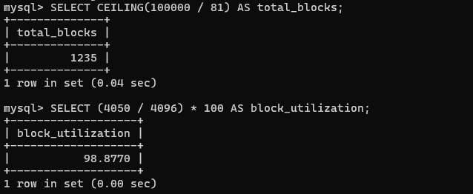
Heap File
In a Heap File, records are stored without any particular order.
Advantages:
- Simple to implement.
- Very fast insertion.
- No sorting is required.
- Suitable for frequent insert operations.
Disadvantages:
- Searching can be slow.
- May require scanning many records.
- Not suitable for frequent range queries.
Sorted File
In a Sorted File, records are stored in a particular order based on a search key.
Advantages:
- Fast searching.
- Very efficient for range queries.
- Records are maintained in order.
- Useful for reporting.
Disadvantages:
- Insertions are slower.
- Deletions can be expensive.
- Maintaining sorted order requires additional work.

Hashed File
In a Hashed File, a hash function determines the location of each record.

Advantages:
- Very fast exact searches.
- Fast insertion.
- Fast deletion.
- Suitable for equality queries.
Disadvantages:
- Poor for range queries.
- Overflow can occur.
- Performance depends on the hash function.
Comparison
Feature | Heap | Sorted | Hashed
Storage | Unordered | Ordered | Hash-based
Search | Slow | Fast | Very Fast
Insert | Very Fast | Slow | Fast
Delete | Fast | Slow | Fast
Range Query | Poor | Excellent | Poor
Equality Search | Poor | Good | Excellent

Conclusion
Heap files are best for fast insertion, sorted files are best for range queries and ordered searching, and hashed files are best for exact-match searches. In practical MySQL applications, InnoDB with B+ Tree indexes is commonly used for efficient data access.

9. A social media platform needs to index 500 million posts by user_id, timestamp, and hashtag. Design a composite indexing strategy.

A social media platform may contain 500 million posts. Searching such a large amount of data without indexes can be very slow.
Each post can contain:
- post_id
- user_id
- post_timestamp
- hashtag
- content
The main requirement is to quickly search posts by user ID, timestamp, and hashtag.

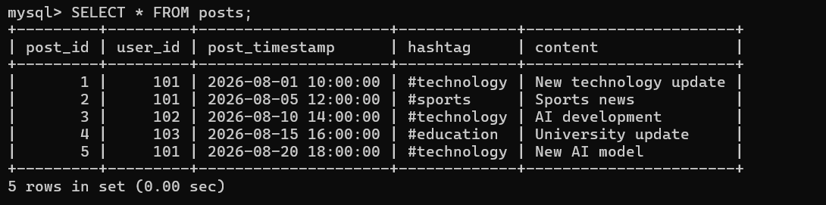
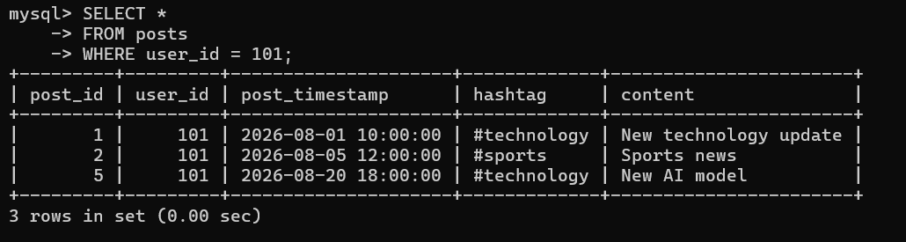
Advantages
- Faster user-based searches.
- Faster timestamp range searches.
- Faster hashtag searches.
- Composite indexes support multiple conditions.
- Reduces unnecessary table scanning.
- Useful for very large databases.
- Improves query performance.
Comparison
Query | Recommended Index
Search by user_id | idx_user
Search by user_id + date | idx_user_timestamp
Search by hashtag | idx_hashtag_timestamp
Search by hashtag + date | idx_hashtag_timestamp

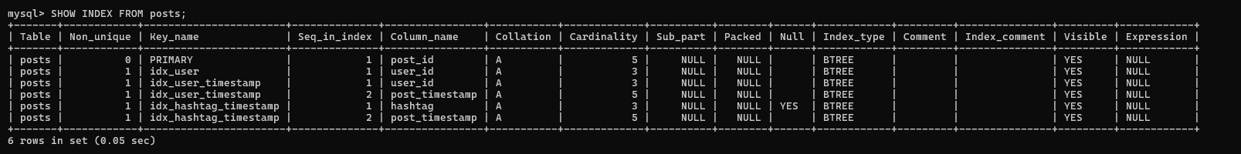
Conclusion
For a social media platform with 500 million posts, a composite indexing strategy provides efficient searching. The (user_id, post_timestamp) index is useful for user timelines, while (hashtag, post_timestamp) is useful for hashtag and date-based searches. MySQL InnoDB with B+ Tree indexes is suitable for these types of queries.
10. Compare the performance (insert, delete, search time) of Heap File, Sorted File, and Hashed File for a supermarket billing system with 1 million daily transactions.

Introduction
A supermarket billing system may generate around 1 million transactions every day. The database should support fast insertion, searching, deletion, and report generation.
Each transaction can contain:
- transaction_id
- customer_id
- transaction_date
- amount
- payment_method
The three file organizations are Heap File, Sorted File, and Hashed File.
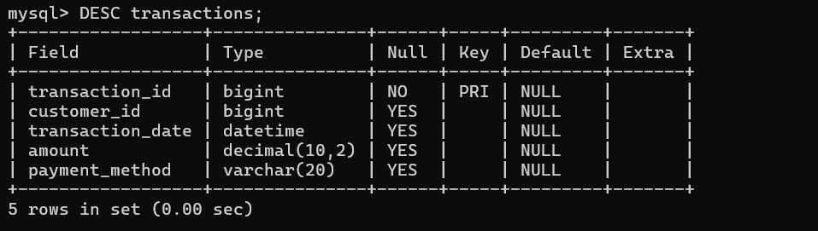
Heap File
In a Heap File, records are stored without any particular order.
New transactions can be added quickly because the database does not need to maintain a sorted order.
Advantages
- Very fast insertion.
- Simple organization.
- Suitable for large numbers of insert operations.
- No sorting is required.
Disadvantages
- Searching can be slow without indexes.
- Range queries are not efficient.
- The system may need to scan many records.
Sorted File
In a Sorted File, records are maintained in a particular order, such as by transaction_id or transaction_date.

Advantages
- Fast searching.
- Efficient range queries.
- Useful for reports.
Disadvantages
- Insertions can be slower.
- Deletions can require additional work.
- Maintaining sorted order has overhead.
Hashed File
In a Hashed File, a hash function determines the location of a record.
Advantages
- Very fast exact-match searches.
- Fast insertion.
- Fast deletion.
- Suitable for searching using a unique key.
Disadvantages
- Poor for range queries.
- Overflow may occur.
- Not suitable when records need to be retrieved in sorted order.

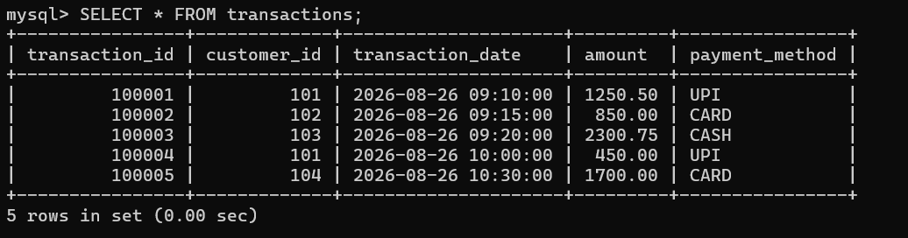
Conclusion
For a supermarket billing system with 1 million daily transactions, Heap Files provide fast insertion, Sorted Files are good for range queries, and Hashed Files are excellent for exact searches.
For an actual MySQL system, InnoDB with B+ Tree indexes is the recommended practical solution. A primary key on transaction_id, indexes on customer_id and transaction_date, and a composite index on (customer_id, transaction_date) provide good performance for common billing queries.

