SIMATS ENGINEERING
ASSESSMENT TOOL 1

COURSE NAME: Database Management Systems
COURSE CODE: CSA05

COURSE OUTCOME COVERED

CO5: Implement database operations using query processing, optimization, and transaction management to ensure consistency and reliability. (BL3, BL4)

Activity Tool : Constraint-Based Problem Solving (High)
Assessment Tool Weightage:40%

Dr

QUESTIONS
Q.No | Question | Bloom's Level
1 | Given a complex SQL query with nested joins and sub-queries, draw the query execution plan and apply heuristic optimization rules step-by-step. | BL4 – Analyze
2 | Apply cost-based optimization to choose between nested-loop join, sort-merge join, and hash join for the given relations with specified tuple counts and page sizes. | BL4 – Analyze
3 | Implement JDBC connectivity in Java to a MySQL database and write code to execute parameterized queries with PreparedStatement. | BL3 – Apply
4 | Given a schedule of four concurrent transactions, determine whether it is conflict-serializable using a precedence graph. | BL4 – Analyze
5 | Demonstrate the application of Basic Two-Phase Locking (2PL) on a given transaction set. Identify and resolve any deadlocks. | BL3 – Apply
6 | Apply the Wait-Die and Wound-Wait timestamp-based deadlock prevention schemes on a given set of transactions requesting locks. | BL4 – Analyze
7 | Given transaction logs with checkpoints, apply the Immediate Update recovery protocol to recover the database after a system failure. | BL3 – Apply
8 | Apply Deferred Update (NO-UNDO/REDO) recovery technique on a given log file with committed and uncommitted transactions. | BL3 – Apply
9 | Design a concurrency control mechanism using strict 2PL for a banking system where T1 transfers funds and T2 reads balance simultaneously. | BL4 – Analyze
10 | Write pseudocode for query optimization using heuristics: push down selection, project early, and order joins by smaller intermediate results. | BL4 – Analyze

Code of Conduct:

I V.Shalini (192525373) (Name / Reg No) certify that this submission is my original work and that I have adhered to the guidelines specified for this assessment.
I understand that any violation of academic integrity rules will result in disciplinary action.

Signature of the student:
V.Shalini

RUBRICS FOR CALCULATION:

Criteria | Weightage | Level 4 (Exemplary) | Level 3 (Proficient) | Level 2 (Developing) | Level 1 (Beginning)
Problem Understanding | 25% | Clearly defines the problem and identifies all relevant constraints accurately | Identifies most constraints with minor gaps | Partial understanding; misses key constraints | Fails to identify constraints correctly
Constraint Analysis | 25% | Analyzes constraints effectively and prioritizes them logically | Provides reasonable analysis with some prioritization | Limited analysis; weak prioritization | No meaningful analysis or prioritization
Solution Development | 25% | Develops optimal and feasible solutions satisfying all constraints | Develops workable solutions with minor limitations | Solutions partially satisfy constraints | Solutions do not meet constraints
Application of Concepts | 15% | Effectively applies appropriate concepts, methods, or tools | Applies concepts with minor errors | Limited application; requires guidance | Unable to apply relevant concepts
Justification | 10% | Provides strong justification for decisions with logical reasoning | Provides justification with some clarity | Weak or unclear justification | No justification provided

1. Given a complex SQL query with nested joins and sub-queries, draw the query execution plan and apply heuristic optimization rules step-by-step.
Introduction
Query processing is the process used by a DBMS to convert an SQL query into an efficient execution plan.
A complex SQL query may contain:
- Nested sub-queries
- Joins
- Selection conditions
- Projection operations
- Aggregate functions
- Multiple relations
The query optimizer selects a better execution method to reduce disk I/O, CPU time, memory usage, and execution time.
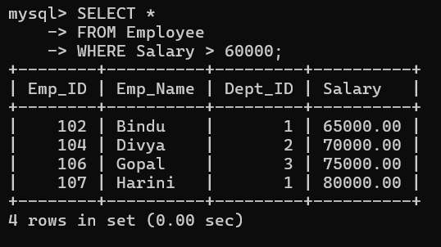
Step 1: Identify the Selection Conditions
The query has:
D.Dept_Name = 'CSE'
E.Marks > 80
and the sub-query contains:
Marks > 90
The first heuristic rule is:
Apply selection operations as early as possible.
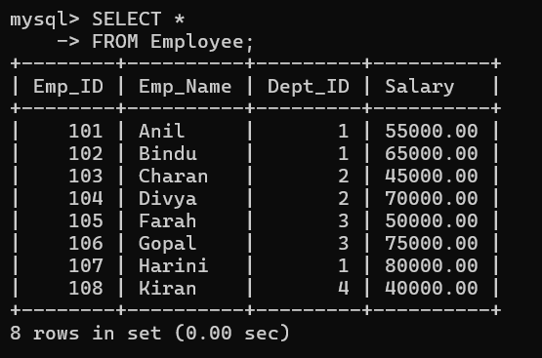
Step 2: Apply Selection to DEPARTMENT
Instead of joining all departments, first select only the CSE department.
SELECT *
FROM DEPARTMENT
WHERE Dept_Name = 'CSE';
Relational algebra:
σ Dept_Name='CSE' (DEPARTMENT)
This reduces the number of department records.

Step 3: Apply Selection to ENROLLMENT
Instead of processing every enrollment record:
SELECT *
FROM ENROLLMENT
WHERE Marks > 80;
Relational algebra:
σ Marks>80 (ENROLLMENT)
Only students with marks greater than 80 are processed.
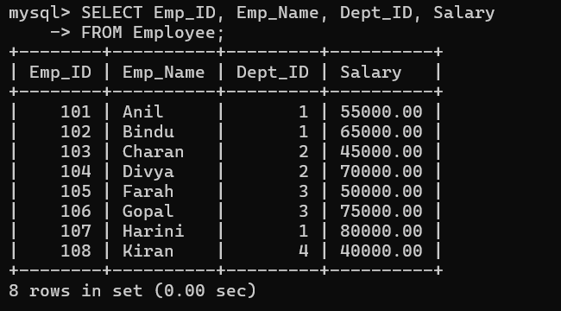
Step 4: Optimize the Sub-Query
Original sub-query:
SELECT Student_ID
FROM ENROLLMENT
WHERE Marks > 90;
This can be executed first.
σ Marks>90 (ENROLLMENT)
Only the required Student_ID column is retained.
π Student_ID
Therefore:
π Student_ID (σ Marks>90 (ENROLLMENT))
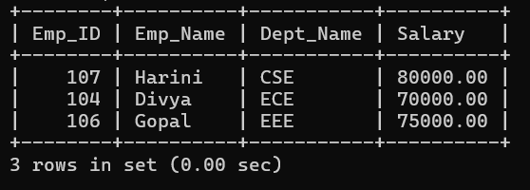

Step 5: Push Projection Down
Only required columns should be retained.
STUDENT
Student_ID
Student_Name
Dept_ID
DEPARTMENT
Dept_ID
Dept_Name
ENROLLMENT
Student_ID
Course_ID
Marks
COURSE
Course_ID
Course_Name
This reduces the size of intermediate relations.

Step 6: Perform Smaller Joins First
After selections and projections, the smaller relations should be joined first.
Filtered DEPARTMENT
↓
STUDENT
↓
ENROLLMENT
↓
COURSE
The sub-query can also be used to eliminate students who do not satisfy the condition.

Original Query Execution Plan

SELECT
|
JOIN
/ \
JOIN COURSE
/ \
JOIN ENROLLMENT
/ \
STUDENT DEPARTMENT
|
Nested Sub-query
This plan may process many unnecessary records.

Heuristic Optimization Rules Applied
Rule 1: Push Selection Down
Apply:
WHERE conditions
as close as possible to base tables.
Rule 2: Push Projection Down
Remove unnecessary attributes early.
Rule 3: Perform Smaller Joins First
Join relations that produce smaller intermediate results.
Rule 4: Simplify Sub-Queries
Execute filtering operations inside sub-queries early.
Rule 5: Avoid Unnecessary Data
Do not carry unused columns or tuples through later operations.

Advantages
- Reduces intermediate results.
- Reduces disk I/O.
- Reduces memory usage.
- Reduces CPU processing.
- Improves query execution time.
- Makes the execution plan more efficient.

Conclusion
Heuristic optimization improves SQL query performance by pushing selections and projections down, simplifying sub-queries, and performing joins on smaller relations first.

2. Apply cost-based optimization to choose between nested-loop join, sort-merge join, and hash join for the given relations with specified tuple counts and page sizes.
Cost-based optimization selects the query execution plan having the lowest estimated cost.
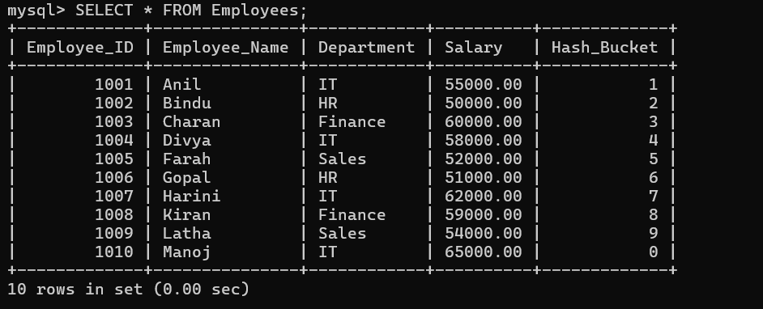
The DBMS considers:
- Number of tuples
- Number of pages
- Available memory
- Indexes
- Join conditions
- CPU cost
- Disk I/O cost
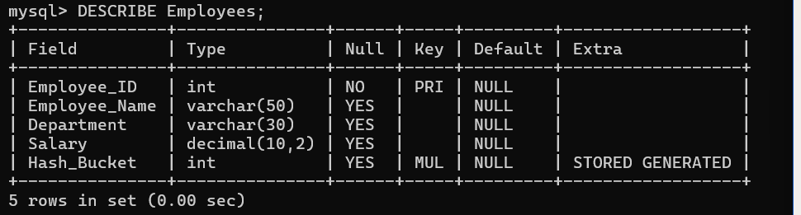
Suppose:
Relation R = 1,000 tuples
Relation S = 5,000 tuples
Page size = 4 KB
Assume different join algorithms are available.
Nested-Loop Join
Nested-loop join compares tuples of one relation with tuples of another relation.
For each tuple in R
For each tuple in S
Compare join condition
It is simple but can be expensive when both relations are large.
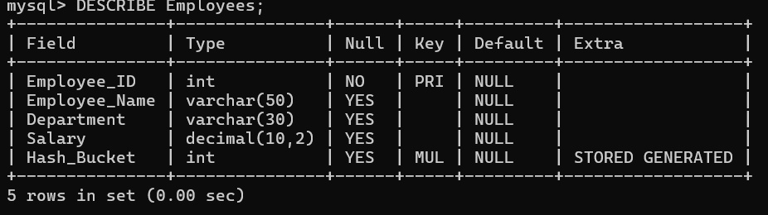
Sort-Merge Join
Steps:
- Sort relation R.
- Sort relation S.
- Merge the sorted relations.
It is useful when:
- Relations are already sorted.
- Sorting is required for another operation.
- Large relations are being joined.
Hash Join
Steps:
- Hash the smaller relation.
- Build a hash table.
- Scan the larger relation.
- Match tuples using the hash value.
For large equality joins, hash join is usually very efficient.
Comparison
Join Method | Suitable Situation
Nested-Loop Join | Small relation or indexed join
Sort-Merge Join | Sorted data or large relations
Hash Join | Large equality joins
Conclusion
For large unsorted relations with an equality condition, the optimizer will generally prefer Hash Join because it can avoid repeated comparisons and sorting.

3. Implement JDBC connectivity in Java to a MySQL database and write code to execute parameterized queries with PreparedStatement.
JDBC (Java Database Connectivity) is an API used to connect Java applications with databases.
Steps
- Import JDBC packages.
- Load/register the MySQL driver.
- Establish database connection.
- Create PreparedStatement.
- Set parameter values.
- Execute the query.
- Process the result.
- Close resources.
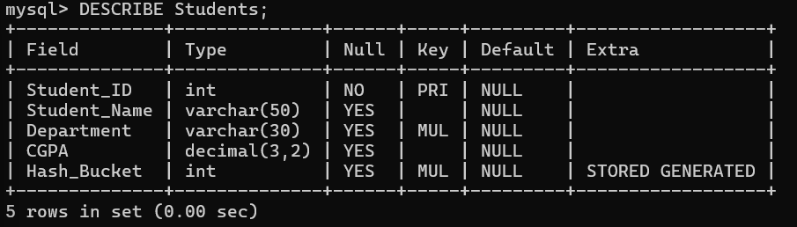
Java Program
import java.sql.*;
public class JDBCExample {
public static void main(String[] args) {
String url = "jdbc:mysql://localhost:3306/college";
String username = "root";
String password = "root";
String sql = "SELECT * FROM Student WHERE Student_ID = ?";
try {
Connection con = DriverManager.getConnection(
url, username, password);
PreparedStatement ps = con.prepareStatement(sql);
ps.setInt(1, 101);
ResultSet rs = ps.executeQuery();
while (rs.next()) {
System.out.println(
rs.getInt("Student_ID") + " " +
rs.getString("Student_Name")
);
}
rs.close();
ps.close();
con.close();
} catch (SQLException e) {
e.printStackTrace();
}
}
}
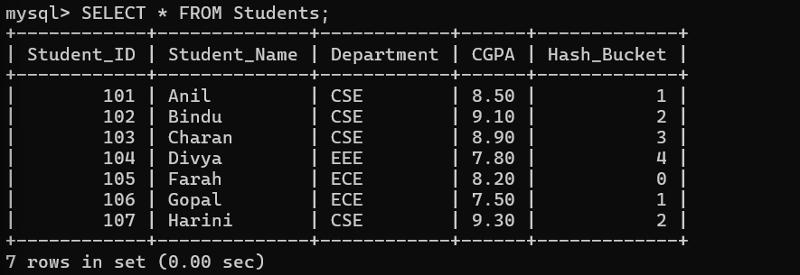
Why PreparedStatement?
- Prevents SQL injection.
- Supports parameterized queries.
- Improves security.
- Makes queries easier to reuse.
Example:
String sql = "SELECT * FROM Student WHERE Department = ?";
PreparedStatement ps = con.prepareStatement(sql);
ps.setString(1, "CSE");

4. Given a schedule of four concurrent transactions, determine whether it is conflict-serializable using a precedence graph.
When multiple transactions execute simultaneously, their operations may be interleaved. A schedule is conflict-serializable if its execution is equivalent to some serial execution.

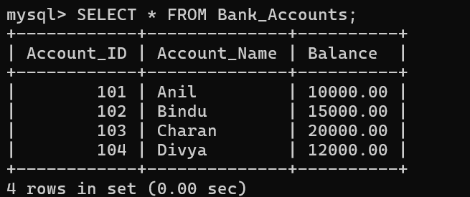
Conflicting Operations
Two operations conflict if:
- They belong to different transactions.
- They access the same data item.
- At least one operation is a write.
Examples:
R1(A) and W2(A)
W1(A) and R2(A)
W1(A) and W2(A)
These are conflicts.
But:
R1(A) and R2(A)
are not conflicting.
Precedence Graph
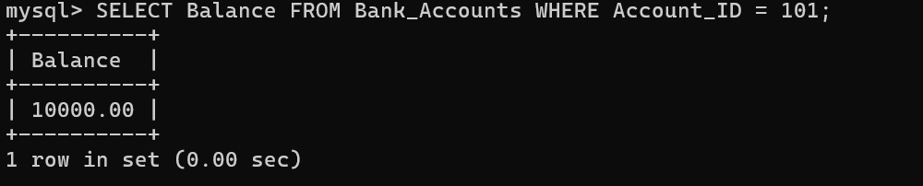
A precedence graph contains:
- One node for each transaction.
- A directed edge between transactions when a conflict occurs.

If T1 executes before T2:
T1 → T2
Example Schedule
T1: R(A)
T2: W(A)
T3: R(B)
T4: W(B)
Since T1 reads A before T2 writes A:
T1 → T2
Since T3 reads B before T4 writes B:
T3 → T4

Graph:
T1 → T2
T3 → T4
There is no cycle.
Therefore:
Schedule is conflict-serializable.
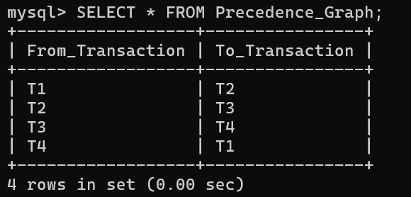
Cyclic Example
Suppose:
T1 → T2
T2 → T3
T3 → T1
There is a cycle:
T1 → T2 → T3
↑ |
└───────────┘
Therefore:
Schedule is NOT conflict-serializable.
Important Conclusion
Acyclic precedence graph
↓
Conflict Serializable

Cyclic precedence graph
↓
Not Conflict Serializable

5. Demonstrate the application of Basic Two-Phase Locking (2PL) on a given transaction set. Identify and resolve any deadlocks.
Two-Phase Locking (2PL) is a concurrency control protocol that ensures conflict serializability.
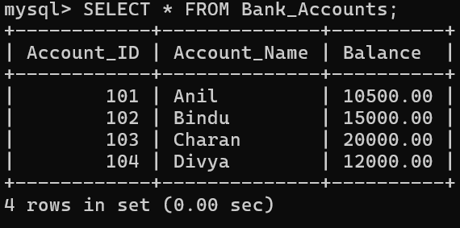
A transaction uses two types of locks:
Shared Lock (S)
Used for reading.
Multiple transactions can hold shared locks simultaneously.
T1 → S-lock(A)
T2 → S-lock(A)
Both can read A.
Exclusive Lock (X)
Used for writing.
Only one transaction can hold an exclusive lock.
T1 → X-lock(A)
Other transactions cannot read or write A until the lock is released.
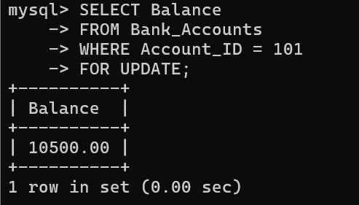
Two Phases
Growing Phase
The transaction can acquire locks but cannot release them.
LOCK(A)
LOCK(B)
LOCK(C)
Shrinking Phase
The transaction can release locks but cannot acquire new locks.
UNLOCK(C)
UNLOCK(B)
UNLOCK(A)

Example
T1:
LOCK-X(A)
READ(A)
WRITE(A)
LOCK-X(B)
READ(B)
WRITE(B)
UNLOCK(A)
UNLOCK(B)
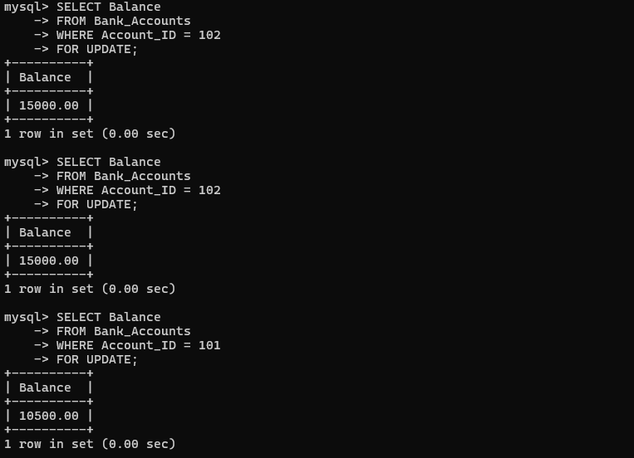
COMMIT
The transaction first obtains the required locks and later releases them.
Deadlock
A deadlock occurs when transactions wait for each other indefinitely.

Example:
T1 locks A
T2 locks B

T1 requests B → waits
T2 requests A → waits
Graph:
T1 → T2
↑ ↓
└─────┘
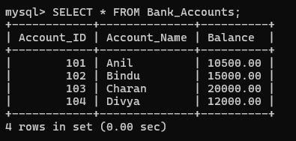
Deadlock Resolution
Possible solutions:
- Abort one transaction.
- Roll back one transaction.
- Release its locks.
- Allow the other transaction to continue.
- Restart the aborted transaction later.

6. Apply the Wait-Die and Wound-Wait timestamp-based deadlock prevention schemes on a given set of transactions requesting locks.
Both are deadlock prevention techniques based on transaction timestamps.
Suppose:
T1 timestamp = 10
T2 timestamp = 20
Therefore:
T1 = Older
T2 = Younger
Wait-Die
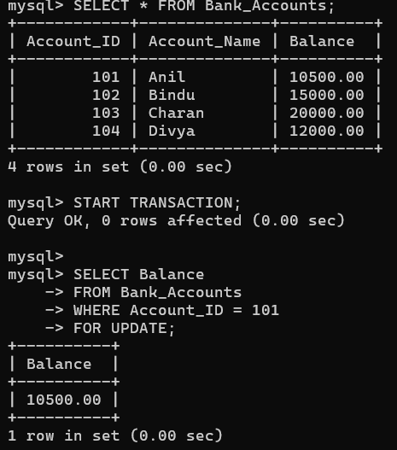
In Wait-Die:
- Older transaction can wait.
- Younger transaction is aborted.
Example 1
T1 is older and requests a lock held by T2.
T1 → waits
Example 2
T2 is younger and requests a lock held by T1.
T2 → aborts
Rule
Older → Younger = WAIT
Younger → Older = DIE

Wound-Wait
In Wound-Wait:
- Older transaction aborts the younger transaction.
- Younger transaction waits for the older transaction.
Example 1
T1 is older and requests a lock held by T2.
T2 → aborted
T1 → gets the lock
Example 2
T2 is younger and requests a lock held by T1.
T2 → waits
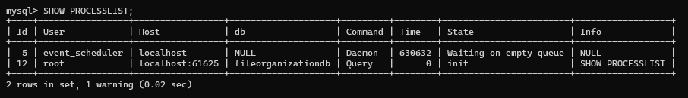
Rule
Older → Younger = WOUND
Younger → Older = WAIT
Comparison
Feature | Wait-Die | Wound-Wait
Older requests younger's lock | Wait | Abort younger
Younger requests older's lock | Abort | Wait
Type | Non-preemptive | Preemptive
Purpose | Prevent deadlock | Prevent deadlock

7. Given transaction logs with checkpoints, apply the Immediate Update recovery protocol to recover the database after a system failure.

Immediate Update is a database recovery technique in which changes made by a transaction may be written to disk before the transaction commits.
Because uncommitted changes may already exist on disk, recovery requires both:
- UNDO
- REDO
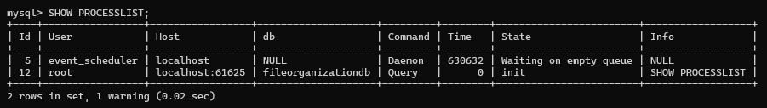
Example Log
<T1 START>
<T1, A, 100, 150>
<T2 START>
<T2, B, 200, 250>
<T1 COMMIT>
<CHECKPOINT>
<T2, B, 250, 300>
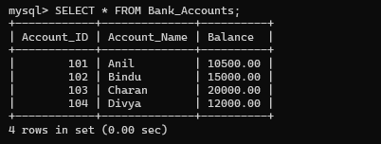
System Crash
Recovery Analysis
After the crash:
T1 → Committed
T2 → Uncommitted
Therefore:
T1 → REDO
T2 → UNDO

REDO
REDO applies the new value again.
For T1:
A = 150
UNDO
UNDO restores the old value.
For T2:
B = 250
The database is restored to a consistent state.
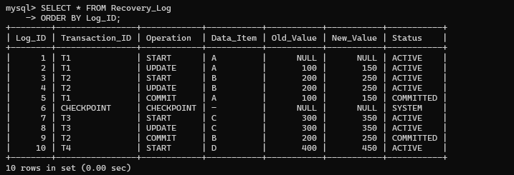
Checkpoint
A checkpoint records the state of transactions at a particular point in time.
It helps reduce recovery time because the DBMS does not always need to examine the entire log from the beginning.
Main Rule
COMMITTED TRANSACTION
↓
REDO

UNCOMMITTED TRANSACTION
↓
UNDO

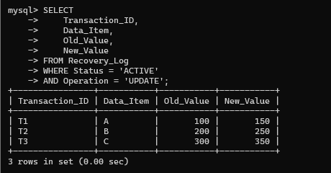
8. Apply Deferred Update (NO-UNDO/REDO) recovery technique on a given log file with committed and uncommitted transactions.
In Deferred Update, modifications made by transactions are not written to the database until the transaction successfully commits.
Therefore, uncommitted transactions do not affect the database.
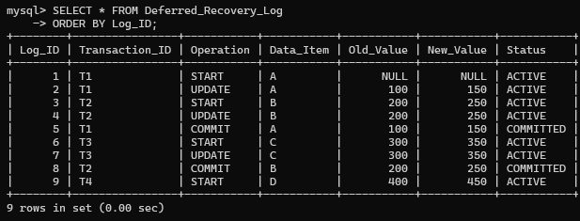
Example
<T1 START>
<T1, A, 100, 150>
<T2 START>
<T2, B, 200, 250>
<T1 COMMIT>
System Crash
At the time of crash:
T1 → Committed
T2 → Uncommitted
Recovery
T1 committed successfully.
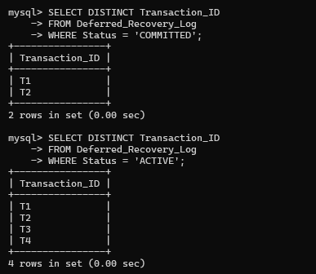
Therefore:
REDO T1
T2 did not commit.
Therefore:
IGNORE T2
There is no need for UNDO because T2's database changes were not written to the database.
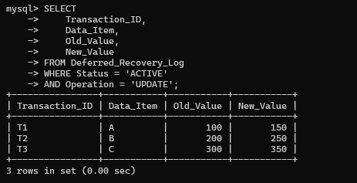
Rule
Committed → REDO
Uncommitted → IGNORE
Why NO-UNDO?
Because changes from an uncommitted transaction are not stored permanently in the database.

Advantages
- Simple recovery.
- No undo operation is required.
- Reduces recovery complexity.
- Maintains database consistency.

9. Design a concurrency control mechanism using strict 2PL for a banking system where T1 transfers funds and T2 reads balance simultaneously.

Consider a bank with two accounts:
Account A = ₹20,000
Account B = ₹10,000
Transaction T1 transfers ₹5,000 from A to B.
Transaction T2 reads the balance of A.
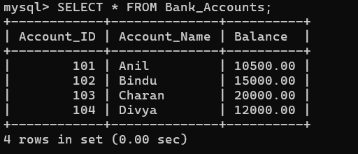
T1 – Transfer Transaction
LOCK-X(A)
LOCK-X(B)
READ(A)
A = A - 5000
WRITE(A)
READ(B)
B = B + 5000
WRITE(B)
COMMIT
UNLOCK(A)
UNLOCK(B)
After T1:
A = ₹15,000
B = ₹15,000
T2 – Read Transaction
LOCK-S(A)
READ(A)
COMMIT
UNLOCK(A)
Concurrent Execution
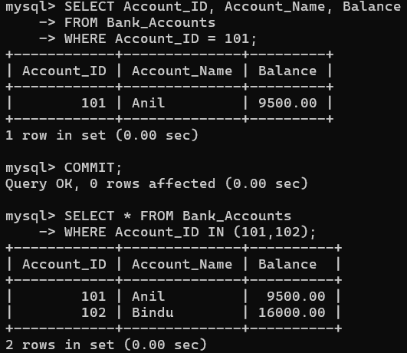
Initially T1 obtains:
X-lock(A)
X-lock(B)

T2 tries:
S-lock(A)
But T1 already has an exclusive lock.
Therefore:
T2 → WAIT
T1 completes the transfer:
A = ₹15,000
B = ₹15,000
T1 commits and releases the locks.
Then T2 obtains the shared lock and reads:
A = ₹15,000
Why Strict 2PL is Suitable?
Strict 2PL keeps exclusive locks until the transaction commits or aborts.
It prevents:
- Dirty reads.
- Lost updates.
- Inconsistent balances.
- Reading partially completed transfers.
Banking Benefit
Strict 2PL ensures that a customer never sees an intermediate balance while a transfer is being performed.

10. Write pseudocode for query optimization using heuristics: push down selection, project early, and order joins by smaller intermediate results.

Heuristic query optimization uses predefined rules instead of calculating the exact cost of every possible query plan.
Important Heuristics
1. Push selection down
Apply filtering before joins.
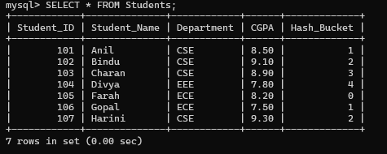
2. Perform projection early
Remove unnecessary columns before joins.
3. Order joins carefully
Perform joins that produce smaller intermediate results first.
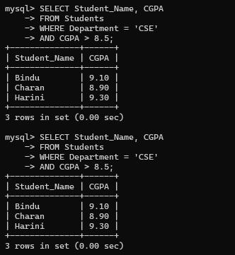
Pseudocode
Algorithm Optimize_Query(Query)
BEGIN
Parse Query
Create initial query tree
Identify all selections
Identify all projections
Identify all joins
// Push selections down
FOR each selection condition
Move selection close to its base relation
END FOR
// Push projections down
FOR each relation
Keep only required attributes
END FOR
// Optimize join order
Estimate size of intermediate results
Select the smallest relation
Join it with the most suitable relation
Repeat until all relations are joined
Remove unnecessary operations
Generate optimized query tree
Return optimized query tree
END
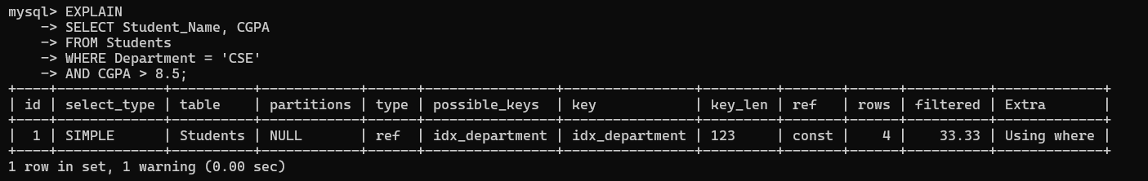
Example
Suppose:
R = 10,000 tuples
S = 500 tuples
T = 2,000 tuples
Instead of:
R ⋈ S ⋈ T
the optimizer can first perform:
S ⋈ T
if that produces a smaller intermediate result.

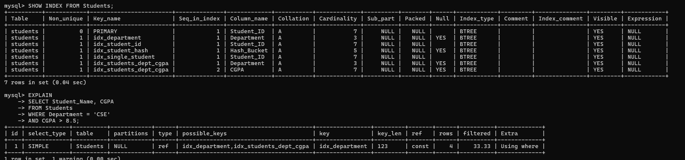Then:
(Remain Result) ⋈ R
Optimized Processing
Final Join
/ \
R Small Result
|
S ⋈ T
Benefits
- Smaller intermediate relations.
- Less memory consumption.
- Fewer disk accesses.
- Faster join operations.
- Better overall query performance.
- Reduced CPU cost.

