SIMATS ENGINEERING

ASSESSMENT TOOL 2

COURSE NAME: Database Management Systems COURSE CODE: CSA05

COURSE OUTCOME COVERED

CO3: Analyze relational databases using functional dependencies, normalization (1NF to 5NF), and key constraints to identify redundancy and ensure data integrity. (BL2, BL3)

Activity Tool : Case Study (Medium) Assessment Tool Weightage: 30%

QUESTIONS Total Marks: 50
Q.N  o | Question | Bloom's Level | Marks
1 | Analyze the case: An online shopping platform stores Order(OrderID, CustID, CustName, ProdID, ProdName, Qty, Price). Identify FDs and normalize to 3NF. | BL2 – Understand | 5
2 | A hospital maintains Patient(PID, PName, DocID, DocName, Specialization, WardNo, WardName). Identify anomalies and normalize to BCNF. | BL3 – Apply | 5
3 | Case study: A university stores Enrollment(SID, SName, CourseID, CourseName, Faculty, Grade). Analyze FDs and apply 2NF decomposition. | BL3 – Apply | 5
4 | Given the airline booking case: Booking(FlightNo, PassID, PassName, Seat, DeptCity, ArrCity, Date). Normalize up to BCNF. | BL3 – Apply | 5
5 | Analyze an HR system schema for a multinational company. Identify all functional and transitive dependencies and normalize to 3NF. | BL2 – Understand | 5
6 | Case: Library(MemberID, MemberName, BookID, Title, Author, Genre, BorrowDate). Identify MVDs and decompose to 4NF. | BL3 – Apply | 5

7 | Analyze a telecom billing schema and identify all candidate keys, primary keys, and functional dependencies before normalization. | BL2 – Understand | 5
8 | A retail inventory system has Product(PID, PName, SupplierID, SupplierName, Category, Price, Warehouse). Apply complete normalization. | BL3 – Apply | 5
9 | Study the given poorly normalized schema for a School ERP and propose a fully normalized design up to BCNF with justification. | BL3 – Apply | 5
10 | Given a movie streaming platform schema, identify join dependencies and decompose to 5NF with lossless-join verification. | BL3 – Apply | 5

Code of Conduct:

I V.Shalini (Name / Reg No) certify that this submission is my original work and that I have adhered to the guidelines specified for this assessment. I understand that any violation of academic integrity rules will result in disciplinary action.

Signature of the student:
V.Shalini

RUBRICS FOR CALCULATION:

Criteria | Level 4 – Exemplary | Level 3 – Proficient | Level 2 – Developing | Level 1 – Beginning
Understandin g of Case | Thorough  understanding  ; clearly identifies all key issues | Good  understanding with most issues identified | Basic  understanding  ; some issues missed | Poor  understanding  ; problem not identified  correctly
Application of Concepts | Effectively applies relevant  concepts to analyze the case deeply | Applies  appropriate concepts with minor gaps | Limited  application of concepts | Fails to apply relevant concepts
Analysis | In-depth  analysis with strong  reasoning and insights | Good analysis with logical reasoning | Basic analysis with limited depth | Weak or no analysis; lacks  reasoning

Solution Design | Innovative, feasible  solutions with strong  justification | Logical solutions with adequate  justification | Basic solutions with weak  justification | Incorrect or no solution  provided
Clarity | Clear,  well-structure d, and easy to understand | Organized and understandabl e presentation | Limited clarity and structure | Poor clarity; difficult to understand

- Analyze the case: An online shopping platform stores Order(OrderID, CustID, CustName, ProdID, ProdName, Qty, Price). Identify FDs and normalize to 3NF.

Aim
To identify the functional dependencies in an online shopping database and normalize the relation up to Third Normal Form (3NF).

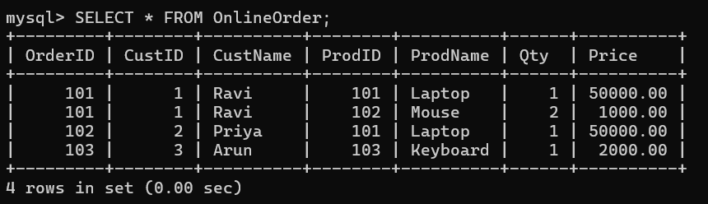
Advantages of Normalization
- Reduces data redundancy.
- Avoids insertion anomalies.
- Avoids deletion anomalies.
- Avoids update anomalies.
- Improves data consistency.
- Makes the database easier to maintain.

Final 3NF Relations
Relation | Primary Key
CUSTOMER(CustID, CustName) | CustID
ORDER(OrderID, CustID) | OrderID
PRODUCT(ProdID, ProdName, Price) | ProdID
ORDER_ITEM(OrderID, ProdID, Qty) | OrderID + ProdID

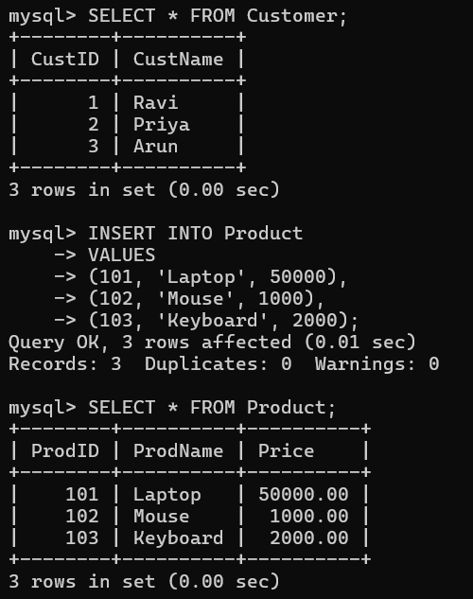
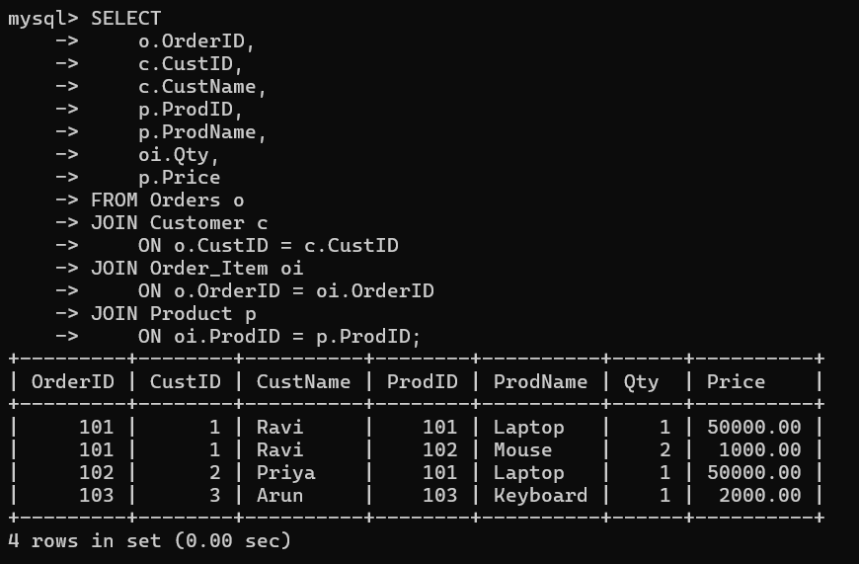
Result
Thus, the given online shopping relation was analyzed using functional dependencies and successfully normalized up to Third Normal Form (3NF) using MySQL.

- A hospital maintains Patient(PID, PName, DocID, DocName, Specialization, WardNo, WardName). Identify anomalies and normalize to BCNF.

Aim
To identify anomalies in a hospital patient relation and normalize the relation up to Boyce-Codd Normal Form (BCNF) using functional dependencies.
Anomalies
1. Update Anomaly
Doctor information is repeated for multiple patients.
For example, if Dr. Kumar's specialization changes, we have to update multiple records. If one record is not updated, inconsistent data occurs.
2. Insertion Anomaly
A new doctor cannot be stored unless a patient is assigned to that doctor because all information is stored in the same relation.
3. Deletion Anomaly
If the last patient associated with a doctor is deleted, the doctor's information may also be lost.

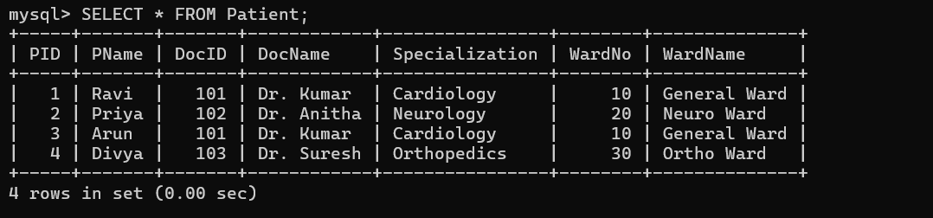

Advantages
- Reduces data redundancy.
- Removes update anomalies.
- Removes insertion anomalies.
- Removes deletion anomalies.
- Improves data consistency.
- Makes the database easier to maintain.

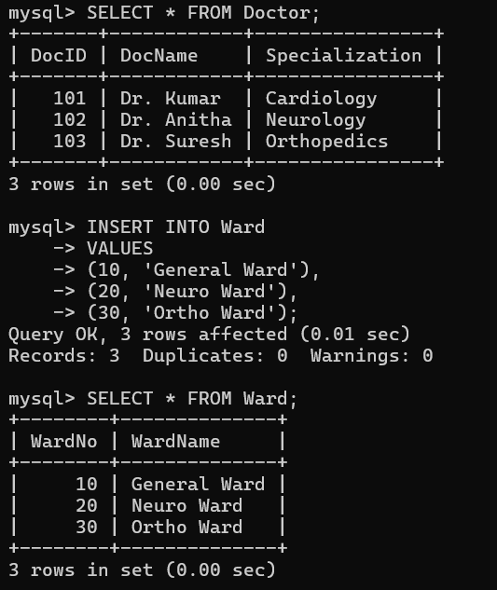
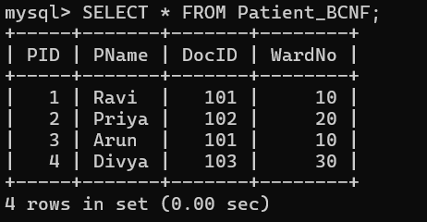
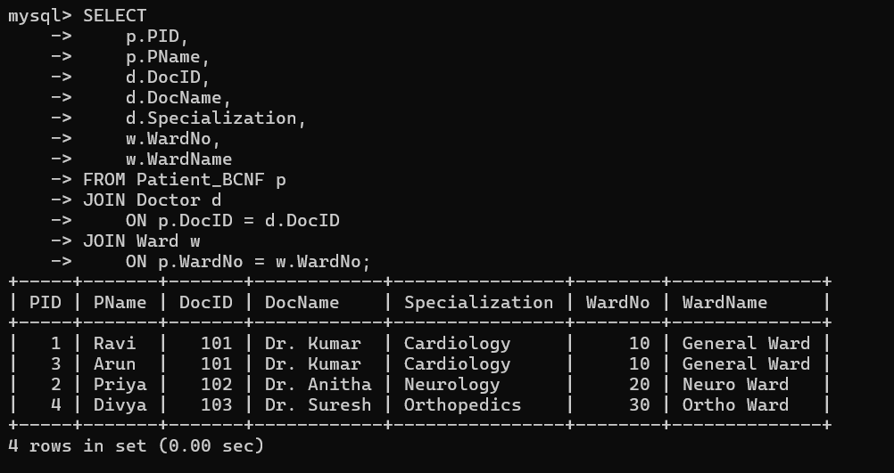
Result
Thus, the anomalies in the hospital Patient relation were identified and the relation was successfully normalized to BCNF using MySQL.

- Case study: A university stores Enrollment(SID, SName, CourseID, CourseName, Faculty, Grade). Analyze FDs and apply 2NF decomposition.

Aim
To analyze the functional dependencies in a university enrollment relation and decompose the relation into Second Normal Form (2NF) using MySQL.

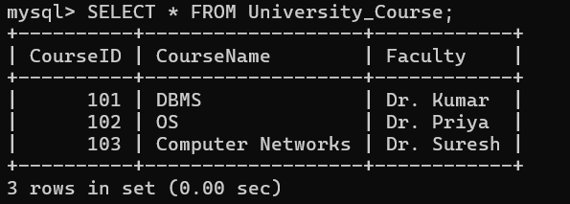
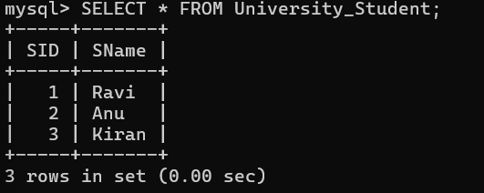
Functional Dependencies
The following functional dependencies are identified:
- SID → SName
Student ID determines the student name.
- CourseID → CourseName, Faculty
Course ID determines the course name and faculty.
- (SID, CourseID) → Grade
The combination of Student ID and Course ID determines the grade obtained by the student.

Advantages of 2NF
- Removes partial dependencies.
- Reduces data redundancy.
- Avoids update anomalies.
- Avoids insertion anomalies.
- Avoids deletion anomalies.
- Improves data consistency.
- Makes the database easier to maintain.

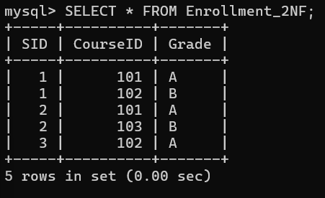

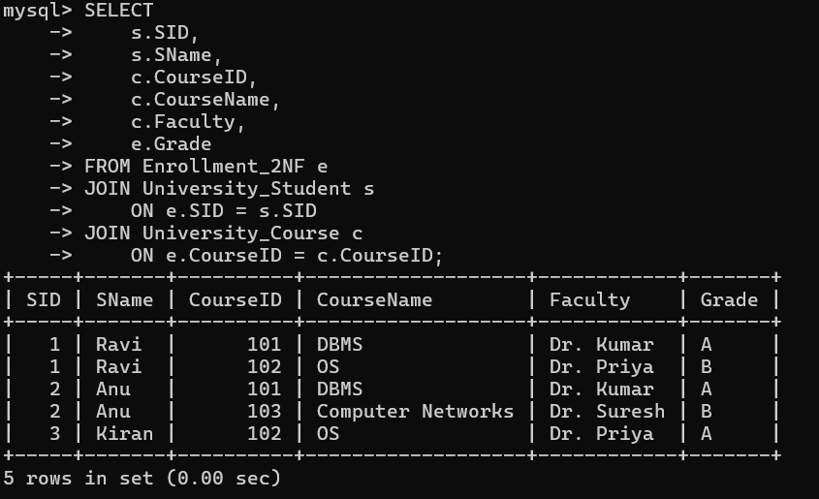

Result
Thus, the functional dependencies in the university Enrollment relation were identified, partial dependencies were removed, and the relation was successfully decomposed into Second Normal Form (2NF) using MySQL.

- Given the airline booking case: Booking(FlightNo, PassID, PassName, Seat, DeptCity, ArrCity, Date). Normalize up to BCNF.

Aim
To identify the functional dependencies in an airline booking relation and normalize the relation up to Boyce-Codd Normal Form (BCNF).

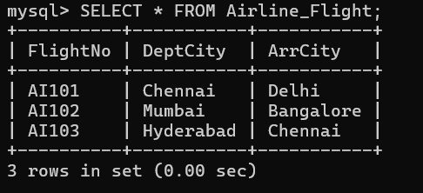

Functional Dependencies
The following functional dependencies are identified:
- PassID → PassName
Passenger ID determines the passenger name.
- FlightNo → DeptCity, ArrCity
Flight number determines the departure and arrival cities.
- (FlightNo, Date, Seat) → PassID
For a particular flight, date, and seat, the passenger occupying that seat is determined.

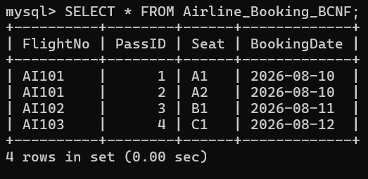

Advantages
- Reduces data redundancy.
- Removes update anomalies.
- Removes insertion anomalies.
- Removes deletion anomalies.
- Maintains data consistency.
- Makes the database easier to maintain.

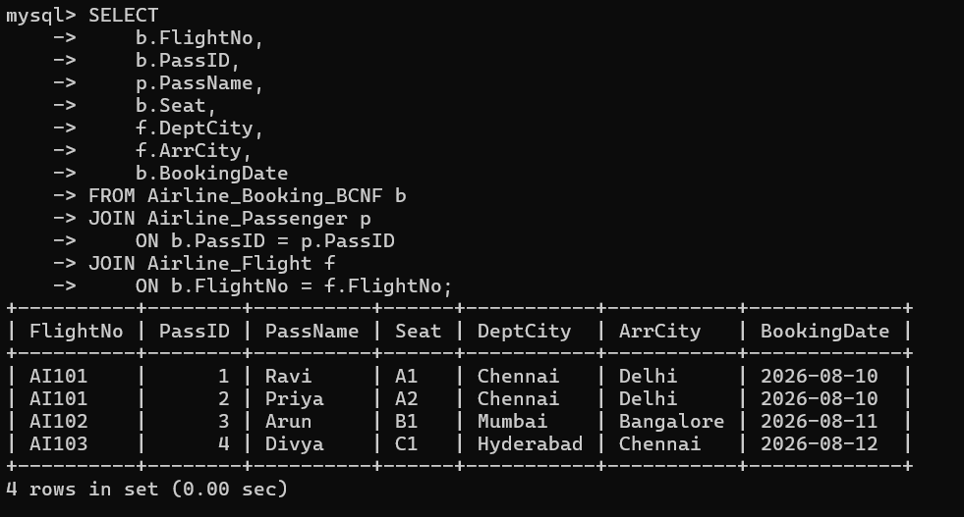

Result
Thus, the functional dependencies and anomalies in the airline Booking relation were identified, and the relation was successfully decomposed into BCNF relations using MySQL.

- Analyze an HR system schema for a multinational company. Identify all functional and transitive dependencies and normalize to 3NF.

Aim
To identify the functional and transitive dependencies in an HR system schema of a multinational company and normalize the relation up to Third Normal Form (3NF).

Functional Dependencies
The following functional dependencies are identified:
- EmpID → EmpName, DeptID, ManagerID, LocationID
Employee ID determines the employee details.
- DeptID → DeptName
Department ID determines the department name.
- ManagerID → ManagerName
Manager ID determines the manager name.
- LocationID → LocationName, Country
Location ID determines the location name and country.

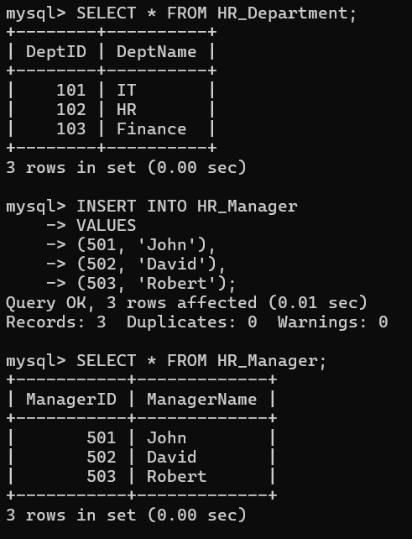
Transitive Dependencies
A transitive dependency occurs when a non-key attribute depends on another non-key attribute through the primary key.

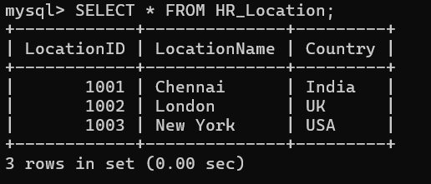
3NF
A relation is in Third Normal Form (3NF) if:
- It is already in 2NF.
- It has no transitive dependency of non-key attributes on the primary key.
The original HR relation contains transitive dependencies, so it is not in 3NF.

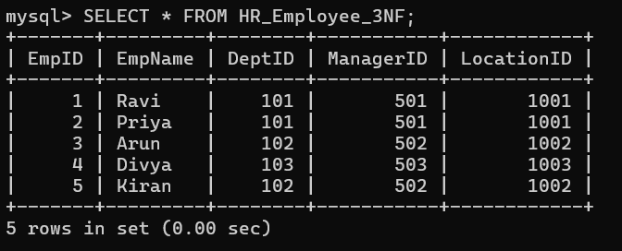
Advantages of 3NF
- Removes transitive dependencies.
- Reduces data redundancy.
- Prevents update anomalies.
- Prevents insertion anomalies.
- Prevents deletion anomalies.
- Improves data consistency.
- Makes the HR database easier to maintain.
- Avoids storing the same department, manager, and location information repeatedly.

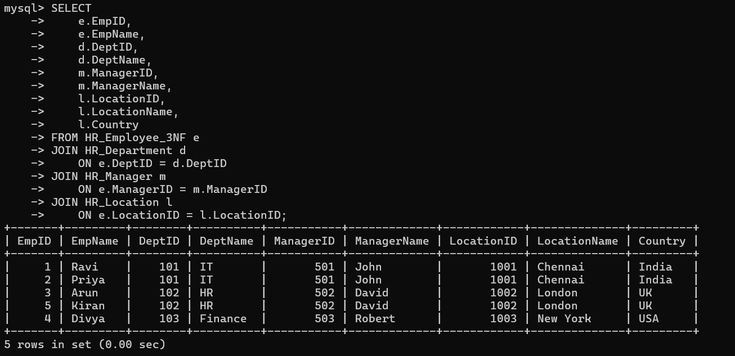

Result
Thus, the functional and transitive dependencies in the HR system were identified, and the relation was successfully normalized up to Third Normal Form (3NF) using MySQL.

- Case: Library(MemberID, MemberName, BookID, Title, Author, Genre, BorrowDate). Identify MVDs and decompose to 4NF.

Aim
To identify the multivalued dependencies (MVDs) in a library database relation and decompose the relation into Fourth Normal Form (4NF).
4NF Decomposition
To remove the multivalued dependencies, the relation is decomposed into four tables.
Advantages of 4NF
- Removes multivalued dependencies.
- Reduces data redundancy.
- Avoids unnecessary combinations of independent data.
- Improves data consistency.
- Makes insertion and deletion easier.
- Makes the database easier to maintain.

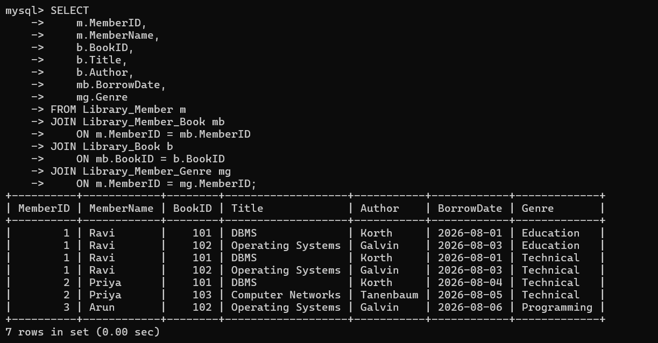

Result
Thus, the multivalued dependencies in the Library relation were identified, and the relation was successfully decomposed into Fourth Normal Form (4NF) using MySQL.

- Analyze a telecom billing schema and identify all candidate keys, primary keys, and functional dependencies before normalization.

Aim
To analyze a telecom billing schema and identify all candidate keys, primary keys, and functional dependencies before normalization.
Primary Key
The candidate key selected to uniquely identify records in the table is called the primary key.

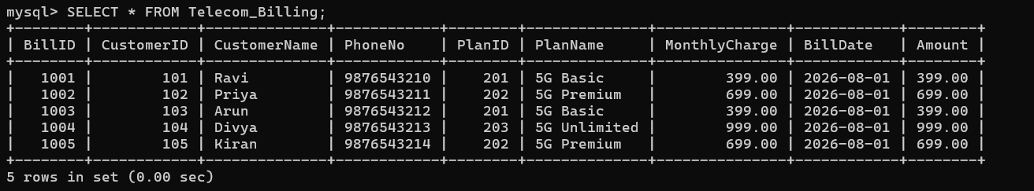

Functional Dependencies
Functional dependencies help us understand how attributes are related and are used during database normalization.

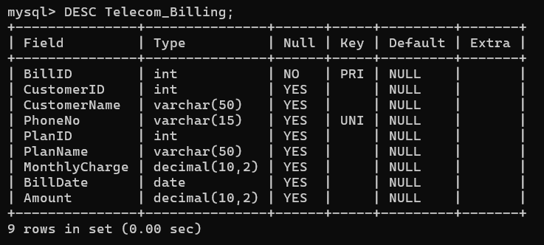

Result
Thus, the candidate key, primary key, unique key, and functional dependencies of the telecom billing schema were identified successfully before normalization using MySQL.

- A retail inventory system has Product(PID, PName, SupplierID, SupplierName, Category, Price, Warehouse). Apply complete normalization.

Aim
To analyze the retail inventory relation, identify functional dependencies, and apply complete normalization up to Third Normal Form (3NF).

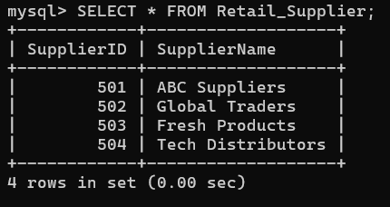
First Normal Form (1NF)
A relation is in 1NF when:
- All attributes contain atomic values.
- There are no repeating groups.
- Each field contains a single value.
The given relation satisfies 1NF because each product has a single product name, supplier, category, price, and warehouse.

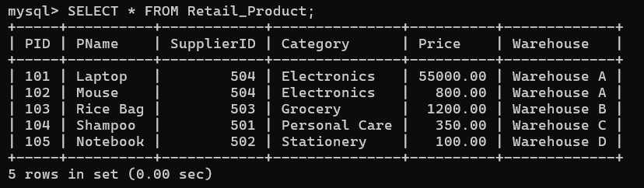
Second Normal Form (2NF)
A relation is in 2NF when:
- It is already in 1NF.
- There is no partial dependency on the primary key.
The primary key is only PID, which is a single attribute.
Therefore, partial dependency is not possible.
Hence, the relation is already in 2NF.
3NF Decomposition
To remove the transitive dependency, the relation is divided into two tables.
Advantages of Normalization
Normalization provides the following benefits:
- Reduces data redundancy.
- Removes transitive dependencies.
- Avoids update anomalies.
- Avoids insertion anomalies.
- Avoids deletion anomalies.
- Improves data consistency.
- Makes the database easier to maintain.
- Prevents repeated supplier information.

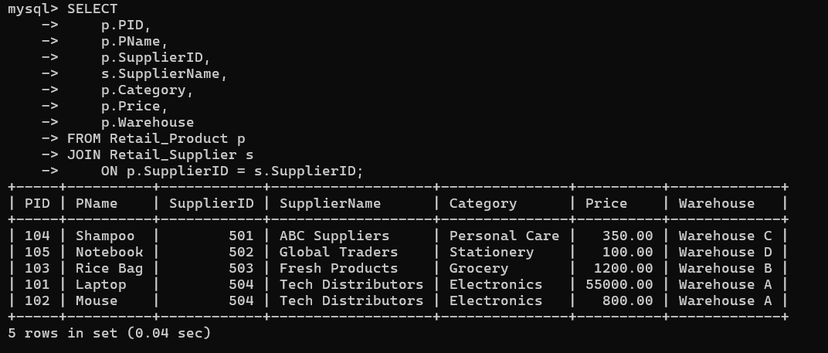

Result
Thus, the functional dependencies in the retail inventory system were identified and the relation was successfully normalized from 1NF to 2NF and finally to 3NF by removing the transitive dependency.

- Study the given poorly normalized schema for a School ERP and propose a fully normalized design up to BCNF with justification.

Aim
To analyze a poorly normalized School ERP schema and design a fully normalized database up to Boyce-Codd Normal Form (BCNF) by identifying functional dependencies, candidate keys, and normalization violations.

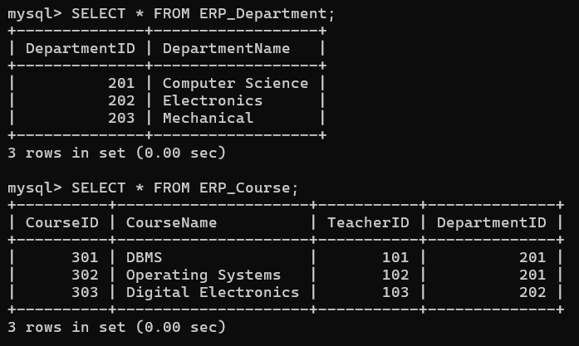
Problems in the Original Relation
The original School ERP relation contains repeated information.
Update Anomaly
If a teacher's name changes, the teacher's name may need to be updated in many records.
Insertion Anomaly
A new course or teacher cannot be easily stored if there is no student enrollment.
Deletion Anomaly
If the last student enrolled in a course is deleted, information about the course or teacher may also be lost.

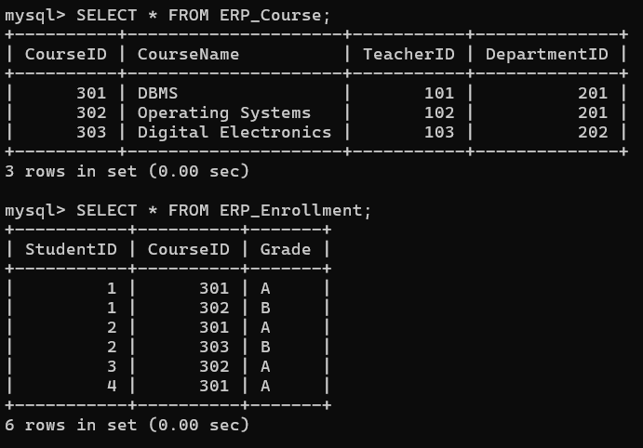
Advantages
- Reduces data redundancy.
- Removes update anomalies.
- Removes insertion anomalies.
- Removes deletion anomalies.
- Maintains data consistency.
- Improves database organization.
- Uses primary and foreign keys to maintain referential integrity.
- Makes the School ERP easier to maintain.

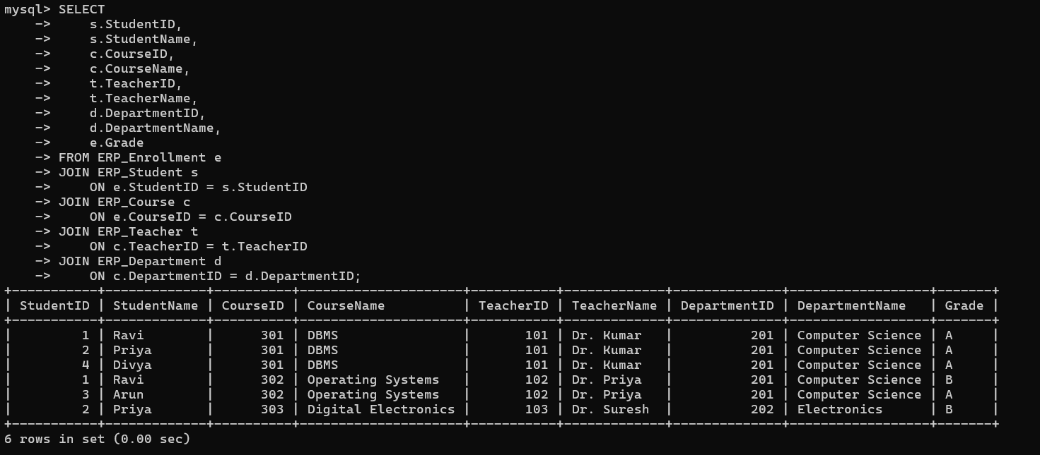

Result
Thus, the poorly normalized School ERP schema was analyzed, its functional dependencies and candidate key were identified, and the schema was successfully decomposed into relations satisfying BCNF.

- Given a movie streaming platform schema, identify join dependencies and decompose to 5NF with lossless-join verification.
Aim
To identify the join dependencies in a movie streaming platform schema and decompose the relation into Fifth Normal Form (5NF) with lossless-join verification.

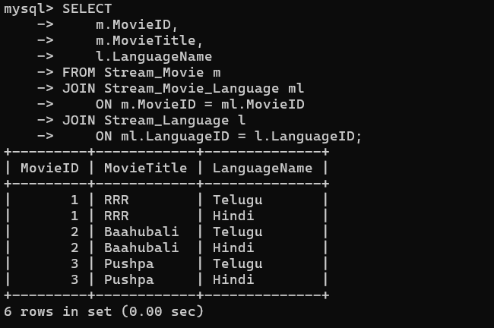
Join Dependencies
A Join Dependency (JD) occurs when a relation can be decomposed into multiple smaller relations and reconstructed by joining them.
Lossless-Join Verification
A decomposition is lossless when the original information can be reconstructed by joining the decomposed relations without losing valid information.

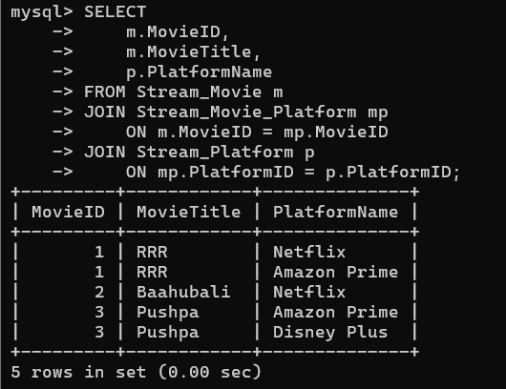

Advantages of 5NF
- Removes redundancy caused by join dependencies.
- Prevents unnecessary combinations of independent data.
- Improves data consistency.
- Makes the database easier to maintain.
- Reduces insertion and deletion anomalies.
- Allows independent movie, actor, language, and platform relationships to be maintained.

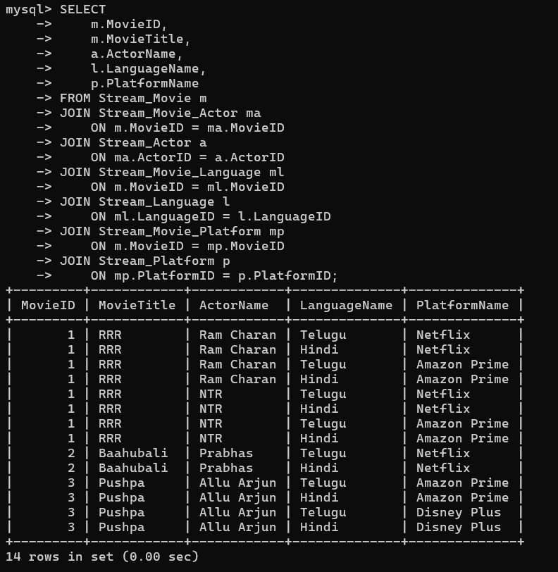

Result
Thus, the join dependencies in the movie streaming platform were identified, and the original relation was successfully decomposed into 5NF relations. The lossless-join property was verified using JOIN operations in MySQL 8.0.

