SIMATS ENGINEERING

ASSESSMENT TOOL 1

COURSE NAME: Database Management Systems COURSE CODE: CSA05

COURSE OUTCOME COVERED

CO3: Analyze relational databases using functional dependencies, normalization (1NF to 5NF), and key constraints to identify redundancy and ensure data integrity. (BL2, BL3)

Activity Tool : Experiments (High) Assessment Tool Weightage: 40%

QUESTIONS Total Marks: 50
Q.N  o | Question | Bloom's Level | Marks
1 | For the relation STUDENT_COURSE(SID, SName, CID, CName, Instructor, Grade), identify all functional dependencies and determine the candidate keys. | BL2 – Understand | 5
2 | Demonstrate the process of converting an unnormalized relation into 1NF with step-by-step justification and example. | BL3 – Apply | 5
3 | Given relation R(A,B,C,D,E) with FDs: A→BC, BC→D, D→E. Analyze and decompose it to 2NF eliminating partial dependencies. | BL3 – Apply | 5
4 | Apply 3NF decomposition on the relation EMPLOYEE(EmpID, EmpName, DeptID, DeptName, ManagerID) with transitive dependencies. | BL3 – Apply | 5
5 | Verify whether R(A,B,C,D) with FDs: AB→C, C→D, D→A is in BCNF. If not, decompose it into BCNF. | BL3 – Apply | 5
6 | Experimentally verify lossless-join decomposition for a given relation using the tabular (Chase) algorithm. | BL3 – Apply | 5

7 | Identify the multi-valued dependencies in TEACHER(TID, Subject, Hobby) and decompose it into 4NF. | BL3 – Apply | 5
8 | Demonstrate how join dependencies lead to redundancy. Decompose a given relation to 5NF (Project-Join Normal Form). | BL3 – Apply | 5
9 | Given a poorly designed database schema for a college, identify all anomalies (insertion, deletion, update) and normalize it to 3NF. | BL2 – Understand | 5
10 | Compute the closure of attribute sets for the given FDs and determine all candidate keys for the relation. | BL3 – Apply | 5

Code of Conduct:

I V.Shalini(192525373) (Name / Reg No) certify that this submission is my original work and that I have adhered to the guidelines specified for this assessment. I understand that any violation of academic integrity rules will result in disciplinary action.

Signature of the student:
V.Shalini

RUBRICS FOR CALCULATION:

Criteria | Level 4 – Exemplary | Level 3 –  Proficient | Level 2 –  Developing | Level 1 –  Beginning
Understanding of Concepts | Demonstrates thorough understanding and effectively integrates multiple concepts/technologie s | Good understanding with proper integration of most concepts | Basic understanding; limited or partial integration | Poor understanding; unable to integrate concepts
Experimental Design | Well-planned, systematic implementation with  optimal solution | Correct implementatio n with minor  issues | Basic implementatio n with errors or  inefficiencies | Incorrect or incomplete implementatio  n
Use of Tools | Effective and advanced use of tools/technologies with proper configuration | Appropriate use of tools with correct execution | Limited or inconsistent use of tools | Incorrect or minimal use of tools
Analysis of Results | Insightful analysis with accurate interpretation and  validation of results | Good analysis with reasonable  interpretation | Basic analysis with limited insights | Poor or incorrect analysis of  results

Documentatio n | Clear, well-structured documentation with diagrams, code, and  results | Organized documentation with necessary  details | Basic documentation with missing  details | Poor or incomplete documentation

1.For the relation STUDENT_COURSE(SID, SName, CID, CName, Instructor, Grade), identify all functional dependencies and determine the candidate keys.

Functional Dependencies and Candidate Keys
Given the relation:
STUDENT_COURSE(SID, SName, CID, CName, Instructor, Grade)
Where:
- SID – Student ID
- SName – Student Name
- CID – Course ID
- CName – Course Name
- Instructor – Instructor Name
- Grade – Grade obtained by the student

Functional Dependency
A functional dependency (FD) is a relationship between two sets of attributes in a relation.
If attribute X determines attribute Y, it is written as:
X → Y
It means that for every value of X, there is only one corresponding value of Y.
For example:
SID → SName
This means that if we know the Student ID, we can uniquely identify the student's name.
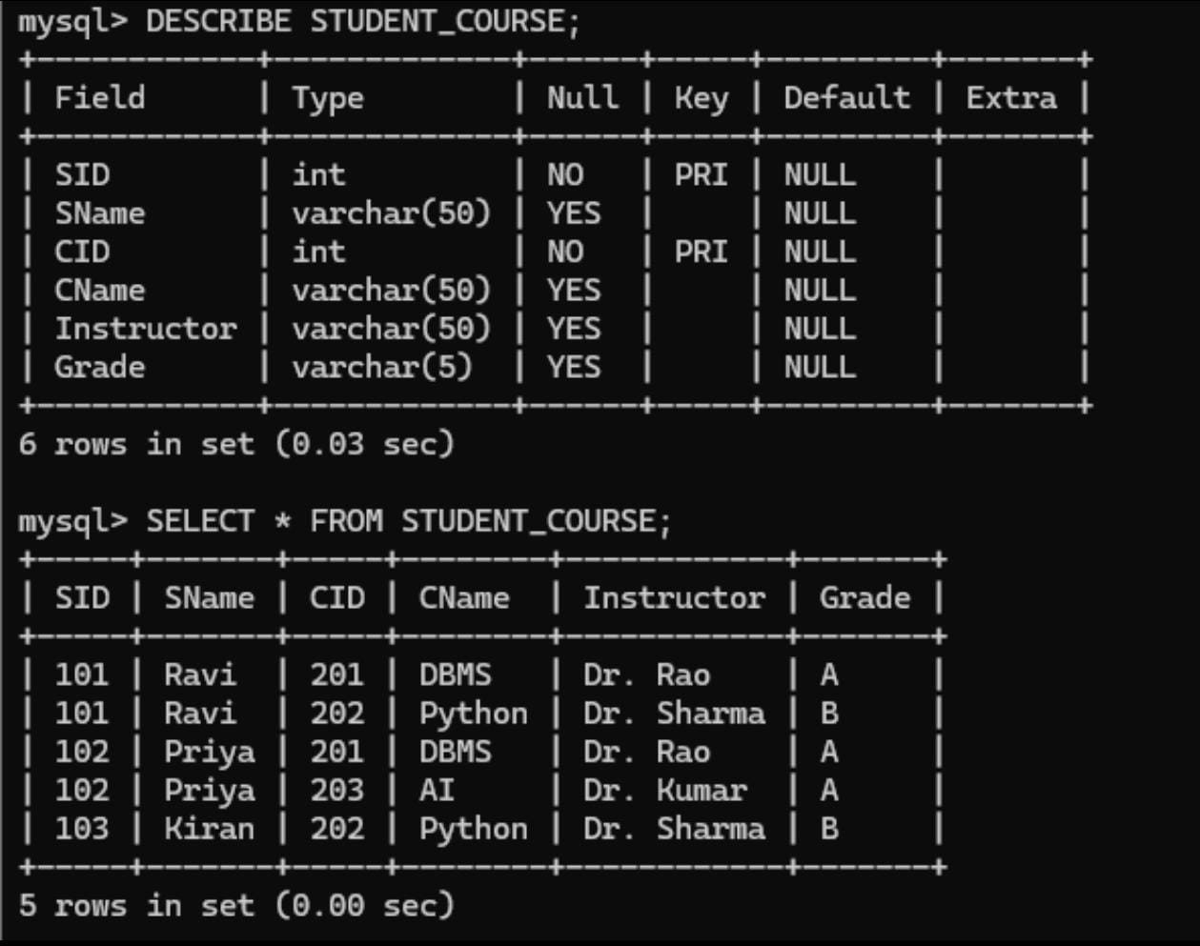

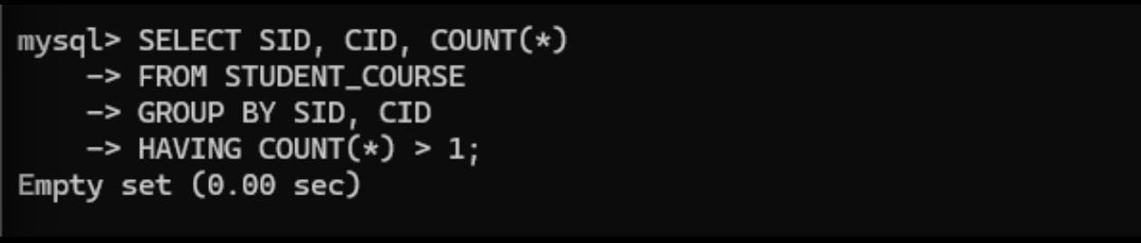
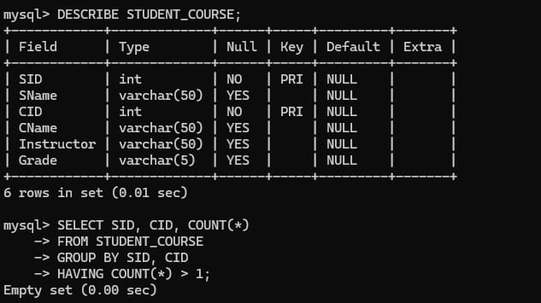
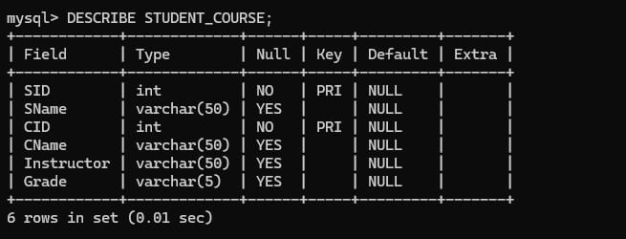
Functional Dependencies in STUDENT_COURSE
a) Student ID determines Student Name
SID → SName
A student has a unique SID and therefore the SID determines the student's name.

b) Course ID determines Course Name
CID → CName
Each course has a unique course ID, so CID determines the course name.

c) Course ID determines Instructor
CID → Instructor
If each course is handled by one instructor, the course ID determines its instructor.
Therefore, we can combine the two dependencies:
CID → CName, Instructor

d) Student ID and Course ID determine Grade
(SID, CID) → Grade
A grade is associated with a particular student in a particular course.
Neither SID nor CID alone is sufficient to determine the grade.
Therefore, the combination is required:
(SID, CID) → Grade

Attribute Closure
Attribute closure is used to find whether a particular set of attributes can determine all attributes in a relation.
The closure of X is represented as:
X⁺
It contains all attributes that can be determined from X using the given functional dependencies.

Superkey
A superkey is a set of one or more attributes that can uniquely identify a tuple in a relation.
In this relation:
{SID, CID} is a superkey.
Some larger sets can also be superkeys, such as:
- {SID, CID, SName}
- {SID, CID, CName}
- {SID, CID, Instructor}
- {SID, CID, Grade}
However, these are not candidate keys because they contain unnecessary attributes.

Candidate Key
A candidate key is a minimal superkey.
It must satisfy two conditions:
- It must uniquely identify every tuple.
- No attribute can be removed from it while maintaining uniqueness.
For this relation:
Candidate Key = {SID, CID}
Because:
- SID alone is wrong.
- CID alone is wrong.
- SID + CID is correct.

Prime and Non-Prime Attributes
A prime attribute is an attribute that is part of at least one candidate key.
The candidate key is:
(SID, CID)
Therefore:
Prime attributes:
- SID
- CID
Non-prime attributes:
- SName
- CName
- Instructor
- Grade

Why Composite Key Is Required?
The candidate key (SID, CID) is called a composite key because it contains more than one attribute.
A student can register for many courses, and a course can have many students.
Therefore:
SID alone → not enough
CID alone → not enough
But:
SID + CID → uniquely identifies a student-course record
Hence, the relation requires a composite candidate key.

Final Conclusion
The relation STUDENT_COURSE represents the association between students and courses. A student ID determines the student's name, while a course ID determines the course name and instructor. The grade depends on both the student and the course. Therefore, the important functional dependencies are SID → SName, CID → CName, Instructor, and (SID, CID) → Grade. By calculating attribute closure, (SID, CID) determines all attributes and is minimal. Hence, (SID, CID) is the only candidate key under the stated assumptions.

2.Demonstrate the process of converting an unnormalized relation into 1NF with step-by-step justification and example.

Conversion of an Unnormalized Relation into 1NF
Introduction
Database normalization is a technique used to organize data efficiently in a relational database. It helps reduce duplicate data, avoid data inconsistencies, and make database operations easier. Normalization is performed in different stages called Normal Forms. The first stage is First Normal Form (1NF).
A relation is said to be in 1NF when all attributes contain atomic values, there are no repeating groups, and each record can be uniquely identified. Converting an unnormalized relation into 1NF is an important step before applying higher normal forms such as 2NF and 3NF.
Meaning of Unnormalized Relation
An unnormalized relation is a relation that may contain multiple values in a single cell or repeating groups of attributes. Such a structure does not follow the basic rules of a relational database.
For example, a student may register for several courses. If all the courses are stored in one cell separated by commas, the data becomes difficult to manage.
Consider:
SID | SName | Courses | Grades
S101 | Ravi | DBMS, OS, CN | A, B, A
S102 | Anu | DBMS, Java | B, A

Here, the Courses and Grades attributes contain multiple values. Therefore, this relation is not in 1NF.
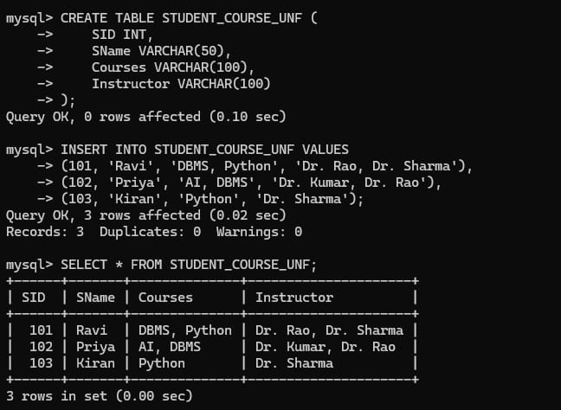
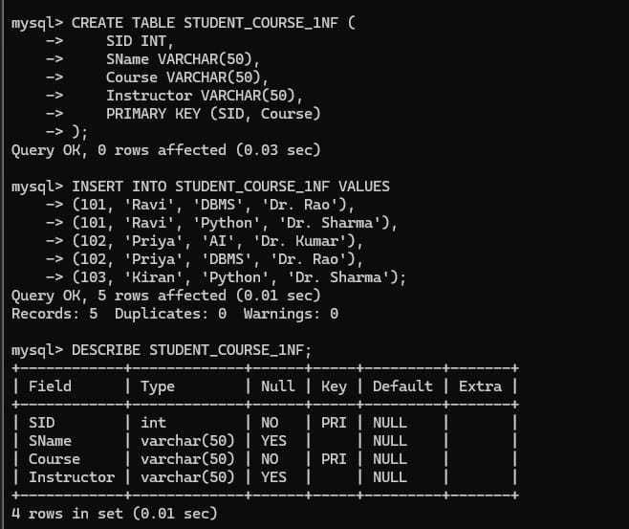

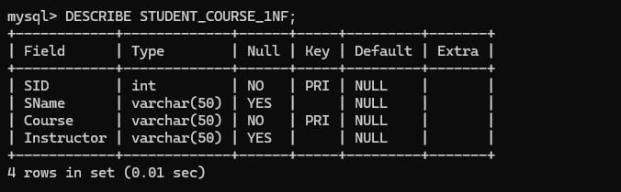
Problems with the Unnormalized Relation
An unnormalized relation can create several problems.
When multiple values are stored in one cell, it becomes difficult to search for a particular course or grade. Updating one course may require modifying a large text value. Adding a new course may also require changing the existing value. Deleting information may accidentally remove other related information.
For example, if Ravi has three courses stored in one cell as:
DBMS, OS, CN
and we want to remove only OS, we have to modify the entire cell.
This makes the database difficult to maintain.
Atomic Values
The most important requirement of 1NF is atomicity.
An atomic value means that a cell contains only one indivisible value.
Conversion Process
Consider the following unnormalized relation:
SID | SName | Courses | Grades
S101 | Ravi | DBMS, OS, CN | A, B, A
S102 | Anu | DBMS, Java | B, A

The first step is to identify the attributes that contain multiple values.
The Courses and Grades attributes contain repeating values.
The next step is to separate each value into its own row.
After conversion:
SID | SName | Course | Grade
S101 | Ravi | DBMS | A
S101 | Ravi | OS | B
S101 | Ravi | CN | A
S102 | Anu | DBMS | B
S102 | Anu | Java | A

Now every cell contains only one value.
Selecting the Key
After converting the relation into 1NF, a key must be identified to uniquely distinguish each record.
SID alone is not sufficient, because one student can take multiple courses.
For example:
SID | SName | Course | Grade
S101 | Ravi | DBMS | A
S101 | Ravi | OS | B

The SID S101 occurs more than once.
Therefore, the combination of:
SID + Course
can be used to uniquely identify a student-course record.
Hence, the composite key is:
(SID, Course)

Functional Dependencies
The relation may have the following functional dependencies:
SID → SName
This means the Student ID determines the Student Name.
Course → Instructor
If each course is handled by one instructor, the Course determines the Instructor.
(SID, Course) → Grade
The grade depends on both the student and the course.
These dependencies help in understanding the structure of the relation and are also useful when moving to higher normal forms.

1NF Relation
The resulting relation can be represented as:
STUDENT_COURSE(SID, SName, Course, Grade)
The composite key is:
(SID, Course)
The relation now satisfies the basic requirements of 1NF.
Properties of 1NF
A relation in 1NF should have:
- Atomic values in every cell.
- No multi-valued attributes.
- No repeating groups.
- A unique way to identify records.
- Values stored in rows and columns according to the relational model.
- Consistent data representation.

Importance of Converting to 1NF
Converting a relation to 1NF makes the database easier to work with. Individual values can be searched, inserted, updated, and deleted more easily. It also provides a proper structure for further normalization.
For example, after converting to 1NF, we can easily find all courses taken by S101 using a query on the Course column.
Similarly, we can find all students who have taken DBMS without searching through comma-separated values.

Difference Before and After Conversion
Before 1NF:
SID | SName | Courses | Grades
S101 | Ravi | DBMS, OS | A, B

The cells contain multiple values.

After 1NF:
SID | SName | Course | Grade
S101 | Ravi | DBMS | A
S101 | Ravi | OS | B

Each cell contains a single value.

Advantages
Converting an unnormalized relation into 1NF provides several advantages. It makes the data more organized, improves searching and querying, simplifies data modification, removes repeating groups, and provides a strong foundation for further normalization.
It also makes the database structure easier to understand because every row represents a specific record and every column represents a specific attribute.

Conclusion
The conversion of an unnormalized relation into First Normal Form (1NF) is achieved by removing repeating groups and ensuring that every cell contains a single atomic value. In the student-course example, multiple courses and grades stored in one cell are separated into individual rows. The combination of SID and Course can be used as a composite key to identify each student-course record. Therefore, the resulting relation follows the requirements of 1NF and can be further normalized into 2NF and 3NF if required.

3.Given relation R(A,B,C,D,E) with FDs: A→BC, BC→D, D→E. Analyze and decompose it to 2NF eliminating partial dependencies.

Decomposition of Relation R(A, B, C, D, E) into 2NF

Introduction
Normalization is a process used in database design to organize data and reduce unnecessary redundancy. Second Normal Form (2NF) is an important stage of normalization. Before checking 2NF, a relation must first satisfy First Normal Form (1NF).
The main purpose of 2NF is to eliminate partial functional dependencies. A relation is in 2NF when every non-prime attribute is completely dependent on the whole candidate key.

Given Relation
Consider the relation:
R(A, B, C, D, E)
with the following functional dependencies:
A → BC
BC → D
D → E

These functional dependencies describe the relationships between the attributes of the relation.
Understanding the Functional Dependencies
The dependency:
A → BC
means that A determines both B and C.
The dependency:
BC → D
means that the combination of B and C determines D.
The dependency:
D → E
means that D determines E.
These dependencies can also be represented as a chain:
A → BC → D → E
Therefore, starting from A, we can determine all the other attributes.
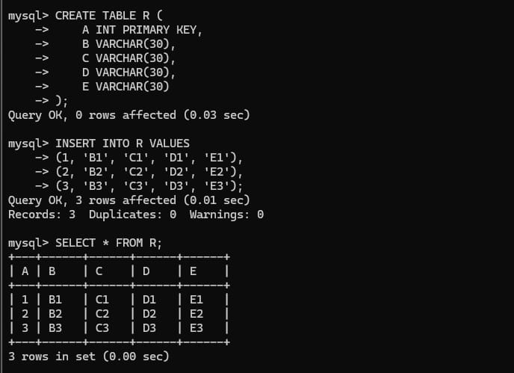
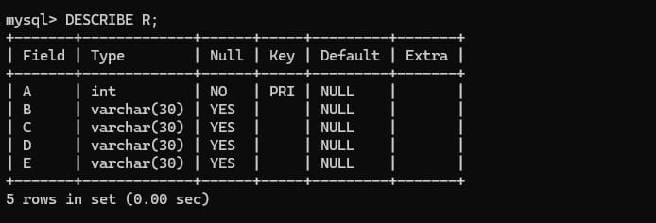
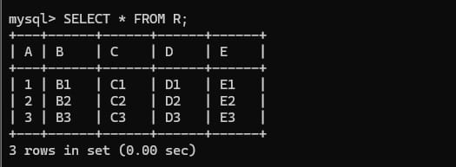
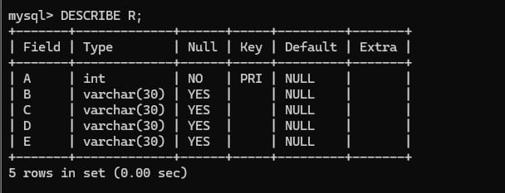
Finding Attribute Closure
To identify the candidate key, we calculate the closure of A.
Initially:
A⁺ = {A}
Using the functional dependency:
A → BC
we add B and C:
A⁺ = {A, B, C}
Now we have B and C, so we can apply:
BC → D
Therefore:
A⁺ = {A, B, C, D}
Now we have D, so we can apply:
D → E
Therefore:
A⁺ = {A, B, C, D, E}
The closure of A contains all attributes of R.
Therefore:
A is a candidate key.

Candidate Key
The candidate key is:
A
A is sufficient to determine every attribute in the relation.
Since A itself is a single attribute, it is not a composite key.
This point is very important when checking for 2NF.
Meaning of Partial Dependency
A partial dependency occurs when a non-key attribute depends on only a part of a composite candidate key.

Checking for Partial Dependency
In the given relation, the candidate key is:
A
The key contains only one attribute.
Therefore, there is no smaller part of the key.
A single-attribute candidate key cannot have a partial dependency.
Hence, there are:
No partial dependencies in R.
Checking Each FD for 2NF
The dependency:
A → BC
is a dependency from the complete candidate key A to B and C. Therefore, it is a full dependency.
The dependency:
BC → D
does not represent a partial dependency because BC is not a part of a composite candidate key.
The dependency:
D → E
also does not represent a partial dependency.
Therefore, none of the given dependencies violate the 2NF condition.

Why the Relation is Already in 2NF
The relation satisfies the following conditions:
- It is assumed to be in 1NF.
- The candidate key is A.
- A is a single-attribute key.
- There are no partial dependencies.
- All non-prime attributes are fully dependent on the candidate key.
Therefore:
R(A, B, C, D, E) is already in 2NF.
No decomposition is needed to achieve 2NF.
Dependency Diagram
The dependencies can be understood as:
A → B, C
B, C → D
D → E
Or:
A → BC → D → E
This diagram shows that A determines the other attributes through direct and indirect dependencies.

Possible 3NF Decomposition
For further normalization, the relations can be organized as:
R1(A, B, C)
R2(B, C, D)
R3(D, E)
Here:
- R1 represents A → BC
- R2 represents BC → D
- R3 represents D → E
This decomposition is useful for achieving a higher normal form.

Important Difference
The question specifically asks to eliminate partial dependencies.
Since there is no partial dependency, we should not unnecessarily decompose the relation for 2NF.
The correct 2NF result is:
R(A, B, C, D, E)
with:
Candidate Key = A
Final Conclusion
The given relation R(A, B, C, D, E) has the functional dependencies A → BC, BC → D, and D → E. By calculating the closure of A, we obtain all attributes of the relation, so A is the candidate key. Since the candidate key contains only one attribute, there cannot be any partial dependency. Therefore, the relation is already in 2NF, and no decomposition is required for 2NF. However, the relation contains a transitive dependency A → D → E, which should be considered when converting the relation into 3NF.

4.Apply 3NF decomposition on the relation EMPLOYEE (EmpID, EmpName, DeptID, DeptName, ManagerID) with transitive dependencies.

3NF Decomposition of EMPLOYEE Relation
Introduction
Third Normal Form (3NF) is a database normalization technique used to remove transitive dependencies. A relation is in 3NF when it is already in 2NF and no non-key attribute depends on another non-key attribute.
A transitive dependency occurs when a non-key attribute determines another non-key attribute through an indirect relationship.
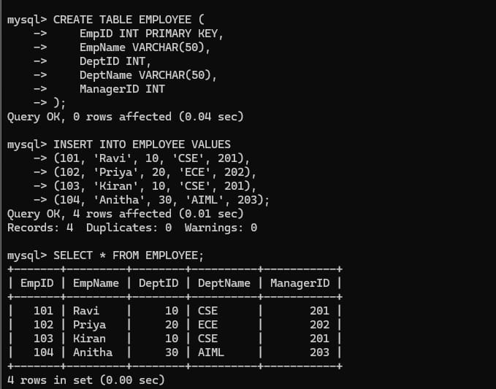
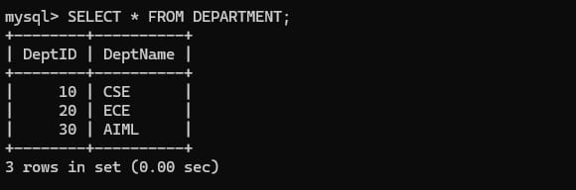
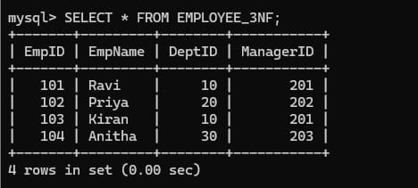
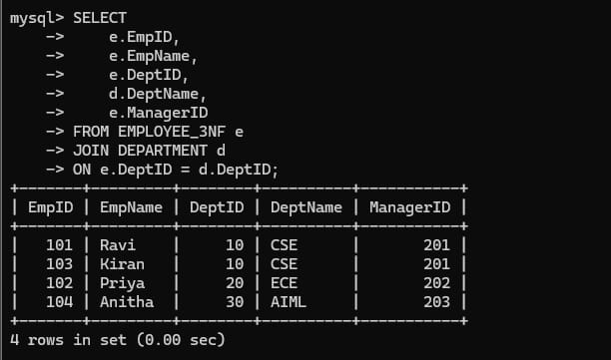
3NF Decomposition
To remove the transitive dependency, separate the department-related attributes into another relation.
The original relation:
EMPLOYEE(EmpID, EmpName, DeptID, DeptName, ManagerID)
is decomposed into:
Employee Relation
EMPLOYEE(EmpID, EmpName, DeptID)
Here:
EmpID → EmpName, DeptID
The primary key is:
EmpID

Department Relation
DEPARTMENT (DeptID, DeptName, ManagerID)
Here:
DeptID → DeptName, ManagerID
The primary key is:
DeptID
DeptID in the EMPLOYEE relation acts as a foreign key referencing the DEPARTMENT relation.
Before Decomposition
EmpID | EmpName | DeptID | DeptName | ManagerID
E101 | Ravi | D01 | CSE | M01
E102 | Anu | D01 | CSE | M01
E103 | Priya | D02 | ECE | M02

Here, department information is repeated for every employee belonging to the same department.
For example, D01, CSE, M01 is repeated.
This causes redundancy.
After Decomposition
EMPLOYEE
EmpID | EmpName | DeptID
E101 | Ravi | D01
E102 | Anu | D01
E103 | Priya | D02

DEPARTMENT
DeptID | DeptName | ManagerID
D01 | CSE | M01
D02 | ECE | M02

Now department information is stored only once.

Advantages of the Decomposition
The 3NF decomposition provides several benefits:
- Removes transitive dependency.
- Reduces data redundancy.
- Avoids repeated department information.
- Makes updates easier.
- Improves data consistency.
- Prevents update anomalies.
- Prevents unnecessary insertion and deletion problems.
- Clearly separates employee and department information.
Final Answer
The original relation is:
EMPLOYEE(EmpID, EmpName, DeptID, DeptName, ManagerID)
Functional dependencies:
EmpID → EmpName, DeptID
DeptID → DeptName, ManagerID
Transitive dependency:
EmpID → DeptID → DeptName, ManagerID

Therefore, decompose into:
EMPLOYEE(EmpID, EmpName, DeptID)
DEPARTMENT(DeptID, DeptName, ManagerID)
Primary Key of EMPLOYEE: EmpID
Primary Key of DEPARTMENT: DeptID
Foreign Key: DeptID in EMPLOYEE

Conclusion
The given EMPLOYEE relation contains a transitive dependency because EmpID determines DeptID, and DeptID determines DeptName and ManagerID. To achieve 3NF, the department-specific attributes are separated into a DEPARTMENT relation. The resulting relations eliminate the transitive dependency, reduce redundancy, and provide a better-organized database structure.

5.Verify whether R(A,B,C,D) with FDs: AB→C, C→D, D→A is in BCNF. If not, decompose it into BCNF.

BCNF Analysis and Decomposition of R(A, B, C, D)
Introduction
Boyce-Codd Normal Form (BCNF) is a higher level of database normalization used to remove certain types of redundancy caused by functional dependencies. BCNF is stricter than Third Normal Form (3NF).
A relation is in BCNF if, for every non-trivial functional dependency X → Y, X must be a superkey of the relation.
BCNF helps improve database design by ensuring that every determinant is capable of uniquely identifying a complete record.

Given Relation
Consider the relation:
R(A, B, C, D)
with the functional dependencies:
AB → C
C → D
D → A
The objective is to determine whether the relation is in BCNF and, if it is not, decompose it into BCNF relations.
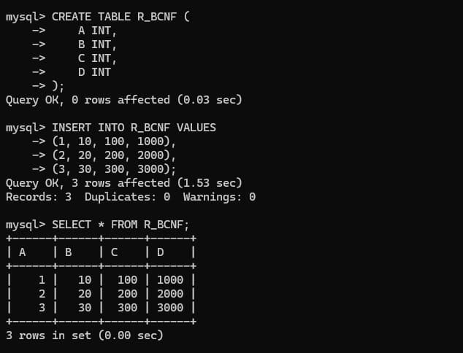

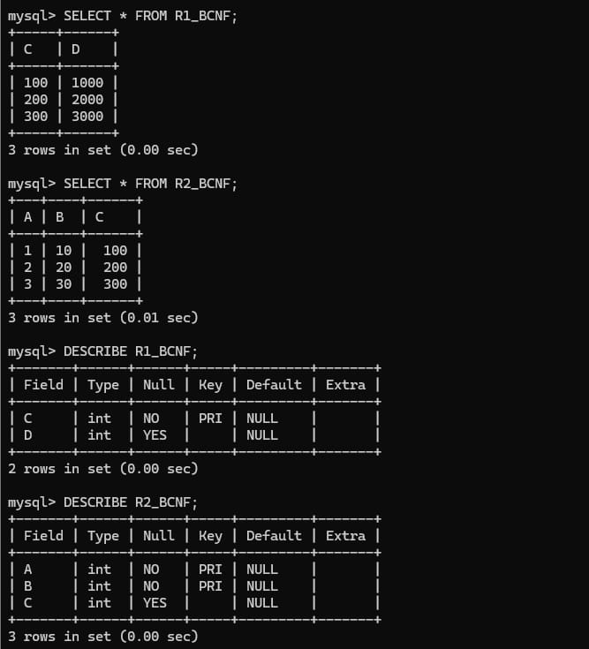

Understanding the Functional Dependencies
The dependency AB → C means that the combination of A and B determines C.
The dependency C → D means that C determines D.
The dependency D → A means that D determines A.
These dependencies create relationships among the attributes:
AB → C → D → A
This chain is important when identifying candidate keys and checking BCNF.
Finding the Candidate Keys
To determine whether a functional dependency violates BCNF, we first need to identify the candidate keys.
Consider AB.
Starting with:
(AB)⁺ = {A, B}
Using AB → C, we obtain C:
(AB)⁺ = {A, B, C}
Using C → D, we obtain D:
(AB)⁺ = {A, B, C, D}
Therefore, AB determines all attributes.
Hence:
AB is a candidate key.
Meaning of Superkey
A superkey is an attribute or set of attributes that can determine all the attributes of a relation.
Since the candidate keys are AB, BC, and BD, each of these is also a superkey.
A candidate key is a minimal superkey, meaning that no attribute can be removed from it without losing the ability to identify all attributes.

BCNF Condition
The rule for BCNF is:
For every non-trivial FD X → Y, X must be a superkey.
We now check each functional dependency.
Checking AB → C
The determinant is AB.
We already found that AB is a candidate key.
Therefore, AB is a superkey.
So the dependency:
AB → C
does not violate BCNF.
Checking C → D
The determinant is C.
Therefore, the relation:
R(A, B, C, D)
is not in BCNF.
Decomposition Using C → D
To eliminate the BCNF violation caused by C → D, we create a new relation containing the determinant and the dependent attribute.
Checking R1(C, D)
The functional dependency in R1 is:
C → D
The closure of C in R1 is:
C⁺ = {C, D}
Therefore, C determines all attributes of R1.
So C is a superkey of R1.
Hence, R1 satisfies BCNF.
Checking R2(A, B, C)
The important dependency in R2 is:
AB → C
The closure is:
(AB)⁺ = {A, B, C}
Therefore, AB determines all attributes of R2.
So AB is a superkey of R2.
Hence, R2 also satisfies BCNF.
Final BCNF Relations

The decomposition is:
R1(C, D)
R2(A, B, C)
The keys are:
R1: C
R2: AB
Both relations satisfy the BCNF condition because the determinant of every relevant functional dependency is a superkey in its respective relation.
Example Data Before Decomposition
The original relation might contain data such as:
A | B | C | D
A1 | B1 | C1 | D1
A2 | B1 | C2 | D2
A3 | B2 | C1 | D1

Because C determines D, the same C-D information may appear repeatedly.
For example, whenever C1 occurs, D1 must occur. This can lead to repeated information.
Data After Decomposition
The information can be stored separately.
R1(C, D)
C | D
C1 | D1
C2 | D2

R2(A, B, C)
A | B | C
A1 | B1 | C1
A2 | B1 | C2
A3 | B2 | C1

This avoids unnecessary repetition of the C-D relationship.

Advantages of BCNF Decomposition
BCNF decomposition helps reduce redundancy in the database. It also minimizes the possibility of update, insertion, and deletion anomalies. Dependencies become easier to understand, and each relation represents a more specific relationship between attributes.
It also makes the database structure more organized by ensuring that determinants are keys within their respective relations.

Conclusion
The relation R(A, B, C, D) with functional dependencies AB → C, C → D, and D → A is not in BCNF. The candidate keys are AB, BC, and BD. Although AB is a superkey, C and D are not superkeys, while they determine other attributes. Therefore, C → D and D → A create BCNF violations. By decomposing the relation using C → D, we obtain R1(C, D) and R2(A, B, C). In these resulting relations, the determinants are superkeys, so the decomposed relations satisfy BCNF.

6.Experimentally verify lossless-join decomposition for a given relation using the tabular (Chase) algorithm.

Experimental Verification of Lossless-Join Decomposition Using the Chase Algorithm
Introduction
In database normalization, a relation is sometimes divided into two or more smaller relations. This process is called decomposition. After decomposition, it is important to verify whether the original relation can be reconstructed correctly by joining the decomposed relations.
A decomposition is called lossless-join if joining the decomposed relations produces exactly the original relation without generating any extra or incorrect tuples.
The Chase algorithm, also called the tabular method, is used to experimentally verify whether a decomposition is lossless.
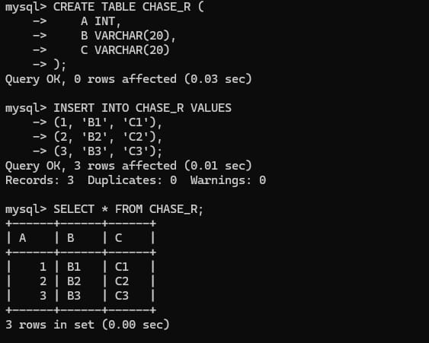
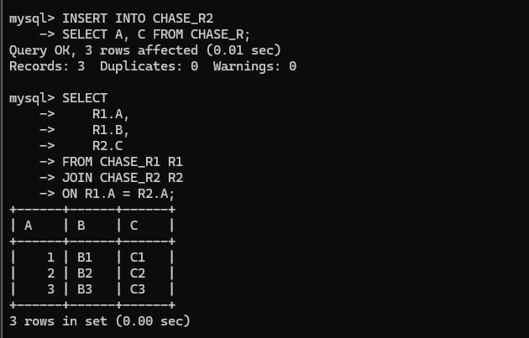
Given Relation
Consider the relation:
R(A, B, C)
with the functional dependency:
A → B
Suppose we decompose R into:
R1(A, B)
and
R2(A, C)
We need to verify whether this decomposition is lossless.
Functional Dependency
The given functional dependency is:
A → B
This means that the value of A uniquely determines the value of B.
For example, if:
A = A1
then there can be only one corresponding value of B.
Chase Algorithm
The Chase algorithm starts by creating a table containing one row for each decomposed relation.
The columns represent all the attributes of the original relation.
For each relation, the attributes that are present in that relation are given special symbols. The attributes that are not present are given different symbols.
For the relation:
R(A, B, C)
we create two rows corresponding to R1 and R2.
Initial Chase Table

Let the symbols be:
- aA, aB, aC → common symbols for the corresponding attributes
- bA, bB, bC → different symbols
The initial table is:
Row | A | B | C
R1(A,B) | aA | aB | bC
R2(A,C) | aA | bB | aC

The first row represents R1(A,B).
Since A and B are present in R1, they receive the common symbols aA and aB. C is not present, so it receives a different symbol.
The second row represents R2(A,C).
Since A and C are present in R2, they receive the common symbols aA and aC. B is not present, so it receives a different symbol.
Applying the Functional Dependency
The given functional dependency is:
A → B
Now examine the A column.
Both rows contain the same value:
A = aA
According to the functional dependency A → B, rows having the same A value must have the same B value.
Currently:
Row | A | B | C
R1 | aA | aB | bC
R2 | aA | bB | aC

The B values are different:
- R1 → aB
- R2 → bB
Since A is the same in both rows, the Chase algorithm forces the B values to become the same.
The common symbol is selected:
aB

The table becomes:
Row | A | B | C
R1 | aA | aB | bC
R2 | aA | aB | aC

Checking the Final Table
Now we check whether any row becomes a complete row containing only the common symbols.
The second row is:
(aA, aB, aC)
This row contains the common symbols for:
- A
- B
- C
Therefore, the Chase algorithm has produced a complete distinguished row.
This proves that the decomposition is lossless.
Result
The decomposition:
R(A, B, C)
into:
R1(A, B)
and:
R2(A, C)
is a lossless-join decomposition with respect to the functional dependency:
A → B
Why Is It Lossless?
The common attribute between the two decomposed relations is:
A
Since:
A → B
the common attribute A determines all attributes of R1 that are not present in R2.
Therefore, when R1 and R2 are joined using A, the original relation can be reconstructed without generating incorrect combinations.
Example with Actual Data

Consider the original relation:
A | B | C
1 | X | P
2 | Y | Q
3 | Z | R

Decompose it into:
R1(A,B)
A | B
1 | X
2 | Y
3 | Z

R2(A,C)
A | C
1 | P
2 | Q
3 | R

Joining R1 and R2 on A gives:
A | B | C
1 | X | P
2 | Y | Q
3 | Z | R

The result is exactly the original relation.
Therefore, there is no spurious tuple.
Lossless and Lossy Decomposition
A lossless decomposition preserves all the information of the original relation. When the decomposed relations are joined, the original relation is obtained exactly.
A lossy decomposition produces additional or incorrect tuples after joining the decomposed relations. These additional tuples are called spurious tuples.

Importance of the Chase Algorithm
The Chase algorithm is useful because it provides a systematic method for checking lossless decomposition. It is especially helpful when dealing with multiple relations and several functional dependencies.
It can be used to:
- Verify lossless-join decomposition.
- Check whether information is preserved.
- Identify possible spurious tuples.
- Support normalization.
- Analyze complex relational decompositions.

Experimental Procedure
For an experiment, the following procedure can be followed:
Given the relation and functional dependencies, first identify all attributes of the original relation.
Create a chase table with one row for each decomposed relation.
Assign symbols to the attributes according to whether they are present in each decomposed relation.
Apply the functional dependencies repeatedly to rows having matching determinant values.
Update the table whenever a functional dependency forces two values to become equal.
Continue the process until no further changes are possible.
Finally, check whether a row contains all the distinguished/common symbols.
If such a row exists, the decomposition is lossless.

Conclusion
The Chase algorithm provides a tabular method for verifying whether a decomposition is lossless. In the example, the relation R(A,B,C) was decomposed into R1(A,B) and R2(A,C). By applying the functional dependency A → B, the Chase table produced a row containing all the common symbols (aA, aB, aC). Therefore, the decomposition is lossless-join, and joining the decomposed relations reconstructs the original relation without loss of information or spurious tuples.

7. Identify the multi-valued dependencies in TEACHER (TID, Subject, Hobby) and decompose it into 4NF.

Decomposition of TEACHER Relation into 4NF
Introduction
Fourth Normal Form (4NF) is a higher level of database normalization used to remove problems caused by multi-valued dependencies (MVDs).
A relation is in 4NF if it is already in BCNF and, for every non-trivial multi-valued dependency X →→ Y, X is a superkey.
A multi-valued dependency occurs when one attribute determines a set of values independently of another attribute.
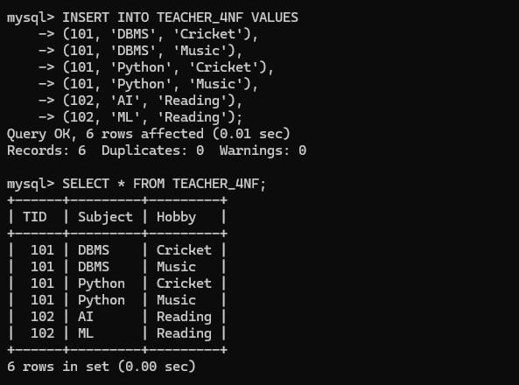

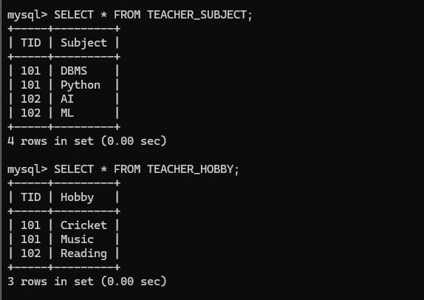
Given Relation
Consider the relation:
TEACHER (TID, Subject, Hobby)
Where:
- TID – Teacher ID
- Subject – Subject taught by the teacher
- Hobby – Hobby of the teacher
Assume that a teacher can teach multiple subjects and can have multiple hobbies, and that the subjects and hobbies are independent of each other.
For example, a teacher may teach:
- DBMS
- Operating Systems
and have hobbies:
- Reading
- Music
The subjects and hobbies are independent.
Multi-Valued Dependencies
The important multi-valued dependencies are:
TID →→ Subject
and
TID →→ Hobby
The first dependency means that a teacher ID determines a set of subjects independently of hobbies.
The second dependency means that a teacher ID determines a set of hobbies independently of subjects.
These are multi-valued dependencies, represented by the double arrow →→.
Example of the Problem
Suppose teacher T01 teaches two subjects and has two hobbies.
The original relation may look like:
TID | Subject | Hobby
T01 | DBMS | Reading
T01 | DBMS | Music
T01 | OS | Reading
T01 | OS | Music

The four combinations occur because the subjects and hobbies are independent.
If a new hobby is added, it may require adding a row for every subject taught by that teacher.
This creates unnecessary redundancy.
Why This Violates 4NF
The relation has two independent multi-valued facts:
TID →→ Subject
and
TID →→ Hobby

4NF Decomposition
To remove the multi-valued dependencies, we separate the independent multi-valued attributes into different relations.
The original relation:
TEACHER (TID, Subject, Hobby)
is decomposed into:
TEACHER_SUBJECT(TID, Subject)
and
TEACHER_HOBBY(TID, Hobby)
TEACHER_SUBJECT Relation
TEACHER_SUBJECT(TID, Subject)
TID | Subject
T01 | DBMS
T01 | OS

Here, the relationship between a teacher and the subjects they teach is stored separately.
The key is:
(TID, Subject)
TEACHER_HOBBY Relation
TEACHER_HOBBY(TID, Hobby)
TID | Hobby
T01 | Reading
T01 | Music
Here, the relationship between a teacher and their hobbies is stored separately.

The key is:
(TID, Hobby)
Why the Decomposition is in 4NF
In TEACHER_SUBJECT, there is no independent multi-valued relationship between Subject and another attribute.
Similarly, in TEACHER_HOBBY, there is no independent multi-valued relationship between Hobby and another attribute.
The two independent facts have been separated.
Therefore, the decomposition removes the multi-valued dependency problem.
Before Decomposition
TEACHER(TID, Subject, Hobby)
TID | Subject | Hobby
T01 | DBMS | Reading
T01 | DBMS | Music
T01 | OS | Reading
T01 | OS | Music

The combinations create redundancy.
After Decomposition
TEACHER_SUBJECT(TID, Subject)
TID | Subject
T01 | DBMS
T01 | OS

TEACHER_HOBBY(TID, Hobby)
TID | Hobby
T01 | Reading
T01 | Music

The subject and hobby information are now independent.

Understanding the Decomposition
The original relation tries to store two independent relationships in one table:
Teacher → Subjects
and
Teacher → Hobbies
Because these relationships are independent, storing them together produces every possible combination of subjects and hobbies.
By separating them, each relationship is stored only once.
Advantages of 4NF Decomposition
The decomposition provides several benefits:
- Removes multi-valued dependencies.
- Reduces unnecessary repetition.
- Avoids redundant combinations.
- Makes insertion easier.
- Makes deletion safer.
- Makes updates simpler.
- Separates independent relationships clearly.
- Improves overall database organization.

Final Answer
Given:
TEACHER(TID, Subject, Hobby)
Multi-valued dependencies:
TID →→ Subject
TID →→ Hobby
Since TID is not a superkey of the original relation, these MVDs violate 4NF.
Therefore, decompose the relation into:
TEACHER_SUBJECT(TID, Subject)
TEACHER_HOBBY(TID, Hobby)
The resulting relations separate the independent subjects and hobbies of each teacher and satisfy the requirements of 4NF.
Conclusion
The TEACHER relation contains two independent multi-valued attributes: Subject and Hobby. The dependencies TID →→ Subject and TID →→ Hobby create redundancy because every subject may be combined with every hobby. By decomposing the relation into TEACHER_SUBJECT(TID, Subject) and TEACHER_HOBBY(TID, Hobby), the multi-valued dependencies are separated and the resulting relations are in 4NF.

8.Demonstrate how join dependencies lead to redundancy. Decompose a given relation to 5NF (Project-Join Normal Form).

Decomposition of a Relation into 5NF
Introduction
Fifth Normal Form (5NF), also called Project-Join Normal Form (PJ/NF), is a higher level of database normalization. It deals mainly with join dependencies.
A relation is in 5NF when every non-trivial join dependency is implied by the candidate keys of the relation. The main purpose of 5NF is to remove redundancy that cannot be eliminated through 1NF, 2NF, 3NF, BCNF, or 4NF.
Join Dependency
A join dependency (JD) occurs when a relation can be reconstructed by joining two or more smaller relations.
It is represented as:
(R1, R2, ..., Rn)
This means that the original relation can be obtained by joining the projections of the relation onto these smaller relations.
Join dependencies become important when three or more entities have a complex relationship.
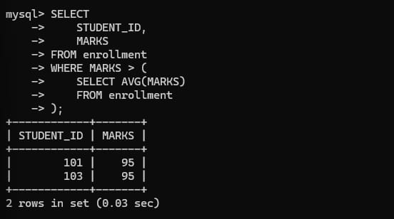
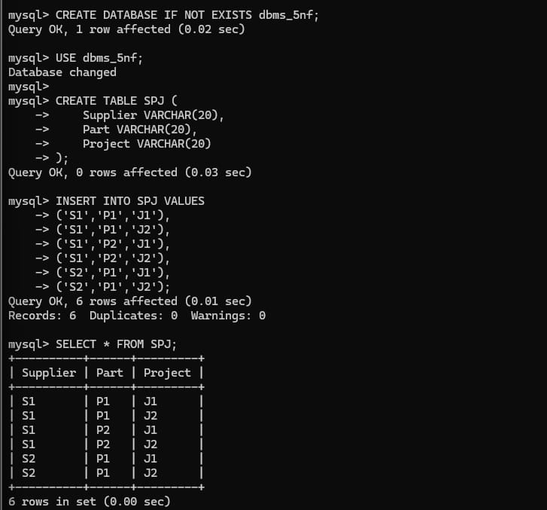

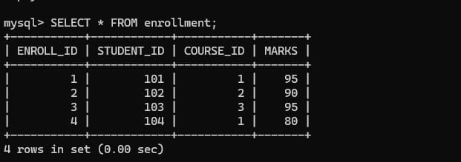
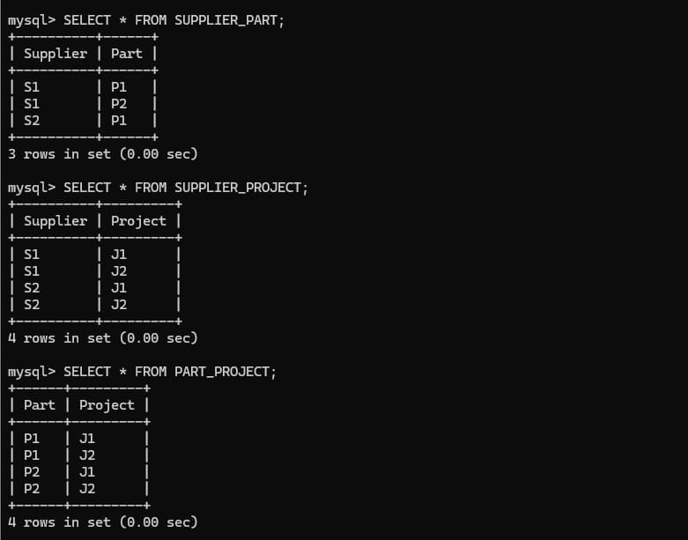
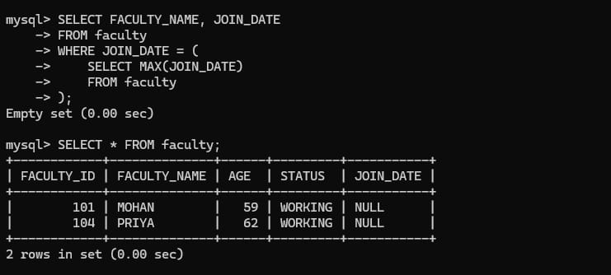
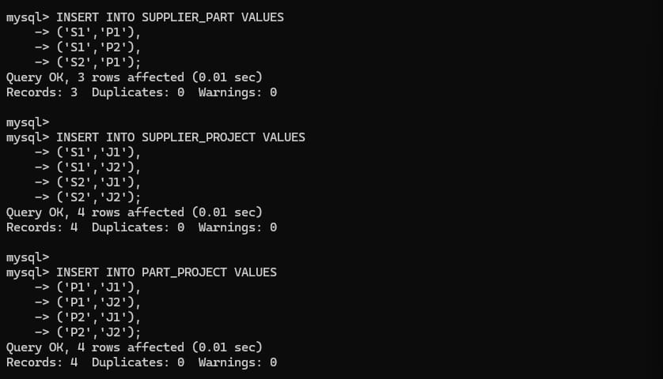
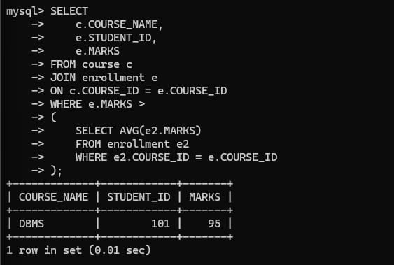
Suppose we have:
Supplier | Part | Project
S1 | P1 | J1
S1 | P1 | J2
S1 | P2 | J1
S1 | P2 | J2

Here, the combinations of Supplier, Part, and Project can create repeated information.
How Join Dependency Causes Redundancy
Suppose supplier S1 supplies parts P1 and P2 and works on projects J1 and J2.
If these relationships are stored together in one relation, we may need to store:
- S1 supplies P1
- S1 supplies P2
- S1 works on J1
- S1 works on J2
- P1 is used in J1
- P1 is used in J2
- P2 is used in J1
- P2 is used in J2
The combinations can cause unnecessary repetition.
For example, if a new project J3 is added, several tuples may have to be inserted.
This creates redundancy and can lead to insertion, deletion, and update anomalies.
Join Dependency in the Example
The original relation is:
SPJ (Supplier, Part, Project)
It can be represented through three smaller relations:
SP (Supplier, Part)
SJ (Supplier, Project)
PJ (Part, Project)
The join dependency can be expressed as:
SPJ = SP ⋈ SJ ⋈ PJ
This means that the original SPJ relation can be reconstructed by joining these three projections.
Loading
Original Relation
Consider:
SPJ(Supplier, Part, Project)
Supplier | Part | Project
S1 | P1 | J1
S1 | P1 | J2
S1 | P2 | J1
S1 | P2 | J2
The relation contains three different types of information:
- Supplier–Part relationship
- Supplier–Project relationship
- Part–Project relationship
When these independent relationships are stored together, redundant combinations can occur.
Projection into Smaller Relations
We decompose the relation into three projections.
SP (Supplier, Part)
Supplier | Part
S1 | P1
S1 | P2

SJ (Supplier, Project)
Supplier | Project
S1 | J1
S1 | J2
PJ (Part, Project)
Part | Project
P1 | J1
P1 | J2
P2 | J1
P2 | J2
Each relation now stores one specific relationship.
Joining the Decomposed Relations
The original relation can be reconstructed by joining the three relations:
SP ⋈ SJ ⋈ PJ
The join produces:
Supplier | Part | Project
S1 | P1 | J1
S1 | P1 | J2
S1 | P2 | J1
S1 | P2 | J2
Thus, the original information can be obtained from the decomposed relations.
Why Decomposition is Required
The purpose of decomposition is to avoid storing independent relationships repeatedly in a single relation.
Instead of storing every possible three-way combination, we store the relationships separately:
Supplier ↔ Part
Supplier ↔ Project
Part ↔ Project
This reduces redundancy and makes the database easier to maintain.
5NF Condition
A relation is in 5NF when:
- It is already in 4NF.
- Every non-trivial join dependency is implied by candidate keys.
- The relation cannot be further losslessly decomposed without losing information or introducing problems.
If a relation has a non-trivial join dependency that is not implied by its candidate keys, it should be decomposed.
5NF Decomposition
The original relation:
SPJ(Supplier, Part, Project)
is decomposed into:
SP(Supplier, Part)
SJ(Supplier, Project)
PJ(Part, Project)
After decomposition, each relation represents an independent binary relationship.

Advantages of 5NF
5NF decomposition provides several advantages:
- Reduces redundancy caused by complex relationships.
- Removes unnecessary repetition of data.
- Prevents modification anomalies.
- Makes insertion and deletion easier.
- Separates independent relationships.
- Improves database consistency.
- Provides a well-structured relational design.
- Handles complex many-to-many-to-many relationships effectively.

Difference Between 4NF and 5NF
4NF mainly deals with multi-valued dependencies.
5NF mainly deals with join dependencies.
4NF separates independent multi-valued facts, while 5NF further decomposes relations when complex relationships can be represented by several smaller relations.

Conclusion
Join dependencies can cause redundancy when a relation stores multiple independent relationships together. In the SUPPLIER_PART_PROJECT example, the three-way relationship can be represented using the three relations SP(Supplier, Part), SJ(Supplier, Project), and PJ(Part, Project). The original relation can be reconstructed by joining these relations. This decomposition removes unnecessary redundancy and demonstrates the basic idea of Fifth Normal Form (5NF) or Project-Join Normal Form (PJ/NF).

9.Given a poorly designed database schema for a college, identify all anomalies (insertion, deletion, update) and normalize it to 3NF.
Normalization of a College Database Schema to 3NF
Introduction
A poorly designed database can contain repeated information and unnecessary duplication. This can lead to three common problems called data anomalies:
- Insertion anomaly
- Update anomaly
- Deletion anomaly
Normalization is used to organize the database properly and remove these problems. The database is first converted into 1NF, then 2NF, and finally 3NF.
For a college database, consider the following poorly designed relation:
COLLEGE(StudentID, StudentName, CourseID, CourseName, FacultyID, FacultyName, FacultyPhone, Grade)
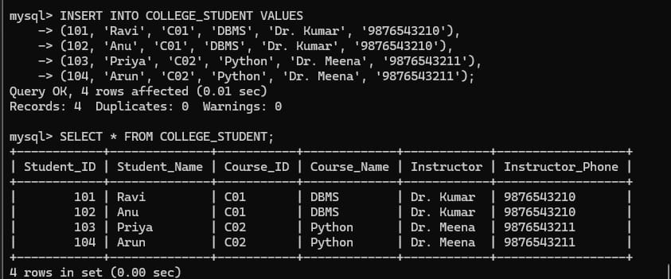
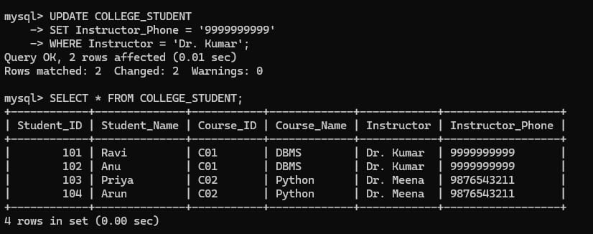

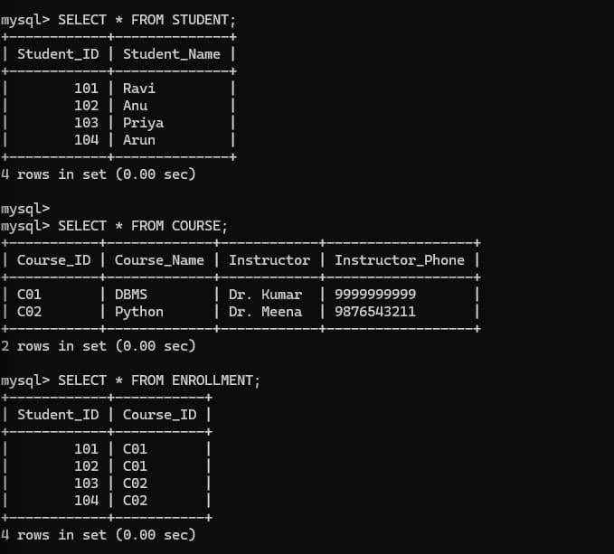

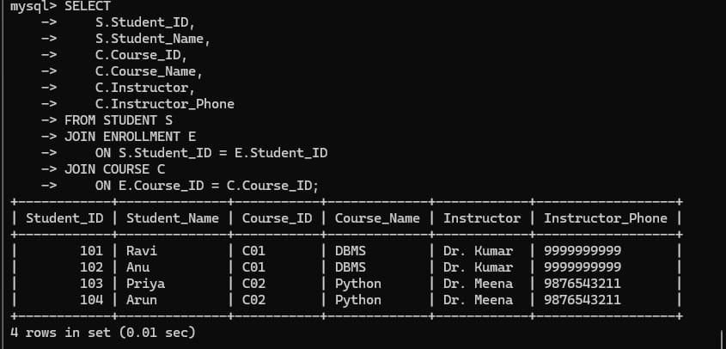

Example of the Poorly Designed Table
StudentID | StudentName | CourseID | CourseName | FacultyID | FacultyName | FacultyPhone | Grade
S101 | Ravi | C01 | DBMS | F01 | Kumar | 9876543210 | A
S101 | Ravi | C02 | OS | F02 | Priya | 9876543211 | B
S102 | Anu | C01 | DBMS | F01 | Kumar | 9876543210 | A
S103 | Arun | C01 | DBMS | F01 | Kumar | 9876543210 | B

The table contains student, course, faculty, and enrollment information together.
Candidate Key
A student can register for multiple courses, and a course can have multiple students.
Therefore, StudentID alone cannot uniquely identify a record.
Similarly, CourseID alone cannot uniquely identify a record.
The combination:
(StudentID, CourseID)
uniquely identifies each enrollment record.
Therefore:
Candidate Key = (StudentID, CourseID)

Insertion Anomaly
An insertion anomaly occurs when we cannot insert some information into the database without having unrelated information.
Suppose a new course C03 – Computer Networks is introduced, but no student has enrolled in it yet.
In the poorly designed table, we may not be able to insert the course properly because the table expects a StudentID and Grade for each record.
Therefore, we may have to insert incomplete or NULL values.
Similarly, if a new faculty member joins the college but has not yet been assigned to a course, their information cannot be stored properly in this table.
This is an insertion anomaly.

Update Anomaly
An update anomaly occurs when the same information is stored in multiple rows and must be updated everywhere.
For example, faculty member Kumar's phone number appears in several rows:
StudentID | CourseID | FacultyID | FacultyName | FacultyPhone
S101 | C01 | F01 | Kumar | 9876543210
S102 | C01 | F01 | Kumar | 9876543210
S103 | C01 | F01 | Kumar | 9876543210

If Kumar changes his phone number, every occurrence must be updated.
If one row is not updated, the database will contain inconsistent information.
This is an update anomaly.

Deletion Anomaly
A deletion anomaly occurs when deleting one record unintentionally removes important information about another entity.
Suppose S103 is the only student enrolled in course C02.
If we delete S103's enrollment record, we may also lose the only stored information about:
- Course C02
- Its faculty
- Its faculty phone number
Therefore, deleting a student's record can accidentally delete course or faculty information.
This is a deletion anomaly.
Conversion to 1NF
The table already contains atomic values because each cell contains a single value.
Therefore, assuming there are no repeating groups, the relation satisfies 1NF.
However, it contains dependencies that need to be handled for higher normalization.
The composite candidate key is:
(StudentID, CourseID)

Conversion to 2NF
A relation is in 2NF when it is in 1NF and there are no partial dependencies of non-key attributes on a part of a composite key.
STUDENT Relation
STUDENT(StudentID, StudentName)
StudentID | StudentName
S101 | Ravi
S102 | Anu
S103 | Arun

Primary Key:
StudentID
COURSE Relation
COURSE(CourseID, CourseName, FacultyID)

CourseID | CourseName | FacultyID
C01 | DBMS | F01
C02 | OS | F02
Primary Key:
CourseID
ENROLLMENT Relation
ENROLLMENT(StudentID, CourseID, Grade)
StudentID | CourseID | Grade
S101 | C01 | A
S101 | C02 | B
S102 | C01 | A
S103 | C01 | B

Primary Key:
(StudentID, CourseID)

Conversion to 3NF
Now we check for transitive dependencies.
In the COURSE relation:
CourseID → FacultyID
and:
FacultyID → FacultyName, FacultyPhone
Therefore:
CourseID → FacultyID → FacultyName, FacultyPhone
This is a transitive dependency.
To achieve 3NF, faculty information should be separated into its own relation.
FACULTY Relation
FACULTY (FacultyID, FacultyName, FacultyPhone)
FacultyID | FacultyName | FacultyPhone
F01 | Kumar | 9876543210
F02 | Priya | 9876543211

Primary Key:
FacultyID
Updated COURSE Relation
COURSE(CourseID, CourseName, FacultyID)
CourseID | CourseName | FacultyID
C01 | DBMS | F01
C02 | OS | F02
Here, FacultyID is a foreign key referencing FACULTY.

ENROLLMENT
ENROLLMENT (StudentID, CourseID, Grade)
Primary Key: (StudentID, CourseID)
Foreign Keys: StudentID, CourseID

Relationship Between the Tables
The structure can be understood as:
STUDENT
↓
StudentID
ENROLLMENT
↓
CourseID
COURSE
↓
FacultyID
FACULTY
This separates student, course, faculty, and enrollment information.

Why the New Design is in 3NF
STUDENT
StudentID → StudentName
StudentID is the primary key, so there is no partial or transitive dependency.
FACULTY
FacultyID → FacultyName, FacultyPhone
FacultyID is the primary key, so all non-key attributes depend directly on it.
COURSE
CourseID → CourseName, FacultyID
CourseID is the primary key, and the attributes depend directly on CourseID.
ENROLLMENT
(StudentID, CourseID) → Grade
Grade depends on the complete composite key, not on only one part of it.
Therefore, the relations satisfy the requirements of 3NF.
Anomalies Removed After Normalization
Insertion Anomaly
A new course can now be inserted into the COURSE table even if no student has enrolled yet.
A new faculty member can be inserted into the FACULTY table without requiring a student or course record.
Update Anomaly
Faculty information is stored only once in the FACULTY table.
If Kumar's phone number changes, only one record needs to be updated.
Deletion Anomaly
Deleting a student's enrollment does not delete the course or faculty information.
For example, if S103 drops C01, we can delete the record from ENROLLMENT without deleting C01 or F01.

Final Conclusion
The poorly designed college relation contains insertion, update, and deletion anomalies because student, course, faculty, and enrollment information is stored together. The functional dependencies reveal partial and transitive dependencies. By decomposing the relation into STUDENT, COURSE, FACULTY, and ENROLLMENT tables, the partial and transitive dependencies are removed. The final database is in 3NF, reduces redundancy, improves consistency, and prevents insertion, deletion, and update anomalies.

10.Compute the closure of attribute sets for the given FDs and determine all candidate keys for the relation.

Attribute Closure and Candidate Keys
Introduction
Attribute closure is an important technique in database normalization used to find all attributes that can be determined by a given set of attributes using a set of functional dependencies.
The closure of an attribute set X is represented as X⁺. It contains X itself and all other attributes that can be derived from X using the given functional dependencies.
Attribute closure is mainly used to:
- Determine whether an attribute set is a superkey.
- Find candidate keys.
- Verify functional dependencies.
- Help in normalization into 2NF, 3NF, and BCNF.
Since the question does not specify a particular relation and set of FDs, the following example demonstrates the complete procedure.
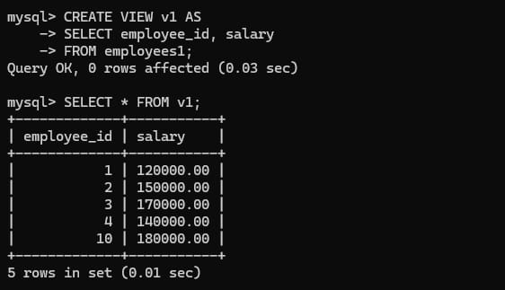
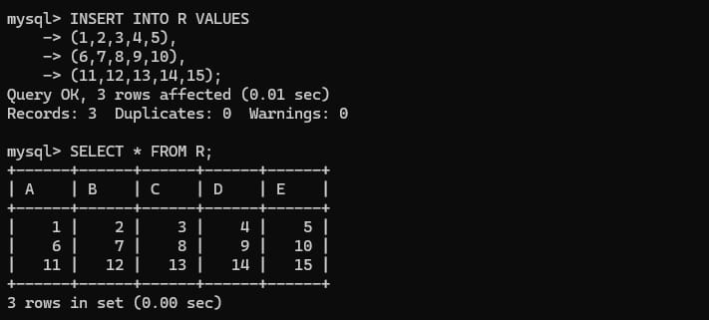
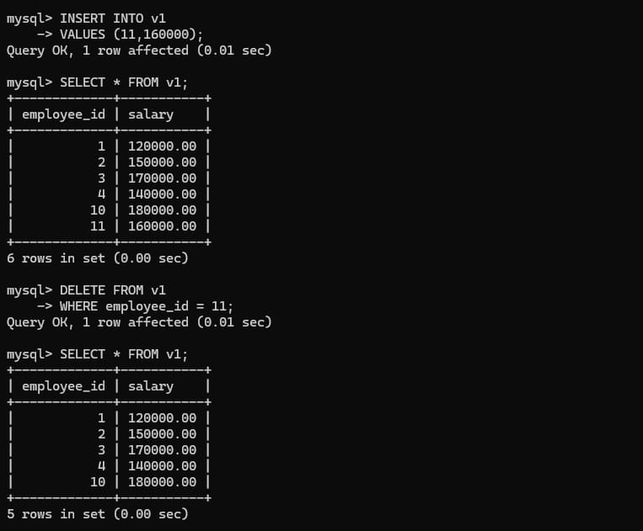
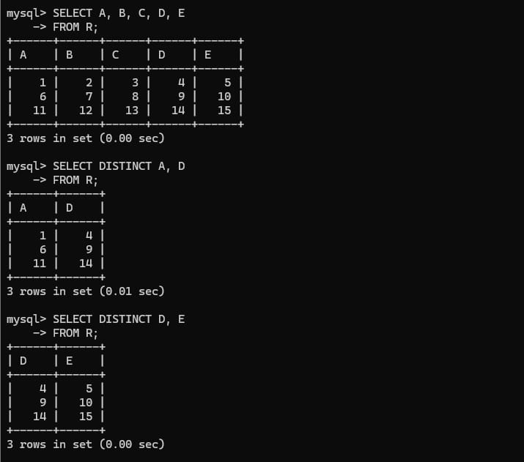
Given Relation
Consider:
R(A, B, C, D, E)
with functional dependencies:
A → B
B → C
CD → E
E → A
We need to calculate attribute closures and identify all candidate keys.

Closure of A
Start with:
A⁺ = {A}
Using:
A → B
we add B:
A⁺ = {A, B}
Using:
B → C
we add C:
A⁺ = {A, B, C}
We cannot apply CD → E because D is not available.
We cannot use E → A because E is not available.
Therefore:
A⁺ = {A, B, C}
Since A does not determine all attributes, A is not a superkey.

Closure of B
Start with:
B⁺ = {B}
Using:
B → C
we get:
B⁺ = {B, C}
No D is available, so CD → E cannot be applied.
Therefore:
B⁺ = {B, C}
B is not a superkey.

Closure of C
Start with:
C⁺ = {C}
There are no applicable dependencies.
Therefore:
C⁺ = {C}
C is not a superkey.

Closure of D
Start with:
D⁺ = {D}
There are no applicable dependencies.
Therefore:
D⁺ = {D}
D is not a superkey.
Closure of E
Start with:
E⁺ = {E}
Using:
E → A
we get A:
E⁺ = {E, A}
Using:
A → B
we get B:
E⁺ = {E, A, B}
Using:
B → C
we get C:
E⁺ = {E, A, B, C}
D is still unavailable.
Therefore:
E⁺ = {A, B, C, E}
E is not a superkey.

Finding a Candidate Key
Since none of the individual attributes determines all attributes, we need to consider combinations.
Notice that D does not appear on the right-hand side of any functional dependency.
Therefore, D must be included in every candidate key.
Now consider AD.
Start with:
(AD)⁺ = {A, D}
Using:
A → B
we get B:
(AD)⁺ = {A, B, D}
Using:
B → C
we get C:
(AD)⁺ = {A, B, C, D}

Using:
CD → E
we now have C and D, so we get E:
(AD)⁺ = {A, B, C, D, E}
Therefore:
AD is a superkey.
Since neither A nor D alone is a superkey:
AD is a candidate key.

Finding Another Candidate Key
Consider DE.
Start with:
(DE)⁺ = {D, E}
Using:
E → A
we get A:
(DE)⁺ = {D, E, A}
Using:
A → B
we get B:
(DE)⁺ = {D, E, A, B}
Using:
B → C
we get C:
(DE)⁺ = {A, B, C, D, E}
Therefore:
DE is a superkey.
Neither D nor E alone is a superkey.
Therefore:
DE is also a candidate key.
Attribute Set | Closure | Candidate Key?
A | A, B, C | No
B | B, C | No
C | C | No
D | D | No
E | A, B, C, E | No
AD | A, B, C, D, E | Yes
CD | A, B, C, D, E | Yes
DE | A, B, C, D, E | Yes

Important Observation
Attribute D must be present in every candidate key because D never appears on the right-hand side of any FD.
This helps reduce the number of combinations that need to be checked.
Superkey and Candidate Key
A superkey is any attribute set whose closure contains all attributes of the relation.
For example:
AD is a superkey.
A candidate key is a minimal superkey.
For example:
AD is a candidate key because:
AD⁺ = {A, B, C, D, E}
but:
A⁺ ≠ R
and:
D⁺ ≠ R
Therefore, no attribute can be removed from AD.
There can be multiple candidate keys in a relation.

General Procedure for Finding Candidate Keys
The following procedure can be used for any attribute-closure problem.
Start with the given attribute set
Write:
X⁺ = {X}
Apply the functional dependencies
If the left-hand side of an FD is already present in the closure, add the right-hand-side attributes.
Continue applying FDs until no new attributes can be added.
Compare the closure with the relation
If:
X⁺ = all attributes of R
then X is a superkey.
If no attribute can be removed from X while still determining all attributes, X is a candidate key.
Check minimality
For a candidate key such as AD, calculate:
A⁺
and:
D⁺
If neither determines all attributes, then AD is minimal.

Final Answer
For the example relation:
R(A, B, C, D, E)
with:
A → B, B → C, CD → E, E → A
the important closures include:
A⁺ = {A, B, C}
E⁺ = {A, B, C, E}
(AD)⁺ = {A, B, C, D, E}
(CD)⁺ = {A, B, C, D, E}
(DE)⁺ = {A, B, C, D, E}
Therefore, the candidate keys are:
AD, CD, and DE
The attribute D must occur in every candidate key because it cannot be derived from any of the given functional dependencies.

