Studio

Design studio has

Job server:This will help to deploy the solution

Repository server

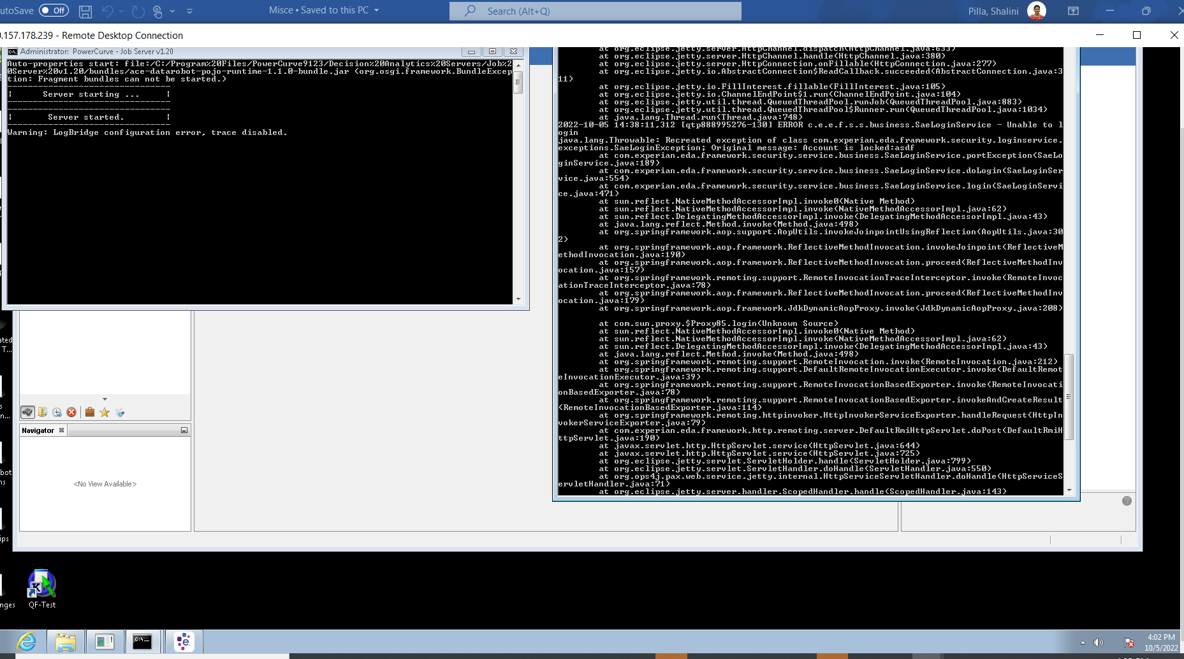

ODS

Originations design studio

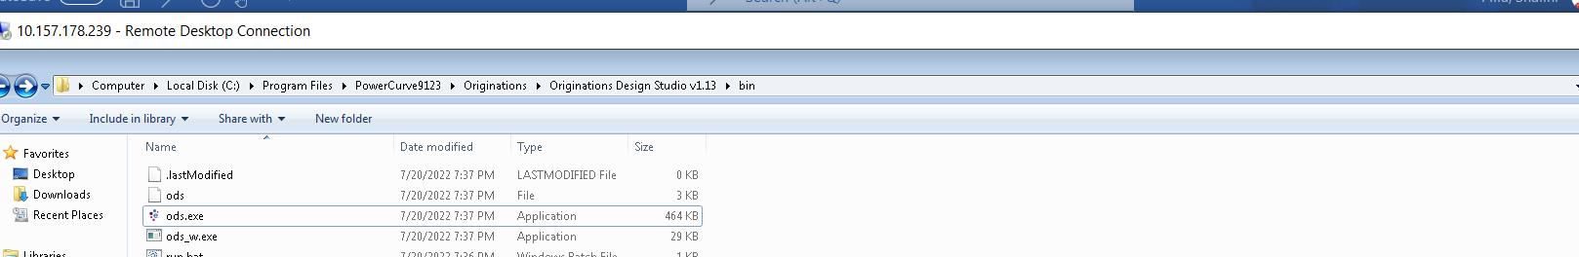

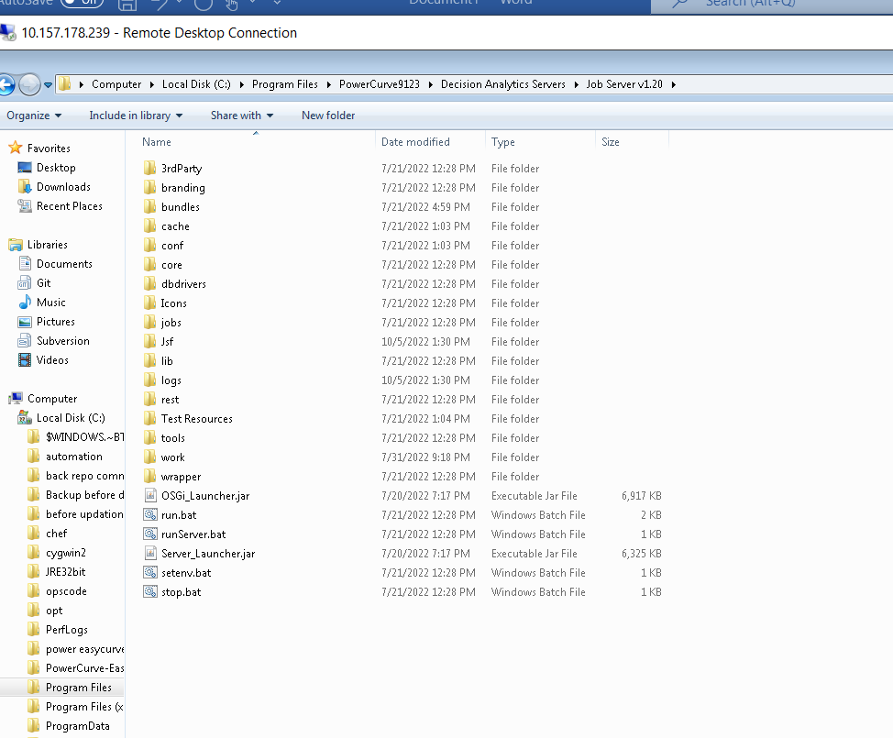

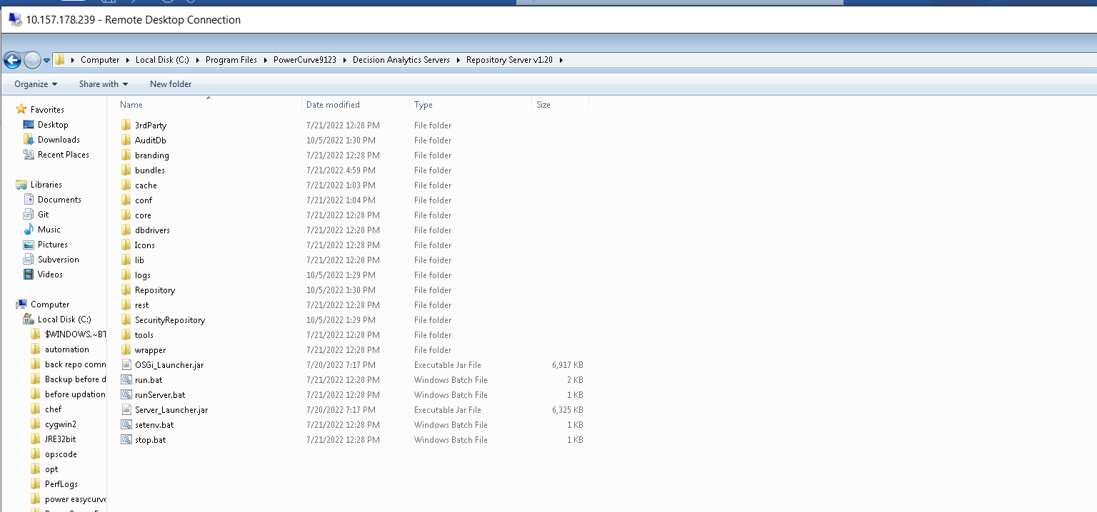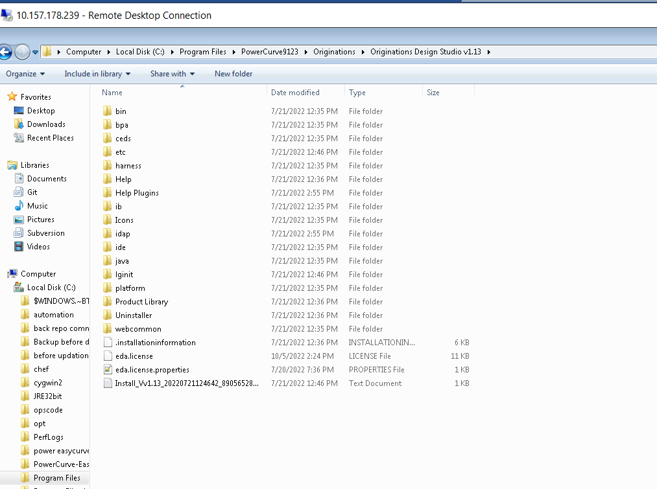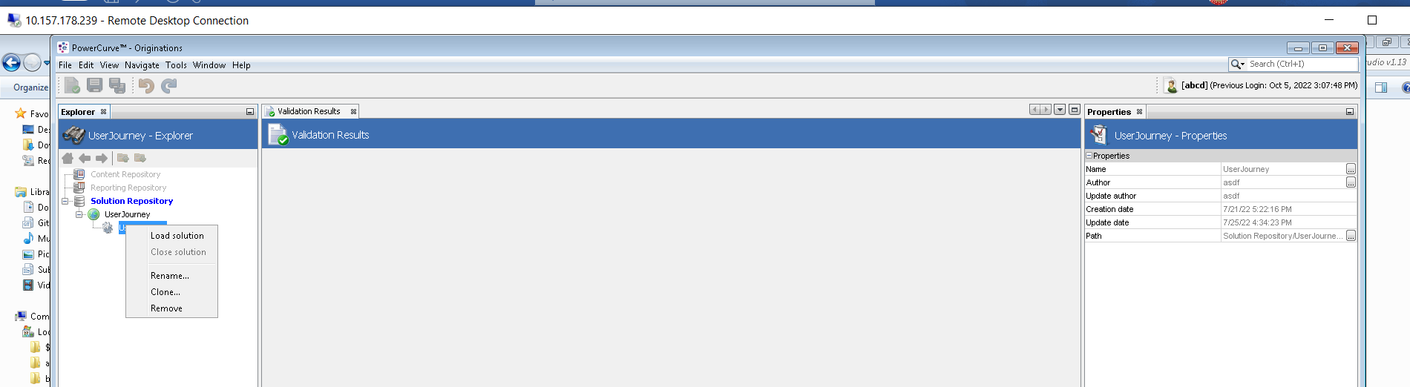

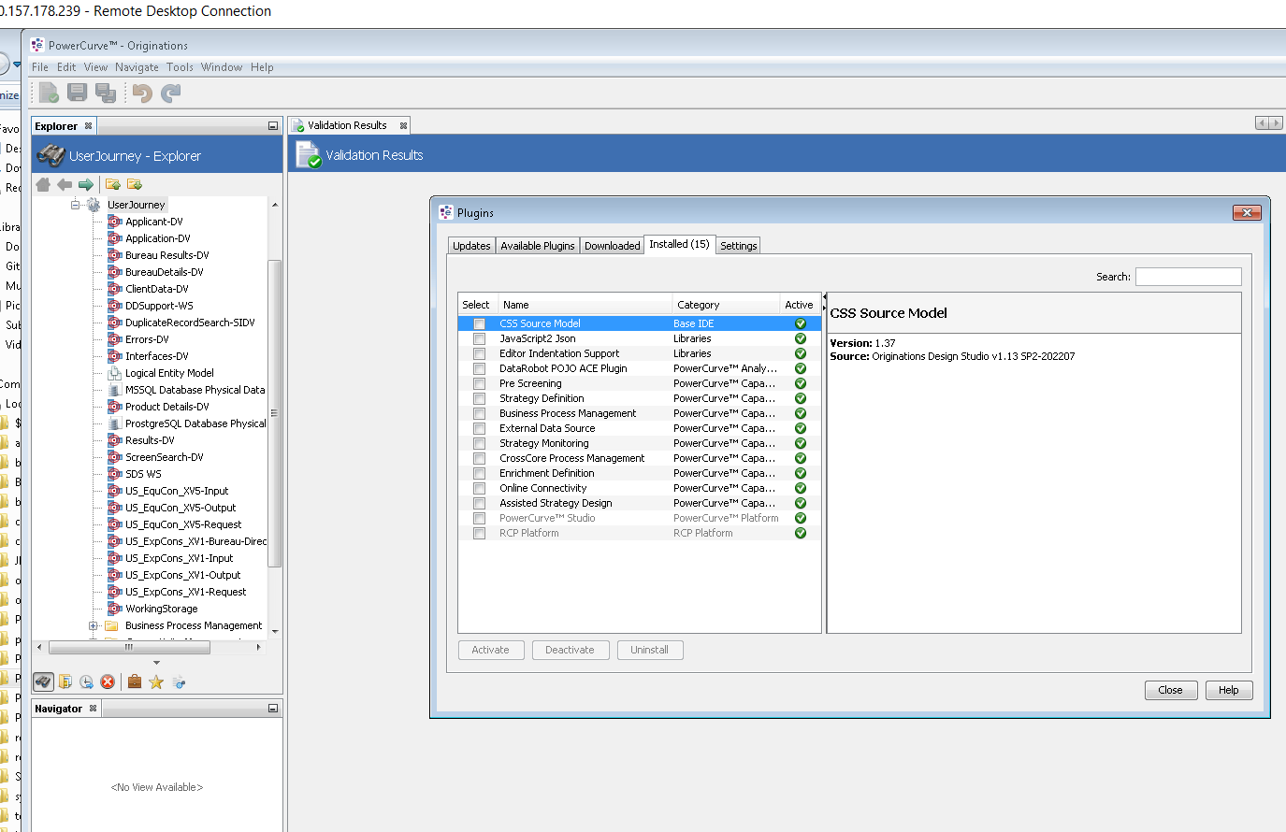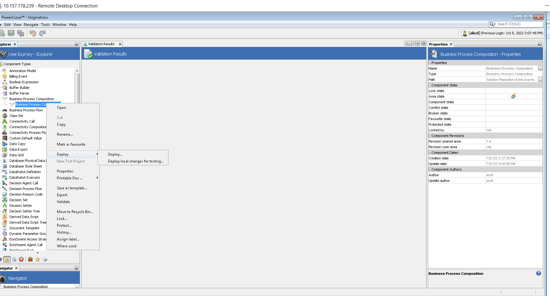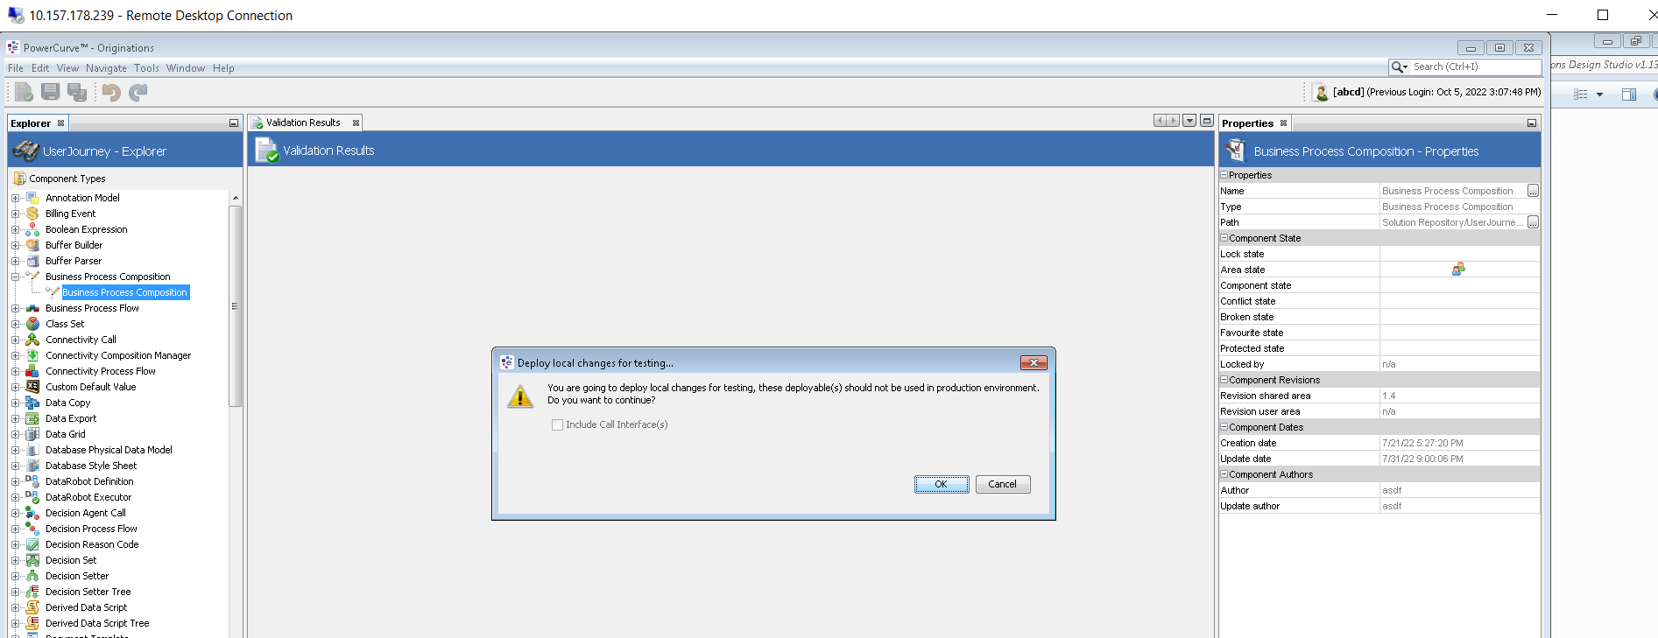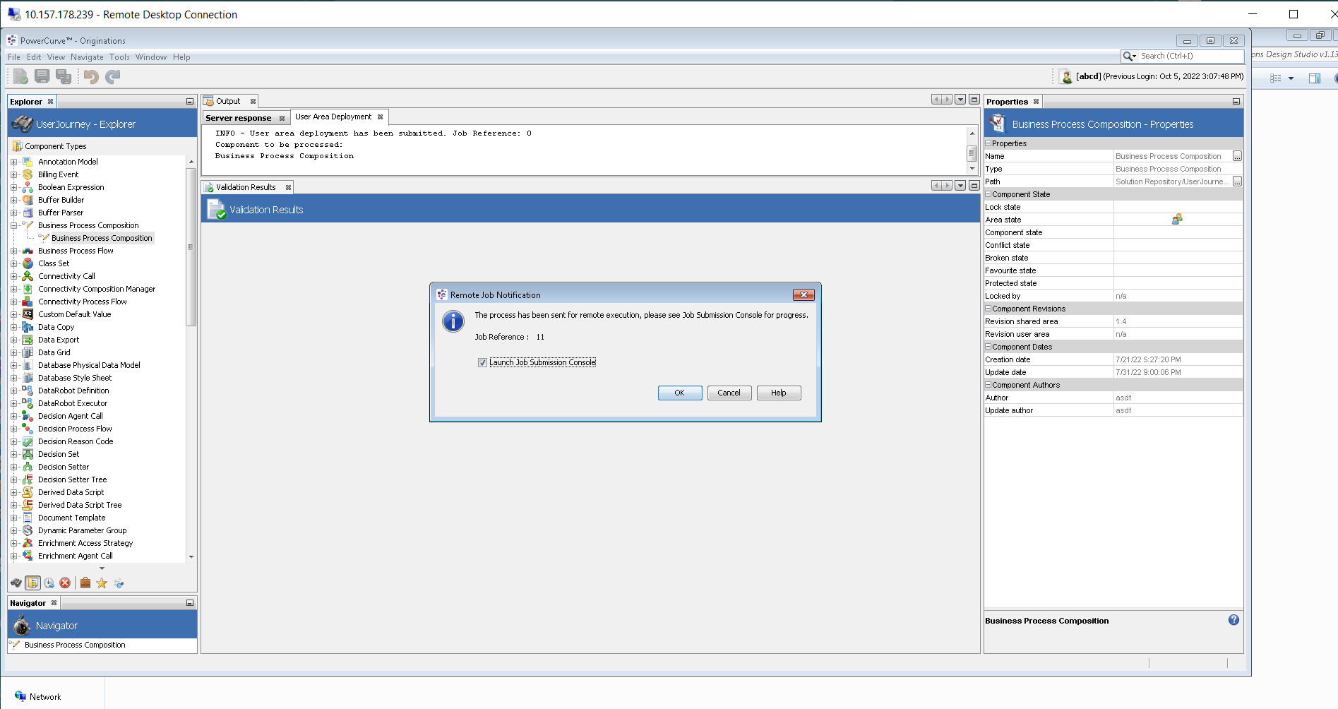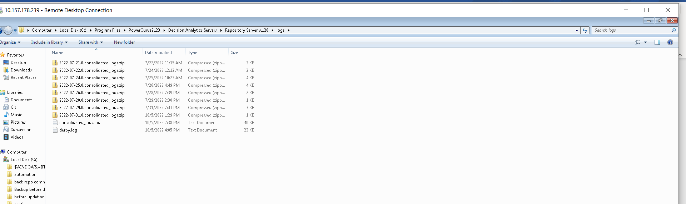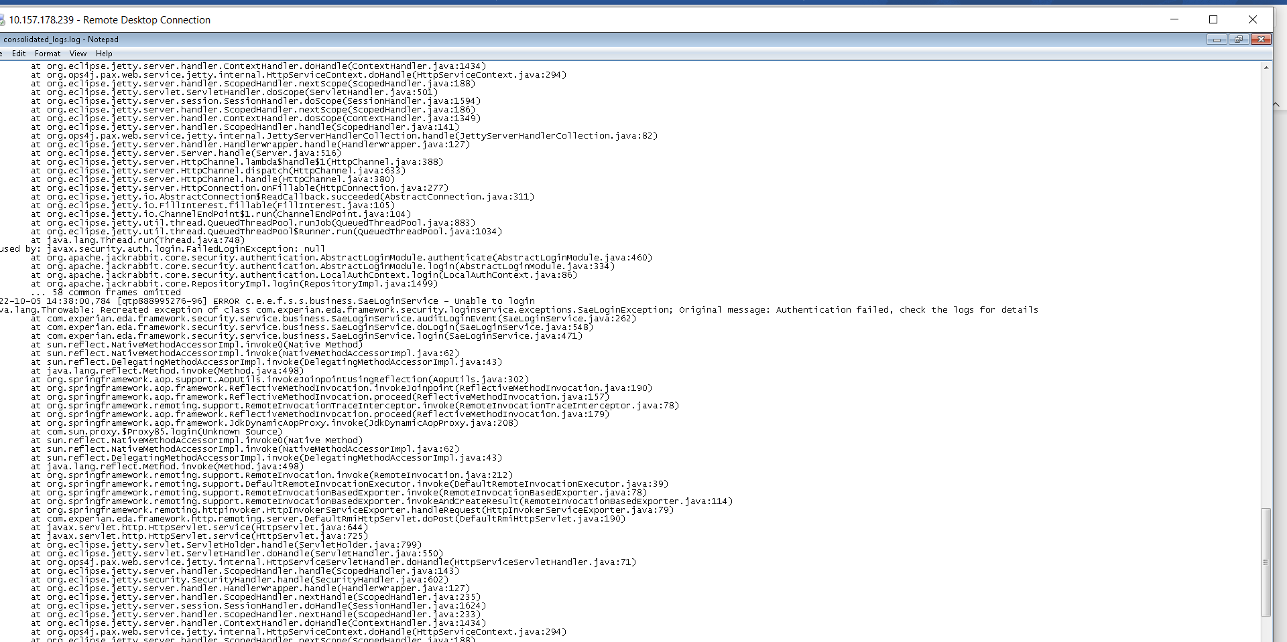

2022-10-05 13:29:40,042 [FelixStartLevel] WARN c.e.e.f.c.c.i.ComponentTypesHandler - Unsupported start element tag types

2022-10-05 13:29:40,073 [FelixStartLevel] WARN c.e.e.f.c.c.i.ComponentTypesHandler - Unsupported end element tag types

2022-10-05 14:26:57,107 [qtp888995276-92] ERROR c.e.e.f.s.s.business.SaeLoginService - SaeLoginService.login() failed; user=asdf

javax.jcr.LoginException: null

at org.apache.jackrabbit.core.RepositoryImpl.login(RepositoryImpl.java:1527)

at org.apache.jackrabbit.commons.AbstractRepository.login(AbstractRepository.java:144)

at com.experian.eda.framework.security.repository.service.impl.SecurityRepositoryService.loginToEdaInt(SecurityRepositoryService.java:1187)

at com.experian.eda.framework.security.repository.service.impl.SecurityRepositoryService.loginToEda(SecurityRepositoryService.java:846)

at com.experian.eda.framework.security.service.business.SaeLoginService.doLogin(SaeLoginService.java:516)

at com.experian.eda.framework.security.service.business.SaeLoginService.login(SaeLoginService.java:471)

at sun.reflect.NativeMethodAccessorImpl.invoke0(Native Method)

at sun.reflect.NativeMethodAccessorImpl.invoke(NativeMethodAccessorImpl.java:62)

at sun.reflect.DelegatingMethodAccessorImpl.invoke(DelegatingMethodAccessorImpl.java:43)

at java.lang.reflect.Method.invoke(Method.java:498)

at org.springframework.aop.support.AopUtils.invokeJoinpointUsingReflection(AopUtils.java:302)

at org.springframework.aop.framework.ReflectiveMethodInvocation.invokeJoinpoint(ReflectiveMethodInvocation.java:190)

at org.springframework.aop.framework.ReflectiveMethodInvocation.proceed(ReflectiveMethodInvocation.java:157)

at org.springframework.remoting.support.RemoteInvocationTraceInterceptor.invoke(RemoteInvocationTraceInterceptor.java:78)

at org.springframework.aop.framework.ReflectiveMethodInvocation.proceed(ReflectiveMethodInvocation.java:179)

at org.springframework.aop.framework.JdkDynamicAopProxy.invoke(JdkDynamicAopProxy.java:208)

at com.sun.proxy.$Proxy85.login(Unknown Source)

at sun.reflect.NativeMethodAccessorImpl.invoke0(Native Method)

at sun.reflect.NativeMethodAccessorImpl.invoke(NativeMethodAccessorImpl.java:62)

at sun.reflect.DelegatingMethodAccessorImpl.invoke(DelegatingMethodAccessorImpl.java:43)

at java.lang.reflect.Method.invoke(Method.java:498)

at org.springframework.remoting.support.RemoteInvocation.invoke(RemoteInvocation.java:212)

at org.springframework.remoting.support.DefaultRemoteInvocationExecutor.invoke(DefaultRemoteInvocationExecutor.java:39)

at org.springframework.remoting.support.RemoteInvocationBasedExporter.invoke(RemoteInvocationBasedExporter.java:78)

at org.springframework.remoting.support.RemoteInvocationBasedExporter.invokeAndCreateResult(RemoteInvocationBasedExporter.java:114)

at org.springframework.remoting.httpinvoker.HttpInvokerServiceExporter.handleRequest(HttpInvokerServiceExporter.java:79)

at com.experian.eda.framework.http.remoting.server.DefaultRmiHttpServlet.doPost(DefaultRmiHttpServlet.java:190)

at javax.servlet.http.HttpServlet.service(HttpServlet.java:644)

at javax.servlet.http.HttpServlet.service(HttpServlet.java:725)

at org.eclipse.jetty.servlet.ServletHolder.handle(ServletHolder.java:799)

at org.eclipse.jetty.servlet.ServletHandler.doHandle(ServletHandler.java:550)

at org.ops4j.pax.web.service.jetty.internal.HttpServiceServletHandler.doHandle(HttpServiceServletHandler.java:71)

at org.eclipse.jetty.server.handler.ScopedHandler.handle(ScopedHandler.java:143)

at org.eclipse.jetty.security.SecurityHandler.handle(SecurityHandler.java:602)

at org.eclipse.jetty.server.handler.HandlerWrapper.handle(HandlerWrapper.java:127)

at org.eclipse.jetty.server.handler.ScopedHandler.nextHandle(ScopedHandler.java:235)

at org.eclipse.jetty.server.session.SessionHandler.doHandle(SessionHandler.java:1624)

at org.eclipse.jetty.server.handler.ScopedHandler.nextHandle(ScopedHandler.java:233)

at org.eclipse.jetty.server.handler.ContextHandler.doHandle(ContextHandler.java:1434)

at org.ops4j.pax.web.service.jetty.internal.HttpServiceContext.doHandle(HttpServiceContext.java:294)

at org.eclipse.jetty.server.handler.ScopedHandler.nextScope(ScopedHandler.java:188)

at org.eclipse.jetty.servlet.ServletHandler.doScope(ServletHandler.java:501)

at org.eclipse.jetty.server.session.SessionHandler.doScope(SessionHandler.java:1594)

at org.eclipse.jetty.server.handler.ScopedHandler.nextScope(ScopedHandler.java:186)

at org.eclipse.jetty.server.handler.ContextHandler.doScope(ContextHandler.java:1349)

at org.eclipse.jetty.server.handler.ScopedHandler.handle(ScopedHandler.java:141)

at org.ops4j.pax.web.service.jetty.internal.JettyServerHandlerCollection.handle(JettyServerHandlerCollection.java:82)

at org.eclipse.jetty.server.handler.HandlerWrapper.handle(HandlerWrapper.java:127)

at org.eclipse.jetty.server.Server.handle(Server.java:516)

at org.eclipse.jetty.server.HttpChannel.lambda$handle$1(HttpChannel.java:388)

at org.eclipse.jetty.server.HttpChannel.dispatch(HttpChannel.java:633)

at org.eclipse.jetty.server.HttpChannel.handle(HttpChannel.java:380)

at org.eclipse.jetty.server.HttpConnection.onFillable(HttpConnection.java:277)

at org.eclipse.jetty.io.AbstractConnection$ReadCallback.succeeded(AbstractConnection.java:311)

at org.eclipse.jetty.io.FillInterest.fillable(FillInterest.java:105)

at org.eclipse.jetty.io.ChannelEndPoint$1.run(ChannelEndPoint.java:104)

at org.eclipse.jetty.util.thread.strategy.EatWhatYouKill.runTask(EatWhatYouKill.java:338)

at org.eclipse.jetty.util.thread.strategy.EatWhatYouKill.doProduce(EatWhatYouKill.java:315)

at org.eclipse.jetty.util.thread.strategy.EatWhatYouKill.tryProduce(EatWhatYouKill.java:173)

at org.eclipse.jetty.util.thread.strategy.EatWhatYouKill.produce(EatWhatYouKill.java:137)

at org.eclipse.jetty.util.thread.QueuedThreadPool.runJob(QueuedThreadPool.java:883)

at org.eclipse.jetty.util.thread.QueuedThreadPool$Runner.run(QueuedThreadPool.java:1034)

at java.lang.Thread.run(Thread.java:748)

**Caused by: javax.security.auth.login.FailedLoginException: null**

**at org.apache.jackrabbit.core.security.authentication.AbstractLoginModule.authenticate(AbstractLoginModule.java:460)**

**at org.apache.jackrabbit.core.security.authentication.AbstractLoginModule.login(AbstractLoginModule.java:334)**

**at org.apache.jackrabbit.core.security.authentication.LocalAuthContext.login(LocalAuthContext.java:86)**

**at org.apache.jackrabbit.core.RepositoryImpl.login(RepositoryImpl.java:1499)**

**... 62 common frames omitted**

**2022-10-05 14:26:57,247 [qtp888995276-92] ERROR c.e.e.f.s.s.business.SaeLoginService - Unable to login**

**java.lang.Throwable: Recreated exception of class com.experian.eda.framework.security.loginservice.exceptions.SaeLoginException; Original message: Authentication failed, check the logs for details**

**at com.experian.eda.framework**.security.service.business.SaeLoginService.auditLoginEvent(SaeLoginService.java:262)

at com.experian.eda.framework.security.service.business.SaeLoginService.doLogin(SaeLoginService.java:548)

at com.experian.eda.framework.security.service.business.SaeLoginService.login(SaeLoginService.java:471)

at sun.reflect.NativeMethodAccessorImpl.invoke0(Native Method)

at sun.reflect.NativeMethodAccessorImpl.invoke(NativeMethodAccessorImpl.java:62)

at sun.reflect.DelegatingMethodAccessorImpl.invoke(DelegatingMethodAccessorImpl.java:43)

at java.lang.reflect.Method.invoke(Method.java:498)

at org.springframework.aop.support.AopUtils.invokeJoinpointUsingReflection(AopUtils.java:302)

at org.springframework.aop.framework.ReflectiveMethodInvocation.invokeJoinpoint(ReflectiveMethodInvocation.java:190)

at org.springframework.aop.framework.ReflectiveMethodInvocation.proceed(ReflectiveMethodInvocation.java:157)

at org.springframework.remoting.support.RemoteInvocationTraceInterceptor.invoke(RemoteInvocationTraceInterceptor.java:78)

at org.springframework.aop.framework.ReflectiveMethodInvocation.proceed(ReflectiveMethodInvocation.java:179)

at org.springframework.aop.framework.JdkDynamicAopProxy.invoke(JdkDynamicAopProxy.java:208)

at com.sun.proxy.$Proxy85.login(Unknown Source)

at sun.reflect.NativeMethodAccessorImpl.invoke0(Native Method)

at sun.reflect.NativeMethodAccessorImpl.invoke(NativeMethodAccessorImpl.java:62)

at sun.reflect.DelegatingMethodAccessorImpl.invoke(DelegatingMethodAccessorImpl.java:43)

at java.lang.reflect.Method.invoke(Method.java:498)

at org.springframework.remoting.support.RemoteInvocation.invoke(RemoteInvocation.java:212)

at org.springframework.remoting.support.DefaultRemoteInvocationExecutor.invoke(DefaultRemoteInvocationExecutor.java:39)

at org.springframework.remoting.support.RemoteInvocationBasedExporter.invoke(RemoteInvocationBasedExporter.java:78)

at org.springframework.remoting.support.RemoteInvocationBasedExporter.invokeAndCreateResult(RemoteInvocationBasedExporter.java:114)

at org.springframework.remoting.httpinvoker.HttpInvokerServiceExporter.handleRequest(HttpInvokerServiceExporter.java:79)

at com.experian.eda.framework.http.remoting.server.DefaultRmiHttpServlet.doPost(DefaultRmiHttpServlet.java:190)

at javax.servlet.http.HttpServlet.service(HttpServlet.java:644)

at javax.servlet.http.HttpServlet.service(HttpServlet.java:725)

at org.eclipse.jetty.servlet.ServletHolder.handle(ServletHolder.java:799)

at org.eclipse.jetty.servlet.ServletHandler.doHandle(ServletHandler.java:550)

at org.ops4j.pax.web.service.jetty.internal.HttpServiceServletHandler.doHandle(HttpServiceServletHandler.java:71)

at org.eclipse.jetty.server.handler.ScopedHandler.handle(ScopedHandler.java:143)

at org.eclipse.jetty.security.SecurityHandler.handle(SecurityHandler.java:602)

at org.eclipse.jetty.server.handler.HandlerWrapper.handle(HandlerWrapper.java:127)

at org.eclipse.jetty.server.handler.ScopedHandler.nextHandle(ScopedHandler.java:235)

at org.eclipse.jetty.server.session.SessionHandler.doHandle(SessionHandler.java:1624)

at org.eclipse.jetty.server.handler.ScopedHandler.nextHandle(ScopedHandler.java:233)

at org.eclipse.jetty.server.handler.ContextHandler.doHandle(ContextHandler.java:1434)

at org.ops4j.pax.web.service.jetty.internal.HttpServiceContext.doHandle(HttpServiceContext.java:294)

at org.eclipse.jetty.server.handler.ScopedHandler.nextScope(ScopedHandler.java:188)

at org.eclipse.jetty.servlet.ServletHandler.doScope(ServletHandler.java:501)

at org.eclipse.jetty.server.session.SessionHandler.doScope(SessionHandler.java:1594)

at org.eclipse.jetty.server.handler.ScopedHandler.nextScope(ScopedHandler.java:186)

at org.eclipse.jetty.server.handler.ContextHandler.doScope(ContextHandler.java:1349)

at org.eclipse.jetty.server.handler.ScopedHandler.handle(ScopedHandler.java:141)

at org.ops4j.pax.web.service.jetty.internal.JettyServerHandlerCollection.handle(JettyServerHandlerCollection.java:82)

at org.eclipse.jetty.server.handler.HandlerWrapper.handle(HandlerWrapper.java:127)

at org.eclipse.jetty.server.Server.handle(Server.java:516)

at org.eclipse.jetty.server.HttpChannel.lambda$handle$1(HttpChannel.java:388)

at org.eclipse.jetty.server.HttpChannel.dispatch(HttpChannel.java:633)

at org.eclipse.jetty.server.HttpChannel.handle(HttpChannel.java:380)

at org.eclipse.jetty.server.HttpConnection.onFillable(HttpConnection.java:277)

at org.eclipse.jetty.io.AbstractConnection$ReadCallback.succeeded(AbstractConnection.java:311)

at org.eclipse.jetty.io.FillInterest.fillable(FillInterest.java:105)

at org.eclipse.jetty.io.ChannelEndPoint$1.run(ChannelEndPoint.java:104)

at org.eclipse.jetty.util.thread.strategy.EatWhatYouKill.runTask(EatWhatYouKill.java:338)

at org.eclipse.jetty.util.thread.strategy.EatWhatYouKill.doProduce(EatWhatYouKill.java:315)

at org.eclipse.jetty.util.thread.strategy.EatWhatYouKill.tryProduce(EatWhatYouKill.java:173)

at org.eclipse.jetty.util.thread.strategy.EatWhatYouKill.produce(EatWhatYouKill.java:137)

at org.eclipse.jetty.util.thread.QueuedThreadPool.runJob(QueuedThreadPool.java:883)

at org.eclipse.jetty.util.thread.QueuedThreadPool$Runner.run(QueuedThreadPool.java:1034)

at java.lang.Thread.run(Thread.java:748)

2022-10-05 14:29:55,429 [qtp888995276-92] ERROR c.e.e.f.s.s.business.SaeLoginService - SaeLoginService.login() failed; user=asdf

javax.jcr.LoginException: null

at org.apache.jackrabbit.core.RepositoryImpl.login(RepositoryImpl.java:1527)

at org.apache.jackrabbit.commons.AbstractRepository.login(AbstractRepository.java:144)

at com.experian.eda.framework.security.repository.service.impl.SecurityRepositoryService.loginToEdaInt(SecurityRepositoryService.java:1187)

at com.experian.eda.framework.security.repository.service.impl.SecurityRepositoryService.loginToEda(SecurityRepositoryService.java:846)

at com.experian.eda.framework.security.service.business.SaeLoginService.doLogin(SaeLoginService.java:516)

at com.experian.eda.framework.security.service.business.SaeLoginService.login(SaeLoginService.java:471)

at sun.reflect.NativeMethodAccessorImpl.invoke0(Native Method)

at sun.reflect.NativeMethodAccessorImpl.invoke(NativeMethodAccessorImpl.java:62)

at sun.reflect.DelegatingMethodAccessorImpl.invoke(DelegatingMethodAccessorImpl.java:43)

at java.lang.reflect.Method.invoke(Method.java:498)

at org.springframework.aop.support.AopUtils.invokeJoinpointUsingReflection(AopUtils.java:302)

at org.springframework.aop.framework.ReflectiveMethodInvocation.invokeJoinpoint(ReflectiveMethodInvocation.java:190)

at org.springframework.aop.framework.ReflectiveMethodInvocation.proceed(ReflectiveMethodInvocation.java:157)

at org.springframework.remoting.support.RemoteInvocationTraceInterceptor.invoke(RemoteInvocationTraceInterceptor.java:78)

at org.springframework.aop.framework.ReflectiveMethodInvocation.proceed(ReflectiveMethodInvocation.java:179)

at org.springframework.aop.framework.JdkDynamicAopProxy.invoke(JdkDynamicAopProxy.java:208)

at com.sun.proxy.$Proxy85.login(Unknown Source)

at sun.reflect.NativeMethodAccessorImpl.invoke0(Native Method)

at sun.reflect.NativeMethodAccessorImpl.invoke(NativeMethodAccessorImpl.java:62)

at sun.reflect.DelegatingMethodAccessorImpl.invoke(DelegatingMethodAccessorImpl.java:43)

at java.lang.reflect.Method.invoke(Method.java:498)

at org.springframework.remoting.support.RemoteInvocation.invoke(RemoteInvocation.java:212)

at org.springframework.remoting.support.DefaultRemoteInvocationExecutor.invoke(DefaultRemoteInvocationExecutor.java:39)

at org.springframework.remoting.support.RemoteInvocationBasedExporter.invoke(RemoteInvocationBasedExporter.java:78)

at org.springframework.remoting.support.RemoteInvocationBasedExporter.invokeAndCreateResult(RemoteInvocationBasedExporter.java:114)

at org.springframework.remoting.httpinvoker.HttpInvokerServiceExporter.handleRequest(HttpInvokerServiceExporter.java:79)

at com.experian.eda.framework.http.remoting.server.DefaultRmiHttpServlet.doPost(DefaultRmiHttpServlet.java:190)

at javax.servlet.http.HttpServlet.service(HttpServlet.java:644)

at javax.servlet.http.HttpServlet.service(HttpServlet.java:725)

at org.eclipse.jetty.servlet.ServletHolder.handle(ServletHolder.java:799)

at org.eclipse.jetty.servlet.ServletHandler.doHandle(ServletHandler.java:550)

at org.ops4j.pax.web.service.jetty.internal.HttpServiceServletHandler.doHandle(HttpServiceServletHandler.java:71)

at org.eclipse.jetty.server.handler.ScopedHandler.handle(ScopedHandler.java:143)

at org.eclipse.jetty.security.SecurityHandler.handle(SecurityHandler.java:602)

at org.eclipse.jetty.server.handler.HandlerWrapper.handle(HandlerWrapper.java:127)

at org.eclipse.jetty.server.handler.ScopedHandler.nextHandle(ScopedHandler.java:235)

at org.eclipse.jetty.server.session.SessionHandler.doHandle(SessionHandler.java:1624)

at org.eclipse.jetty.server.handler.ScopedHandler.nextHandle(ScopedHandler.java:233)

at org.eclipse.jetty.server.handler.ContextHandler.doHandle(ContextHandler.java:1434)

at org.ops4j.pax.web.service.jetty.internal.HttpServiceContext.doHandle(HttpServiceContext.java:294)

at org.eclipse.jetty.server.handler.ScopedHandler.nextScope(ScopedHandler.java:188)

at org.eclipse.jetty.servlet.ServletHandler.doScope(ServletHandler.java:501)

at org.eclipse.jetty.server.session.SessionHandler.doScope(SessionHandler.java:1594)

at org.eclipse.jetty.server.handler.ScopedHandler.nextScope(ScopedHandler.java:186)

at org.eclipse.jetty.server.handler.ContextHandler.doScope(ContextHandler.java:1349)

at org.eclipse.jetty.server.handler.ScopedHandler.handle(ScopedHandler.java:141)

at org.ops4j.pax.web.service.jetty.internal.JettyServerHandlerCollection.handle(JettyServerHandlerCollection.java:82)

at org.eclipse.jetty.server.handler.HandlerWrapper.handle(HandlerWrapper.java:127)

at org.eclipse.jetty.server.Server.handle(Server.java:516)

at org.eclipse.jetty.server.HttpChannel.lambda$handle$1(HttpChannel.java:388)

at org.eclipse.jetty.server.HttpChannel.dispatch(HttpChannel.java:633)

at org.eclipse.jetty.server.HttpChannel.handle(HttpChannel.java:380)

at org.eclipse.jetty.server.HttpConnection.onFillable(HttpConnection.java:277)

at org.eclipse.jetty.io.AbstractConnection$ReadCallback.succeeded(AbstractConnection.java:311)

at org.eclipse.jetty.io.FillInterest.fillable(FillInterest.java:105)

at org.eclipse.jetty.io.ChannelEndPoint$1.run(ChannelEndPoint.java:104)

at org.eclipse.jetty.util.thread.QueuedThreadPool.runJob(QueuedThreadPool.java:883)

at org.eclipse.jetty.util.thread.QueuedThreadPool$Runner.run(QueuedThreadPool.java:1034)

at java.lang.Thread.run(Thread.java:748)

Caused by: javax.security.auth.login.FailedLoginException: null

at org.apache.jackrabbit.core.security.authentication.AbstractLoginModule.authenticate(AbstractLoginModule.java:460)

at org.apache.jackrabbit.core.security.authentication.AbstractLoginModule.login(AbstractLoginModule.java:334)

at org.apache.jackrabbit.core.security.authentication.LocalAuthContext.login(LocalAuthContext.java:86)

at org.apache.jackrabbit.core.RepositoryImpl.login(RepositoryImpl.java:1499)

... 58 common frames omitted

2022-10-05 14:29:55,438 [qtp888995276-92] ERROR c.e.e.f.s.s.business.SaeLoginService - Unable to login

java.lang.Throwable: Recreated exception of class com.experian.eda.framework.security.loginservice.exceptions.SaeLoginException; Original message: Authentication failed, check the logs for details

at com.experian.eda.framework.security.service.business.SaeLoginService.auditLoginEvent(SaeLoginService.java:262)

at com.experian.eda.framework.security.service.business.SaeLoginService.doLogin(SaeLoginService.java:548)

at com.experian.eda.framework.security.service.business.SaeLoginService.login(SaeLoginService.java:471)

at sun.reflect.NativeMethodAccessorImpl.invoke0(Native Method)

at sun.reflect.NativeMethodAccessorImpl.invoke(NativeMethodAccessorImpl.java:62)

at sun.reflect.DelegatingMethodAccessorImpl.invoke(DelegatingMethodAccessorImpl.java:43)

at java.lang.reflect.Method.invoke(Method.java:498)

at org.springframework.aop.support.AopUtils.invokeJoinpointUsingReflection(AopUtils.java:302)

at org.springframework.aop.framework.ReflectiveMethodInvocation.invokeJoinpoint(ReflectiveMethodInvocation.java:190)

at org.springframework.aop.framework.ReflectiveMethodInvocation.proceed(ReflectiveMethodInvocation.java:157)

at org.springframework.remoting.support.RemoteInvocationTraceInterceptor.invoke(RemoteInvocationTraceInterceptor.java:78)

at org.springframework.aop.framework.ReflectiveMethodInvocation.proceed(ReflectiveMethodInvocation.java:179)

at org.springframework.aop.framework.JdkDynamicAopProxy.invoke(JdkDynamicAopProxy.java:208)

at com.sun.proxy.$Proxy85.login(Unknown Source)

at sun.reflect.NativeMethodAccessorImpl.invoke0(Native Method)

at sun.reflect.NativeMethodAccessorImpl.invoke(NativeMethodAccessorImpl.java:62)

at sun.reflect.DelegatingMethodAccessorImpl.invoke(DelegatingMethodAccessorImpl.java:43)

at java.lang.reflect.Method.invoke(Method.java:498)

at org.springframework.remoting.support.RemoteInvocation.invoke(RemoteInvocation.java:212)

at org.springframework.remoting.support.DefaultRemoteInvocationExecutor.invoke(DefaultRemoteInvocationExecutor.java:39)

at org.springframework.remoting.support.RemoteInvocationBasedExporter.invoke(RemoteInvocationBasedExporter.java:78)

at org.springframework.remoting.support.RemoteInvocationBasedExporter.invokeAndCreateResult(RemoteInvocationBasedExporter.java:114)

at org.springframework.remoting.httpinvoker.HttpInvokerServiceExporter.handleRequest(HttpInvokerServiceExporter.java:79)

at com.experian.eda.framework.http.remoting.server.DefaultRmiHttpServlet.doPost(DefaultRmiHttpServlet.java:190)

at javax.servlet.http.HttpServlet.service(HttpServlet.java:644)

at javax.servlet.http.HttpServlet.service(HttpServlet.java:725)

at org.eclipse.jetty.servlet.ServletHolder.handle(ServletHolder.java:799)

at org.eclipse.jetty.servlet.ServletHandler.doHandle(ServletHandler.java:550)

at org.ops4j.pax.web.service.jetty.internal.HttpServiceServletHandler.doHandle(HttpServiceServletHandler.java:71)

at org.eclipse.jetty.server.handler.ScopedHandler.handle(ScopedHandler.java:143)

at org.eclipse.jetty.security.SecurityHandler.handle(SecurityHandler.java:602)

at org.eclipse.jetty.server.handler.HandlerWrapper.handle(HandlerWrapper.java:127)

at org.eclipse.jetty.server.handler.ScopedHandler.nextHandle(ScopedHandler.java:235)

at org.eclipse.jetty.server.session.SessionHandler.doHandle(SessionHandler.java:1624)

at org.eclipse.jetty.server.handler.ScopedHandler.nextHandle(ScopedHandler.java:233)

at org.eclipse.jetty.server.handler.ContextHandler.doHandle(ContextHandler.java:1434)

at org.ops4j.pax.web.service.jetty.internal.HttpServiceContext.doHandle(HttpServiceContext.java:294)

at org.eclipse.jetty.server.handler.ScopedHandler.nextScope(ScopedHandler.java:188)

at org.eclipse.jetty.servlet.ServletHandler.doScope(ServletHandler.java:501)

at org.eclipse.jetty.server.session.SessionHandler.doScope(SessionHandler.java:1594)

at org.eclipse.jetty.server.handler.ScopedHandler.nextScope(ScopedHandler.java:186)

at org.eclipse.jetty.server.handler.ContextHandler.doScope(ContextHandler.java:1349)

at org.eclipse.jetty.server.handler.ScopedHandler.handle(ScopedHandler.java:141)

at org.ops4j.pax.web.service.jetty.internal.JettyServerHandlerCollection.handle(JettyServerHandlerCollection.java:82)

at org.eclipse.jetty.server.handler.HandlerWrapper.handle(HandlerWrapper.java:127)

at org.eclipse.jetty.server.Server.handle(Server.java:516)

at org.eclipse.jetty.server.HttpChannel.lambda$handle$1(HttpChannel.java:388)

at org.eclipse.jetty.server.HttpChannel.dispatch(HttpChannel.java:633)

at org.eclipse.jetty.server.HttpChannel.handle(HttpChannel.java:380)

at org.eclipse.jetty.server.HttpConnection.onFillable(HttpConnection.java:277)

at org.eclipse.jetty.io.AbstractConnection$ReadCallback.succeeded(AbstractConnection.java:311)

at org.eclipse.jetty.io.FillInterest.fillable(FillInterest.java:105)

at org.eclipse.jetty.io.ChannelEndPoint$1.run(ChannelEndPoint.java:104)

at org.eclipse.jetty.util.thread.QueuedThreadPool.runJob(QueuedThreadPool.java:883)

at org.eclipse.jetty.util.thread.QueuedThreadPool$Runner.run(QueuedThreadPool.java:1034)

at java.lang.Thread.run(Thread.java:748)

2022-10-05 14:38:00,784 [qtp888995276-96] ERROR c.e.e.f.s.s.business.SaeLoginService - SaeLoginService.login() failed; user=asdf

javax.jcr.LoginException: null

at org.apache.jackrabbit.core.RepositoryImpl.login(RepositoryImpl.java:1527)

at org.apache.jackrabbit.commons.AbstractRepository.login(AbstractRepository.java:144)

at com.experian.eda.framework.security.repository.service.impl.SecurityRepositoryService.loginToEdaInt(SecurityRepositoryService.java:1187)

at com.experian.eda.framework.security.repository.service.impl.SecurityRepositoryService.loginToEda(SecurityRepositoryService.java:846)

at com.experian.eda.framework.security.service.business.SaeLoginService.doLogin(SaeLoginService.java:516)

at com.experian.eda.framework.security.service.business.SaeLoginService.login(SaeLoginService.java:471)

at sun.reflect.NativeMethodAccessorImpl.invoke0(Native Method)

at sun.reflect.NativeMethodAccessorImpl.invoke(NativeMethodAccessorImpl.java:62)

at sun.reflect.DelegatingMethodAccessorImpl.invoke(DelegatingMethodAccessorImpl.java:43)

at java.lang.reflect.Method.invoke(Method.java:498)

at org.springframework.aop.support.AopUtils.invokeJoinpointUsingReflection(AopUtils.java:302)

at org.springframework.aop.framework.ReflectiveMethodInvocation.invokeJoinpoint(ReflectiveMethodInvocation.java:190)

at org.springframework.aop.framework.ReflectiveMethodInvocation.proceed(ReflectiveMethodInvocation.java:157)

at org.springframework.remoting.support.RemoteInvocationTraceInterceptor.invoke(RemoteInvocationTraceInterceptor.java:78)

at org.springframework.aop.framework.ReflectiveMethodInvocation.proceed(ReflectiveMethodInvocation.java:179)

at org.springframework.aop.framework.JdkDynamicAopProxy.invoke(JdkDynamicAopProxy.java:208)

at com.sun.proxy.$Proxy85.login(Unknown Source)

at sun.reflect.NativeMethodAccessorImpl.invoke0(Native Method)

at sun.reflect.NativeMethodAccessorImpl.invoke(NativeMethodAccessorImpl.java:62)

at sun.reflect.DelegatingMethodAccessorImpl.invoke(DelegatingMethodAccessorImpl.java:43)

at java.lang.reflect.Method.invoke(Method.java:498)

at org.springframework.remoting.support.RemoteInvocation.invoke(RemoteInvocation.java:212)

at org.springframework.remoting.support.DefaultRemoteInvocationExecutor.invoke(DefaultRemoteInvocationExecutor.java:39)

at org.springframework.remoting.support.RemoteInvocationBasedExporter.invoke(RemoteInvocationBasedExporter.java:78)

at org.springframework.remoting.support.RemoteInvocationBasedExporter.invokeAndCreateResult(RemoteInvocationBasedExporter.java:114)

at org.springframework.remoting.httpinvoker.HttpInvokerServiceExporter.handleRequest(HttpInvokerServiceExporter.java:79)

at com.experian.eda.framework.http.remoting.server.DefaultRmiHttpServlet.doPost(DefaultRmiHttpServlet.java:190)

at javax.servlet.http.HttpServlet.service(HttpServlet.java:644)

at javax.servlet.http.HttpServlet.service(HttpServlet.java:725)

at org.eclipse.jetty.servlet.ServletHolder.handle(ServletHolder.java:799)

at org.eclipse.jetty.servlet.ServletHandler.doHandle(ServletHandler.java:550)

at org.ops4j.pax.web.service.jetty.internal.HttpServiceServletHandler.doHandle(HttpServiceServletHandler.java:71)

at org.eclipse.jetty.server.handler.ScopedHandler.handle(ScopedHandler.java:143)

at org.eclipse.jetty.security.SecurityHandler.handle(SecurityHandler.java:602)

at org.eclipse.jetty.server.handler.HandlerWrapper.handle(HandlerWrapper.java:127)

at org.eclipse.jetty.server.handler.ScopedHandler.nextHandle(ScopedHandler.java:235)

at org.eclipse.jetty.server.session.SessionHandler.doHandle(SessionHandler.java:1624)

at org.eclipse.jetty.server.handler.ScopedHandler.nextHandle(ScopedHandler.java:233)

at org.eclipse.jetty.server.handler.ContextHandler.doHandle(ContextHandler.java:1434)

at org.ops4j.pax.web.service.jetty.internal.HttpServiceContext.doHandle(HttpServiceContext.java:294)

at org.eclipse.jetty.server.handler.ScopedHandler.nextScope(ScopedHandler.java:188)

at org.eclipse.jetty.servlet.ServletHandler.doScope(ServletHandler.java:501)

at org.eclipse.jetty.server.session.SessionHandler.doScope(SessionHandler.java:1594)

at org.eclipse.jetty.server.handler.ScopedHandler.nextScope(ScopedHandler.java:186)

at org.eclipse.jetty.server.handler.ContextHandler.doScope(ContextHandler.java:1349)

at org.eclipse.jetty.server.handler.ScopedHandler.handle(ScopedHandler.java:141)

at org.ops4j.pax.web.service.jetty.internal.JettyServerHandlerCollection.handle(JettyServerHandlerCollection.java:82)

at org.eclipse.jetty.server.handler.HandlerWrapper.handle(HandlerWrapper.java:127)

at org.eclipse.jetty.server.Server.handle(Server.java:516)

at org.eclipse.jetty.server.HttpChannel.lambda$handle$1(HttpChannel.java:388)

at org.eclipse.jetty.server.HttpChannel.dispatch(HttpChannel.java:633)

at org.eclipse.jetty.server.HttpChannel.handle(HttpChannel.java:380)

at org.eclipse.jetty.server.HttpConnection.onFillable(HttpConnection.java:277)

at org.eclipse.jetty.io.AbstractConnection$ReadCallback.succeeded(AbstractConnection.java:311)

at org.eclipse.jetty.io.FillInterest.fillable(FillInterest.java:105)

at org.eclipse.jetty.io.ChannelEndPoint$1.run(ChannelEndPoint.java:104)

at org.eclipse.jetty.util.thread.QueuedThreadPool.runJob(QueuedThreadPool.java:883)

at org.eclipse.jetty.util.thread.QueuedThreadPool$Runner.run(QueuedThreadPool.java:1034)

at java.lang.Thread.run(Thread.java:748)

Caused by: javax.security.auth.login.FailedLoginException: null

at org.apache.jackrabbit.core.security.authentication.AbstractLoginModule.authenticate(AbstractLoginModule.java:460)

at org.apache.jackrabbit.core.security.authentication.AbstractLoginModule.login(AbstractLoginModule.java:334)

at org.apache.jackrabbit.core.security.authentication.LocalAuthContext.login(LocalAuthContext.java:86)

at org.apache.jackrabbit.core.RepositoryImpl.login(RepositoryImpl.java:1499)

... 58 common frames omitted

2022-10-05 14:38:00,784 [qtp888995276-96] ERROR c.e.e.f.s.s.business.SaeLoginService - Unable to login

java.lang.Throwable: Recreated exception of class com.experian.eda.framework.security.loginservice.exceptions.SaeLoginException; Original message: Authentication failed, check the logs for details

at com.experian.eda.framework.security.service.business.SaeLoginService.auditLoginEvent(SaeLoginService.java:262)

at com.experian.eda.framework.security.service.business.SaeLoginService.doLogin(SaeLoginService.java:548)

at com.experian.eda.framework.security.service.business.SaeLoginService.login(SaeLoginService.java:471)

at sun.reflect.NativeMethodAccessorImpl.invoke0(Native Method)

at sun.reflect.NativeMethodAccessorImpl.invoke(NativeMethodAccessorImpl.java:62)

at sun.reflect.DelegatingMethodAccessorImpl.invoke(DelegatingMethodAccessorImpl.java:43)

at java.lang.reflect.Method.invoke(Method.java:498)

at org.springframework.aop.support.AopUtils.invokeJoinpointUsingReflection(AopUtils.java:302)

at org.springframework.aop.framework.ReflectiveMethodInvocation.invokeJoinpoint(ReflectiveMethodInvocation.java:190)

at org.springframework.aop.framework.ReflectiveMethodInvocation.proceed(ReflectiveMethodInvocation.java:157)

at org.springframework.remoting.support.RemoteInvocationTraceInterceptor.invoke(RemoteInvocationTraceInterceptor.java:78)

at org.springframework.aop.framework.ReflectiveMethodInvocation.proceed(ReflectiveMethodInvocation.java:179)

at org.springframework.aop.framework.JdkDynamicAopProxy.invoke(JdkDynamicAopProxy.java:208)

at com.sun.proxy.$Proxy85.login(Unknown Source)

at sun.reflect.NativeMethodAccessorImpl.invoke0(Native Method)

at sun.reflect.NativeMethodAccessorImpl.invoke(NativeMethodAccessorImpl.java:62)

at sun.reflect.DelegatingMethodAccessorImpl.invoke(DelegatingMethodAccessorImpl.java:43)

at java.lang.reflect.Method.invoke(Method.java:498)

at org.springframework.remoting.support.RemoteInvocation.invoke(RemoteInvocation.java:212)

at org.springframework.remoting.support.DefaultRemoteInvocationExecutor.invoke(DefaultRemoteInvocationExecutor.java:39)

at org.springframework.remoting.support.RemoteInvocationBasedExporter.invoke(RemoteInvocationBasedExporter.java:78)

at org.springframework.remoting.support.RemoteInvocationBasedExporter.invokeAndCreateResult(RemoteInvocationBasedExporter.java:114)

at org.springframework.remoting.httpinvoker.HttpInvokerServiceExporter.handleRequest(HttpInvokerServiceExporter.java:79)

at com.experian.eda.framework.http.remoting.server.DefaultRmiHttpServlet.doPost(DefaultRmiHttpServlet.java:190)

at javax.servlet.http.HttpServlet.service(HttpServlet.java:644)

at javax.servlet.http.HttpServlet.service(HttpServlet.java:725)

at org.eclipse.jetty.servlet.ServletHolder.handle(ServletHolder.java:799)

at org.eclipse.jetty.servlet.ServletHandler.doHandle(ServletHandler.java:550)

at org.ops4j.pax.web.service.jetty.internal.HttpServiceServletHandler.doHandle(HttpServiceServletHandler.java:71)

at org.eclipse.jetty.server.handler.ScopedHandler.handle(ScopedHandler.java:143)

at org.eclipse.jetty.security.SecurityHandler.handle(SecurityHandler.java:602)

at org.eclipse.jetty.server.handler.HandlerWrapper.handle(HandlerWrapper.java:127)

at org.eclipse.jetty.server.handler.ScopedHandler.nextHandle(ScopedHandler.java:235)

at org.eclipse.jetty.server.session.SessionHandler.doHandle(SessionHandler.java:1624)

at org.eclipse.jetty.server.handler.ScopedHandler.nextHandle(ScopedHandler.java:233)

at org.eclipse.jetty.server.handler.ContextHandler.doHandle(ContextHandler.java:1434)

at org.ops4j.pax.web.service.jetty.internal.HttpServiceContext.doHandle(HttpServiceContext.java:294)

at org.eclipse.jetty.server.handler.ScopedHandler.nextScope(ScopedHandler.java:188)

at org.eclipse.jetty.servlet.ServletHandler.doScope(ServletHandler.java:501)

at org.eclipse.jetty.server.session.SessionHandler.doScope(SessionHandler.java:1594)

at org.eclipse.jetty.server.handler.ScopedHandler.nextScope(ScopedHandler.java:186)

at org.eclipse.jetty.server.handler.ContextHandler.doScope(ContextHandler.java:1349)

at org.eclipse.jetty.server.handler.ScopedHandler.handle(ScopedHandler.java:141)

at org.ops4j.pax.web.service.jetty.internal.JettyServerHandlerCollection.handle(JettyServerHandlerCollection.java:82)

at org.eclipse.jetty.server.handler.HandlerWrapper.handle(HandlerWrapper.java:127)

at org.eclipse.jetty.server.Server.handle(Server.java:516)

at org.eclipse.jetty.server.HttpChannel.lambda$handle$1(HttpChannel.java:388)

at org.eclipse.jetty.server.HttpChannel.dispatch(HttpChannel.java:633)

at org.eclipse.jetty.server.HttpChannel.handle(HttpChannel.java:380)

at org.eclipse.jetty.server.HttpConnection.onFillable(HttpConnection.java:277)

at org.eclipse.jetty.io.AbstractConnection$ReadCallback.succeeded(AbstractConnection.java:311)

at org.eclipse.jetty.io.FillInterest.fillable(FillInterest.java:105)

at org.eclipse.jetty.io.ChannelEndPoint$1.run(ChannelEndPoint.java:104)

at org.eclipse.jetty.util.thread.QueuedThreadPool.runJob(QueuedThreadPool.java:883)

at org.eclipse.jetty.util.thread.QueuedThreadPool$Runner.run(QueuedThreadPool.java:1034)

at java.lang.Thread.run(Thread.java:748)

2022-10-05 14:38:11,312 [qtp888995276-130] ERROR c.e.e.f.s.s.business.SaeLoginService - Unable to login

java.lang.Throwable: Recreated exception of class com.experian.eda.framework.security.loginservice.exceptions.SaeLoginException; Original message: Account is locked:asdf

at com.experian.eda.framework.security.service.business.SaeLoginService.portException(SaeLoginService.java:189)

at com.experian.eda.framework.security.service.business.SaeLoginService.doLogin(SaeLoginService.java:554)

at com.experian.eda.framework.security.service.business.SaeLoginService.login(SaeLoginService.java:471)

at sun.reflect.NativeMethodAccessorImpl.invoke0(Native Method)

at sun.reflect.NativeMethodAccessorImpl.invoke(NativeMethodAccessorImpl.java:62)

at sun.reflect.DelegatingMethodAccessorImpl.invoke(DelegatingMethodAccessorImpl.java:43)

at java.lang.reflect.Method.invoke(Method.java:498)

at org.springframework.aop.support.AopUtils.invokeJoinpointUsingReflection(AopUtils.java:302)

at org.springframework.aop.framework.ReflectiveMethodInvocation.invokeJoinpoint(ReflectiveMethodInvocation.java:190)

at org.springframework.aop.framework.ReflectiveMethodInvocation.proceed(ReflectiveMethodInvocation.java:157)

at org.springframework.remoting.support.RemoteInvocationTraceInterceptor.invoke(RemoteInvocationTraceInterceptor.java:78)

at org.springframework.aop.framework.ReflectiveMethodInvocation.proceed(ReflectiveMethodInvocation.java:179)

at org.springframework.aop.framework.JdkDynamicAopProxy.invoke(JdkDynamicAopProxy.java:208)

at com.sun.proxy.$Proxy85.login(Unknown Source)

at sun.reflect.NativeMethodAccessorImpl.invoke0(Native Method)

at sun.reflect.NativeMethodAccessorImpl.invoke(NativeMethodAccessorImpl.java:62)

at sun.reflect.DelegatingMethodAccessorImpl.invoke(DelegatingMethodAccessorImpl.java:43)

at java.lang.reflect.Method.invoke(Method.java:498)

at org.springframework.remoting.support.RemoteInvocation.invoke(RemoteInvocation.java:212)

at org.springframework.remoting.support.DefaultRemoteInvocationExecutor.invoke(DefaultRemoteInvocationExecutor.java:39)

at org.springframework.remoting.support.RemoteInvocationBasedExporter.invoke(RemoteInvocationBasedExporter.java:78)

at org.springframework.remoting.support.RemoteInvocationBasedExporter.invokeAndCreateResult(RemoteInvocationBasedExporter.java:114)

at org.springframework.remoting.httpinvoker.HttpInvokerServiceExporter.handleRequest(HttpInvokerServiceExporter.java:79)

at com.experian.eda.framework.http.remoting.server.DefaultRmiHttpServlet.doPost(DefaultRmiHttpServlet.java:190)

at javax.servlet.http.HttpServlet.service(HttpServlet.java:644)

at javax.servlet.http.HttpServlet.service(HttpServlet.java:725)

at org.eclipse.jetty.servlet.ServletHolder.handle(ServletHolder.java:799)

at org.eclipse.jetty.servlet.ServletHandler.doHandle(ServletHandler.java:550)

at org.ops4j.pax.web.service.jetty.internal.HttpServiceServletHandler.doHandle(HttpServiceServletHandler.java:71)

at org.eclipse.jetty.server.handler.ScopedHandler.handle(ScopedHandler.java:143)

at org.eclipse.jetty.security.SecurityHandler.handle(SecurityHandler.java:602)

at org.eclipse.jetty.server.handler.HandlerWrapper.handle(HandlerWrapper.java:127)

at org.eclipse.jetty.server.handler.ScopedHandler.nextHandle(ScopedHandler.java:235)

at org.eclipse.jetty.server.session.SessionHandler.doHandle(SessionHandler.java:1624)

at org.eclipse.jetty.server.handler.ScopedHandler.nextHandle(ScopedHandler.java:233)

at org.eclipse.jetty.server.handler.ContextHandler.doHandle(ContextHandler.java:1434)

at org.ops4j.pax.web.service.jetty.internal.HttpServiceContext.doHandle(HttpServiceContext.java:294)

at org.eclipse.jetty.server.handler.ScopedHandler.nextScope(ScopedHandler.java:188)

at org.eclipse.jetty.servlet.ServletHandler.doScope(ServletHandler.java:501)

at org.eclipse.jetty.server.session.SessionHandler.doScope(SessionHandler.java:1594)

at org.eclipse.jetty.server.handler.ScopedHandler.nextScope(ScopedHandler.java:186)

at org.eclipse.jetty.server.handler.ContextHandler.doScope(ContextHandler.java:1349)

at org.eclipse.jetty.server.handler.ScopedHandler.handle(ScopedHandler.java:141)

at org.ops4j.pax.web.service.jetty.internal.JettyServerHandlerCollection.handle(JettyServerHandlerCollection.java:82)

at org.eclipse.jetty.server.handler.HandlerWrapper.handle(HandlerWrapper.java:127)

at org.eclipse.jetty.server.Server.handle(Server.java:516)

at org.eclipse.jetty.server.HttpChannel.lambda$handle$1(HttpChannel.java:388)

at org.eclipse.jetty.server.HttpChannel.dispatch(HttpChannel.java:633)

at org.eclipse.jetty.server.HttpChannel.handle(HttpChannel.java:380)

at org.eclipse.jetty.server.HttpConnection.onFillable(HttpConnection.java:277)

at org.eclipse.jetty.io.AbstractConnection$ReadCallback.succeeded(AbstractConnection.java:311)

at org.eclipse.jetty.io.FillInterest.fillable(FillInterest.java:105)

at org.eclipse.jetty.io.ChannelEndPoint$1.run(ChannelEndPoint.java:104)

at org.eclipse.jetty.util.thread.QueuedThreadPool.runJob(QueuedThreadPool.java:883)

at org.eclipse.jetty.util.thread.QueuedThreadPool$Runner.run(QueuedThreadPool.java:1034)

at java.lang.Thread.run(Thread.java:748)

