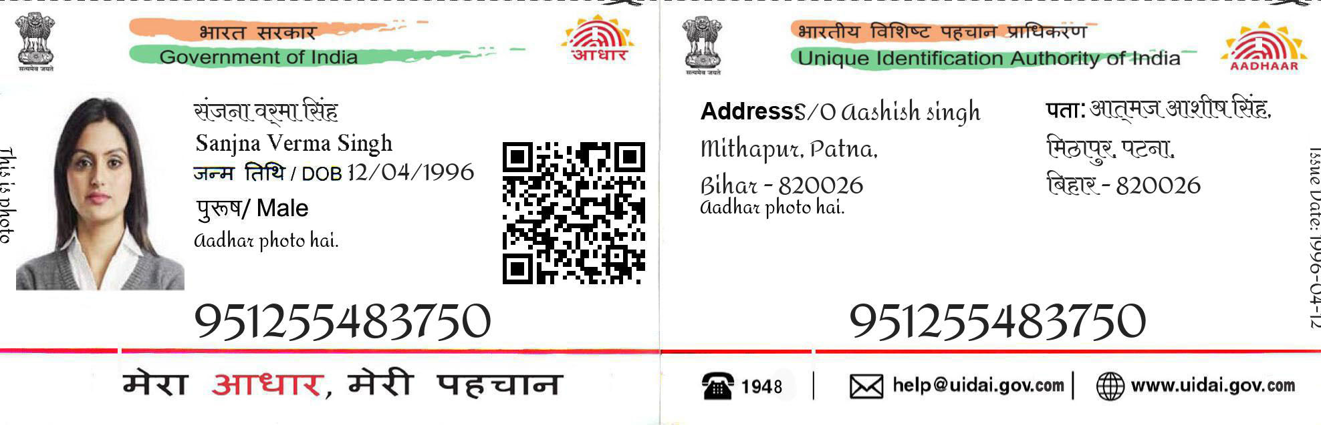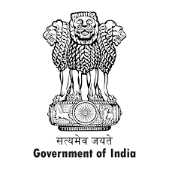

Address nahru camp bijwasan

New delhi 110061

9953 1234 3441