Introduction
This document provides an overview of the Mobile Helix Link HTML5 SDK. The Link SDK consists of four major components:
- A library of JavaScript, CSS, and image resources that can be incorporated into any web-based application to build high performance, native-like mobile experiences using HTML5.
- A JSF integration built as an extension library to PrimeFaces. Building applications using the JSF integration requires JSF2.0, a Java EE container, and PrimeFaces.
- A series of plugins to Apache Cordova, built for Android and iOS with support planned for Windows 8 in the near future. These extensions come in two flavors: community and proprietary. As a general rule, community plugins are implemented to function without the security features of the Mobile Helix Container and the associated key management and encryption. Proprietary plugins require integration with the Link system and deliver all of the security benefits provided by Link. The security features of Mobile Helix Link are described elsewhere in the Link documentation.
- The Link web services. These services are available to application developers who are building enterprise applications to run within the Link system and they are available to developers using Link's cloud-based service offering.

Licensing
All open source components of the Link HTML5 SDK are licensed under a BSD-style license that can be found in the source file entitled “LICENSE” in the Link HTML5 SDK download.

How to get the SDK?
The Link HTML5 SDK and all Community plugins are available as open source software. These are available on GitHub at https://github.com/shallem.
Customers of Mobile Helix Link can also download the Link HTML5 SDK and the Link Container including all proprietary plugins from the Link support center.

The Architecture of the Link HTML5 SDK
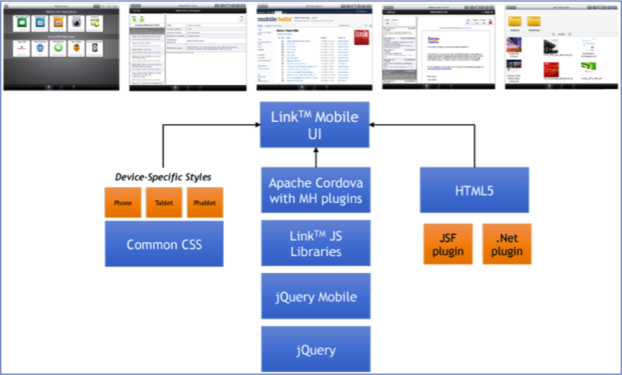
The diagram above provides an overview of the architecture of the Link HTML5 SDK. There are three components of the SDK:
- A set of style sheets designed to render mobile-optimized HTML5 apps.
- A JavaScript library, built on top of jQuery and jQuery Mobile with extensions to support Apache Cordova and a number of enhanced features built by Mobile Helix that are described in this documentation.
- Standard HTML5, with a Java Server Faces (JSF) plugin available to make it easy to generate the HTML5 markup using JSF. We intend to release a .NET plugin in Q3 of this year. The JSF plugin is an extension to the popular PrimeFaces JSF component library.

Key Benefits of the Link HTML5 SDK
Understanding why the Link HTML5 SDK is valuable provides insight into its design, structure, and usage model. Each section below describes a benefit of the Link SDK and how that impacts application developers.

Develop Mobile Apps using Familiar Tools and Technologies
To ease the transition from the enterprise web to mobile, the Link HTML5 SDK is designed to leverage the existing tools, technologies, and processes supporting the enterprise web. Specifically, the Link HTML5 SDK:
- Enables developers to build mobile apps using existing tools for development and deployment and existing infrastructure. This means that apps built with the Link HTML5 SDK are built in the same IDE that developers use for building any web application.
- Enables developers to debug apps using desktop browsers. Developers are already familiar with the debugging tools available in standard desktop browsers and use them regularly. Apps built with the Link HTML5 SDK are first debugged on the desktop then, once they are working in a browser, can be further debugged using FireBug Lite or any other tool of choice on the mobile device. Currently both Chrome and Safari are fully supported desktop browsers. Firefox and IE10 support are on the roadmap.
- To further the point above, Mobile Helix is increasingly ensuring that all Apache Cordova plugins available via either the standard Cordova library or Link's extensions to it perform reasonably on the desktop so that the core application code can be tested in a standard browser. This does not mean that they do exactly the same thing because there is, for example, no “iOS Photo Roll” on a desktop – it does mean, though, that when the code attempts to access the photo roll it will open the “Photos” folder to select a photo on a desktop machine. The rest of the code that uses the returned image data can then be tested on the desktop browser.
- Delivers applications via standard web services and HTTPS infrastructure. Link apps are not hybrid-native in the traditional sense. The Link Container (and its Community edition companion) are native apps that run on the device. However, each individual app does not require its own container. There is one native app on the device that is the browser environment used for downloading and running each app that you build. Apps are downloaded from your web delivery infrastructure (i.e. app servers, web servers, etc.) over HTTPS. In this respect they are no different than any other web application, whether it is targeted for mobile or not.
- Aside from the infrastructure benefits of the point above, Link HTML5 apps can dynamically generate HTML in the same fashion as any standard enterprise web application built with .NET, Java EE, PHP, or any other framework. While providing a full offline experience requires that an app function properly without access to the server, not all apps or app features make sense fully offline. In addition, even when offline the Link Container's browser cache will provide a static view of the last version of a page that the user viewed. In many cases, this static page is sufficient to make the app functional offline. The summary is that the same programming model and much of the same code used in enterprise web apps can be re-purposed for mobile use.
- For JSF developers, the Link HTML5 SDK enables a seamless migration from the desktop JSF World to mobile. There are caveats, especially for offline-enabled applications, that require that JSF developers read the section entitled “Migrating from JSF for Desktops to the Link JSF Integration.” However, the concepts and fundamentals are familiar. Beyond the conceptual integration, per the previous point, Link HTML5 SDK apps are able to re-use all of the server-side infrastructure you have already built in EJBs and Persistence layers running in your Java EE containers. The more code you can re-use, the faster and more reliably you can take your enterprise apps mobile.

Develop Native-like User Experiences
Familiar tools and infrastructure is great, but we all know that mobile apps are only as good as the user experience. Users have high expectations for intuitive, touch-first UIs. With the Link HTML5 SDK developers can build apps every bit as wonderful to use as native apps, but without the many headaches of native development, starting with the proprietary tools, architectures, SDKs, and languages that are required to build native UIs for each mobile platform.
The Link HTML5 SDK is based on standard and open technology – specifically jQuery Mobile – and all UI components in the SDK that are not part of jQuery Mobile are built as plugins for jQuery Mobile. The Link SDK will feel familiar for any jQuery developer to pickup and run with. However, jQuery Mobile does not on its own answer the many challenges of mobile app development. The Link HTML5 SDK solves a number of specific problems that make mobile HTML5 apps challenging:
- Full screen layouts – generally a native mobile app is designed as a full screen layout with individually scrolling components inside of that layout. In an e-mail app you might have a header for navigating between the folder list and your inbox, a footer for navigating between e-mail/contacts/calendar, and in the middle a list of e-mails and the body of the current e-mail you are viewing. That part in the middle needs to scroll on its own without forcing the whole screen to scroll. Apps built in the Link SDK are full-screen apps, and all of the technology to implement independent scrolling is built into the SDK.
- Adaptive UIs – an adaptive UI is an app that looks different on a phone than it does on a tablet without requiring specific coding to each device. In Link, UI components are adaptive, meaning they are styled and act appropriately on different screen sizes without any involvement from the programmer. In addition, the standard CSS3 @media tag is an essential partner in making sure that your own UIs adapt cleanly. The Link SDK JSF integration makes it particularly easy to build adaptive UIs by simply placing phone vs. phablet vs. tablet styles in different CSS files.
- Full component suite – through our efforts to build the Link email and Link content share applications, we have developed and integrated a comprehensive component suite for HTML5 app development. Everything is tested and incorporated seamlessly into the Link SDK. See the “Component Library” section of this documentation to learn about all of the components now at your disposal.

Develop Offline-Enabled Mobile Apps
Mobile apps should be designed to run anytime, anywhere. This requirements means that they must work offline. The good news is that HTML5 includes multiple standardized mechanisms for creating offline user experiences with HTML5. The bad news is that the restrictions and nuances make them difficult to use ubiquitously for enterprise apps. The Link HTML5 SDK is designed to make it easy to use offline apps with a familiar and cross-platform API that will feel natural for enterprise web developers. In addition, customers of Mobile Helix Link can be assured that all offline data is encrypted using Link's key management and security features.
Specifically, the challenges with HTML5 offline storage that the SDK aims to solve are:
- Enterprise apps generally download data from a server, manipulate that data, and allow users to add or modify said data in the app. This pattern is ideally suited to object-relational mapping, which is why ORM has become so popular through frameworks like Hibernate and JDO for Java, and NHibernate and the ADO .NET Entity Framework for .NET. The Link HTML5 SDK includes an enhanced version of PersistenceJS, an open source O-R-M framework for JavaScript. The Link enhancements to PersistenceJS make it easy to synchronize any JSON objects against a local database.
- There are multiple competing standards for HTML5 offline storage. To address this challenge, the SDK abstracts the underlying browser standard from the programmer via PersistenceJS. Today, only WebSQL is supported which limits desktop debugging and mobile apps to webkit-based browsers (e.g. Android, iOS, Chrome, Safari). We are hard at work adding IndexedDB support, which will expand browser support to include recent versions of Firefox and Internet Explorer 10.
- Device-local storage is not ideal in all situations. When storing preferences, for example, it would be better to be able to optionally synchronize data across devices. The Link HTML5 SDK provides access to Link's cloud services which do exactly that. Apps built using the SDK can optionally mark certain preference-style data for synchronization across devices. Preferences are represented as simple key-value pairs, mapping keys to JSON values. To maximize performance, only changes in preferences are downloaded when an app loads, and the most recent preferences download is always available locally for offline execution.
In addition to the usability challenges of developing offline HTML5 applications outlined above, in an enterprise context security is of the utmost importance. With the Link Container's proprietary plugins, full encryption for all offline data is transparently available to application developers without requiring apps to manage keys, explicitly encrypt data, or worry about all of the associated policies that IT might want to set around data lifetime and retention.

No Vendor Lock-in
Because Link HTML5 apps can function both inside of the Link Container and in any standard browser, there is no vendor lock-in with the Link HTML5 SDK. Should you decide not to use the Link infrastructure or to have certain apps run outside of the Link infrastructure, you can do so without any changes to your app. If your app uses Cordova plugins, you can integrate it directly with the open source components available from the Apache Cordova project and with the community extensions to Cordova that Mobile Helix provides on github. In addition, as noted above, we are increasingly ensuring that when possible we provide JavaScript-only alternatives to the functions of the Cordova plugins that work appropriately on modern desktop browsers. There is not always a perfect analogy available, but we do our best to find one and integrate it into our JavaScript libraries.

What is PrimeFaces and how is it related to the Link SDK?
PrimeFaces is an extremely popular JSF component library built by Prime Teknoloji. PrimeFaces is intended for use as both a desktop component framework and a mobile framework. The Mobile Helix Link JSF integration is built as an extension to PrimeFaces, which has several benefits:
- All components in PrimeFaces, PrimeFaces Mobile, and PrimeFaces Extensions are available for use – nothing in the Mobile Helix Link SDK conflicts with the PrimeFaces project.
- The style of JSF development and many aspects of the implementation are familiar to PrimeFaces developers, and there is an increasingly large community of PrimeFaces developers out there.
Beyond those points, our code is not at this point in any way integrated with the PrimeFaces project. We apply our best efforts to ensure that JSF developers can use the Link SDK with any recent version of PrimeFaces.

Guide to this Documentation
This documentation is divided into four sections, which introduce the major concepts in the Link SDK:
- “Data in the Link SDK,” which introduces how the Link SDK synchronizes data to the client and how offline data works.
- “Components in the Link SDK,” which provides an overview of the UI components available as plugins to jQuery Mobile and how jQuery Mobile and these additional plugins are used in the JSF integration.
- “Integration with the Link System,” which particularly focuses on security and how the Link system ensures the secure delivery and execution of HTML5 apps.

