MINISTRY OF EDUCATION AND SCIENCE OF UKRAINE
American University Kyiv
EPAM School of Digital Technologies

SDT 100 Principles of Programming
Homework 1 Report

Instructor: Kolesnikov V.
Student: Moroz A.

Kyiv 2026
I acknowledge that this is my own work and that no unauthorized help was used.

Task: design and implement two abstract data types in Java - a Counter ADT (increment, value, toString) and a BankAccount ADT (deposit, withdraw, balance) - explain the behavior of every operation, write a client program for each ADT, and trace a Fibonacci-like while loop.

Design and behavior of the operations:
Part 1. Counter ADT
increment() - adds 1 to the internal count. Takes no arguments and returns nothing; it is the only operation that changes the state of the counter.
value() - returns the current count as an int. A pure observer: calling it never changes the state.
toString() - returns the name of the counter together with its count, for example "clicks: 3", so a Counter can be printed directly.
The count field is private, so a client can only move it upward one step at a time. That invariant is what makes Counter an abstract data type rather than a plain int.
Part 2. BankAccount ADT
deposit(amount) - adds amount to the balance. A zero or negative amount is rejected with IllegalArgumentException and the balance stays unchanged.
withdraw(amount) - subtracts amount from the balance. A non-positive amount is rejected with IllegalArgumentException, and an amount larger than the balance is rejected with IllegalStateException; in both cases the balance stays unchanged.
balance() - returns the current balance. A pure observer that never changes the state.
The invariant is that the balance can never become negative, which is why withdraw checks the amount before subtracting it.
Part 3. Fibonacci-like loop
The key detail is that b is updated before a. Since the new b equals a + b, the expression b - a in the next statement gives back the previous value of b, so every pass copies the old b into a and the pair (a, b) walks through consecutive Fibonacci numbers: (1,1), (1,2), (2,3), (3,5), (5,8), (8,13), (13,21). After the sixth pass b is 21, the condition b < 20 is false, and the program prints 13, 21.
--
Source code (link to GitHub repository):
https://github.com/shalltearfrost/Homework-1.-Introduction-and-Data-Abstraction
Note: Make sure the link to repository is clickable (!!!) and it leads to proper repository.
--
For online students only: Record Loom video and explain your code while sharing screen and your face. See example and explanations here. Add a loom link here. (Note: make sure the link is clickable (!!!) and it leads to proper video).
[paste your Loom link here]
--

Program Output:
Part 1. Counter ADT
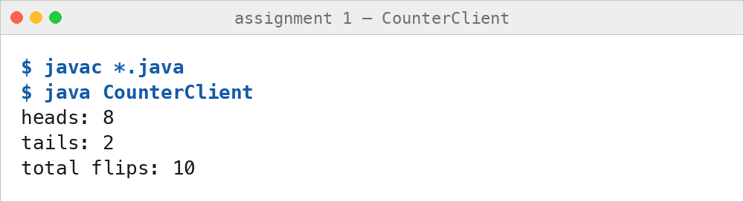
Part 2. Bank Account ADT
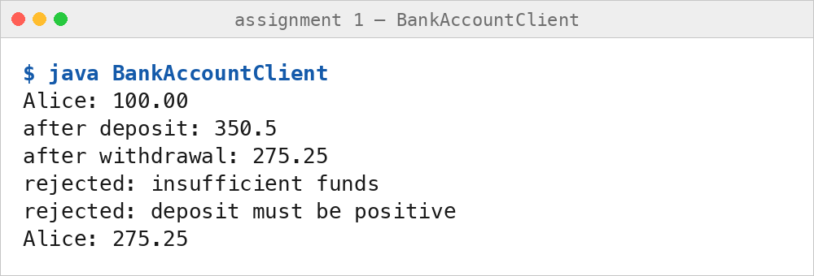
Part 3. Fibonacci-like Loop
