American University Kyiv
SDT 202: Design and Analysis of Data Structures and Algorithms
Project report
“Gradient Descent Algorithm — RetentionRadar”
Instructor: Dr. Valeriy Kolesnikov
Students: Uliana Matviienko
Andrii Moroz
Group: BSEAI 2025
Team: Team 4

Kyiv 2026

CONTENTS
CONTENTS 2
1 INTRODUCTION 3
2 REQUIREMENTS 4
3 DESIGN 5
3.1 Classical gradient descent 5
3.2 Improvement: Nesterov acceleration 5
3.3 Application objective and data 5
3.4 Program architecture and interface 5
4 DIAGRAMS 8
5 CODE WITH COMMENTS 9
6 TESTING REPORT 10
7 INDIVIDUAL CONTRIBUTION 12
8 USER GUIDE 13
8.1 About the program 13
8.2 Requirements 13
8.3 Run in IntelliJ 13
8.4 Run from a terminal 13
8.5 Menu overview 13
8.6 Option 1 — Load UCI cohort 13
8.7 Option 5 — Compare and evaluate 14
8.8 Option 7 — Decision costs 14
8.9 Option 8 — Quadratic contours 14
8.10 Option 9 — Verification 14
9 ABSTRACT 15
REFERENCES 16
APPENDIX A SOURCE CODE LISTING 17

1 INTRODUCTION
The aim of this work is to implement classical batch gradient descent and an accelerated improvement (Nesterov’s method) in plain Java 17, and to apply them to a concrete smooth convex objective: binary logistic regression for an educational student-retention demonstration called RetentionRadar.
Gradient descent is a first-order iterative method for minimizing a differentiable objective f : R^d → R. When a closed-form solution of ∇f(x) = 0 is unavailable, repeated updates of the form x ← x − α∇f(x) provide a practical numerical procedure. Under standard smoothness and convexity assumptions, classical gradient descent admits an O(1/k) objective-gap bound; Nesterov acceleration improves the convex rate to O(1/k²) for ordinary iterates under an appropriate step-size choice.
The application minimizes regularized logistic loss on synthetic data and on an attributed extract of the UCI Machine Learning Repository dataset “Predict Students’ Dropout and Academic Success” (dataset #697) by Realinho et al. [3]. The related open-access descriptor is Realinho et al. (2022) [4]. The binary task is eventual Dropout versus Graduate using seven first-semester features. The program trains models, compares optimizers, evaluates held-out metrics, ranks records, supports an illustrative cost-based decision threshold, and draws ASCII objective contours with sampled optimizer paths. Dataset attribution, licence (CC BY 4.0) [6] and the exact column changes for this project are recorded in data/DATA-SOURCE.md.
Collective work uses a single GitHub repository [7]. Project repository: https://github.com/shalltearfrost/RetentionRadar
The implementation uses only the JDK (no Maven/Gradle and no external Java libraries). Interactive use is through a console menu; demonstration modes are also available via command-line flags.

Loom video with code overview and demonstration of cli: https://www.loom.com/share/cc00903b85c24884a7a22bbc0e00cc9a

Slides: https://docs.google.com/presentation/d/1a0D-lV8_tCeVkLgVUL2ufW6ebyDE_gtb0frY-4JIT18/edit?usp=sharing

[Report will still be updated and refined for the final submission. It doesn’t have all of the required screenshots and diagrams yet and uses placeholders]

2 REQUIREMENTS
The primary requirement is to implement the gradient descent algorithm in Java and demonstrate it on a meaningful optimization problem, including an improved variant with comparison against the classical method.
Project requirements addressed by this deliverable include:
- implementation of classical batch gradient descent with a shared optimizer interface;
- implementation of Nesterov accelerated gradient descent as the improvement;
- a reusable ObjectiveFunction abstraction (value and gradient);
- a stable logistic-regression objective with unregularized bias;
- synthetic cohort generation with a fixed seed for offline demos;
- loading of an attributed real CSV extract with strict schema checks;
- stratified train/test split and train-only feature standardization;
- held-out evaluation (accuracy, precision, recall, F1, AUC, log-loss, Brier, confusion);
- comparison of updates, objective values, gradient norms and evaluation call counts;
- ASCII contour visualization of optimizer trajectories;
- top-25 held-out ranking and an illustrative error-cost threshold control;
- dependency-free verification suite (58 checks);
- English interactive console menu and non-interactive demonstration modes;
- reproducibility with JDK 17+ and IntelliJ project descriptors.

3 DESIGN

3.1 Classical gradient descent
The vector update is x_{k+1} = x_k − α ∇f(x_k). For an L-smooth convex objective with 0 < α ≤ 1/L and an attained minimizer, the standard bound is f(x_k) − f(x*) ≤ ‖x_0 − x*‖² / (2 α k), i.e. an O(1/k) objective-gap rate. The implementation stops on gradient-norm tolerance (a different criterion from an objective-gap benchmark).
Pseudocode matching GradientDescent.minimize:
GRADIENT-DESCENT(f, x0, α, tolerance, maxUpdates)
x ← copy(x0); updates ← 0
repeat
value ← f(x); g ← ∇f(x)
if non-finite or magnitude-guard failure → return DIVERGED
if ‖g‖ ≤ tolerance → return x, CONVERGED, updates
if updates = maxUpdates → return x, MAX_ITERATIONS, updates
x ← x − α g; updates ← updates + 1
Worked example: for f(x) = x², ∇f = 2x, L = 2, start x0 = 5. With α = 0.1 the iterates contract (5, 4, 3.2, …); with α = 1.1 the magnitude grows.

3.2 Improvement: Nesterov acceleration
NesterovGradientDescent evaluates the update gradient at a look-ahead point y and uses momentum β_k = (k−1)/(k+2) with 0 < α ≤ 1/L. Stopping, history and the returned point refer to the ordinary iterate x. For smooth convex objectives the ordinary-iterate gap bound is O(1/k²): f(x_k) − f(x*) ≤ 2‖x_0−x*‖² / (α (k+1)²).

3.3 Application objective and data
Logistic loss with softplus-stable evaluation, unregularized bias and slope L2 penalty λ is minimized. A conservative smoothness bound B = Σ‖x_i‖²/(4m) + λ yields α = 1/B. Real data come from the UCI dataset “Predict Students’ Dropout and Academic Success” [3], [4]: the bundled extract keeps 4 424 source rows and seven first-semester features; at load time 794 Enrolled outcomes are omitted and 3 630 Dropout/Graduate records are retained; a stratified 80/20 split (seed 202604) is used for evaluation.

3.4 Program architecture and interface
The program is a console application written in plain Java 17. There is no graphical UI toolkit; visualization is provided by ASCII contour plots printed to the terminal. Numeric output uses Locale.ROOT so decimal points remain stable across JVM locales.
Source packages under auk.sdt202.team4 separate concerns: optimization (classical GD, Nesterov, configuration and results), model (logistic objective), data (CSV loader, synthetic cohort, split, standardizer), app (driver, evaluation, ranking, costs, contours, comparison), and verify (self-checks).
Both optimizers expose the same entry point minimize(ObjectiveFunction, double[], OptimizerConfig) and return an OptimizationResult with the ordinary iterate, objective value, gradient norm, update count, stop reason and optional sampled history. Stopping uses the gradient-norm tolerance before each update and again after the final allowed update.
The main interactive window of the program is the console menu shown after launch with no arguments. Replace the placeholder below with a screenshot of the menu at project root working directory.
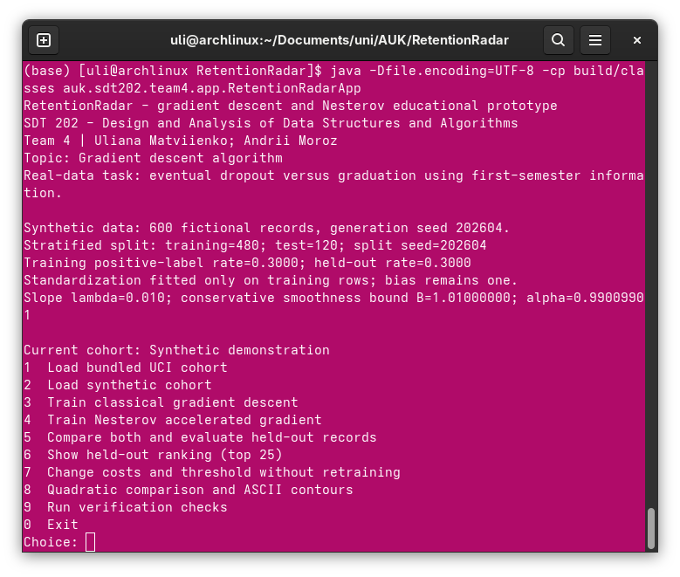
Figure 3.1 – Main console menu of RetentionRadarApp
Selecting option 1 loads the bundled UCI extract. The loader reports source rows, omitted Enrolled outcomes and retained Dropout/Graduate records.
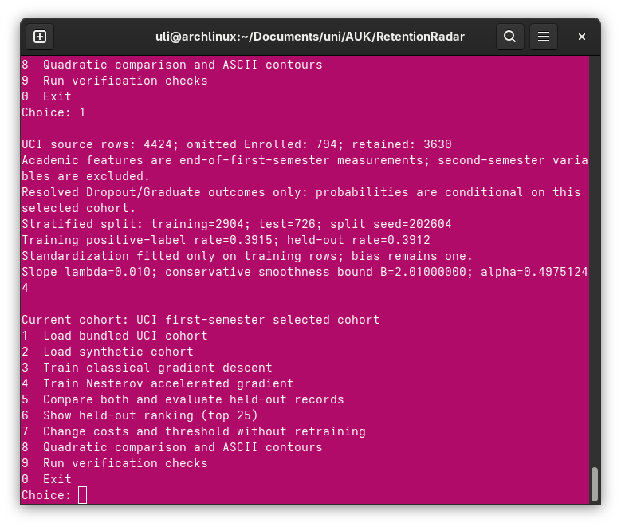
Figure 3.2 – Loading the bundled UCI cohort (menu option 1)
Options 3 and 4 train classical gradient descent and Nesterov acceleration on the current cohort. Option 5 trains both methods, prints a comparison table, held-out metrics and projected ASCII contours for two coefficient coordinates.
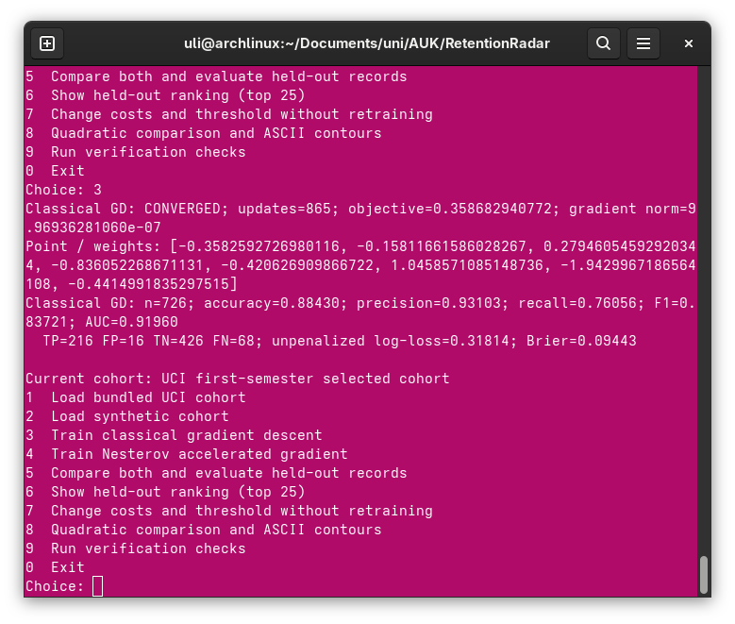
Figure 3.3 – Classical gradient descent training summary (menu option 3)
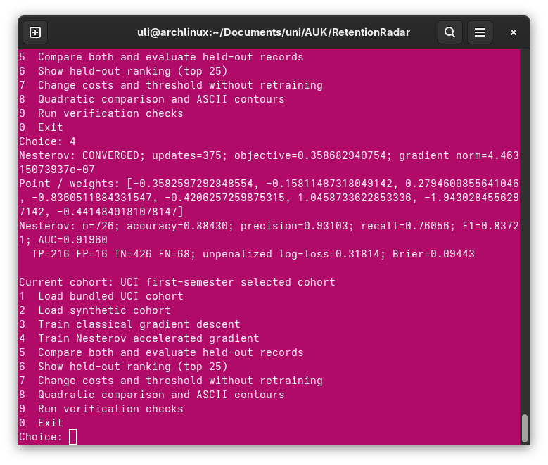
Figure 3.4 – Nesterov training summary (menu option 4)
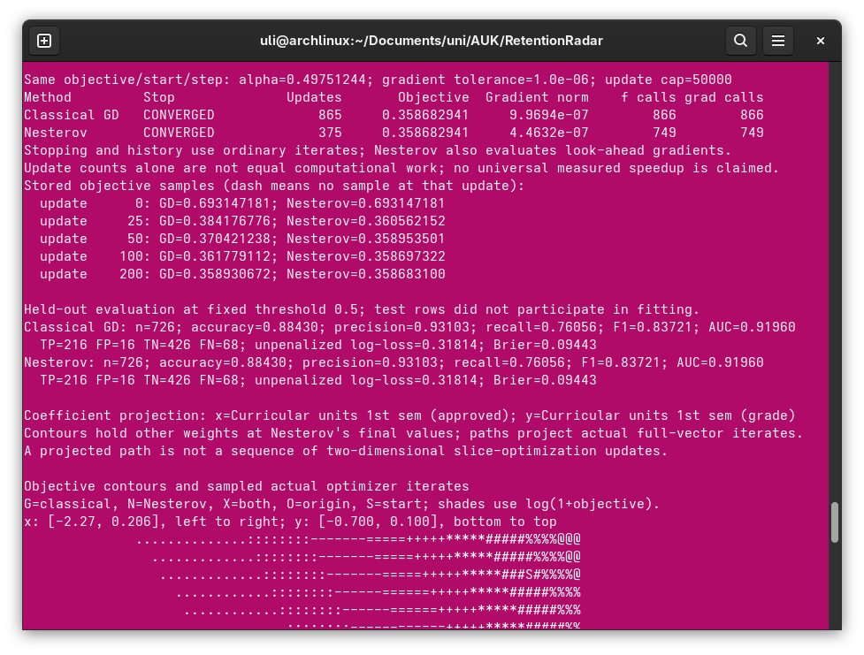
Figure 3.5 – Side-by-side comparison, held-out metrics and ASCII contours (menu option 5)
Option 6 prints the top-25 held-out ranking by predicted risk score. Option 7 changes illustrative missed-positive and unnecessary-outreach costs; the decision threshold updates without retraining model coefficients.
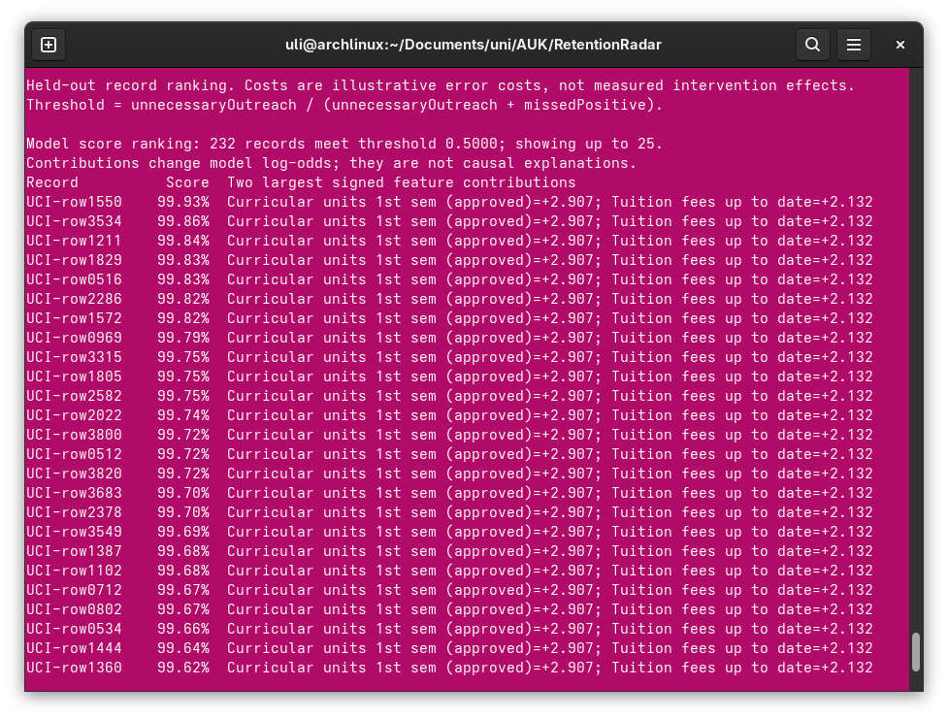
Figure 3.6 – Held-out ranking, top 25 (menu option 6)
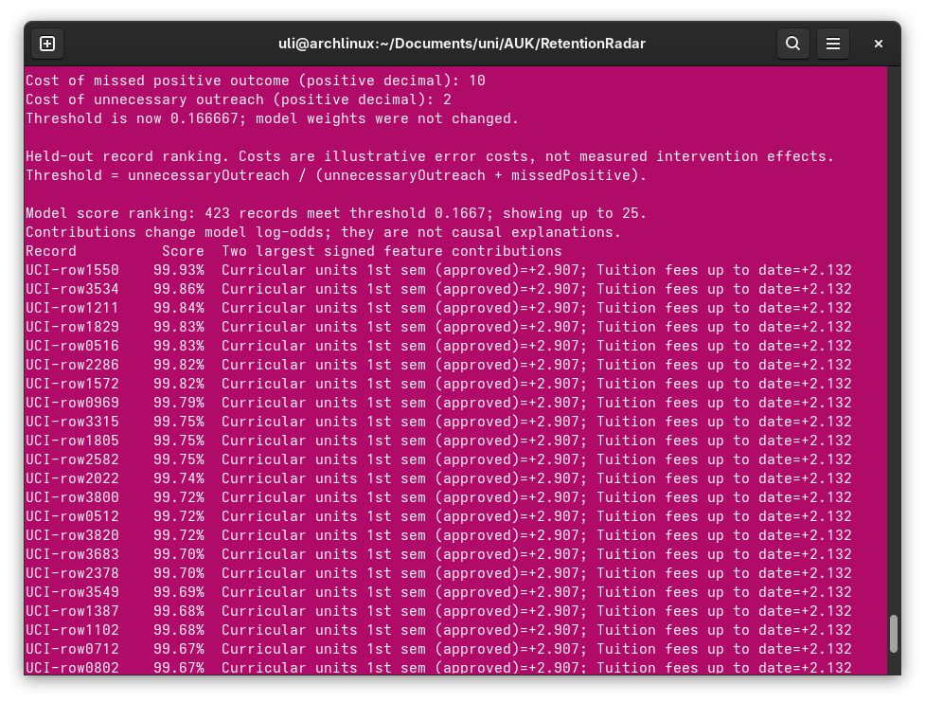
Figure 3.7 – Cost inputs and updated threshold (menu option 7)
Option 8 runs the known quadratic comparison used to illustrate acceleration on a smooth strongly curved bowl. Option 9 runs the full verification suite.
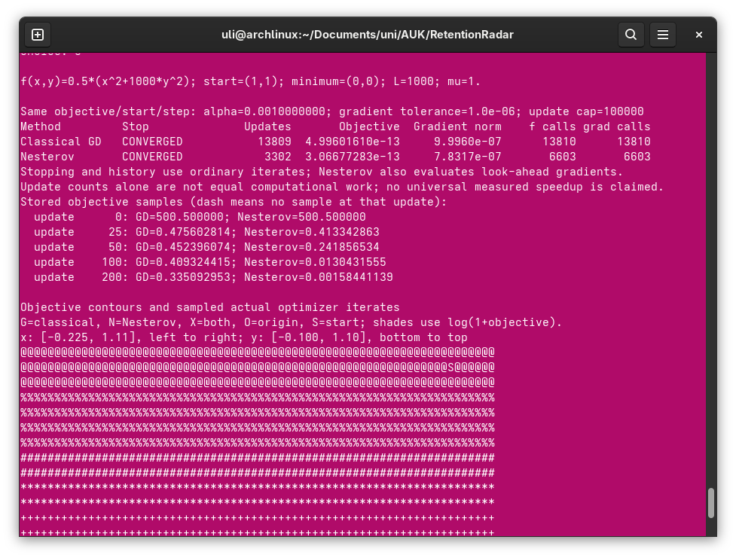
Figure 3.8 – Quadratic comparison and ASCII contours (menu option 8)
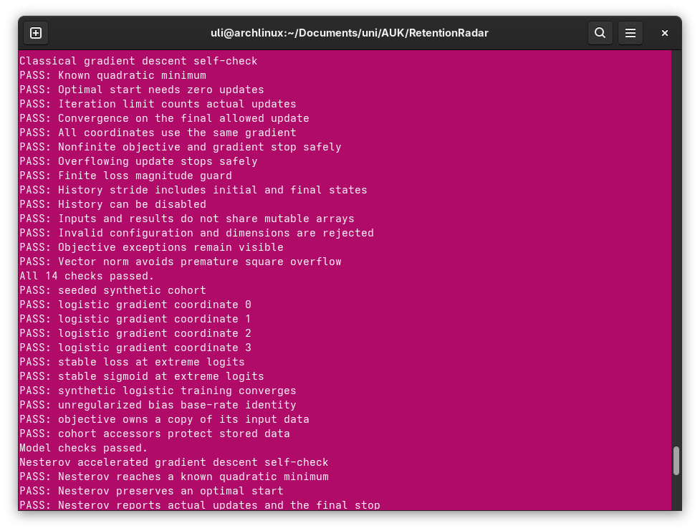
Figure 3.9 – Verification checks passing (menu option 9 / --verify)
IntelliJ project layout and the remote repository provide structural evidence of the deliverable organization.
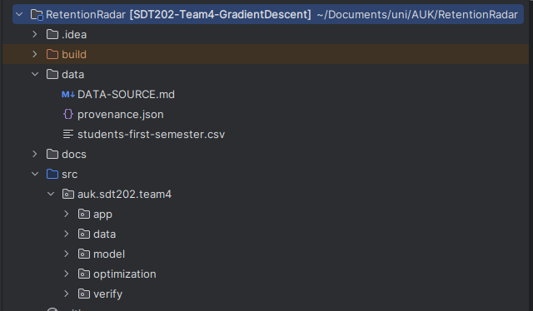
Figure 3.10 – IntelliJ project structure (src packages and data/)

4 DIAGRAMS
This section will be added for final project submission.

5 CODE WITH COMMENTS
Source code is provided in Appendix A. New comments and code for UI will be added for the final submission.
The driver class is auk.sdt202.team4.app.RetentionRadarApp. Classical and accelerated optimizers live in the optimization package and share the ObjectiveFunction interface implemented by LogisticObjective and QuadraticObjective.

6 TESTING REPORT
Functional behaviour was checked with the built-in verification mode (RetentionRadarApp --verify), which currently executes 58 dependency-free checks, and with recorded demonstration runs on synthetic data, the UCI extract and a known quadratic. Table 6.1 summarizes representative tests.
Table 6.1 – Program tests
ID | Description | Steps | Input | Expected | Actual | 0/1
V-01 | All verification checks pass | Run --verify from project root | — | 58 PASS lines; exit 0 | See Fig. 6.1 | 1
V-02 | Classical GD reaches known quadratic minimum | Run --quadratic or menu 8 | f=0.5(x²+100y²), start (1,1) | CONVERGED near (0,0) | See Fig. 6.2 | 1
V-03 | Nesterov uses fewer updates than GD on ill-conditioned bowl | Run --compare | f=0.5(x²+1000y²), α=0.001 | Nesterov updates < GD updates | GD 13809 / Nest. 3302 (recorded) | 1
V-04 | UCI loader retains resolved outcomes only | Run --real or menu 1 then 5 | bundled CSV | 3630 retained; 794 Enrolled omitted | Matches recorded run | 1
V-05 | Held-out metrics printed for both methods | Menu 5 after UCI load | seed 202604 split | Accuracy/AUC etc. finite; both methods agree | Acc. 0.88430, AUC 0.91960 | 1
V-06 | Cost change updates threshold without retraining | Menu 7 after compare | missed=9, outreach=1 | Threshold falls; more eligible rows | 0.5→0.1; 232→558 eligible | 1
V-07 | Ranking lists top 25 held-out scores | Menu 6 | fitted model present | 25 rows with scores/labels | See Fig. 6.6 | 1
V-08 | Invalid CSV schema rejected | Load malformed file via --real path | wrong headers | Clear error; no crash | Covered by DataCheck | 1
V-09 | Too-large step reports divergence | Self-check magnitude/step cases | unsafe α in checks | StopReason DIVERGED or guarded | Covered by SelfCheck | 1
V-10 | Fresh clone builds and verifies | Clone repo; compile; --verify; --real | JDK 17+ | Same counts/metrics as validation notes | Documented in validation.md | 1

Recorded UCI configuration: stratified 80/20 split (train 2904 / test 726, seed 202604), λ = 0.01, B = 2.01, α = 1/B, tolerance 1e−6, maximum 50 000 updates. Classical GD used 865 updates (866 gradient calls); Nesterov used 375 updates (749 gradient calls). Held-out confusion at threshold 0.5: TP=216, FP=16, TN=426, FN=68.
Update-count reductions are not wall-clock speedups: Nesterov also evaluates look-ahead points. Results are for one fixed selected-cohort split and do not establish institutional deployment performance.
[SCREENSHOT PLACEHOLDER — insert image here]
Figure 6.1 – Verification output (--verify), all checks PASS
[SCREENSHOT PLACEHOLDER — insert image here]
Figure 6.2 – Quadratic demonstration output
[SCREENSHOT PLACEHOLDER — insert image here]
Figure 6.3 – Compare mode: iteration/call counts and ASCII contours
[SCREENSHOT PLACEHOLDER — insert image here]
Figure 6.4 – Real-data training comparison (UCI)
[SCREENSHOT PLACEHOLDER — insert image here]
Figure 6.5 – Held-out metrics and confusion counts
[SCREENSHOT PLACEHOLDER — insert image here]
Figure 6.6 – Top-25 ranking output
[SCREENSHOT PLACEHOLDER — insert image here]
Figure 6.7 – Cost/threshold change without retraining
[SCREENSHOT PLACEHOLDER — insert image here]
Figure 6.8 – Sample verification of a rejected/invalid input case

7 INDIVIDUAL CONTRIBUTION
Table 7.1 – Contribution summary [will be updated for the final submission]
Member | Areas of work | Estimated share
Uliana Matviienko | Report, presentation slides, UI and GUI, visualisations | 50%
Andrii Moroz | Classical GD, Nesterov, CLI, tests, data | 50%

8 USER GUIDE

8.1 About the program
RetentionRadar is a console tool that trains logistic regression with classical gradient descent and Nesterov acceleration, then evaluates and ranks held-out student records for an educational retention demonstration.

8.2 Requirements
- JDK 17 or newer on PATH (or selected in IntelliJ);
- working directory set to the project root so data/students-first-semester.csv resolves;
- no external Java libraries required.

8.3 Run in IntelliJ
Open the project folder, select JDK 17+, set the working directory to the project root, and run auk.sdt202.team4.app.RetentionRadarApp. With no program arguments the interactive menu appears. Optional arguments: --verify, --quadratic, --compare, --synthetic, --real, or --real "path/to/file.csv".

8.4 Run from a terminal
mkdir -p build/classes && find src -name '*.java' > sources.txt && javac --release 17 -d build/classes @sources.txt && java -Dfile.encoding=UTF-8 -cp build/classes auk.sdt202.team4.app.RetentionRadarApp
On Windows, build.ps1 / run.ps1 wrap the same workflow.

8.5 Menu overview
The menu starts on the reproducible synthetic cohort. Changing cohorts clears the latest fitted model.
- 1 — Load bundled UCI cohort;
- 2 — Load synthetic cohort;
- 3 — Train classical gradient descent;
- 4 — Train Nesterov accelerated gradient;
- 5 — Compare both methods and evaluate held-out records;
- 6 — Show held-out ranking (top 25);
- 7 — Change illustrative costs and threshold (no retraining);
- 8 — Quadratic comparison and ASCII contours;
- 9 — Run verification checks;
- 0 — Exit.

8.6 Option 1 — Load UCI cohort
Loads data/students-first-semester.csv, omits Enrolled outcomes, and prepares a stratified split with train-only standardization when training is requested.
[SCREENSHOT PLACEHOLDER]
Figure 8.1 – Loading the UCI cohort

8.7 Option 5 — Compare and evaluate
Trains both optimizers with the same objective, initial point, step and tolerance, prints call counts and held-out metrics, and draws projected ASCII contours.
[SCREENSHOT PLACEHOLDER]
Figure 8.2 – Comparison and evaluation output

8.8 Option 7 — Decision costs
Enter positive costs for a missed positive outcome and for unnecessary outreach. The score threshold is derived from these illustrative costs; model weights do not change. Costs are demonstration assumptions, not evidence that outreach prevents dropout.
[SCREENSHOT PLACEHOLDER]
Figure 8.3 – Changing costs and observing the new threshold

8.9 Option 8 — Quadratic contours
Compares both methods on a known two-dimensional quadratic and prints ASCII contours with sampled ordinary iterates.
[SCREENSHOT PLACEHOLDER]
Figure 8.4 – Quadratic ASCII contour view

8.10 Option 9 — Verification
Runs optimizer, model, acceleration, data-pipeline and evaluation checks. All checks should report PASS before a demonstration or submission.
[SCREENSHOT PLACEHOLDER]
Figure 8.5 – Verification menu result

9 ABSTRACT
Gradient Descent Algorithm — RetentionRadar
Authors: Uliana Matviienko, student of group BSEAI 2025; Andrii Moroz, student of group BSEAI 2025
American University Kyiv, Kyiv, Ukraine
This project implements classical batch gradient descent and Nesterov accelerated gradient descent in plain Java 17 and applies both methods to logistic regression. The educational application RetentionRadar estimates the probability of eventual student dropout versus graduation from seven first-semester academic and administrative features, using a reproducible synthetic cohort and an attributed UCI data extract. The shared optimizer interface returns ordinary iterates with explicit stop reasons. On a fixed stratified UCI split, both methods reached the same held-out accuracy and AUC to the displayed precision, while Nesterov required fewer parameter updates (with additional look-ahead evaluations). The deliverable includes ASCII trajectory contours, held-out ranking, an illustrative cost-based threshold, and a 58-check offline verification suite. Limitations of the selected cohort, feature timing and single-split evaluation are stated explicitly.
Supervisor: Dr. Valeriy Kolesnikov

REFERENCES
1. Tibshirani R. Gradient Descent. Carnegie Mellon University convex optimization lecture notes. URL: https://www.stat.cmu.edu/~ryantibs/convexopt/lectures/grad-descent.pdf (accessed: 09.10.2026).
2. Su W., Boyd S., Candes E. A Differential Equation for Modeling Nesterov’s Accelerated Gradient Method: Theory and Insights. URL: https://web.stanford.edu/~boyd/papers/pdf/ode_nest_grad.pdf (accessed: 09.10.2026).
3. Realinho V. et al. Predict Students’ Dropout and Academic Success. UCI Machine Learning Repository, dataset #697. URL: https://archive.ics.uci.edu/dataset/697/predict+students+dropout+and+academic+success (accessed: 09.10.2026).
4. Realinho V., Machado J., Baptista L., Martins M. V. Predicting Student Dropout and Academic Success. Data 2022, 7(11), 146. URL: https://www.mdpi.com/2306-5729/7/11/146 (accessed: 09.10.2026).
5. Shalizi C. Logistic Regression. CMU lecture notes. URL: https://stat.cmu.edu/~cshalizi/dm/20/lectures/07/lecture-07.html (accessed: 09.10.2026).
6. Creative Commons Attribution 4.0 International (CC BY 4.0). URL: https://creativecommons.org/licenses/by/4.0/ (accessed: 09.10.2026).
7. Project repository (GitHub). URL: https://github.com/shalltearfrost/RetentionRadar (accessed: 09.10.2026).
Clickable repository link: https://github.com/shalltearfrost/RetentionRadar
Clickable UCI dataset link: https://archive.ics.uci.edu/dataset/697/predict+students+dropout+and+academic+success

APPENDIX A SOURCE CODE LISTING
Uliana Matviienko; Andrii Moroz
SDT 202 — Design and Analysis of Data Structures and Algorithms
Project: Gradient Descent Algorithm — RetentionRadar
Date: 19.10.2026
Estimated team hours: 20
We acknowledge that this is our team work.
[Full code will be provided in the finahttps://docs.google.com/presentation/d/1a0D-lV8_tCeVkLgVUL2ufW6ebyDE_gtb0frY-4JIT18/edit?usp=sharingl report]
- auk/sdt202/team4/app/RetentionRadarApp.java — driver and interactive menu
- auk/sdt202/team4/app/ComparisonReport.java — comparison tables and contour projection
- auk/sdt202/team4/app/Evaluation.java — held-out metrics
- auk/sdt202/team4/app/Watchlist.java — ranking
- auk/sdt202/team4/app/DecisionCosts.java — illustrative threshold from costs
- auk/sdt202/team4/app/AsciiContour.java — ASCII contour renderer
- auk/sdt202/team4/app/QuadraticObjective.java — known quadratic demo objective
- auk/sdt202/team4/optimization/ObjectiveFunction.java
- auk/sdt202/team4/optimization/OptimizerConfig.java
- auk/sdt202/team4/optimization/OptimizationResult.java
- auk/sdt202/team4/optimization/StopReason.java
- auk/sdt202/team4/optimization/GradientDescent.java
- auk/sdt202/team4/optimization/NesterovGradientDescent.java
- auk/sdt202/team4/optimization/VectorMath.java
- auk/sdt202/team4/model/LogisticObjective.java
- auk/sdt202/team4/data/SyntheticCohort.java
- auk/sdt202/team4/data/StudentCsvLoader.java
- auk/sdt202/team4/data/DataSplit.java
- auk/sdt202/team4/data/Standardizer.java
- auk/sdt202/team4/verify/SelfCheck.java
- auk/sdt202/team4/verify/ModelCheck.java
- auk/sdt202/team4/verify/AccelerationCheck.java
- auk/sdt202/team4/verify/DataCheck.java
- auk/sdt202/team4/verify/EvaluationCheck.java
Representative classical update (conceptual; match GradientDescent.java after adding your comments):
x ← x − α · ∇f(x)
stop when ‖∇f(x)‖ ≤ tolerance, or after maxUpdates, or on non-finite / magnitude divergence
Representative Nesterov look-ahead step (conceptual; match NesterovGradientDescent.java):
evaluate gradient at look-ahead y;
x ← y − α · ∇f(y);
β ← (k−1)/(k+2);
y ← x + β (x − x_previous);
return and stop on the ordinary iterate x

