Tutorial 4 – Mapping and Autonomous Navigation

Exercise 4.1 – Creating a Virtual Map (simulation)
- In this exercise, the concept of creating a virtual map using a laser scanner will be performed. The required files have already been created by the original developer and this exercise will have focus on the application usage.

- If other SLAM packages (apart from gmapping) is used, there is a need to install their individual package. After installing the SLAM package, run a world developed by Turtlebot3.

$ ros2 launch turtlebot3_gazebo turtlebot3_world.launch.py

$ ros2 param set /gazebo use_sim_time True
$ ros2 launch turtlebot3_cartographer cartographer.launch.py use_sim_time:=True
Note: The package will require the definition of the Turtlebot type. It may be done using:
$ export TURTLEBOT3_MODEL=model
- After executing the SLAM package, a rviz GUI will appear with the Turtlebot slowly mapping out area which the laser scanner can detect (Figure 1).
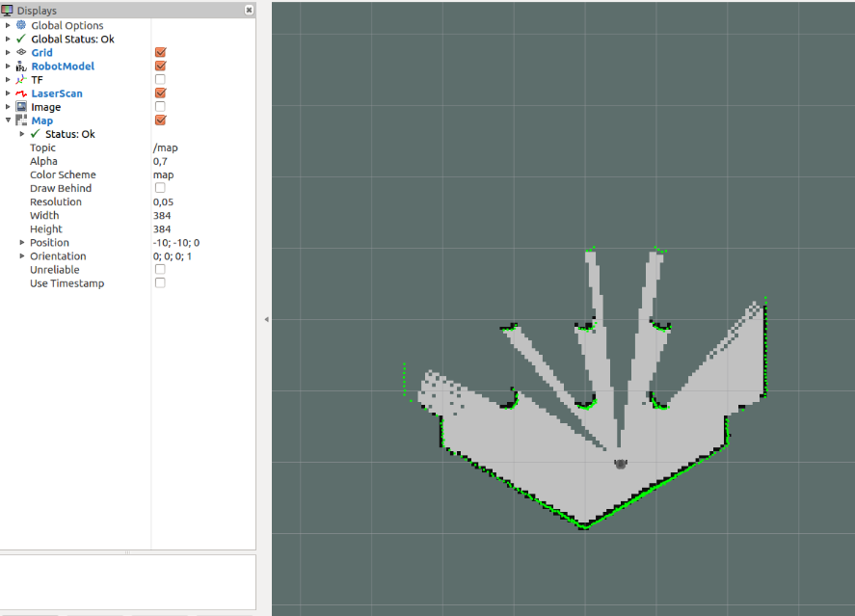
Figure 1. SLAM package mapping area which the laser scanner can detect.
- Move the Turtlebot around the arena (using turtlebot3_teleop package) until a satisfied map of the world is formed. Next, save the map using a different terminal with the command:
$ ros2 run nav2_map_server map_saver_cli –f ~/name_of_map

- The map created by the package: map_server will automatically be saved in the Home directory.

- Next, you may add new obstacles or clean the map using an edit tool called Gimp. Right click on the .pgm file created and select open with: gimp image editor (Figure 2). A GUI should appear looking similar to windows paint application.
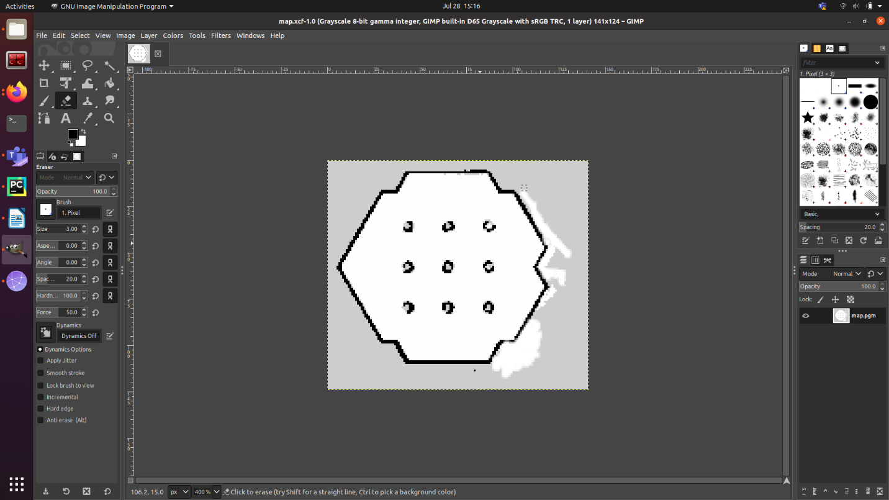
Figure 2. Gimp image editor.
Use the pencil and eraser tool to create and remove obstacles respectively. Save the map upon completion. You can also add in a fake obstacle across half the map to see the effect on the system.

Exercise 4.2 – Autonomous Navigation to Target (Figure 3)
- This exercise focus on using an algorithm called move_base to allow the Turtlebot to navigate autonomously to a location. This algorithm plans the path autonomously and adjust the path to target dynamically if there is a new obstacle appearing. The algorithm would require the use of the map created in Exercise 4.1.

- While keeping the gazebo map running, launch the navigation package using the command:

$ ros2 launch turtlebot3_navigation2 navigation2.launch.py

- The rviz GUI would appear with the Turtlebot randomly located. The background would contain the .pgm created earlier will be static while the region which the Turtlebot scans with its laser would appear green.

- Do an estimate orientation of the Turtlebot using the 2D Pose Estimate button in rviz. The direction of the green arrow represents the orientation which the Turtlebot is currently facing. Drop the location to where the Turtlebot is and face the arrow in the direction the Turtlebot is facing.

- The scanned region would match with the .pgm image if the position has been set correctly.

- To perform autonomous navigation, drop the 2D Nav Goal arrow anywhere on the map and the Turtlebot would autonomously plan the path towards the target.

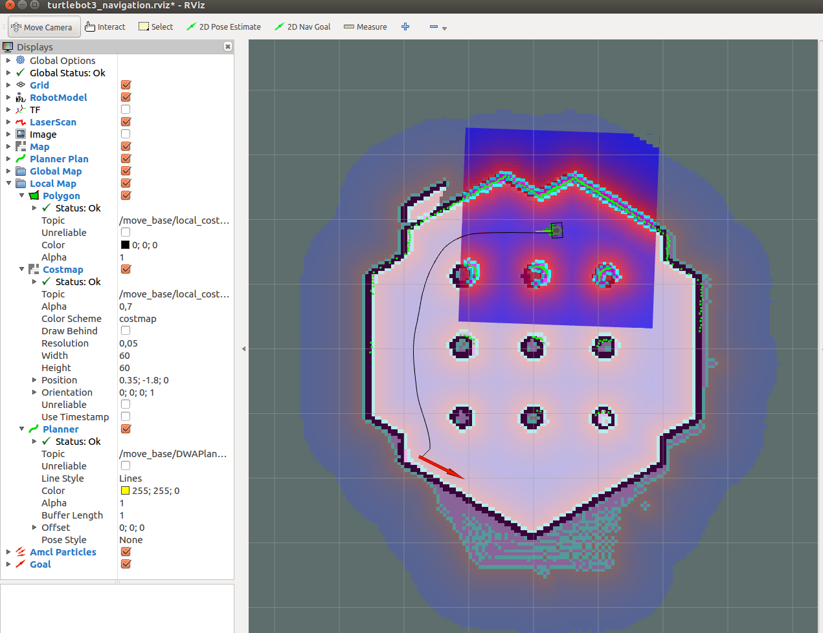
Figure 3. Autonomous Navigation using move_base
Exercise 4.3 – Autonomous Navigation (Physical)
In this exercise, the objective is to piece everything together from the previous exercises to create an autonomous navigation script. The script will be evaluated at the end of the program based on the speed and accuracy which the Turtlebot navigates through the maze.
The main equipment to perform the autonomous navigation are the camera and the laser scanner. The laser scanner gives the reading of distance between the Turtlebot and the obstacles in the range between 120mm to 3500mm. Anything beyond the range would yield infinity reading from the rostopic.

Part One: Maze Runner
The initial (skeleton) coding to complete a maze is as shown below:

For Maze Runner: install dependencies! (Hint: Use rosdep)
sudo pip3 install transforms3d
- import rclpy
- import time
- from threading import Thread
- from rclpy.executors import SingleThreadedExecutor, MultiThreadedExecutor
- from rclpy.node import Node
- # Message Interface Imports
- from geometry_msgs.msg import Twist
- from nav_msgs.msg import Odometry
- from sensor_msgs.msg import LaserScan
- # Transformations for ROS2
- import tf_transformations
- from rclpy.callback_groups import MutuallyExclusiveCallbackGroup, ReentrantCallbackGroup
- from rclpy.qos import QoSProfile, QoSReliabilityPolicy, QoSHistoryPolicy

- #Declaring Global Variables
- maxpos = 0
- yaw = 0
- turnindex = 0

- class MazeNav(Node):
- def __init__(self):
- # Class Constructor
- super().__init__('maze_nav')

- reentrant_callback_group = ReentrantCallbackGroup()
- timer_cb_group = MutuallyExclusiveCallbackGroup()

- # Twist: Publisher Object [Queue Size : 1]
- self.cmd_vel_pub = self.create_publisher(Twist, 'cmd_vel', 1)
- # Laser Scan: Subscriber Object
- self.laser_subscriber = self.create_subscription(
- LaserScan, '/scan', self.scan_callback, QoSProfile(depth=1, reliability=QoSReliabilityPolicy.BEST_EFFORT),callback_group=reentrant_callback_group)
- # Odometry: Subscriber Object
- self.odom_subscriber = self.create_subscription(
- Odometry, '/odom', self.odom_callback, QoSProfile(depth=1, reliability=QoSReliabilityPolicy.BEST_EFFORT),callback_group=reentrant_callback_group)

- # Variable Declaration
- self.laser_subscriber
- self.odom_subscriber
- self.turnindex = 0
- # define the timer period for 0.5 seconds
- self.timer_period = 0.5
- # define the variable to save the received info
- self.laser_forward = 0
- # Twist message: Definition
- self.command = Twist()
- self.command.linear.x = 0.0
- self.command.linear.z = 0.0

- self.motion_freq = 0.05
- self.motion_timer = self.create_timer(self.motion_freq, self.nav_motion, callback_group=timer_cb_group)

- # Function for odom_callback

- def scan_callback(self, msg):
- global range_front
- global range_right
- global range_left
- global ranges
- global maxpos

- # Obtain Range from the Front, Right and Left
- range_front = msg.ranges[0]
- range_right = msg.ranges[270]
- range_left = msg.ranges[90]

- # Obtain the Furthest Distance odom_callback
- ranges = [range_front, range_right, range_left]
- maxpos = ranges.index(max(ranges)) + 1

- # Function for Orientation

- def odom_callback(self, msg2):
- global yaw

- # Obtain Quaternion Orientation
- quaternion = (msg2.pose.pose.orientation.x, msg2.pose.pose.orientation.y,
- msg2.pose.pose.orientation.z, msg2.pose.pose.orientation.w)
- # Transform Quaternion to Euler coordinate system
- euler = tf_transformations.euler_from_quaternion(quaternion)
- yaw = euler[2]

- # Transform Yaw into 360 degrees format
- if (yaw < 0):
- yaw += 6.28319

- def nav_motion(self):
- global maxpos
- global yaw

- ########### GO FORWARD ##################
- # Edit Here

- ############################################
- ########### TURN RIGHT ###################
- # Edit Here

- ############################################
- ########### TURN LEFT ###################
- # Edit Here

- def main(args=None):
- rclpy.init()
- node = MazeNav()
- executor = MultiThreadedExecutor()
- executor.add_node(node)

- try:
- node.get_logger().info('Beginning client, shut down with CTRL-C')
- executor.spin()
- except KeyboardInterrupt:
- node.get_logger().info('Keyboard interrupt, shutting down.\n')
- node.destroy_node()
- rclpy.shutdown()

- if __name__ == '__main__':
- main()

The idea of the maze solver was to detect the furthest distance in 3 directions: front, left and right. Next, the Turtlebot would go forward autonomously in the direction which has the furthest distance.
- The first function (callback) subscribes to the /scan topic and gives the range between in the 3 directions. It also provides the index (maxpos) of which direction has the furthest distance.

- The second function (location) subscribes to the /odom topic and gives the orientation of the Turtlebot in the unit of degrees (°).

- The main function was split into 3 portions each doing its required navigation for the 3 directions. The left and right algorithm will be similar with the only difference in positive and negative velocity.

During this exercise, each team may share the physical maze to test the code and the team. The scoring system is as follows:
- Any team who requested for the answer code to be revealed will have points deducted.
Maximum reveal is 2 per team (50 points per review).

- Team may decide between two types of review; changing orientation and compensation.

- Team with the fastest clear time (once the team exit the marking for the maze) will have no points deducted. Subsequent team will have 10 points deducted (i.e. rank 6 will have 50 points deducted).

- Each time the Turtlebot hits the wall, 10 points will be deducted.

- Turtlebot turning at the wrong direction will be allowed for retries. (i.e. /scan topic publish false details).

- During the start of the script, no team shall be allowed to touch the computer, Turtlebot or any of the race settings.

- The team are not allowed to use scripts from other sources (e.g. move_base or other open sources). No sharing of scripts as well!
The team with the highest point wins!

