TUTORIAL 3 – AR SENSING AND AUTONOMOUS TRACKING

Exercise 3.1 – Creating a launch file to open your webcam
- Install the package usb_node to allow the usage of cameras connected via usb.
$ sudo apt-get install ros-version_name-usb-cam
To Check version_name:
$ echo $ROS_DISTRO
- To find the camera connection to which port and index of the turtlebot, use the command
$ ls –ltrh /dev/video*
- Create a launch file, called cam.launch.py within the tut3 package in the workspace.
- Launch File should launch two nodes:
  - Node to run Camera Driver
  - Node to display Camera image
from launch import LaunchDescription
from launch_ros.actions import Node

def generate_launch_description():
return LaunchDescription([
Node(
package="add usb camera package name" ,
executable="add node executable for camera driver",
parameters=[{
"video_device": "/dev/video*",#identify video device number
"image_width": 640,
"image_height": 480,
"framerate": 10.0,
"camera_frame_id": "camera_link" ,
"pixel_format": "yuyv",
}],
name="camera"
),
Node(
package=" add usb camera package name ",
executable=" add node executable for displaying image ",
remappings=[
("image", "camera/image_raw"),
],
output="screen",
emulate_tty=True,
respawn="false",
name="image_view"
),
])

- To Identify the node executables, run
$ ros2 pkg executables <camera package name>
- After Build, run the launch file.
Terminal 1
$ ros2 launch <camera_package_name> cam.launch.py
- Change the mapping to camera
Terminal 2 [Keep changing values to see the Transformation in RViz]
$ ros2 run tf2_ros static_transform_publisher 0 0 0 0 0 0 map default_cam
Value format: x y z qx qy qz
Units: meters and radians
- In another tmux terminal, launch rviz2
Terminal 3
$ rviz2
- In RViz window,
  - Click Add
  - Select “By topic” tab
  - Select /image_raw and Camera[raw]
  - Follow 9.a and 9.b and add Image
  - Click Add
  - Select “By display type”
  - Select TF

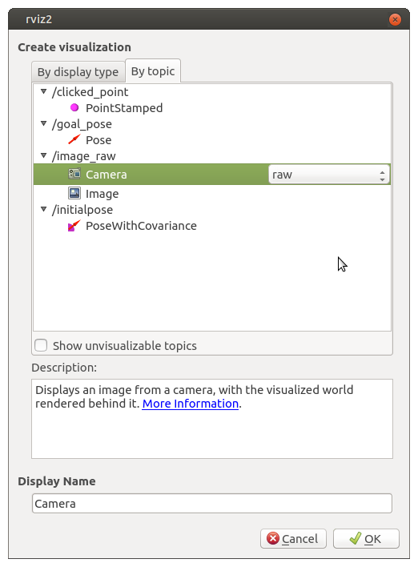

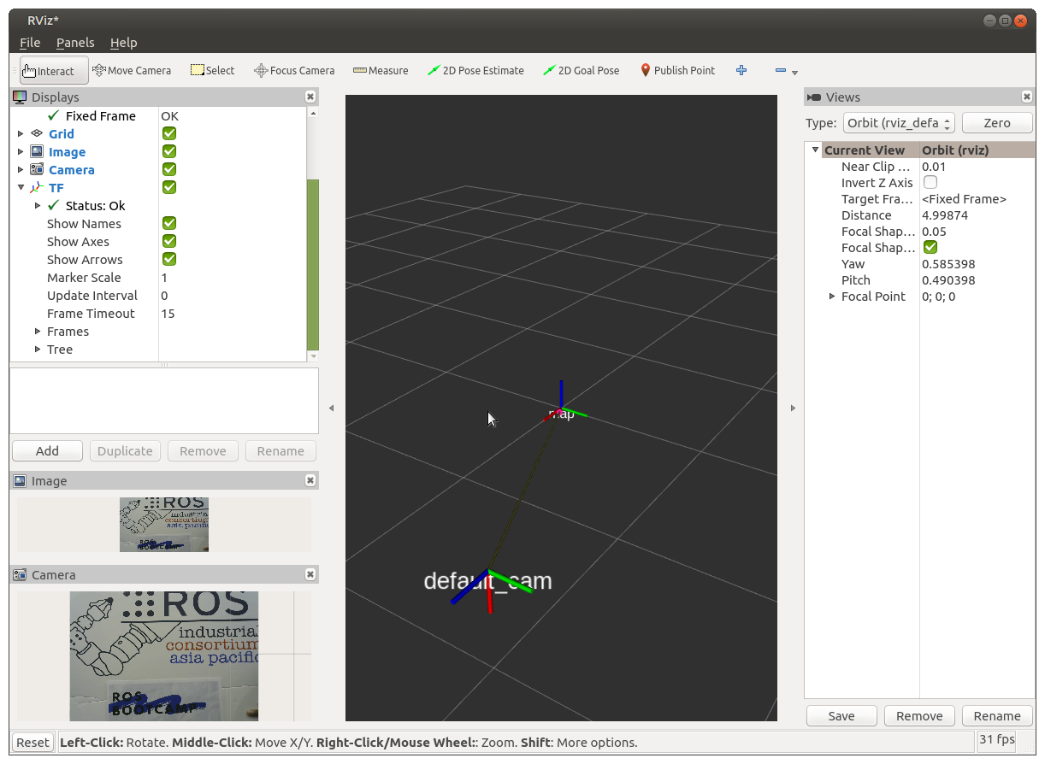
Exercise 3.2 – Calibrating the Camera
https://navigation.ros.org/tutorials/docs/camera_calibration.html (size 8x6)
- Install Camera Calibration Parser, Camera Info Manager & Launch Testing
sudo apt install ros-foxy-camera-calibration-parsers
sudo apt install ros-foxy-camera-info-manager
sudo apt install ros-foxy-launch-testing-ament-cmake
- Image Pipeline need to be built from source in your workspace with:
git clone -b foxy https://github.com/ros-perception/image_pipeline.git
- Launch the ROS driver for the camera
- Make sure camera is publishing images over ROS by running
ros2 topic list
- Start camera calibration node
ros2 run camera_calibration cameracalibrator --size 8x6 --square 0.20 image: image_raw
- Once the calibration is complete, click Save and Commit. Locate the generated file and do the following to make it accessible by the workspace.
$ tar -xvf calibration.tar.gz
- Find calibration configuration yaml file and copy it to tut3/config [create config folder]
- Insert a new line of parameter (for your camera node) within the launch file camera driver node parameters created in Exercise 3.1
“camera_info_url”: ”package://tut3/config/ost.yaml”,

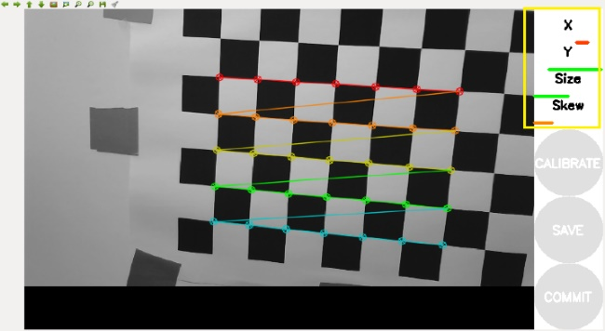
Figure 2. Calibration process with 4 bars marked in yellow box.

Exercise 3.3 – Detecting AR Tag ID and Pose Information
- Collect ARUCO Marker from the trainers. Sample Aruco Marker shown below,

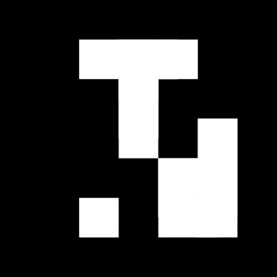

- Create a ar_id_node.py file in the tut3 package. Use the ar_id_code_template.py inside tut3 package as a reference and follow instructions mentioned in them.
- Add entry points for executables in setup.py
- Add ros2_aruco executable dependency in package.xml
- Open 4 Terminals
  - Terminal 1: Launch Camera launch file created in 3.1.
  - Terminal 2: Run robot.launch.py from turtlebot3_bringup.
  - Terminal 3: Run aruco_node from ros2_aruco package.
  - Terminal 4: Run created ar_id_node from tut3 package.
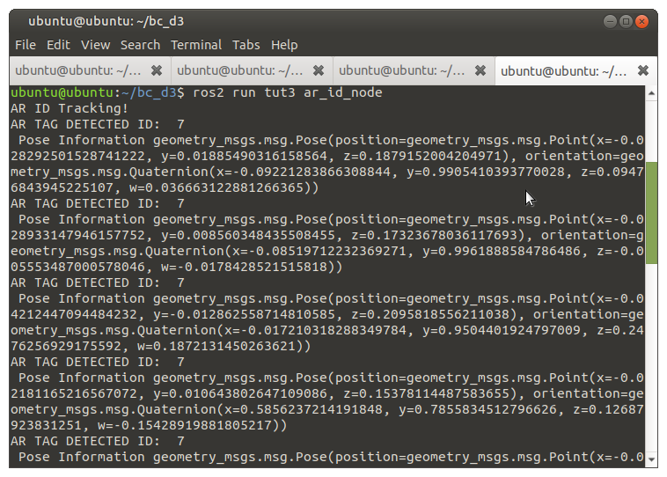

Exercise 3.4 – AR Tag Tracking
The following task would allow the Turtlebot to track an AR tag. Breakdown of task:
- Obtain the right orientation and direction between the Turtlebot and the AR tag.
- The Turtlebot needs to publish velocity based on the distance to the AR tag
- The Turtlebot has to orientate itself to the AR tag so it will stay perpendicular to the it.

Task 1: Coordinate Confirmation based on Pose
Use the pose information obtained in the Exercise 3.3. Observe the pose changes by moving the AR tag forward and backward in Exercise 3.3 and determine which coordinates the translation occurs.
Task 2: P Controller for Linear Velocity [self.linear]
Using the concept of a proportional controller, it will (1) reduce/increase the speed of the Turtlebot as well as (2) going forward/backward based on its distance to the AR tag. The of the proportional controller will be the linear velocity needed to publish to the Turtlebot.
The Equation of a Proportional Controller is as given:
Where:
- is an arbitrary constant decided by the user.
- is the current distance between Turtlebot and the AR tag.
- is the fixed distance between the Turtlebot and the AR tag which the Turtlebot is required to stop.

Task 3: P Controller for Linear Velocity [self.angular]
Use the Pythagoras’ Theorem to determine the angle to which the AR tag is location at. After the angle is found, use a similar Proportional Controller in Task 2 (without ) to publish the angular velocity.
Pythagoras’ Theorem
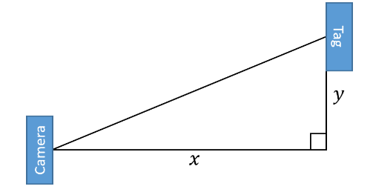

- Create a ar_tracking.py file in the tut3 package. Use the ar_tracking_template.py inside tut3 package as a reference and follow instructions mentioned in them.
- Add entry points for executables in setup.py
- Add ros2_aruco executable dependency in package.xml
- Open 4 Terminals
  - Terminal 1: Launch Camera launch file created in 3.1.
  - Terminal 2: Run robot.launch.py from turtlebot3_bringup.
  - Terminal 3: Run aruco_node from ros2_aruco package.
  - Terminal 4: Run created ar_tracking from tut3 package.

