R Markdown 格式测试

测试作者

2025-04-11

Table of Contents

# 基本文本格式

这是**粗体**文本，这是*斜体*文本。

## 列表示例

1. 第一项
2. 第二项
   * 子项 A
   * 子项 B
3. 第三项

# 数据可视化

## 散点图

ggplot(mtcars, aes(x = wt, y = mpg, color = factor(cyl))) +  
 geom_point(size = 3) +  
 labs(title = "汽车重量与油耗关系",  
 x = "重量（1000磅）",  
 y = "每加仑英里数",  
 color = "气缸数") +  
 theme_minimal()

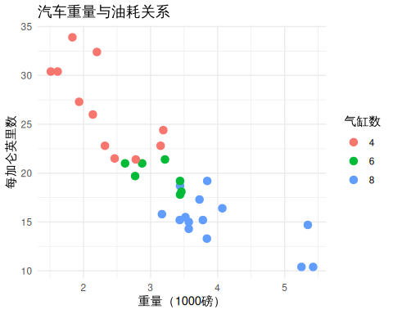

## 箱线图

ggplot(mtcars, aes(x = factor(cyl), y = mpg, fill = factor(cyl))) +  
 geom_boxplot() +  
 labs(title = "不同气缸数的油耗分布",  
 x = "气缸数",  
 y = "每加仑英里数",  
 fill = "气缸数") +  
 theme_minimal()

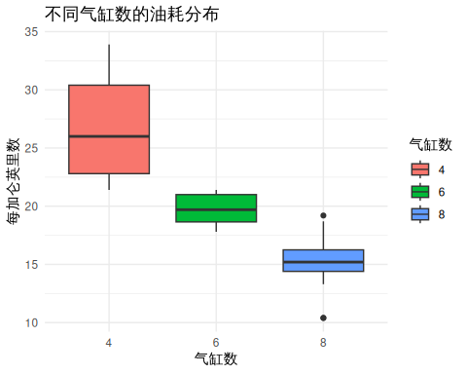

# 表格

## 基本表格

knitr::kable(head(mtcars[, 1:5]),   
 caption = "mtcars 数据集前6行",  
 booktabs = TRUE)

mtcars 数据集前6行

|  | mpg | cyl | disp | hp | drat |
| --- | --- | --- | --- | --- | --- |
| Mazda RX4 | 21.0 | 6 | 160 | 110 | 3.90 |
| Mazda RX4 Wag | 21.0 | 6 | 160 | 110 | 3.90 |
| Datsun 710 | 22.8 | 4 | 108 | 93 | 3.85 |
| Hornet 4 Drive | 21.4 | 6 | 258 | 110 | 3.08 |
| Hornet Sportabout | 18.7 | 8 | 360 | 175 | 3.15 |
| Valiant | 18.1 | 6 | 225 | 105 | 2.76 |

## 统计摘要

summary_stats <- aggregate(mpg ~ cyl, data = mtcars,   
 FUN = function(x) c(mean = mean(x),   
 sd = sd(x)))  
knitr::kable(summary_stats,  
 caption = "不同气缸数的油耗统计",  
 booktabs = TRUE)

## Warning in `[<-.data.frame`(`*tmp*`, , isn, value = structure(list(cyl =  
## structure(c("4", : provided 3 variables to replace 2 variables

不同气缸数的油耗统计

| cyl | mpg |
| --- | --- |
| 4 | 26.663636 |
| 6 | 19.742857 |
| 8 | 15.100000 |

# 数学公式

行内公式：当 $x→∞$ 时， $e^{−x}→0$

显示公式：

$$f\left(x\right)=\frac{1}{σ\sqrt{2π}}e^{−\frac{{\left(x−μ\right)}^{2}}{2σ^{2}}}$$

# 代码示例

fibonacci <- function(n) {  
 if (n <= 1) return(n)  
 fib <- numeric(n+1)  
 fib[1] <- 0  
 fib[2] <- 1  
 for (i in 3:(n+1)) {  
 fib[i] <- fib[i-1] + fib[i-2]  
 }  
 return(fib[n+1])  
}  
  
# 测试函数  
sapply(0:5, fibonacci)

## [1] 0 1 1 2 3 5