APPANROM: A TANGLISH PROGRAMMING LANGUAGE
AND ANDROID APP DEVELOPMENT STUDIO
A PROJECT REPORT
Submitted By
P. SANTHOSH 310124104083
SHALOM ARPUTHA SINGH 310124104089
In Partial Fulfillment for The Award of The Degree
Of
BACHELOR OF ENGINEERING
in
COMPUTER SCIENCE AND ENGINEERING
ANAND INSTITUTE OF HIGHER TECHNOLOGY
(AN AUTONOMOUS INSTITUTION)

ANNA UNIVERSITY: CHENNAI 600025
NOVEMBER 2026

1. ABSTRACT:
AppPanrom is a web-based programming language and development studio that lets people build Android apps by writing in natural Tanglish, everyday spoken Tamil mixed with familiar English programming words, written in the Roman alphabet. Programs use constructs such as app_uruvakku, screen_uruvakku, button with click_pannumbodhu, mari, enna_na/illana, ovvoru and irukkura_varai. The toolchain is implemented in Python and follows the traditional compiler structure. Lexical analysis turns the indentation-based source into tokens, a recursive-descent parser builds an abstract syntax tree, and semantic analysis validates scopes, event handlers, navigation targets and style values, reporting every problem with a line, a column and a suggestion. Valid programs are lowered into a JSON intermediate representation (IR) that also lists the Android permissions needed. One JavaScript runtime interprets the IR under strict step and size limits, and the same file drives both the live phone preview in the Studio and the WebView inside the generated Android app. The Studio, built with React, TypeScript and FastAPI, includes an editor with live diagnostics and a visual designer in which components are dragged from a palette, moved and edited; every designer action is written into the source code, and every code change redraws the design. An Android build engine generates a Gradle project from the IR, builds debug and signed release APKs and AABs in a background job, verifies the result, and keeps signing keys out of code and logs. AppPanrom therefore works both as a compiler toolchain and as a practical environment for creating Android apps in Tanglish.

2. OBJECTIVES:
- To design and implement a multi-phase compiler for a Tanglish language with variables, loops, functions, events, screens and UI components.
- To lower every valid program into one validated intermediate representation shown identically in the preview and the Android app.
- To provide a drag-and-drop designer that updates the code live, and to automate debug and signed release APK and AAB builds.

3. PROPOSED ARCHITECTURE
The system has four layers:
- Presentation layer (frontend/): editor, phone preview, console, palette, design canvas, inspector and build panel.
- Language engine and runtime: lexer, parser, semantic analyzer, IR generator, designer engine, and the shared interpreter and renderer.
- Service layer: FastAPI and SQLite for projects, files, validation, design edits, build jobs and downloads.
- Android build engine: project generator, Gradle build manager, signing checks and artifact verification.
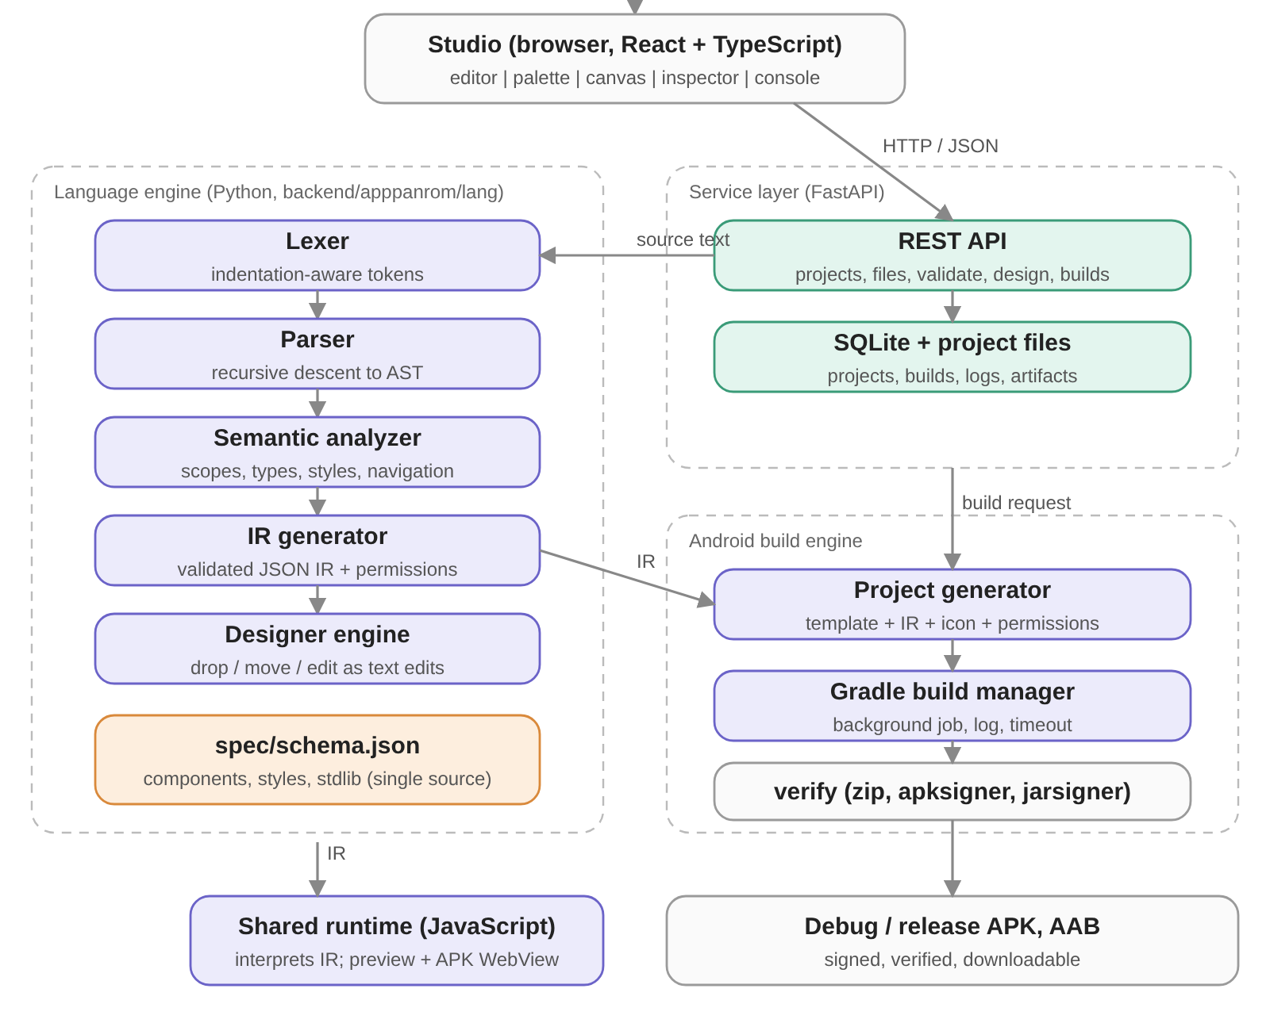
Fig. A: Layered architecture of AppPanrom

4. SYSTEM WORKFLOW:
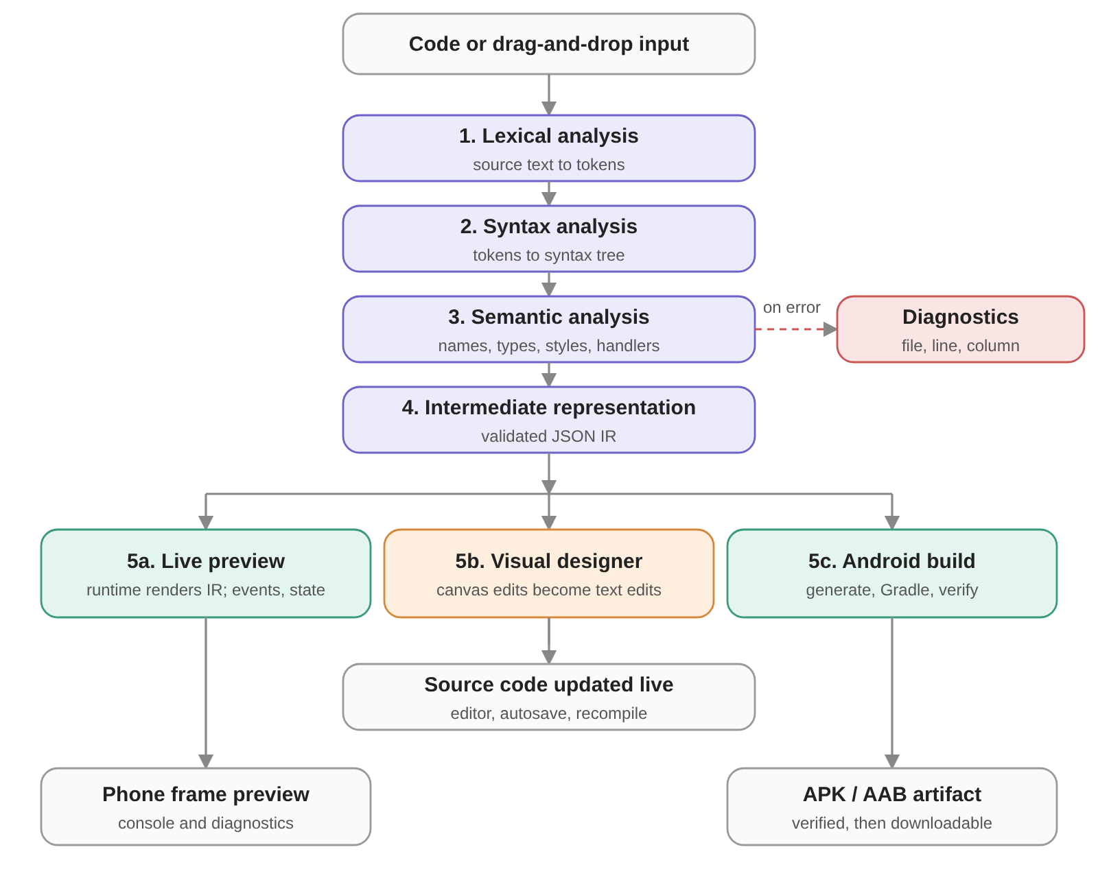
Fig. B: From source or drag-and-drop input to preview, design and Android build

5. ADVANTAGES:
- Complete toolchain: lexical, syntax and semantic analysis, an intermediate representation, a runtime, a designer and an Android build pipeline in one system.
- Natural Tanglish and live design: the language reads like spoken Tanglish, and drag-and-drop edits and code edits update each other instantly.
- Preview equals app: the preview and the APK run the same runtime on the same IR, and invalid designer edits are rejected before they are written.
- Safe and honest builds: an APK is offered only after a real, verified build; signing keys stay out of code and logs, and no user code is run as Python or JavaScript.
- Automatically tested: 114 backend tests, 30 runtime tests and a browser end-to-end suite that drives the real Studio.

APPENDIX – I
SOURCE CODE

======================================================================
A.1 The language
======================================================================

app_uruvakku("Vanakkam App")
mari clicks = 0
function welcome():
clicks = clicks + 1
screen_uruvakku("home"):
button("Click Pannu", click_pannumbodhu=welcome)

======================================================================
A.2 Compiler pipeline (backend/apppanrom/lang/compiler.py)
======================================================================

def compile(self, source: str) -> CompileResult:
try:
program = parse(source)
except SyntaxProblem as e:
return CompileResult(False, [e.diagnostic])

for st in program: # pass 1: declarations
t = st["t"]
if t == "function":
if st["n"] in self.functions:
self.error(st, f"Function '{st['n']}' is already defined.", "duplicate_function")
elif st["n"] in self.spec["functions"] or st["n"] in self.spec["components"]:
self.error(st, f"'{st['n']}' is a built-in name and cannot be redefined.", "reserved_name")
else:
self.functions[st["n"]] = st
elif t == "block_call" and st["f"] == "screen_uruvakku":
name = self._screen_name(st)
if name is not None:
if name in self.screens:
self.error(st, f"Screen '{name}' is declared more than once.", "duplicate_screen")
else:
self.screens[name] = st

ir_globals: list[dict] = []
ir_screens: dict[str, dict] = {}
for st in program: # pass 2: bodies
t = st["t"]
if t == "call_stmt" and st["f"] in self.spec["config_functions"]:
self._config(st)
elif t == "let":
e = self._expr(st["e"], self.globals, None)
if st["n"] in self.globals:
self.error(st, f"Variable '{st['n']}' is already declared.", "duplicate_variable")
self.globals.add(st["n"])
# ... pass 2 (bodies), screens and app metadata: see compiler.py

======================================================================
A.3 Lexical analyzer (backend/apppanrom/lang/lexer.py)
======================================================================

def tokenize(source: str) -> list[Token]:
if len(source.encode("utf-8")) > MAX_SOURCE_BYTES:
raise SyntaxProblem(f"Source is larger than {MAX_SOURCE_BYTES} bytes.", 1, 1, "source_too_large")
tokens: list[Token] = []
indents = [0]
depth = 0 # open brackets: newlines are ignored inside them
lines = source.replace("\r\n", "\n").replace("\r", "\n").split("\n")
for lineno, raw in enumerate(lines, start=1):
i = 0
n = len(raw)
if depth == 0:
stripped = raw.lstrip(" ")
if "\t" in raw[: n - len(raw.lstrip())]:
raise SyntaxProblem("Tabs are not allowed for indentation.", lineno, 1, "tab_indent",
"Use 4 spaces per indentation level.")
if stripped == "" or stripped.startswith("#"):
continue
width = n - len(stripped)
if width % INDENT_WIDTH:
raise SyntaxProblem(f"Indentation must be a multiple of {INDENT_WIDTH} spaces (found {width}).",
lineno, 1, "bad_indent", f"Use {INDENT_WIDTH} spaces per level.")
if width > indents[-1]:
if width != indents[-1] + INDENT_WIDTH:
raise SyntaxProblem("Indented too far; indent one level (4 spaces) at a time.", lineno, 1, "bad_indent")
indents.append(width)
tokens.append(Token("INDENT", None, lineno, 1))
else:
while width < indents[-1]:
indents.pop()
tokens.append(Token("DEDENT", None, lineno, 1))
if width != indents[-1]:
raise SyntaxProblem("Unindent does not match any outer indentation level.", lineno, 1, "bad_indent")
i = width
while i < n:
ch = raw[i]
col = i + 1
if ch in " \t":
i += 1
# ... numbers, names, operators and brackets: see lexer.py

======================================================================
A.4 Syntax analyzer (backend/apppanrom/lang/parser.py)
======================================================================

def or_expr(self):
left = self.and_expr()
while self.is_kw("or"):
t = self.advance()
left = {"t": "bin", "op": "or", "l": left, "r": self.and_expr(), "pos": self.pos(t)}
return left

def compare(self):
left = self.additive()
if self.cur.kind == "OP" and self.cur.value in COMPARE_OPS:
t = self.advance()
left = {"t": "bin", "op": t.value, "l": left, "r": self.additive(), "pos": self.pos(t)}
if self.cur.kind == "OP" and self.cur.value in COMPARE_OPS:
self.err("Chained comparisons are not supported.", suggestion="Use 'and': a < b and b < c")
return left

def additive(self):
left = self.term()
while self.cur.kind == "OP" and self.cur.value in "+-":
t = self.advance()
left = {"t": "bin", "op": t.value, "l": left, "r": self.term(), "pos": self.pos(t)}
return left

======================================================================
A.5 Semantic analyzer (backend/apppanrom/lang/compiler.py)
======================================================================

def _handler(self, node: dict, event: str) -> str:
if node["t"] != "name":
self.error(node, f"{event} must be the name of a function, e.g. {event}=welcome (no quotes, no parentheses).", "bad_handler")
return ""
fn = self.functions.get(node["n"])
if fn is None:
self.error(node, f"Handler function '{node['n']}' is not defined.", "undefined_handler",
self.suggest(node["n"], self.functions) or f"Define it: function {node['n']}():")
elif fn["params"]:
self.error(node, f"Handler '{node['n']}' must take no parameters.", "handler_params")
return node["n"]

def _style_value(self, key: str, d: dict, v: dict):
lt = literal_type(v)
if lt is None:
return # dynamic value: validated again by the runtime
typ = d["type"]
ok = True
if typ == "color":
ok = lt == "str" and bool(HEX_RE.fullmatch(v["v"]))
hint = 'Use a hex color like "#2563EB" or "#FFF".'
elif typ == "number":
ok = lt == "num" and d["min"] <= v["v"] <= d["max"]
hint = f"Use a number from {d['min']} to {d['max']}."
elif typ == "size":
ok = (lt == "num" and 0 <= v["v"] <= 2000) or (lt == "str" and bool(SIZE_RE.fullmatch(v["v"])))
hint = 'Use a number, a percentage like "100%", or "fill".'
elif typ == "enum":
ok = lt == "str" and v["v"] in d["values"]
hint = f"Allowed: {', '.join(d['values'])}."
else: # bool
ok = lt == "bool"
hint = "Use true or false."
if not ok:
self.error(v, f"Invalid value for style '{key}'.", "bad_style_value", hint)

======================================================================
A.6 Runtime interpreter (runtime/apppanrom-runtime.js)
======================================================================

function evalBin(e, env) {
var op = e.op;
if (op === 'and') { var l = evalExpr(e.l, env); return truthy(l) ? truthy(evalExpr(e.r, env)) : false; }
if (op === 'or') { var l2 = evalExpr(e.l, env); return truthy(l2) ? true : truthy(evalExpr(e.r, env)); }
var a = evalExpr(e.l, env), b = evalExpr(e.r, env);
if (op === '==') return deepEqual(a, b);
if (op === '!=') return !deepEqual(a, b);
var ta = typeOf(a), tb = typeOf(b);
if (op === '+') {
if (ta === 'number' && tb === 'number') return finite(a + b, e);
if (ta === 'text' && tb === 'text') {
if (a.length + b.length > LIMITS.stringLength) throw new ApError('Text is too long.', e.pos);
return a + b;
}
if (ta === 'list' && tb === 'list') return a.concat(b);
throw new ApError("Cannot use '+' between " + ta + ' and ' + tb + '.' + (ta === 'text' || tb === 'text' ? ' Use str(...) to convert numbers to text.' : ''), e.pos);
}
if (op === '<' || op === '>' || op === '<=' || op === '>=') {
if (!((ta === 'number' && tb === 'number') || (ta === 'text' && tb === 'text'))) throw new ApError("Cannot compare " + ta + " with " + tb + " using '" + op + "'.", e.pos);
return op === '<' ? a < b : op === '>' ? a > b : op === '<=' ? a <= b : a >= b;
}
if (ta !== 'number' || tb !== 'number') throw new ApError("Cannot use '" + op + "' between " + ta + ' and ' + tb + '.', e.pos);
if (op === '-') return finite(a - b, e);
if (op === '*') return finite(a * b, e);
if (b === 0) throw new ApError('Division by zero.', e.pos);
return op === '/' ? finite(a / b, e) : a % b;
}

function tick(pos) {
if (++steps > LIMITS.steps) throw new ApError('Program ran too long (more than ' + LIMITS.steps + ' steps); it may contain an endless loop.', pos, true);
}
function callUser(name, fn, args, pos) {
if (args.length !== fn.params.length) throw new ApError("Function '" + name + "' expects " + fn.params.length + ' argument(s).', pos);
if (++depth > LIMITS.depth) throw new ApError('Too much recursion (more than ' + LIMITS.depth + ' nested calls).', pos, true);
var env = new Map();
fn.params.forEach(function (p, i) { env.set(p, args[i]); });
try {
var r = execBlock(fn.body, env, null);
return r ? r.v : null;
} finally { depth--; }
}

======================================================================
A.7 Design canvas drop target (runtime/apppanrom-runtime.js)
======================================================================

function zoneFor(ev) {
var t = ev.target && ev.target.closest ? ev.target.closest('[data-ap-line]') : null;
if (t && !app.contains(t)) t = null;
if (dragEl && t && (t === dragEl || dragEl.contains(t))) return null;
if (!t) return { el: null, position: 'inside' };
var r = t.getBoundingClientRect(), par = t.parentElement;
var row = !!par && /^row/.test(doc.defaultView.getComputedStyle(par).flexDirection);
var ratio = row ? (ev.clientX - r.left) / (r.width || 1) : (ev.clientY - r.top) / (r.height || 1);
if (t.hasAttribute('data-ap-container')) return { el: t, position: ratio < 0.25 ? 'before' : ratio > 0.75 ? 'after' : 'inside', row: row };
return { el: t, position: ratio < 0.5 ? 'before' : 'after', row: row };
}

======================================================================
A.8 Designer engine (backend/apppanrom/lang/designer.py)
======================================================================

def _insertion_point(program, target: Loc | None, screen: Loc | None, position: str, edits: Edits) -> tuple[int, int]:
"""Returns (0-based index to insert at, indent). May schedule removal of a lone `summa` placeholder."""
if position == "inside":
box = target or screen
if box is None or not is_container(box.node):
raise DesignError("You can only drop inside a container or a screen.", "not_a_container")
kids = box.node["children"]
indent = _indent_of(kids[0]) if kids else _indent_of(box.node) + INDENT
if len(kids) == 1 and kids[0]["t"] == "summa":
edits.remove(kids[0]["pos"][0] - 1, kids[0]["end"])
return kids[0]["pos"][0] - 1, indent
return box.node["end"], indent
if target is None:
raise DesignError("A target component is required.", "bad_target")
if target.parent is None or not _in_screen(target) or is_screen(target.node):
raise DesignError("You can only drop next to components inside a screen.", "bad_target")
if position == "before":
return target.node["pos"][0] - 1, _indent_of(target.node)
if position == "after":
return target.node["end"], _indent_of(target.node)
raise DesignError("Position must be before, after or inside.", "bad_position")

def _op_move(program, lines, source, op):
node_loc = _need_component(program, int(op["line"]))
if is_screen(node_loc.node):
raise DesignError("Screens cannot be moved here.", "protected")
a, b = node_loc.node["pos"][0] - 1, node_loc.node["end"]
screen = None if op.get("target_line") is not None else _first_screen(program, op.get("screen"))
target = _target(program, op)
if target is not None and a <= target.node["pos"][0] - 1 < b:
raise DesignError("A component cannot be moved into itself.", "bad_target")
edits = Edits()
idx, indent = _insertion_point(program, target, screen, op.get("position", "inside"), edits)
if a <= idx < b and idx != a:
raise DesignError("A component cannot be moved into itself.", "bad_target")
block = reindent(lines[a:b], indent - _indent_of(node_loc.node))
edits.remove(a, b)
_fill_if_empty(edits, node_loc, (a, b))
edits.insert(idx, block)
return edits.apply(lines), idx + edits.shift_before(idx) + 1

======================================================================
A.9 Android build engine (backend/apppanrom/android/builder.py)
======================================================================

// Build job
def _run(self, build_id: str, project_id: str, ir: dict, kind: str, icon: Path | None) -> None:
started = time.monotonic()
work = self.s.builds_dir / build_id / "work"
try:
self.db.execute("UPDATE builds SET status='running', started_at=? WHERE id=?", (_now(), build_id))
pre = check_prerequisites(self.s, use_cache=False)
if not pre["ok"]:
text = format_problems(pre)
self._log(build_id, text)
self._fail(build_id, started, "prerequisites_missing", "Android build prerequisites are missing; see the log.")
return
task, rel_out, suffix, is_release = KINDS[kind]
if is_release:
sign = check_signing(self.s)
if not sign["configured"]:
self._log(build_id, f"{sign['detail']}\n fix: {sign['fix']}")
self._fail(build_id, started, "signing_not_configured", "Release signing is not configured; see the log. No unsigned release is ever produced.")
return
self._log(build_id, "[apppanrom] prerequisites OK; generating Android project")
try:
generate_project(ir, work, icon)
except GenerateError as e:
self._fail(build_id, started, "invalid_project", str(e))
return
code, timed_out = self._gradle(build_id, work, task, is_release)
if timed_out:
self._fail(build_id, started, "timeout", f"Build exceeded the {self.s.build_timeout_s}s time limit and was stopped.", code)
return
if code != 0:
self._fail(build_id, started, "gradle_failed", f"Gradle exited with code {code}; see the log.", code)
# ... store the verified artifact, clean the work directory

// Release signature check
def _verify_release_signature(self, build_id: str, path: Path, kind: str) -> tuple[str | None, str]:
"""Independently checks the signature of a release artifact. Returns (problem, human-readable signing status)."""
if kind == "release_apk":
tool = find_apksigner(self.s)
if not tool:
self._log(build_id, "[apppanrom] apksigner not found in the SDK build-tools; the signature could not be independently verified")
return None, "release key (Gradle signed it; not independently verified: apksigner missing)"
rc, out = _run_tool([tool, "verify", "--print-certs", str(path)])
self._log(build_id, "[apppanrom] apksigner verify:\n" + out.strip()[:2000])
if rc != 0:
return "apksigner could not verify the APK signature.", ""
if "CN=Android Debug" in out:
return "The release APK is signed with the Android debug key, not a release key.", ""
return None, "release key (verified with apksigner)"
tool = find_jarsigner(self.s)
if not tool:
self._log(build_id, "[apppanrom] jarsigner not found; the bundle signature could not be independently verified")
return None, "release key (Gradle signed it; not independently verified: jarsigner missing)"
rc, out = _run_tool([tool, "-verify", "-certs", str(path)])
self._log(build_id, "[apppanrom] jarsigner -verify:\n" + out.strip()[:2000])
if rc != 0 or "jar verified" not in out:
return "jarsigner could not verify the AAB signature (it may be unsigned).", ""
if "CN=Android Debug" in out:
return "The release bundle is signed with the Android debug key, not a release key.", ""
return None, "release key (verified with jarsigner)"

======================================================================
A.10 Android template (android-template/app/build.gradle)
======================================================================

plugins {
id 'com.android.application'
}

android {
// Fixed code namespace; the user-facing application id is set below.
namespace 'com.apppanrom.shell'
compileSdk 34

defaultConfig {
applicationId "__APPLICATION_ID__"
minSdk 24
targetSdk 34
versionCode __VERSION_CODE__
versionName "__VERSION_NAME__"
}

// Release signing material is read from the environment of the Gradle process only (never from files in this project).
signingConfigs {
release {
def storeFilePath = System.getenv("APPANROM_SIGN_STORE_FILE")
if (storeFilePath) {
storeFile file(storeFilePath)
storePassword System.getenv("APPANROM_SIGN_STORE_PASSWORD")
keyAlias System.getenv("APPANROM_SIGN_KEY_ALIAS")
keyPassword System.getenv("APPANROM_SIGN_KEY_PASSWORD")
}
}
}

buildTypes {
release {
minifyEnabled false
// Without the environment above this fails loudly instead of producing an unsigned "release".
signingConfig signingConfigs.release
}

======================================================================
A.11 Automated test of the designer (backend/tests/test_designer.py)
======================================================================

def test_move_out_of_container_reindents():
out = op(BASE, kind="move", line=7, target_line=9, position="after")
lines = out["source"].split("\n")
assert lines[-2] == ' title("Hello")' and lines[out["line"] - 1] == ' title("Hello")'

def test_many_random_edits_keep_source_compilable():
import random
rnd = random.Random(7)
s = BASE
types = ["title", "text_kaattu", "button", "input_uruvakku", "card_uruvakku", "row_uruvakku", "column_uruvakku", "list_kaattu", "divider_kaattu"]
for _ in range(150):
from apppanrom.lang.parser import parse

======================================================================
A.12 Sample run
======================================================================

// Tokens produced by the lexical analyzer (first 10)
# TOKEN TYPE VALUE LINE
1 NAME app_uruvakku 1
2 OP ( 1
3 STRING Vanakkam App 1
4 OP ) 1
5 KEYWORD mari 2
6 NAME clicks 2
7 OP = 2
8 NUMBER 0 2
9 KEYWORD function 3
10 NAME welcome 3

// Intermediate representation (excerpt)
{
"app": {
"name": "Vanakkam App",
"id": "com.apppanrom.myapp",
"version": "1.0.0",
"theme": "light",
"start_screen": "home"
},
"globals": [
{
"t": "let",
"n": "clicks",
"e": {
"t": "num",
"v": 0
}
}
],
"screens": {
"home": {
"body": [
{
"t": "comp",
"c": "button",
"props": {
"label": {
"t": "str",
"v": "Click Pannu"
}
},
"events": {
"click_pannumbodhu": "welcome"
}
}
]
}
},
"permissions": []
}

// Diagnostics for a program with two mistakes
[
{
"severity": "error",
"code": "unknown_function",
"message": "Unknown function 'titel'.",
"line": 2,
"col": 5,
"suggestion": "Did you mean 'title'?"
},
{
"severity": "error",
"code": "undefined_handler",
"message": "Handler function 'missing' is not defined.",
"line": 3,
"col": 36,
"suggestion": "Define it: function missing():"
}
]

// Designer: text edits for a drop and a drag
# Before
screen_uruvakku("home"):
column_uruvakku(style={"gap": 8}):
title("Hello")
text_kaattu("Footer")

# Drop a Button into the column (insert, position=inside, target_line=2)
screen_uruvakku("home"):
column_uruvakku(style={"gap": 8}):
title("Hello")
button("Button")
text_kaattu("Footer")

# Drag the footer text into the column (move, line=4, target_line=2, position=inside)
screen_uruvakku("home"):
column_uruvakku(style={"gap": 8}):
title("Hello")
text_kaattu("Footer")

APPENDIX – II
SCREENSHOTS

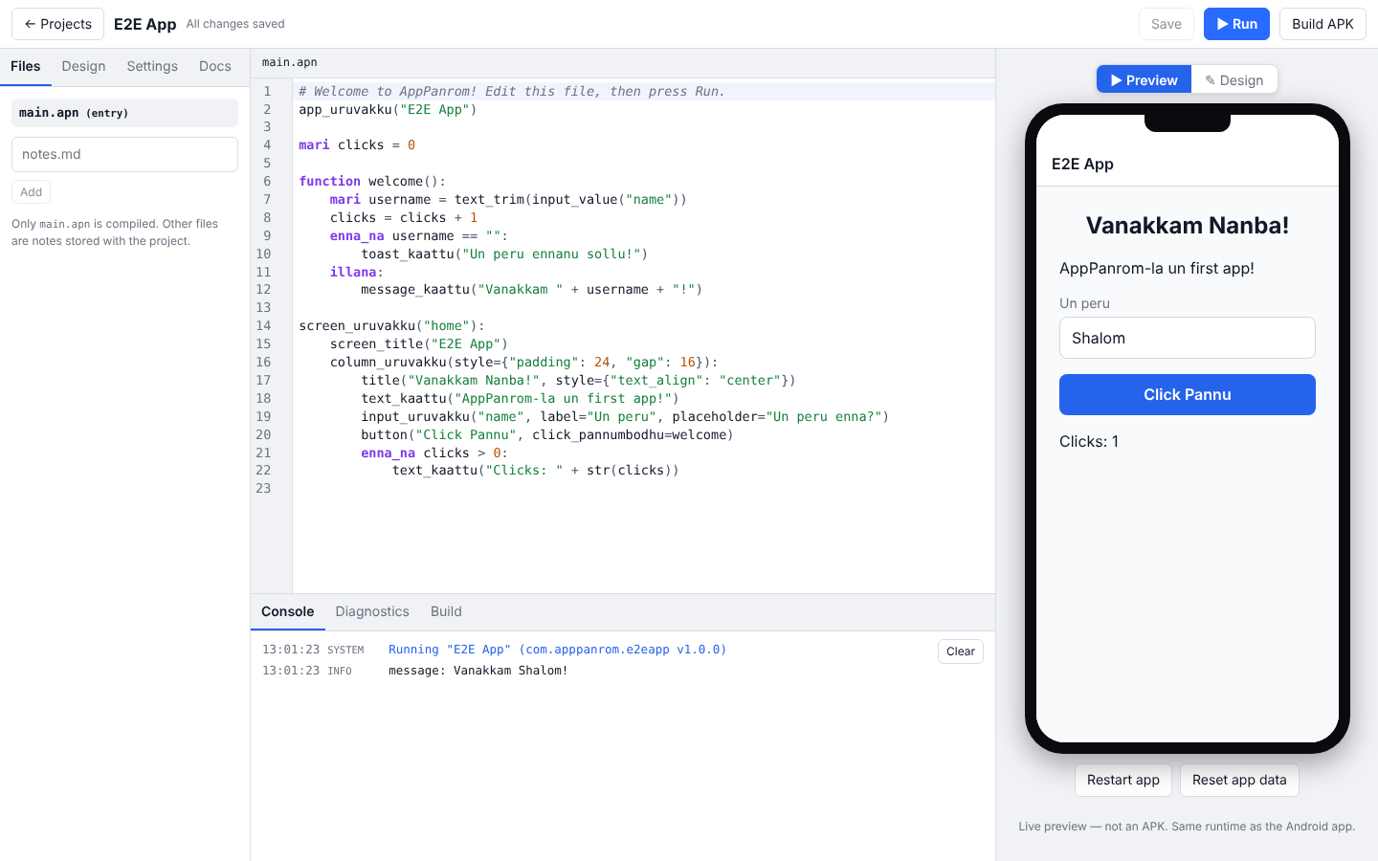
Fig. 1: Code editor and live phone preview after Run
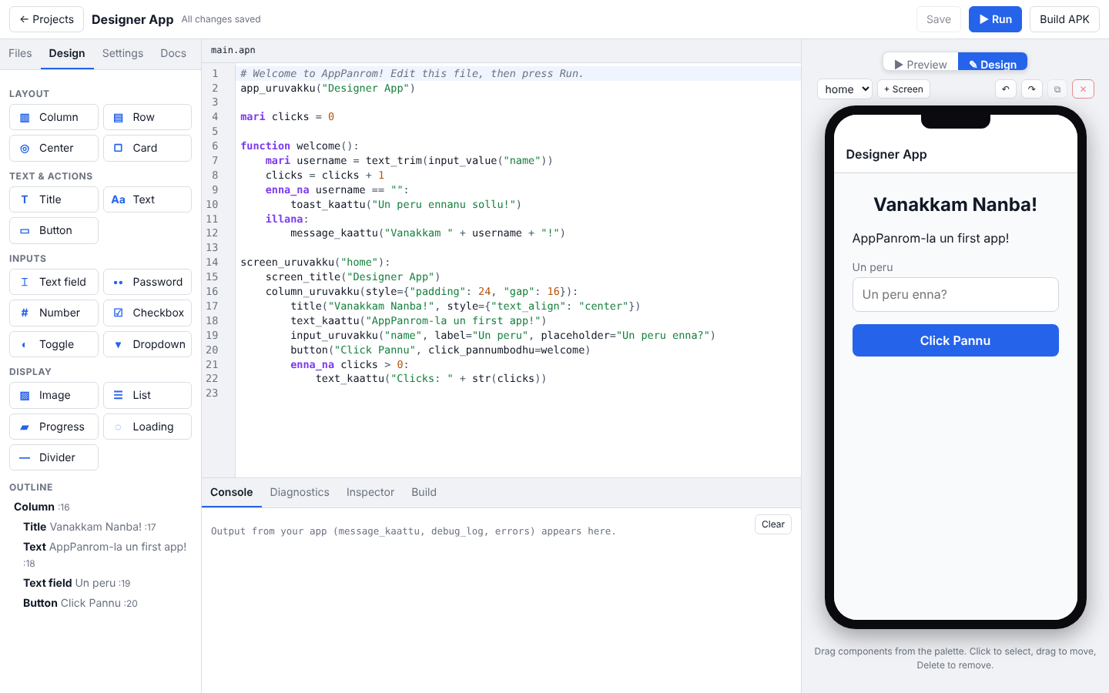
Fig. 2: Visual designer: palette, code and phone canvas
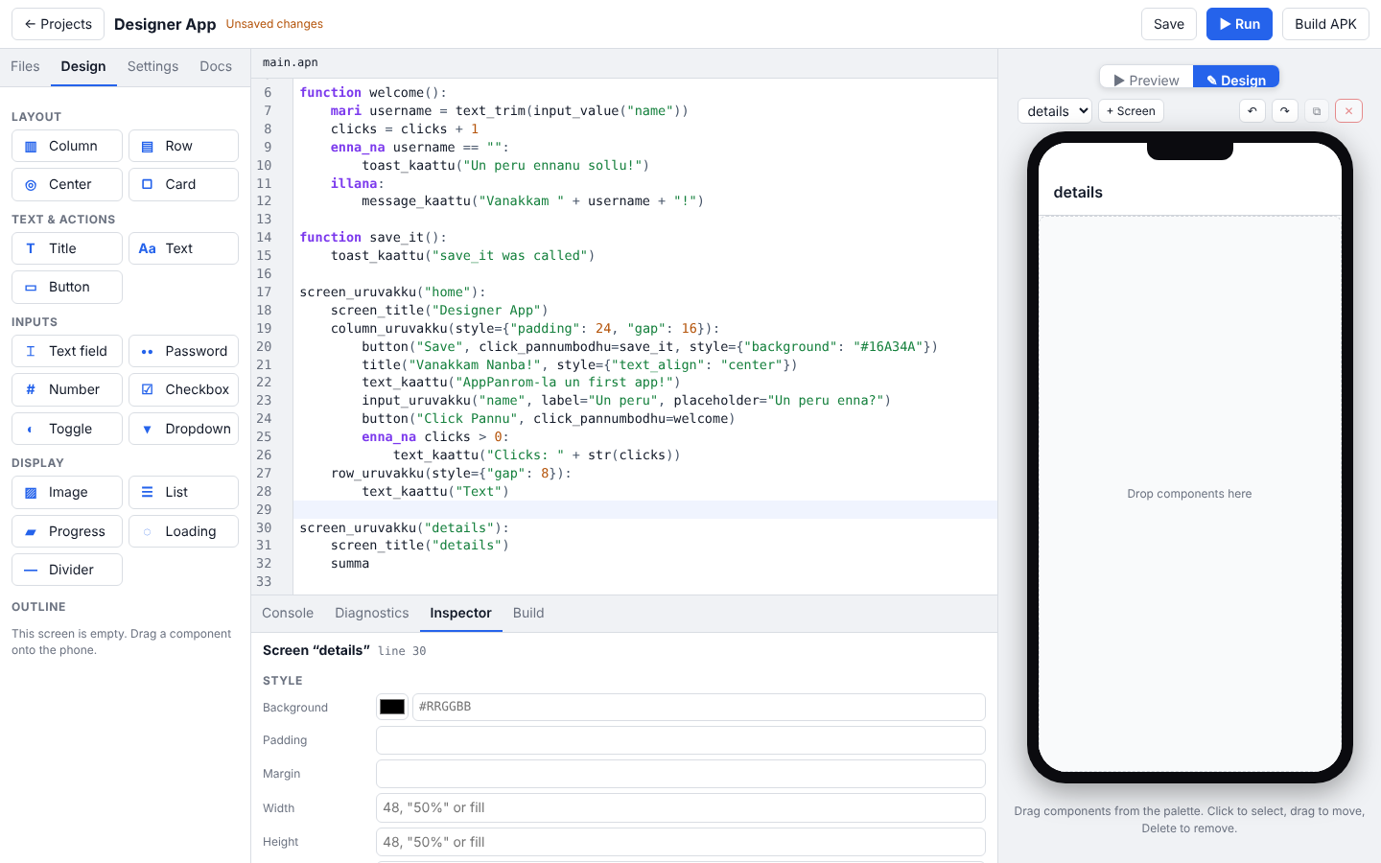
Fig. 3: Code updated live after dragging and editing components

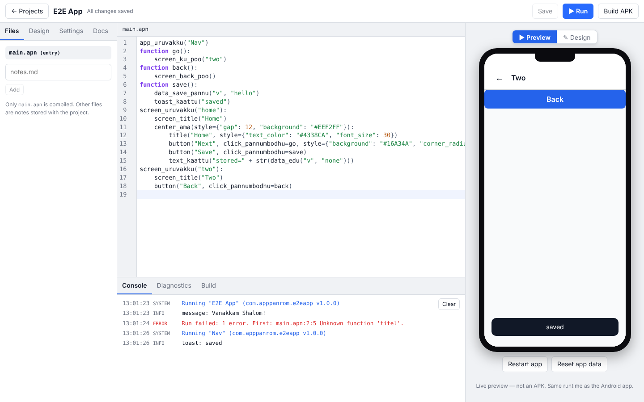
Fig. 4: A styled two-screen app with navigation and storage
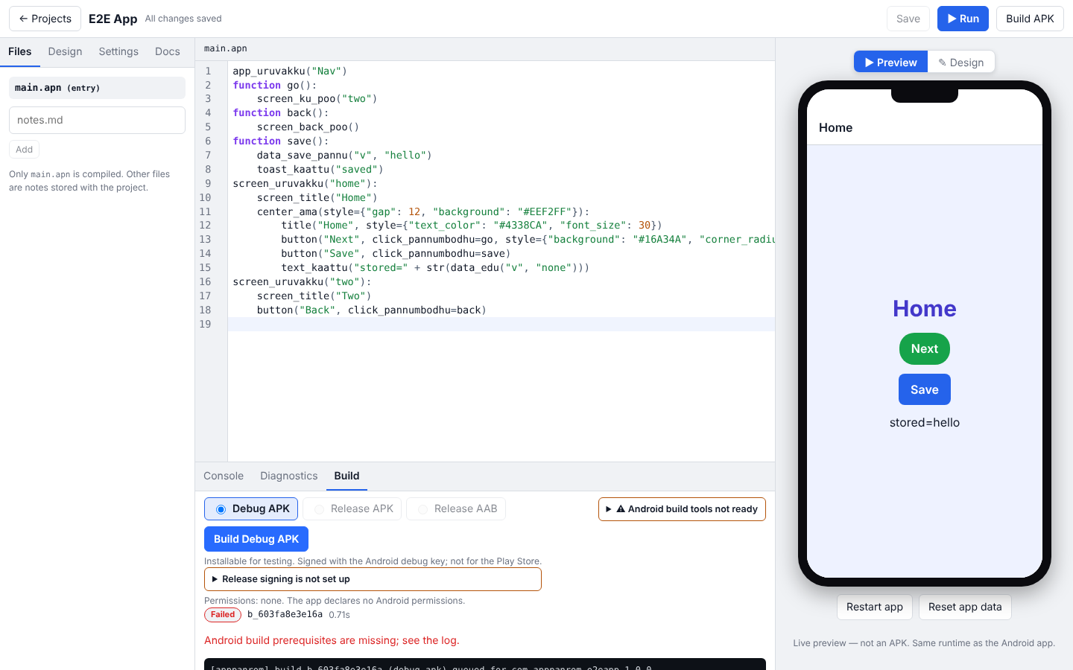
Fig. 5: Build panel with an honest failure when the SDK is missing

CONCLUSION :
AppPanrom brings a Tanglish language, a visual designer and an Android build pipeline together in one studio. Source code passes through lexical, syntax and semantic analysis into one validated intermediate representation that a shared runtime renders identically in the preview and in the Android app. The designer and the code editor change the same text, so they update each other live, and a build is reported successful only when a verified artifact exists.
A full Gradle build with the Android SDK and an install on a device could not be done in the development environment, and is the first item for future work, along with network access and camera and location features.

