Learning Web Development

HTML
<!DOCTYPE htmll>,
<html>,
<head>,
<title>
<body>,
<title>,
<h1> - <h6>,
<p>,
<a>,
<img>,
<span>,

<div>,
<ul>,
<ol>,
<li>,
<table>,
<form>.
<input>

CSS
Selectors, properties, and values.
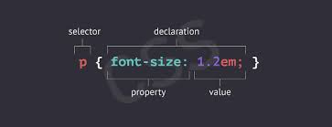

Understand inline, internal, and external CSS styles.
Styling basics: colors, fonts, text alignment, borders, margins, and padding.

