**USER MANUAL FOR SITE SUITABILITY ANALYSIS MODEL**

**INSTALLATION:**

The Site Suitability Analysis model is written and run in Python 3 which is a high-level computer programming language. It can be accessed by downloading the Anaconda 3 distribution package which is developed by data scientists and computer engineers who made it easier to download and distribute Python tools.



The anaconda package comes with various options to run the python codes in. In your computer start menu search for anaconda and choose Spyder(Anaconda3) from the options available.

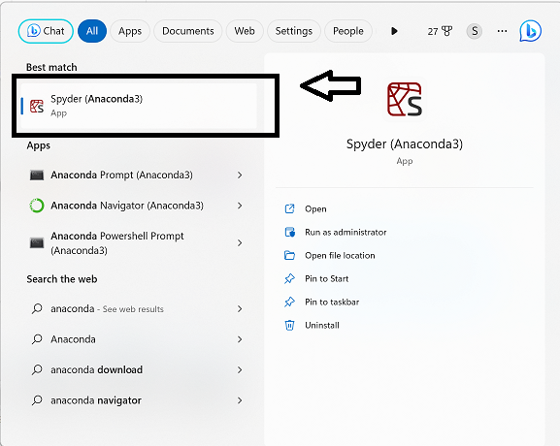

**USAGE:**

The layout of Spyder has three panels namely, editor, display and the console.

**Editor**: This is where we write and display our codes

**Display**: This is where our outputs are displayed in the form of plots

**Console**: This where we can check for the execution of the print statements and errors if any.

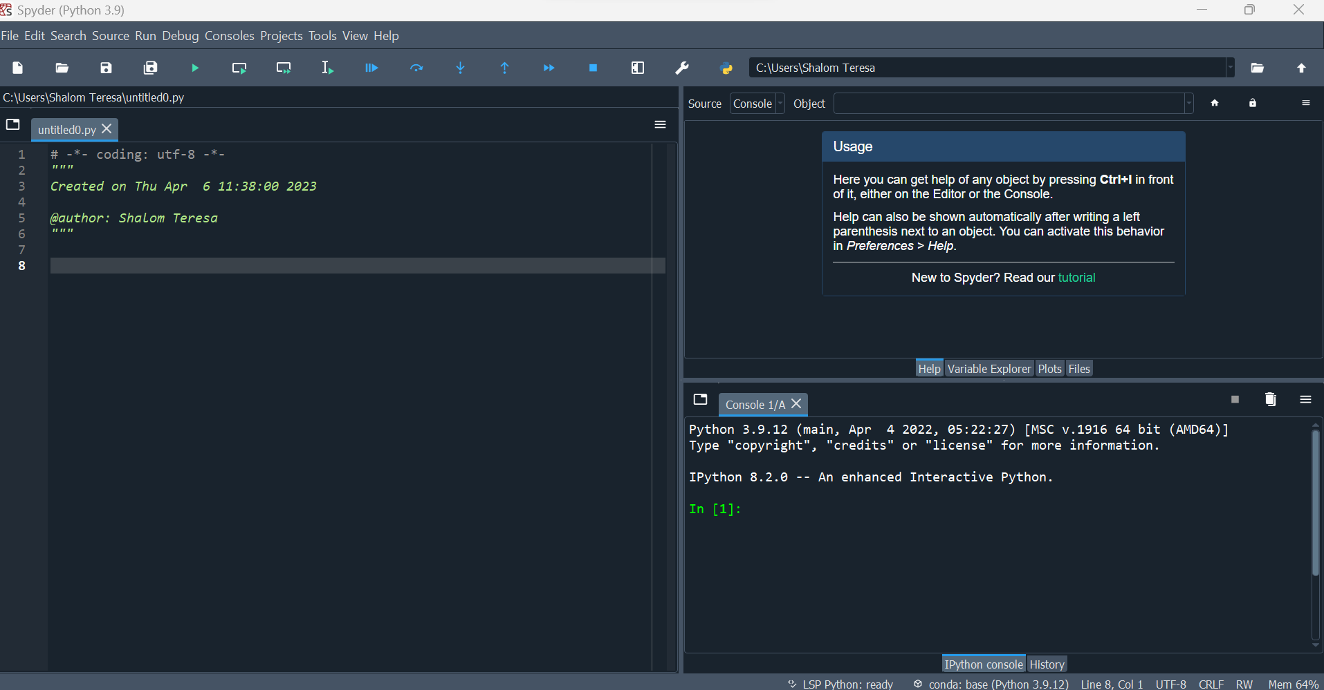

CONSOLE

DISPLAY

EDITOR

Load the model and its related files as below

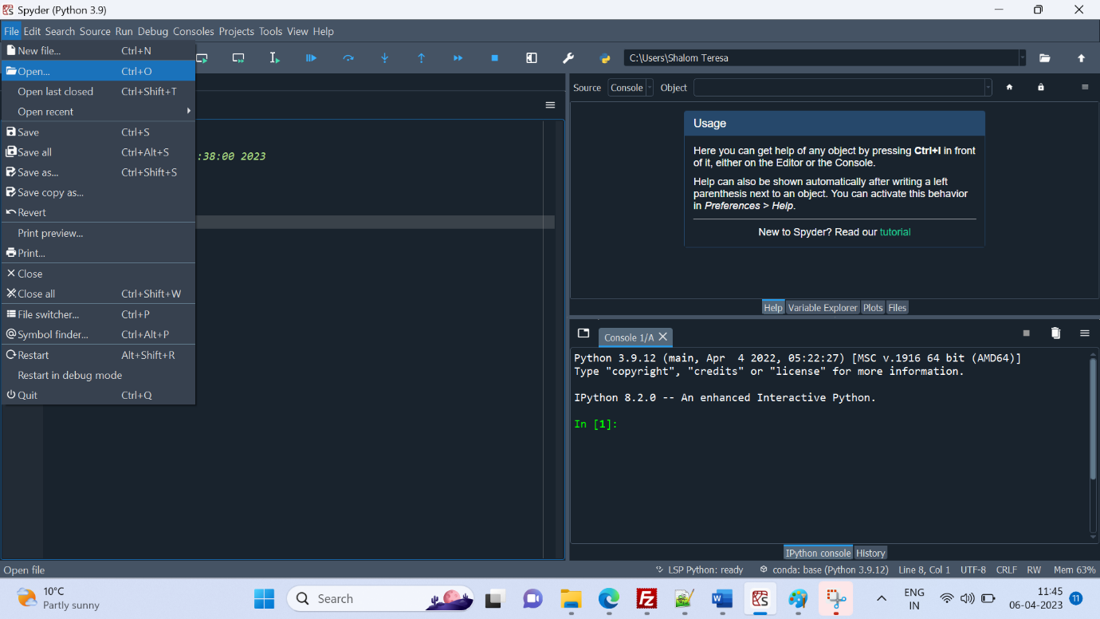

The python files are organised according to their functionality in the following manner:

The source code of the software is found in the src folder

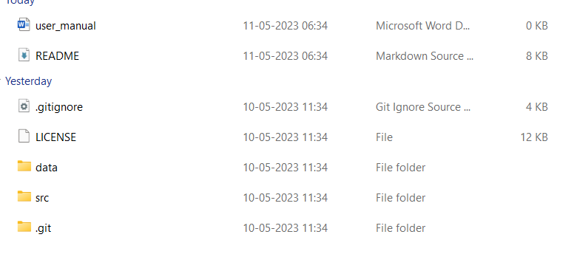

The src contains the MCE folder

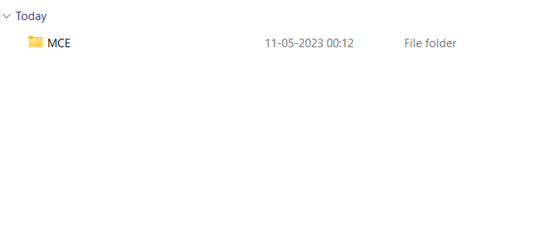

and upon opening the MCE folder, you should come across these set of files:

Load this

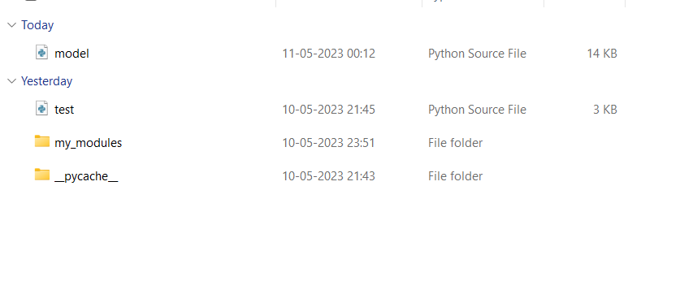

Open this

Upon opening my_modules folder, you will come across the input and output source file.

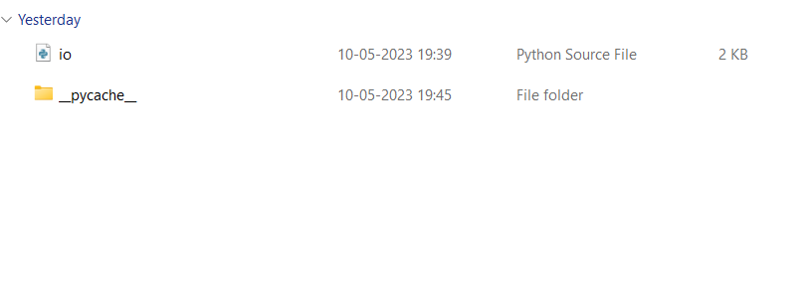

Open the model file in Spyder and run the model by clicking on the button mentioned below:



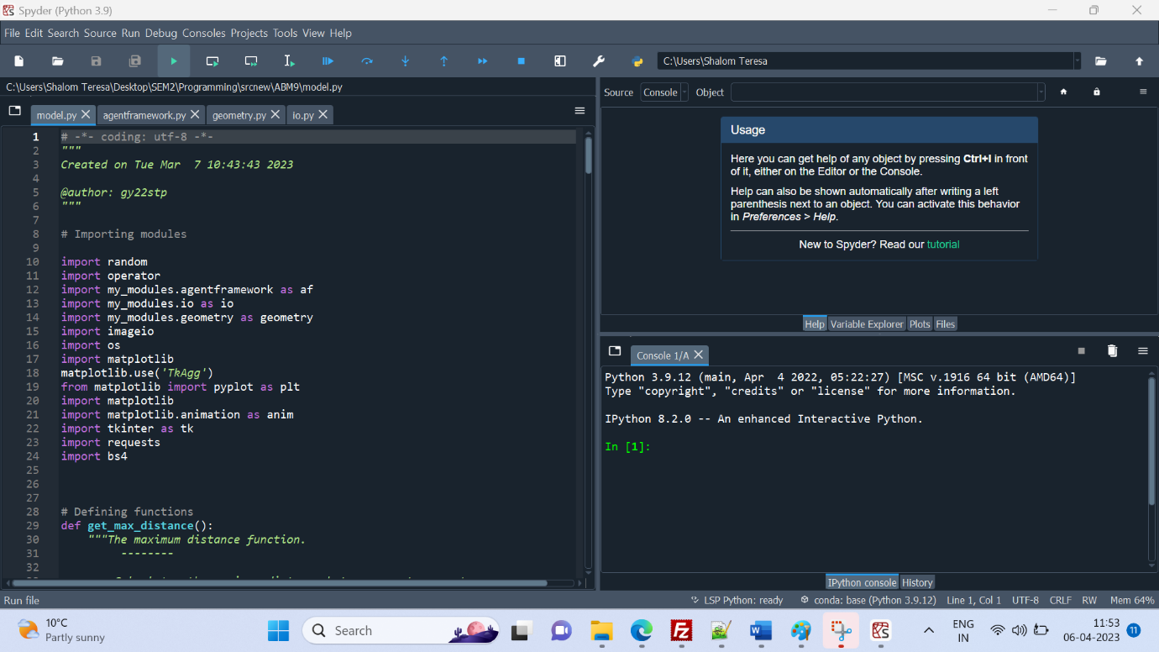

The model is executed and the output is generated as a GUI

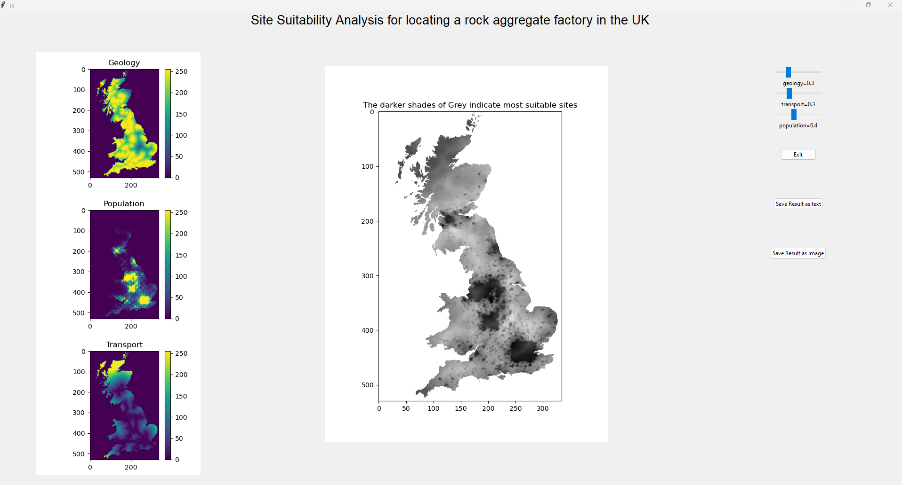

The frame on the left displays the input rasters which are the factors considered for the site suitability analysis

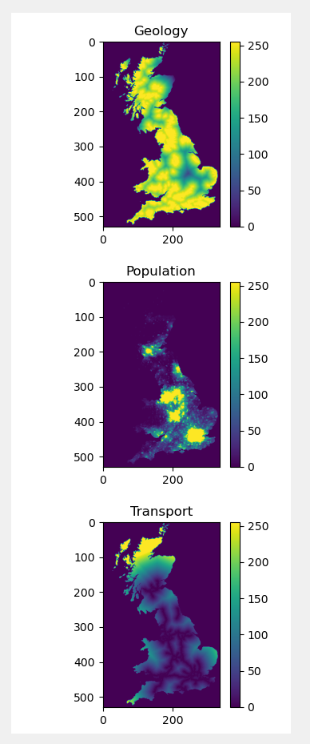

The frame on the top right corner contains sliders to allot weights to the factors. The weights are set on a scale of 0 to 1. In multi criteria evaluation, the sum of the weights of the factors should be equal to 1.

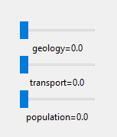

Move the slider to set weights

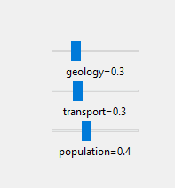

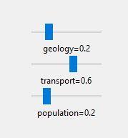

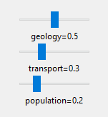

The output is displayed in the frame in the middle. The frame is empty until the weights are set as the initial weights are set to 0 for all three factors. The map is displayed upon moving the sliders.

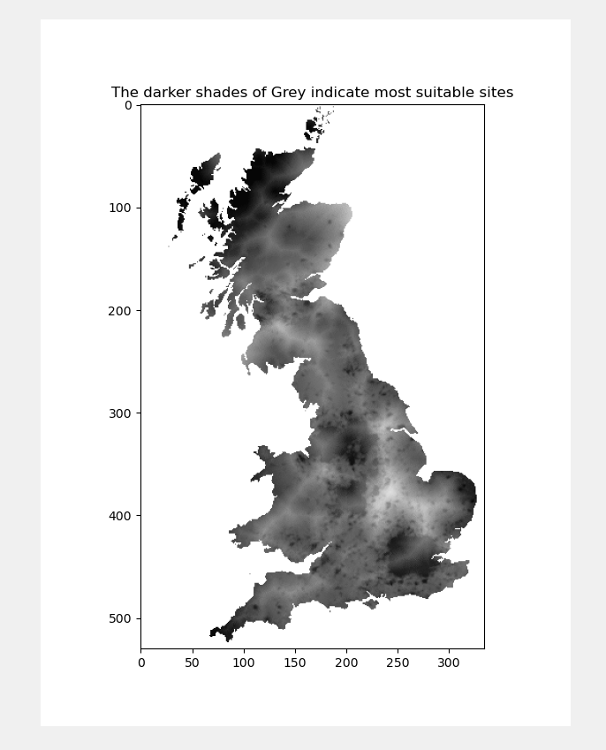

The displayed map is modified according to the weights being set.

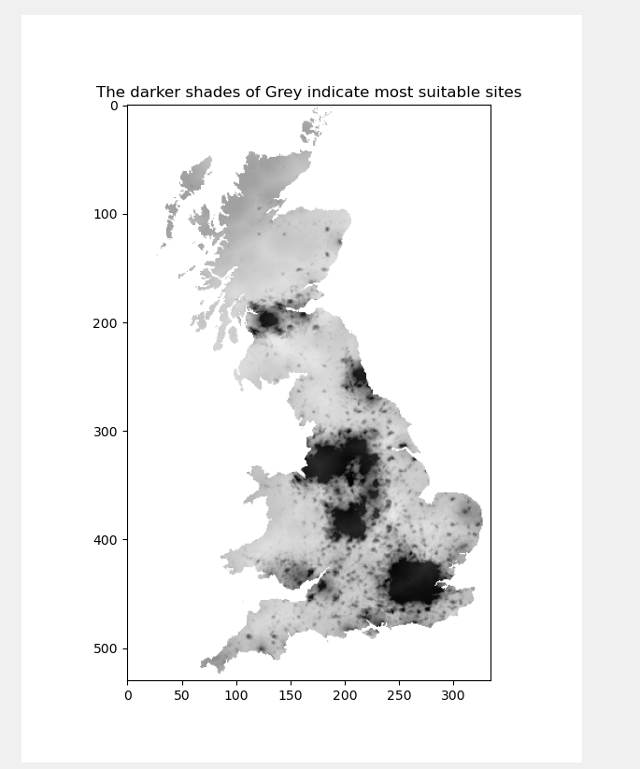

The functionality of the buttons in the bottom right are as follows:

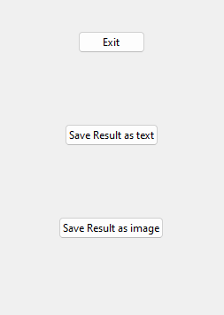

Click this button to save the resultant map as an image in png format

Click this button to save the resultant map as a text file in CSV format

Click this button to exit   
the GUI

TROUBLESHOOTING:

Depending on the version of Spyder used for running the software, the following glitch maybe encountered.

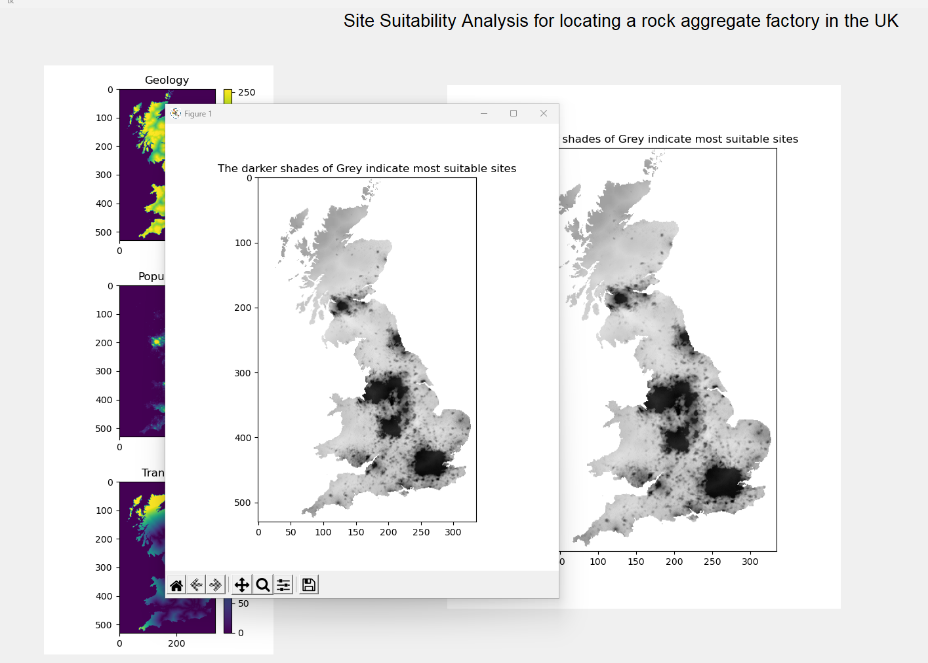

The output map is displayed on a separate window as a figure along with the GUI

This glitch can be resolved by using the latest version of Spyder.

Any calculation errors in the code are displayed in the console.

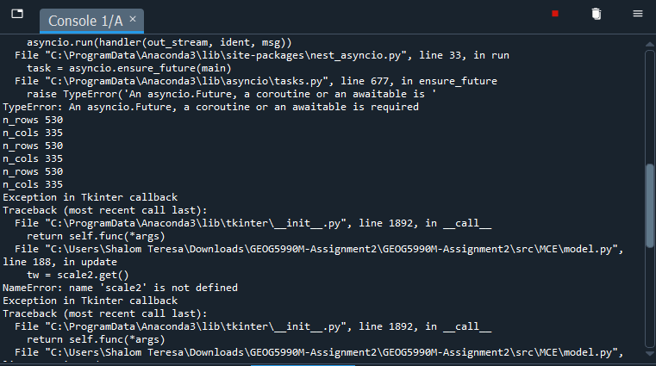

For further queries contact the developers.