**USER MANUAL FOR SPATIAL AGENT BASED MODEL**

**INSTALLATION:**

The Agent based model is written and run in Python 3 which is a high level computer programming language. It can be accessed by downloading the Anaconda 3 distribution package which is developed by data scientists and computer engineers who made it easier to download and distribute Python tools.



The anaconda package comes with various options to run the python codes in. In your computer start menu search for anaconda and choose Spyder(Anaconda3) from the options available.

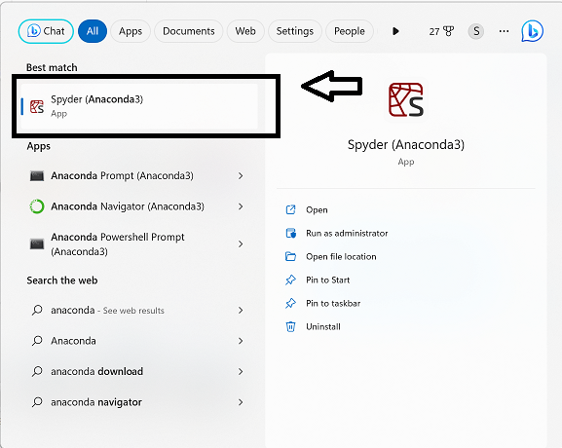

**USAGE:**

The layout of Spyder has three panels namely, editor, display and the console.

**Editor**: This is where we write and display our codes

**Display**: This is where our outputs are displayed in the form of plots

**Console**: This where we can check for the execution of the print statements and errors if any.

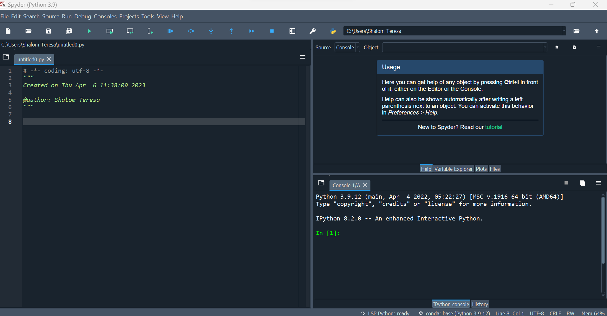

CONSOLE

DISPLAY

EDITOR

Load the model and its related files as below

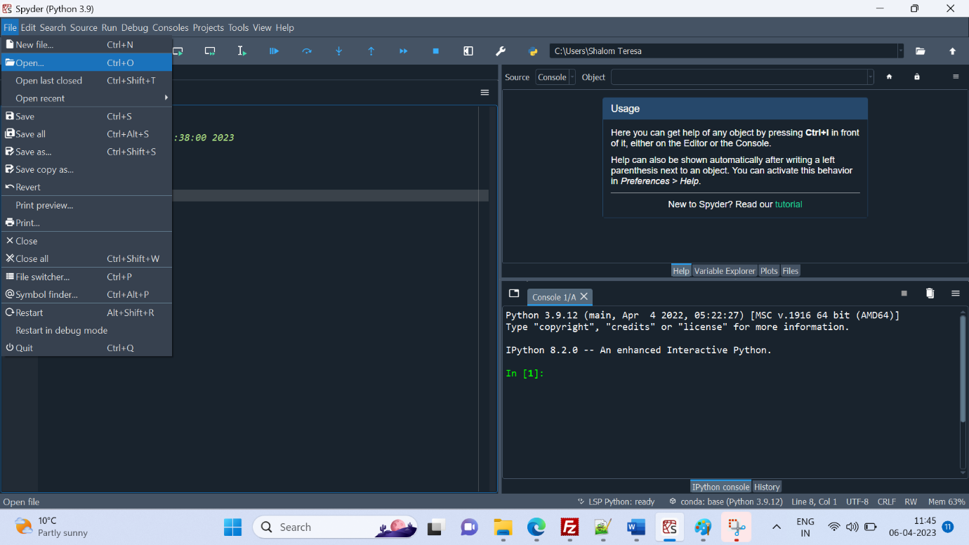

The python files are split according to their functionality in the following manner:

This is the main model file

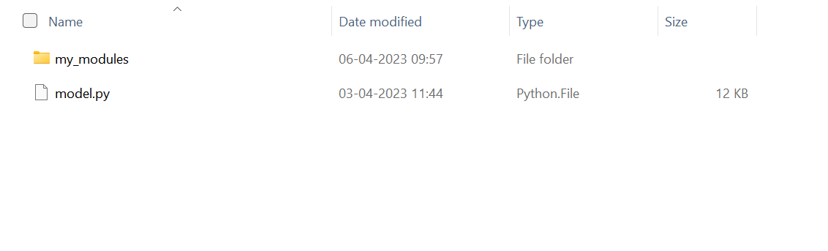

and upon opening the my_modules, you should come across these sets of files:

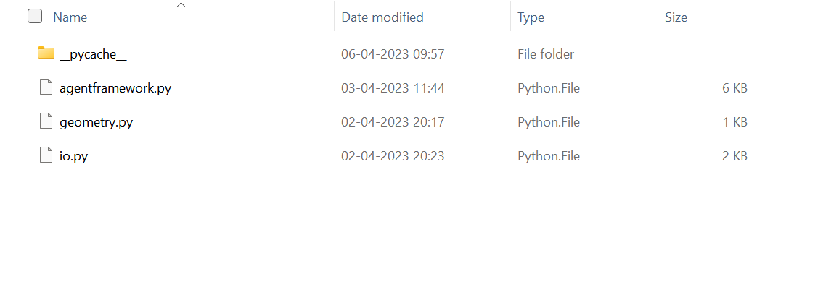

Open all of the files in Spyder and run the model by clicking on the button mentioned below:  


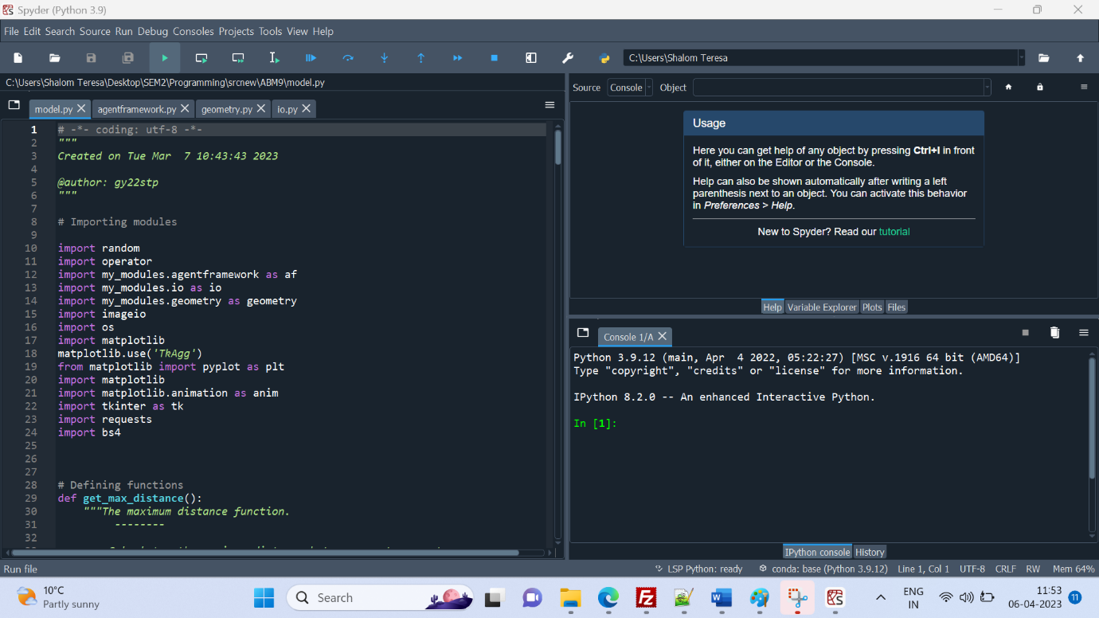

The model is executed and the output is generated as a GUI

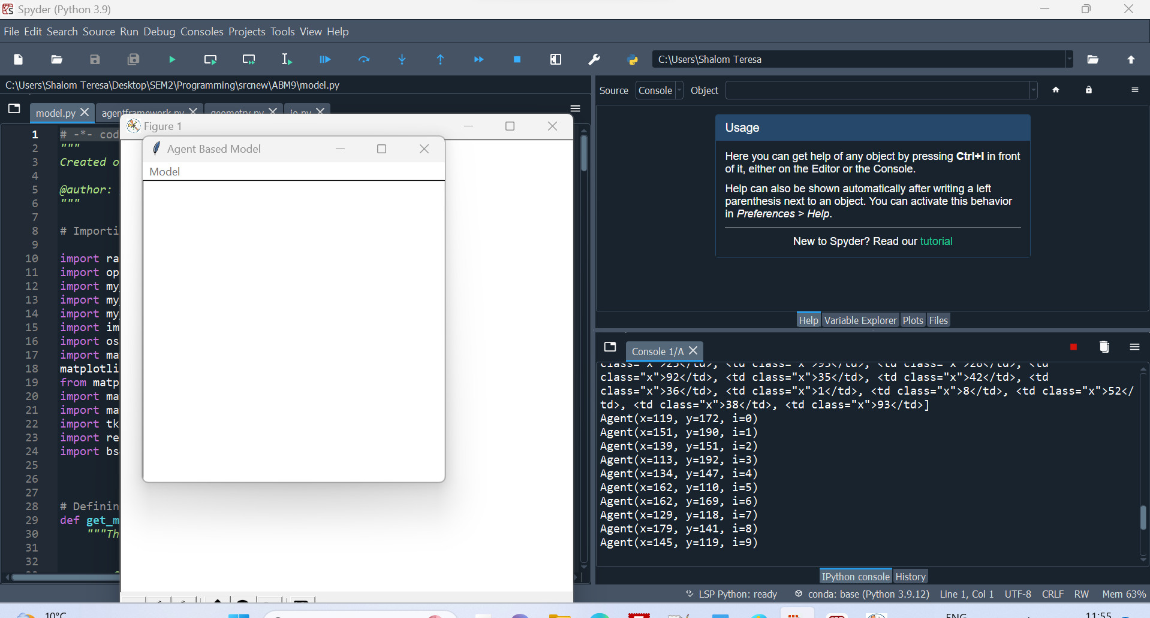

Run the model from the GUI

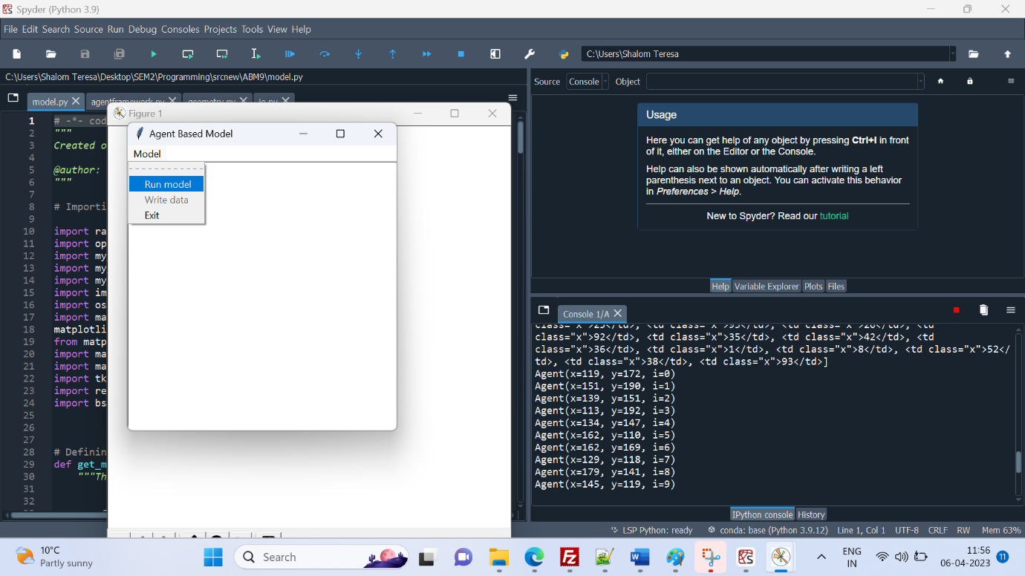

The movements of the agents can be observed in the form of an animation on the GUI

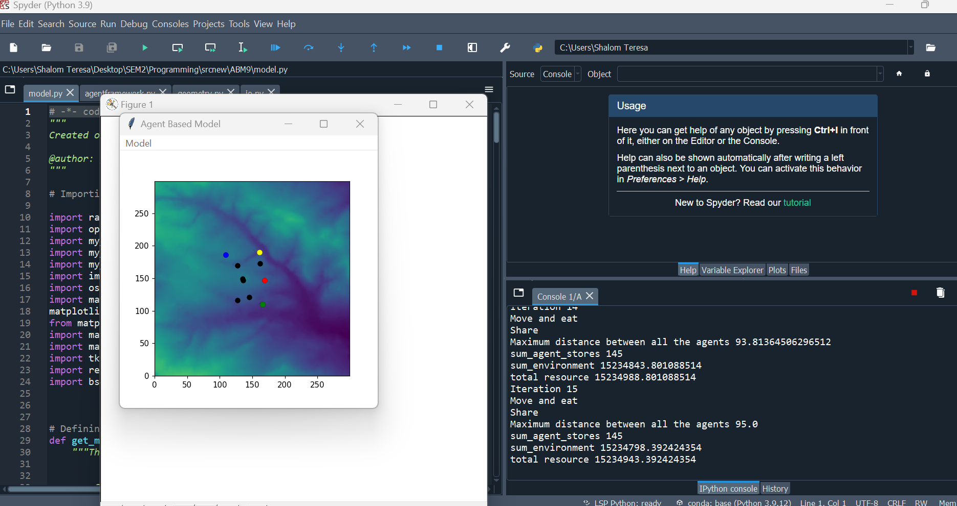

The print statements and outputs in the console explain the calculations being made in the model code.

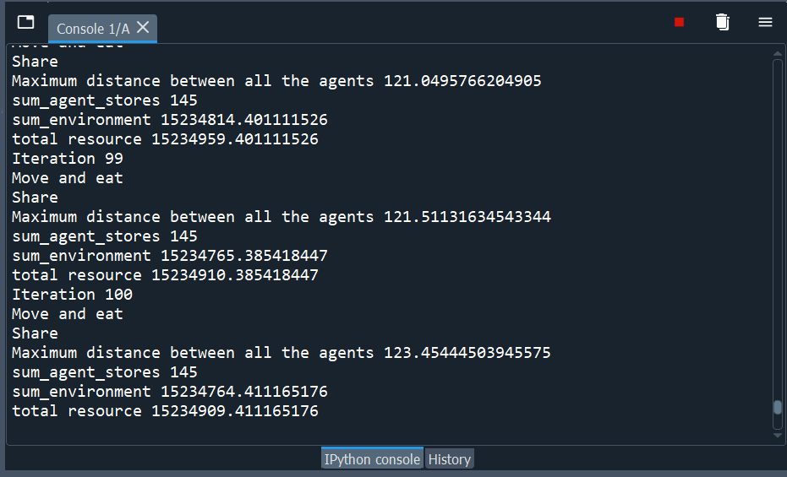

Further analyse the model by zooming in the figure canvas

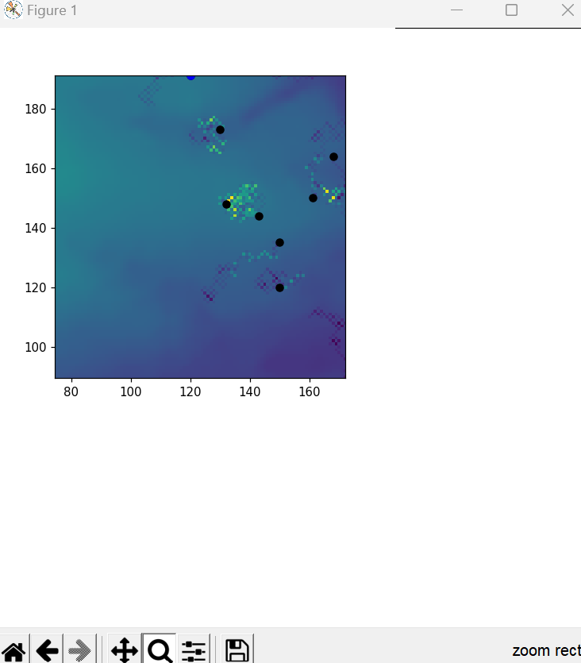

If you want to reset the zoom back to its default then click on the home button

