CDACL-005 | Week 1
Exploratory Data Analysis Report & Domain Analysis
What the raw transaction data looks like and what it means for market basket analysis
Project: Purchase Pattern Analytics (Market Basket Analysis)

1. Executive summary
- The raw table has 522,064 rows, 7 columns and 21,663 bills, spanning 1 Dec 2010 to 9 Dec 2011. About 93% of rows are from the United Kingdom.
- Bills are large: a bill holds a median of 13 and a mean of 23.6 distinct products, which gives Apriori plenty of co-occurrence to work with.
- Revenue is strongly seasonal: it rises from September and peaks in November 2011. Activity during the day peaks around 12:00 and 15:00.
- No NULLs are reported, but 1,455 rows have a blank product name, 5,286 rows are exact duplicates, 1,336 rows have negative quantity and 2,513 have a price of zero or less. Non-product lines such as POSTAGE and Bank Charges are present.
- These issues motivate the cleaning pipeline documented in Deliverable 03.

2. Domain analysis

2.1 Retail context
The data describes the sales lines of a retailer of giftware and home décor products. Many bills contain dozens of lines and large quantities of the same item, which is typical of a business that also sells in bulk to trade buyers. This is an inference from the basket and quantity distributions, not a field in the data.

2.2 Market basket analysis
Market basket analysis looks for items that are bought together more often than chance would suggest. A basket is one bill. Three measures describe a rule A → B:
Measure | Definition | Reading
Support | Share of all baskets that contain the itemset | How common the pattern is
Confidence | Of baskets with A, share that also contain B | How reliable the rule is
Lift | Confidence divided by the support of B | Above 1: bought together more than by chance; 1 means independence

2.3 Business questions
- Which products are the backbone of the baskets?
- Which products pull other products into the basket?
- When do customers buy (month, hour) and how does this shape promotions?
- Which cross-sell, bundle or promotion actions are worth the most?

2.4 Stakeholders and KPIs
Stakeholder | Interest | KPI
Merchandising | Range, bundles, placement | Attach rate, lift of bundled items
Marketing | Promotions and campaign timing | Conversion of recommended items
Operations | Stock planning for seasonal peak | Stock-outs on high-support items
Management | Revenue growth | Revenue per basket, items per basket

3. Dataset overview
Column | Type (as loaded) | Description
BillNo | text | Bill / invoice number; one bill is one basket
Itemname | text | Product description
Quantity | integer | Units on the line (negative values exist)
Present_Date | text, converted to datetime | Transaction timestamp, format dd-mm-yyyy hh:mm
Price | decimal | Unit price (zero and negative values exist)
CustomerID | text | Customer identifier
Country | text | Customer country

A derived column, Revenue = Quantity × Price, was added for the analysis.

4. Key statistics
Statistic | Quantity | Price
Mean | 10.09 | 3.83
Median | 3 | 2.08
Mode | 1 | 1.25
Minimum | -9,600 | -11,062.06
25th percentile | 1 | 1.25
75th percentile | 10 | 4.13
Maximum | 80,995 | 13,541.33
Standard deviation | 161.11 | 41.90

The mean is far above the median for both columns, so both are right-skewed by a small number of extreme values. The extreme minima and maxima are the main outlier concern.
Measure | Value
Distinct products per bill: mean / median | 23.6 / 13
Distinct products per bill: 25th / 75th percentile | 4 / 26
Distinct products per bill: maximum | 1,108
Top countries (rows) | United Kingdom 487,622; Germany 9,042; France 8,408; Spain 2,485; Netherlands 2,363

5. Distributions and patterns

5.1 Quantity and price
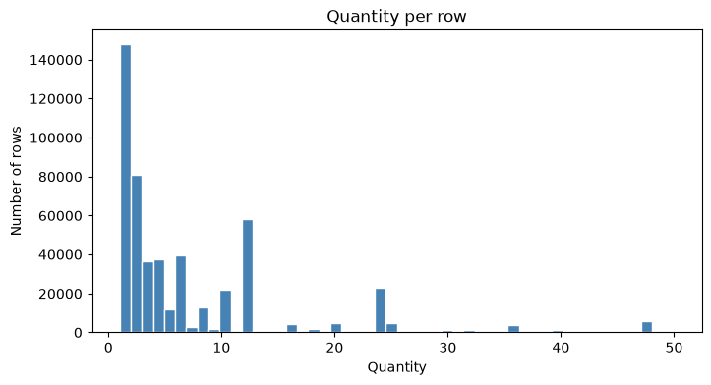
Figure 1. Distribution of quantity per row (1-50 units)
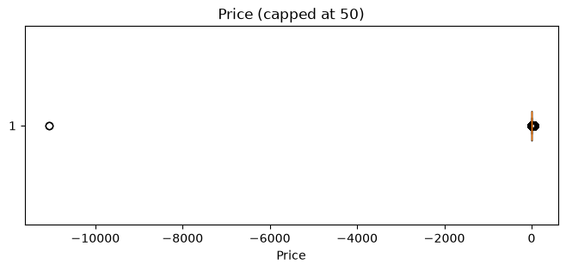
Figure 2. Unit price box plot (capped at 50)
Most lines are for small quantities, with a long tail of bulk lines. Prices cluster at low values (median 2.08); capping at 50 is needed just to read the box plot.

5.2 Basket size
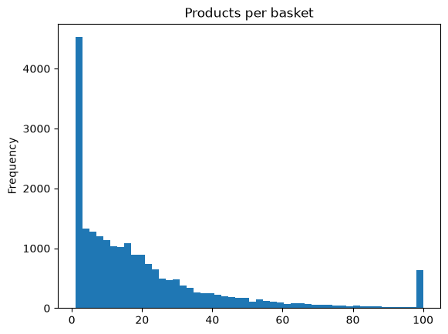
Figure 3. Distinct products per basket (capped at 100)
Basket size is skewed: many small bills and a long tail of very large ones, up to 1,108 distinct products on a single bill.

5.3 Products
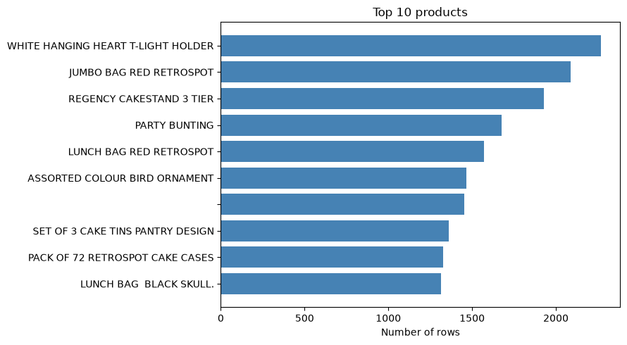
Figure 4. Top 10 products by number of transaction rows
WHITE HANGING HEART T-LIGHT HOLDER (2,269 rows), JUMBO BAG RED RETROSPOT (2,087) and REGENCY CAKESTAND 3 TIER (1,930) lead the ranking. Note that a blank product name also ranks in the top 10 with 1,455 rows; it is removed during cleaning.

5.4 Time patterns
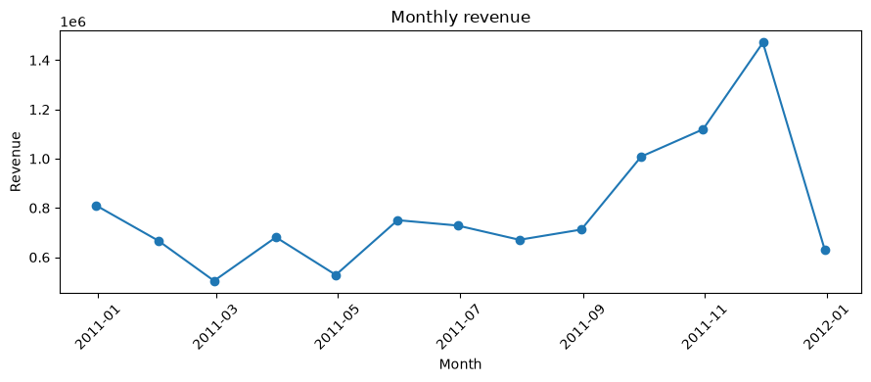
Figure 5. Monthly revenue on the raw data (Dec 2010 to 9 Dec 2011; the last point is a partial month)
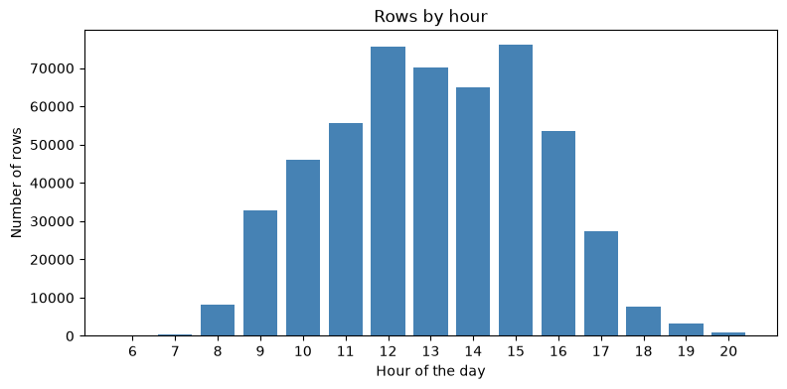
Figure 6. Transaction rows by hour of day
- Seasonality: revenue is flat to declining between January and August 2011, then climbs from September to a peak in November 2011 (about 1.47 million). The final point is a partial month (data ends on 9 December), so it should not be read as a drop. This chart uses raw data, including returns and extreme values.
- Time of day: activity starts at 08:00, builds through the morning and has two peaks at 12:00 and 15:00; it falls away after 17:00. The chart counts rows, not revenue.

6. Data-quality findings
Check | Result | Handling
NULL values | 0 in every column | None needed, but see blank names below
Blank product names | 1,455 rows (empty strings, not NULL) | Removed (cleaning step 1)
Exact duplicate rows | 5,286 | Removed (step 2)
Bills starting with 'C' (credit notes) | 0 | Returns appear instead as negative quantities
Negative quantity | 1,336 rows | Removed (step 3)
Price of zero or less | 2,513 rows | Removed (step 3)
Price outliers (IQR rule) | 36,941 rows outside -3.07 to 8.45 | Not removed by the IQR rule: only the 99.9th percentile cap is applied (step 5)
Non-product lines | POSTAGE, DOTCOM POSTAGE, Manual, Bank Charges, AMAZON FEE, CARRIAGE, Next Day Carriage | Removed by keyword (step 4)

7. Implications for the next phase
- Cleaning must remove blanks, duplicates, returns, non-product rows and extreme values before any basket is built.
- With 2,000+ distinct products, most are rare; restricting to products that appear in at least 30 bills keeps rules statistically meaningful.
- Bills with a single product contain no co-occurrence information and can be dropped.
- The same product appears in different letter-case and spacing, so names are trimmed and upper-cased.

