CDACL-005| Week 3
Apriori Implementation & Visualisation Report
Frequent itemsets, association rules and product relationships
Project: Purchase Pattern Analytics (Market Basket Analysis)

1. Implementation
Parameter | Value | Reason
Input | Boolean basket matrix, 17,750 × 2,559 | One row per bill, one column per product
Library | mlxtend: apriori, association_rules | Standard implementation
min_support | 0.015 (about 266 bills) | Keeps patterns seen in enough bills to be reliable, while the large catalogue keeps support values small
max_len | 3 | Limits itemset size for speed and interpretability
low_memory | True | Handles the 2,559-column matrix
Rule metric / threshold | lift >= 1.0 | Keep only positive associations

The implementation is in src/data_project.py and in the notebook (cells 73 to 91).

2. Results
Result | Value
Frequent itemsets | 890
Association rules (lift >= 1) | 926
Most frequent single product | WHITE HANGING HEART T-LIGHT HOLDER, 12.2% of baskets
Next most frequent | JUMBO BAG RED RETROSPOT 11.5%; REGENCY CAKESTAND 3 TIER 10.6%; PARTY BUNTING 9.2%; LUNCH BAG RED RETROSPOT 8.7%

2.1 Strongest rules by lift
Antecedent | Consequent | Support | Confidence | Lift
PACK OF 60 PINK PAISLEY CAKE CASES | 60 TEATIME FAIRY CAKE CASES | 0.019 | 0.402 | 9.01
60 TEATIME FAIRY CAKE CASES | PACK OF 60 PINK PAISLEY CAKE CASES | 0.019 | 0.421 | 9.01
PACK OF 72 RETROSPOT CAKE CASES | 60 TEATIME FAIRY CAKE CASES | 0.024 | 0.338 | 7.57
60 TEATIME FAIRY CAKE CASES | PACK OF 72 RETROSPOT CAKE CASES | 0.024 | 0.541 | 7.57
PACK OF 72 RETROSPOT CAKE CASES | 72 SWEETHEART FAIRY CAKE CASES | 0.016 | 0.221 | 6.67
72 SWEETHEART FAIRY CAKE CASES | PACK OF 72 RETROSPOT CAKE CASES | 0.016 | 0.477 | 6.67
ALARM CLOCK BAKELIKE GREEN | ALARM CLOCK BAKELIKE CHOCOLATE | 0.015 | 0.285 | 12.12
ALARM CLOCK BAKELIKE CHOCOLATE | ALARM CLOCK BAKELIKE GREEN | 0.015 | 0.657 | 12.12
ALARM CLOCK BAKELIKE RED | ALARM CLOCK BAKELIKE CHOCOLATE | 0.016 | 0.278 | 11.82
ALARM CLOCK BAKELIKE CHOCOLATE | ALARM CLOCK BAKELIKE RED | 0.016 | 0.681 | 11.82

These are the first rows of the rule table, which the notebook prints in the order mlxtend returns them. Two product families stand out: cake cases (pink paisley, 60 teatime, 72 retrospot, 72 sweetheart) and Bakelike alarm clocks in different colours. The alarm clock rules reach a lift of about 12, the highest observed (for example Green with Chocolate at 12.12), and the reverse direction has a confidence of 0.66 to 0.68: customers who buy a chocolate alarm clock usually buy another colour too.

3. Visualisations

3.1 Product occurrence
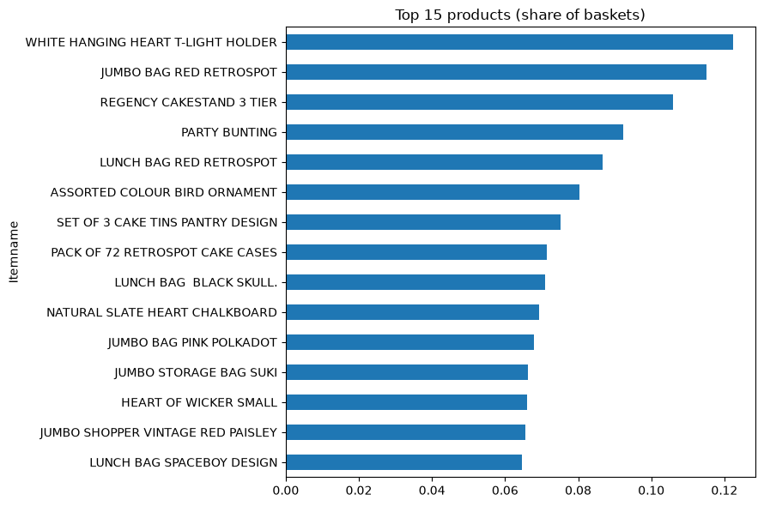
Figure 1. Top 15 products by share of baskets (support)
Support is concentrated in a handful of best-sellers: the top product appears in over 12% of baskets, and the 15th in roughly 6%.

3.2 Co-purchase
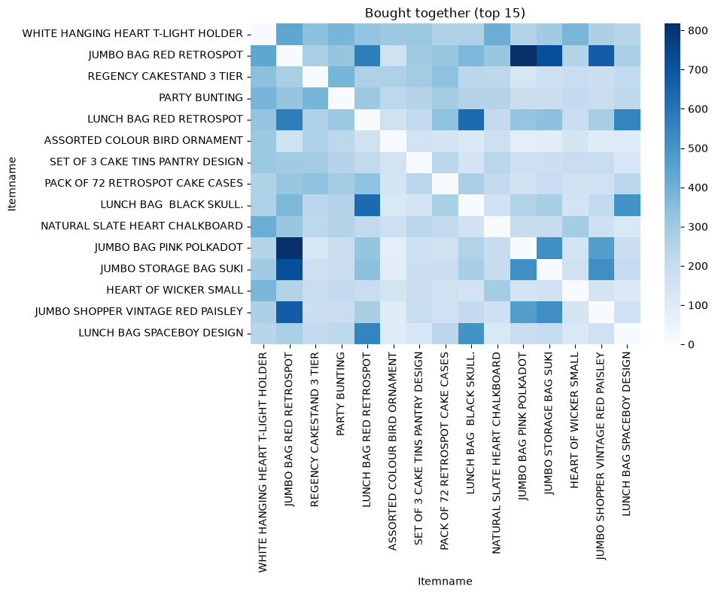
Figure 2. Co-purchase counts for the top 15 products (diagonal masked)
The T-light holder is the most frequent partner for the other best-sellers (for example 439 shared bills with JUMBO BAG RED RETROSPOT and 411 with NATURAL SLATE HEART CHALKBOARD). The red-retrospot and jumbo bag families also co-occur strongly (JUMBO BAG RED RETROSPOT with LUNCH BAG RED RETROSPOT: 573 bills).

3.3 Trend
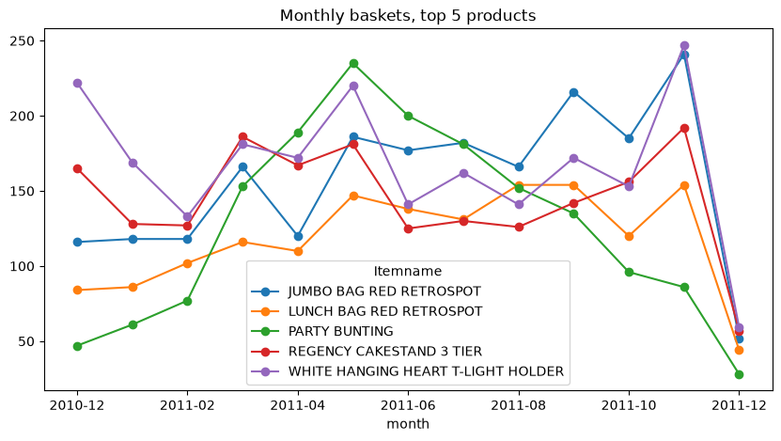
Figure 3. Monthly baskets containing each of the top 5 products
All five top products peak around November 2011. PARTY BUNTING peaks earlier (May) and declines through the autumn, which suggests a spring and summer party season. The last point is a partial month.

3.4 Rule structure
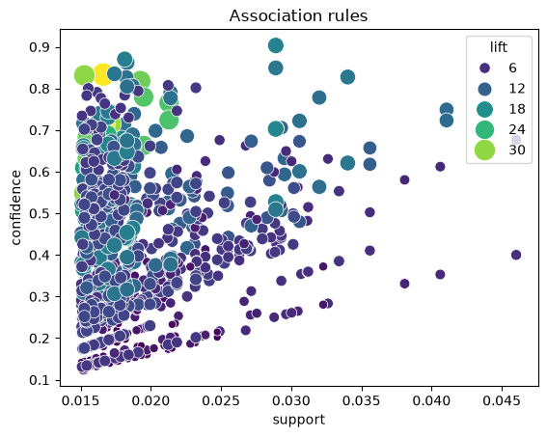
Figure 4. Association rules: support vs confidence, sized and coloured by lift
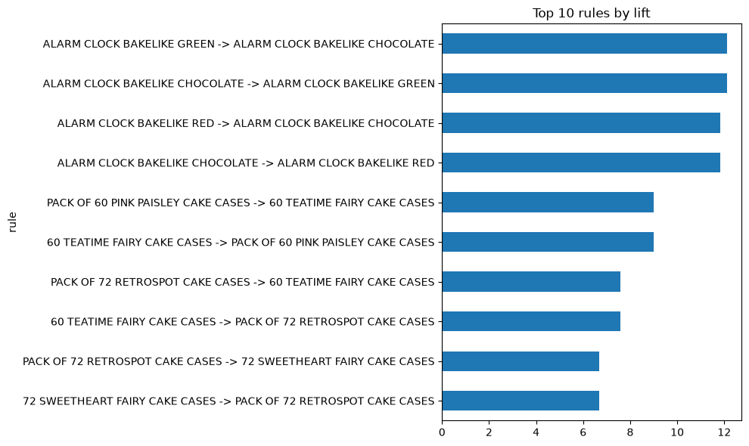
Figure 5. First 10 rules in the rule table, by lift
Most rules sit at low support (about 1.5% to 3%) with confidence between 0.2 and 0.7. Higher lift tends to occur at lower support, as expected.

3.5 Product-to-product lift
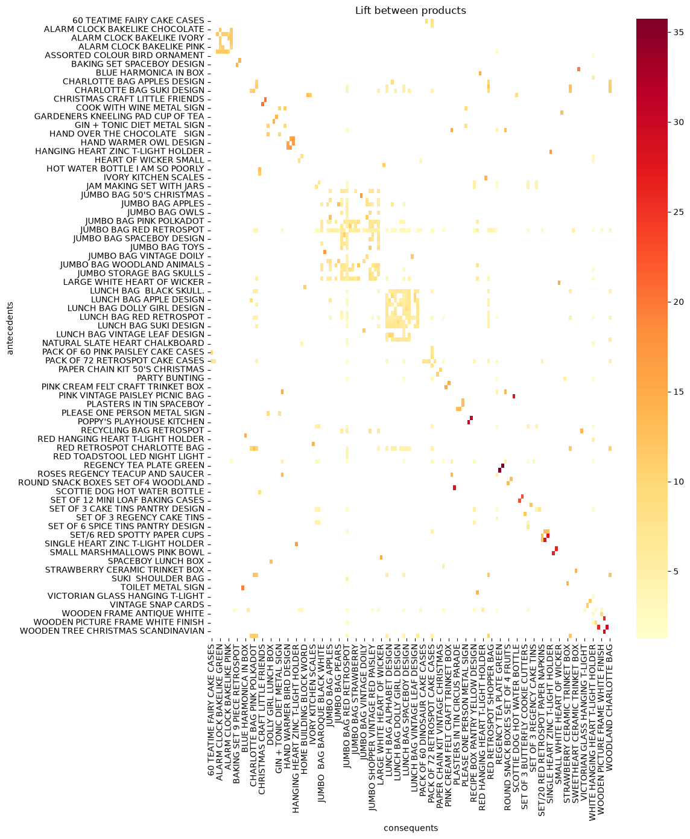
Figure 6. Lift between single products
The lift heat map shows dense blocks for product families that come in several variants. These blocks are where bundles are most natural.

4. Interpretation guide
- Lift above about 5 with confidence above 0.4 flags near-substitute or collection products (colour or pack-size variants).
- Lift of 2 to 3 between different product types (e.g. party items and the cake stand) is the most useful cross-sell signal because the products are complementary rather than variants.
- Lift near 1 means the pair appears together only about as often as chance, so no action is warranted.

5. Limitations
- Rules are measured on the same data they were mined from; there is no hold-out test.
- Support is based on bill counts and ignores quantities and prices.
- Variants of the same design inflate lift; consider grouping variants for a second pass.
- The bar chart titled 'Top 10 rules by lift' uses the first 10 rows of the rule table, which are not sorted by lift; see the review log.

