Step 2 — Connect a Google Credential
Google Sheets / Google Docs access for the n8n workflow
This guide shows exactly where to click to create the Google credential and reuse it across the Google Sheets and Google Docs nodes.
Important: Keep the Google Client ID and Client Secret private. The red boxes in the screenshots show exactly where you need to click or enter information.

Part A — Create the Google Credential
Step 1: Go to your n8n workflow and open the Google Sheets node named “Check Duplicate”.
Step 2: Click the “Credential to connect with” field.
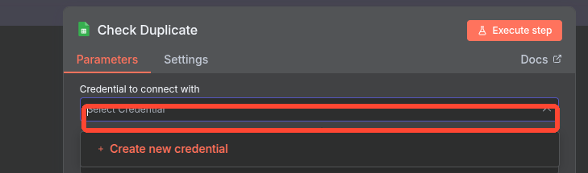
CLICK HERE → Credential to connect with

Step 3: Click “Create new credential”.
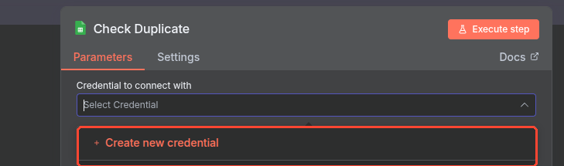
CLICK HERE → Create new credential

Step 4: A Google Sheets credential window will open. Keep “OAuth2 (recommended)” selected.
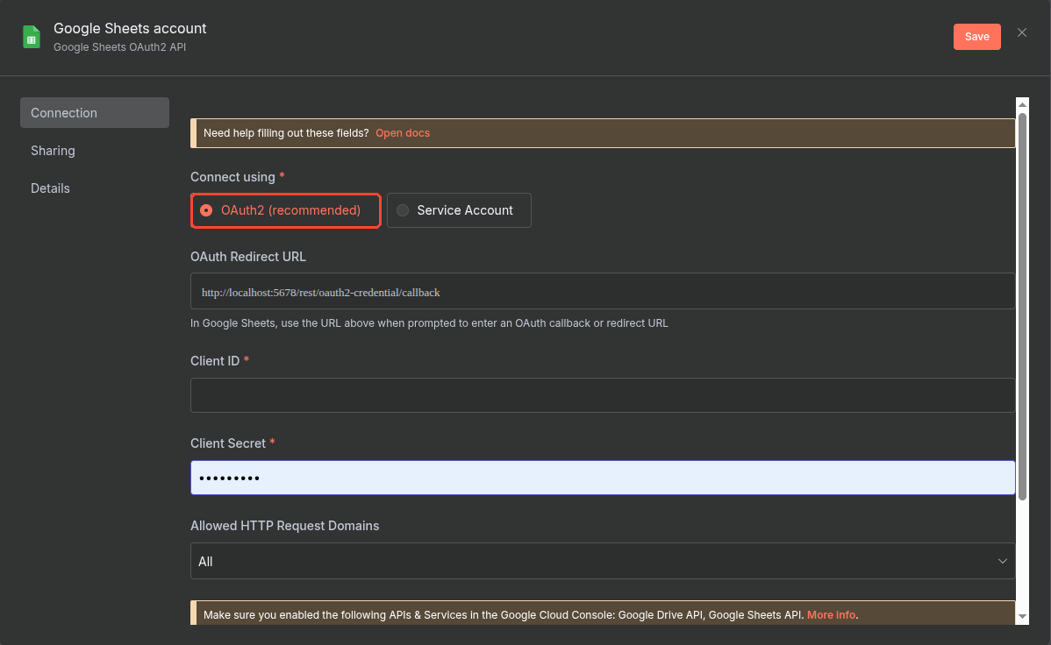
Step 5: Enter your Google OAuth Client ID in the “Client ID” field and your Google OAuth Client Secret in the “Client Secret” field.
Step 6: Click “Save” in the top-right corner.
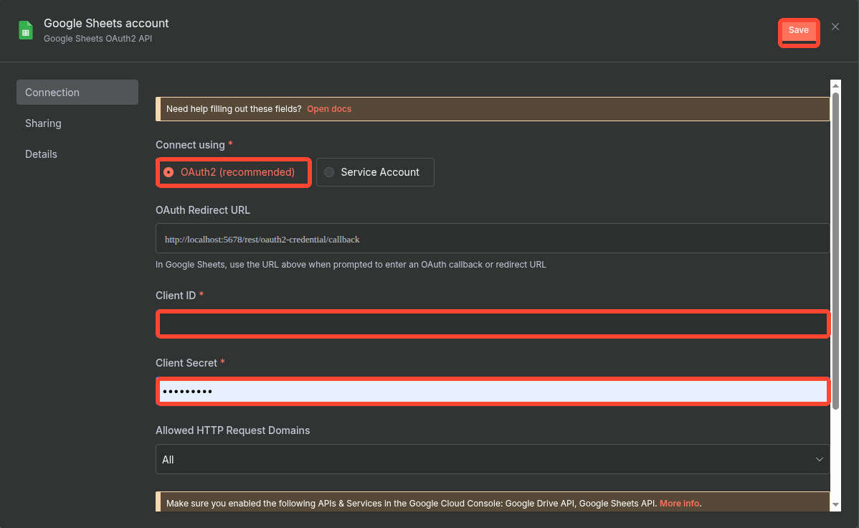
CHECK → OAuth2 (recommended) | ENTER → Client ID + Client Secret | CLICK → Save

Step 7: After saving, click “Sign in with Google” to connect the Google account.
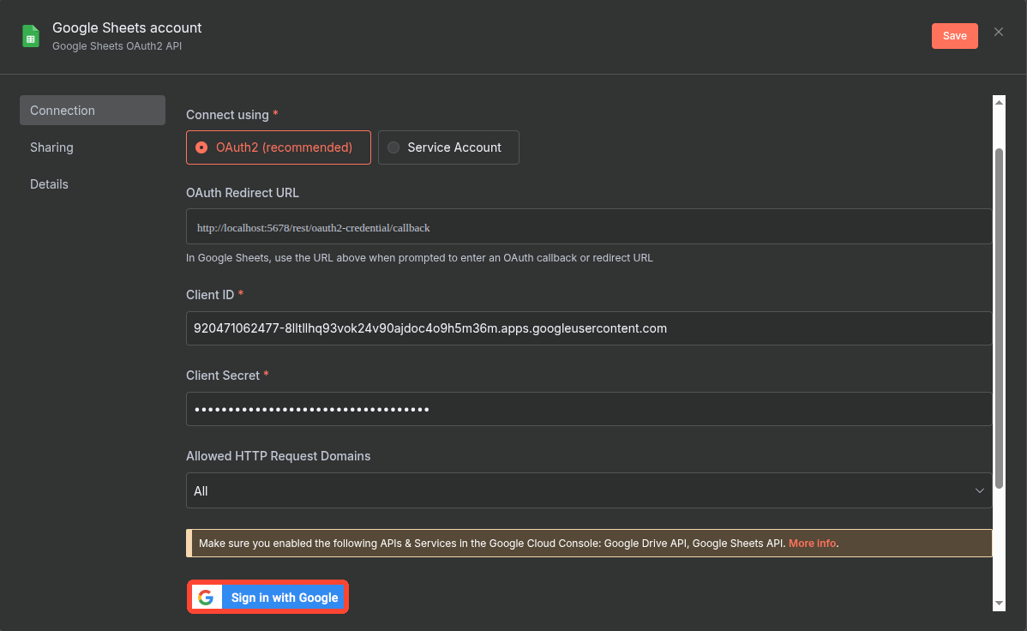
CLICK HERE → Sign in with Google

Step 8: After Google authentication is completed, you should see “Account connected”. Then close the credential window using the X.
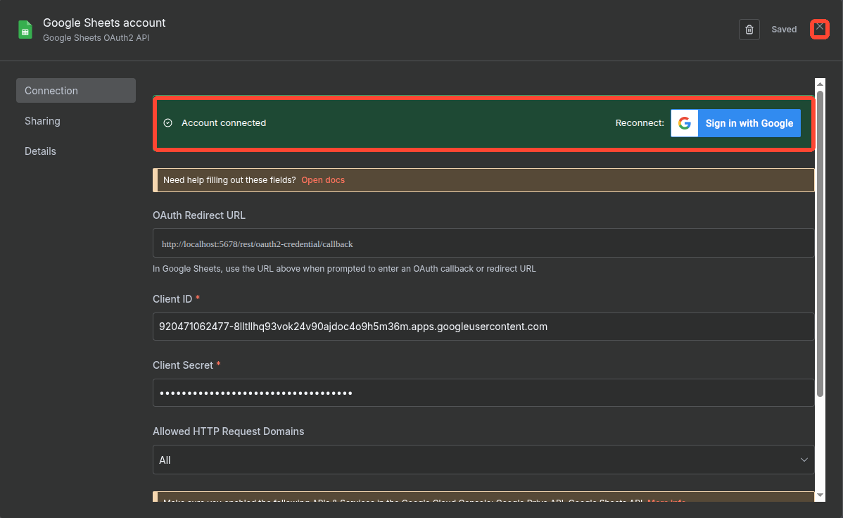
SUCCESS → Account connected → then close the credential window

Part B — Complete the Check Duplicate Setup
Step 9: Return to the “Check Duplicate” node. The saved Google credential should now be selected.
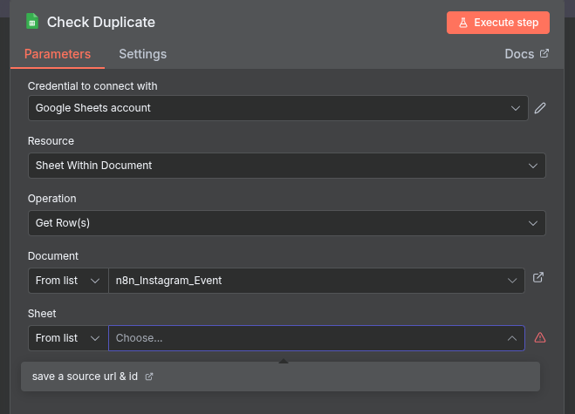
Step 10: Go to the “Document” section. Click the selector on the left and choose “From list”.
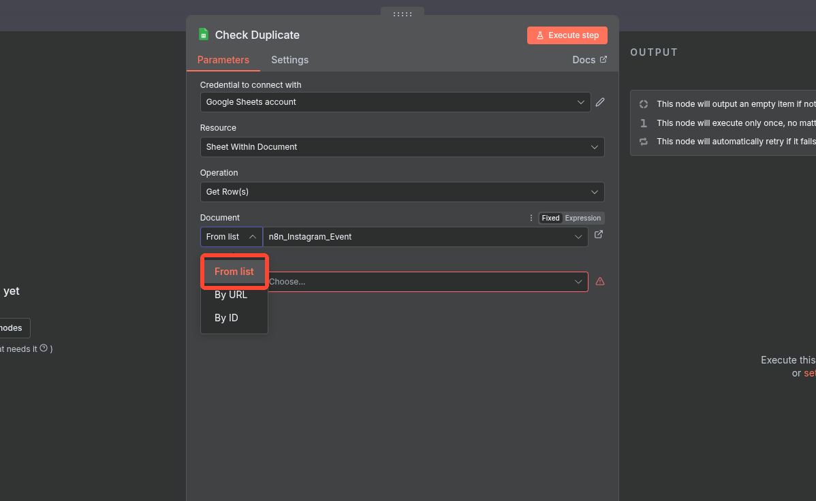
CLICK → From list

Step 11: Click the document dropdown next to “From list”. A list of available Google Sheets will appear.
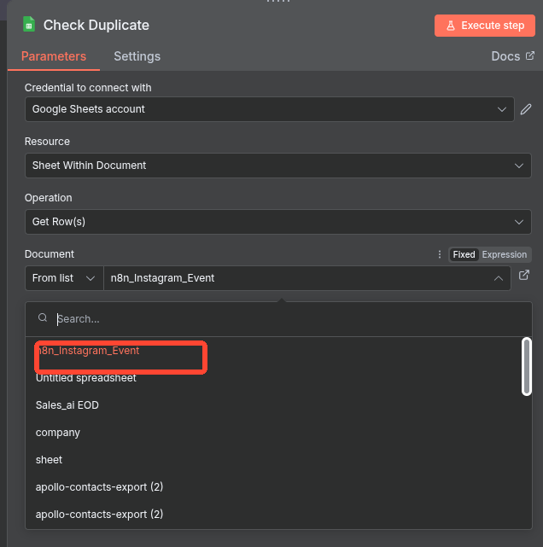
Step 12: Select the Google Sheet where the event source information will be stored. In this example, select “n8n_Instagram_Event”.
SELECT THE GOOGLE SHEET → n8n_Instagram_Event

Step 13: Make sure the selected Google Sheet contains these two fields: “source_url” and “source_id”.
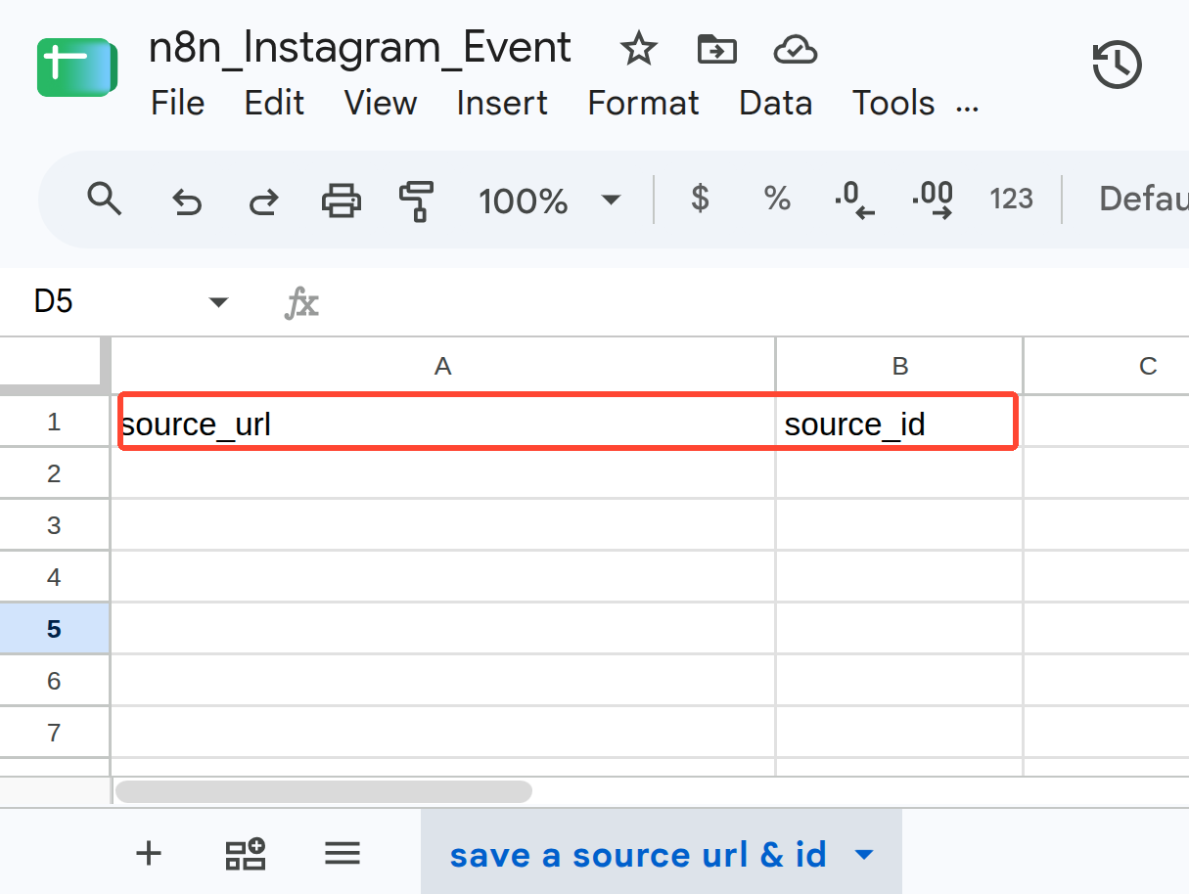
REQUIRED FIELDS → source_url and source_id

Step 14: Return to the “Check Duplicate” node and select the required Sheet from the Sheet section.
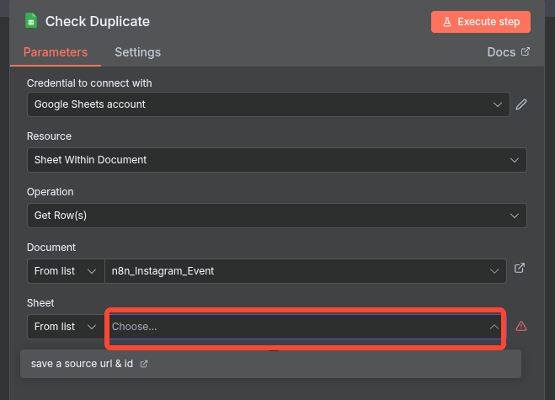
Check Duplicate setup is now completed.

Part C — Set up the Save Event Node
Step 15: Open the “Save Event” node. The credential setup is the same as the “Check Duplicate” node.
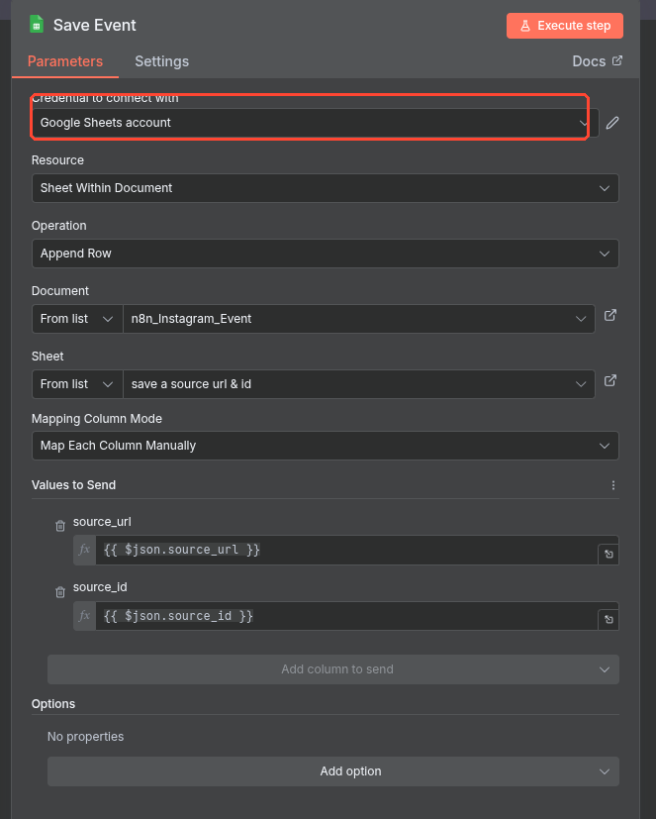
Step 16: In “Credential to connect with”, select the same saved Google credential. Do not create another credential.
REUSE THE SAME GOOGLE CREDENTIAL

Step 17: Confirm that the correct Document and Sheet are selected. The Save Event node can now use the same Google connection.
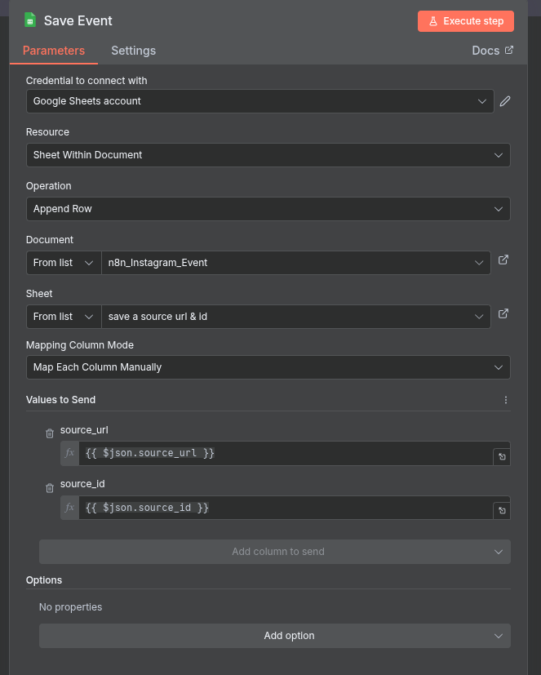

Part D — Connect the Google Credential to Google Docs
Step 18: For the “Create New Google Doc” node, select the Google OAuth2 API credential.
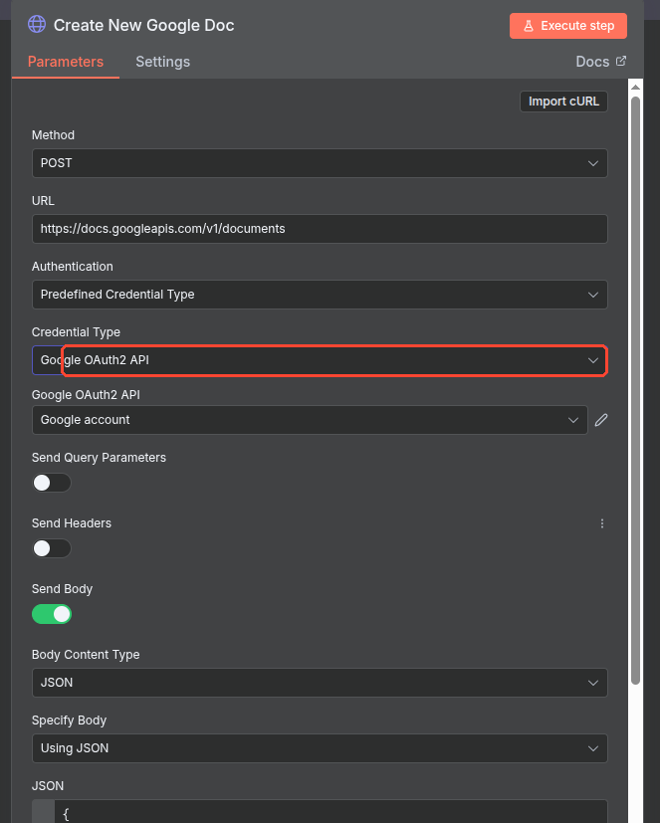
Step 19: Make sure the Credential Type is “Google OAuth2 API” and the credential points to your saved Google account.
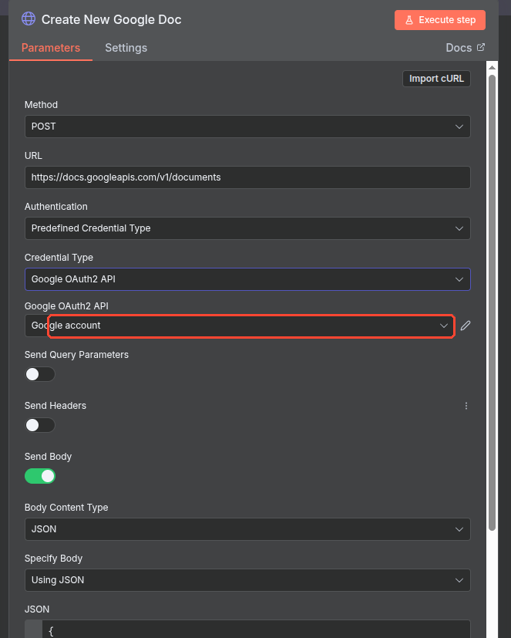
SELECT → Google OAuth2 API → your saved Google account

Step 20: For the “Write Event Content to Google Doc” node, follow the same process: open the node and select the existing Google credential.
Step 21: For the “Insert Cover Image” node, follow the same process: open the node and select the existing Google credential.
No new credential is required for these nodes. Reuse the saved Google credential.

Final Result
Google credential setup is complete. The same saved Google connection can be reused for the required Google Sheets and Google Docs nodes.

Create Credential → Client ID + Client Secret → Sign in with Google → Account connected → Select Sheet → Reuse Credential

