KYNCT — INSTAGRAM EVENT IMPORT
========================================

Import Date: 18/09/2026
Import Time: 17:45
Total Events: 1

These events were automatically extracted from
Instagram posts and are ready for human review.

EVENT 1
========================================

COVER IMAGE

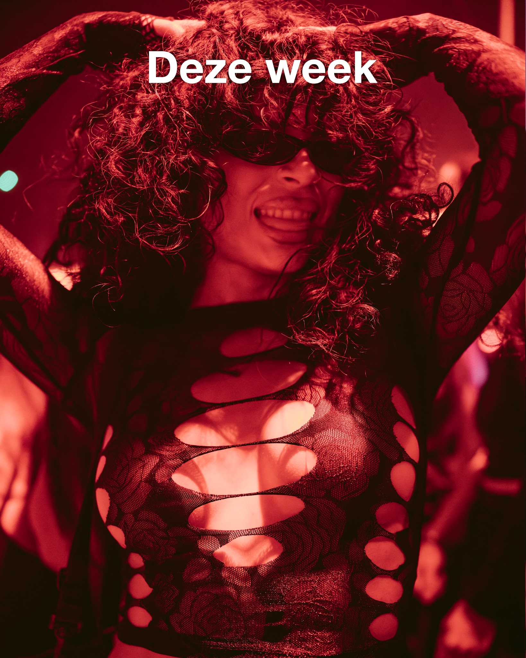
TITLE
Mibo bij Locura

CATEGORY
party

DATE & TIME
17/09/2026

LOCATION NAME
Locura

LOCATION ADDRESS
Not specified

DESCRIPTION
Een mibo (middagborrel) op donderdag waar je buiten of binnen bij Locura dansend kunt genieten.

SOCIAL IMPACT
Level: Neutral
Reason: The event is a standard social party with no specified broader societal impact.

TICKET LINK
https://annabel.nu/locura/

SOURCE URL
https://www.instagram.com/p/DdYhWKhjoN9

SOURCE ID
DdYhWKhjoN9

CONFIDENCE FLAGS
missing_start_time

MAX ATTENDEES
Not specified

SAFETY POLICY FLAGS
None

SAFETY RISK LEVEL
None

SAFETY REVIEW REASON
The event is a standard social and nightlife gathering. No safety policy violations or risks were detected.

========================================
END OF IMPORT
========================================

