KYNCT — INSTAGRAM EVENT IMPORT
========================================

Import Date: 18/09/2026
Import Time: 17:30
Total Events: 1

These events were automatically extracted from
Instagram posts and are ready for human review.

EVENT 1
========================================

COVER IMAGE

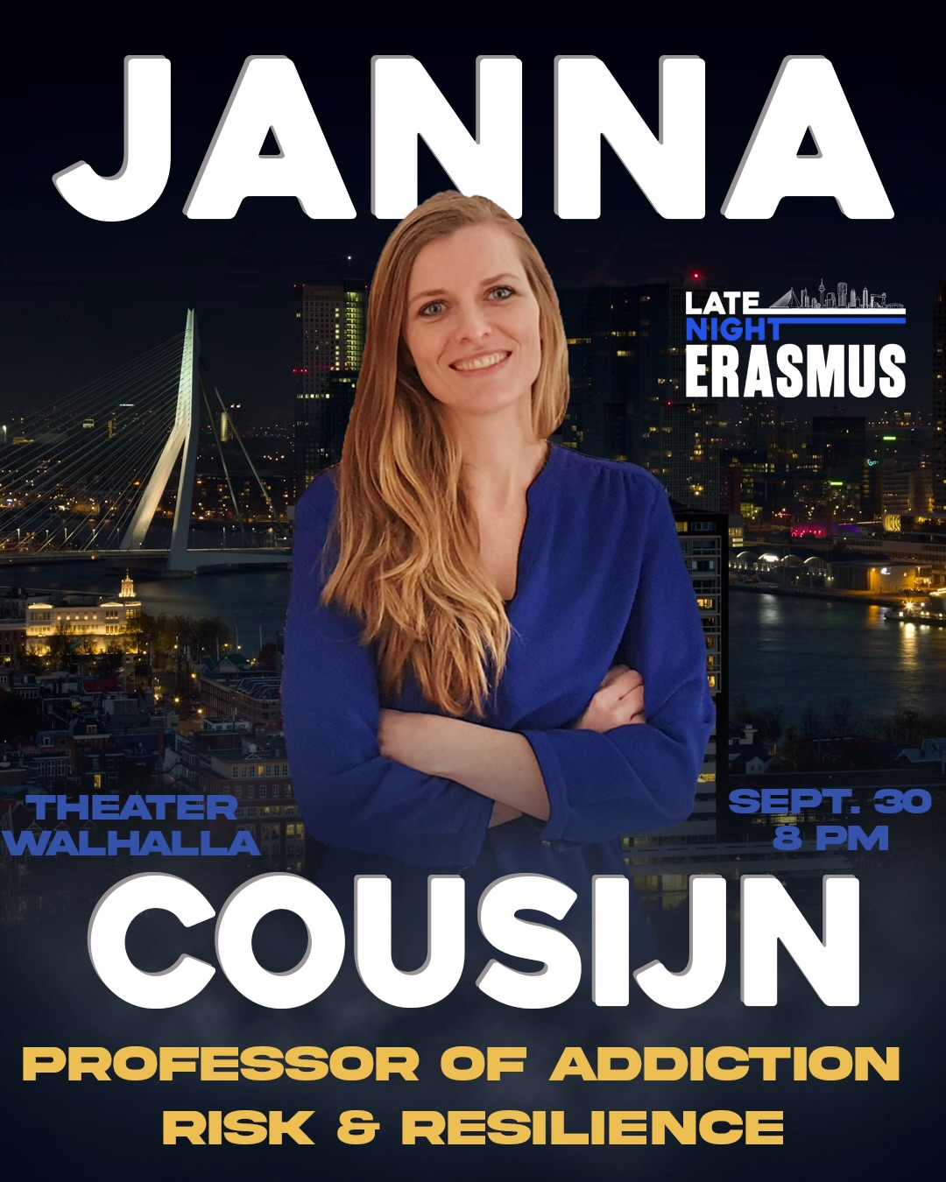
TITLE
Late Night Erasmus: Janna Cousijn

CATEGORY
study

DATE & TIME
30/09/2026 at 20:00

LOCATION NAME
Theater Walhalla

LOCATION ADDRESS
Not specified

DESCRIPTION
An interactive late-night talk about alcohol and addiction featuring Prof. Dr. Janna Cousijn (Professor of Addiction Risk & Resilience) and Christophe Romein (PhD candidate). They will discuss why people get addicted, how friend groups rewire the brain, and the societal definitions of alcohol problems, in a conversation on stage with a bartender.

SOCIAL IMPACT
Level: Positive
Reason: Educates the audience about alcohol addiction, peer pressure, and neural rewiring, promoting healthy awareness.

TICKET LINK
https://buytickets.at/hartwighosting/2363365

SOURCE URL
https://www.instagram.com/p/DdZZoKzDN7f

SOURCE ID
DdZZoKzDN7f

CONFIDENCE FLAGS
None

MAX ATTENDEES
Not specified

SAFETY POLICY FLAGS
None

SAFETY RISK LEVEL
None

SAFETY REVIEW REASON
The event is an academic talk about addiction and peer pressure with no safety concerns.

========================================
END OF IMPORT
========================================

