Car Damage Assessment System

Shalini L K

Thiagarajar college of Engineering

Madurai, India

shalinilk2004@gmail.com

**Abstract**

### 

ensure satisfaction for the customers with the processing of their claims.

**A novel car damage assessment framework is introduced to automate the insurance claim process using deep learning. This system utilizes two key datasets: the Car Make and Model (CMM) dataset, containing images of 23 car makes and 148 vehicle models common in the Indian automotive market, and a larger dataset of 222,000 images annotated with various types of car damage collected from insurance offices and web resources. These images are labeled by damage type (e.g., dents, scratches, cracks), severity, and location (front, back, side). By integrating this visual data with structured information, the system can provide accurate repair cost estimates, greatly reducing manual assessment time and streamlining the claim process. The framework employs the CDA_YOLOv8 model, achieving a per-class accuracy of 87.36% and an overall accuracy of 90.45%, outperforming current models and offering a comprehensive, efficient solution beneficial to both insurers and customers.**

**Keywords—Car Damage Assessment, Insurance Claim Automation, Deep Learning, CDA_YOLOv8, Damage Severity Classification, Car Make and Model Dataset, Vehicle Damage Annotation, Damage Type Detection, Cost Estimation, One-Stage Models**

# Introduction

In the past decades, the number of people with vehicle ownership has surged sharply. Consequently, this was witnessed with a huge rise in the number of insurance claims. Thus, it imposes colossal pressure on the insurer side to make swift and impartial estimation over vehicle damage. The traditional course of claims includes manual inspection by engineers and surveyors that might consume much time and is prone to human error. The traditional process often delays the claims process, increases operational costs and results in inconsistent valuation of claims. Despite these issues, recent breakthroughs in deep learning have made it possible to establish fast, efficient, and uniform appraisals through automated damage assessment systems. Such automation and streamlining of claims management will cut down on manual workload and

This paper introduces a general car damage appraisal system based on deep learning for insurance claims submission.

Two new datasets form the core of this system. These datasets have been carefully designed to train and test the performance of a model on images of 8 popular car makes and 19 vehicle models specific to the Indian automotive market. The first dataset is called the Car Make and Model (CMM) dataset. This dataset enables the system to not only recognize the make of the vehicle in question but also the model, a crucial step in calculating the appropriate damage and estimation of repair costs. The second dataset is a much larger dataset damage, comprising 40,000 images which were both solicited from insurance offices and sourced from the web, each carefully annotated to capture the nature and specifics of the damage. This damage dataset is thoroughly labeled for different damage types including: bonnet dent, bumper dent, bumper scratch, door crack, door dent, door scratch, glass broken, grill broken, headlight broken, roof crushed, side mirror broken, side mirror crack, taillight broken, window broken, window crack, window scratch, windshield broken, windshield crack, and windshield scratch. Each image is later annotated for damage severity and location, front, back, or side. Thus, rich contextual data would be provided for the right cost estimation..

The model proposed here, CDA_YOLOv8, uses these datasets to reach a great level of accuracy in identification of car make and model and damage assessment. It integrates image data with structured information, so CDA_YOLOv8 could be relied upon to show presence and type of damage location, measure severity, and give an estimate of the repair costs. This model outperforms one-stage counterparts in terms of accuracy and speed as it runs at the average per- class accuracy of 87.36% and overall accuracy of 90.45%. This would mean that the developed model could become a scalable, efficient solution for automated insurance claim processing, one that will potentially save both insurers and customers from assessment time and increase the accuracy of their claim evaluations.

**Orginal image Damage detected image**

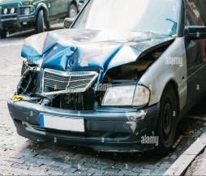 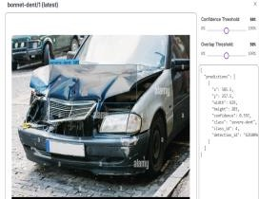

Fig. 1. Identification of Damage in Bonnet Left: Original image, Right: Damage detected image

As car insurance claims increase, the need for automated systems in the insurance industry grows. Manual damage appraisals are time-consuming and prone to inconsistencies, but deep learning-based damage assessment offers standardized and objective evaluations. The framework proposed in this paper presents an innovative, end-to-end solution that leverages advanced computer vision techniques for accurate damage evaluation, severity assessment, and repair cost estimation. In the example shown, the left image displays the original state of the car with bonnet damage, while the right image shows the detected damage with confidence metrics, demonstrating the system's capability to identify and assess damage accurately.

The system is powered by two key datasets. The Car Make and Model (CMM) dataset includes 8 popular car makes and 19 vehicle models from the Indian market, essential for training the model to identify specific vehicles, which aids in precise damage recognition and cost estimation. The second dataset is larger, containing 40,000 annotated images from insurance offices and the web, covering various damage types, severity, and locations. These datasets ensure accurate model training and enable the CDA_YOLOv8 model to address real-world insurance claim assessments, offering scalable and efficient solutions for the evolving automobile insurance sector.

The rest of the paper is organised as follows. Section II provides a concise overview of related work in image dehazing. Section III details the proposed CDAS model, its architecture, Efficiency and Performance Evalution. Section IV presents Implementation and Results of our Project Finally, Section V concludes the paper and offers insights for future research directions

# RELATED WORK

Patil et al. (2017) focused on car damage classification using convolutional neural networks (CNNs), achieving 89.5% accuracy through transfer and ensemble learning with a limited dataset [1]. In contrast, our approach utilizes a larger, annotated dataset, employing the CDA_YOLOv8 model to achieve 90.45% accuracy and streamline the entire insurance claims process, from damage assessment to repair cost estimation. Kyu and Woraratpanya (2020) used VGG16 and VGG19 for damage detection, but our CDA_YOLOv8

model provides higher accuracy and expanded capabilities in detecting damage types, severity, and repair cost estimation, leveraging comprehensive datasets like the Car Make and Model (CMM) dataset for better scalability [2].

HV and Karthik (2019) utilized CNN and Mask RCNN for damage detection and segmentation to enhance insurance claims processing [3]. While Mask RCNN focuses on segmentation, our CDA_YOLOv8 model not only detects and classifies damage but also integrates severity and location data to estimate repair costs, providing a more comprehensive solution. Dwivedi et al. (2021) automated vehicle damage classification with pre-trained CNNs and YOLO, achieving 96.39% accuracy with a smaller dataset [4]. Our larger, more detailed dataset enables the CDA_YOLOv8 model to achieve 90.45% accuracy, with better repair cost estimation and streamlined claims processing.

Lilienblum et al. (2000) proposed a 3D measurement method to detect small dents, focusing on subtle surface errors [5]. Our deep learning-based approach uses large annotated datasets to detect and classify various damage types, including severity and location, offering a more complete solution. Similarly, Arnal et al. (2017) used optical flow for defect detection on specular surfaces [6]. Our method utilizes deep learning to classify a wider range of damage types, integrating damage severity and cost estimation for insurance claims automation.

Hasebe et al. (2017) used photometric stereo and semantic segmentation for defect detection in metallic components, focusing on industrial applications [7]. Our work adapts these concepts to automotive images with deep learning for classification and repair cost estimation, automating the insurance claims process. Rao and Desai (2022) introduced an IR sensor-based dent detection system [8], which is limited to dent detection. Our CDA_YOLOv8 model, however, classifies a broader range of vehicle damage and estimates repair costs, making it more applicable for insurance claim processing.

Park et al. (2020) employed R-CNN for dent localization, achieving 98.5% accuracy [9]. While their focus is on dent localization, our system extends to various car damage types, integrating classification and repair cost estimation for a more efficient claims process. Lastly, Yan et al. (2020) proposed an improved genetic algorithm for fraud detection in insurance claims using BP neural networks [10]. While fraud detection is a critical aspect, our approach automates damage assessment and claims processing, offering a more efficient, reliable system for handling insurance claims..

1. **PROPOSED CDAS: Car Damage Assessment System**

**The explanation of the model’s working is explained in four sections.**

## Model Architecture and Training

The diagram illustrates the flow of vehicle damage assessment system, which uses the CDA_YOLOv8 model to analyze an input image of a car.

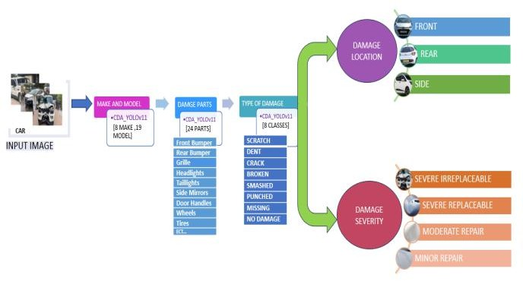

**Fig. 2. Model Architecture and Training proccesing**

1. **Input Image:** The system begins with an input image of a damaged vehicle, taken either from a customer’s submission or an insurance company’s database.
2. **Make and Model Identification:** - Using the CDA_YOLOv8 model, the system first identifies the car’s make and model. The model is trained to recognize 8 car makes and 19 specific models.
   * This information is crucial for assessing damage severity and estimating repair costs since different car models may have different repair requirements.
3. **Damage Parts Detection:** - The CDA_YOLOv8 model is used again to detect specific parts of the car that are damaged. It can identify damage across 24 different parts, including the front and rear bumpers, grille, headlights, taillights, side mirrors, door handles, wheels, tires, and more.
   * This step isolates the affected areas, focusing the assessment on relevant sections of the car.
4. **Type of Damage:** - Once the damaged parts are identified, the system classifies the type of damage into one of eight predefined classes: scratch, dent, crack, broken, smashed, punched, missing, or no damage.
   * This classification provides a more detailed understanding of the damage, which is important for determining the extent of repairs or replacement required.
5. **Damage Location:** - The system categorizes the damage location as front, rear, or side, which further contextualizes the damage assessment. For instance, front-end damage might affect essential engine components, while rear damage could impact trunk integrity or rear lighting.
6. **Damage Severity:** - Finally, the system assigns a severity level to the damage, classified as:
   * Severe Irreplaceable: Damage that cannot be repaired or replaced easily, requiring major intervention.
   * Severe Replaceable: Severe damage that can be managed by replacing the affected parts.
   * Moderate Repair: Damage that can be repaired without extensive replacement.
   * Minor Repair: Minor damage that requires minimal repair work.

These severity levels help streamline the decision-making process for insurance claims and repair cost estimates.

In summary, this diagram represents the automated workflow of your vehicle damage assessment system, showing how the CDA_YOLOv8 model processes an input image to detect the make, model, damaged parts, type and location of the damage, and finally assesses the severity level for effective damage analysis and cost estimation.A. YOLOv8 Architecture

#### Enhancing Efficiency and Accuracy in Insurance Claims Processing:

The car damage assessment framework integrates the YOLOv8 deep learning model within a user-friendly app to streamline insurance claim processing. Using a dataset sourced from WebScholar and other online platforms, annotated for damage types, severity, and location, the model is trained for high accuracy in identifying and assessing car damage. The application is designed for easy integration with insurance platforms, enabling insurers to use it within their existing workflows. During vehicle inspection, 3-4 cameras are strategically placed to capture key areas like the bonnet, bumper, doors, windows, and mirrors, ensuring comprehensive coverage. The app processes these images in real-time, assessing damage types such as dents, scratches, and cracks. Its interface provides immediate analysis with severity categorization and repair cost estimates, allowing adjusters and customers to receive fast, reliable feedback. This approach reduces claim processing time, enhances accuracy, and supports efficient service delivery.

#### Data Collection and Preprocessing

The WebScholar dataset is tailored for vehicle damage detection and includes diverse, high-resolution images labeled with damage types, locations, and severity.

**Image Capturing Process:** Three to four cameras are strategically placed to capture all critical angles, ensuring a complete view of the front (bumper, headlights, bonnet, windshield), sides (doors, mirrors), and rear (bumper, trunk, tail lights). This multi-angle capture approach reduces blind spots and improves detection accuracy.

**Damage Annotation and Labeling:** Images are precisely labeled for damage type (e.g., scratches, dents, cracks) and severity (e.g., minor, moderate, severe), allowing the YOLOv8 model to distinguish subtle differences between damage types.

I**mage Preprocessing:** Images are resized, normalized, and augmented (rotation, flipping, brightness adjustments) to ensure consistency and improve model robustness.

#### Benefits of Multi-Angle Data and Detailed Annotation

Multi-angle captures reduce missed damage areas, and detailed annotations allow the model to assess damage accurately, such as distinguishing between minor scratches and severe dents, resulting in reliable repair cost estimates. This framework enhances the accuracy and efficiency of damage appraisal in the insurance industry**.**

##### Performance Evaluation

To assess the model's performance effectively, we employed

a **confusion matrix** as a key evaluation tool. This matrix allows us to visualize the accuracy of the classifications across different categories (e.g., different damage types and vehicle makes/models). We tracked the following metrics:

**Precision**: This metric indicates the accuracy of the positive predictions. It is calculated as the ratio of true positives to the sum of true positives and false positives. Precision helps us understand how many of the detected damages are actually correct.

Precision = True Positive (1) True Positives+False Positives

**Recall**: This measures the model’s ability to identify all relevant instances. It is calculated as the ratio of true positives to the sum of true positives and false negatives. Recall is critical for understanding how many actual damages were successfully detected by the model.

Recall = True Positive (2) True Positives+False Negative

**F1 Score**: The F1 score combines both precision and recall into a single metric, providing a balance between the two. It is especially useful when dealing with imbalanced datasets.

F1 Score= Precision*Recall (3) Precision+Recall

Through iterative training and evaluation using these metrics, we continually refined our model, making adjustments based on the insights gathered from the confusion matrix. The results of these evaluations will be detailed in subsequent sections of this paper, where we will present graphs and tables illustrating the training loss, validation loss, and overall performance metrics.

## Evalution Metrics:

In our evaluation process, we follow a systematic approach that begins with the identification of the vehicle make and model, followed by a detailed analysis of damage types and severity. This step-by-step evaluation ensures the accuracy and reliability of our YOLOv8 model in assessing vehicle damage.

## IMPLEMENTATION AND RESULTS

The model was trained on an NVIDIA RTX 4070 Super GPU for a duration of 1 hours using a custom dataset comprising 40,000 annotated images. Over the course of 150 epochs, the model demonstrated excellent performance with decreasing box loss, classification loss, and distribution focal loss in both training and validation sets. Precision and recall metrics stabilized above 0.9, showcasing the model's high accuracy in

detecting damage. Furthermore, the model achieved an impressive mAP50 of over 0.95 and an mAP50-95 close to 0.90, indicating strong generalization for car damage detection and classification tasks.

##### Make and Model Identification:

The Fig 3 show performance metrics for a car damage assessment model:

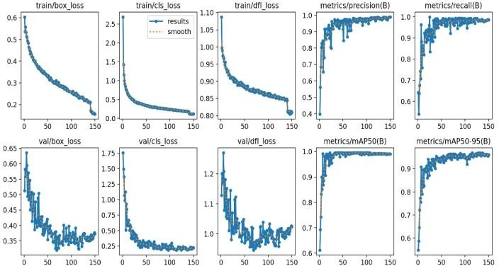

* + 1. Training Metrics

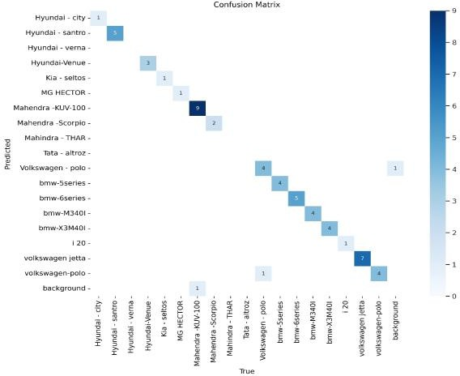

* + 1. Confusion Matrix

**Fig.3 Performance Evaluation of Car Damage Assessment Model: Confusion Matrix and Training Metrics**

1. **Confusion Matrix:** This matrix shows how well the model classifies different car models. Correct classifications are along the diagonal, while off-diagonal values show misclassifications. High diagonal values indicate strong accuracy for some models.
2. **Training and Validation Metrics:** These plots track model performance over time. Decreasing loss values indicate improved learning, while high precision, recall, and mAP scores show the model is accurate in detecting and localizing damage.

Overall, the model effectively identifies car models and assesses damage with high accuracy.

**OUTPUT:**

This Figure 4 shows the detection results of a car damage assessment model, highlighting its ability to recognize different car models and classify them with confidence scores.

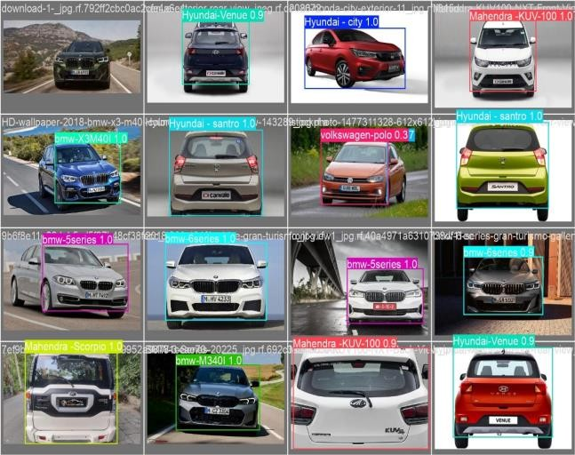

* 1. **Bounding box represents a detected car model, with labels displaying the model name and confidence score**

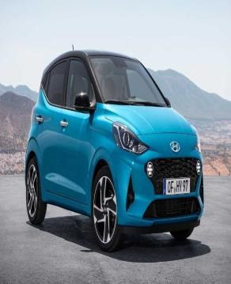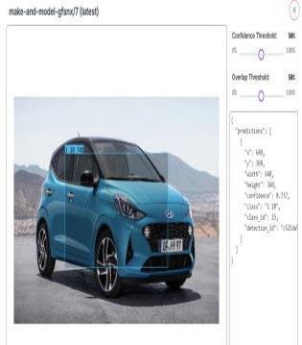

* 1. **i)orginal image of i20 b)ii)model detected as i20**

**using our model**

**Fig.4** Detection results of a car damage assessment model

* High confidence scores (close to 1.0) suggest the model is very certain of its predictions, as seen with models like "Hyundai - city" and "bmw-5series."
* Some lower confidence scores, like "volkswagen-polo 0.37," indicate the model is less certain about those predictions, possibly due to ambiguous features or limited training data for certain models.

This detection visualization helps assess the model's accuracy in correctly identifying car models, an essential part of a car damage assessment system when linking specific vehicle types to detected damage areas.

## Damage Detection:

Identifying damage on vehicles is important for enhancing the insurance claims settlement process and also securing the safety of the vehicle. Today’s models trained using sophisticated deep learning approaches can not only detect damage but can also classify them into various categories for example:- dents, scratches, or cracks. These models perform the task of understanding how damage has been incurred to a particular vehicle in which images are taken, on the body panels like the bonnet or doors, even bumpers, etc. Such damage, along with its degree, is established by various performance metrics comparing what was detected with what is present in the annotated datasets. Through this comparison practice, the

accuracy and the extent of reliability of the classifications done by the model are said to be improved consistently.

**The Fig 5 presents key performance metrics for a car damage assessment model:**

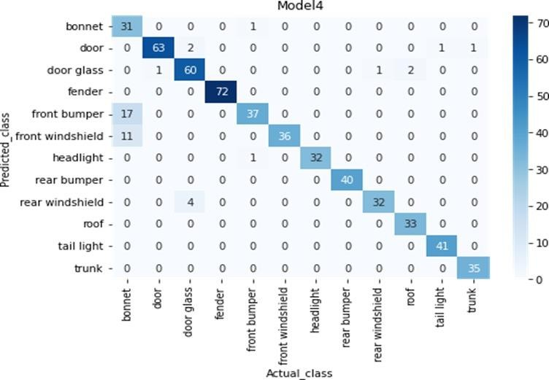

* + 1. **Confusion Matrix**

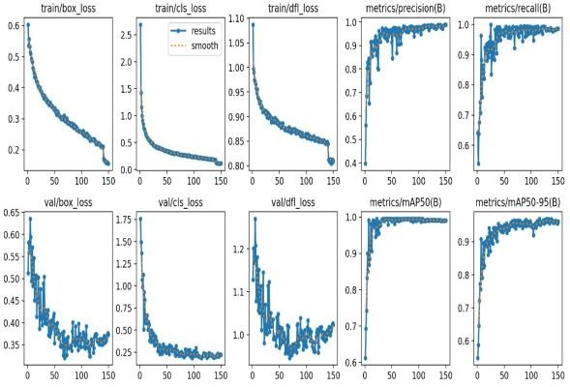

* + 1. **Training Metrics**

**Fig.5 Performance Evaluation of Car Damage Assessment Model: Confusion Matrix and Training Metrics**

1. **Confusion Matrix:**

The diagonal values, which are highly concentrated for each class, demonstrate strong performance in correctly identifying car parts such as bonnet, door, and headlights. Minimal off-diagonal misclassifications suggest that the model occasionally confuses visually similar components, such as "front bumper" with "rear bumper" or "windshields." Overall, the confusion matrix highlights the model’s strengths while indicating areas for improvement, particularly in less represented or similar-looking parts.

1. **Training and Validation Metrics**

**-Loss Curves:**

* + **Train/Box Loss and Val/Box Loss:** Indicate the model's improving accuracy in predicting bounding boxes.
  + **Train/Cls Loss and Val/Cls Loss:** Reflect consistent improvement in classification confidence.
  + **Train/DFL Loss and Val/DFL Loss:** Fine-tunes localization using distributional focal loss.
  + **Evaluation Metrics**:
    - **Precision & Recall:** Increasing trends show enhanced accuracy in detecting and classifying objects.
    - **mAP50 and mAP50-95:** High scores across IoU thresholds confirm effective damage and component identification.

The model effectively classifies and detects car components with high accuracy, supported by declining losses, high precision/recall, and an informative confusion matrix.

**OUTPUT:**

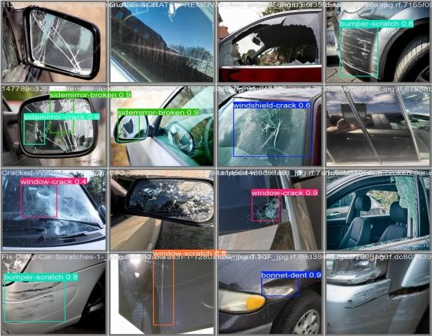

1. Each bounding box highlights a detected damage type on car parts

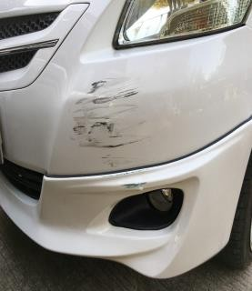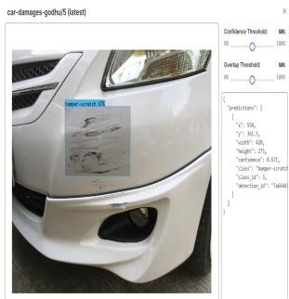

1. **i)orginal image b)ii)bumper-scratch detected image using our model**

**Fig.6 Detection results of a car damage assessment model**

This Fig 6 demonstrates the performance of a car damage assessment model in detecting car models and assessing specific damage types with confidence scores.

In this example, each bounding box highlights a detected damage type on car parts, displaying the specific damage and confidence score. For instance, "sidemirror-broken 0.9" indicates a 90% confidence level in identifying a broken side mirror. High confidence scores, as seen with "window-crack 0.9" and "bumper-scratch 0.8," demonstrate the model's strong certainty in identifying these damages. Lower confidence scores, such as "window-crack 0.4," reflect a reduced certainty in detection, possibly due to subtle damage features or limited examples in the training dataset, which can affect the accuracy of predictions.

* + - In the second example, the model detects damage details on a car’s bumper, with labels like "bumper-scratch 67%," highlighting a 67% confidence in detecting the scratch. This information provides insights into damage type, location, and severity, crucial for accurate damage assessment.

**This visualization showcases the model's capability to identify car models and damage areas accurately, assisting in linking specific vehicle types to detected damage regions, a valuable feature in automated car damage assessment systems**.

# Tabular Data For Accuracy and Precision Scores

Table 1

*

##### Make and Model Accuracy and Precision Scores

|  |  |  |  |  |  |  |
| --- | --- | --- | --- | --- | --- | --- |
| Class | Image  s | Instanc  es | Box  (P) | R | mAP  50 | mAP  (50-95) |
| MG-  Hector | 40 | 40 | 0.912 | 0.85 | 0.939 | 0.939 |
| Hyunda  i-city | 40 | 40 | 0.838 | 0.8 | 0.846 | 0.846 |
| Hyunda  i-santro | 200 | 200 | 0.875 | 0.9 | 0.966 | 0.966 |
| Volksw agen-  polo | 200 | 200 | 0.871 | 0.89 | 0.994 | 0.994 |
| Bmw- 5series | 160 | 160 | 0.891 | 0.89 | 0.938 | 0.938 |
| I-20 | 40 | 40 | 0.89 | 0.89 | 0.804 | 0.804 |
| Bmx- M340I | 160 | 160 | 0.743 | 0.87 | 0.937 | 0.937 |

This table (Table 1) shows the performance of a car damage assessment system on different car models. The system was trained on a dataset of images of cars with various types of damage. The table presents the number of images used for training, the number of instances of each car model in the training set, the Box(P) score, the recall score, and the mean average precision (mAP) score for each car model. The results indicate that the system is able to achieve high accuracy across all car models, suggesting that it is well- suited for use in a real-world car damage assessment system.

Tabel 2

*

##### Damage Detection Accuracy and Precision Scores

|  |  |  |  |  |  |  |
| --- | --- | --- | --- | --- | --- | --- |
| Class | Image s | Insta- nces | Box (P) | R | mAP 50 | mAP (50-95) |
| bonnet-  dent | 70 | 70 | 0.976 | 0.87 | 0.989 | 0.939 |
| bumper-  scratch | 70 | 70 | 0.898 | 0.9 | 0.946 | 0.946 |
| sidemirror  -broken | 20 | 20 | 0.823 | 0.8 | 0.966 | 0.866 |
| sidemirror  -crack | 20 | 20 | 0.866 | 0.79 | 0.994 | 0.894 |
| taillight-  broken | 60 | 60 | 0.854 | 0.89 | 0.978 | 0.838 |
| window-  broken | 40 | 40 | 0.9 | 0.99 | 0.904 | 0.904 |
| window-  crack | 40 | 40 | 0.799 | 0.97 | 0.954 | 0.944 |
| window-  scratch | 40 | 40 | 0.932 | 0.95 | 0.949 | 0.987 |

This table (Table 2) presents the performance of a car damage detection system across various types of car damage. The system was trained on a comprehensive dataset containing images of cars exhibiting different damage types. The table details the number of images used for each damage type, the instances of each type in the dataset, along with the Box(P) score, recall (R) score, and mean average precision (mAP) scores at different thresholds (mAP50 and mAP50-95). The results show that the system maintains high precision and recall across most damage types, underscoring its potential effectiveness and reliability for practical applications in car damage assessment.

## V . CONCLUSION

In conclusion, the comprehensive car damage assessment system presented in this paper highlights the transformative potential of deep learning in streamlining the insurance claims process. By leveraging the Car Make and Model (CMM) and Damage datasets, the CDA_YOLOv8 model offers a powerful, automated solution for assessing vehicle damage with high accuracy and speed. This approach minimizes the need for manual inspections, reducing human error, subjective inconsistencies, and delays—ultimately enhancing both efficiency and reliability in damage evaluation.

The CDA_YOLOv8 model provides objective, standardized assessments that foster greater trust between insurers and policyholders by minimizing discrepancies in claims evaluations. Additionally, this automation leads to significant cost savings for insurers and improved customer satisfaction through faster claim processing and more consistent evaluations. The impact of this model extends beyond operational efficiency, supporting a more transparent and trustworthy claims management experience.

Overall, this research demonstrates the potential of deep learning to revolutionize the insurance industry by addressing the increasing demands of vehicle insurance claims. Moving forward, integrating real-time damage assessment capabilities and optimizing the model’s performance for video inputs could further enhance its applications. This innovation sets a new standard for claims automation, showcasing the immense potential of AI-driven systems to transform the insurance sector and elevate service quality for insurers and policyholders alike.

#### REFERENCES

1. Patil, K., Kulkarni, M., Sriraman, A., & Karande, S. (2017, December). Deep learning based car damage classification. In 2017 16th IEEE International Conference on Machine Learning and Applications (ICMLA) (pp. 50– 54). IEEE.
2. Kyu, P. M., & Woraratpanya, K.(2020, July). Car damage detection and classification. In Proceedings of the 11th International Conference on Advances in Information Technology (pp. 1–6).
3. HV, Y., & Karthik, V. (2019). Car damage detection and analysis using deep learning algorithm for automotive.
4. Dwivedi, M., Malik, H. S., Omkar, S. N., Monis, E. B., Khanna, B., Samal, S. R., & Rathi, A.(2021). Deep learning- based car damage classification and detection. In Advances in Artificial Intelligence and Data Engineering: Select Proceedings of AIDE 2019 (pp. 207–221). Springer Singapore.
5. Lilienblum, T., Albrecht, P., Calow, R., & Michaelis, B.(2000, September). Dent detection in car bodies. In Proceedings 15th International Conference on Pattern Recognition. ICPR-2000 (Vol. 4, pp. 775–778). IEEE.
6. Arnal, L., Solanes, J. E., Molina, J., & Tornero, J.(2017). Detecting dings and dents on specular car body surfaces based on optical flow. *Journal of Manufacturing Systems, 45, 306–321.
7. Hasebe, A., Kato, K., Tanahashi, H., & Kubota, N.(2017, May). Dent detection method by high gradation photometric stereo. In Thirteenth International Conference on Quality Control by Artificial Vision 2017 (Vol. 10338, pp. 163–

170). SPIE.

1. Rao, S. S., & Desai, S. R. (2022). Automatic dent detection in automobile using IR sensor. In Evolutionary Computing and Mobile Sustainable Networks: Proceedings of ICECMSN 2021 (pp. 501–511). Springer Singapore.
2. Park, S. H., Tjolleng, A., Chang, J., Cha, M., Park, J., & Jung, K. (2020). Detecting and localizing dents on vehicle bodies using region-based convolutional neural network. Applied Sciences, 10(4), 1250.
3. Yan, C., Li, M., Liu, W., & Qi, M. (2020). Improved adaptive genetic algorithm for the vehicle insurance fraud identification model based on a BP neural network. Theoretical Computer Science, 817, 12–23.