Contents

Description 2

Intended User 2

Features 2

User Interface Mocks 3

Screen 1 3

Screen 2 4

Screen 3 5

Screen 4 5

Screen 5 6

Screen 6 7

Screens in landscape mode 7

Key Considerations 8

How will your app handle data persistence? 8

Describe any edge or corner cases in the UX. 8

Describe any libraries you’ll be using and share your reasoning for including them. 9

Describe how you will implement Google Play Services or other external services. 9

Next Steps: Required Tasks 9

Task 1: Project Setup 9

Task 2: Implement UI for Each Activity and Fragment 9

Task 3: Setup database 9

Task 4: Hook functionality with UI 10

Task 5: Implement Google Play Services 10

Task 6: Refine UIs with material design guidelines 10

Task 7: Testing the App 10

**GitHub Username**: shalus

My Kitchen Diaries

# Description

My Kitchen Diaries help you save your recipes and manage your grocery shopping. Pen down your own recipes in a quick and organized way with a photo for later viewing and sharing. My Kitchen Diaries will be your digital book of recipes. Share your intended recipes to your friends. It also manages your shopping list. Note down your missing ingredients and get notified when you enter your desired grocery stores.

# Intended User

This app is for your users who love to keep a diary of recipes and manage their grocery shopping.

# Features

* Saves photo of recipe along with its ingredients and other detail steps
* Sharing recipes to friends
* Managing the recipe information
* Manage grocery shopping
* Location based notification for shopping

# User Interface Mocks

## Screen 1

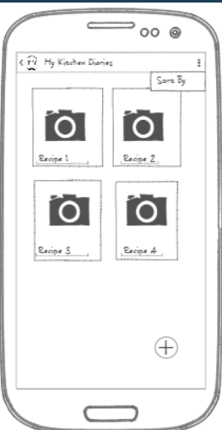

This is the main screen that shows the list of recipes that were saved by the user. Clicking on an item helps the user to view the recipe details. The plus icon button helps the user to quickly add a new recipe.

## Screen 2

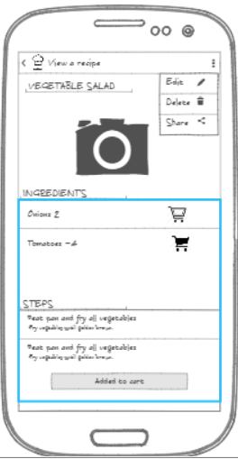

This screen shows the detailed recipe information such as its title, image, ingredients and steps. The menu enables the user to edit the recipe details, delete if not necessary or share the recipe to the users’ contacts. It also allows quickly adding items to shopping list by tapping the cart icon next to the ingredients display.

## Screen 3

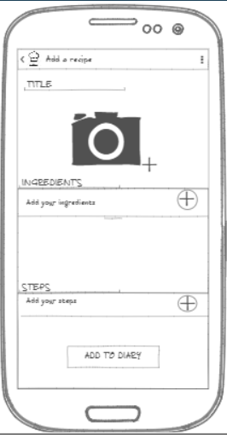

Add a recipe screen allows users to enter new recipe information into the database.

## Screen 4

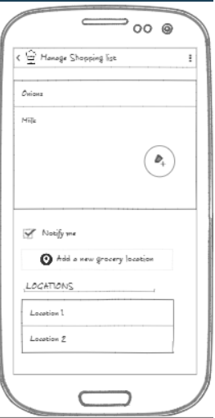

Manage shopping list is a screen that helps to view the items in the shopping list. It also enables editing or deleting an item.

The second half of the screen allows the user to enable notification and add desired locations. When enabled, a notification is shown at the location.

## Screen 5

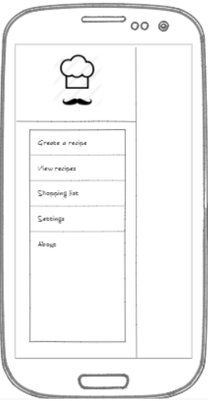

This screen shows a navigation drawer where the user can do the main actions of the application such as add a new recipe, view list of recipes and manage shopping list.

## Screen 6

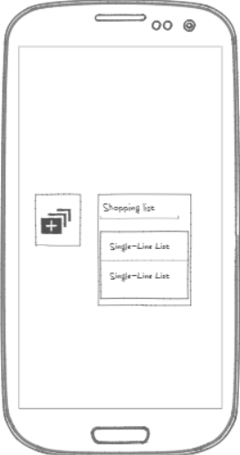

This screen shows the available widgets for the application. The first widget allows the user to directly create a new recipe. It opens the Add a recipe screen. The second widget allow the user to see the shopping list.

## Screens in landscape mode

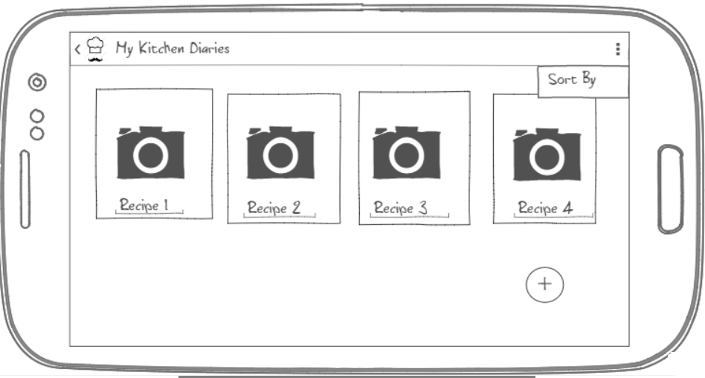

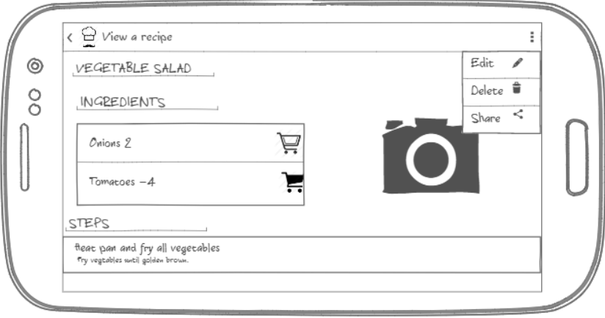

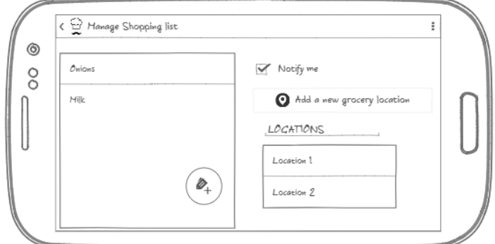

# Key Considerations

### How will your app handle data persistence?

The app will store all its recipe information such as title, ingredients, steps etc., shopping list and user preferred locations in a native SQLite Database and they will be exposed via a content provider.

The images captured are written to the external storage

### Describe any edge or corner cases in the UX.

If the user hits the back button while entering a new recipe information in create a recipe screen, a dialog appears to the user whether to save the entered information or cancel it.

If the user wishes to edit the entered information for a recipe, the current screen goes to add a recipe screen with all the fields filled with previous data before deleting from the database.

If the shopping list is empty, then no notifications are shown to the user even when they are in the desired grocery store.

### Describe any libraries you’ll be using and share your reasoning for including them.

Butter Knife library will be used to bind the views as there are many views in the layouts. This library will help in generating boilerplate code.

As this application is database intensive, Schematic library is used to automatically generate a content provider.

### Describe how you will implement Google Play Services or other external services.

In order to provide location-based notification to the user, Google places and Google location API’s will be used. Google places is used to access the Place Picker class to get the places selected by the user. Google location API will be used to get the device’s current location and create geofences.

# Next Steps: Required Tasks

## Task 1: Project Setup

* Set up the project.
  + Choose package name, minimum and target SDK version.
* Configure libraries – App compat support library, Recycler View, Butter Knife, Schematic and google play services places and location.
* Add required permissions for manifest

## Task 2: Implement UI for Each Activity and Fragment

* Build home UI with navigation drawer
* Build main UI with a recycler view of recipes and a floating action button to add a new recipe
* Build View a recipe activity with menu items
* Build add a recipe activity
* Build shopping list activity

## Task 3: Setup database

* Create database schema for tables for managing
  + Recipe information
  + Shopping list
  + User desired locations
* Expose it as a content provider

## Task 4: Hook functionality with UI

* Implement recipe addition to database using Async Task
* Implement recipe viewing using loaders and handle corner cases
* Implement shopping list management
* Implement widgets and flow to the application

## Task 5: Implement Google Play Services

* Implement Place picker to enable users to pick desired places and list them on the UI
* Implement Geo fences to enable users to get notified

## Task 6: Refine UIs with material design guidelines

* Choose proper colors and styles for the UI’s
* Add best font and create intuitive user experience

## Task 7: Testing the App

Test the app for every possible use case on a phone and tablet.