SHRI JAI NARAYAN MISHRA PG COLLEGE

DEPARTMENT OF COMPUTER SCIENCESESSION: 2024-2025
Name:
Father’s name:
Class:
Semester:
Roll number:
Subject:
Topic:
Supervisor Name:
Date:
1



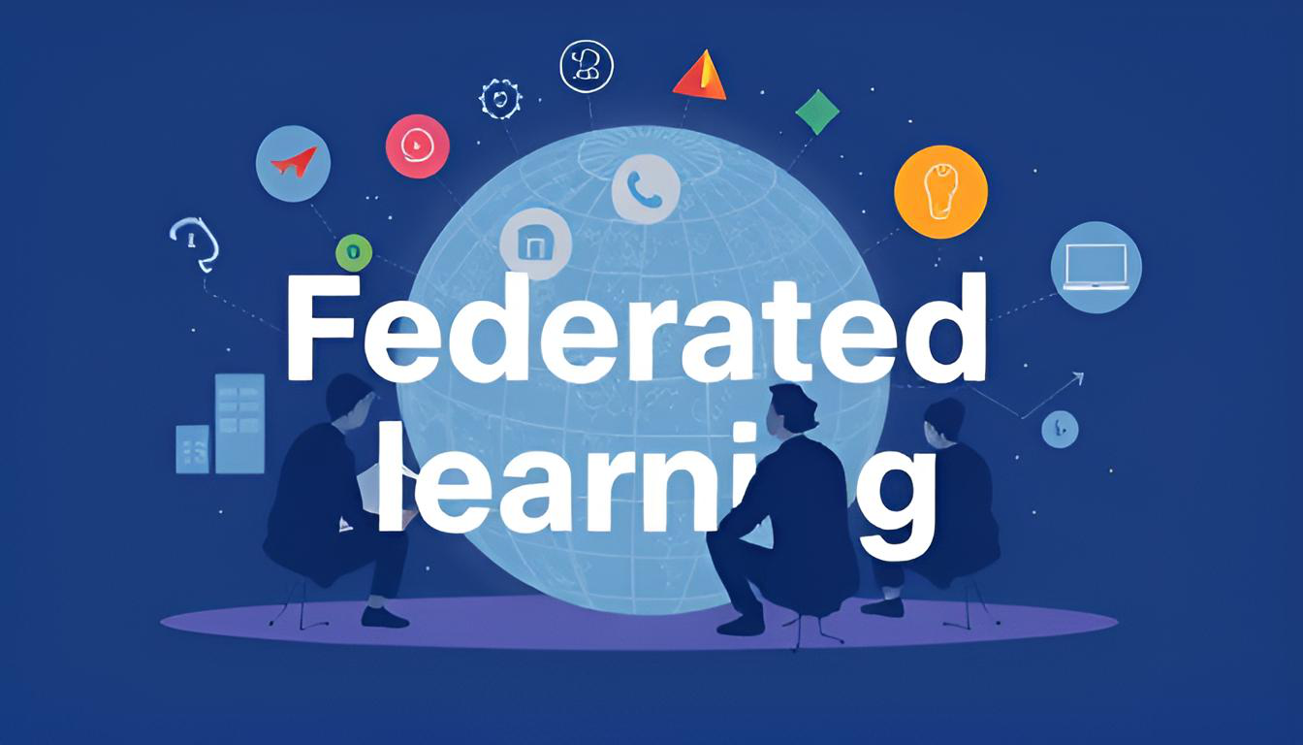



Federated learning
2

Acknowledgement
I would like to express my sincere gratitude to all those who supported me throughout the completion of this term paper on Federated Learning. This project has been a significant undertaking, and I deeply appreciate the assistance and encouragement I received along the way.
First and foremost, I would like to extend my heartfelt thanks to my professor, Ms. Kriti Jaiswal. Her invaluable guidance and unwavering support have been instrumental in shaping the direction of my research. Her insights into the field of artificial intelligence, particularly in Federated Learning, have greatly enhanced my understanding and inspired my work.
I am grateful for the opportunity to delve into the fascinating world of Federated Learning. Working on this term paper has provided me with invaluable insights into how Federated Learning is revolutionizing the way we process and analyze data while maintaining privacy and security. Exploring its applications, challenges, and future prospects has been both enlightening and inspiring.
Furthermore, I extend my gratitude to the authors and researchers whose work I referenced throughout this paper. Their pioneering contributions to the field of Federated Learning provided a solid foundation for my research and enriched my understanding of the subject matter. I have drawn inspiration from their innovative approaches and findings, which have been pivotal in guiding my exploration of the various techniques and applications of Federated Learning.
Lastly, I would like to thank my friends, and peers for their encouragement and support during this journey.
3

INDEX
➢Overview of Federated Learning  ➢What is Federated Learning?  ➢History of Federated Learning  ➢Key Concepts in Federated Learning  ➢Types of Federated Learning  ➢Federated Learning Tasks  ➢Key Models in Federated Learning  ➢Technologies Related to Federated Learning  ➢Applications of Federated Learning  Healthcare  Finance  IoT and Edge Computing  Retail and Marketing  ➢Advantages and Market Insights  Benefits of Federated Learning  Global Market Trends in Federated Learning Market Dynamics  ➢Federated Learning Ecosystem | 5  6  9  10  15  26  30  33  39  42  53
4

FEDERATED LEARNING
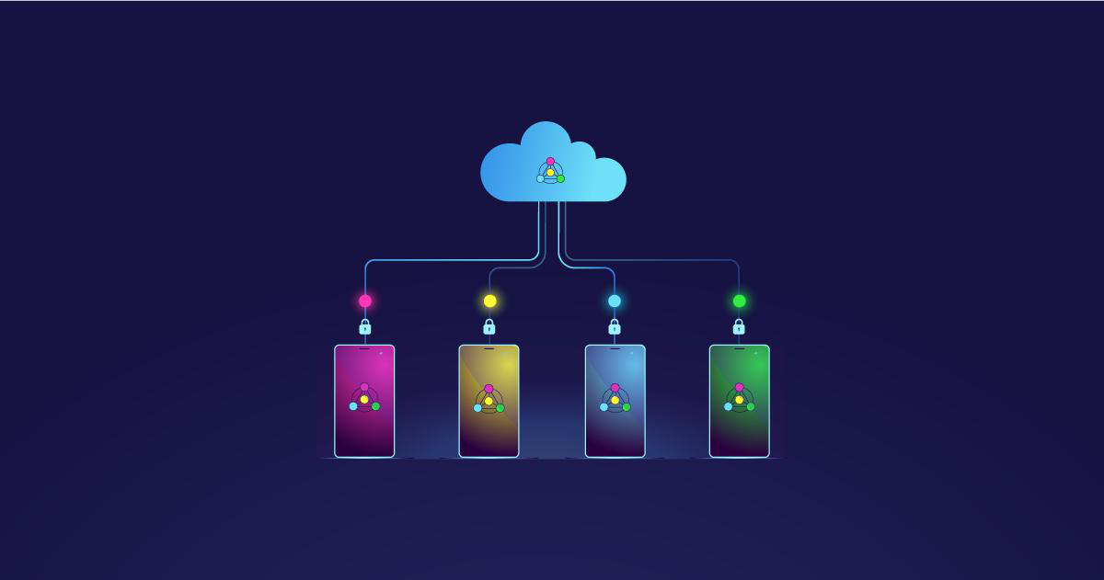
Overview:
Federated Learning (FL) is a machine learning approach that allows multiple devices or systems to collaboratively train a model without sharing their raw data. Unlike traditional centralized learning, where data is collected and stored on a central server, FL ensures that data remains on the devices where it was generated. This approach addresses privacy concerns while enabling robust model development.
The concept of FL revolves around a central server and several edge devices, such as smartphones, laptops, or IoT devices. Each device trains a local version of the model using its data. Instead of transferring the data to the central server, only the model's updates (e.g., weights or parameters) are sent. The server aggregates these updates to improve the global model, which is then shared back with the devices.
FL is particularly useful in scenarios where data privacy is critical, such as healthcare, finance, and personalized recommendations. For example, in healthcare, FL allows hospitals to develop a shared model for disease diagnosis while keeping patient data confidential. Similarly, FL is used in mobile devices to improve personalized services like predictive text and voice recognition without compromising user data privacy.
The main advantages of FL include enhanced data privacy, reduced bandwidth usage (since raw data is not transmitted), and the ability to leverage diverse datasets from multiple sources. However, it also comes with challenges, such as ensuring data heterogeneity, managing device variability, and maintaining secure communication during model updates.
5

As data privacy concerns grow globally, FL is becoming an essential tool for developing artificial intelligence solutions. With continuous advancements, it is expected to play a significant role in enabling secure, decentralized, and efficient machine learning systems in the future.
What is Federated Learning?
Federated Learning (FL) is an innovative approach to machine learning that allows multiple devices or organizations to collaboratively train a shared model while keeping their data decentralized. Instead of sending raw data to a central server, each device trains the model locally using its data. Then, only the trained model updates—such as weights or parameters—are sent to a central server, where they are aggregated to improve the global model.
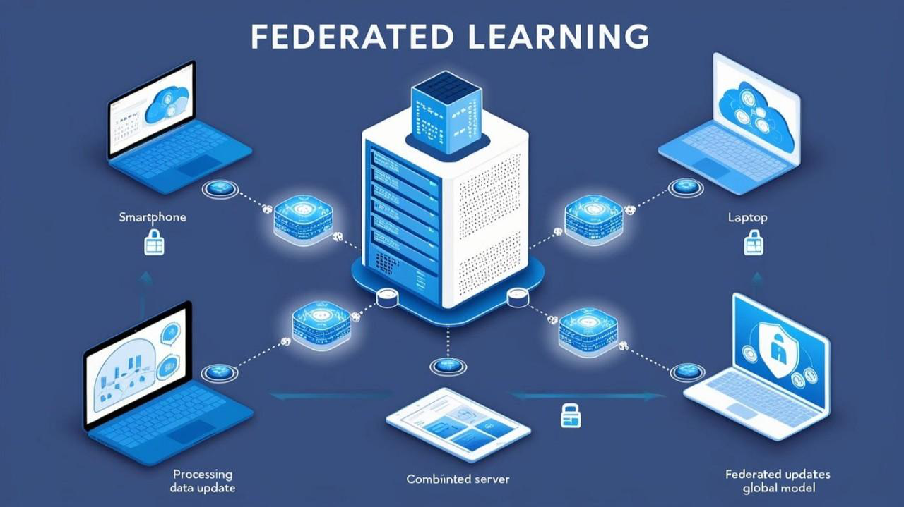
Federated Learning
This process ensures that sensitive data never leaves the devices, addressing critical concerns about privacy, security, and data ownership. By keeping data local, FL minimizes the risks of data breaches and meets stringent data privacy regulations, such as GDPR or HIPAA.
Federated Learning is particularly valuable in environments where data is distributed across many devices or locations, such as smartphones, IoT devices, or across organizations like hospitals and banks. For instance:
❖Smartphones: FL powers predictive typing and personalized recommendations without transferring user data to central servers.
6

❖Healthcare: Hospitals can collaboratively train models for disease prediction without sharing patient records.
❖Finance: Banks can improve fraud detection by learning from distributed data while maintaining customer privacy.
Key Features of Federated Learning:
•Decentralized Training: Data stays on the source devices or systems, promoting privacy.
•Model Aggregation: Updates from devices are combined on a central server to enhance the global model.
•Privacy and Security: Sensitive data remains protected by avoiding data transfer. •Efficiency: Reduces bandwidth usage since raw data isn’t transmitted.
Federated Learning represents a paradigm shift in how machine learning models are built,
offering a secure and collaborative way to harness the power of distributed data. It has
wide-ranging applications and is expected to play a critical role in the future of artificial intelligence.
Advantages of Federated Learning:
oPrivacy and Security: One of the biggest benefits of federated learning is that it
protects the privacy and security of the data. Since the data is not centralized, the
central server can't access sensitive information. This makes federated learning an
ideal solution for sensitive data, such as medical or financial records, that must be protected.
oScalability: Federated learning is highly scalable, as it can easily accommodate
large amounts of data. As data sources increase, the global model can be updated to
reflect the new data, making federated learning an ideal solution for large-scale machine learning problems.
oCost-effectiveness: Federated learning is more cost-effective than traditional
machine learning, as it reduces the need for large data centers and the cost of storing and processing large amounts of data.
oDecentralization: Federated learning is decentralized, meaning the data is
distributed across multiple sources. This makes it possible for organizations to work together to train models, even in different parts of the world.
oImproved Performance: Federated learning has been shown to improve the
performance of machine learning models, as it enables models to be trained on diverse data sets that would otherwise be difficult to access.
7

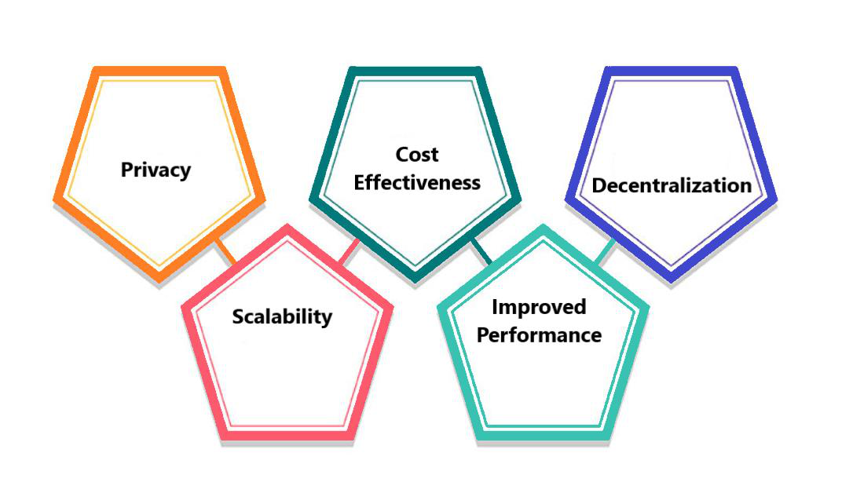
Limitations of Federated Learning:
oLatency: One of the biggest challenges with federated learning is latency, as it can take a long time for the models to be updated. This can result in slow performance and reduced accuracy.
oBandwidth: Federated learning requires high-bandwidth networks to be effective, as the models must be transmitted between the data sources and the central server.
oTrust: Federated learning relies on trust between the data sources and the central server, as the models need to be shared and updated. If a data source is untrustworthy, it could compromise the accuracy of the global model.
oTechnical Expertise: Federated learning requires technical expertise to implement, as it requires the development of complex algorithms and protocols.
How federated learning works:
Federated learning is a promising approach for addressing privacy concerns in machine learning. In traditional machine learning, the data is centralized, meaning that the data is collected, stored, and processed in a single location. This data centralization can create privacy and security issues, as sensitive information is often collected, stored, and processed in this manner.
Federated learning enables machine learning models to be trained on decentralized data sources by allowing multiple parties to train models on their local data while sharing the learned parameters with the central server. This allows the server to aggregate the models and update the global model while preserving the privacy and security of the data. To implement federated learning, the central server must communicate with the data sources, and the data sources must be able to train models on their local data. The central server then aggregates the models and updates the global model.
Federated learning has numerous potential applications, including medical research, financial services, and consumer data analytics. For example, in medical research, federated learning can train models on sensitive medical data while preserving privacy. In financial
8

services, federated learning can train models on financial data while preserving security.
And in consumer data analytics, federated learning can train models on consumer data
while preserving privacy
HISTORY OF FEDERATED LEARNING
•1990s–2000s: Foundations of Distributed Learning
Early research into distributed computing and machine learning algorithms focused on
improving computational efficiency by splitting workloads across multiple systems.
However, these approaches required transferring raw data to centralized servers, which
raised privacy and security concerns as data-intensive applications began to emerge.
•2016: Introduction of Federated Learning by Google
The concept of Federated Learning was formally introduced by Google researchers in
2016. This marked a significant shift in machine learning as it allowed decentralized
training of AI models. The first practical application was implemented in Gboard,
Google’s predictive keyboard, enabling devices to improve their language models
locally without sharing raw user data.
•2017: Development of Secure Aggregation Protocols
Researchers began incorporating secure aggregation techniques, ensuring that model
updates from devices could be combined without exposing individual contributions.
This innovation enhanced the privacy and security of FL and addressed the concerns of
using personal or sensitive data in collaborative learning.
•2018: Expansion to Cross-Silo Learning
Federated Learning expanded beyond mobile and edge devices to include collaborative
learning across organizations, often referred to as cross-silo FL. Industries like
healthcare and finance began experimenting with FL to share knowledge without
exposing proprietary or sensitive data.
•2019: Integration of Differential Privacy
In 2019, FL research introduced differential privacy techniques to further anonymize
model updates. This was a critical step in ensuring compliance with privacy regulations
like GDPR in Europe and HIPAA in healthcare, making FL more appealing for
regulatory-sensitive applications.
•2020–2021: Adoption in Critical Industries
FL saw rapid adoption in areas like autonomous vehicles, IoT, and healthcare.
Companies and institutions began using FL to develop collaborative AI models for tasks
such as disease diagnosis, predictive maintenance, and fraud detection while ensuring
data privacy.
•2022–Present: Addressing Challenges and Scaling Federated Learning
Recent research has focused on improving the scalability of FL, addressing issues like
heterogeneity in data and device capabilities, and ensuring trust in decentralized
systems. Federated Learning is now recognized as a cornerstone technology for
privacy-preserving AI, with continuous advancements shaping its future role in
machine learning.
9

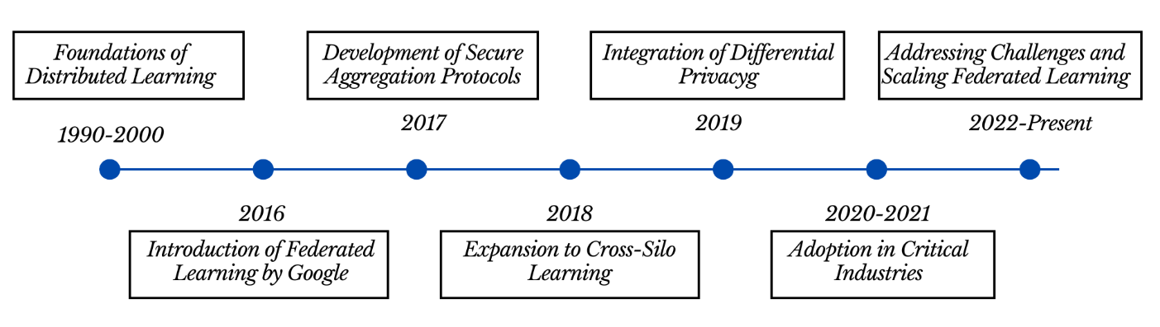
Timeline of federated learning
KEY CONCEPTS IN FEDERATED LEARNING
Federated Learning (FL) introduces unique principles and mechanisms that differentiate it from traditional centralized machine learning. Below are the key concepts central to understanding FL:
Decentralized Data Processing
Decentralized Data Processing is a cornerstone of Federated Learning (FL), designed to tackle the growing need for data privacy, security, and efficient use of distributed systems. This approach fundamentally changes how data is handled and processed compared to traditional centralized machine learning methods. Below is a detailed breakdown of this concept:
I. Data Stays Local
In FL, the raw data never leaves the device or system where it was generated.
Devices, such as smartphones, IoT sensors, or organizational servers, process and use the data locally to train machine learning models.
This eliminates the need for a centralized repository of sensitive data, reducing the risk of breaches or unauthorized access.
II. Local Model Training
Each device trains its version of the model using its own data.
Training is performed locally on edge devices, where computational resources are limited but sufficient for smaller-scale learning tasks.
Once training is completed, the updated model parameters (such as weights or gradients) are sent to a central server for aggregation.
10

III. Eliminating Centralized Data Transfer
Unlike traditional machine learning, where data is transferred to a central server for processing, FL bypasses this step entirely.
This approach minimizes bandwidth usage, as only model updates (small, compressed data packets) are transmitted rather than the raw datasets.
It also complies with data protection regulations like GDPR, as sensitive information remains confined to its source.
IV. Data Privacy and Security
Keeping data local ensures privacy by design. This is especially important in fields like healthcare, finance, and personalized technology.
For example, in healthcare, hospitals can collaborate to train a disease prediction model without sharing confidential patient records.
V. Distributed Systems and Scalability
FL leverages a decentralized structure to scale learning across thousands or even millions of devices.
This makes it highly adaptable for use in environments with diverse data sources, such as mobile networks or IoT ecosystems.
VI. Enabling Personalized Models
Since data is processed locally, FL can support the development of personalized machine learning models.
Each device’s training data reflects unique usage patterns, enabling the model to adapt to individual user preferences while contributing to a global model.
VII. Challenges in Decentralized Data Processing
Data Heterogeneity: Data on each device may vary significantly in format, distribution, and quality, complicating the training process.
Device Variability: Devices participating in FL often differ in computational power, storage, and connectivity, requiring adaptive algorithms to handle these disparities. Communication Overhead: While raw data isn’t transmitted, the exchange of model updates still requires efficient communication protocols to reduce latency and bandwidth usage.
VIII. Real-World Examples
Mobile Applications: Google’s Gboard keyboard uses FL to improve word prediction models by learning from user typing patterns without sending keystrokes to central servers.
11

IoT Devices: Smart home systems can collaboratively train models for energy optimization while preserving user privacy.
Healthcare: Hospitals can train a unified diagnostic model while keeping patient data secure within their local systems.
Data Privacy and Security
Data privacy and security are core principles of Federated Learning (FL), distinguishing it
from traditional centralized machine learning approaches. These principles ensure that
sensitive information remains protected throughout the model training process, even when
data originates from diverse and distributed sources. Here's a detailed breakdown of how FL addresses privacy and security challenges
1. Privacy by Design
•  •  • | In FL, raw data remains on local devices or systems and never moves to a central server.  The training process happens locally, and only model updates (e.g., weights or gradients) are shared with the central server.  This decentralized approach minimizes exposure to data breaches and ensures compliance with privacy regulations such as GDPR, HIPAA, and CCPA.
2. Differential Privacy
•  •  • | Differential privacy is a mathematical framework that introduces controlled noise into the data or model updates.  This technique ensures that individual data points cannot be reconstructed or identified from the model's outputs or updates.  In FL, differential privacy is applied to prevent leakage of sensitive information during the aggregation of model updates.
3. Secure Aggregation
•  • | Secure aggregation protocols ensure that the server aggregates model updates without accessing the individual contributions from devices.  Cryptographic methods like homomorphic encryption or multi-party
computation (MPC) are used to securely combine updates while keeping them encrypted during transmission and aggregation.
4. Localized Data Storage and Processing
•  • | Data remains stored and processed locally on devices or organizational systems, reducing risks associated with centralized data storage.  Even if a device is compromised, the impact is limited to that specific device, and the global model remains unaffected.
12

5. Protection Against Adversarial Attacks
•  • | Model Poisoning: FL employs anomaly detection algorithms to identify and mitigate malicious updates from compromised devices.  Eavesdropping: Encryption techniques protect updates during transmission, ensuring they cannot be intercepted or tampered with.
Model Aggregation
Model aggregation is a central concept in Federated Learning (FL) that ensures the collaboration of distributed devices or nodes to build a unified global model without exposing their local data. It involves combining updates (e.g., weights, gradients) from individual participants into a single, improved model. Below is a detailed explanation of the process and its components:
1. Core Purpose of Model Aggregation
The goal of model aggregation is to integrate knowledge from multiple decentralized devices into a global model.
This allows the global model to benefit from diverse and distributed datasets while maintaining data privacy and security.
2. The Aggregation Process
Local Training: Each device trains a model on its local data and computes updates, such as gradients or model parameters.
Transmission to the Server: These updates are securely transmitted to a central server or aggregator node.
Global Update: The central server combines the updates using an aggregation algorithm to refine the global model.
Distribution: The updated global model is distributed back to the participating devices for further local training, creating an iterative learning loop.
3. Common Aggregation Techniques • Federated Averaging (FedAvg):
Introduced in the early development of FL, this is the most widely used aggregation method. Each device's model update is weighted by its dataset size before averaging with others. Ensures fair contribution from all participants while accounting for dataset disparities.
• Weighted Aggregation:
Assigns varying weights to updates based on device trustworthiness, data quality, or computational resources.
13

• Robust Aggregation:
Implements techniques to mitigate the impact of outliers or malicious updates,
ensuring the integrity of the global model.
4. Secure and Privacy-Preserving Aggregation
• Secure Aggregation Protocols:
Cryptographic techniques such as homomorphic encryption or multi-party
computation (MPC) ensure that individual updates remain confidential. The
server performs computations on encrypted data without decrypting it,
preserving privacy.
• Anonymization:
Device contributions can be anonymized to prevent identification of participants.
• Differential Privacy in Aggregation:
Adds controlled noise to updates before aggregation to ensure that no sensitive
information can be inferred from the aggregated results.
5. Challenges in Model Aggregation
• Non-IID Data:
Data on devices may not be independent or identically distributed (non-IID),
leading to skewed updates. Aggregation algorithms must be robust to handle
such heterogeneity.
• Device Variability:
Differences in computational power and network availability can result in some
devices contributing more frequently or effectively than others.
• Communication Overhead:
Transmitting updates between devices and the server can consume significant
bandwidth in large-scale systems. Techniques like model compression and
sparse updates help reduce this overhead.
• Adversarial Updates:
Malicious participants may send corrupted updates to manipulate the global
model. Defence mechanisms like anomaly detection and robust aggregation
mitigate this risk.
14

TYPES OF FEDRATED LEARNING
Federated Learning (FL) can be classified into various types based on the nature of
participants, the structure of collaboration, and the kind of data involved. These types address specific use cases, challenges, and requirements in distributed machine learning.
Horizontal Federated Learning (HFL)
Horizontal Federated Learning (HFL) is a type of federated learning that is designed for
scenarios where the datasets across different entities (e.g., devices, organizations) share the
same feature space but have different sample spaces. In simpler terms, the participants have similar types of data (features), but the data pertains to different individuals or samples.
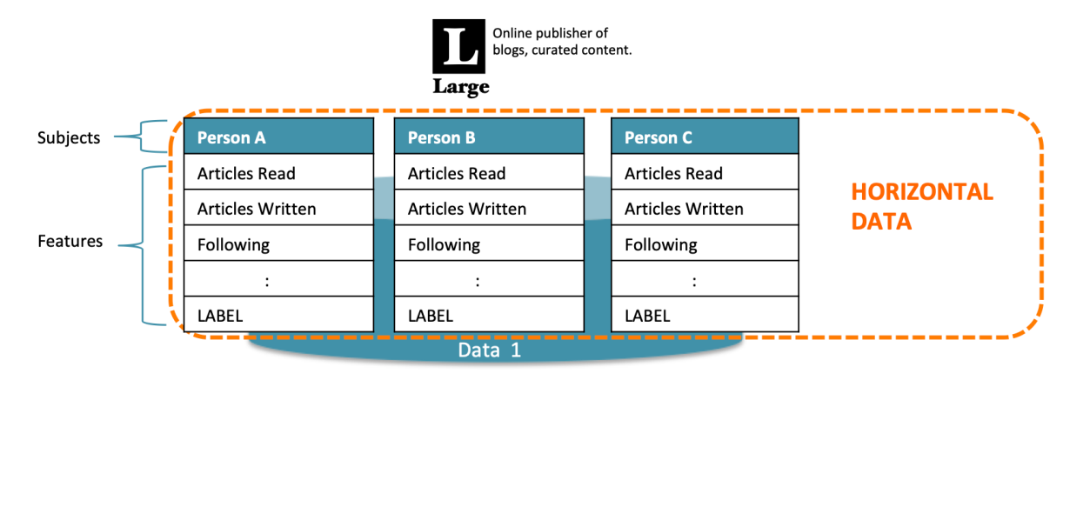
Single organisation, Horizontal Data
Key Characteristics of HFL
1.Common Feature Space:
All participants use the same input features or data attributes. Example: Two hospitals
with the same patient health attributes (e.g., age, blood pressure, glucose level) but for different sets of patients.
2.Disjoint Sample Space:
Each participant's dataset contains unique individuals or samples, with minimal or no
overlap between the entities. Example: One bank’s dataset contains information about
its customers, while another bank has data about its own customers, but the customers of the two banks do not overlap.
3.Decentralized Collaboration:
Participants work collaboratively to train a global machine learning model without sharing their raw data.
15

Steps in Horizontal Federated Learning 1.Initialization:
A shared model structure is agreed upon by all participants. An initial global model is distributed to the participants.
2.Local Training:
Each participant trains the shared model using its local dataset. The training process involves forward and backward propagation to update local model parameters (e.g., weights).
3.Model Update Sharing:
Participants send their updated model parameters (e.g., gradients) to a central aggregator.
4.Aggregation:
The central server aggregates the updates using techniques like Federated Averaging (FedAvg), producing an improved global model.
5.Global Model Update:
The updated global model is sent back to all participants. This process is repeated for several rounds until the model converges.
Advantages of HFL
1.Data Privacy:
Sensitive data remains localized, reducing privacy concerns and compliance risks (e.g., GDPR, HIPAA).
2.Scalability:
Supports distributed systems with large numbers of participants.
3.Efficiency:
Reduces the need for centralizing large datasets, lowering communication and storage costs.
Challenges in HFL
1.Communication Overhead:
Transmitting model updates can be bandwidth-intensive.
2.Non-IID Data:
16

Data across participants may not follow identical independent distributions, potentially affecting model convergence.
3.Security Concerns:
Vulnerabilities like model poisoning and inference attacks can arise during model update sharing.
4.Heterogeneous Systems:
Differences in hardware capabilities and network conditions across participants can create inefficiencies.
Applications of HFL
• Healthcare:
Hospitals with the same diagnostic features collaborate to train disease prediction models without sharing patient data.
• Banking and Finance:
Banks with the same transaction features train fraud detection models on their disjoint customer bases.
• IoT and Edge Devices:
Devices with similar functionality (e.g., smart thermostats) train shared models for energy optimization.
Vertical Federated Learning (VFL)
Vertical Federated Learning (VFL) is a variant of federated learning designed for scenarios
where different entities (e.g., organizations, institutions) possess datasets that share the
same sample space but have different feature spaces. In simpler terms, the datasets involve
the same set of individuals or entities (overlapping users) but contain different types of attributes or features about them.
17

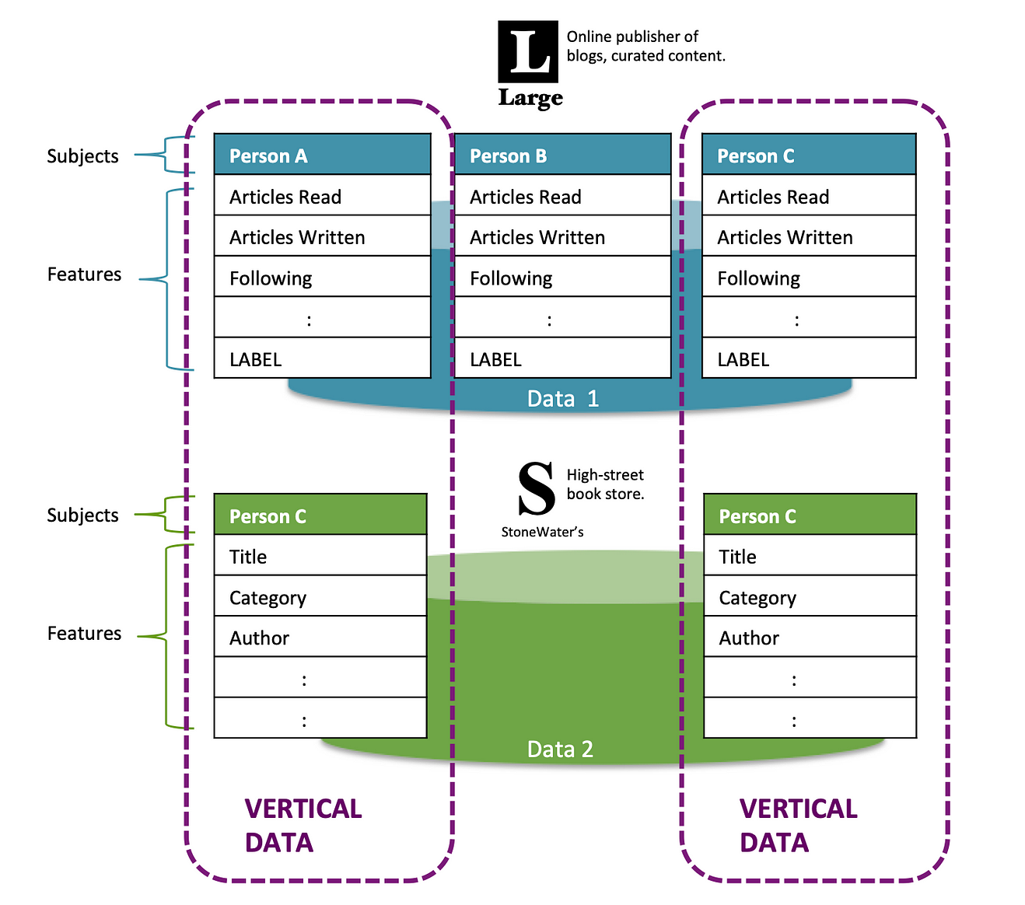
Multiple organisation, vertical data
Key Characteristics of VFL
1.Common Sample Space:
The datasets from participating entities pertain to the same individuals, businesses, or other entities. Example: A bank and an e-commerce company both have information about the same customers but collect different attributes (e.g., financial data vs. shopping preferences).
2.Disjoint Feature Space:
Each entity collects and retains unique features about the common samples. Example: The bank has credit scores and account balances, while the e-commerce company has purchase histories and browsing behaviours.
3.Data Partitioning:
The datasets are vertically partitioned, meaning the feature dimensions (columns) are distributed across the entities, while the sample IDs (rows) are aligned.
18

Steps in Vertical Federated Learning
1.Entity Alignment:
Participating entities align their datasets to ensure they are working with the same sample space. This often involves secure methods like cryptographic hashing to match records without revealing sensitive identifiers.
2.Model Initialization:
A shared global model is defined, with specific components assigned to each participant based on their features. Example: A linear model where features from different entities contribute to different parts of the computation.
3.Collaborative Training:
Each entity computes intermediate results (e.g., partial gradients, encrypted values) locally on its own data. These results are securely shared (often encrypted) with a central server or other participants for aggregation.
4.Secure Aggregation:
The shared intermediate results are aggregated to compute model updates without exposing raw data or individual contributions. Techniques like homomorphic encryption, secure multi-party computation (MPC), or differential privacy are commonly used.
5.Model Update Distribution:
The updated model parameters are sent back to all participants, allowing for further rounds of training.
Advantages of VFL
1.Data Privacy:
Each participant retains control over its raw data, complying with privacy regulations (e.g., GDPR, HIPAA).
2.Cross-Domain Collaboration:
Enables collaboration between organizations with complementary datasets, enhancing model performance.
3.Expanded Feature Space:
Leveraging diverse features from multiple entities often results in more robust and accurate models.
Challenges in VFL
1.Entity Alignment:
19

Securely aligning datasets across entities while preserving privacy can be technically complex.
2.Communication Overhead:
Exchanging intermediate results (e.g., gradients, encrypted values) increases communication costs.
3.Computational Complexity:
Encryption and secure computation techniques can add significant computational overhead.
4.Trust and Governance:
Participants must agree on protocols and trust each other to follow them, as well as decide how to handle model ownership and benefits.
Applications of VFL
1.Banking and E-commerce:
A bank and an e-commerce platform jointly build a credit scoring model using the bank's financial data and the e-commerce platform's shopping behaviour data.
2.Healthcare:
A hospital and a genetic research lab collaborate to develop a disease prediction model by combining patient health records and genetic information.
3.Marketing and Advertising:
An advertiser and a social media platform work together to create targeted marketing models by combining user engagement data with purchase history.
Federated Transfer Learning (FTL)
Federated Transfer Learning (FTL) is a specialized approach within federated learning
designed for scenarios where the participating entities have both different feature spaces
and different sample spaces. It combines principles of federated learning with transfer
learning, allowing entities with minimal overlap in data (both features and samples) to collaboratively train models by leveraging their complementary knowledge.
20

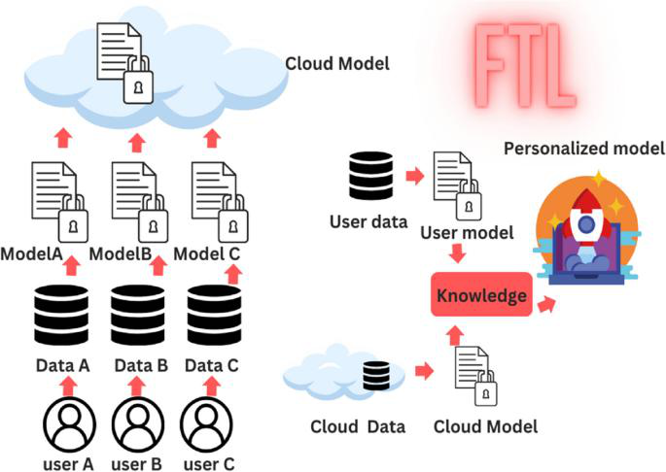
Federated Transfer Learning
Key Characteristics of FTL
1.Different Feature Spaces:
Participating entities have distinct and non-overlapping features. Example: A hospital might have medical diagnostic data, while an insurance company has policyholder information.
2.Different Sample Spaces:
The datasets have minimal or no overlap in the individuals or samples they represent. Example: A hospital's patients may not overlap with the insurance company's customers.
3.Knowledge Transfer:
Transfer learning techniques are used to share knowledge between entities, even though their datasets do not align perfectly.
4.Privacy Preservation:
Like other federated learning methods, FTL ensures that raw data is never shared, maintaining strict privacy controls.
21

Steps in Federated Transfer Learning
1.Model Initialization:
Each participant initializes its local model, which is designed to work with its unique features. A shared global model structure may also be established to facilitate knowledge transfer.
2.Local Model Training:
Each participant trains its local model on its dataset, focusing on extracting useful patterns and representations.
3.Knowledge Sharing:
Participants share intermediate results (e.g., embeddings, model parameters, or gradients) in a privacy-preserving way. Transfer learning techniques (e.g., knowledge distillation, domain adaptation) enable the global model to combine knowledge across participants.
4.Aggregation and Adaptation:
A central aggregator combines the shared knowledge to improve the global model. Each participant adapts the global model to its local data to improve its own performance.
5.Iterative Refinement:
The process is repeated over several rounds until the global model converges or achieves satisfactory performance.
Advantages of FTL
1.Collaborative Learning with Heterogeneous Data:
FTL facilitates learning from entities with vastly different datasets, enabling richer and more robust models.
2.Improved Generalization:
Leveraging diverse data sources enhances the model’s ability to generalize to new tasks or domains.
3.Privacy and Security:
Sensitive data remains localized, reducing privacy risks and ensuring regulatory compliance.
4.Maximized Data Utility:
Combines insights from fragmented or isolated datasets, unlocking their potential value.
22

Challenges in FTL
1.Complexity in Model Design:
Designing models and algorithms that can handle both feature and sample disparities is challenging.
2.Communication Overhead:
Sharing intermediate results across participants can be resource-intensive.
3.Alignment of Knowledge:
Ensuring effective transfer of knowledge between participants with distinct datasets requires advanced techniques.
4.Trust and Collaboration:
Entities must agree on protocols, ensure fairness, and address intellectual property concerns.
Applications of FTL
1.Healthcare and Insurance:
A hospital and an insurance company collaboratively build a health risk prediction model by combining medical data (hospital) and policyholder data (insurance company).
2.Banking and Retail:
A bank and a retail chain collaborate to create personalized financial products by leveraging financial transaction data (bank) and shopping preferences (retail).
3.Education:
Universities with different academic datasets (e.g., grades, extracurricular activities) collaborate to develop student performance prediction models.
4.Cross-Domain Recommendations:
Online platforms from different domains (e.g., e-commerce and video streaming) collaborate to provide personalized recommendations across services.
Collaborative federated Learning
Collaborative Federated Learning refers to a specialized paradigm of federated learning (FL) where multiple participants, such as organizations or individuals, collaboratively train a machine learning model while preserving data privacy. This approach is particularly
23

effective in scenarios where data is distributed across various entities, and data sharing is either infeasible or restricted due to privacy, legal, or competitive constraints.
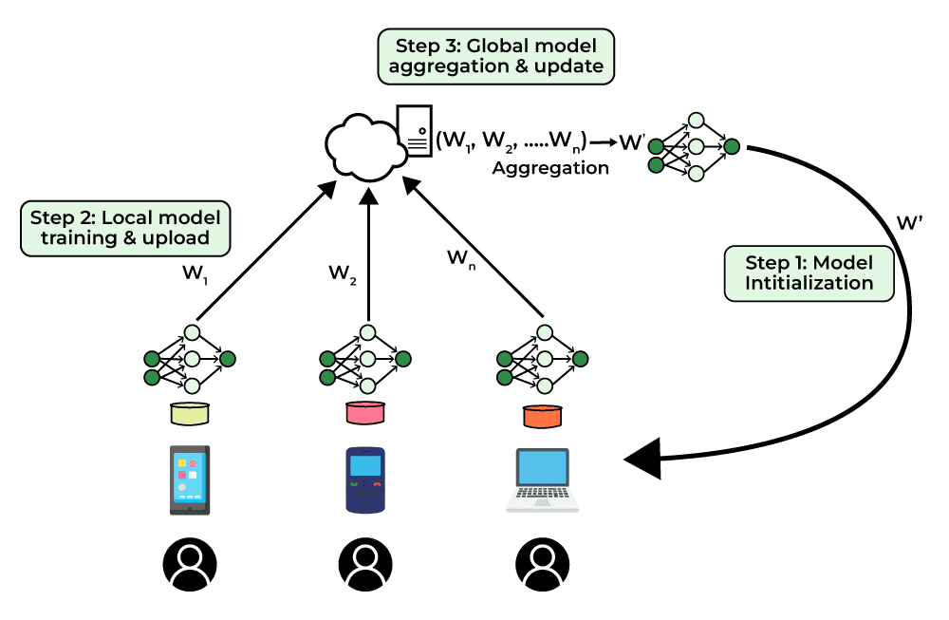
Collaboratives Learning
Key Features of Collaborative Federated Learning: 1.Decentralized Training:
Data remains on local devices or within organizational boundaries. Only model updates (e.g., gradients or parameters) are shared, not raw data.
2.Privacy Preservation:
Uses techniques such as differential privacy and secure aggregation to prevent leakage of sensitive information.
3.Collaboration Across Diverse Entities:
Participants may have heterogeneous data distributions (non-IID data). Supports entities with different resources and computational capabilities.
4.Model Optimization:
A global model is iteratively improved by aggregating updates from all participants.
Algorithms like Federated Averaging (FedAvg) ensure robust convergence.
24

Applications:
1.Healthcare:
Hospitals collaborate to train diagnostic models without sharing patient records.
Example: Predicting diseases using MRI data from multiple institutions.
2.Finance:
Banks collaborate on fraud detection models without exposing sensitive transaction data. Example: Cross-bank anomaly detection systems.
Smart Cities:
IoT devices in different regions contribute to training models for traffic management or pollution monitoring.
3.Cross-Industry Research:
Companies from different industries co-develop foundational AI models (e.g., for NLP or computer vision).
25

Federated learning tasks
Federated learning (FL) can be applied to a variety of tasks across industries and domains. These tasks typically involve scenarios where data is distributed across multiple devices or organizations, and privacy, efficiency, or scalability are critical concerns. Below are the primary categories of tasks in federated learning:
1. Classification Tasks
Objective: Assign labels to input data based on patterns learned from distributed datasets.
Examples:
•  •  • | Image Classification: Training a model to classify images stored on personal devices (e.g., identifying cats vs. dogs).  Document Classification: Classifying emails as spam or non-spam using distributed email data.  Medical Diagnosis: Predicting diseases based on patient records stored in hospitals.
2. Regression Tasks
Objective: Predict continuous values using distributed data.
Examples:
•  • | Energy Consumption Prediction: Using IoT devices to collaboratively predict energy usage patterns in smart homes.  Stock Price Prediction: Banks collaborating to predict market trends without sharing sensitive financial data.
3. Recommendation Tasks
Objective: Provide personalized recommendations based on user behavior distributed across devices or platforms.
Examples:
•  • | E-commerce: Suggesting products to users by learning from shopping behavior across multiple retailers.  Media Streaming: Recommending videos or music using user interaction data from multiple platforms.
26

• | Mobile Apps: Personalizing app suggestions or notifications based on user activity on smartphones.
4. Natural Language Processing (NLP) Tasks
Objective: Process and analyze textual data stored on distributed devices.
Examples:
•  •  • | Text Prediction: Training models for predictive text or autocomplete features on mobile devices (e.g., keyboards).  Sentiment Analysis: Analyzing sentiment from reviews or messages across multiple platforms.  Language Translation: Collaboratively training translation models using data distributed across regions
5. Computer Vision Tasks
Objective: Train models to analyze and interpret visual data stored locally.
Examples:
•  •  • | Object Detection: Collaborative training of autonomous vehicle systems for recognizing objects in distributed visual datasets.  Face Recognition: Enhancing facial recognition algorithms using images stored on individual devices.  Healthcare Imaging: Training models to analyze X-rays, MRIs, or CT scans stored in different hospitals.
6. Time-Series Analysis Tasks
Objective: Analyze sequential data distributed across devices or organizations.
Examples:
oIoT Monitoring: Predicting anomalies in sensor data from distributed IoT networks.
oFinancial Forecasting: Collaborating across financial institutions to predict trends based on transactional time-series data.
oHealth Monitoring: Analyzing wearable device data for real-time health insights.
27

7. Clustering and Anomaly Detection
Objective: Group similar data points or detect outliers in distributed datasets.
Examples:
•  •  • | Fraud Detection: Banks collaborating to detect fraudulent activities without sharing customer data.  Network Security: Identifying malicious activities in distributed network traffic.  Customer Segmentation: Grouping customers into segments based on distributed purchasing behavior.
8. Generative Tasks
Objective: Train models to generate new data (e.g., images, text) using distributed data.
Examples:
•  • | Synthetic Data Generation: Generating realistic but anonymized datasets for research.  Content Creation: Collaborating on distributed data to create personalized content, such as art or music.
9. Federated Reinforcement Learning
Objective: Use distributed data to train reinforcement learning models that learn from interactions with an environment.
Examples:
•  • | Robotics: Training robots to perform tasks using shared learning from distributed environments.  Game AI: Improving game-playing agents by learning from distributed user gameplay data.
10. Privacy-Preserving Analytics
Objective: Perform secure and privacy-respecting analytics on distributed data.
Examples:
•  • | Health Data Research: Conducting statistical analyses of health outcomes across hospitals.  Market Analysis: Deriving consumer insights without accessing raw sales data.
28

Key Concepts in Federated Learning
1. Decentralized
Data TrainingDefinition: Instead of centralizing data, FL allows machine learning models to be trained across multiple devices or servers holding local data samples.
• Significance: Enhances privacy and minimizes data transfer costs.
2. Model Aggregation
Definition: Local models trained on individual devices are aggregated at a central server or coordinator to create a global model.
Techniques:
•  • | Federated Averaging (FedAvg): A popular method to average local model updates.  Secure Aggregation: Ensures updates are aggregated without revealing individual data.
3. Data Privacy
Techniques Used:
• Differential Privacy (DP): Adds noise to local updates to prevent data leakage.
• Homomorphic Encryption: Enables computations on encrypted data.
Objective: Protect sensitive user data during training and communication.
4. Communication Efficiency
Challenge: Large-scale distributed systems generate significant communication overhead.
Solutions:
• Compression: Reducing update sizes using techniques like scarification.
• Update Frequency: Sending updates less frequently to save bandwidth.
5. Heterogeneous Data and Devices
Data Distribution: FL must handle non-IID (Independent and Identically Distributed) data, where data characteristics vary across devices. Device Variability: Devices differ in compute power, memory, and availability.
6. Cross-Silo vs. Cross-Device Learning
•  • | Cross-Silo FL: Focuses on a small number of reliable entities (e.g., hospitals, companies).  Cross-Device FL: Involves millions of consumer devices like smartphones.
29

7. Trust and Security
• Threat Models:
oMalicious Clients: Can send poisoned updates to corrupt the global model.
oByzantine Fault Tolerance: Methods to detect and mitigate such adversarial behaviors.
• | Trust-Building: Leveraging cryptographic and validation techniques to ensure robustness.
8. Scalability
Challenges: Coordinating thousands or millions of participants.
Advancements:
• Hierarchical aggregation structures.
• Partial participation (only a subset of devices participate per round).
10. Applications
• Healthcare: Collaborating on medical models without sharing patient data.
• Finance: Fraud detection across banks while maintaining data confidentiality.
• Smart Devices: Personalized experiences like predictive text and voice recognition.
Key Models in Federated Learning1. Federated Averaging (FedAvg)
Description: The foundational algorithm in FL, introduced by Google.
How It Works:
1.Devices train local models on their data.
2.Local updates are sent to the central server.
3.The server averages these updates to produce the global model. Advantages: Simple, effective for non-IID data to some extent.
Limitations: Struggles with extreme non-IID data distributions
30

2. Federated Optimization Algorithms
FedProx:
•  • | Improvement on FedAvg for heterogeneous data.  Introduces a proximal term to penalize local updates that deviate too much from the global model.
Scaffold:
• Mitigates client-drift by using control variates to correct model updates. FedCurv:
• Adds curvature-based regularization to improve model personalization.
3. Secure Aggregation Protocols
Objective: Protect local updates from being exposed during transmission.
Popular Methods:
•  • | Secure Multi-Party Computation (SMPC): Aggregates encrypted updates without decrypting them.  Homomorphic Encryption: Enables computations directly on encrypted data.
4. Differential Privacy Algorithms
Goal: Ensure individual data points cannot be inferred from updates.
Mechanisms:
•  • | Adding Gaussian or Laplace noise to gradients or model updates.  Balancing privacy with model accuracy using privacy budgets (e.g., the epsilon parameter).
5. Algorithms for Non-IID Data
Challenges: Data distributions vary significantly between clients.
Solutions:
oClustered FL:
Groups clients with similar data distributions to train separate models.
oPersonalized FL:
Fine-tunes the global model for individual clients post-aggregation.
31

Example: Meta-learning approaches like Per-FedAvg (personalized FedAvg).
oAgnostic FL:
Aims to create a model that performs well across all clients by minimizing worst-case loss.
6. Federated Reinforcement Learning (FRL)
•  • | Description: Extends FL to reinforcement learning tasks, where clients collectively learn policies.  Key Use Case: Multi-agent systems, such as IoT networks or smart city coordination.
7. Gradient Compression and Sparsification
Why It’s Needed: To reduce communication costs.
Techniques:
• Top-k Sparsification: Only the top-k gradients are transmitted. • Quantization: Compresses updates using fewer bits.
8. Adaptive Aggregation Techniques
FedNova: Adjusts for differing local training times or data volumes across devices. Weighted Aggregation: Assigns weights to clients based on their contribution (e.g., data size, quality).
9. Byzantine-Resilient Algorithms
Problem: Malicious clients can corrupt the global model by sending poisoned updates.
Solutions:
• Krum: Selects updates that minimize the impact of outliers.
• Trimmed Mean: Excludes extreme values during aggregation.
10. Hierarchical Federated Learning
Description: Organizes clients into groups with local aggregators to scale FL for massive networks.
Example: Devices in the same geographical region share a local aggregator before updates are sent to the central server.
32

Algorithm/Model | Purpose | Strength | Use Case
FedAvg | Basic FL | Simplicity | General applications FL
FedProx | Non-IID  handling | Addresses  heterogeneity | Cross-device FL
Scaffold | Reducing client-drift | Better  convergence | Complex distributions data
Secure  Aggregation | Privacy-  preserving updates | Protects  sensitive data | Healthcare, Finance
Krum/Trimmed Mean | Byzantine-resilience | Robust to  adversarial  clients | High-stakes settings FL
Personalized FL | Local model  adaptation | Tailored  solutions | Smart devices, IoT
FedGNN | Decentralized graph learning | Sensitive graph data analysis | Social networks,  Bioinformatics

Technologies Related to Federated Learning1. Privacy-Preserving Techniques
The core idea behind FL is to ensure privacy by decentralizing training data. Privacy-
preserving technologies enhance this by introducing mechanisms to protect data during training and aggregation.
a. Differential Privacy (DP)
Theory: DP introduces controlled noise to a dataset or model output to ensure that individual data points cannot be inferred.
Key Principle: Any single record's inclusion or exclusion should not significantly change the training result.
Mathematical Framework:
• A mechanism MMM satisfies ϵ\epsilonϵ-DP if for all datasets DDD and D′D'D′ differing in a single entry, and for all subsets SSS of outputs:

33

• | Here, ϵ\epsilonϵ represents the privacy budget—a smaller ϵ\epsilonϵ implies better privacy but may affect utility.
Challenges: Balancing noise addition with model accuracy in heterogeneous data environments.
b. Homomorphic Encryption (HE)
Theory: HE allows computations on encrypted data without decryption, preserving privacy throughout the computation process.
Types:
1.Fully Homomorphic Encryption (FHE): Supports arbitrary computations on ciphertexts.
2.Partially Homomorphic Encryption (PHE): Supports specific operations like addition or multiplication.
Mathematical Basis:
oFor plaintexts m1,m2m_1, m_2m1,m2, ciphertexts c1=Enc(m1)c_1 = Enc(m_1)c1=Enc(m1), c2=Enc(m2)c_2 = Enc(m_2)c2=Enc(m2), and operation ⊕

o⊕: operation on ciphertexts; ⊗: corresponding operation on plaintexts.
Challenges: High computational and communication overhead, especially for large-scale FL systems.
c. Secure Multi-Party Computation (SMPC)
Theory: Enables parties to jointly compute a function over their inputs while keeping those inputs private.
Mathematical Representation:
oGiven f(x1,x2,...,xn) where xi is private to party i, the goal is to compute f such that no party learns xj for j≠i.
oSecret-sharing schemes like Shamir’s secret sharing are commonly used:
▪ | A value x is split into n shares such that any k shares can reconstruct x, but fewer than k shares reveal nothing about x.
Challenges: Scalability and efficient protocol design for complex functions.
34

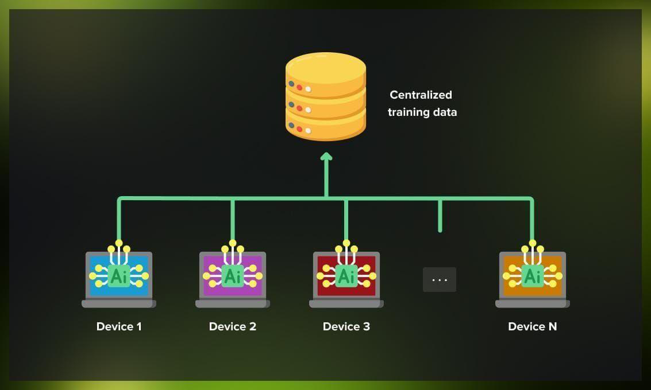
2. Machine Learning Frameworks with FL Support
Federated Learning frameworks provide the infrastructure necessary for implementing distributed training while integrating privacy-preserving and secure aggregation techniques. These frameworks abstract complex operations like local training, model aggregation, and communication, making FL accessible to researchers and practitioners.
They are designed to handle the heterogeneity of devices, networks, and data distributions while ensuring scalability and robustness. By supporting theoretical constructs like non-IID data distributions, hierarchical communication, and adversarial resilience, these frameworks address fundamental challenges in FL research and deployment. Each framework incorporates distinct methodologies to cater to specific use cases, including cross-device and cross-silo learning.
• TensorFlow Federated (TFF)
TensorFlow Federated (TFF) is an open-source framework that extends TensorFlow to support Federated Learning scenarios. TFF’s theoretical foundation is built on decomposing FL workflows into two key components: ClientWork, which handles local training on individual devices, and ServerWork, which aggregates updates and orchestrates training rounds.
Framework Structure:
oLocal computation is represented by ClientWork.
35

oAggregation is abstracted as ServerWork.
oThe two are combined in iterative rounds of updates.
•PySyft
PySyft is a Python library that focuses on enabling privacy-preserving machine learning through Federated Learning, differential privacy, and secure computation protocols. The library integrates with PyTorch, making it suitable for experimenting with deep learning models in an FL setting. The theoretical motivation behind PySyft is to allow computations on distributed data without compromising privacy, even in adversarial environments.
3. Communication and Networking
Communication is a fundamental aspect of Federated Learning, as model updates and parameters need to be exchanged between clients and servers. Theoretical considerations in FL communication focus on optimizing bandwidth, ensuring robustness to failures, and maintaining data security during transmission.
a.Gradient Compression
Gradient compression reduces the size of model updates by transmitting only the most significant changes. This is particularly effective in deep learning, where many gradients have negligible values. Theoretical models for gradient sparsification rely on techniques like top-k selection, where only the largest k gradients are transmitted, and quantization, which reduces gradient precision. While gradient compression reduces communication costs, it introduces challenges in convergence and accuracy.
b. Hierarchical Communication
In hierarchical communication, devices are grouped into clusters, each with a local aggregator. Updates are first aggregated within clusters before being sent to the central server. This reduces the number of direct communications with the server, alleviating bottlenecks in large-scale FL deployments. Theoretically, hierarchical communication can be represented as a two-level optimization problem, where local updates minimize client loss functions, and global aggregation optimizes overall model performance.
c. Secure Communication Protocols
Secure communication protocols in FL rely on cryptographic methods to ensure that transmitted data cannot be intercepted or tampered with. Techniques like Transport Layer Security (TLS) and Virtual Private Networks (VPNs) provide foundational security. Advanced protocols integrate SMPC or HE to encrypt model updates, ensuring that even the server cannot access raw data.
36

Tools, Libraries, and Frameworks for Federated
Learning
Federated Learning requires robust tools and frameworks to manage the complexity of distributed systems, secure data handling, and privacy-preserving machine learning. These technologies are designed to abstract complex operations such as data partitioning, communication, model aggregation, and integration of privacy-preserving methods. A solid theoretical foundation ensures that these tools align with the principles of distributed optimization, cryptography, and machine learning. Below is a comprehensive exploration of key tools and frameworks:
1. TensorFlow Federated (TFF)
TensorFlow Federated (TFF) is a Python-based framework designed to support research and development in Federated Learning. It extends TensorFlow by providing abstractions for client-server architectures, local computation, and global aggregation.
Theoretical Foundation
•  • | TFF builds upon functional programming paradigms to represent federated computations as compositions of smaller functions.  It incorporates distributed optimization theories, enabling iterative training through weighted aggregation of local models:

where wti is the local model update from client i, and piis the weight determined by the client’s data size.
•TFF supports differential privacy, ensuring compliance with privacy- preserving regulations by introducing controlled noise to model updates.
Features
• Simulates non-IID data distributions.
• Provides APIs for defining custom aggregation strategies.
• Integrates seamlessly with TensorFlow for deep learning tasks.
2. PySyft
PySyft is an open-source library designed for privacy-preserving machine learning. It provides tools for Federated Learning, differential privacy, and secure computation techniques.
37

Theoretical Foundation
PySyft relies on abstract pointer objects to represent data residing on remote machines, enabling computations on distributed datasets without centralizing data. It integrates cryptographic techniques like Homomorphic Encryption (HE) and Secure Multi-Party Computation (SMPC) to ensure privacy during computations.
Features
•  •  • | Implements virtual workers for FL simulations.  Provides support for federated datasets, making it easy to partition data across devices.  Enables encrypted computations, allowing secure execution of machine learning workflows.
3. Flower (Federated Learning Framework)
Flower is a flexible framework for Federated Learning, designed to accommodate diverse FL use cases, including cross-device and cross-silo learning.
Theoretical Foundation
Flower uses a client-server communication model, where clients perform local training, and the server aggregates updates. Supports advanced aggregation algorithms, such as FedAvg and FedProx, which address issues of data heterogeneity and client participation variability.
Features
•  •  • | Provides a modular design for experimenting with different aggregation strategies. Enables deployment across heterogeneous devices, such as mobile phones and IoT systems.  Supports integration with popular ML frameworks like PyTorch and TensorFlow.
4. FATE (Federated AI Technology Enabler)
FATE is an industrial-grade FL framework developed by WeBank, focusing on cross-silo Federated Learning scenarios.
Theoretical Foundation
FATE incorporates federated transfer learning to facilitate collaboration between organizations with non-overlapping feature spaces. Secure aggregation is implemented using techniques like SMPC and HE, ensuring data confidentiality.
Features
38

• Designed for enterprise-level FL applications.
• Provides built-in modules for secure feature engineering and federated evaluation.
• Includes tools for managing large-scale deployments in production environments.
5. OpenFL (Open Federated Learning)
OpenFL is an open-source framework designed by Intel for Federated Learning research and deployment.
Theoretical Foundation
OpenFL is built around a federated coordinator that orchestrates training by managing client participation, model updates, and aggregation. The framework supports byzantine-resilient aggregation algorithms to mitigate the impact of malicious or unreliable clients.
Features
• Facilitates the deployment of FL workflows across secure enclaves.
• Provides tools for visualizing training progress and monitoring model performance.
• Optimized for integration with edge devices and distributed cloud environments.
Applications of Federated Learning
Federated learning (FL) has transformative applications across various industries where data privacy, scalability, and decentralized collaboration are critical. Below are detailed applications categorized with objectives and comprehensive examples
1. Healthcare
Federated learning enables collaborative advancements in healthcare while maintaining patient data privacy. Hospitals and medical institutions often face restrictions in sharing sensitive patient data due to regulations like GDPR and HIPAA. FL facilitates training models across distributed datasets without moving data. For instance, hospitals can collaboratively develop models for early detection of diseases such as cancer, diabetes, or heart conditions using patient data stored locally. Additionally, FL is used in drug discovery, where pharmaceutical companies share insights without exposing proprietary datasets. Wearable devices like smartwatches also benefit from FL by enabling
personalized health monitoring and anomaly detection without compromising user privacy.
2. Finance
The finance industry is highly sensitive to data security and privacy. Federated learning addresses these concerns by enabling banks, credit unions, and financial institutions to build collaborative models without sharing customer data. For example, FL is used to
39

enhance fraud detection by analyzing transaction patterns from multiple banks,
identifying fraudulent activities more effectively. Credit scoring is another significant application, where federated learning combines data from different financial institutions to provide accurate risk assessments while protecting individual privacy. FL also helps financial analysts predict market trends by pooling insights from various organizations, allowing for smarter investment decisions and risk management.
3. Retail and E-commerce
Retailers and e-commerce platforms leverage federated learning to improve
personalization and operational efficiency. FL enables the creation of recommendation systems that analyze customer preferences across different platforms without sharing sensitive shopping data. For example, a collaborative FL model can recommend products based on user interactions from multiple retailers, offering personalized suggestions while protecting privacy. Retailers also use FL for demand forecasting, optimizing inventory management, and streamlining supply chains. Additionally, loyalty programs across platforms can be enhanced by federating customer data, enabling better targeting of promotions and improving customer retention rates without compromising sensitive information.
4. Mobile and Edge Devices
Federated learning plays a crucial role in mobile and edge computing by enabling on-device machine learning. For instance, mobile keyboards like Gboard use FL to improve text prediction and autocorrect features by training models directly on users' devices.
Similarly, voice assistants like Alexa, Siri, or Google Assistant utilize FL to enhance speech recognition capabilities while ensuring user privacy. FL is also instrumental in edge devices like smart cameras and IoT sensors, where local data is used to improve algorithms for object detection, anomaly detection, and energy optimization. This decentralized approach reduces latency, conserves bandwidth, and respects user privacy.
5. Smart Cities
Smart cities rely on distributed IoT devices to optimize urban infrastructure and improve the quality of life. Federated learning helps process data from connected devices, such as traffic sensors, smart meters, and surveillance systems, without centralizing sensitive information. For instance, FL enables traffic management systems to predict congestion and optimize routes based on distributed vehicle data. Smart energy grids use FL to forecast demand, reduce energy wastage, and balance loads across regions. Public safety systems also benefit from FL, with applications like crime prediction and real-time monitoring, ensuring citizen privacy while enabling efficient resource allocation and planning.
6. Education
In education, federated learning empowers institutions to create personalized learning experiences while protecting student data. FL enables the development of adaptive learning systems that adjust to individual students' needs by analyzing their interaction patterns and performance metrics. For example, online learning platforms like Coursera or Khan Academy can use FL to improve content recommendations and learning paths across diverse learners. Schools and universities can collaborate to refine predictive
40

models for student engagement, dropout prevention, and academic performance
forecasting without sharing raw data. FL also supports education analytics for identifying effective teaching methods and optimizing resource allocation.
7. Autonomous Systems
Federated learning is a key enabler for autonomous systems like self-driving cars and drones. These systems require continuous learning from diverse environments to improve performance and safety. FL allows autonomous vehicles to share insights from local data, such as road conditions and traffic patterns, to enhance their global navigation models. Similarly, drones used for delivery or mapping can collaboratively learn from their flight data to optimize routes and avoid obstacles. By training models in a decentralized manner, FL ensures that sensitive location data remains on devices while enabling advancements in autonomous technology across industries.
8. Healthcare Wearables
Healthcare wearables like smartwatches and fitness trackers generate vast amounts of personal health data. Federated learning allows these devices to collaboratively train models for better health monitoring while preserving user privacy. For instance, FL can help detect anomalies like irregular heart rhythms or early signs of illness using distributed data from wearables. Fitness apps can also use FL to provide personalized workout recommendations based on aggregated user activity patterns. Additionally, FL supports chronic disease management by enabling wearables to monitor patient conditions in real-time, sharing insights with healthcare providers while safeguarding individual data privacy.
9. Telecommunications
The telecommunications sector uses federated learning to optimize network performance and improve user experiences. FL enables operators to analyse distributed network data for traffic prediction, capacity planning, and resource allocation. For example, telecom providers can use FL to predict network congestion and reduce latency by learning from usage patterns across regions. FL also helps improve customer experiences by enabling personalized service recommendations and proactive troubleshooting. In addition, telecom companies use FL for predictive maintenance of network infrastructure, identifying potential failures before they occur, and ensuring uninterrupted services for users.
10. Cybersecurity
Federated learning enhances cybersecurity by enabling collaborative threat detection across organizations. By analysing distributed data, FL helps identify emerging threats such as malware, phishing attacks, or insider threats while ensuring sensitive information remains confidential. For example, FL allows companies to build intrusion detection systems by sharing patterns of malicious activity without exposing internal network data.
Cybersecurity firms also use FL to develop robust fraud detection and prevention mechanisms across industries. This collaborative approach strengthens defences against evolving cyber threats while maintaining compliance with data protection regulations.
41

Advantages and Market Insights
Advantages of Federated Learning
Federated Learning (FL) offers a paradigm shift in how machine learning models are trained by emphasizing data decentralization, privacy preservation, and collaborative intelligence. These advantages are particularly significant in today’s data-driven world, where privacy concerns and regulatory constraints are critical.
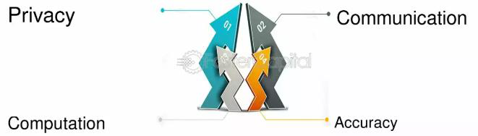
1. Enhanced Data Privacy and Security
Federated Learning eliminates the need for raw data to leave local devices, reducing the risk of data breaches or unauthorized access. By sharing only model updates or gradients, FL complies with stringent data protection regulations such as the General Data Protection Regulation (GDPR) and the California Consumer Privacy Act (CCPA). Theoretical underpinnings like differential privacy and secure multi-party computation (SMPC) further strengthen FL’s privacy guarantees. For example, by adding controlled noise to updates, differential privacy ensures that individual data points cannot be inferred, even in adversarial settings.
2. Compliance with Regulatory Frameworks
The growing emphasis on privacy laws globally has created challenges for traditional centralized data processing methods. FL aligns seamlessly with these legal frameworks by keeping data localized. In healthcare, for instance, patient data never leaves hospital servers, yet institutions can collaboratively train diagnostic models. This decentralization ensures compliance with frameworks like HIPAA (Health Insurance Portability and Accountability Act) in the U.S. and GDPR in the EU, reducing the legal and ethical risks associated with data sharing.
3. Efficient Utilization of Distributed Data
In many industries, data is inherently distributed across devices, regions, or organizations. FL enables collaborative training across these distributed datasets without transferring them to a central server. This capability is particularly valuable in cases of non-IID (non-
42

independent and identically distributed) data, where data distributions vary significantly across nodes. Theoretical approaches like personalized FL and federated transfer learning address challenges posed by data heterogeneity, enabling better performance and adaptability of models in real-world settings.
4. Scalability and Resource Optimization
Federated Learning leverages the computational power of edge devices, reducing the reliance on centralized infrastructure. This decentralized approach minimizes bottlenecks in data transfer and central server computations. Theoretical models for distributed optimization, such as FedAvg, provide efficient aggregation techniques that scale well with an increasing number of clients. Additionally, FL can reduce the overall cost of training large-scale models by distributing computational load across multiple participants.
5. Real-Time Personalization
Federated Learning supports on-device training, allowing models to be fine-tuned to individual user preferences while benefiting from global updates. For instance, FL-powered recommendation systems on mobile devices can adapt to user behavior in real-time without compromising privacy. This capability improves user experiences and retention, making FL an attractive solution for industries like e-commerce, social media, and entertainment.
6. Reduced Data Transfer Overhead
Traditional centralized learning requires transferring large volumes of raw data to a central server, incurring significant bandwidth costs and latency. FL mitigates this by transmitting model updates, which are often smaller in size. Techniques like gradient sparsification and quantization further reduce communication overhead, making FL viable for deployment in resource-constrained environments, such as IoT networks and mobile devices.
7. Robustness to Failures and Attacks
Decentralized data storage in FL reduces the risk of single points of failure. Even if one node fails or is compromised, the overall training process continues with minimal disruption. Theoretical constructs like Byzantine-resilient aggregation ensure robustness against malicious or unreliable clients, safeguarding the integrity of the global model.
Market Insights for Federated Learning
Federated Learning is rapidly transitioning from a research concept to a commercially viable technology, with applications spanning multiple industries. Its adoption is fueled by
43

increasing privacy concerns, the proliferation of edge devices, and advancements in AI and cryptography.
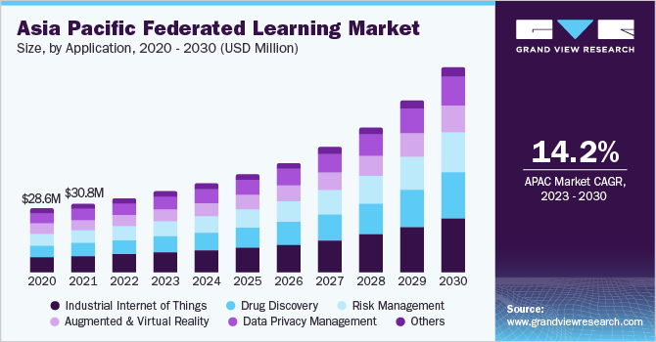
Market Insight
1. Market Growth and Adoption Trends
The global Federated Learning market is expected to grow at a compound annual growth rate (CAGR) of over 40% during the next decade. Key drivers include:
•  •  • | The exponential growth of IoT and edge computing devices.  Rising demand for privacy-preserving AI solutions in regulated industries.  Growing investments in FL research and infrastructure by tech giants such as Google, NVIDIA, and Intel.
Key Industries Adopting FL
1.Healthcare: Collaborative medical research, diagnostic tools, and personalized treatments.
2.Finance: Fraud detection, credit scoring, and anti-money laundering systems.
3.Telecommunications: Network optimization and predictive maintenance. 4.Retail and E-commerce: Recommendation systems and demand forecasting. 5.Automotive: Autonomous vehicles and traffic management systems.
2. Competitive Landscape
44

Leading companies in the Federated Learning space are developing proprietary frameworks, tools, and platforms:
•  •  •  • | Google: TensorFlow Federated, focusing on cross-device learning for mobile ecosystems.  NVIDIA: Clara FL for healthcare and industrial applications.  Intel: OpenFL for secure FL deployments.  WeBank: FATE for cross-silo FL in financial and enterprise sectors.
Startups like Sherpa.AI and Owkin are also making significant strides in deploying FL solutions tailored to specific use cases.
3. Challenges in Adoption
While FL shows immense potential, several challenges hinder its widespread adoption:
•  •  •  • | Communication Overhead: Ensuring efficiency in scenarios involving thousands of clients remains a technical bottleneck.  Privacy Guarantees: Achieving provable privacy with minimal impact on model accuracy requires further innovation in cryptography and noise optimization. Standardization: The lack of universally accepted standards for FL protocols and implementations limits interoperability.  Cost of Deployment: Establishing infrastructure for large-scale FL systems, including edge devices and secure aggregation servers, can be expensive.
4. Future Outlook
The future of FL lies in:
•  •  • | Improved | Scalability: | Advancements | in | aggregation | techniques | and
communication protocols will enable FL to scale across billions of devices. Integration with Blockchain: Combining FL with blockchain technology can enhance transparency, security, and incentive mechanisms.
Domain-Specific Innovations: Tailoring FL techniques to industries like agriculture, energy, and education will open new avenues for adoption.
Benefits of Federated Learning
Federated Learning (FL) represents a paradigm shift in machine learning, where the focus is on collaborative model training while ensuring data privacy and security. Unlike
45

traditional centralized learning approaches, FL brings computation to the data, allowing distributed nodes to train models locally and share updates rather than raw data. This architecture offers several significant benefits across technical, ethical, and practical dimensions, which are elaborated below:
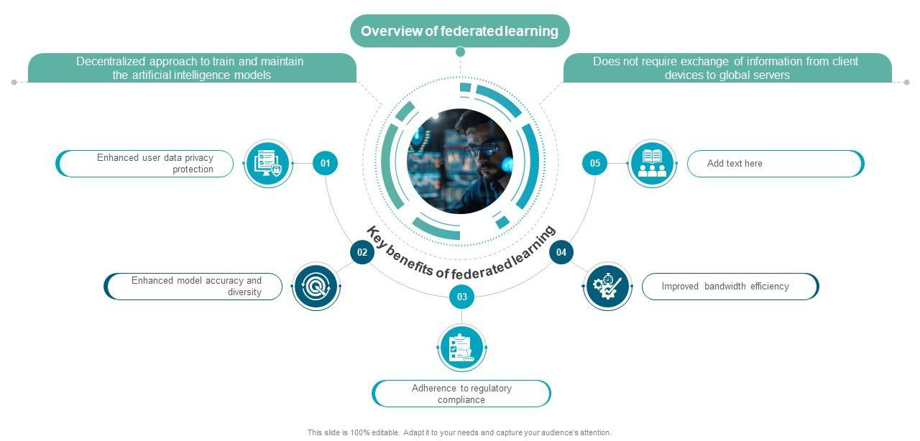
Benefits of FL
1. Enhanced Data Privacy and Security
One of the most significant benefits of Federated Learning is its ability to maintain data privacy. Traditional machine learning approaches often require centralizing data on a single server, which increases the risk of breaches and non-compliance with privacy regulations. FL, however, ensures that sensitive data remains on the local device or within the organization. This local processing aligns with privacy-preserving techniques like differential privacy and homomorphic encryption. By transmitting only model parameters or updates, FL minimizes the exposure of raw data to external entities, making it particularly useful in sensitive domains like healthcare and finance. For example, hospitals can collaboratively train diagnostic models without ever sharing patient records, thus complying with data protection laws like HIPAA and GDPR.
2. Improved Scalability
FL’s decentralized architecture naturally supports scalability, making it ideal for modern applications that involve large-scale, geographically distributed data sources. In traditional systems, transferring enormous volumes of raw data to a central server incurs significant bandwidth and storage costs. FL avoids these issues by enabling devices, such as mobile phones, IoT sensors, or edge servers, to process data locally. Theoretical models like federated averaging (FedAvg) further enhance scalability by optimizing the aggregation of updates from a vast number of clients. This benefit is particularly relevant in scenarios with billions of devices, such as personal assistants, smart home systems, and autonomous
46

vehicles, where each device contributes to training without overloading central infrastructure.
3. Compliance with Data Protection Regulations
With the growing emphasis on data sovereignty and privacy laws, organizations are under pressure to adopt ethical data-handling practices. Federated Learning provides a technical solution to comply with global regulatory frameworks like the GDPR, CCPA, and China’s Data Security Law. By ensuring that data never leaves its source, FL respects regional restrictions on cross-border data transfers and reduces legal risks for organizations. This compliance benefit positions FL as a viable approach for industries that must handle confidential data, such as law enforcement, healthcare, and financial services.
4. Addressing Data Fragmentation
In many real-world scenarios, data is fragmented across multiple entities, devices, or geographic locations. This fragmentation creates barriers to centralized learning approaches, as pooling data is often infeasible due to privacy, ownership, or logistical constraints. Federated Learning bridges this gap by enabling collaboration among distributed data sources without requiring data centralization. For instance, FL can facilitate collaborative research among pharmaceutical companies to train predictive models for drug discovery, leveraging diverse datasets while protecting proprietary information. Similarly, it allows cross-device learning in mobile ecosystems, where each device trains on its unique user data.
5. Real-Time Personalization
Federated Learning supports the development of models that are not only globally robust but also locally personalized. This is achieved through a combination of local fine-tuning and global aggregation, which allows devices to learn from both local data and shared insights from other devices. For example, FL-powered recommendation systems can offer highly personalized suggestions by adapting to a user’s preferences in real-time without compromising their privacy. This ability to combine personalization with privacy is a key differentiator for FL, making it highly valuable in applications like personalized healthcare, adaptive education platforms, and user-centric e-commerce systems.
6. Robustness and Fault Tolerance
Centralized systems often face challenges related to single points of failure, where issues with the central server can disrupt the entire workflow. Federated Learning inherently mitigates this risk by distributing computation across multiple nodes. Even if some nodes fail or go offline, the system can continue to function with minimal disruption, as updates
47

from other nodes can still be aggregated. Furthermore, FL’s theoretical advancements in Byzantine-resilient aggregation ensure robustness against malicious or unreliable clients. These mechanisms make FL particularly suitable for critical applications, such as autonomous driving or disaster response systems, where reliability is paramount.
7. Reduced Communication Overhead
FL significantly reduces the amount of data that needs to be transmitted between devices and central servers. Instead of transferring raw data, FL sends only model updates, which are typically much smaller in size. Advanced techniques like gradient sparsification, quantization, and adaptive communication schedules further optimize this process, making FL feasible in environments with limited bandwidth or high latency. This benefit is particularly relevant for IoT networks, where devices often operate with constrained resources and intermittent connectivity.
8. Facilitating Ethical AI
Ethical considerations are becoming increasingly important in AI development. Federated Learning aligns with ethical AI principles by promoting data minimization, transparency, and inclusivity. It empowers individuals and organizations to participate in collaborative model training without relinquishing control over their data. By respecting user privacy and fostering equitable participation, FL helps build trust in AI systems, which is critical for their widespread adoption. Moreover, FL reduces biases associated with centralized datasets by incorporating diverse data sources, leading to more equitable and generalizable models.
9. Enabling New Use Cases
FL opens up possibilities for applications that were previously constrained by privacy concerns or data silos. In healthcare, FL enables collaborative disease prediction and personalized treatment models. In finance, it facilitates fraud detection and credit scoring across institutions. Emerging use cases, such as Federated Learning in smart cities, allow for real-time optimization of traffic flow, energy consumption, and public safety without violating citizen privacy. These innovative applications demonstrate FL’s potential to transform industries while addressing modern challenges.
10. Contribution to Edge and IoT Ecosystems
The rise of edge computing and IoT devices has created a demand for distributed AI solutions. Federated Learning is a natural fit for these ecosystems, as it allows devices to process data locally while contributing to collective intelligence. This integration reduces latency, enhances responsiveness, and ensures that critical applications, such as industrial
48

automation or medical monitoring, can operate efficiently and securely. FL’s ability to leverage edge devices also supports green AI initiatives by minimizing the energy-intensive transfer of data to centralized servers.
Global Market Trends in Federated LearningFederated Learning (FL) is emerging as a transformative paradigm in the field of artificial intelligence, addressing critical issues such as data privacy, security, and decentralized computation. Its adoption is fuelled by advancements in edge computing, the proliferation of connected devices, and stringent data protection regulations worldwide. Below, we explore key market trends, growth drivers, and challenges shaping the global FL market.
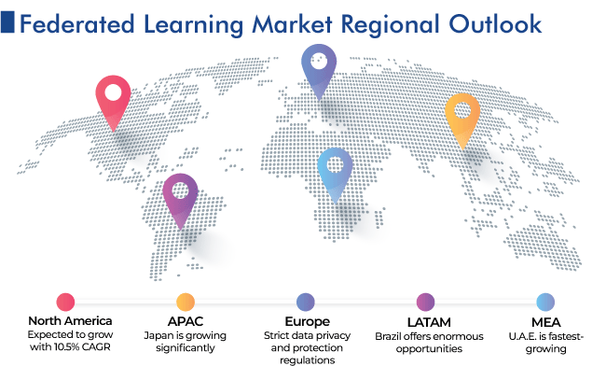
1. Market Growth and Adoption Rates
The global Federated Learning market has been experiencing exponential growth, with a compound annual growth rate (CAGR) projected to exceed 40% over the next decade. This rapid expansion is driven by the increasing need for privacy-preserving machine learning solutions in industries such as healthcare, finance, and telecommunications.
• | Statistical Insight: According to recent reports, the FL market size, valued at approximately $150 million in 2023, is expected to surpass $2 billion by 2030.
49

• Driving Factors: The adoption of FL is particularly prominent in regions with stringent privacy regulations, such as the European Union (GDPR compliance) and the United States (CCPA compliance). The Asia-Pacific region is also witnessing significant growth, with China and Japan investing heavily in FL for smart cities and healthcare applications.
2. Industry-Specific Applications
Federated Learning has found applications across multiple industries, addressing unique challenges and unlocking new opportunities:
a)Healthcare:
oUse Case: Collaborative training of diagnostic models across hospitals without sharing sensitive patient data.
oMarket Impact: The adoption of FL in healthcare is driven by its ability to comply with privacy laws like HIPAA while advancing precision medicine and predictive diagnostics.
b)Finance:
oUse Case: Fraud detection, anti-money laundering (AML), and credit risk modeling across financial institutions.
oMarket Impact: FL enables secure data sharing between banks, reducing systemic risks and improving fraud prevention models.
c)Telecommunications:
oUse Case: Optimization of network traffic and predictive maintenance using data from distributed telecom devices.
oMarket Impact: FL is being integrated into 5G networks to enhance efficiency while minimizing bandwidth usage.
d)Retail and E-Commerce:
oUse Case: Personalization of recommendation systems across global retail chains without centralizing customer data.
oMarket Impact: FL allows companies to adapt to user preferences in real- time while maintaining compliance with privacy norms.
3. Technological Advancements Driving Market Growth
The evolution of Federated Learning is closely tied to advancements in complementary technologies:
• Edge Computing: The increasing computational capabilities of edge devices (e.g., smartphones, IoT devices) support FL's decentralized architecture, making it feasible for large-scale deployments.
50

• Secure Aggregation Protocols: Innovations in cryptographic techniques, such as homomorphic encryption and secure multi-party computation (SMPC), have enhanced the security of FL implementations.
• Differential Privacy: The integration of differential privacy mechanisms ensures that individual data points cannot be inferred, further strengthening trust in FL systems.
• Blockchain Integration: Combining FL with blockchain technology has introduced transparency and robust incentive mechanisms, paving the way for decentralized, trustworthy AI ecosystems.
4. Regional Insights and Initiatives
• North America:
oThe United States leads in FL adoption, with major technology firms like Google, IBM, and NVIDIA investing heavily in research and development.
oFederal initiatives, such as AI strategies focusing on privacy, further bolster FL’s adoption.
Europe: •
oThe European Union has positioned itself as a strong advocate for FL due to its alignment with GDPR. Collaborative projects in healthcare and autonomous systems are driving adoption in countries like Germany and France.
• Asia-Pacific:
oChina and Japan are leveraging FL for applications in smart cities, autonomous vehicles, and next-generation telecommunications.
oGovernment-backed initiatives in China aim to integrate FL with national AI strategies.
• Rest of the World:
oDeveloping regions in Africa and Latin America are exploring FL for agriculture, financial inclusion, and healthcare, particularly where data sharing across institutions is limited.
5. Competitive Landscape
The Federated Learning market is highly competitive, with significant contributions from both established technology companies and startups.
1.Major Players:
51

oGoogle: Pioneered FL with frameworks like TensorFlow Federated, focusing on mobile ecosystems.
oNVIDIA: Developed Clara FL, catering to the healthcare industry.
oIntel: Created OpenFL to promote open-source collaboration in FL.
2.Emerging Startups:
oOwkin: Specializes in federated healthcare solutions for collaborative research.
oSherpa.AI: Offers enterprise-grade FL solutions tailored for finance and healthcare.
3.Collaborative Efforts: Initiatives like the Federated AI Ecosystem (FAIE) foster collaboration among academia, enterprises, and governments to standardize FL protocols and frameworks.
6. Challenges in the FL Market
Despite its transformative potential, Federated Learning faces several challenges:
•  •  •  • | High Communication Overhead: Transmitting updates across devices can strain network resources, especially in low-bandwidth environments.  Heterogeneity of Data: Non-IID (non-independent and identically distributed) data across clients leads to challenges in training globally effective models.  Lack of Standardization: The absence of standardized FL protocols hinders interoperability and scalability.  Cost of Implementation: Setting up infrastructure for large-scale FL systems, including edge devices and secure aggregation servers, can be resource-intensive.
7. Future Prospects and Innovations
The future of Federated Learning lies in addressing these challenges through innovations in algorithm design, hardware optimization, and cross-domain applications:
•  •  •  • | Improved Scalability: Novel aggregation techniques like hierarchical federated learning will enable FL to scale across billions of devices.  Real-Time Applications: Advancements in edge AI will support real-time FL applications in areas like autonomous driving and smart manufacturing.  Incentivized Ecosystems: Blockchain-integrated FL systems will facilitate decentralized collaboration by providing transparent incentive mechanisms.  Global Collaborations: Governments, academia, and industry leaders are expected to converge on standardizing FL protocols, driving global adoption.
52

Federated Learning Ecosystem
The Federated Learning (FL) ecosystem is a multifaceted network of participants, tools, frameworks, and infrastructure that collaborate to enable privacy-preserving, decentralized machine learning. This ecosystem is shaped by a combination of technological innovations, industry stakeholders, and regulatory influences, all working together to create scalable, secure, and effective FL solutions. Below, we explore the key components, stakeholders, and interactions within the FL ecosystem.
1. Key Components of the FL Ecosystem 1.1. Distributed Data Sources
The foundation of the FL ecosystem lies in distributed data sources, which may include edge devices, organizations, or sensors. These entities generate and store data locally and act as nodes in the FL architecture.
•  • | Examples: Smartphones (e.g., for predictive text), IoT devices (e.g., for smart home systems), hospitals (e.g., for medical imaging), and banks (e.g., for fraud detection).  Challenges: Non-IID data (non-independent and identically distributed), diverse device capabilities, and data imbalance can impact model training.
1.2. Model Training Infrastructure
FL requires an infrastructure that facilitates distributed model training while maintaining data privacy. Key elements include:
•  •  • | Aggregation Servers: Responsible for securely aggregating local model updates from distributed nodes.  Edge Devices: Execute local training and communicate updates to the central server or a decentralized network.  Cloud and Edge Integration: Combines the computational power of cloud servers with real-time responsiveness from edge devices.
1.3. Communication Protocols
Efficient and secure communication is vital for transmitting updates between nodes and servers. FL ecosystems rely on:
•  •  • | Federated Averaging (FedAvg): A widely used algorithm to aggregate model updates.  Compression Techniques: Reduce communication overhead through sparsification, quantization, or gradient pruning.  Secure Protocols: Ensure privacy using encryption, homomorphic encryption, or differential privacy.
1.4. Privacy-Preserving Mechanisms
53

The FL ecosystem incorporates advanced privacy techniques to safeguard sensitive data during training:
•  •  • | Differential Privacy: Adds noise to updates to prevent inference attacks.  Homomorphic Encryption: Allows computations on encrypted data without decrypting it.  Secure Multi-Party Computation (SMPC): Ensures collaborative computations without revealing private inputs.
2. Stakeholders in the FL Ecosystem 2.1. Industry Players
The FL ecosystem includes contributions from large technology firms, startups, and open-source communities.
•  •  • | Big Tech Companies: Google (TensorFlow Federated), NVIDIA (Clara FL), IBM (OpenFL).  Startups: Owkin (healthcare FL), Sherpa.AI (enterprise-grade FL solutions).  Collaborative Projects: Federated AI Ecosystem (FAIE), a global initiative to standardize FL protocols.
2.2. Academic and Research Institutions
Universities and research labs play a critical role in advancing FL algorithms and
addressing challenges like non-IID data and communication overhead. They also explore
novel use cases in domains like healthcare, autonomous systems, and personalized education.
2.3. Regulators and Policy Makers
Regulatory bodies influence the FL ecosystem by defining data protection and privacy
guidelines. Compliance with frameworks like GDPR, CCPA, and HIPAA has shaped the development of FL technologies to align with global privacy standards.
2.4. End-Users
End-users include individuals or organizations benefiting from FL-powered solutions. For example:
•  • | Consumers using FL-enabled devices like smartphones or wearables.  Enterprises leveraging FL to train collaborative models across partners or subsidiaries.
3. Tools and Frameworks in the FL Ecosystem
The FL ecosystem thrives on a variety of tools and frameworks that support development and deployment:
54

•  •  •  •  • | TensorFlow Federated (TFF): Open-source framework by Google for experimenting with FL algorithms.  PySyft: A Python library for FL and privacy-preserving data analysis.  OpenFL: Open-source FL framework by Intel, focusing on cross-silo learning.  FATE (Federated AI Technology Enabler): A comprehensive framework designed for industrial FL applications, developed by WeBank.  Flower: A lightweight, user-friendly framework supporting flexible FL experimentation.
These frameworks enable developers to prototype FL algorithms, test deployment strategies, and ensure security and scalability.
4. Regulatory and Ethical Considerations
The FL ecosystem is heavily influenced by global regulatory and ethical frameworks. Key principles include:
•  •  •  • | Data Minimization: FL aligns with the principle of processing only necessary data, as data never leaves the local device or organization.  Transparency: Ensures stakeholders understand how FL models are trained and how data privacy is maintained.  Equity and Inclusivity: Promotes diverse and unbiased model training by incorporating data from multiple sources without centralized control.  Compliance with Laws: FL implementations must adhere to laws like GDPR (Europe), CCPA (California), and China's Data Security Law.
5. Emerging Trends in the FL Ecosystem 5.1. Integration with Blockchain
Blockchain technology is increasingly integrated into the FL ecosystem to provide
transparent and secure record-keeping for model updates. This integration facilitates decentralized collaboration while maintaining trust among participants.
5.2. Cross-Domain Applications
FL is expanding beyond traditional domains like healthcare and finance to include smart
cities, autonomous vehicles, and personalized education. This expansion reflects the ecosystem's adaptability and growing relevance.
5.3. Standardization Efforts
55

As the FL ecosystem grows, standardization of protocols, security measures, and
communication frameworks is becoming a priority. Organizations like the IEEE and ISO are working on creating standardized FL guidelines.
6. Challenges in the FL Ecosystem
6.1. Communication Overhead
The need for frequent communication between nodes and central servers creates significant bandwidth demands, especially in resource-constrained environments.
6.2. Heterogeneous Data and Devices
Non-IID data and varying computational capacities across devices pose challenges to achieving globally optimized models.
6.3. Scalability and Resource Constraints
Scaling FL systems to support millions of devices requires significant advancements in aggregation algorithms and resource optimization techniques.
56

Conclusion
Federated Learning (FL) represents a revolutionary paradigm in the field of machine learning, offering a privacy-preserving, decentralized approach to model training. The comprehensive study of its ecosystem, applications, and market trends highlights its transformative potential across various industries and sectors.
FL addresses critical challenges associated with data privacy and security, ensuring compliance with global regulations such as GDPR, CCPA, and HIPAA. By enabling collaborative model training without requiring data centralization, it has unlocked new possibilities in sensitive domains like healthcare, finance, and telecommunications. The integration of advanced privacy-preserving mechanisms, such as differential privacy, secure multi-party computation, and homomorphic encryption, strengthens trust in FL systems and ensures robust protection of individual and organizational data.
The FL ecosystem is enriched by a growing number of tools, frameworks, and technologies, including TensorFlow Federated, PySyft, and Flower, which provide developers with flexible and secure solutions for implementing FL. Contributions from academic institutions, industry leaders, and regulatory bodies drive innovation, standardization, and global adoption. Moreover, the integration of complementary technologies like edge computing and blockchain further enhances the scalability, transparency, and trustworthiness of FL systems.
Market trends reveal an exponential rise in FL adoption, driven by advancements in edge devices, demand for real-time applications, and the need for scalable AI solutions. The FL market is projected to grow significantly, with applications expanding beyond traditional industries to include autonomous systems, personalized education, and smart cities.
However, challenges such as communication overhead, non-IID data distributions, and scalability remain barriers to widespread adoption. Addressing these challenges will require continued innovation in algorithm design, resource optimization, and regulatory collaboration.
In conclusion, Federated Learning represents the future of ethical and privacy-conscious AI. By fostering collaborative intelligence, enabling decentralized innovation, and aligning with global data governance standards, FL is set to redefine the landscape of artificial intelligence and machine learning in the coming years. Its potential to empower industries, improve user experiences, and protect individual privacy positions it as a cornerstone of the next generation of AI technologies.
57

Bibliography •Wikipedia: https://www.wikipedia.org/
•Youtube: https://www.youtube.com/?themeRefresh=1
•
•Notebook LM: https://notebooklm.google/
•
•https://research.ibm.com/
58

