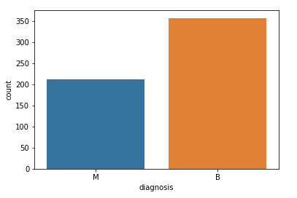

Chart displaying Malignant (cancerous) & Benign(non-cancerous) diagnosis

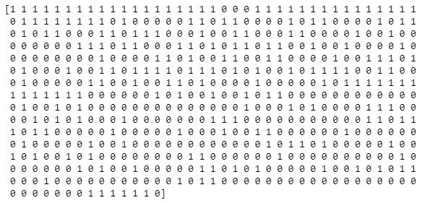

The encoded values of the feature/column diagnosis.



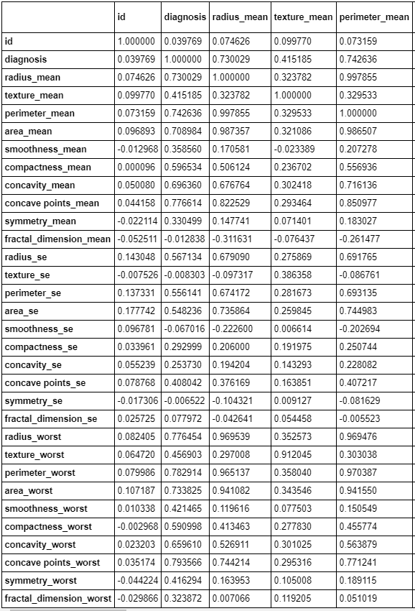

Column correlation

**Visualize the correlation** by creating a heat map.

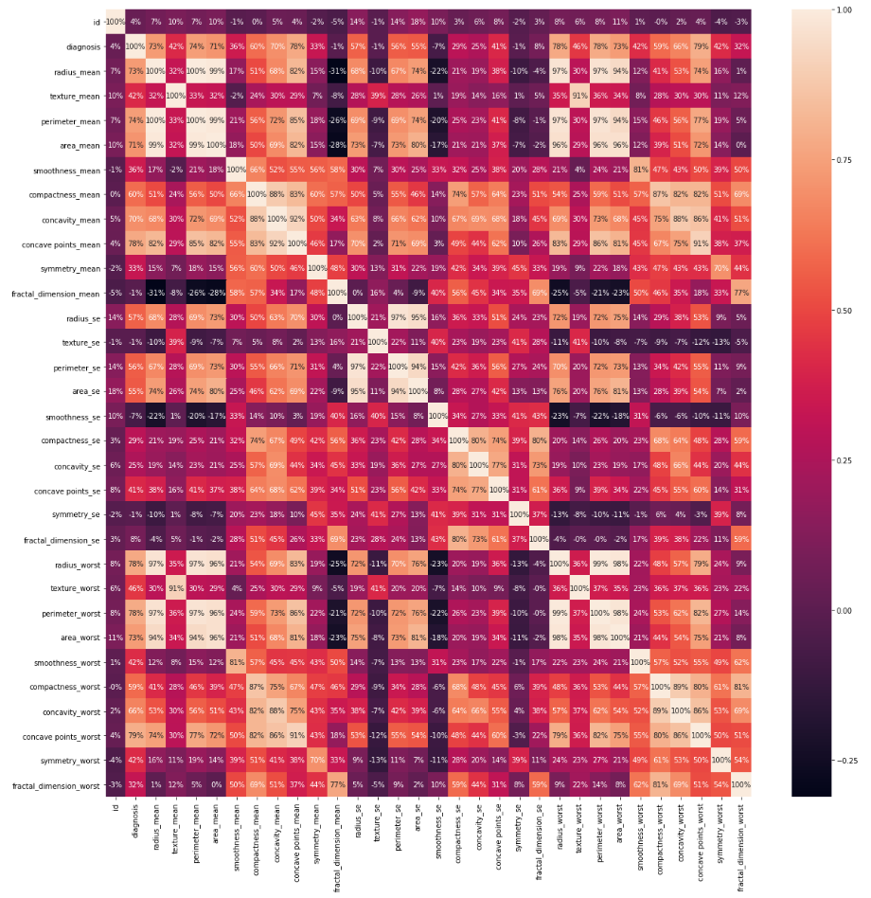

Heat map of correlations

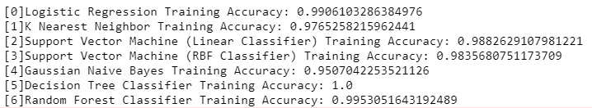

The accuracy of each model on the training data

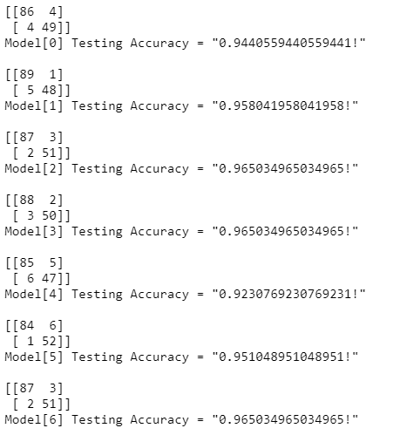

The models confusion matrix and accuracy on test data

Other ways to get metrics on the model to see how well each one performed.

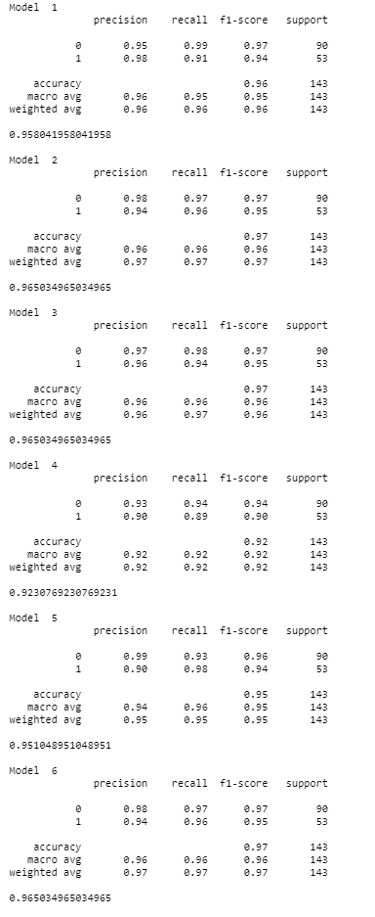

**PREDICTED AND ACTUAL VALUES OF PATIENTS**

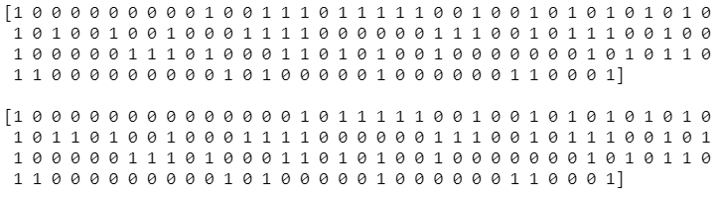

**Top:** Decision Tree Classifier prediction, **Bottom:** The actual classification of the patients