Amazon Sales Dashboard Project Report
Prepared by: Gaurav Kondane
Tool Used: Power BI
Date: November 2025

Project Objective
The objective of this project was to design and develop an interactive Power BI dashboard to analyze Amazon's sales performance across various parameters such as sales amount, courier status, top product categories, fulfillment methods, and state-wise shipping data. The dashboard aims to provide key insights into sales trends and operational efficiency to support business decision-making.

Data Description
The dataset contains sales transaction details including order date, product category, courier status, fulfillment type, delivery partner, size, and state of shipment. This data was used to calculate total sales amount, identify top categories, and visualize distribution patterns across India.

Dashboard Design & Components
The Amazon Sales Dashboard was designed in Power BI with the following interactive elements and KPIs:
Total Sales: Displays cumulative sales of 78.50M within the selected date range.Date Slicer: Enables users to filter data dynamically between March 2022 and June 2022.Courier Status: Pie chart showing distribution of Shipped, On the Way, Unshipped, and Cancelled orders.Top 5 Categories: Highlights top-performing categories such as T-shirt, Trousers, Wallet, Socks, and Watch.Delivery Partner: Bar chart comparing performance of Ekart and Easy Ship.Fulfillment Type: Visualization of Amazon vs Merchant fulfillment performance.Size Distribution: Breakdown of product sizes (M, XL, XXL, S, XS).Ship-State Analysis: State-wise shipment count identifying major contributors like Maharashtra and Karnataka.

Dashboard Snapshot

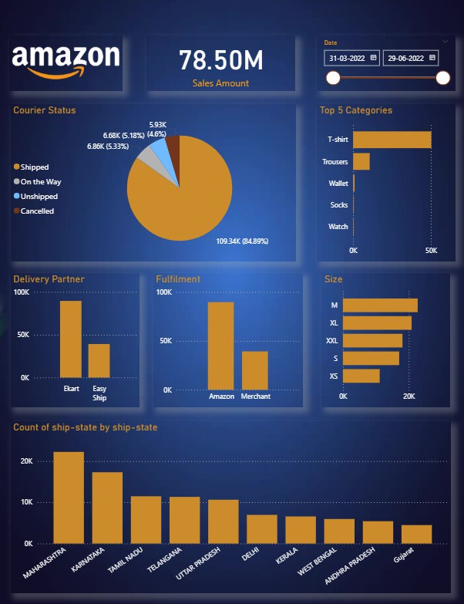

- Key Insights
Over 84.89% of total orders were successfully shipped, indicating a strong logistics performance.T-shirts emerged as the highest-selling product category, dominating sales across multiple regions.Maharashtra and Karnataka were the top-performing states in terms of shipment
volume.Amazon Fulfillment outperformed Merchant Fulfillment, suggesting efficiency advantages in Amazon’s network.

Recommendations & Future Improvements
Integrate real-time data connections for continuous performance monitoring.Include customer satisfaction and return rate metrics for deeper insights.Expand the dashboard with drill-through pages for product and region-level details.Automate data refresh and scheduling to enhance dashboard accuracy and usability.

Conclusion
The Amazon Sales Dashboard successfully visualizes key sales metrics and operational data, providing a clear view of performance drivers and improvement opportunities. This project demonstrates strong Power BI skills in data modeling, visualization design, and business analysis.

Prepared by: Gaurav Kondane
© 2025 Power BI Project Report

