

PROJECT: FES MANAGEMENT DATA ANALYSIS IN SYDNEY

PREPARE FOR: CITY OF SYDNEY OPEN DATA HUB
PREPARED BY: GROUP 4 – INFORMATION TECHNOLOGY DEPARTMENT
- Ashmita Tamang as Project Manager
- Sumnima Adhikari as Data Analyst
- Shama Praveen as Data Analyst
- Yueyang Zhou as Data Analyst
- Quynh Anh Nguyen as Web Developer/ UI Designer
CLASS: INFT6900 – INFORMATION TECHNOLOGY PROJECT
PROF. TEUKU GEUMPANA
SUBMISSION DATE: 15 NOV 2024

Abstract
This report explores and analyzes the trends of different industries in different areas of Sydney from 2007 to 2017. It aims to identify the growth /decline of industry, skill gaps and opportunity to balance employment and skills to fulfill the demand of industry. Using data from the City of Sydney Open data hub we conducted analysis starting from data cleaning, converting coordinates to standard geographic data and analyzed the patterns of industry across different areas. The key findings were the growth of hospitality and legal services and decline in retail sectors. Recommendation is provided focusing on maintaining the workforce skills with growing industries. It also includes creation of interactive dashboards and implementation on websites exploring the data and discussing the challenges encountered during the project.
Table of Contents
Introduction 1
Project planning and Approach 2
Project timeline and milestones 2
Resource allocation 3
Challenges 3
METHODOLOGY 4
Dataset Desciption 4
Data Cleaning 6
Loading Dataset 6
Handling Missing Data 6
Remove Missing Value Data and Duplicate Columns 7
Standardizing Text Data 7
Create a New Column 8
Conversion of X, Y coordinates to Latitude and Longitude 8
Data ANALYSIS AND FINDINGS 10
Top Industries by Division and Year 33
Evaluation 37
Recommendations 39
Dashboard Overview 41
Dashboard purpose and audience 41
WEB DEVELOPMENT 48
Retrospective: Mistakes Made and Lessons Learned 58
Conclusion 62
Appendices 63
Minutes of Meeting from Week from Week 5 – 12 63
Pre-Action Plan/Kanban Board 70
MS Project/MS Teams 71
Bibliography 74

Introduction
This report analyzes and evaluates the patterns of industry in different areas of Sydney using the data from the City of Sydney open data hub. It explores the growth/decline patterns, findings and emerging industry in Sydney. It aims to identify the gaps between available skills and industry needs, look over the emerging economic opportunities and provide recommendations for local council, business organizations and skill development initiatives. Through the analysis of industries over the years, this project provides insights into the factors that have brought changes in the economic condition and helps to understand the requirement for skill and employment.
This report offers an approach to project, starting with Planning which covers project timeline, resource allocation and challenges faced. The Methodology section contains details about dataset used, data types, data cleaning process. The Data Analysis and Findings section provides the analysis of industries over time in different areas of Sydney, their growth and decline over time, key insights, and findings. It also provides recommendations to create some strategies to implement over certain areas to support economic growth and provide the skills to fulfill the demand. Additionally, Dashboard Overview provides the visualization of the findings in interactive form. The Web Development section provides details on the creation of websites.
Finally, the Retrospective section reflects the challenges, mistakes made, lessons learned , providing the reflection to improve for future projects. Overall, all this report forms an important analysis of the emerging economic situation of Sydney and the methods that are used to analyze and gather this information.

Project planning and Approach

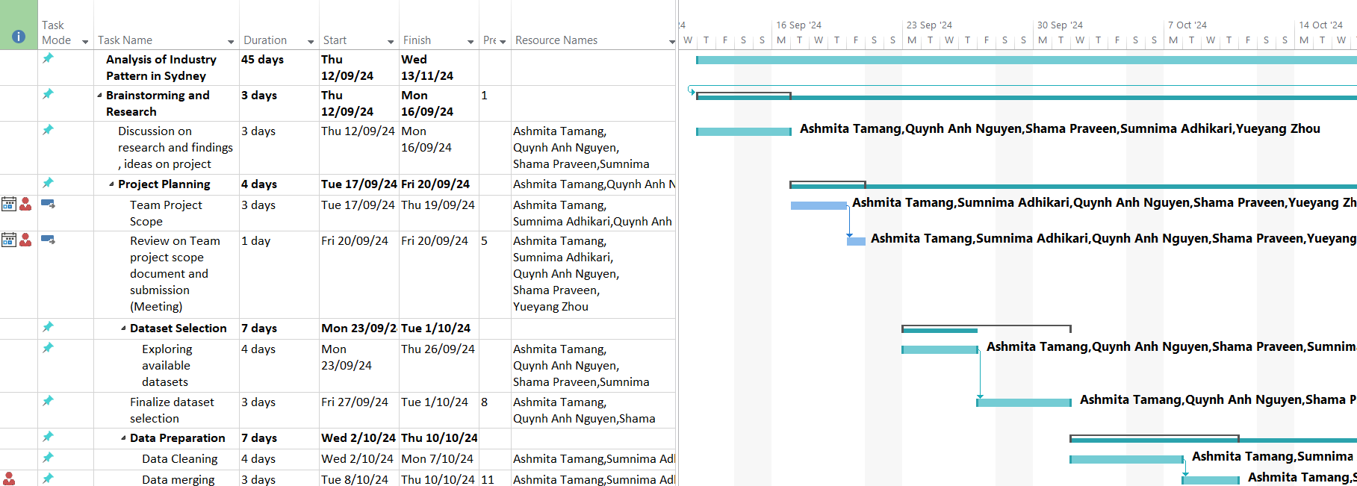
Project timeline and milestones

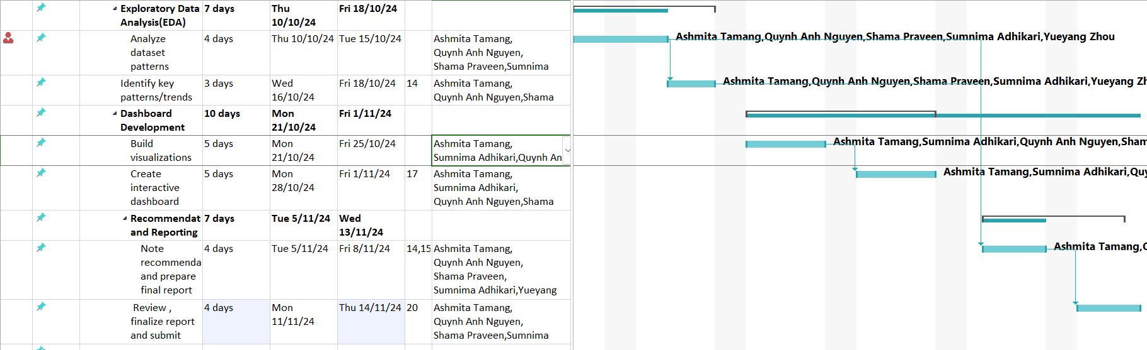

Figure: Gantt Chart

Resource allocation
Data Analysis:
For the data analysis project, Python was selected for data preprocessing on Anaconda Navigator using Jupiter notebook. Power BI was used for data analysis purposes as it offers robust visualization capabilities and user-friendly interface. To validate the visualization statistics, MS Excel is utilized for the project.
Web Development:
For the web development, part, tools like GitHub, React JS and Vite were utilized.
Project Management:
For project management, tools like MS project, MS teams and MS planner were utilized.

Challenges
- Initial Challenge: To select dataset and to work on the dataset to create insights.
- Data Analysis Challenges: Data analytics being a new topic to the team, it was quite challenging for the team to work on Power BI.
- Web Development: Due to time and resource limitation, we encountered issue to embed power bi dashboard to our website. We only had access to free power bi and did not have admin access, which limited us to embed the link to the website.

METHODOLOGY

Dataset Desciption
The data for the current analysis was retrieved from the City of Sydney Open Data Hub and it consists of various industries of occupation within the Sydney region. This dataset is extracted from the Floorspace and Employment Survey (FES) and includes data on commercial establishments, industries, geographical locations, and related activity.
The data has been compiled in a CSV format of 64622 rows where every row contains corresponding data of 18 features defining industries and locations in the city. The primary columns of interest include:
OBJECTID: A reference number used to identify a record distinctly in the given dataset.
ID: Yet another identifier referring to precise components of the database.
X and Y: Geographical UTM coordinates referring to the position of every single industry or business.
IndustryCode: A code whereby we could analyze the results differently based on the type of industry of the firm.
DivisionName: The larger industrial sector classification in which the business falls into (for instance, Information Media, Professional Services).
ClassificationCode: A unique identifier for a particular industry which performs certain function within a group.
ClassificationName: A name for the particular industry that lies under the classified section of certain groups.
Village: Sub region in Sydney where the industry resides (such as CBD & Harbour and Inner West).
Year: The period during which data was collected.
The information in this dataset is a general profile of economic activity and location of sectors within the City of Sydney. It is useful for analysis of trends, spatial distribution and employment distribution throughout the city.

Table : Dataset Variables
Dataset | Data Type
X | float64
Y | float64
OBJECTID | int64
ID | int64
Key_ | int64
DivisionCode | object
DivisionName | object
SubDivisionCode | int64
SubDivisionName | object
GroupCode | int64
GroupName | object
ClassificationCode | int64
ClassificationName | object
IndustryCode | object
IndustryName | object
CityBasedIndustry | object
Year | int64
Village | object

Data Cleaning
Even though most of the data is already clean, it's essential to ensure that:
- In critical columns, there are no missing values.
- Text data is standardized.
- Repetitive messages which may be unnecessary are eliminated or excluded.
Import Necessary Libraries:

Loading Dataset

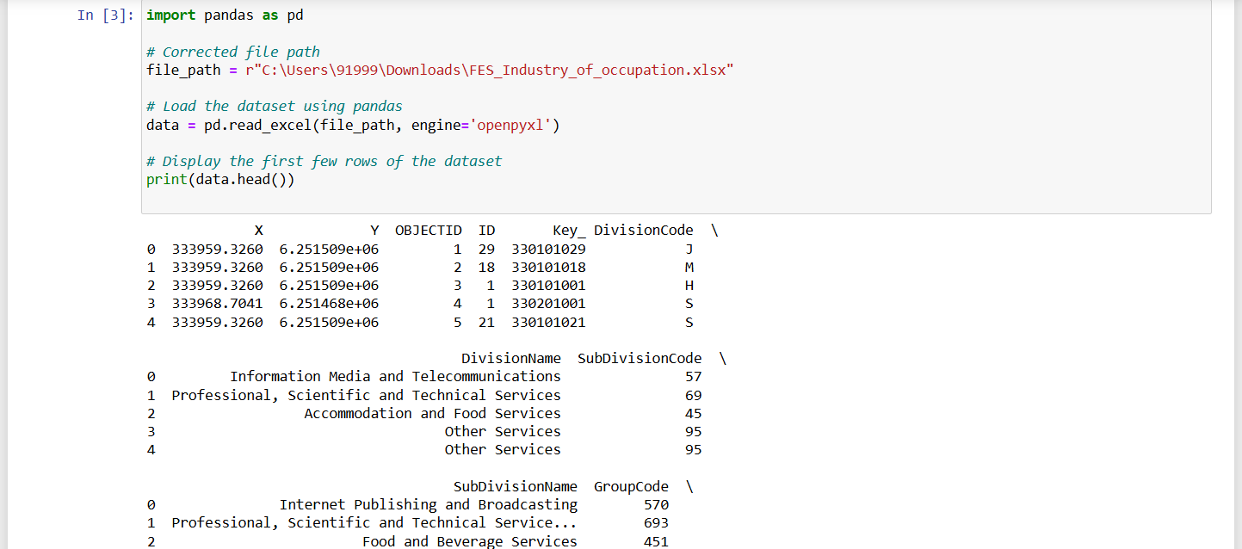

Handling Missing Data
We Looked for missing values in the data set particularly under important field like X, Y, Industry Code.
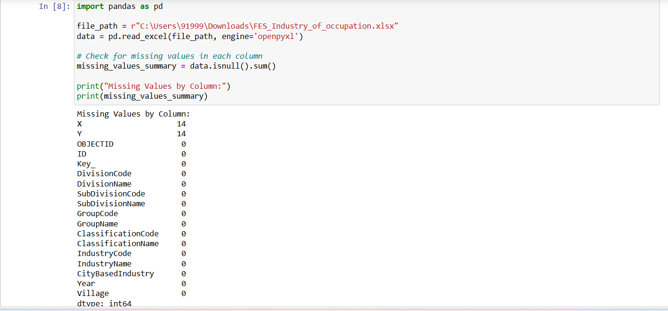

There were each 14 missing values in the X and Y columns; two fields that were vital for spatial analysis. Many of these rows were omitted to achieve better analysis.

Remove Missing Value Data and Duplicate Columns
Remove duplicate with identification code and focus on key columns as X, Y, OBJECTID, ID, IndustryCode and Year.

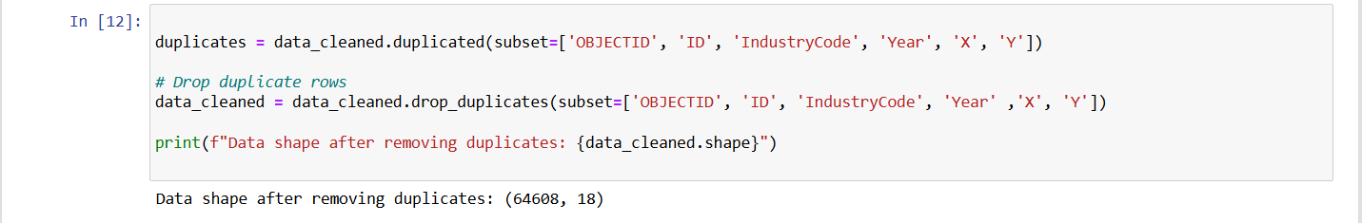

Standardizing Text Data
In case text-based columns are included they will be changed to lower case and trailing/leading spaces have also been removed (DivisionName, IndustryName, Village etc).

Create a New Column
Location Summary: To improve geography, a new column was added which is known as Location Summary which gives Village and DivisionName in one view

Conversion of X, Y coordinates to Latitude and Longitude
The project utilized PowerBI to visualize the dashboard. For the mapping in real time map, PowerBI only accepts longitude and latitude form of coordinates. Since in dataset, the X and Y coordinates are in EPSG (European Petroleum Survey Group) 28356 GDA94 (Geocentric Datum of Australia 1994)/MGA (Map Grid of Australia) zone 56 which consist of area of Australia-onshore and offshore between 150⁰ E and 156⁰E i.e. for example: one of the points in CBD & Harbor area it has X= 333959.3, Y= 6251508.582, we converted it to EPSG: 4326 WGS 84 (World Geodetic System 1984) i.e. Latitude: -33.8637 and Longitude: 151.205 using python pyproj library (epsg.io, 2024).
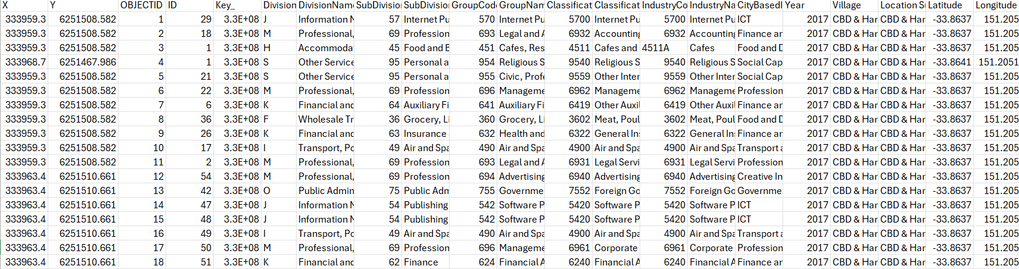
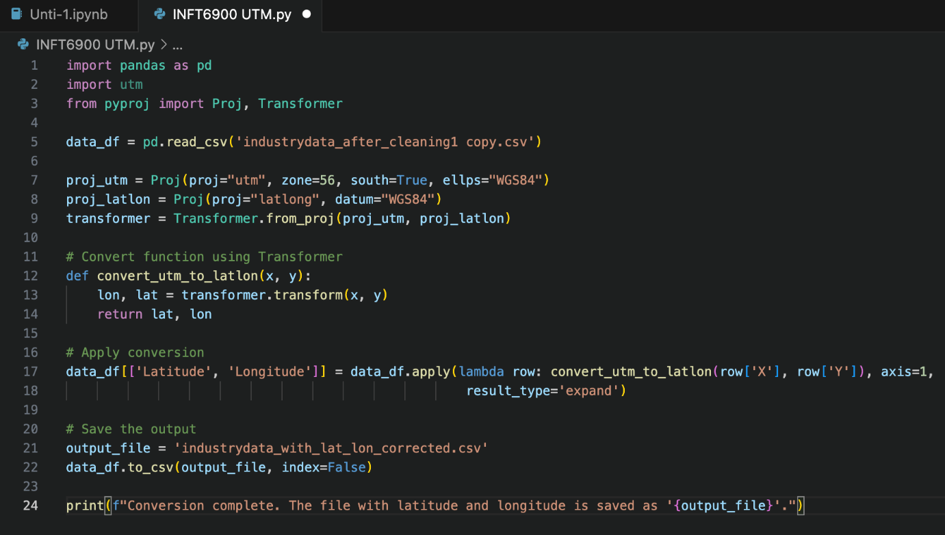

Data ANALYSIS AND FINDINGS
Objective 1: Study of Growth and Decline of Industry Over Time.
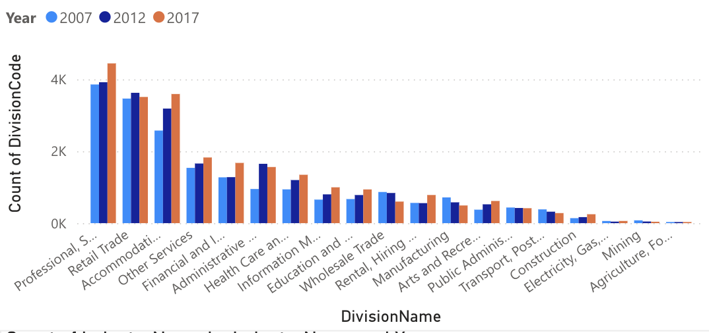
Figure 1 Count of Industry division in year 2007, 2012 and 2017

Division Growth Analysis
Top Growth Divisions:
  - Professional, Scientific, and Technical Services consistently led in terms of growth and dominance, with counts rising from 3,800 in 2007 to 3,900 in 2012 and reaching 4,444 in 2017.
  - Retail Trade and Accommodation and Food Services ranked second and third, respectively, in division dominance across the years.
Declining Divisions:
- Divisions like Retail Trade, Wholesale Trade, and Manufacturing experienced a decline from 2007 to 2017, which indicates a shift in economic focus away from retail and manufacturing sectors.
Consistent Growth:
  - Divisions such as Health Care and Social Assistance, Information Media and Telecommunications, and Education and Training showed gradual and steady growth, reflecting an increased focus on knowledge and service-based industries.

Least Dominant Divisions:
- Electricity, Gas, Water, and Waste Services, Mining, and Agriculture, Forestry, and Fishing divisions were the least dominant, each maintaining low counts (below 10), suggesting minimal employment or economic focus in these sectors within Sydney.

Growth and decline of industries based on division in the year 2007, 2012 and 2017.
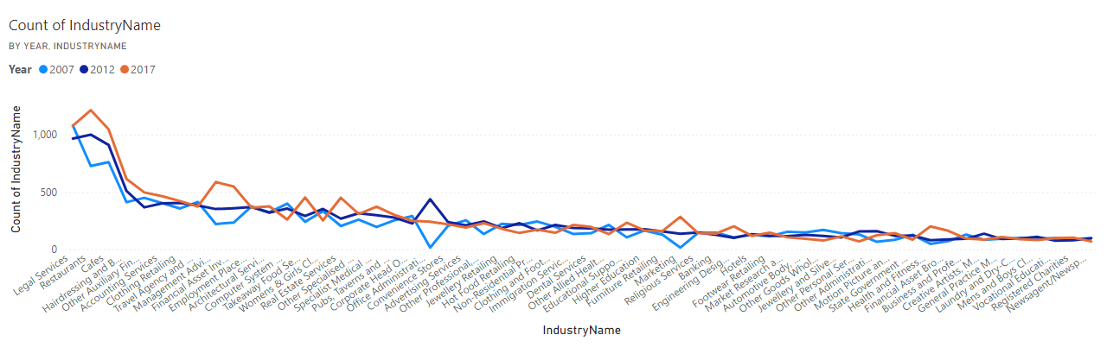
Figure 2 Line graph representing the growth of industries.
Professional, Scientific, and Technical Services:
Legal Services dominated within this division and demonstrated steady growth, maintaining its position as a critical industry in the City of Sydney.
Co-working Spaces emerged in 2017 with an initial count of 36, indicating a shift towards flexible working arrangements and shared office spaces.
Market Research and Statistical Services saw a decline, as did Computer System Design and Related Services, which may suggest a move toward alternative or more integrated technology and business services.
Retail Sector:
Clothing Retailing showed dominance with gradual growth, indicating strong consumer demand in this segment.
Conversely, Women’s & Girls' Clothing Retailing, Convenience Stores, and Jewellery Retailing saw declines, reflecting possible shifts in consumer preferences and shopping patterns.
Accommodation and Food Services:
Restaurants, Cafés, and Takeaway Food Services displayed major growth, suggesting a thriving food and dining culture in Sydney.
Other areas like Pubs, Taverns, and Bars also saw growth, indicating a broader increase in hospitality services across the city.
Top sectors showing growth and their percentage.
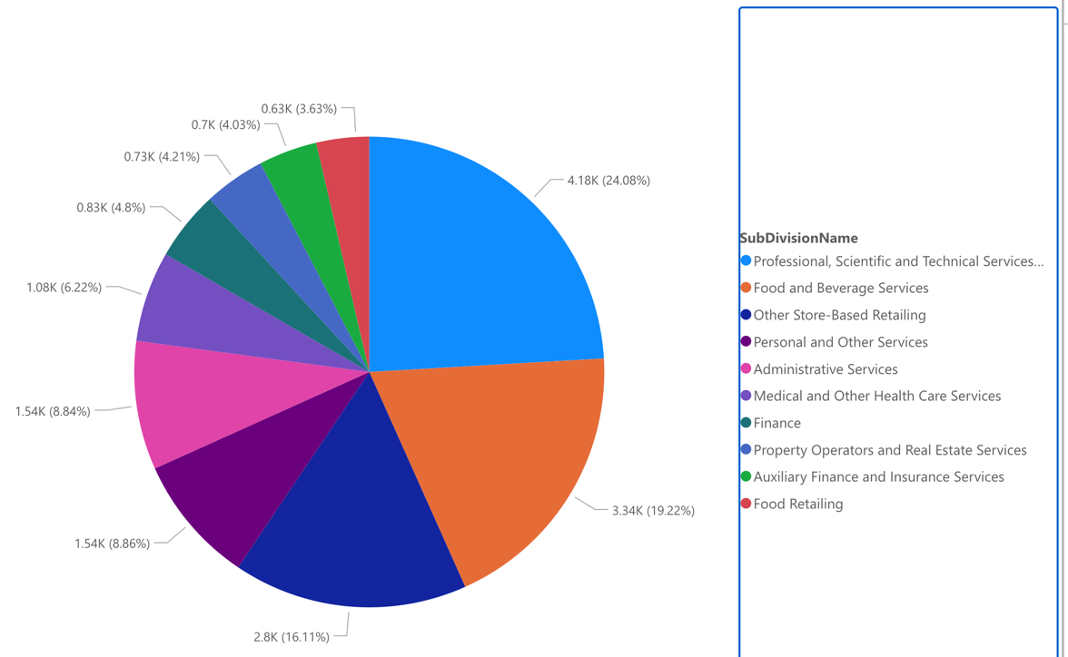
Figure 3 Pie Chart representing top Sub divisions in the year 2017

- Professional, Scientific, and Technical Services held approximately 24.08% of the total count in 2017.
- Food and Beverage Services accounted for 19.22%, reflecting its significant role in Sydney’s economy.
- Other notable subdivisions include Personal and Other Services, Administrative Services, and Medical and Other Health Services, each contributing a considerable share to the total
From the above analysis, it highlights significant trends in the landscape of Sydney from 2007 to 2017. There is a clear shift towards service-based and knowledge-driven industries. Professional services, healthcare services and educational services showcased gradual growth while retail and manufacturing sectors had seen relative decline. The Accommodation and food services sectors experienced notable growth, such as restaurants, cafes, and bars. In this findings, co-working service spaces started in 2017 with count of 36 in the city of Sydney which also suggests consumer behaviors and workplace dynamic.
Objective 2: Finding The Most Dominant And Non dominant Industries Over The Area And Year.

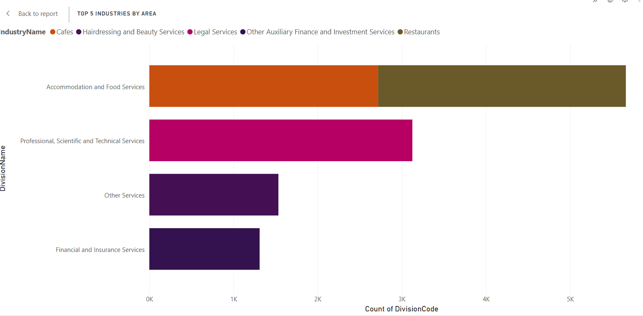
Dominant Industries:
Healthcare: They are most frequently located in urbanized workspaces with extensive development and connectivity such as Sydney CBD & Inner West.
Retail Trade: Located mostly in suburbs that experience much commercial activity, like Northern Beaches or Parramatta.
Professional Services: High concentration in CBDs which depicts that they act as economic centers.
Increased presence of technology and creative industries in 2017.
Non-Dominant Industries:
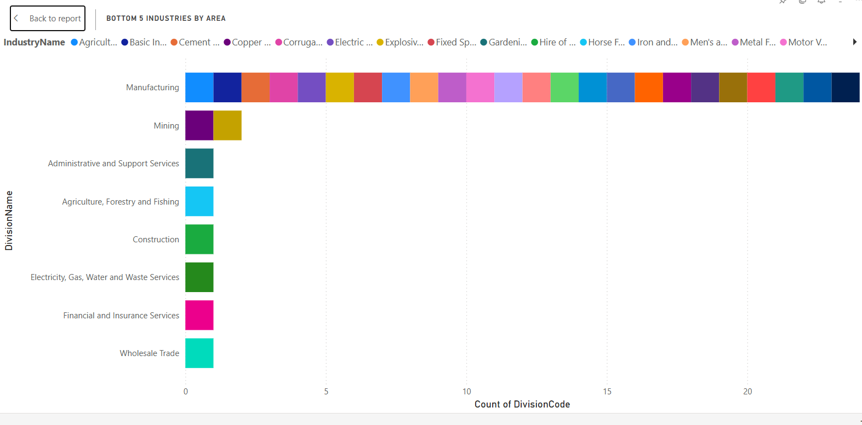

Least Common Industries: Industries such as Agriculture, Mining, and Manufacturing are consistently at the bottom across most villages.
Limited Presence: These industries are primarily absent in urban and suburban settings due to a lack of infrastructure or demand.
Key insights and observations
- Persistent Growth in Service Sectors: Over the decade, the Professional, Scientific, and Technical Services, along with Accommodation and Food Services, consistently showed growth. These sectors adapted to increasing demand driven by both economic expansion and consumer preferences.
- Stability in Niche Markets: Industries like Legal Services and Cafes maintained their significance, highlighting a stable demand within their respective professional and consumer markets.
- Diversification within Manufacturing: The manufacturing sector, despite its overall decline in prominence, displayed a wide range of specialized industries, each holding a small but steady presence, suggesting a transition from traditional to more specialized manufacturing processes.
- Emergence of Management and Consulting Services: By 2017, there was noticeable growth in Management Advice and Related Consulting Services, reflecting the evolving needs of businesses for expert advice and strategic planning.

Objective 3: Analyze And Explore How Certain Industries Are Distributed Across Different Region Of Sydney.

Key insights and observations
Observations
To start the analysis, I focused on the top 5 industries in Sydney for the year 2017. The data shows the following industry counts:
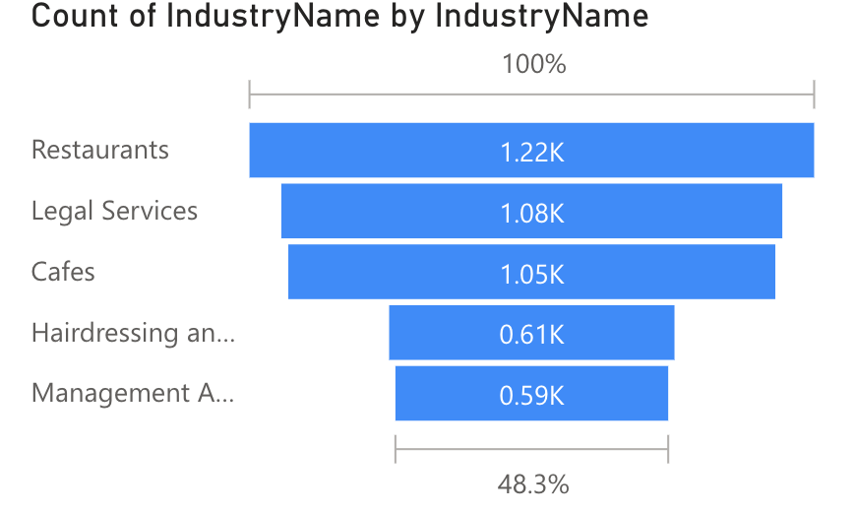
From this analysis, some observations have been made:
- Restaurants, Legal Services, and Cafes dominate the top three spots with relatively close counts, suggesting that the food and beverage industry, along with professional services, plays a significant role in Sydney’s economy.
- The fifth-ranked industry (Management Advice and Consulting Services) accounts for only 48.3% of the count of Restaurants, highlighting a sharp drop-off after the top three industries.
When analysing the industry counts over time, observing that the top three industries consistently remained Restaurants, Legal Services, and Cafes across the years 2007, 2012, and 2017. However, the rankings among these industries have shifted over time:
- In 2007, Legal Services held the top spot with 1.08K, followed by Cafes as the second most prevalent industry.
- By 2012, Restaurants rose to the top with 1K, surpassing both Legal Services and Cafes.
This shift indicates a growing focus on the hospitality sector, possibly driven by changes in consumer behaviour and an increase in dining-out culture.
Additionally, there is a noticeable trend in the overall industry counts:
- The total number of businesses declined between 2007 and 2012, reflecting a potential economic slowdown or restructuring during that period.
- However, there was a significant increase in industry counts between 2012 and 2017, suggesting a recovery phase, possibly driven by economic growth and increased demand in key sectors like food services.
These findings highlight not only the stability of certain industries over time but also the shifts in consumer and business priorities in Sydney over the past decade.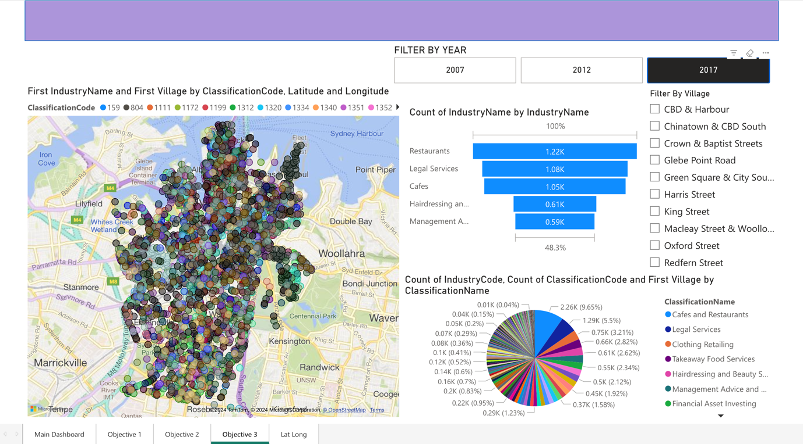

In-Depth Village-Level Analysis of Industry Distribution
Upon delving deeper into the industry distribution across different villages in Sydney, the data reveals some clear patterns:
The CBD & Harbour area shows a high concentration of industries, particularly in professional and financial sectors. Notably:
- There are over 700 Legal Services businesses, making it the most dominant sector in this area.
- This is followed by 468 Financial Asset Investing firms and 403 Auxiliary Finance and Investment services, indicating the CBD's role as a financial hub.
The Chinatown & CBD South area ranks as the second highest in terms of industry density:
- It hosts 257 Restaurants and 207 Legal Services. This mix highlights Chinatown's dual focus on both dining and professional services.
- Interestingly, Legal Services, which are prevalent in the CBD & Harbour, also have a significant presence in Chinatown, yet they are largely absent from the top industries in other villages.
Based on the following diagrams, we can observe that Legal services are centralized in the CBD & Chinatown, while Restaurants dominate other villages.
e.g. distribution of legal service.
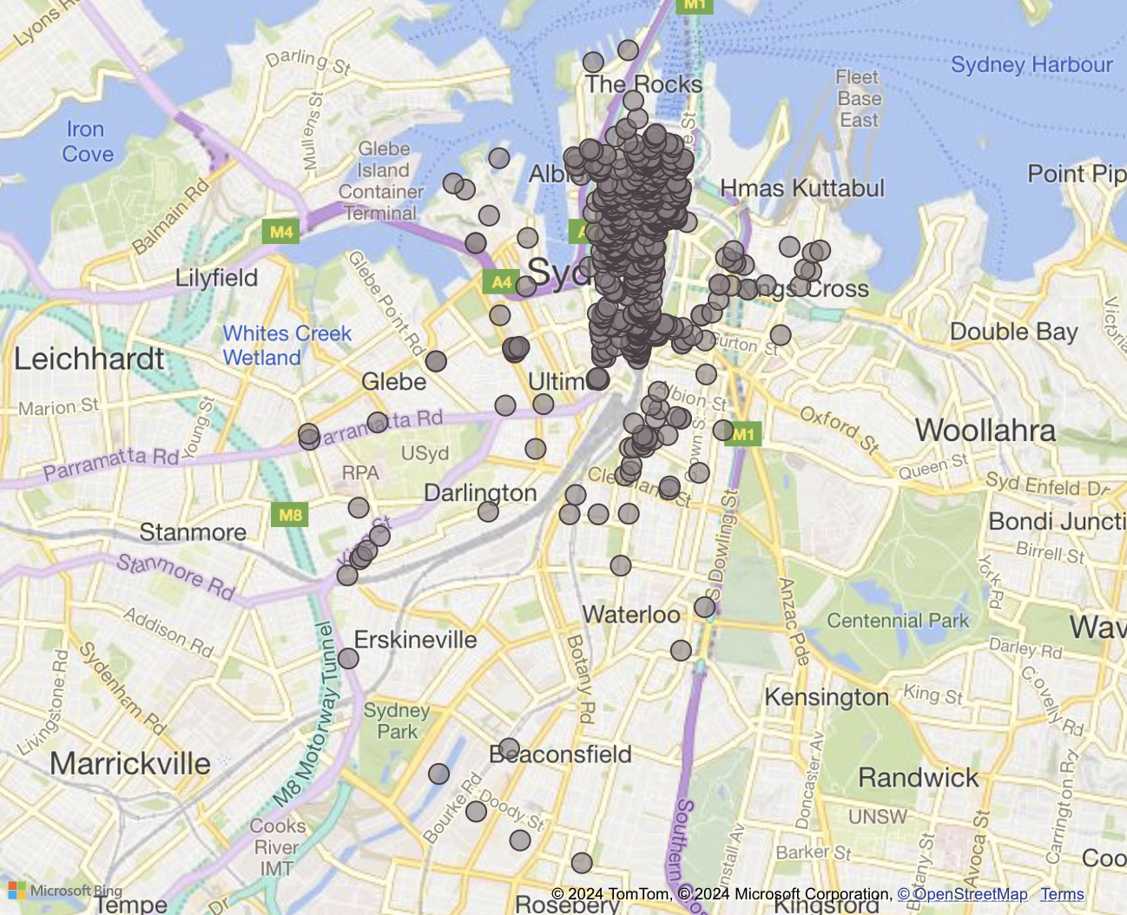

Distribution of restaurants:
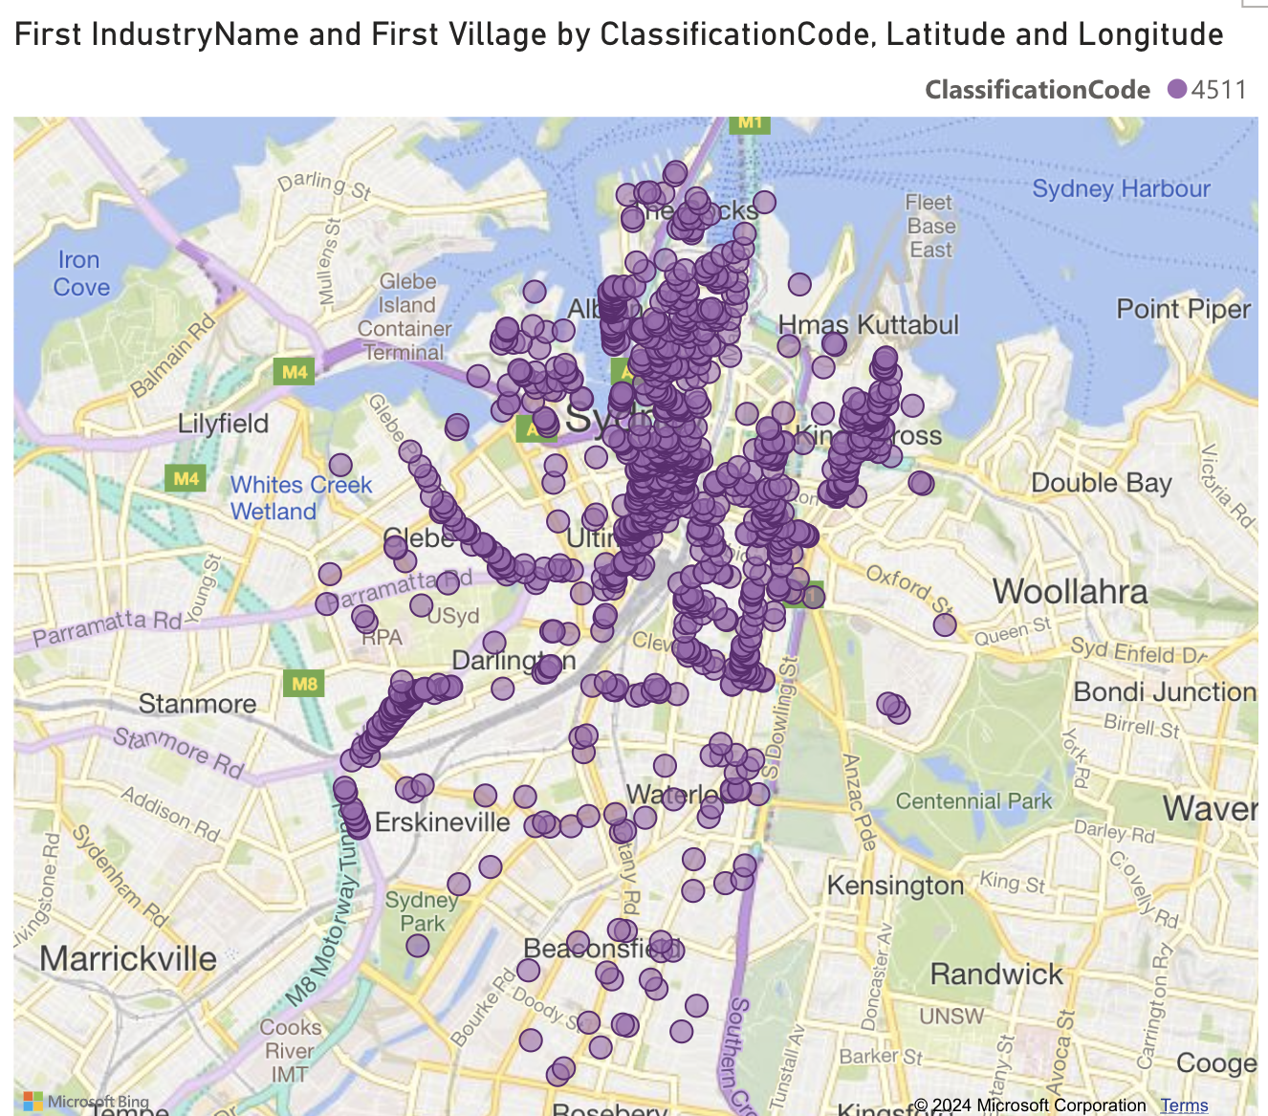

Then zoom in on two specific villages for restaurant industry—King Street and Glebe Point Road—to examine their industry distribution in more detail.
King Street:
- Restaurants are densely concentrated along King Street, particularly around the Camperdown and Newtown areas.
- The distribution extends southward towards St Peters, indicating that King Street serves as a major dining hub for both locals and visitors.
- This concentration suggests that King Street has a vibrant food scene, with restaurants clustered closely together, likely benefiting from high foot traffic and visibility.
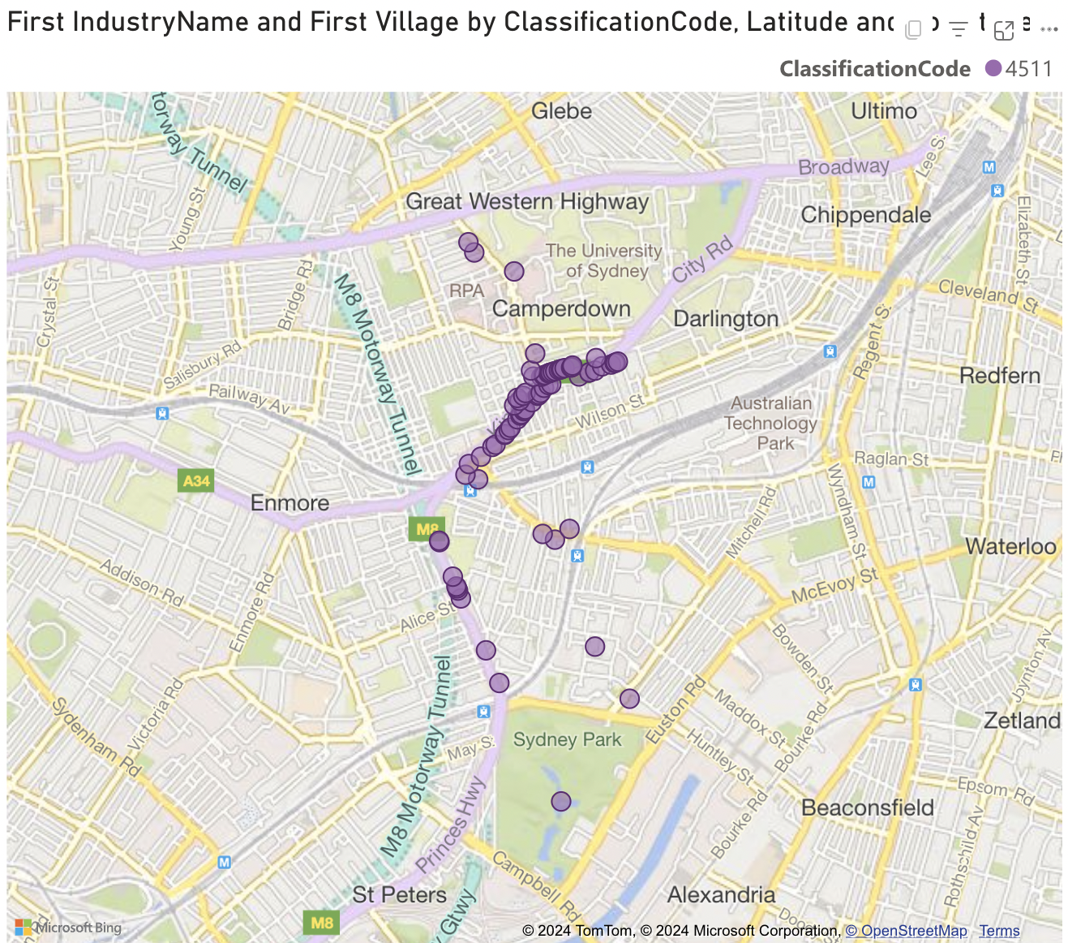
Glebe Point Road:
- Restaurants are primarily concentrated along Glebe Point Road, especially near intersections like Bridge Road and Parramatta Road.
- The distribution is more dispersed compared to King Street, with restaurants spread out along the entire length of Glebe Point Road, creating a more relaxed dining atmosphere.
- The proximity to Sydney University and TAFE NSW Ultimo likely attracts a mix of students and residents, making Glebe Point Road a popular spot for casual dining.
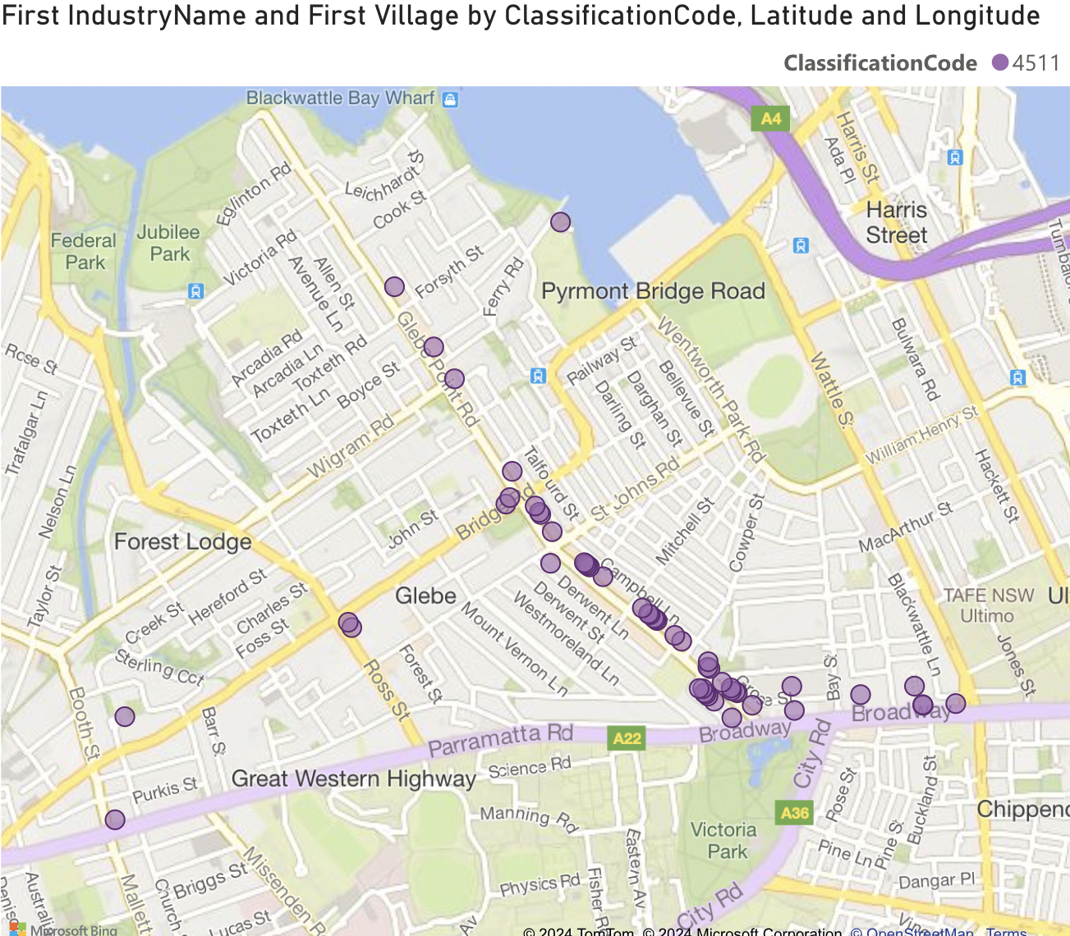
When analysing other villages:
- Legal Services do not appear in the top five industries, suggesting that they are primarily concentrated in central business districts (CBD & Harbour, and Chinatown & CBD South).
- Restaurants are the most common industry across multiple villages, holding the top spot in areas such as Crown & Baptist Streets, Harris Street, King Street, Macleay Street, and Oxford Street. This reflects these areas' popularity as dining and social hotspots.

Key insights:
The high concentration of Legal and Financial services in the CBD & Harbour and Chinatown areas reflects their economic focus on business and professional services.
The dominance of the restaurant industry in other regions emphasizes the cultural and social role these areas play in Sydney’s urban life.
The absence of Legal Services from top industries in non-CBD areas indicates a clear centralization of professional services within the city centre, suggesting opportunities for expanding such services in suburban areas.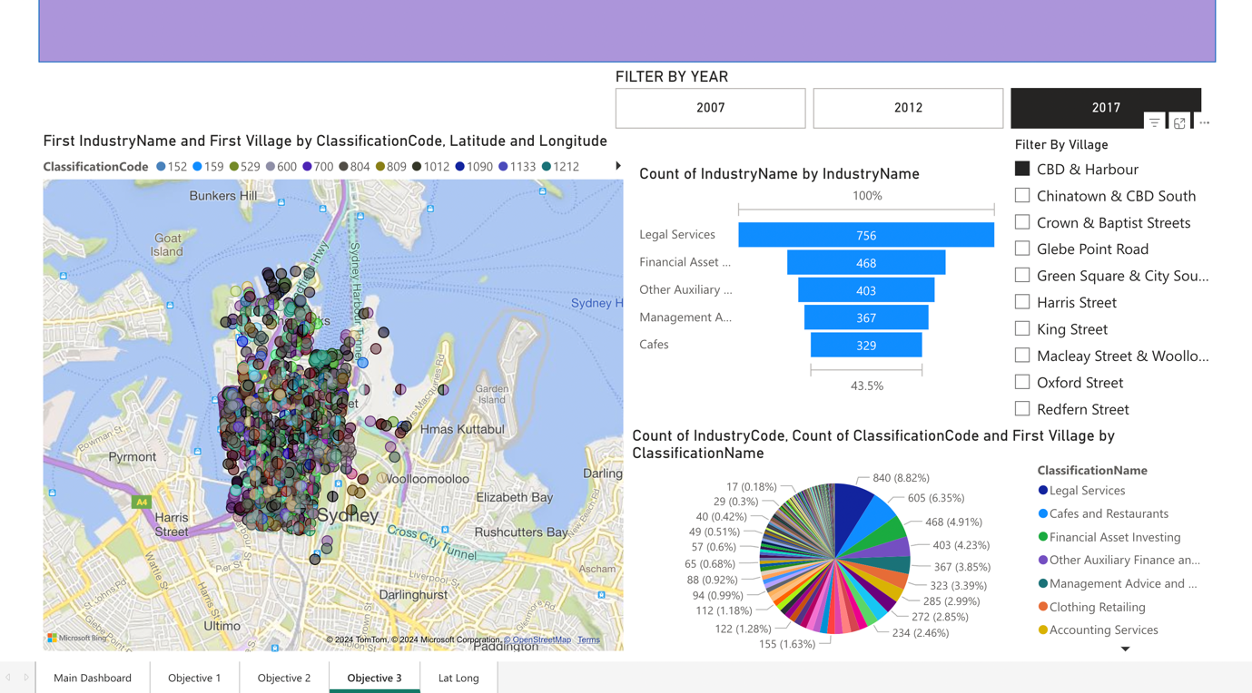
Statistical Summaries
Top 5 industries in Count of industry in Sydney
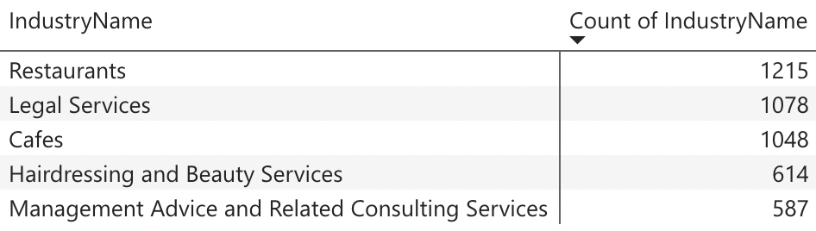

Top 5 industries in Count of industry in CBD & Harbour
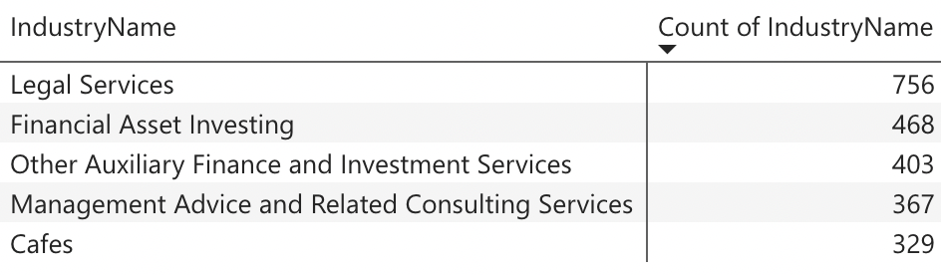

Top 5 industries in Count of industry in Chinatown & CBD South
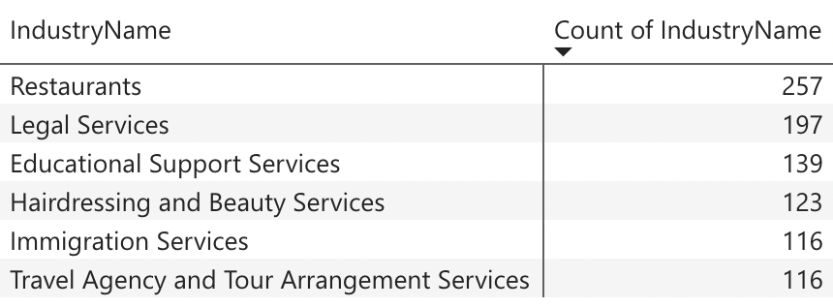

Top 5 industries in Count of industry in King Street
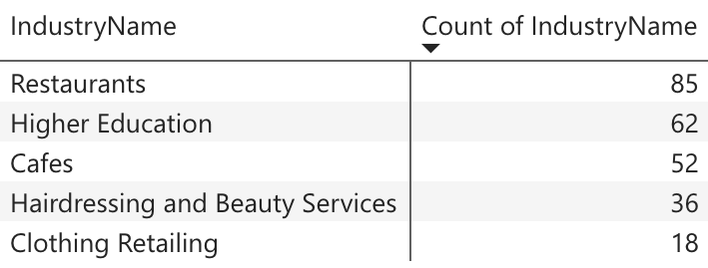

Top 5 industries in Count of industry in Glebe Point Road
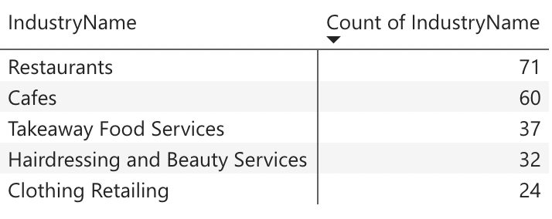

Objective 4: Analyse Areas With High or Low Number Of Specific Industries Compared To Others Which Will Help To Study And Explore Economic Profile Of That Region.
There is total 10 Villages as per dataset from where data are collected from year 2007 to 2017. So, the project is going to compare the distribution of different industries among those 10 villages throughout the year. It will explore the economic condition of that region.
CBD & Harbour
Industry(CBD & Harbor) | 2007 Count and % | 2012 Count and % | 2017 Count and % | % Change (2007-2012) | % Change (2012-2017)
Legal Services | 853  10.21% | 705  8.27% | 840  8.82% | -17.34% | +19.15%
Cafes and Restaurants | 462  5.53% | 540  6.34% | 605  6.35% | +16.88% | +12.04%
Clothing Retailing | 406  4.86% | 409  4.8% | 323  3.39% | +0.74% | -21.03%
Other Auxiliary Finance and Investment Services | 400  4.79% | 301  3.53% | 403  4.23% | -24.75% | +33.89%
Financial Asset Investing | - | 297  3.48% | 468  4.91% | - | +57.58%

Key Findings
- Legal Services decline from 2007-2012 but increase in 2017. The reason can be due to market competition and shift in business demands.
- Cafes and Restaurants is growing consistently showing stable demand which shows the strong demand for dining and social gathering areas.
- Clothing Retailing is declining consistently due to shift of people preferences towards online shopping.
- Other Auxiliary Finance and investment services decline till 2012 but recover back by 2017 showing the renewed interest of people in financial investment.
- Financial Asset Investing is seen as emerging sector in 2017 which shows growing interest of people in investment.

Chinatown & CBD South
Industry(Chinatown & South CBD) | 2007 Count and % | 2012 Count and % | 2017 Count and % | % Change (2007-2012) | % Change (2012-2017)
Legal Services | 272  10.91% | 334  11.49% | 313  10.11% | +22.79% | -6.29%
Cafes and Restaurants | 235  9.43% | 309  10.63% | 361  11.66% | +31.49% | +16.18%
Clothing Retailing | 139  5.58% | 184  6.33% | 130  4.2% | +32.37% | -29.35%
Takeaway Food services | 115  4.61% | 149  5.13% | 161  5.2% | +29.57% | +8.05%
Travel Agency and Tour Arrangement | 98  3.93% | 102  3.51% | - | +4.08% | -
Educational Support Services | - | - | 139  4.49% | - | -

Key Findings
- Opposite to CBD & Harbor area Legal Services increases from 2007-2012 but decline by 2017.
- Cafes and Restaurants is growing rapidly showing strong demand for dining and social gathering areas.
- Clothing Retailing has growth in initial year but drop by 2017 due to shift of people preferences towards online shopping.
- Takeaway food services is showing slow growth indicating people preferences for quick dining.
- Travel Agencies is continuously declining which shows the shift of people preferences towards online bookings.
- Educational Support Services seems as emerging sector in 2017, due to increase in demand for training and support services.

Crown & Baptist Streets

Industry(Crown & Baptist Streets) | 2007 Count and % | 2012 Count and % | 2017 Count and % | % Change (2007-2012) | % Change (2012-2017)
Cafes and Restaurants | 162  8.7% | 203  9.69% | 243  10.68% | +25.31% | +19.7%
Architectural Services | 112  6.01% | 82  3.91% | 113  4.69% | -26.79% | +37.8%
Clothing and Footwear Wholesaling | 82  4.4% | 99  4.73% | - | +20.73% | -
Advertising Services | 71  3.81% | 69  3.29% | 79  3.47% | -2.82% | +14.49%
Other Specialised Design services | 63  3.38% | 111  5.3% | 102  4.48% | +76.19% | -8.11%

Key Findings
- Cafes and Restaurants is growing gradually showing strong demand for dining and social gathering areas.
- Architectural services decline from 2007 to 2012, had slight recovery by 2017, showing changes in design and development regulations and demand of construction.
- Clothing and Footwear Wholesaling has growth in initial year but drop by 2017 due to shift of people preferences towards online shopping.
- Advertising services declined by 2012 but recover in 2017 showing its increasing demand for advertising for businesses.

Glebe Point Road
Industry (Glebe Point Road) | 2007 Count and % | 2012 Count and % | 2017 Count and % | % Change (2007-2012) | % Change (2012-2017)
Cafes and Restaurants | 90  12.45% | 127  14.14% | 131  14.7% | +41.11% | +3.15%
Clothing Retailing | 47  6.5% | 46  5.12% | 40  4.94% | -2.13% | -13.04%
Takeaway Food services | 35  4.84% | 37  4.12% | 44  4.94% | +5.71% | +18.92%
Hairdressing and Beauty Services | 26  3.6% | 28  3.12% | 32  3.59% | +7.69% | +14.29%
Supermarket and Grocery Stores | 20  2.77% | 28  3.12% | 22  2.47% | +40.0% | -21.43%

Key Findings
- Cafes and Restaurants is growing consistently, showing strong demand for dining and social gathering areas.
- Clothing Retailing is declining by 2017.
- Takeaway food services are increasing rapidly, indicating increase in demand for quick dine service.
- Hairdressing and Beauty services are growing finely showing demand for personal and beauty care.

Green Square & City South

Industry(Green Square and City South) | 2007 Count and % | 2012 Count and % | 2017 Count and % | % Change (2007-2012) | % Change (2012-2017)
Cafes and Restaurants | 68  3.84% | 100  4.76% | 166  7.16% | +47.06% | +66.0%
Clothing and Footwear Wholesaling | 84  4.74% | 85  4.05% | - | +1.19 | -
Automotive Bod repair | 79  4.46% | 74  3.52% | 55  2.37% | -6.33% | -25.68%
Other goods wholesaling | 109  6.15% | 72  3.43% | - | -33.94% | -
Furniture Retailing | 41  2.31% | 57  2.71% | 79  3.41% | +39.02% | +38.6%

Key Findings
- Cafes and Restaurants is growing consistently, showing strong demand for dining and social gathering areas.
- Clothing Retailing is declining by 2017.
- Automotive services are gradually declining due to pressure of urban development.
- Furniture Retailing is gradually growing due to increase in residential areas.

Harris Street
Industry(Harris Street) | 2007 Count and % | 2012 Count and % | 2017 Count and % | % Change (2007-2012) | % Change (2012-2017)
Cafes and Restaurants | 63  8.29% | 116  11.11% | 149  12.83% | +84.13% | +28.45%
Other Administrative services | - | 39  3.74% | 43  3.7% | New entry | +10.26%
Real estate services | - | 31  2.97% | 36  3.1% | New entry | +16.13%
Management advice & consulting | - | 33  3.16% | 32  2.76% | New entry | -3.03%
Architectural services | - | - | 32  2.76% | New entry | -

Key Findings
- Cafes and Restaurants is growing consistently, showing the area is becoming hub for social gathering.
- Administrative services are seen increasing by year 2017.
- Real estate services are increasing slightly over years showing the preference of people in real estate.
- Management advice and consulting is declining by year 2017.
- Architectural services are seen as emerging sector in this area.

King Street
Industry(King Street) | 2007 Count and % | 2012 Count and % | 2017 Count and % | % Change (2007-2012) | % Change (2012-2017)
Cafes and Restaurants | 98  13.19% | 114  14.18% | 137  18.1% | +16.33% | +20.18%
Higher Education | 73  9.83% | 73  9.08% | 62  8.19% | -0.76% | -9.85%
Clothing Retailing | 41  5.52% | 46  5.72% | 27  3.57% | +4.44% | -41.3%
Hairdressing and Beauty Services | 25  3.36% | 34  4.23% | 36  4.76% | +36% | +5.88%
Educational Support Services | 22  2.96% | 29  3.61% | 26  3.43% | +31.82% | -6.9%

Key Findings
- Cafes and Restaurants is growing consistently, showing strong demand for dining and social gathering areas.
- Higher education is declining gradually over time.
- Clothing Retailing has slight decline due to decrease in demand replaced by online shopping
- Hairdressing and Beauty services is growing consistently showing demand for local personal care services.

Macleay Street & Woolloomooloo

Industry (Macleay Street & Woolloomooloo) | 2007 Count and % | 2012 Count and % | 2017 Count and % | % Change (2007-2012) | % Change (2012-2017)
Cafes and Restaurants | 102  13.56% | 127  15.64% | 135  15.13% | +24.51% | +6.3%
Accommodation | 52  6.91% | 52  6.4% | 59  5.61% | 0% | +13.46%
Hairdressing and Beauty Services | 33  4.39% | 31  3.82% | 32  3.59% | -3.13% | +3.23%
Defense | 32  4.26% | 31  3.82% | 32  3.59% | -3.13% | +3.23%
Other store-based retailing | 30  3.99% | - | - | - | -
Educational Support Services | - | - | 28  3.14% | - | -
Key Findings
- Cafes and Restaurants has shown steady growth showing strong demand for food and services.
- Accommodation services is growing slightly indicating demand for short term stay and lodge.
- Personal care services are growing stably.
- Educational support services seem emerging sector in this area.

Oxford Street
Industry(Oxford Street) | 2007 Count and % | 2012 Count and % | 2017 Count and % | % Change (2007-2012) | % Change (2012-2017)
Cafes and Restaurants | 144  12.44% | 185  13.84% | 189  14.18% | +28.47% | +2.16%
Clothing Retailing | 58  5.01% | 57  4.26% | 52  3.9% | -1.72% | -8.77%
Hairdressing and Beauty Services | 44  3.8% | 53  3.96% | 63  4.73% | +20.45% | +18.87%
Pubs, Tavern and Bars | 35  3.02% | 50  3.74% | 54  4.05% | +42.86% | +8%
Motion Picture and Video Production | 37  3.2% | - | 49  3.68% | - | -
Educational Support Services | - | 42  3.14% | - | - | -
Architectural Services | - | - | 42  3.15% | - | -

Key Findings
- Cafes and Restaurants showing steady growth.
- Clothing Retailing is declining slightly.
- Pubs and bars are growing gradually over time which shows increase in vibrant nightlife for locals.
- Architectural services are emerging over time adding diversity in the area.

Redfern Street
Industry (Redfern Street) | 2007 Count and % | 2012 Count and % | 2017 Count and % | % Change (2007-2012) | % Change (2012-2017)
Cafes and Restaurants | 64  6.81% | 91  8.33% | 147  12.41% | +42.19% | +61.54%
Higher Education | 36  3.83% | 39  3.57% | 34  2.87% | +8.33% | -12.82%
Pubs, Taverns, and Bars | 26  2.77% | 26  2.38% | 33  2.78% | No change | +26.92%
Other Specialized Design Services | 27  2.87% | 27  2.47% | 30  2.53% | No change | +11.11%
Takeaway Food Services | - | - | 46  3.88% | - | -
Hairdressing and Beauty Services | - | - | 27  2.28% | - | -

Key Findings
- Cafes and Restaurants are growing significantly.
- Higher Education is declining slightly over time reflecting shift in demand for educational services.
- Increase in number of pubs and bars shows demand for night venues.

Statistical Summaries
Industrial division in year 2007, 2012 and 2017

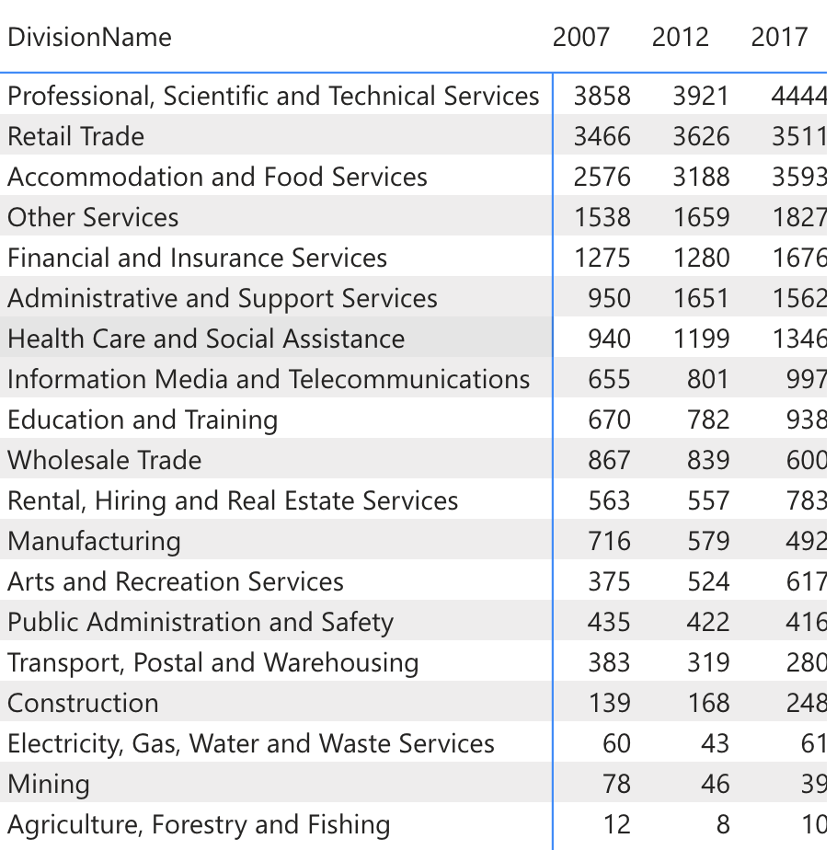
Figure 4 Division of industries in year 2007, 2012 and 2017.
The above statistical summary highlights the count of each division in the respective years where the count of top industrial divisions:
- Professional, Scientific and Technical Services is 3858, 3921 and 4444 in year 2007, 2012 and 2017 respectively. This reflects gradual growth over the years.
- Retail trade service is 3466, 3626, and 3511 in year 2007, 2012 and 2017. This reflects up and down in the industry.
- Accommodation service is 2576, 3188 and 3511 in year 2007, 2012 and 2017. This reflects gradual growth.
- Electricity, Gas, Water and waste services, Mining and Agriculture, forestry and fishing being the lowest through the years.

Top Industries by Division and Year
DOMINANCE Data By 2007
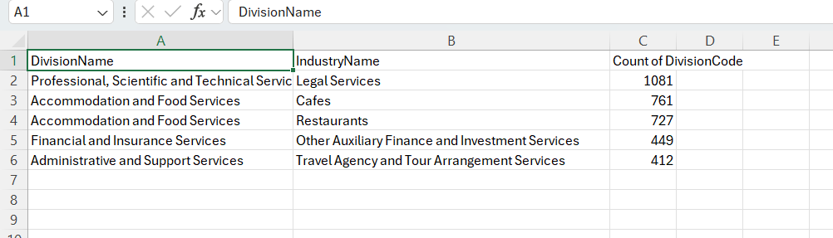

- Professional, Scientific, and Technical Services:
Legal Services: 1,081 counts
- Accommodation and Food Services:
Restaurants: 761 counts
Cafes: 727 counts
- Financial and Insurance Services:
Other Auxiliary Finance and Investment Services: 449 counts
- Administrative and Support Services:
Travel Agency and Tour Arrangement Services: 412 counts

DOMINANCE Data By 2012
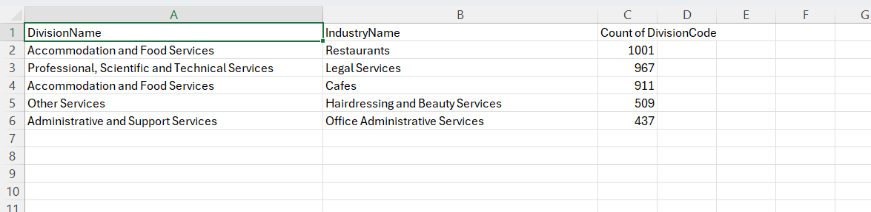

- Accommodation and Food Services:
Restaurants: 1,001 counts
Cafes: 967 counts
- Professional, Scientific, and Technical Services:
Legal Services: 967 counts
- Other Services:
Hairdressing and Beauty Services: 509 counts
- Administrative and Support Services:
Office Administrative Services: 437 counts

DOMINANCE Data By 2017
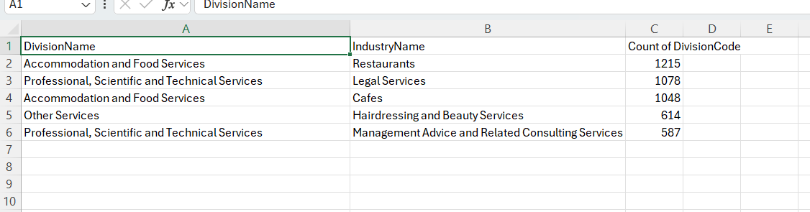

- Professional, Scientific, and Technical Services:
Legal Services: 1,081 counts
- Accommodation and Food Services:
Restaurants: 761 counts
Cafes: 727 counts
- Financial and Insurance Services:
Other Auxiliary Finance and Investment Services: 449 counts
- Administrative and Support Services:
Travel Agency and Tour Arrangement Services: 412 counts

NON-DOMINANT Industries
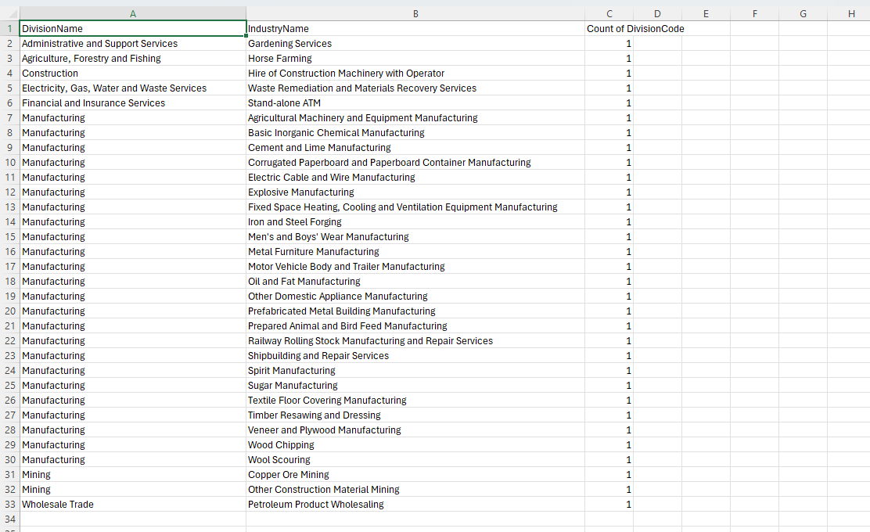

Bottom Industries Data Analysis:
Manufacturing:
Total Number of Sub-sectors Counted: 20
Example Sub-sectors: Explosive Manufacturing, Textile Floor Covering Manufacturing, Corrugated Paperboard Container Manufacturing
Each industry count: 1 (indicating the presence of each sub-sector in only minimal numbers across the datasets)
Mining:
Total Sub-sectors: 2 (Copper Ore Mining, Other Construction Material Mining)
Count for each: 1
Administrative and Support Services:
Example Sub-sectors: Gardening Services, Office Administrative Services
Count for each: 1
Agriculture, Forestry, and Fishing:
Example Industry: Horse Farming
Count: 1
Construction:
Sub-sector Highlight: Hire of Construction Machinery with Operator
Count: 1
Electricity, Gas, Water, and Waste Services:
Example Sub-sector: Waste Remediation and Materials Recovery Services
Count: 1
Count of Division Code by Division Name
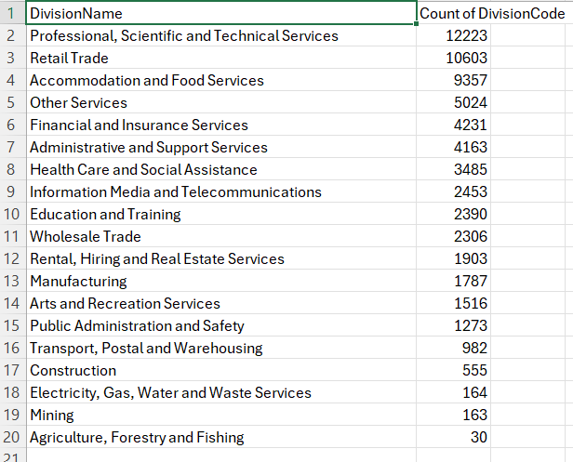

This summary will provide a high-level view of the distribution of the industry divisions through DivisionCodes count and inform the Sydney based sectors that are dominant and negligible.
Data Presentation:
Professional, Scientific and Technical Services: 12,223
Retail Trade: 10,603
Accommodation and Food Services: 9,357
Other Services: 5,024
Financial and Insurance Services: 4,231
Administrative and Support Services: 4,163
Health Care and Social Assistance: 3,485
Information Media and Telecommunications: 2,453
Education and Training: 2,390
Wholesale Trade: 2,306
Rental, Hiring and Real Estate Services: 1,906
Manufacturing: 1,787
Arts and Recreation Services: 1,516
Public Administration and Safety: 1,273
Transport, Postal and Warehousing: 982
Construction: 555
Electricity, Gas, Water and Waste Services: 164
Mining: 163
Agriculture, Forestry and Fishing: 30

Evaluation
Accuracy and Reliability of Data
Source Credit:
The dataset is taken from City of Sydney Open data Hub. It is a reputable source as it provides official government sourced data. It adds more data credibility as government organizations follow all the standards of data collection and validation process.
Data Collection:
The City of Sydney is one of the agencies of government which collect data using systematic methods. They are transparent and updated from time to time for accuracy. It could include surveys, census, administrative records.
Data Completeness and Timeline:
The dataset provides data through years i.e. 2007, 2012 and 2017. As per City of Sydney the data is updated on July 2, 2020. So, there may be slight differences when the data is compared to current trends.

Limitations of Analysis
The limitations of data analysis project are:
- The analysis is only based on year 2007, 2012 and 2017. Hence, it does not show the latest industry trends in the city of Sydney.
- The analysis is only confined to the dataset from City of Sydney, excluding potential insights from other sources.
- To access the analysis dashboard, the user must be signed in.
- The analysis provides snapshot based on data available till 2017 but does not provide predictive analysis or future trends.
- The dataset only focuses on city of Sydney, while could be overlooking issues or trends in closer areas.

Ethical Considerations
- Data Source Transparency: The dataset was accessed from City of Sydney Open Data Hub, which ensures that all the data was publicly available and used in compliance with the terms and conditions.
- Data Privacy and Confidentiality: The dataset was publicly accessible, and no individuals or organizations information was compromised.
- Appropriate Use of Data: The data was solely used for the purpose of final year project.
- Ownership: The dataset was used following the guidelines, ensuring the analysis aligned with the platform’s intended purpose of recommendation.

Recommendations
Based on the key findings, the summarized recommendations are:
- Support and Promote Growth Sectors emphasize enhancing service-oriented sectors like tech services and consultancy through professional development and business innovation. Focus on developing commercial infrastructure in suburban villages to support dominant and emerging industries.
- Sustain Niche and Specialized Industries: Implement targeted support for niche markets within manufacturing and agriculture to help them adapt to market changes and leverage unique selling propositions.
- For industries facing decline or competition, promote diversification and introduce resilience-building strategies to help them stay relevant and competitive.
- Enhance Infrastructure and Incentives: For sectors showing consistent demand, such as food services and legal services, further develop infrastructure and provide incentives to sustain and boost their growth. This also suggests, these sectors are offering more employment opportunities.
- Food and Beverage Services: With strong demand for Restaurants, cafes, takeaway food services, the city should continue to support and promote hospitality industry.
- Balanced Growth: Encourage diversification of industries, while also focusing on small markets like agriculture, forestry, and fishing.
- In Chinatown & South CBD area, cafes and restaurants have shown continuous growth, they can partner with TAFE or local colleges to provide food service and hospitality training that focus on skills like fast paced dining environment and customer service. This training can provide career transition opportunities in the food and hospitality sector.
- King Street has shown gradual growth in cafes and restaurants but a slight decline in the education sector can be due to competition or changing demands. The local council can offer reductions in rent or tax to support new businesses particularly for education-focused businesses like vocational programs or training centers.
- In CBD & Harbor area, financial asset investment is seen growing gradually, more courses in finance and investment should be included in collab with universities or training providers that focus on skill of asset management, finance and investment advising.
- Macleay Street & Woolloomooloo has consistent growth in accommodation and tourism services, the local government should enhance job matching platforms that focus on hospitality and tourism skills.

Dashboard Overview

Dashboard purpose and audience
Main Dashboard
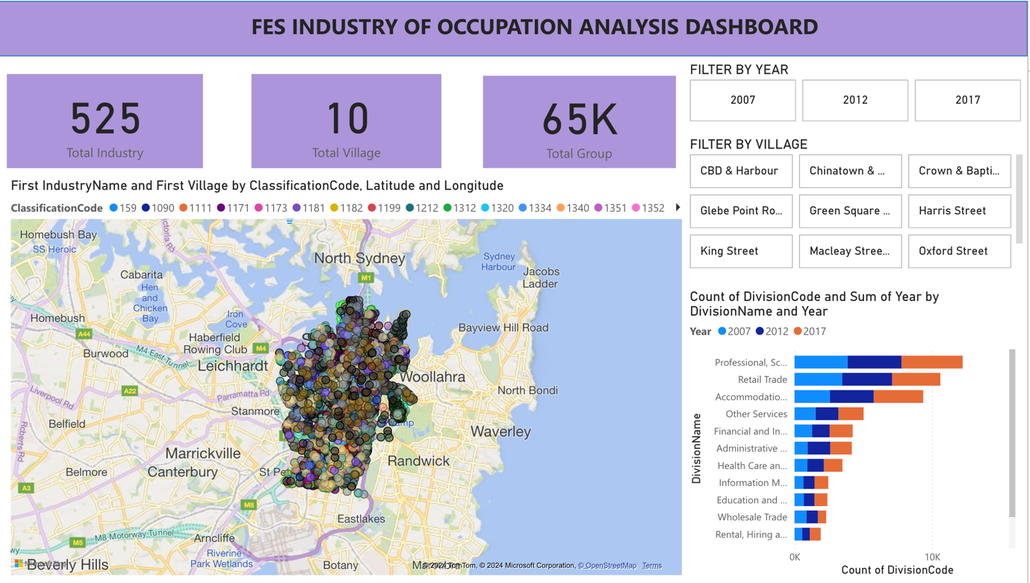
Figure 5 Main Dashboard in Power BI
In the main dashboard, there is a summary of the analysis which has total industries count, cities as well as groups count. The users have flexibility to perform analysis based on filtering years and city and based on the industries, the users can view the scatterplot in map view.
Design and interactivity features.
Design Elements:
Clean and Structured Layout: The dashboard is also created in a manner that enables the users to switch from one visualization aspect to another aspect of the visualization.
Consistent Visual Theme: Has the right color scheme and typeface that is appropriate for the profession for the targeted audience.

Interactivity Features:
Dynamic Filters: The program allows choosing the needed data according to year, industry, and region, so everyone can see only the necessary information.
Drill-Down Capabilities: Offers more detailed details about the several data points so that users can select an area or industry they wish to be given more information on.
Hover Details: Supplementary information is presented when the mouse pointer is over some object which provides clear vision without disturbing the widgets space.
Accessibility Considerations:
High Contrast Colors: It guarantees that all visuals are readable to visually impaired users.
Text Size and Font: Provides larger font size and contrasts for improved readability to everybody, including those with eye problems.
Keyboard Navigable: Helps to guarantee that all user interface components are operable through a keyboard interface only.
Screen Reader Support: It has been made possible to operate the dashboard by folks with vision impairment by developing a screen reader that makes all texts and images click-able
Objective 1: Study of growth and decline of industries over time
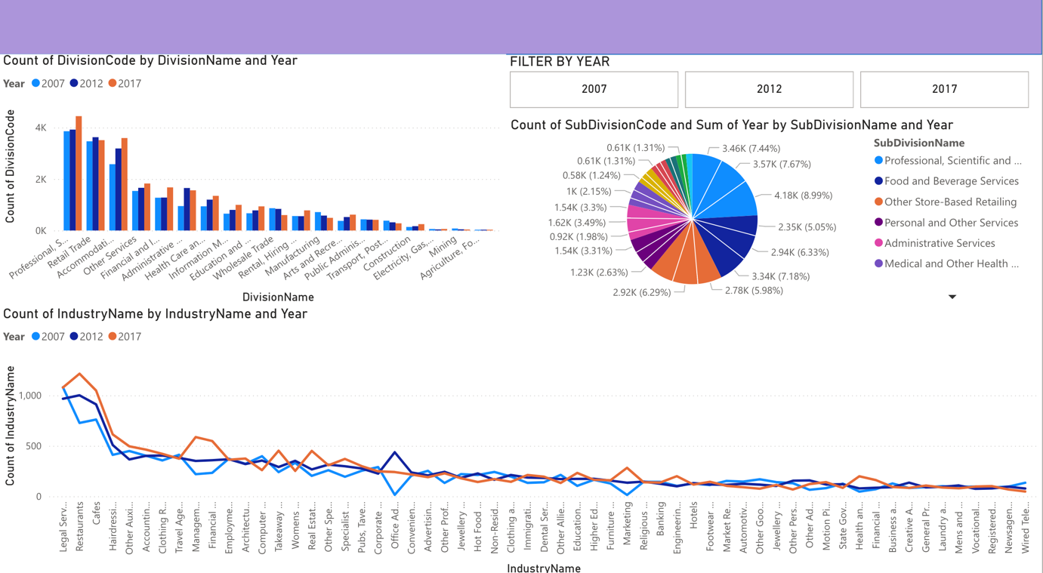
Figure 6 Dashboard to study growth and decline of industry over time.
Link to Dashboard: Objective 1 Link
Purpose:
The purpose of this page of the dashboard is to deliver insights on the growth and decline of certain industries over the years.
Audience:
The target audience are as follows:
City of Sydney Council Members: To keep informed about the industrial growth and decline over the years.
Urban Planners and Developers: For both strategic planning and for investment planning based on the potential of growth of industries.
Job Seekers: Normal users to analyze the job market over the years and perform predictive analysis based on the findings.

Interactive Features:
In this section, there are three main charts.
- Bar chart representing the division count in each year. In this graph, users can analyze the growth of certain industries as well as their presence in distinct years.
- Line chart which represents the growth or decline of certain industries that can be filtered either by year or can be filtered based on the division.
- Pie chart which represents the top industries in year 2007, 2012 and 2017 which highlights the presence by percentage.

Objective 2: Top and bottom 5 Industries by the area
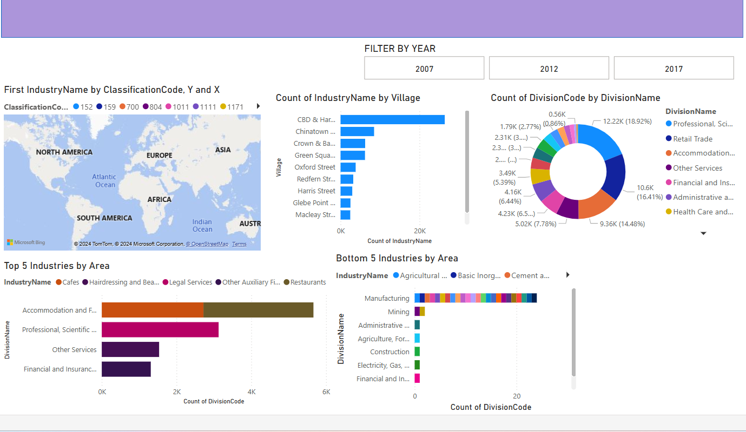
Link to Dashboard: Objective 2 Link

Purpose:
To display the distribution of major and the least dominant industries in Sydney.
This is to help the policymakers, urban planners, and economic development specialists to plan better based on current trends in the industry.

Audience:
City of Sydney Council Members: To inform policy and strategy choice for improved urban management and development.
Urban Planners and Developers: For both strategic planning and for investment planning.
Business Owners and Investors: To find possible areas for investment or growth.
General Public: For students and other interested members of the community who wish to get information about in economic subsectors and opportunities in the city.

Design and interactivity features.
Design Elements:
Clean and Structured Layout: The dashboard is also created in a manner that enables the users to switch from one visualization aspect to another aspect of the visualization.
Consistent Visual Theme: Has the right color scheme and typeface that is appropriate for the profession for the targeted audience.

Interactivity Features:
Dynamic Filters: The program allows choosing the needed data according to year, industry, and region, so everyone can see only the necessary information.
Drill-Down Capabilities: Offers more detailed details about the several data points so that users can select an area or industry they wish to be given more information on.
Hover Details: Supplementary information is presented when the mouse pointer is over some object which provides clear vision without disturbing the widgets space.

Objective 3: Analyze And Explore How Certain Industries Are Distributed Across Different Region Of Sydney
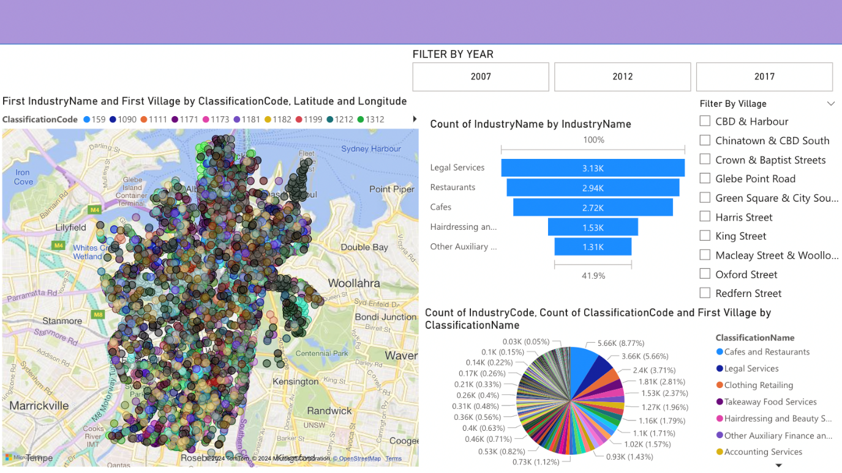
Link to Dashboard: Objective 3 Link
Purpose:
- Analyse and explore how certain industries are distributed across different regions of Sydney.
- Analyse areas with high or low number of specific industries compared to others which will help to study and explore the economic profile of that region.

Audience:
- City of Sydney Council Members: the dashboard can provide valuable insights of the distribution and density of industries across the city to guide urban planning and economic development.
- Policymakers: the dashboard can provide valuable insights about industry data for informed policymaking regarding economic growth, job creation, and business support programs.
- Researchers: the dashboard can facilitate academic and industry research into urban economics, business growth, and spatial distribution of industries.

Design and interactivity features.
Design Elements:
Map visualization: An interactive map of Sydney is utilized to display a scatterplot representing the distribution of industries throughout the city. The visualization is based on latitude and longitude coordinates of the industry, allowing users to see the precise locations of various industries across the villages of Sydney.
Colour Utilization: Colour should be meaningful in data visualisation tool (Midway, 2020). As a result, a unified colour palette is applied to differentiate industries and classification codes, making it easier for users to visually distinguish between various data points. The colour legend at the top provides a clear reference for understanding industry classifications.

Interactivity Features:
1.Yearly Filter:
Users can select a specific year (e.g., 2007, 2012, 2017) to analyse how the distribution of industries has changed over time.
The map, charts, and data update automatically based on the selected year.
2.Village Filter:
Users can filter data by specific villages (e.g., CBD & Harbour, Chinatown & CBD South, King Street) to analyse the distribution trends.
3.Tooltip Hover Information:
Hovering over the plots on the map or bars reveals detailed information such as industry names, industry counts, and classification codes.
This feature provides deeper insights without cluttering the main visualization.
4.Responsive Charts:
The bar chart and pie chart respond to filter selections, allowing users to focus on specific industries or villages while dynamically updating to reflect the current dataset.

WEB DEVELOPMENT
- JavaScript Framework: Money-Stack, incorporating React, Vite, and TypeScript, is employed for streamlined front-end development. React’s component-driven logic, with clear props and modular structure, allows precise control over input and output. Vite ensures efficient performance with fast React development. TypeScript integrates smoothly with React and other UI frameworks, making it an optimal choice for robust and maintainable applications.
- UI Components and Framework: ShadCN, Flowbite, and TailwindCSS provide a responsive and customizable design solution. TailwindCSS allows effortless responsiveness across tablets and mobile devices and offers a simple approach to webpage customization. ShadCN and Flowbite come with pre-styled modern components, including cards, sheets, buttons, and inputs. This project’s tables require complex functions such as pagination, editing, updating, and scrolling, which ShadCN natively supports.
- Authentication: Clerk (free version) supports various third-party sign-up options, including Google, Microsoft, Apple ID, and Facebook. It also enables email-based sign-up with OTP verification, which saves development time compared to building a custom solution. Clerk efficiently manages user sessions, automatically expiring inactive sessions to prompt re-login upon return.
- Database: Supabase (free version) handles straightforward tasks like storing, updating, and deleting post information using JSON data types for simplicity. Access to Supabase’s framework is secured with a project-specific key and link. The JSON structure used when calling Supabase functions is as follows:
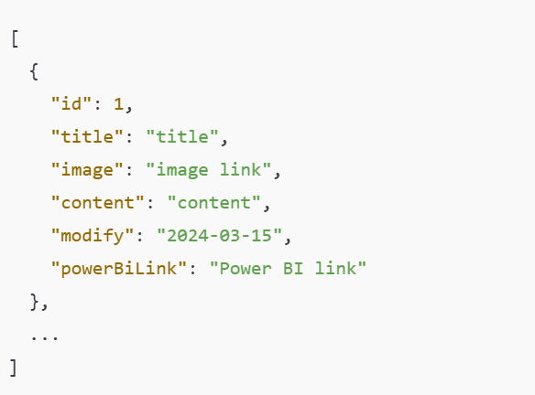

WEB INTERFACE
Login Page & Authentication Check:
Start with the login page. Users must log in to access the data webpage
Use Clerk's ClerkProvider component, which automatically verifies if a user is logged in.
When the page loads, ClerkProvider runs alongside the logic to retrieve post data.
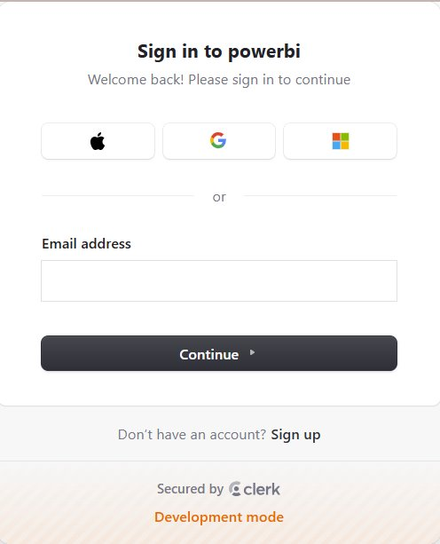
Retrieve and Display Posts:
Data from Supabase is fetched as a JSON array.
A function loops through the JSON array, adding each post to the web interface.
Each post is displayed in a card format with a "View" button
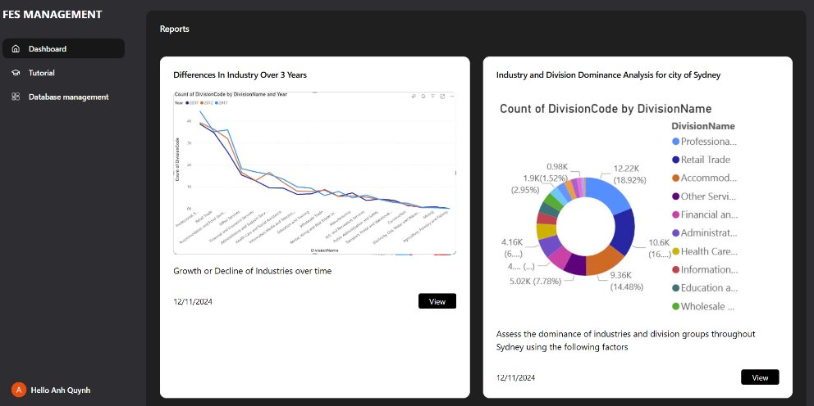Post Detail Drawer:
The "View" button on each post card opens a ShadCN drawer component, which displays more details in a full-screen view, including a large image and embedded Power BI link.
To ensure the drawer shows the correct information, a function runs when the "View" button is clicked. This function:
Retrieves the post data based on its ID from the JSON array.
Sets the drawer's input to match the post data.
The drawer is closed by default, opening when the "View" button is clicked.
Power BI Report Access:
The primary data in this project is the Power BI report link.
The report is only accessible to users logged in with a school account; without this authentication, the embedded report remains unavailable.
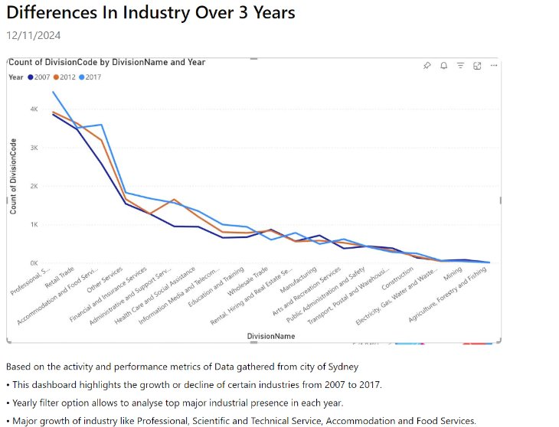
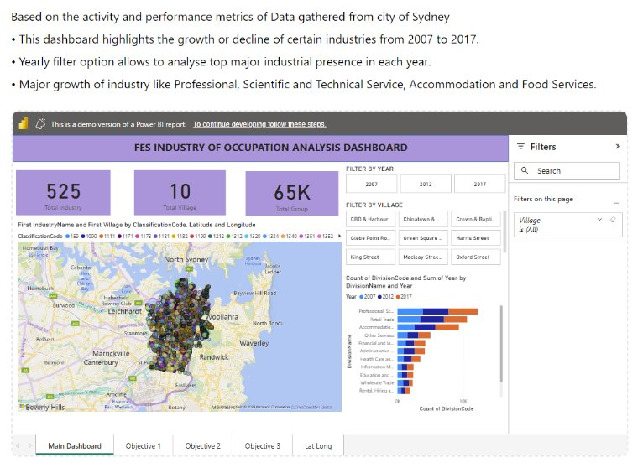 Post Management (Create, Edit, Delete):
Creating a Post: Similar to the drawer functionality, the form allows users to input data, which is then sent to Supabase.
Editing and Deleting Posts: When the user clicks edit or delete, the post’s ID is checked, and the respective Supabase API is called to update or delete the entry.
After creating, editing, or deleting a post, the page refreshes to reflect the changes
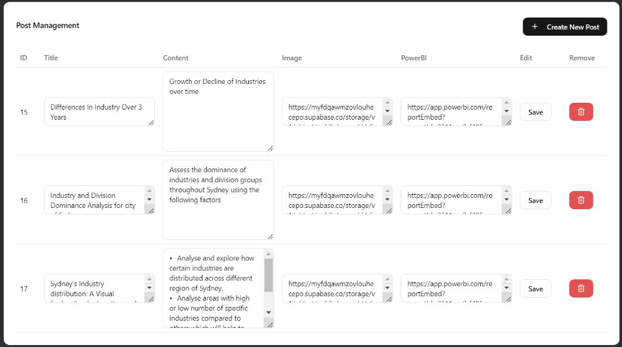
User Menu in Sidebar:
The sidebar includes a user button where users can log out or view additional information. While this info may be unimportant, Clerk provides it automatically, so it's displayed for convenience.
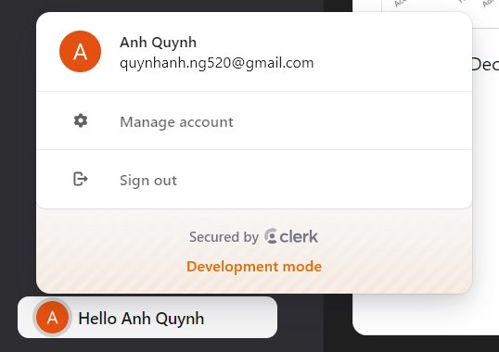

LINK TO WEBSITE: https://potential-memory-5gx7xj777rjgcxxg-5175.app.github.dev/

Activity Diagram
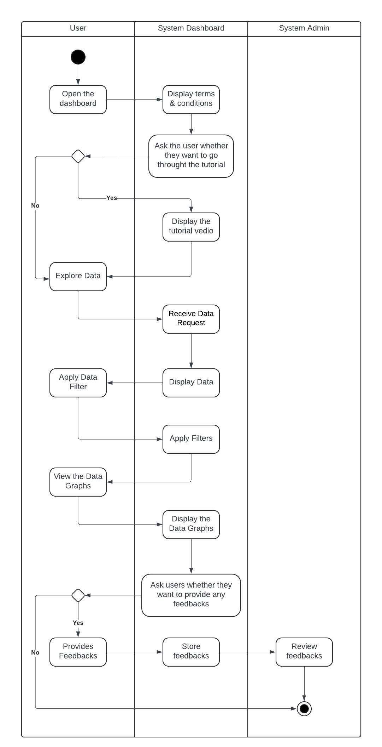
Use Case Diagram
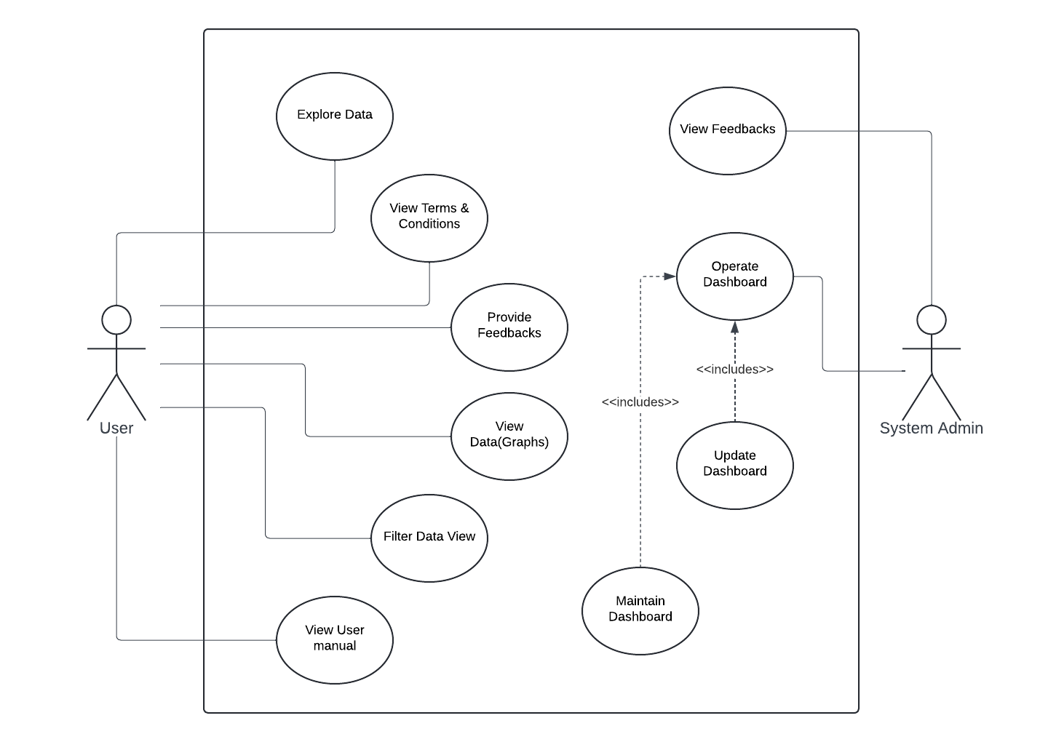

Retrospective: Mistakes Made and Lessons Learned
This section contains problems faced by individual team members while carrying out tasks during the project.
Challenges faced while using Power BI:
  - Power BI Microsoft store desktop version was installed in laptop but was unable to load the dataset showing the error ‘’unable to register class”. Later downloaded the installer file of Power BI and the desktop version was installed, and it worked well.
  - Microsoft Power BI does not have a desktop version for Mac users, which limited some team members to use the desktop versions which had more features compared to web version.
  - All the team members had access to free version, which limited users to explore more features to build interactive features and make power bi accessible to public via website.
  - Due to admin access limitation, there was few delays in the project while embedding dashboard to power BI.
Challenges Faced while building website and integrating Power BI:
- Power BI link cannot be embedded to the website due to the limitation access which need university administration department to approve.
- Using local host instead of public host which makes the remote collaboration challenging as the application is only available within the local network. It also lacks scalability, as the resources of a local machine may not handle high traffic or large-scale operations effectively.
- Need finding the website framework supports Power BI integration and is compatible with its APIs.

Resolution adopted:
- Team member worked on power BI workspace to merge the dashboards and work on the same dashboard to resolve the issue of using Web version and Desktop Version.
- Build a website where the power BI was embedded to the website but had to be logged in to the website.
Skills Developed:
Despite the challenges faced while doing the project, each team members learned new skills. This skills and lessons will surely be valuable for everyone on their professional career.
- Teamwork: All the team members, worked as a team effectively, which is important while working in a real-world scenario. This also enabled team members who collaborate efficiently and leverage each other’s strength.
- Project Management: Team member learned how to manage the team, set priorities, allocate responsibilities, and assign tasks to individual team members, learning valuable project management skills.
- Web Development: Team member learned how to develop a dynamic and interactive website using emerging tools and technologies like React JS, GitHub, and so on.
- Data Cleaning: Team members learned how to pre-process data, how to manipulate data as required.
- Data Analysis: Team members learned how to perform analysis on data and get insights and recommendation. Team members got to get familiar with tools like Power BI, Jupyter Notebook, and Excel.
- Research: The project required extensive research to understand the context, which enhanced team members ability to conduct research, conduct literature review and apply research findings.
Impacts on future project (what would you suggest for the next cohort of students?)
It’s not only about completing a project but a process to learn something new. Whether its small change but it adds one skill for your development. Take challenges, so that you will know what things you are capable of. Try to keep up with your teammates well, understand each other strengths well so that you can divide task to right person which will make your project strong.
Technical Challenges
Mistake: Lack of understanding of operation complexity of merging multiple datasets which lead to wrong merges and data loss.
Lesson Learned: Also, more time is needed to integrate the data, and preliminary experiments are needed to check whether the data can be merged without the data loss or data corruption.
Visualization Implementation:
Mistake: Deciding on the tools that were not very basic to use but had some compatibility issues with some of the user software applications.
Lesson Learned: Choose tools according to the context in which the final user is going to operate and try the visualizations in different operating systems for maximum crossing and compatibility.
Team Member’s Contribution
Name | Role | Responsibilities
Ashmita Tamang | Project Manager | Tracking the progress,  Data cleaning,  Interactive dashboard for Objective 3:  Analysis on the areas with high or low no. of industries and comparing them,  Recommendations,  Gantt chart,  Documentation,
Sumnima Adhikari | Data Analyst | Interactive dashboard for Objective 1: Analysis on growth and decline market trends,  Findings and Recommendations,  Project Management Documentation,  File management in MS Teams,  Merge Dashboards,  Documentation
Shama Praveen | Data Analyst | Interactive dashboard for,  Data cleaning,  Objective 2: Analysis on industries based on area  Findings and recommendations,  Kanban Board management,  File management in MS team,  Documentation
Yueyang Zhou | Data Analyst | Data cleaning,  UML Diagrams,  Interactive dashboard for Objective 4: Analysis of industries over cities and their economic impact  Findings,  Tutorial for Dashboard,  Documentation
Quynh Anh Nguyen | Frontend Developer | Visualization, website building, interface, documentation
Table 1 Team Members' Contribution

Conclusion
After analyzing the industry trends in the City of Sydney from the year 2007 to 2017 this report has explored changes in different industries. The growing demand for cafes and restaurants across most city areas highlights the growing importance of hospitality and tourism sector, while the decline in physical retail stores such as clothing suggests a shift of people preference towards online shopping. Emerging sectors like financial asset investment show new opportunities for employment and investment. While some fluctuating industry like legals services and advertising services reflect the competitive and changing market.
With these findings, we can work on different areas of city planning and skill development programs. The skill gaps in growing industry like hospitality and financial services will require training programs and job focused education. Additionally, declining sectors like retail sector can sustain by adapting to digital platforms or diversifying services with the changing preferences of people. To maintain equal economic opportunities across the city, infrastructure and resources can be allocated to less economically lower neighboring cities.
This study provides an important overview of Sydney’s economic sectors while the future work can focus on tracking these trends over time. By addressing skill gaps, supporting emerging sectors and maintaining balanced economic growth Sydney can make more adaptive and flexible economy.

Appendices

Minutes of Meeting from Week from Week 5 – 12

Minutes of meeting 6

Team: G4 Place: Sydney Campus Date/Time: 03/10/2024

In attendance
ASHMITA TAMANG
SUMNIMA ADHIKARI
YUEYANG ZHOU

Apologies
N/A
Agenda
- Task Division Documentation
- Activity Diagram

Action sheet
Task | Responsible | Due | Notes
Work on Activity Diagram | Yueyang Zhou | 10/10/2024 | To work on activity diagram.
Research on how to embed power bi to web application | Sumnima Adhikari | 10/10/2024 | To research on how to embed power bi dashboard to website.

Minutes of meeting 7

Team: G4 Place: Teams Date/Time: 10/10/2024

In attendance
ASHMITA TAMANG
SHAMA PRAVEEN
SUMNIMA ADHIKARI
QUYNH ANH NGUYEN
YUEYANG ZHOU

Apologies
N/A
Agenda
- Data Preprocessing
- Documentation
- Website discussion

Action sheet
Task | Responsible | Due | Notes
Data Preprocessing | Shama Praveen, Ashmita Tamang | 13/10/2024 | Team member to clean data.
Outline documentation | Ashmita Tamang | 17/10/2024 | Team member to outline documentation.
Research on embedding power bi to website | Sumnima Adhikari | 20/10/2024 | Team member to research on how to embed power bi dashboard in a website.
Research on web-based user interface. | Quynh Anh Nguyen, Yueyang Zhou | 20/10/2024 | Team members to research on functional data interface.
Minutes of meeting 8

Team: G4 Place: Teams Date/Time: 17/10/2024

In attendance
ASHMITA TAMANG
SHAMA PRAVEEN
SUMNIMA ADHIKARI
QUYNH ANH NGUYEN
YUEYANG ZHOU

Apologies
N/A
Agenda
- Progress review on website
- Data Analytics task division
Action sheet
Task | Responsible | Due | Notes
Work on analytics on power BI | Shama Praveen, Ashmita Tamang, Sumnima Adhikari,  Yueyang Zhou | 31/10/2024 | Team members to work on analysis as divided based on objectives and take note on statistical analysis.
Build website dashboard | Yueyang Zhou,  Quynh Anh Nguyen | 07/11/2024 | Team members to build a website with a dashboard to view analysis reports.

Minutes of meeting 9

Team: G4 Place: Teams Date/Time: 31/10/2024

In attendance
ASHMITA TAMANG
SHAMA PRAVEEN
SUMNIMA ADHIKARI
QUYNH ANH NGUYEN
YUEYANG ZHOU

Apologies
N/A
Agenda
- Allocate Task for documentation
- Allocate Task for presentation
- Merge analysis
- Embed power bi to website

Action sheet
Task | Responsible | Due | Notes
Merge analysis to a single dashboard | Sumnima Adhikari | 07/11/2024 | Team member to merge all analysis dashboard to a single dashboard.
Start working on documentation and presentation. | Shama Praveen, Ashmita Tamang, Sumnima Adhikari | 12/11/2024 | Team members to load the clean data into power bi and initialize data analytics based on objectives.
Embed power bi to website | Quynh Anh Nguyen | 10/11/2024 | Team member to integrate power bi dashboard to the website.
Prepare tutorial for the web dashboard | Yueyang Zhou | 10/11/2024 | Team member to create a tutorial for the web-based dashboard for the end users.

Minutes of meeting 10

Team: G4 Place: Sydney Campus Date/Time:14/11/2024

In attendance
ASHMITA TAMANG
SHAMA PRAVEEN
SUMNIMA ADHIKARI
QUYNH ANH NGUYEN
YUEYANG ZHOU

Apologies
N/A

Agenda
- Finalize Documentation and presentation slide.

Action sheet

Task | Responsible | Due | Notes
Finalize documentation | All team members | 14/11/2024 | All team members to merge reports, verify tasks and finalize presentation, codes, documentation for submission.

Pre-Action Plan/Kanban Board
Kanban board was used for the project management where the team members were assigned respective tasks with deadlines. The team members could track the progress of the project overall. The statistics of the board and the grid view of the Kanban board is given in the diagram below:
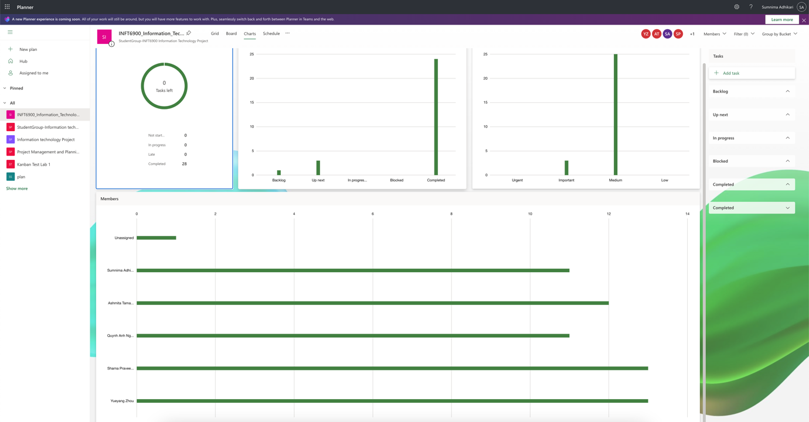

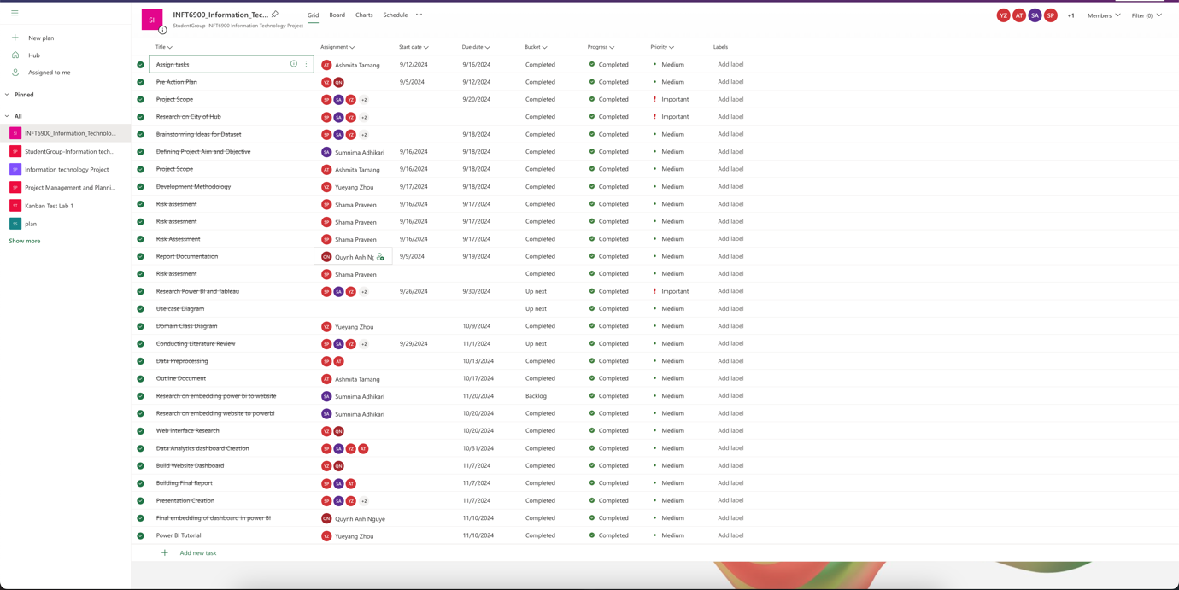
Figure 7 Screenshot of Kanban board

MS Project/MS Teams
In terms of hosting meetings and sharing files, the team members utilized MS Team where all the team members actively engaged. Informally, the team utilized whatsapp to chat with the team members, share progress regarding the project. The screenshot of analysis of the Teams and meeting is given in the diagrams below:
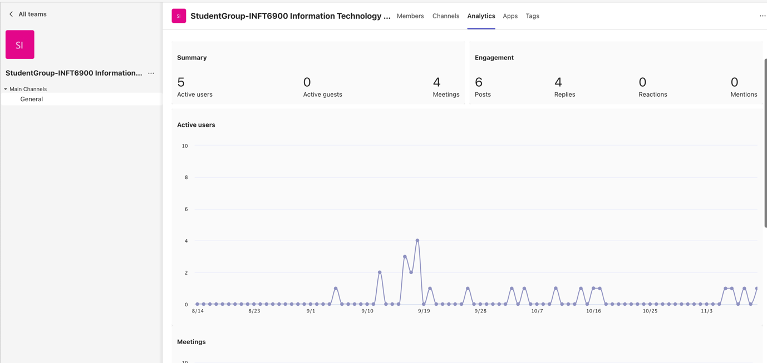
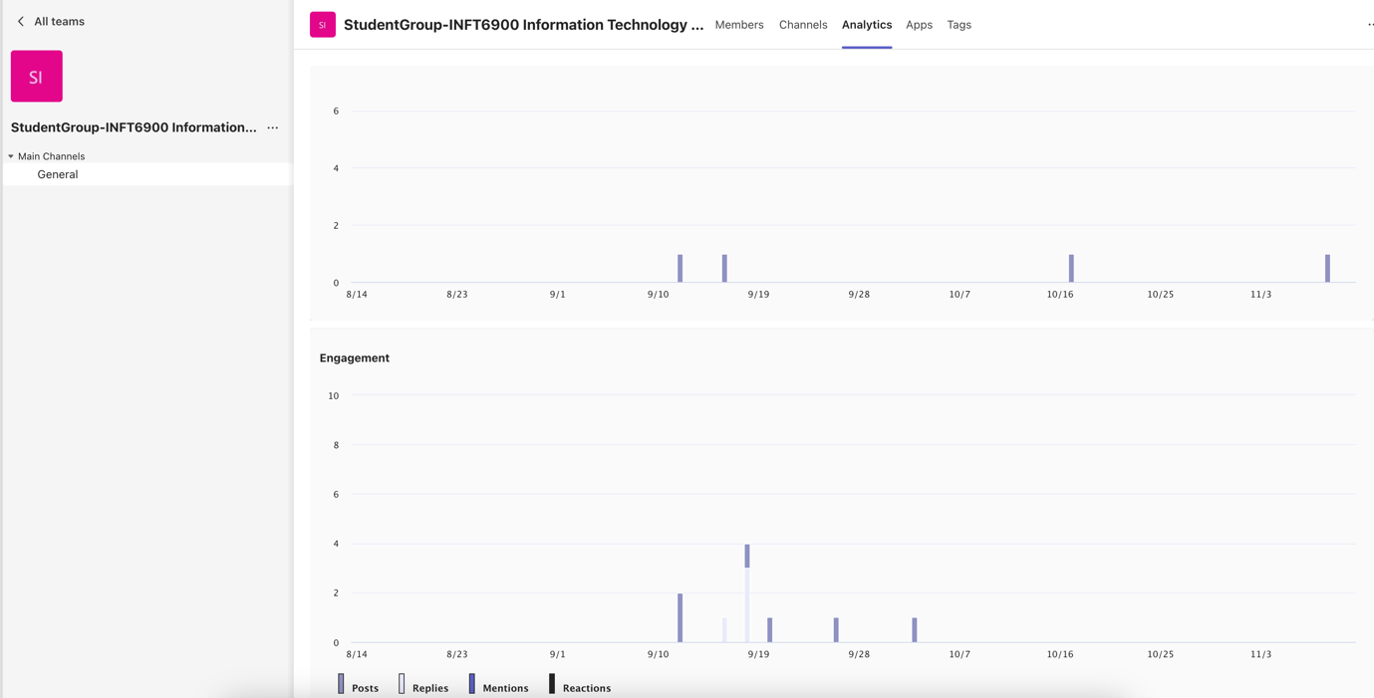
Figure 8 Meeting analysis in teams.

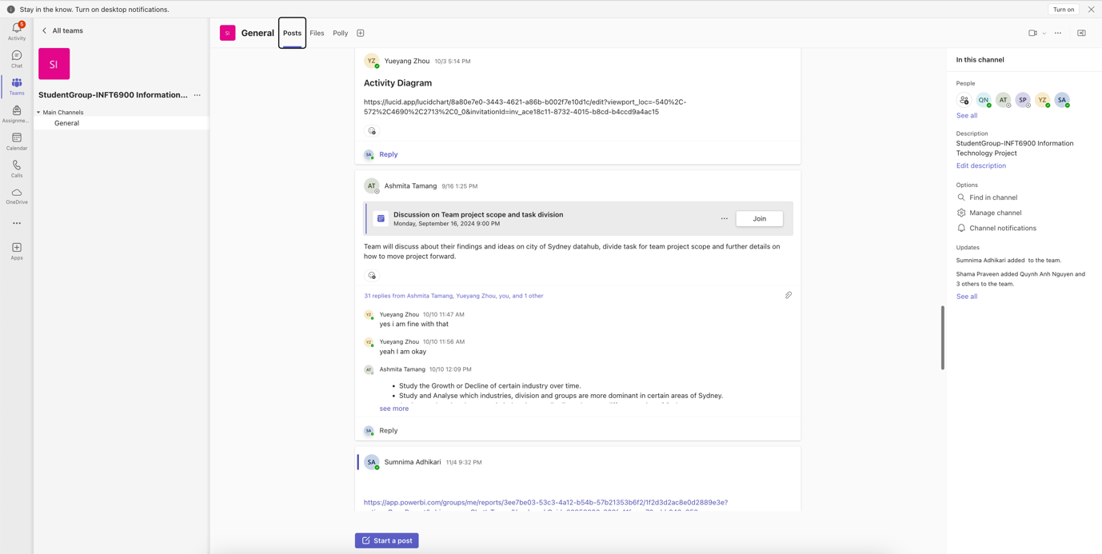
Figure 9 Example of how team members utilized teams to share files and post replies.
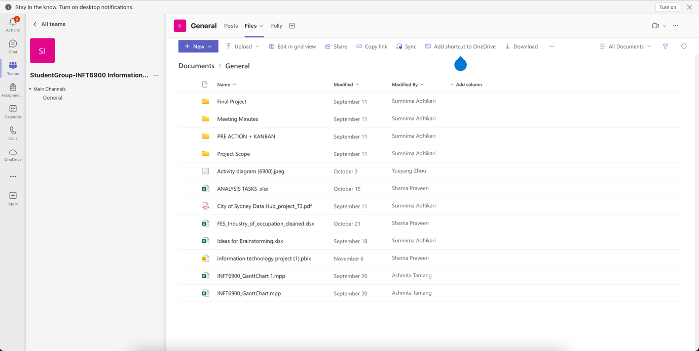
Figure 10 File sharing platform in MS Teams

Bibliography
Midway, S. R. (2020). Principles of effective data visualization. Patterns, 1(10), 100141. https://doi.org/10.1016/j.patter.2020.100141
Reddy Dodla, T. (2024). Mastering Knowledge Management Using Microsoft Technologies : Secrets to Leveraging Microsoft 365 and Becoming a Knowledge Management Guru (1st ed. 2024.). Apress. https://doi.org/10.1007/979-8-8688-0372-7
Simpson, J. (2023). How JavaScript Works: Master the Basics of JavaScript and Modern Web App Development (1st ed.). Apress L. P. https://doi.org/10.1007/978-1-4842-9738-4
Utomo, P., & Falahah. (2020). Building Serverless Website on GitHub Pages. IOP Conference Series. Materials Science and Engineering, 879(1), 12077-. https://doi.org/10.1088/1757-899X/879/1/012077

