DATA FLOW DIAGRAM

LEVEL ZERO
FILE TRANSACTION
LOG DETAILS
CLOUD SERVER
USER
BLOCKCHAIN SERVER

LEVEL 1
Browse File
USER
SUCCESS
CLOUD SERVER
Upload/Edit/Download File

LEVEL 2

Save Log
Generate Log
BLOCKCHAIN SERVER
USER
File upload/ download/ edit/ delete

USECASE DIAGRAM

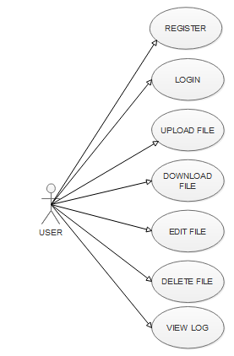

SEQUENCE DIAGRAM

