**Repository**

<https://github.com/shamaaf/udacity_project4>

**Repository Environments**

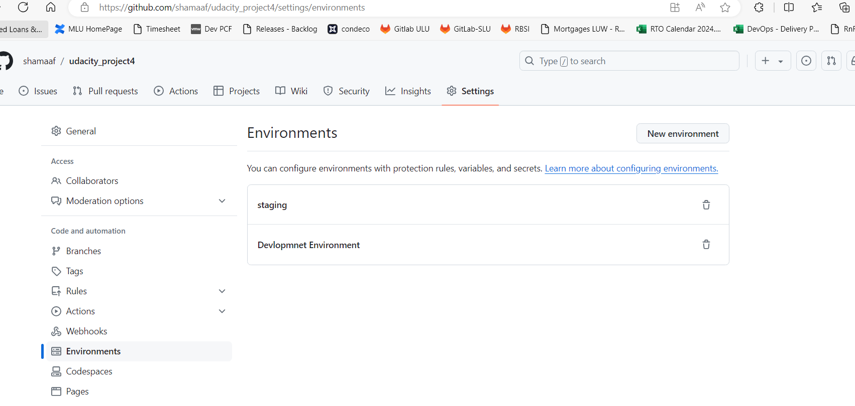

**Repository Secrets**

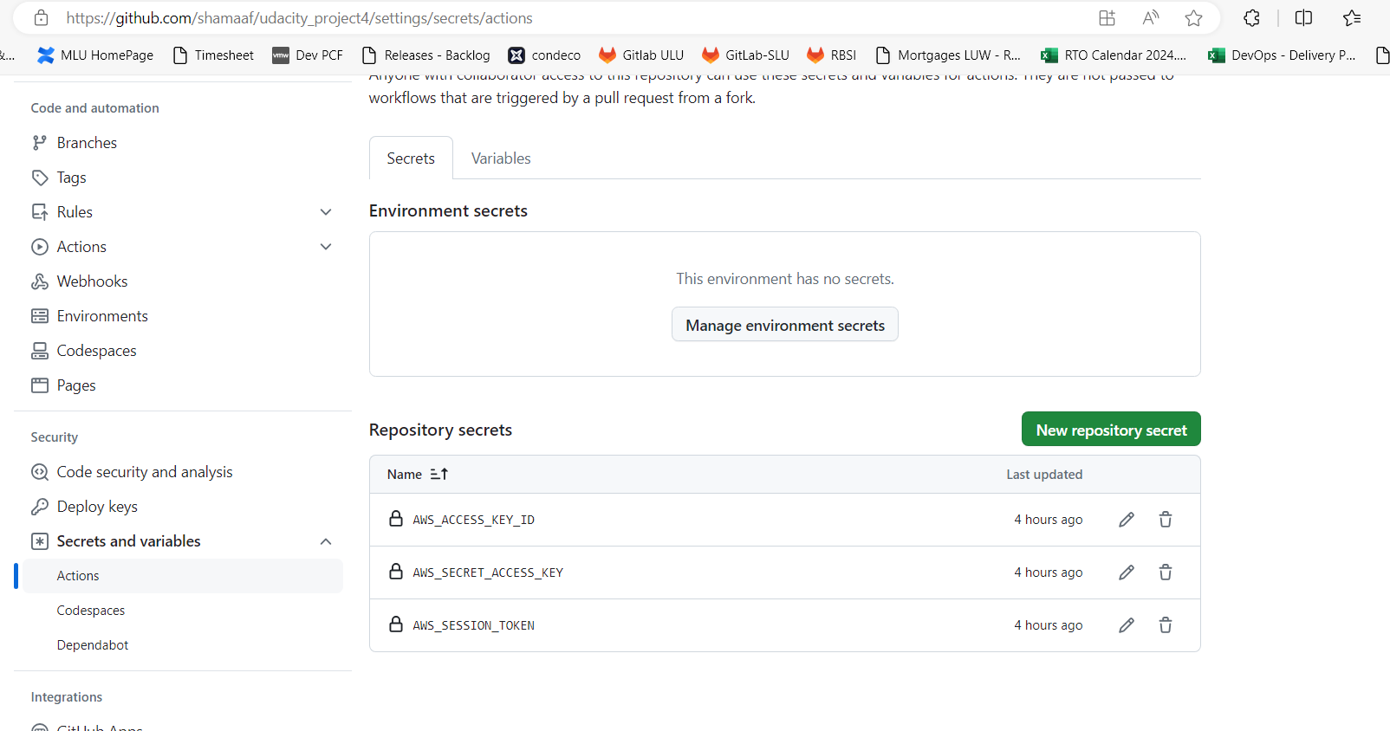

**Frontend Continuous Integration**

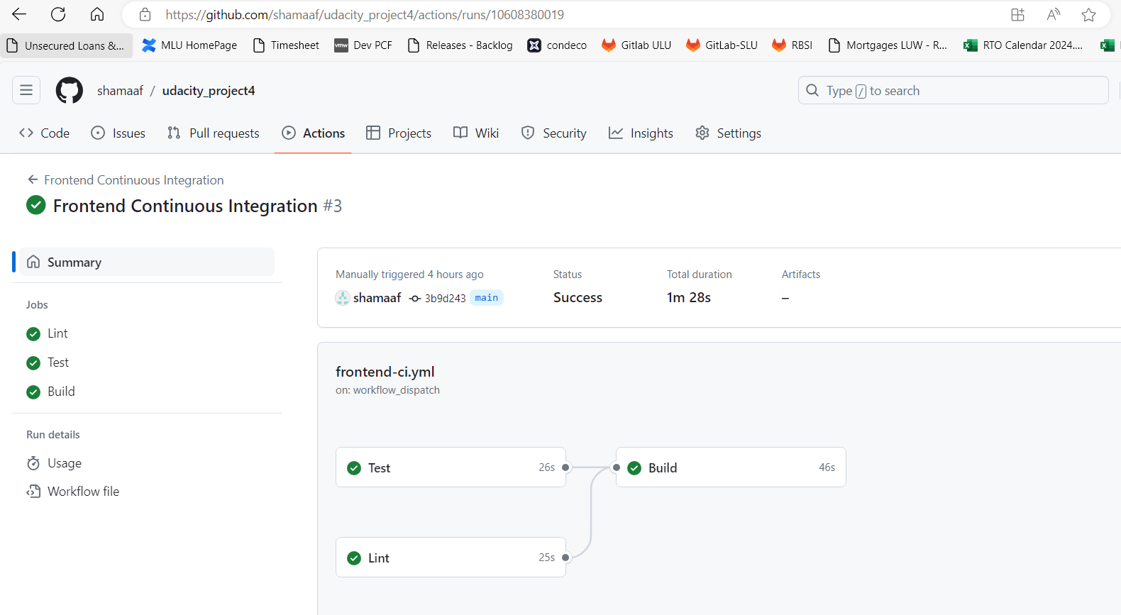

**Frontend Continuous Deployment**

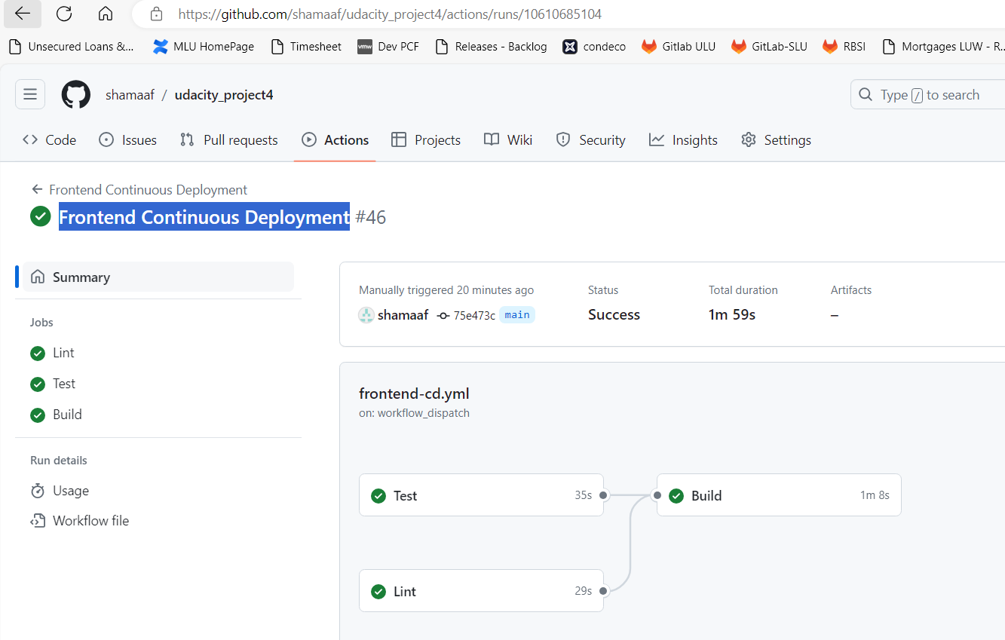

**Backend Continuous Integration**

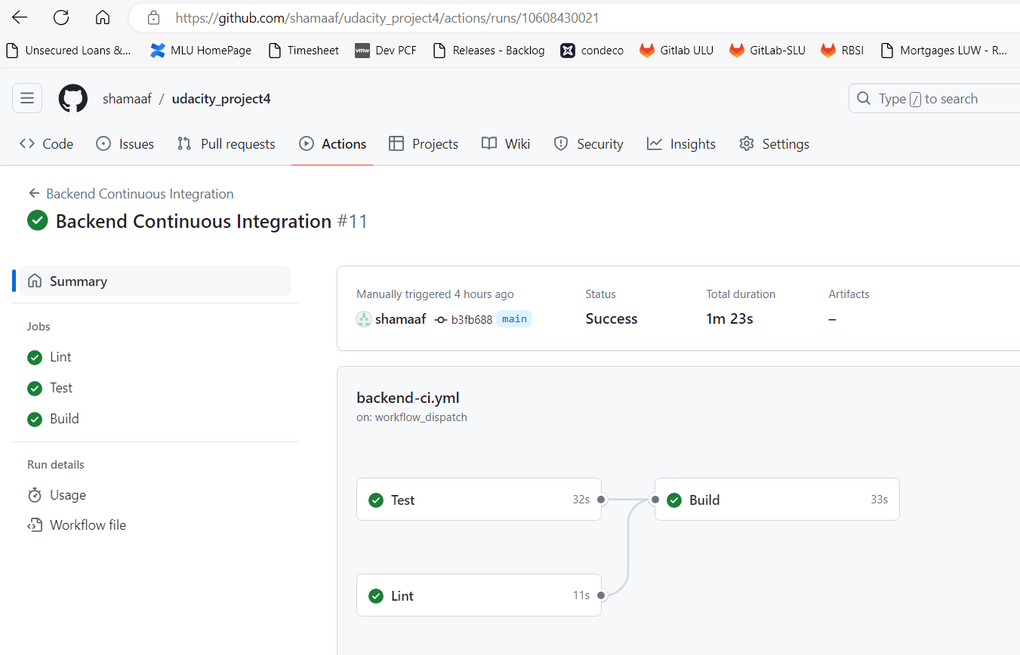

**Backend Continuous Deployment**

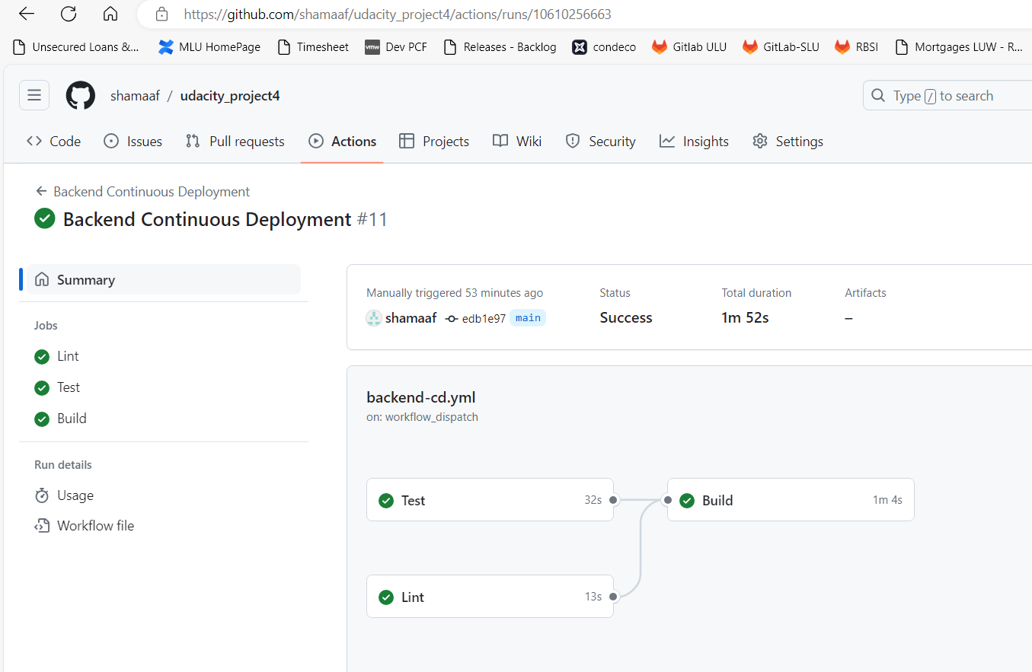

**ECR**

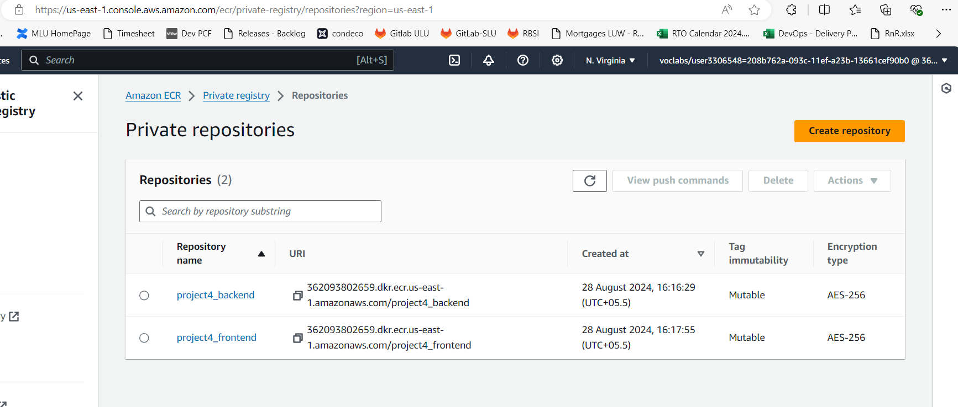

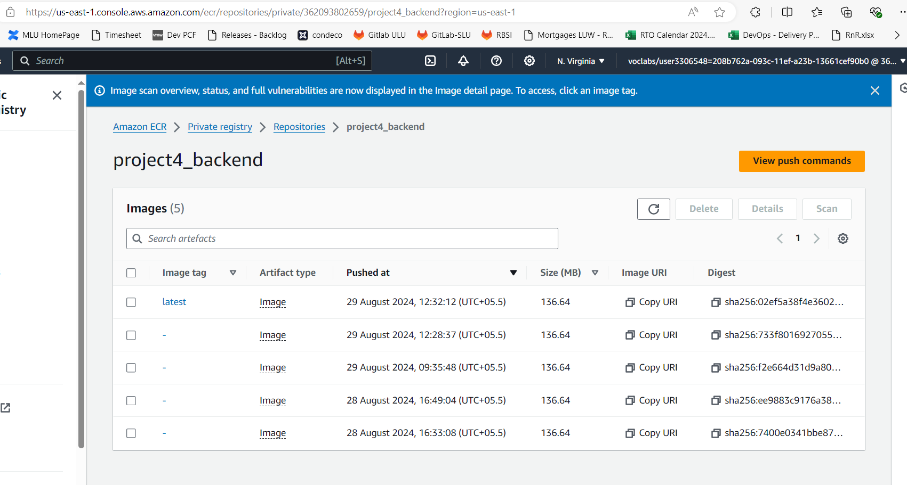

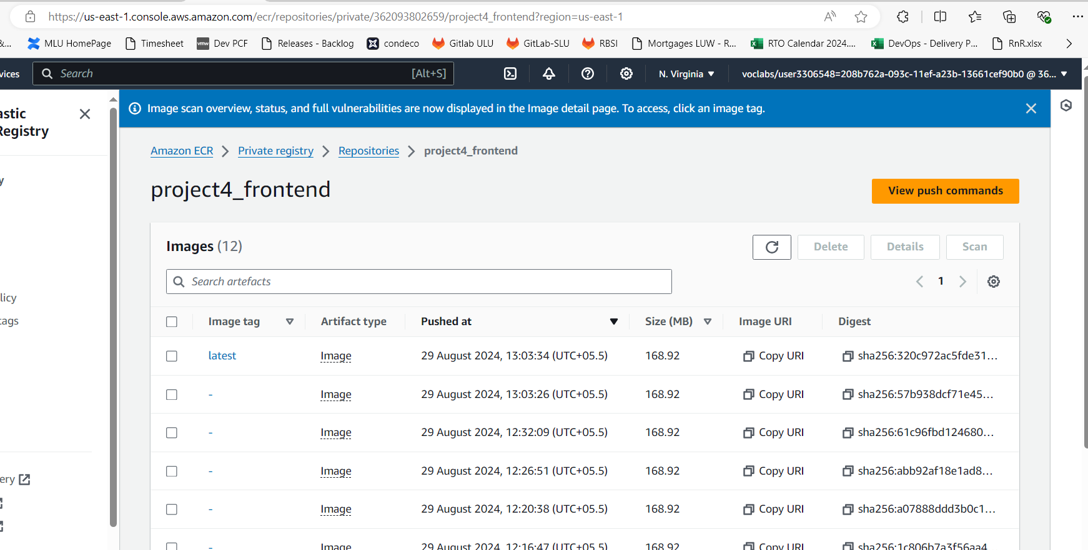

**EKS Cluster**

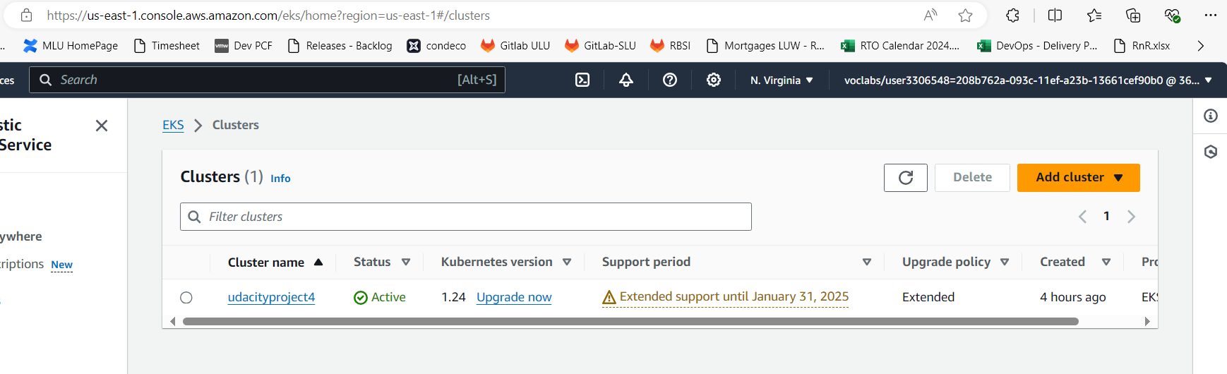

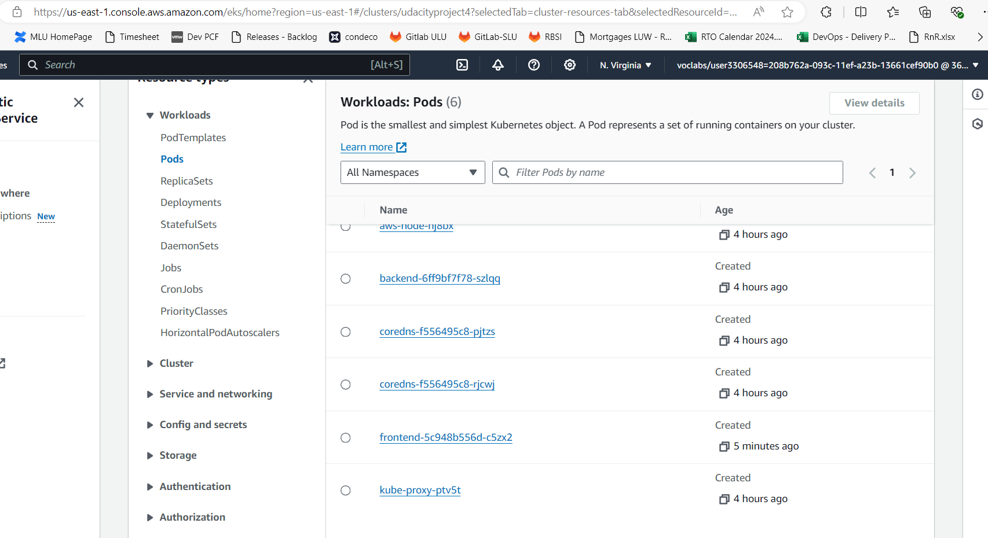

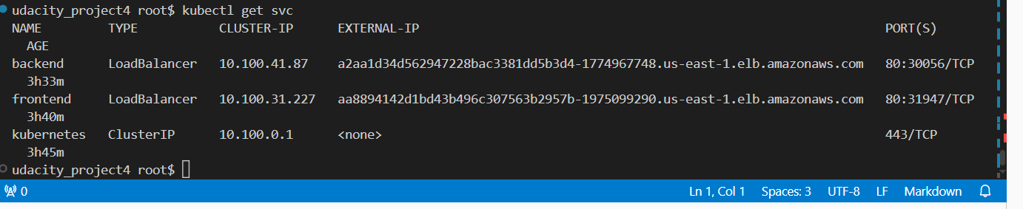

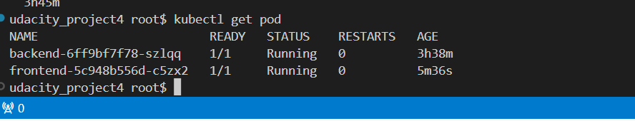

**Application URL:**

[React App (aa8894142d1bd43b496c307563b2957b-1975099290.us-east-1.elb.amazonaws.com)](http://aa8894142d1bd43b496c307563b2957b-1975099290.us-east-1.elb.amazonaws.com/)

