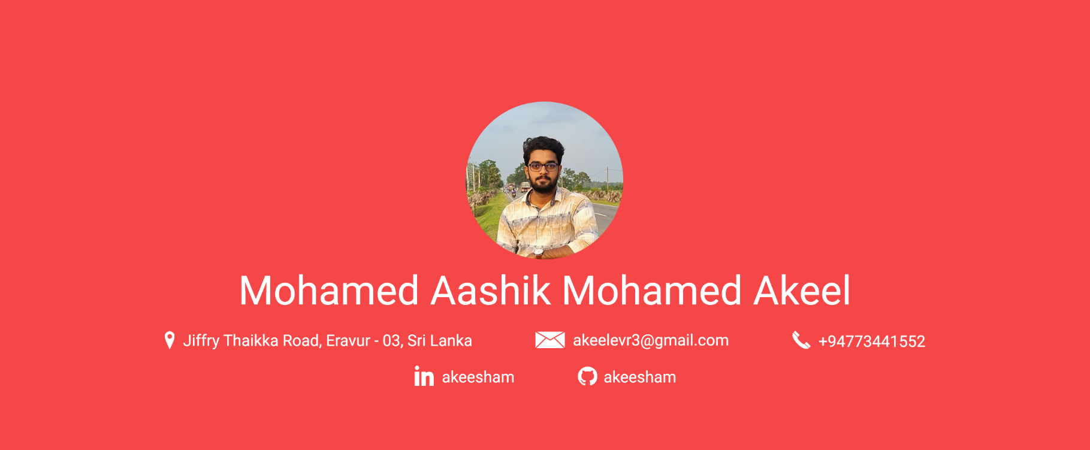

Profile

I am an enthusiastic Undergraduate; experienced Secretary with a demonstrated history of working in the non-profit organization management industry, strong administrative professional with a B.Sc. in Information Technology focused in Information Technology from Rajarata University of Sri Lanka, looking forward to succeeding my career in Software Engineering and Associate Software Engineering.

Education

|  |  |
| --- | --- |
| 2017 – Present | **Rajarata University of Sri Lanka**  *B.Sc. in Information Technology*  Reading the degree  Current GPA – 0.00 |
| 2014 – 2016 | **G.C.E. Advanced Level Examination**  *BT/BC/Alighar National School, Eravur*  Combined Mathematics: B, Physics: C, Chemistry: C  Z-Score – 0.000 |
| 2013 | **G.C.E. Ordinary Level Examination**  *BT/BC/Alighar National School, Eravur*  I have got 7 A’s incl. ICT and 2 B’s. |

Projects

**Ticket Reservation System using C++**

*Semester 2 – Individual Project*

**Ticket Reservation System using C#**

*Semester 3 – Group Project*

**Deepfake Video Detection using Neural Networks**

*Semester 5 – Group Project*

Online Courses

**Programming for Everybody (Getting Started with Python)**

*University of Michigan*

**Introduction to Git and GitHub**

*Google*

**Machine Learning Foundations a Case Study Approach**

*University of Washington*

**Technical Support Fundamentals**

*Google*

Skills

|  |  |  |
| --- | --- | --- |
| **MS Office**  *Worked with all kind of MS Office products including VBA Macros* | **Adobe Products**  *Freelanced graphic design projects and YouTube video making* | **MATLAB/Octave**  *Used MATLAB for Image Processing* |
| **Python**  *Worked on many projects including OpenCV & Tensorflow.* | **Other Programming Language**  *C, C++ and C#* | **Web Development**  *HTML5, CSS, JavaScript & PHP* |
| **Frameworks**  *Angular, Laravel* | **Database Design**  *MySQL* |  |

Soft Skills

* Time management
* Critical thinking
* Problem solving
* Leadership
* Communication skill

Organisations

|  |  |
| --- | --- |
| 2020 – 2021 | **Undergraduates Association of Social Service - Eravur**  *Secretary* |
| 2016 – Present | **Eastern Cancer Care & Hospice**  *Media Coordinator* |
| 2019 – 2020 | **Eastern Student Development Association**  *Editor* |

Extra Carricular

**The Silence**

*Short Film – Semester 4*

**Abi**

*Short Film – in 2016*

**Documentary**

*Made Documentary for Eastern Cancer Care & Hospice Fund Raising*

**Founder of Cyber DotCom**

*A Tech YouTube Channel Since 2019*

**ICT Teacher**

*Part time job*

Interests

|  |  |  |  |
| --- | --- | --- | --- |
| * Graphics Design | * Web Development | * Video making | * Film Making |
| * User Interface Design | * SW Development | * Teaching |  |

Languages

|  |  |  |  |
| --- | --- | --- | --- |
| Tamil |  | English |  |
| Sinhala |  |  |  |