**生信分析报告**

**项目标题： 菌群补充绘图 ;**

**单 号： _ ;**

**分析人员： 黄礼闯 ;**

**分析类型： 生信协助 ;**

**委 托 人： 吴国琳 ;**

**受 托 人： 杭州铂赛生物科技有限公司 .**

# 1 分析流程

# 2 材料和方法

## 2.1 数据分析平台

在 Linux pop-os x86_64 (6.9.3-76060903-generic) 上，使用 R version 4.4.2 (2024-10-31) (<https://www.r-project.org/>) 对数据统计分析与整合分析。

# 3 分析结果

**Tab.** Data all

| X.OTU.ID | Sample | Value | Group | Phylum |
| --- | --- | --- | --- | --- |
| P Acidobacteriota | S10 | 0.00167830653457 | Control | Acidobacteriota |
| P Acidobacteriota | S9 | 2.51502728805e-05 | Control | Acidobacteriota |
| P Acidobacteriota | S7 | 0.000649508808963 | Control | Acidobacteriota |
| P Acidobacteriota | S5 | 0.00165172889984 | Control | Acidobacteriota |
| P Acidobacteriota | I2 | 0 | Model | Acidobacteriota |
| ... | ... | ... | ... | ... |

**(File path: Figure+Table_support/data-all.csv)**

**Tab.** Data mean

| Phylum | Group | Mean | Rank | Rank group |
| --- | --- | --- | --- | --- |
| Firmicutes | Model | 98.034033271725 | 2.17607307924368 | High |
| Proteobacteria | HCQ | 88.498628905775 | 1.70577069921365 | High |
| Firmicutes | Control | 87.203792300925 | 2.17607307924368 | High |
| Proteobacteria | TCM | 72.506287041225 | 1.70577069921365 | High |
| Firmicutes | TCM | 23.2397710403 | 2.17607307924368 | High |
| ... | ... | ... | ... | ... |

**(File path: Figure+Table_support/data-mean.csv)**

**Tab.** Significant pvalue

| Phylum | Pvalue | Coord | Rank group | Sig |
| --- | --- | --- | --- | --- |
| Acidobacteriota | 0.0264577109551595 | 0.100117362906337 | Low | * (0.0265) |
| Armatimonadota | 0.00217266367531017 | 0.01682434086553 | Low | ** (0.0022) |
| Campilobacterota | 0.0205073696576146 | 0.08609738884975 | Low | * (0.0205) |
| Cyanobacteria | 0.0157800034145233 | 0.222428127914925 | Low | * (0.0158) |
| Dadabacteria | 0.00217266367531017 | 0.19403573400405 | Low | ** (0.0022) |
| ... | ... | ... | ... | ... |

**(File path: Figure+Table_support/significant-pvalue.csv)**

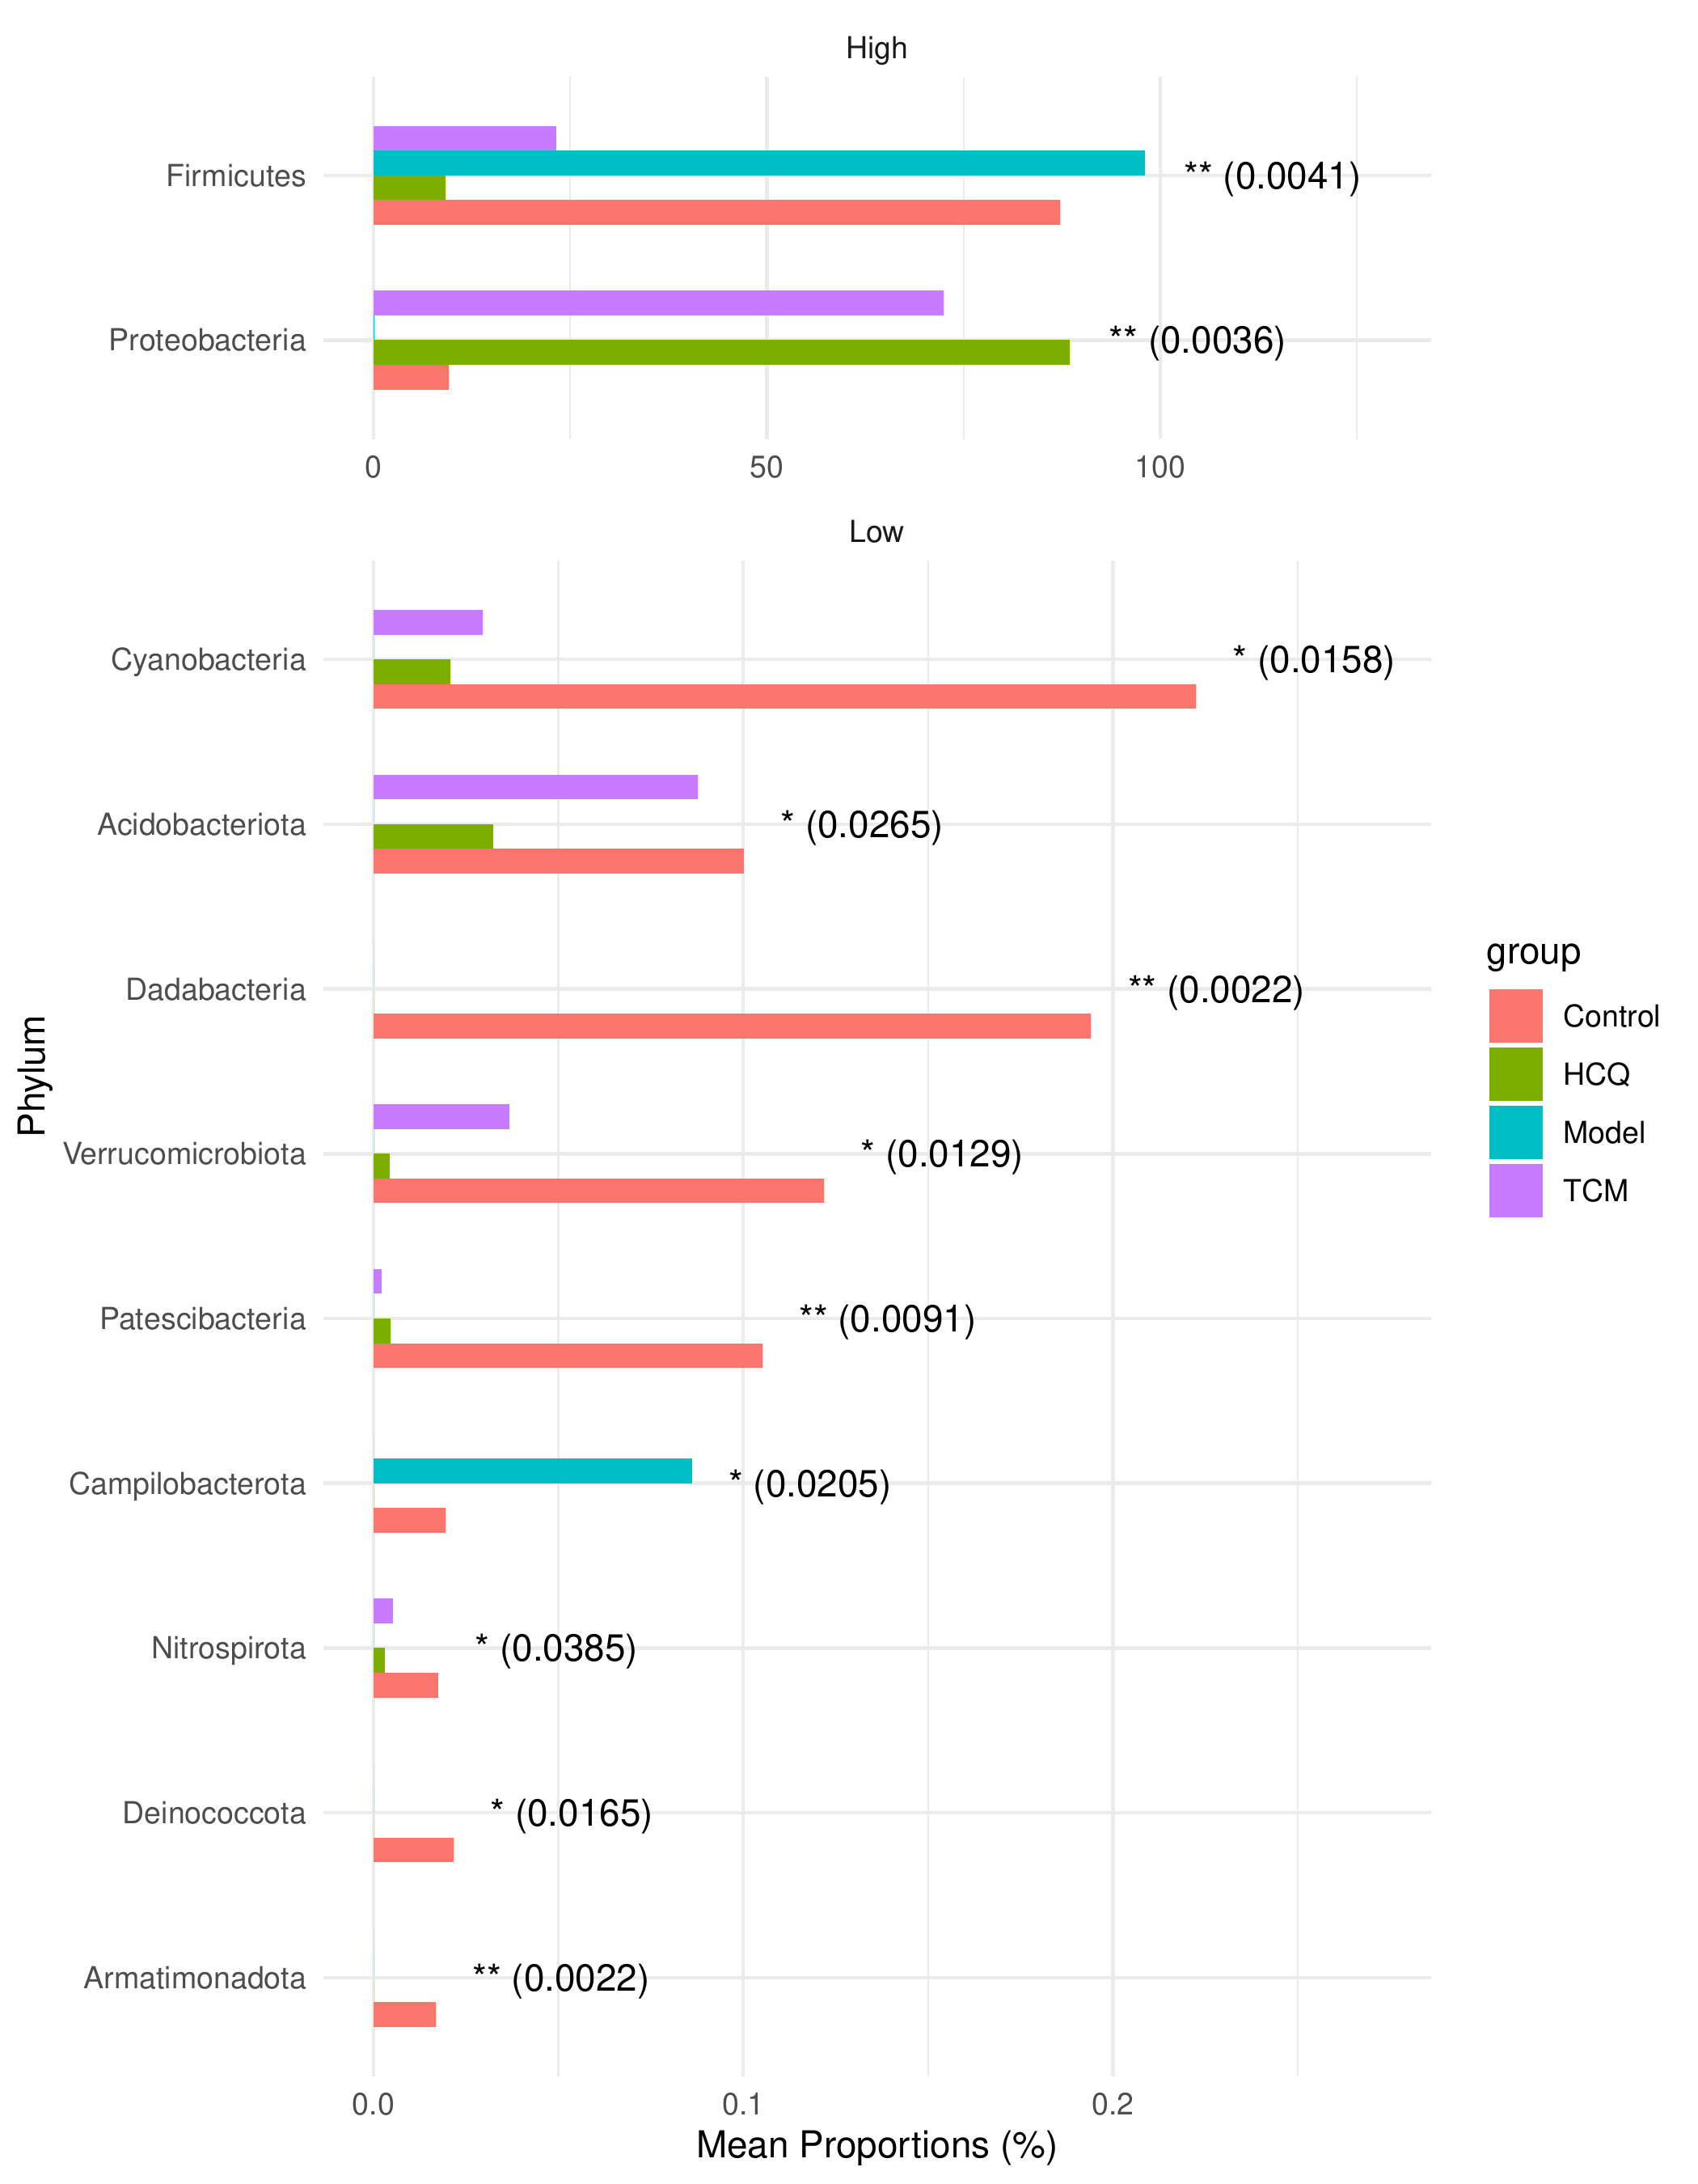

**Fig.** Plot significant

**(File path: Figure+Table_support/plot-significant.pdf)**

# 4 总结