**生物医药合作项目开发**

**研究方向： 睡眠呼吸暂停症+间歇性低氧诱导的动物模型 ;**

**委托人： 凌继祖 ;**

**受托人： 杭州铂赛生物科技有限公司 .**

# 1 研究背景

阻塞性睡眠呼吸暂停 (OSA) 是一种呼吸障碍，当睡眠期间上呼吸道反复阻塞导致呼吸暂停、低通气和(或)呼吸困难觉醒时就会发生(2018, **IF:14.6**, Q1, Autophagy)1。 自噬是体内正常的生理过程，参与细胞稳态和正常呼吸细胞的生存机制。自噬是一种基本的细胞内过程，负责溶酶体降解微生物（病毒、细菌、真菌和原生生物/原生动物）、受损细胞器和蛋白酶体无法降解的受损蛋白质(2018, **IF:14.6**, Q1, Autophagy)1。 自噬在 OSA 发病机制中的作用受到了关注。动物研究已将自噬调节与慢性间歇性缺氧联系起来。使用慢性间歇性缺氧大鼠模型，研究人员证明，通过施用褪黑激素增加自噬可防止 OSA 中常见的心脏变化(2016, **IF:3.8**, Q1, Archives of biochemistry and biophysics)2。另一项研究测试了自噬在驱动慢性间歇性缺氧引起的胰岛素抵抗中的作用，发现这些过程没有因果关系(2015, **IF:2.5**, Q3, Biochemical and biophysical research communications)3。

目前仍缺少从 RNA-seq 或 scRNA-seq 等组学水平研究自噬与 OSA 关系的报道。

## 1.1 思路

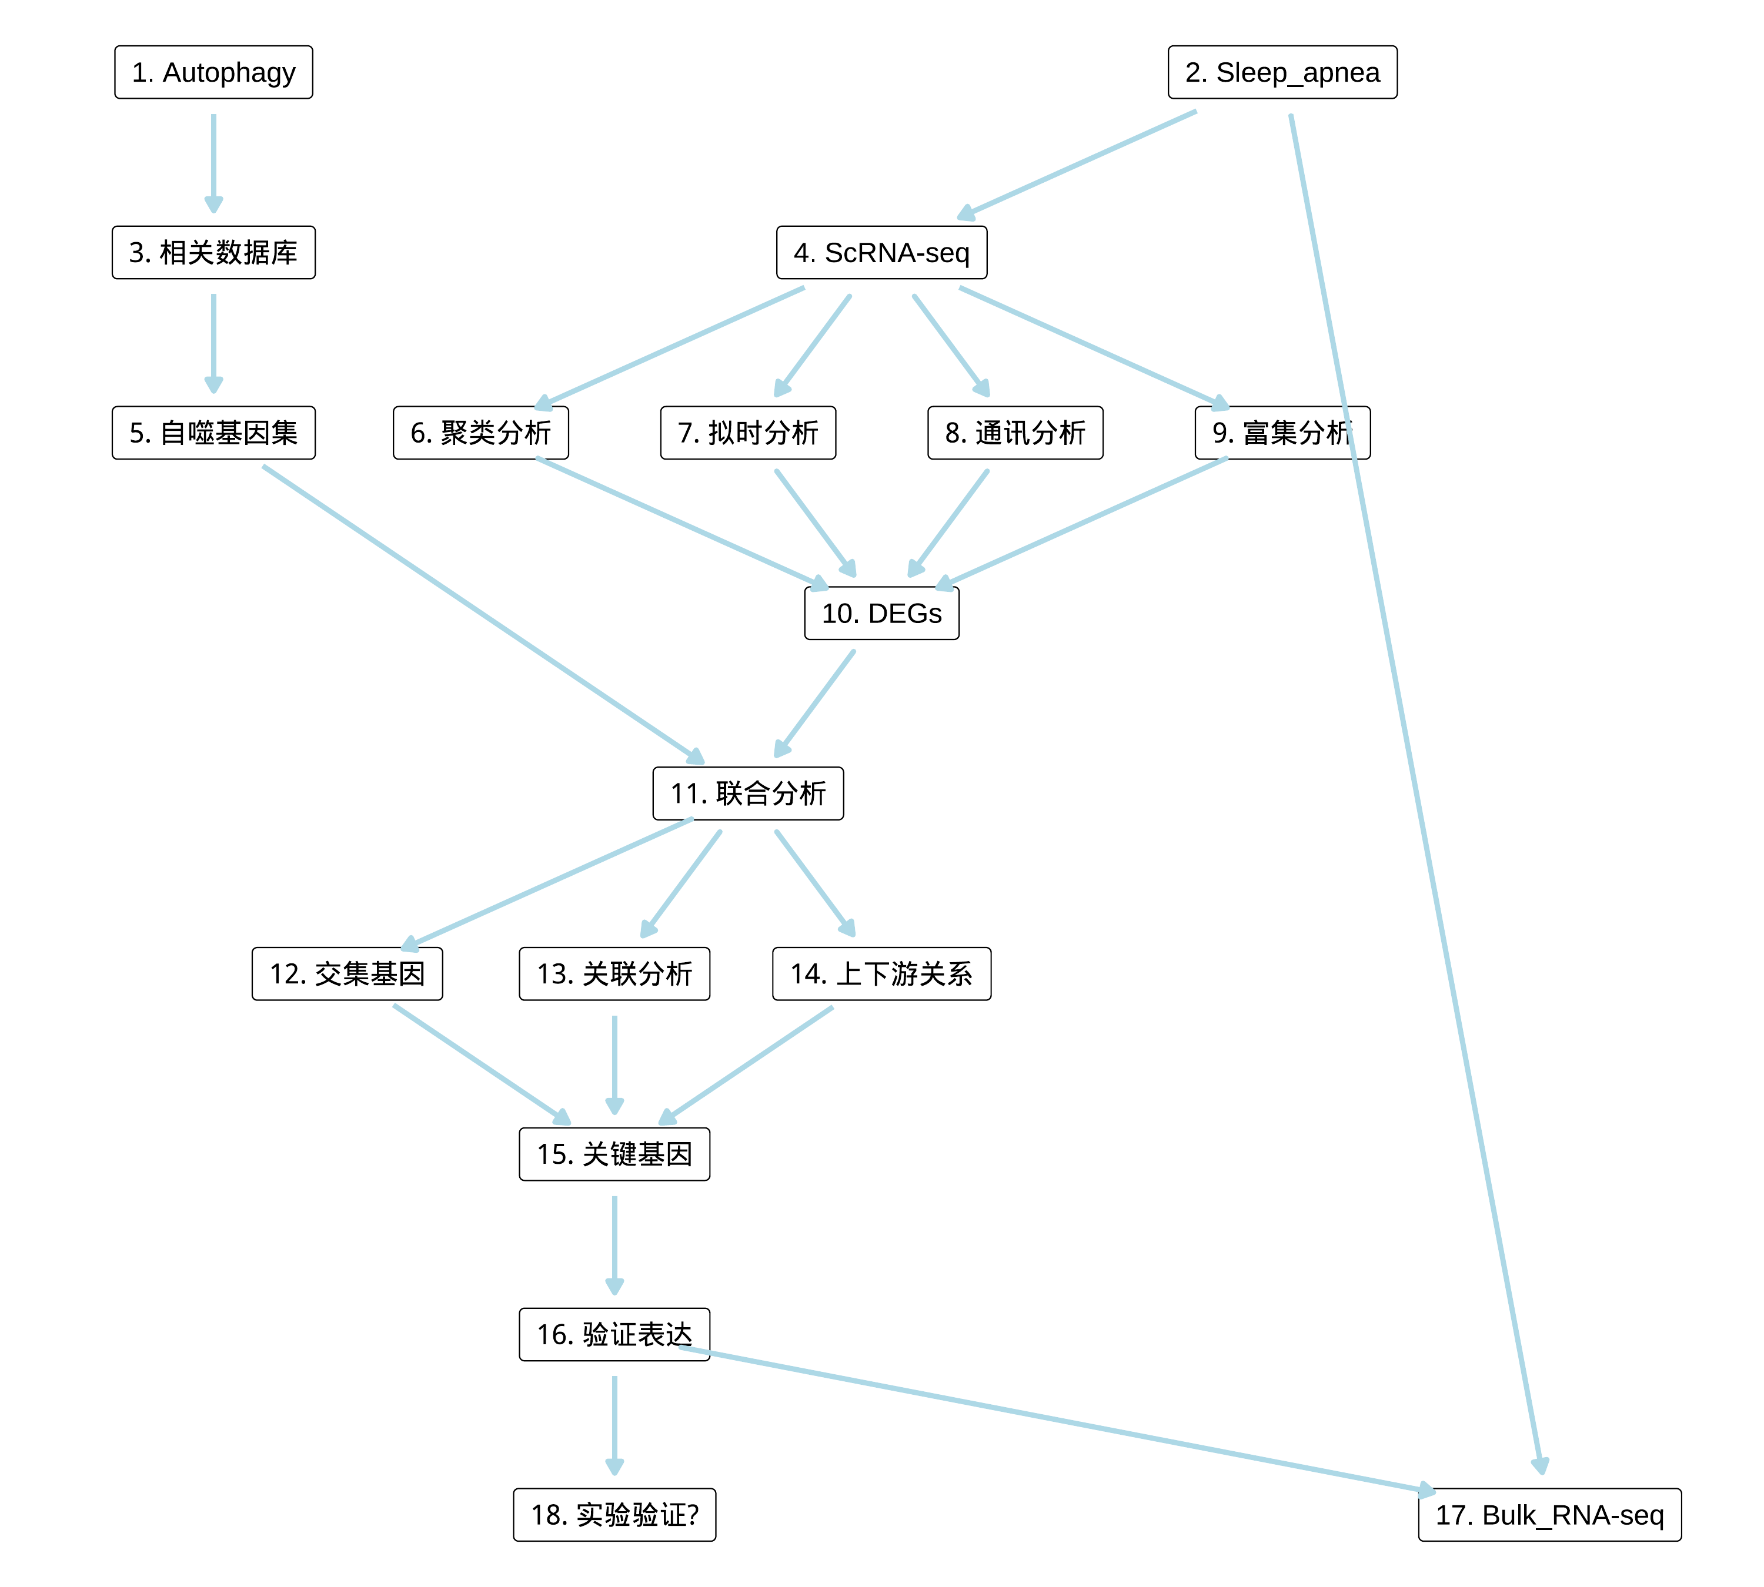

**Fig.** Route

# 2 可行性

## 2.1 以 "Sleep apnea" AND "autophagy" 搜索文献。

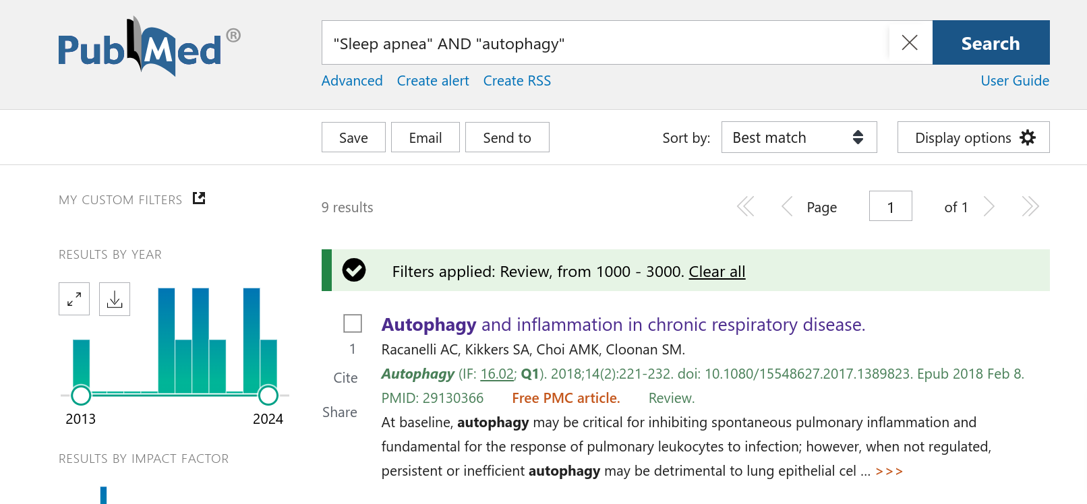

# 3 创新性

## 3.1 以 "Sleep apnea" AND "autophagy" AND "single cell" 搜索文献。

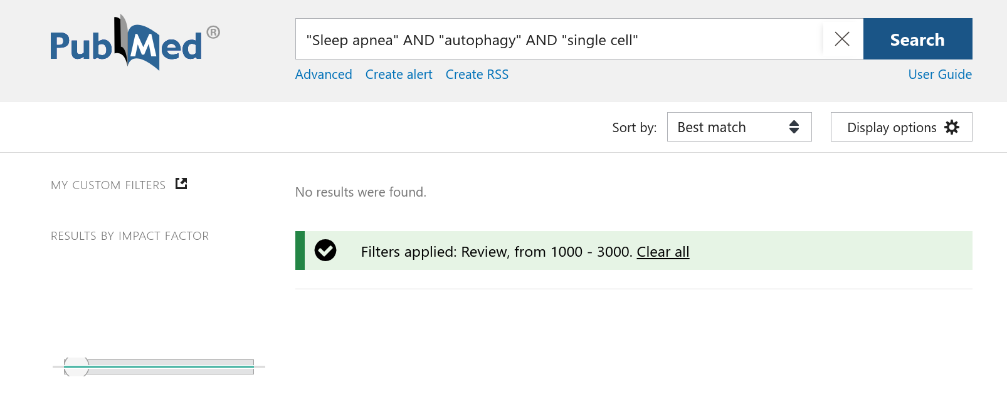

# 4 GEO 检索方法

## 4.1 数据分析平台

在 Linux pop-os x86_64 (6.9.3-76060903-generic) 上，使用 R version 4.4.2 (2024-10-31) (<https://www.r-project.org/>) 对数据统计分析与整合分析。

## 4.2 GSE 数据搜索 (Dataset: SA)

使用 Entrez Direct (EDirect) <https://www.ncbi.nlm.nih.gov/books/NBK3837/> 搜索 GEO 数据库 (esearch -db gds)，查询信息为: ((Sleep apnea[Description]) AND ((6:1000[Number of Samples]) AND (GSE[Entry Type]))。 以正则匹配，滤除包含 ‘single cell’ 或 ‘scRNA’ 的数据例。仅获取类型包含 ‘Expression profiling by high throughput sequencing’ 或 ‘Expression profiling by array’ 的数据例。 以 GEOquery 获取 GSE 数据集 (n=12)。

# 5 参考文献和数据集

## 5.1 GSE 数据搜索 (SA)

以 Entrez Direct (EDirect) 搜索 GEO 数据库 (检索条件见方法章节) 。匹配 taxon 中不包含 “Homo Sapiens” 字符的数据, 匹配 summary 中包含 “Intermittent hypoxia” 字符的数据，最终得到 12 例数据。这些数据为：GSE242668, GSE235867, GSE215935, GSE189958, GSE145435, GSE145434, GSE145221, GSE21409, GSE14981, GSE2271, GSE1873, GSE480等。

* **GSE242668**, **Type**: RNA-seq
  + intermittent_hypoxia (n = 5)
  + normoxic_control (n = 5)
* **GSE235867**, **Type**: RNA-seq
  + ORX-IH (n = 5)
  + ORX-Nx (n = 5)
  + Sham-IH (n = 5)
  + Sham-Nx (n = 5)
* **GSE215935**, **Type**: Microarray; Non-coding RNA-seq
  + chronic intermittent hypoxia (CIH) system combined with Ang II (n = 3)
  + normal saline (n = 3)
* **GSE189958**, **Type**: RNA-seq
  + Intermittent hypoxia (n = 4)
  + Overlap hypoxia (n = 4)
  + Room air (n = 4)
  + Sustained hypoxia (n = 4)
* **GSE145435**, **Type**: (scRNA-seq) RNA-seq
  + Ctrl (n = 3)
  + Hypo (n = 3)
* **GSE145434**, **Type**: RNA-seq
  + CTRL (n = 6)
  + HYPO (n = 6)
* **GSE145221**, **Type**: Microarray
  + CIH for 12 (n = 4)
  + CIH for 8 (n = 5)
  + CIH for 8 weeks followed by normoxia for 4 (n = 4)
  + normoxia for 12 (n = 5)
  + normoxia for 8 (n = 5)
* **GSE21409**, **Type**: Microarray
  + Interm Hypoxia (n = 5)
  + Normoxia (n = 5)
* **GSE14981**, **Type**: Microarray
  + CH (n = 3)
  + IH (n = 3)
  + NC (n = 3)
* **GSE2271**, **Type**: Microarray
  + mouse subjected (n = 2)
  + mouse subjected 1 week to chronic constant hypoxia (n = 1)
  + mouse subjected 1 week to chronic intermittent hypoxia (n = 2)
  + mouse subjected 2 week to chronic constant hypoxia (n = 1)
  + mouse subjected 2 week to chronic intermittent hypoxia (n = 2)
  + mouse subjected 4 week to chronic constant hypoxia (n = 2)
  + mouse subjected 4 week to chronic intermittent hypoxia (n = 2)
  + mouse, 1 week control (n = 2)
  + mouse, 2 week control (n = 2)
  + mouse, 4 week control (n = 2)
* **GSE1873**, **Type**: Microarray
  + Liver, Intermittent Hypoxia (n = 5)
  + Liver, Normoxia (n = 5)
* **GSE480**, **Type**: Microarray
  + PGA-MGM-ConBrain (n = 1)
  + PGA-MGM-ConHeart (n = 1)
  + PGA-MGM-ConHyp (n = 2)
  + PGA-MGM-ConLung (n = 1)
  + PGA-MGM-ConMuscle (n = 1)
  + PGA-MGM-ConNonHyp (n = 2)
  + PGA-MGM-FragBrain (n = 1)
  + PGA-MGM-FragHeart (n = 1)
  + PGA-MGM-FragLung (n = 1)
  + PGA-MGM-FragMuscle (n = 1)
  + PGA-MGM-GlucoseHyp (n = 2)
  + PGA-MGM-GlucoseNonHyp (n = 2)
  + PGA-MGM-HypoxiaBrain (n = 1)
  + PGA-MGM-HypoxiaHeart (n = 1)
  + PGA-MGM-HypoxiaLung (n = 1)
  + PGA-MGM-HypoxiaMuscle (n = 1)

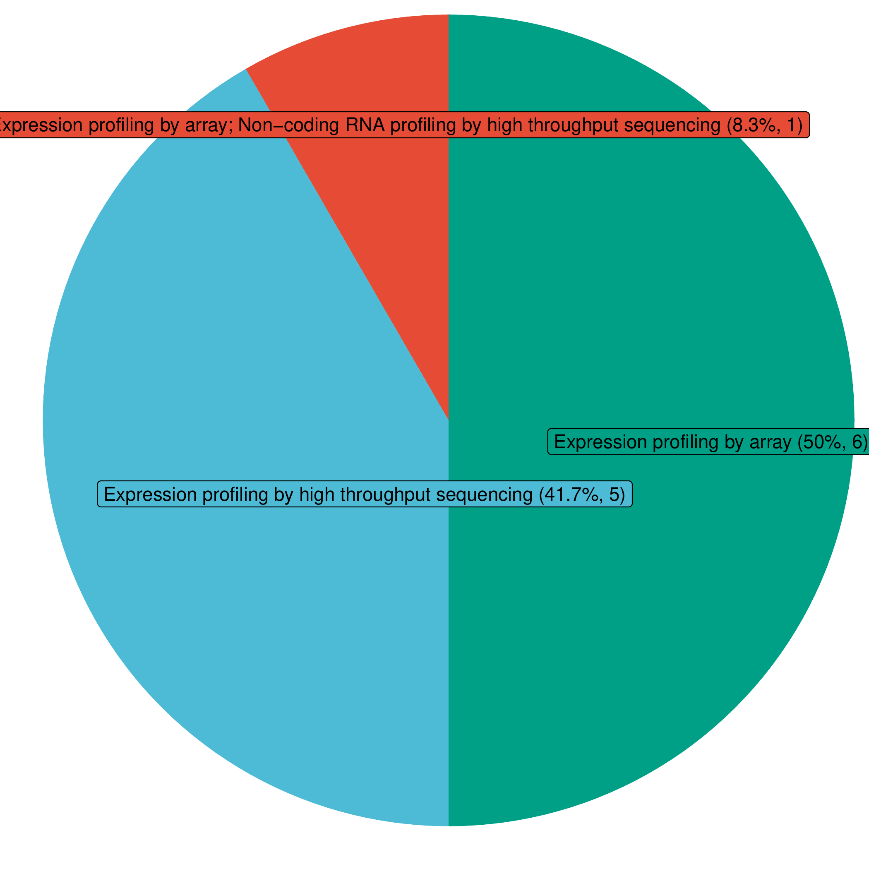

**Fig.** SA All Gds Type

# Reference

1. Racanelli, A. C., Kikkers, S. A., Choi, A. M. K. & Cloonan, S. M. Autophagy and inflammation in chronic respiratory disease. *Autophagy* **14**, 221–232 (2018).

2. Xie, S. *et al.* Chronic intermittent hypoxia induces cardiac hypertrophy by impairing autophagy through the adenosine 5-monophosphate-activated protein kinase pathway. *Archives of biochemistry and biophysics* **606**, 41–52 (2016).

3. Xie, S. *et al.* Melatonin protects against chronic intermittent hypoxia-induced cardiac hypertrophy by modulating autophagy through the 5adenosine monophosphate-activated protein kinase pathway. *Biochemical and biophysical research communications* **464**, 975–981 (2015).