**生物医药合作项目开发**

**研究方向： 骨质疏松 ;**

**委托人： 赵斌 ;**

**受托人： 杭州铂赛生物科技有限公司 .**

# 1 研究背景

骨质疏松症是一种骨骼疾病，会导致骨骼结构和强度受损，从而导致脆性骨折的风险逐渐增加。全球老龄人口中骨质疏松症的患病率正在上升。由于骨质疏松症具有慢性特点，需要数年甚至数十年的预防措施或治疗 (2023, **IF:31**, Q1, Nature reviews. Endocrinology)1。 骨细胞在维持骨稳态和调节骨骼对激素和机械负荷的反应方面发挥着关键作用。大量证据表明，骨细胞及其陷窝在老化的骨骼中表现出形态变化，表明骨细胞在骨骼老化过程中起着潜在的作用。值得注意的是，最近的研究表明老化的骨细胞具有机械敏感性受损、细胞衰老积累、骨陷窝周围/小管重塑功能障碍以及陷窝-小管网络退化等特征。然而，骨细胞的详细分子机制仍不清楚(2022, **IF:12.5**, Q1, Ageing research reviews)2。

代谢重编程（Metabolic reprogramming）是指细胞为了应对各种刺激压力而做出的代谢改变。 近年有多数报道就骨质疏松症与代谢重编程展开探讨(2023, **IF:14.7**, Q1, Nature communications)3，(2024, **IF:20.3**, Q1, Annals of the rheumatic diseases)4。然而两者关系并未系统阐明。

## 1.1 思路

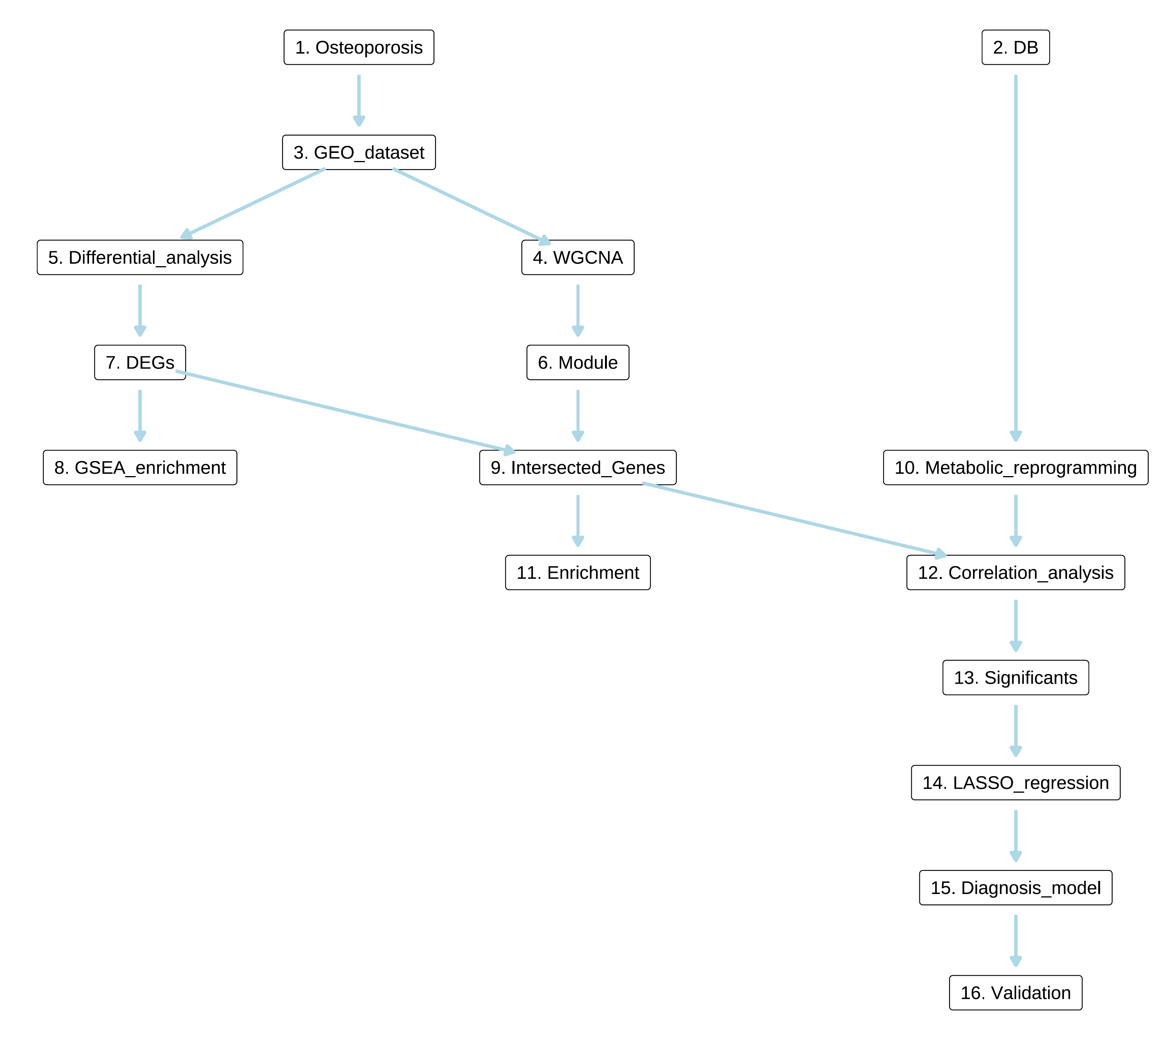

**Fig.** Route

# 2 GEO 检索方法

## 2.1 数据分析平台

在 Linux pop-os x86_64 (6.9.3-76060903-generic) 上，使用 R version 4.4.2 (2024-10-31) (<https://www.r-project.org/>) 对数据统计分析与整合分析。

## 2.2 GSE 数据搜索 (Dataset: OS)

使用 Entrez Direct (EDirect) <https://www.ncbi.nlm.nih.gov/books/NBK3837/> 搜索 GEO 数据库 (esearch -db gds)，查询信息为: ((Osteoporosis[Description]) AND ((2:1000[Number of Samples]) AND (GSE[Entry Type]) AND (Homo Sapiens[Organism]))。 仅查询临床样本信息，因此滤除匹配到 ‘cells’, ‘cell type’ 或 ‘cell line’ 的实验数据例。 此外，去除了以特定 Marker 细胞类型为研究对象的数据例 (CD4、CD8 T 细胞等)。仅获取类型包含 ‘Expression profiling by high throughput sequencing’ 或 ‘Expression profiling by array’ 的数据例。 以 GEOquery 获取 GSE 数据集 (n=32)。

# 3 参考文献和数据集

## 3.1 GSE 数据搜索 (OS)

以 Entrez Direct (EDirect) 搜索 GEO 数据库 (检索条件见方法章节) 。 可用数据，及其组别为：

* **GSE262092**, **Type**: RNA-seq
  + empty vectors, duplicate (n = 2)
  + pcDNA3.1-WNT1, duplicate (n = 2)
* **GSE262091**, **Type**: RNA-seq
  + Control sample (n = 1)
  + Type XV OI sample (n = 1)
* **GSE255297**, **Type**: RNA-seq
  + CL144 (n = 2)
  + control (n = 2)
  + Nutlin-3 (n = 2)
* **GSE255659**, **Type**: RNA-seq
  + Health control (n = 5)
  + Osteroporosis (n = 5)
* **GSE216357**, **Type**: RNA-seq
  + PBMCs (n = 12)
* **GSE154548**, **Type**: RNA-seq
  + Cholangiocarcinoma, hypertension, diabetes mellitus (n = 1)
  + Diabetes mellitus, dyslipidemia (n = 1)
  + Dyslipidemia (n = 3)
  + Dyslipidemia, subclinical hypothyroidism (n = 1)
  + HTN, dyslipidemia, bronchial asthma, osteoporosis (n = 1)
  + Hypertension (n = 2)
  + Hypertension, allergic rhinitis (n = 1)
  + Hypertension, aortic dissection (n = 1)
  + Hypertension, cerebral atherosclerosis, cervial radiculopathy (n = 1)
  + Hypertension, dementia (n = 1)
  + Hypertension, dementia, benign prostatic hyperplasia (n = 1)
  + Hypertension, diabetes mellitus, cerebral infarction (n = 1)
  + Hypertension, diabetes mellitus, dyslipidemia (n = 1)
  + Hypertension, diabetes mellitus, dyslipidemia, atrial fibrillation, cerebral infarction, chronic kidney disease, gout, benign prostatic hyperplasia (n = 1)
  + Hypertension, diabetes mellitus, dyslipidemia, cerebral infarction (n = 1)
  + Hypertension, dyslipidemia, cerebral infarction (n = 1)
  + Hypertension, dyslipidemia, chronic kidney disease (n = 1)
  + Hypertension, dyslipidemia, coronary artery disease, gastric cancer, cataract (n = 1)
  + Hypertension, liver abscess (n = 1)
  + Hypertension, neurogenic bladder (n = 1)
  + Hypertension, prostate cancer (n = 1)
  + Liver cirrhosis, hypertension, gout (n = 1)
  + None (n = 13)
  + Primary biliary cirrhosis, nonalcoholic steatohepatitis, hypertension, diabetes mellitus (n =
  + Spinal cord injury, dyslipidemia (n = 1)
* **GSE230665**, **Type**: Microarray
  + healthy postmenopausal women; control group (n = 3)
  + postmenopausal osteoporosis (n = 12)
* **GSE224330**, **Type**: Microarray
  + Monocytes_abatacept_rep (n = 5)
  + Monocytes_anti-TNFalpha_rep (n = 5)
  + Monocytes_healthy_rep (n = 10)
  + Monocytes_MTX_rep (n = 6)
  + Monocytes_tocilizumab_rep (n = 5)
* **GSE177024**, **Type**: RNA-seq
  + macrophage (n = 3)
* **GSE160310**, **Type**: RNA-seq; Non-coding RNA-seq
  + Control (n = 40)
  + Diabetic (n = 40)
  + NPDR (n = 38)
  + NPDR + DME (n = 30)
  + PDR + DME (n = 10)
* **GSE152293**, **Type**: RNA-seq
  + with osteoporosis (n = 3)
  + without osteoporosis (n = 3)
* **GSE156508**, **Type**: Microarray
  + Fracture OB (n = 6)
  + Osteoarthritis OB (n = 6)
* **GSE93883**, **Type**: Microarray
  + Healthy (n = 6)
  + Osteoporosis with vertebral fracture (n = 6)
  + Osteoporosis without vertebral fracture (n = 6)
* **GSE112318**, **Type**: RNA-seq
  + BMSCs (n = 2)
* **GSE128641**, **Type**: RNA-seq
  + embryonic kidney (n = 18)
* **GSE100609**, **Type**: RNA-seq
  + Normal (n = 4)
  + Osteoporosis (n = 4)
* **GSE90548**, **Type**: Microarray
  + 17-B-estradiol (n = 6)
  + Ethanol (n = 6)
* **GSE72490**, **Type**: Microarray
  + Cushing’s disease (n = 12)
* **GSE43861**, **Type**: Microarray
  + control (n = 2)
  + Fibrogenesis imperfecta ossium (n = 2)
* **GSE56815**, **Type**: Microarray
  + postmenopausal (n = 40)
  + premenopausal (n = 40)
* **GSE56814**, **Type**: Microarray
  + postmenopausal (n = 42)
  + premenopausal (n = 31)
* **GSE62402**, **Type**: Microarray
  + monocytes (n = 10)
* **GSE57273**, **Type**: Microarray
  + deficiency (n = 6)
* **GSE56116**, **Type**: Microarray
  + control group (n = 3)
  + kidney Yang deficiency (n = 3)
  + kidney Yin deficiency (n = 4)
  + non-kidney deficiency (n = 3)
* **GSE51495**, **Type**: Microarray
  + cortical bone (n = 15)
  + Peripheral blood mononuclear cells (n = 15)
* **GSE30159**, **Type**: Microarray
  + Bone biopsy_post (n = 9)
  + Bone biopsy_pre (n = 9)
* **GSE20941**, **Type**: Microarray
  + with osteoporosis (n = 6)
  + without osteoporosis (n = 6)
* **GSE35959**, **Type**: Microarray
  + NA (n = 14)
  + primary osteoporosis (n = 5)
* **GSE20881**, **Type**: Microarray
  + ascending colon biopsy from crohns disease subject PRB (n = 20)
  + ascending colon biopsy from healthy subject GSM (n = 17)
  + descending colon biopsy from crohns disease subject PRB (n = 29)
  + descending colon biopsy from healthy subject GSM (n = 23)
  + sigmoid colon biopsy from crohns disease subject PRB (n = 33)
  + sigmoid colon biopsy from healthy subject GSM (n = 27)
  + terminal ileum biopsy from crohns disease subject PRB (n = 17)
  + terminal ileum biopsy from healthy subject GSM (n = 6)
* **GSE8075**, **Type**: Microarray
  + BMD steady state control rib bone vs. osteoporotic rib bone_HA74 (n = 2)
  + BMD steady state control rib bone vs. regenerating rib bone_HA74 (n = 1)
  + osteoporotic rib bone vs. BMD steady state control rib bone_ HA74 (n = 1)
  + osteoporotic rib bone vs. regenerating rib bone_HA74 (n = 2)
  + regenerating rib bone vs. BMD steady state control rib bone (n = 1)
  + regenerating rib bone vs. BMD steady state control rib bone_HA74 (n = 1)
  + regenerating rib bone vs. osteoporotic rib bone_HA74 (n = 1)
* **GSE7158**, **Type**: Microarray
  + High PBM (n = 14)
  + Low PBM (n = 12)
* **GSE2208**, **Type**: Microarray
  + Unknown (n = 19)

# Reference

1. Foessl, I., Dimai, H. P. & Obermayer-Pietsch, B. Long-term and sequential treatment for osteoporosis. *Nature reviews. Endocrinology* **19**, 520–533 (2023).

2. Cui, J., Shibata, Y., Zhu, T., Zhou, J. & Zhang, J. Osteocytes in bone aging: Advances, challenges, and future perspectives. *Ageing research reviews* **77**, (2022).

3. Rohatgi, N. *et al.* BAP1 promotes osteoclast function by metabolic reprogramming. *Nature communications* **14**, (2023).

4. Cao, S. *et al.* L-arginine metabolism inhibits arthritis and inflammatory bone loss. *Annals of the rheumatic diseases* **83**, 72–87 (2024).