**生物医药合作项目开发**

**研究方向： 哮喘相关 ;**

**委托人： 赵蓓蓓 ;**

**受托人： 杭州铂赛生物科技有限公司 .**

# 1 研究背景

哮喘是影响全球儿童和成人的最常见呼吸道疾病之一，其表型多样，其潜在致病机制尚不明确。随着基因组测序技术的进步，人们做出了科学努力来解释和预测哮喘的复杂性和异质性，全基因组关联研究 (GWAS) 迅速成为首选的研究方法 (2021, **IF:4.9**, Q2, International journal of molecular sciences)1。

TWAS （Transcriptome-Wide Association Study，全转录组关联研究）是一种强大的方法，用于探索基因表达与表型之间的关联，为基因组学研究和遗传病因探索提供了重要工具。它结合了 GWAS 的遗传变异数据和功能基因组数据，能够识别潜在的功能基因，为疾病机制研究和药物开发提供重要线索。

将 TWAS (2016, **IF:31.7**, Q1, Nature Genetics)2 和 WGCNA（Weighted Gene Co-Expression Network Analysis，加权基因共表达网络分析）(2008, **IF:2.9**, Q1, BMC Bioinformatics)3以及差异分析结合起来，能够充分挖掘基因表达调控与表型（例如疾病）之间的复杂关系

## 1.1 思路

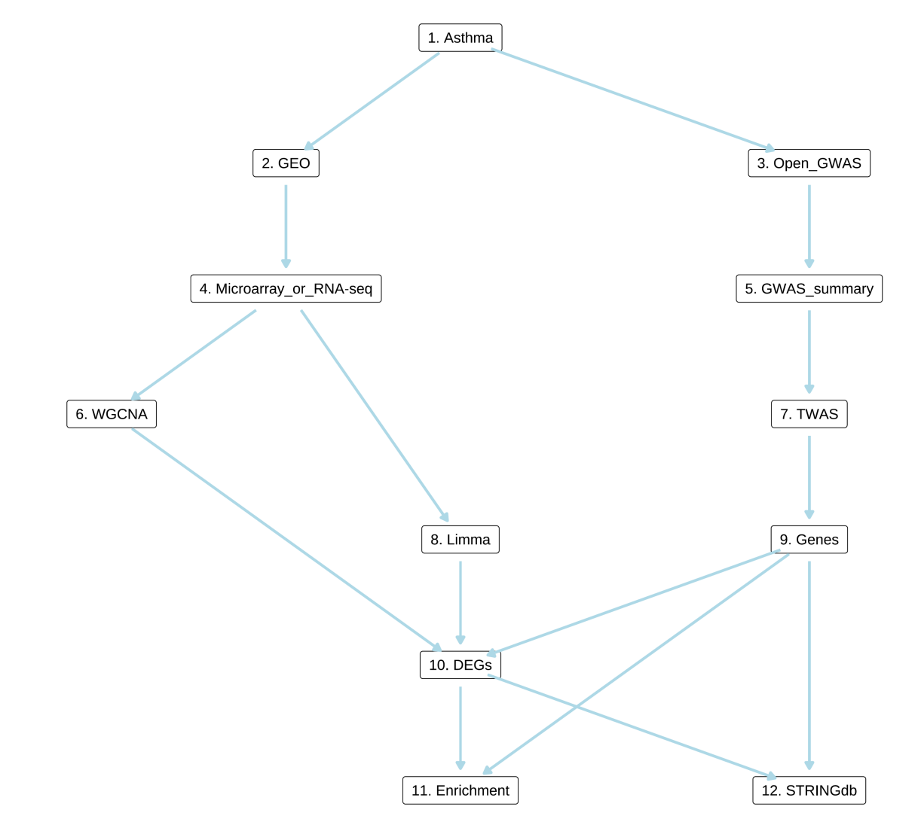

**Fig.** **1** Route

# 2 可行性

## 2.1 以 asthma AND TWAS 搜索文献。

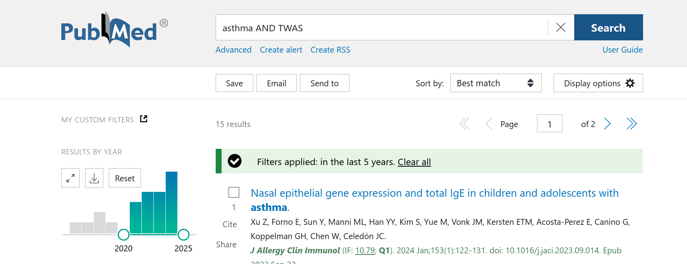

# 3 创新性

## 3.1 以 asthma AND TWAS AND WGCNA 搜索文献。

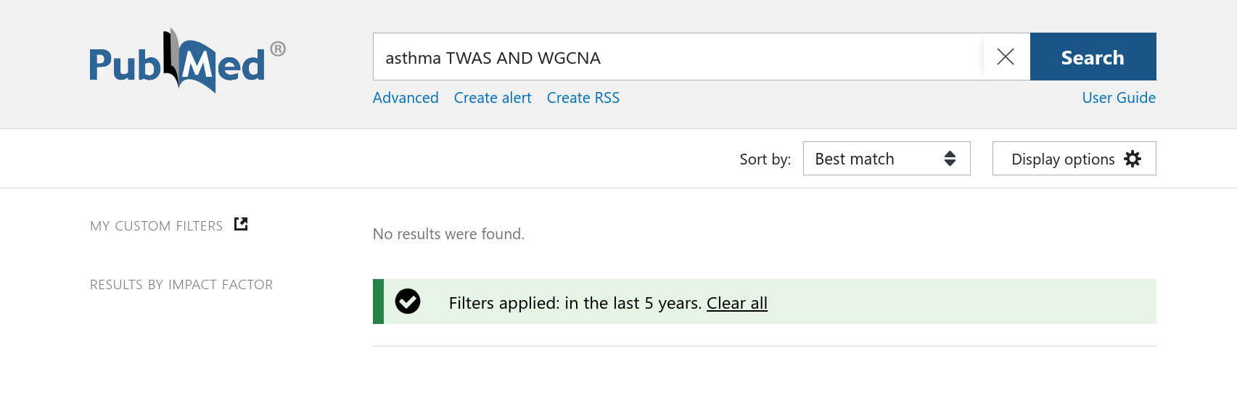

# 4 GEO 检索方法

## 4.1 数据分析平台

在 Linux pop-os x86_64 (6.9.3-76060903-generic) 上，使用 R version 4.4.2 (2024-10-31) (<https://www.r-project.org/>) 对数据统计分析与整合分析。

## 4.2 GSE 数据搜索 (Dataset: AS)

使用 Entrez Direct (EDirect) <https://www.ncbi.nlm.nih.gov/books/NBK3837/> 搜索 GEO 数据库 (esearch -db gds)，查询信息为: ((asthma[Description] AND (healthy[Description]) AND ((6:1000[Number of Samples]) AND (GSE[Entry Type]) AND (Homo Sapiens[Organism]))。 以正则匹配，滤除包含 ‘single cell’ 或 ‘scRNA’ 的数据例。仅查询临床样本信息，因此滤除匹配到 ‘cells’, ‘cell type’ 或 ‘cell line’ 的实验数据例。 此外，去除了以特定 Marker 细胞类型为研究对象的数据例 (CD4、CD8 T 细胞等，可能是来源于实验室的数据)。 (注：以上仅为查找合适的 GEO 数据所做的数据筛选，与实际分析无关) 。仅获取类型包含 ‘Expression profiling by high throughput sequencing’ 或 ‘Expression profiling by array’ 的数据例。 以 GEOquery 获取 GSE 数据集 (n=59)。

# 5 参考文献和数据集

## 5.1 GWAS 数据

**Tab.** **1** Traits found in Open GWAS

| Id | Trait | Coverage | Ncase | Group ... | Year | Mr | Author | Sex | Qc pri... |
| --- | --- | --- | --- | --- | --- | --- | --- | --- | --- |
| Ebi-a-... | Asthma |  | 9209 | Public | 2021 | 1 | Guindo... | NA |  |
| Ebi-a-... | Asthma |  | 9209 | Public | 2021 | 1 | Guindo... | NA |  |
| Ebi-a-... | Asthma |  | 9209 | Public | 2021 | 1 | Guindo... | NA |  |
| Ebi-a-... | Asthma |  | 9209 | Public | 2021 | 1 | Guindo... | NA |  |
| Ebi-a-... | Asthma |  | 56090 | Public | 2021 | 1 | D<U+00... | NA |  |
| ... | ... | ... | ... | ... | ... | ... | ... | ... | ... |

## 5.2 GSE 数据搜索 (AS)

以 Entrez Direct (EDirect) 搜索 GEO 数据库 (检索条件见方法章节) 。 可用数据，及其组别为：

* **GSE245608**, **Type**: RNA-seq
  + Control (n = 12)
  + MAA (n = 11)
  + SAA (n = 9)
* **GSE256534**, **Type**: RNA-seq
  + Cont (n = 13)
  + Pat (n = 19)
* **GSE252878**, **Type**: RNA-seq
  + IL-13 (n = 9)
  + No_stim (n = 18)
* **GSE252877**, **Type**: RNA-seq
  + Asthma (n = 4)
  + Healthy (n = 4)
* **GSE252876**, **Type**: RNA-seq
  + IL-13 (n = 9)
  + No_stim (n = 18)
* **GSE226825**, **Type**: RNA-seq
  + cells (n = 436)
* **GSE222129**, **Type**: RNA-seq
  + Asthma (n = 27)
  + Healthy (n = 27)
* **GSE207751**, **Type**: RNA-seq
  + H (n = 14)
  + M (n = 19)
  + S (n = 23)
* **GSE184382**, **Type**: Microarray
  + no (n = 23)
  + yes (n = 16)
* **GSE195599**, **Type**: RNA-seq
  + Asthma_rep (n = 4)
  + Healthy_rep (n = 3)
* **GSE182798**, **Type**: Microarray
  + NA (n = 102)
  + Nasal_biopsy (n = 80)
* **GSE182797**, **Type**: Microarray
  + AAD (n = 13)
  + AND (n = 15)
  + APD (n = 17)
  + Ctrl (n = 21)
  + IEI (n = 14)
* **GSE182503**, **Type**: Microarray
  + AAD (n = 16)
  + AND (n = 17)
  + APD (n = 17)
  + Ctrl (n = 21)
  + Ctrl_II (n = 15)
  + IEI (n = 16)
* **GSE147881**, **Type**: Microarray
  + healthy (n = 13)
  + mild/moderate_asthma (n = 18)
  + severe_asthma (n = 42)
* **GSE147880**, **Type**: Microarray
  + healthy_control (n = 10)
  + mild/moderate_asthma (n = 18)
  + severe_asthma (n = 16)
* **GSE147878**, **Type**: Microarray
  + healthy (n = 13)
  + mild/moderate_asthma (n = 18)
  + severe_asthma (n = 42)
* **GSE143303**, **Type**: Microarray
  + healthy (n = 13)
  + Severe_asthma (n = 47)
* **GSE179156**, **Type**: Microarray
  + n/a (n = 29)
  + off (n = 38)
  + on (n = 19)
* **GSE143192**, **Type**: Microarray; Non-coding Microarray
  + normal (n = 2)
  + patients (n = 1)
  + S (n = 5)
* **GSE167225**, **Type**: Microarray
  + allergy (n = 16)
  + allergy+asthma (n = 14)
  + healthy (n = 10)
* **GSE165934**, **Type**: Microarray
  + asthma (n = 10)
  + control (n = 9)
* **GSE148004**, **Type**: Microarray
  + AE (n = 9)
  + CN (n = 7)
  + HC (n = 9)
* **GSE134544**, **Type**: Microarray
  + Healthy_Control_Blood_Donor_BD (n = 13)
  + Healthy_Control_Blood_Donor_BD105933_Replicate (n = 2)
  + Healthy_Control_Blood_Donor_BD106691_Replicate (n = 2)
  + Healthy_Control_Blood_Donor_BD110992_Replicate (n = 2)
  + Healthy_Control_Blood_Donor_BD155612_Replicate (n = 2)
  + Patient_X (n = 45)
  + Patient_X10 (n = 3)
  + Patient_X11 (n = 4)
  + Patient_X12 (n = 4)
  + Patient_X13 (n = 4)
  + Patient_X14 (n = 4)
  + Patient_X15 (n = 4)
  + Patient_X16 (n = 4)
  + Patient_X17 (n = 4)
  + Patient_X18 (n = 4)
  + Patient_X19 (n = 4)
  + Patient_X2 (n = 4)
  + Patient_X20 (n = 4)
  + Patient_X21 (n = 3)
  + Patient_X22 (n = 4)
  + Patient_X23 (n = 4)
  + Patient_X25 (n = 4)
  + Patient_X26 (n = 4)
  + Patient_X27 (n = 4)
  + Patient_X28 (n = 4)
  + Patient_X29 (n = 4)
  + Patient_X30 (n = 4)
  + Patient_X31 (n = 4)
  + Patient_X32 (n = 4)
  + Patient_X33 (n = 4)
  + Patient_X34 (n = 4)
  + Patient_X35 (n = 4)
  + Patient_X36 (n = 4)
  + Patient_X37 (n = 4)
  + Patient_X38 (n = 4)
  + Patient_X39 (n = 4)
  + Patient_X40 (n = 4)
  + Patient_X41 (n = 4)
  + Patient_X42 (n = 4)
  + Patient_X43 (n = 4)
  + Patient_X44 (n = 4)
  + Patient_X45 (n = 4)
  + Patient_X46 (n = 4)
  + Patient_X47 (n = 4)
  + Patient_X48 (n = 4)
  + Patient_X49 (n = 4)
  + Patient_X5 (n = 2)
  + Patient_X50 (n = 4)
  + Patient_X6 (n = 3)
  + Patient_X7 (n = 3)
  + Patient_X9 (n = 3)
* **GSE152004**, **Type**: RNA-seq
  + HR (n = 686)
  + SJ (n = 9)
* **GSE152729**, **Type**: RNA-seq; Non-coding RNA-seq
  + Healthy (n = 8)
  + severe_asthmatic (n = 12)
* **GSE151631**, **Type**: RNA-seq
  + healthy_control (n = 7)
  + Keratoconus (n = 19)
* **GSE101720**, **Type**: RNA-seq
  + B.AR (n = 7)
  + B.C (n = 9)
  + B.R (n = 10)
  + N.AR (n = 7)
  + N.C (n = 9)
  + N.R (n = 10)
* **GSE132006**, **Type**: Microarray
  + Allergic_Asthmatic (n = 10)
  + Healthy_Control (n = 10)
* **GSE110551**, **Type**: Microarray
  + W (n = 117)
  + Z (n = 39)
* **GSE137268**, **Type**: Microarray
  + Sputum_Asthma (n = 54)
  + Sputum_Healthy (n = 15)
* **GSE128027**, **Type**: RNA-seq
  + 09 (n = 1)
  + 10_007_IL (n = 1)
  + 11_007_IL (n = 1)
  + 12 (n = 1)
  + 13 (n = 1)
  + 14_006_IL (n = 1)
  + 15_006_IL (n = 1)
  + 16 (n = 1)
  + 17 (n = 1)
  + 18_002_IL (n = 1)
  + 19_002_IL (n = 1)
  + 20 (n = 1)
  + 21 (n = 1)
  + 22_018_IL (n = 1)
  + 23_018_IL (n = 1)
  + 24 (n = 1)
  + 25 (n = 1)
  + 26_019_IL (n = 1)
  + 27_019_IL (n = 1)
  + 28 (n = 1)
  + GMCSF (n = 2)
  + IL3 (n = 2)
  + IL5 (n = 2)
  + neg_control (n = 2)
* **GSE127773**, **Type**: RNA-seq
  + Asthmatic (n = 40)
  + Healthy (n = 24)
* **GSE117038**, **Type**: RNA-seq; Non-coding RNA-seq
  + blood__health__lncRNA_mRNA_rep (n = 3)
  + blood_Eos__lncRNA_mRNA_rep (n = 3)
  + blood_Neu__lncRNA_mRNA_rep (n = 6)
* **GSE120855**, **Type**: Microarray
  + Mononuclear_Leukocytes (n = 10)
* **GSE114669**, **Type**: Microarray
  + Healthy_controls (n = 12)
  + Severe_asthma (n = 10)
* **GSE85307**, **Type**: Microarray; Other
  + Subject (n = 155)
  + Subject_1050601-M,_microRNA,_Normal_Pregnancy,_Replicate (n = 2)
  + Subject_3017557-M,_microRNA,_Preeclampsia_Pregnancy,_Replicate (n = 2)
* **GSE97668**, **Type**: RNA-seq
  + Asthmatic (n = 15)
  + Non-asthmatic (n = 18)
* **GSE17905**, **Type**: Microarray
  + large_airways,_non-smoker (n = 21)
  + large_airways,_smoker (n = 31)
  + small_airways,_non-smoker (n = 41)
  + Small_airways,_non-smoker (n = 6)
  + small_airways,_smoker (n = 56)
  + small_airways,_smoker_058,_MAS (n = 1)
  + small_airways,_smoker_063,_MAS (n = 1)
* **GSE64913**, **Type**: Microarray
  + Healthy_Central_Patient (n = 23)
  + Healthy_Peripheral_Patient (n = 19)
  + Severe_Central_Patient (n = 13)
  + Severe_Peripheral_Patient (n = 15)
* **GSE69683**, **Type**: Microarray
  + Healthy,_non-smoking (n = 87)
  + Moderate_asthma,_non-smoking (n = 77)
  + Severe_asthma,_non-smoking (n = 246)
  + Severe_asthma,_smoking (n = 88)
* **GSE83233**, **Type**: (scRNA-seq) Microarray
  + Budesonide (n = 11)
  + Placebo (n = 11)
* **GSE65239**, **Type**: Microarray
  + Dermatologic_Disease (n = 3)
  + Healthy_Control (n = 3)
  + Parasitic_Disease (n = 3)
  + Pulmonary_Aspergillosis (n = 4)
  + Severe_Asthma (n = 4)
* **GSE65204**, **Type**: Microarray
  + 15-02 (n = 22)
  + 15-04 (n = 5)
  + 15-05 (n = 10)
  + 15-06 (n = 5)
  + 15-07 (n = 9)
  + 15-08 (n = 18)
* **GSE41863**, **Type**: Microarray
  + Asthma (n = 47)
  + Control (n = 9)
* **GSE41862**, **Type**: Microarray
  + Asthma (n = 95)
  + Control (n = 21)
* **GSE41861**, **Type**: Microarray
  + Asthma (n = 91)
  + Control (n = 47)
* **GSE74075**, **Type**: Microarray
  + asthmatic (n = 10)
  + healthy (n = 6)
* **GSE61225**, **Type**: Microarray
  + post (n = 29)
  + post_16 (n = 2)
  + post_32 (n = 2)
  + post_48 (n = 2)
  + post_49 (n = 2)
  + pre (n = 29)
  + pre_16 (n = 2)
  + pre_32 (n = 2)
  + pre_48 (n = 2)
  + pre_49 (n = 2)
* **GSE67472**, **Type**: Microarray
  + asthma (n = 62)
  + healthy (n = 43)
* **GSE38003**, **Type**: RNA-seq
  + Atopic_asthma_airway_smooth_muscle_A (n = 12)
  + Atopic_healthy_control_airway_smooth_muscle_H (n = 6)
  + Non-atopic_healthy_control_airway_smooth_muscle_H (n = 6)
* **GSE54605**, **Type**: Microarray
  + asthma_patient (n = 6)
  + healthy_adult (n = 4)
* **GSE46171**, **Type**: Microarray
  + NATURI (n = 14)
  + NATURI_06_Nasal_mucosa_Healthy_day (n = 1)
  + NATURI_07_Nasal_mucosa_Healthy_day (n = 1)
  + NATURI_08_Nasal_mucosa_Healthy_day (n = 1)
  + NATURI_09_Nasal_mucosa_Healthy_day (n = 1)
  + NATURI_11_Nasal_mucosa_Healthy_day (n = 1)
  + NATURI_12_Nasal_mucosa_Healthy_day (n = 1)
  + NATURI_13_Nasal_mucosa_Healthy_day (n = 1)
  + NATURI_14_Nasal_mucosa_Healthy_day (n = 1)
  + NATURI_15_Nasal_mucosa_Healthy_day (n = 1)
  + NATURI_17_Nasal_mucosa_Healthy_day (n = 1)
  + NATURI_21_Nasal_mucosa_Allrg_Rhin_day (n = 1)
  + NATURI_23_Nasal_mucosa_Allrg_Rhin_day (n = 1)
  + NATURI_25_Nasal_mucosa_Allrg_Rhin_day (n = 1)
  + NATURI_27_Nasal_mucosa_Allrg_Rhin_day (n = 1)
  + NATURI_49_Nasal_mucosa_AsmNoEx_day (n = 1)
  + NATURI_50_Nasal_mucosa_AsmNoEx_day (n = 1)
  + NATURI_51_Nasal_mucosa_AsmNoEx_day (n = 1)
  + NATURI_53_Nasal_mucosa_AsmNoEx_day (n = 1)
  + NATURI_54_Nasal_mucosa_AsmNoEx_day (n = 1)
  + NATURI_59_Nasal_mucosa_AsmNoEx_day (n = 1)
  + NATURI_60_Nasal_mucosa_AsmNoEx_day (n = 1)
  + NATURI_64_Nasal_mucosa_AsmNoEx_day (n = 1)
  + NATURI_65_Nasal_mucosa_AsmNoEx_day (n = 1)
  + NATURI_67_Nasal_mucosa_AsmNoEx_day (n = 1)
  + NATURI_68_Nasal_mucosa_AsmNoEx_day (n = 1)
  + NATURI_73_Nasal_mucosa_AsmNoEx_day (n = 1)
  + NATURI_84_Nasal_mucosa_AsmEx_day (n = 1)
  + NATURI_87_Nasal_mucosa_AsmEx_day (n = 1)
  + NATURI_90_Nasal_mucosa_AsmEx_day (n = 1)
  + NATURI_91_Nasal_mucosa_AsmEx_day (n = 1)
* **GSE41649**, **Type**: Microarray
  + allergic_asthmatic_subjects (n = 4)
  + non_allergic_non_asthmatic_subject,_without_any_stimulation (n = 4)
* **GSE19190**, **Type**: Microarray
  + Healthy (n = 11)
  + NA (n = 21)
  + Rhinitis (n = 14)
  + Rhinitis_with_controlled_asthma (n = 7)
  + Uncontrolled_asthma (n = 6)
* **GSE23611**, **Type**: Microarray
  + Asthma (n = 49)
  + Healthy (n = 13)
* **GSE20881**, **Type**: Microarray
  + ascending colon biopsy from crohns disease subject PRB (n = 20)
  + ascending colon biopsy from healthy subject GSM (n = 17)
  + descending colon biopsy from crohns disease subject PRB (n = 29)
  + descending colon biopsy from healthy subject GSM (n = 23)
  + sigmoid colon biopsy from crohns disease subject PRB (n = 33)
  + sigmoid colon biopsy from healthy subject GSM (n = 27)
  + terminal ileum biopsy from crohns disease subject PRB (n = 17)
  + terminal ileum biopsy from healthy subject GSM (n = 6)
* **GSE22528**, **Type**: Microarray
  + asthma (n = 5)
  + normal (n = 5)
* **GSE15823**, **Type**: Microarray
  + BL (n = 11)
  + CLE (n = 1)
* **GSE11223**, **Type**: Microarray
  + Normal (n = 73)
  + UC (n = 129)

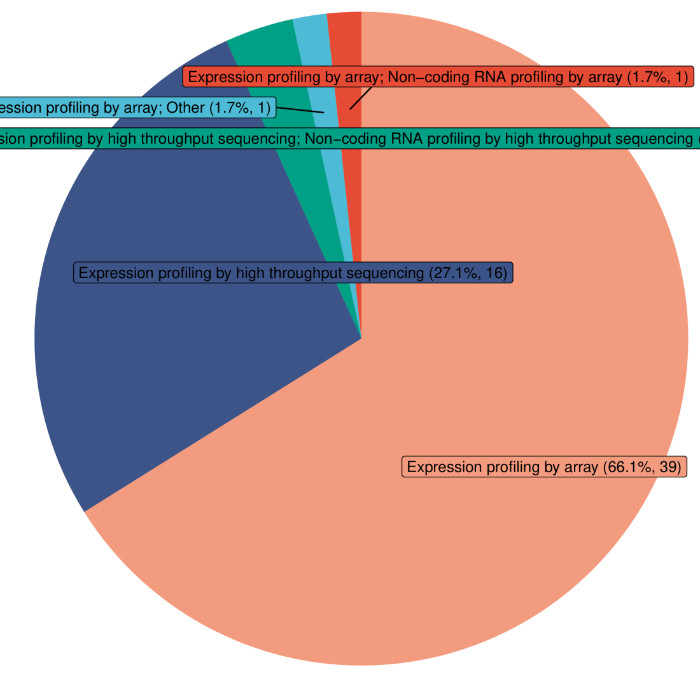

**Fig.** **2** AS All Gds Type

# Reference

1. Ntontsi, P., Photiades, A., Zervas, E., Xanthou, G. & Samitas, K. Genetics and epigenetics in asthma. *International journal of molecular sciences* **22**, (2021).

2. Gusev, A. *et al.* Integrative approaches for large-scale transcriptome-wide association studies. *Nature Genetics* **48**, 245–252 (2016).

3. Langfelder, P. & Horvath, S. WGCNA: An r package for weighted correlation network analysis. *BMC Bioinformatics* **9**, (2008).