**生信分析报告**

**项目标题： 线粒体自噬 ;**

**单 号： BSJF250113 ;**

**分析人员： 黄礼闯 ;**

**分析类型： 生信协助 ;**

**委 托 人： 傅兰君 ;**

**受 托 人： 杭州铂赛生物科技有限公司 .**

# 1 分析流程

筛选与lncRNA MEG3 相关的差异靶基因，且与线粒体自噬相关。

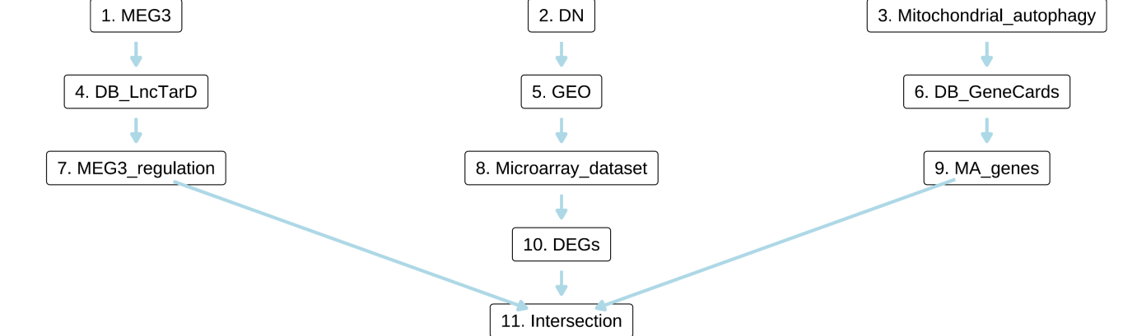

**Fig.** **1** Route

**(File path: Figure+Table_support/1.0_分析流程_{#abstract}/Route.pdf)**

# 2 材料和方法

## 2.1 数据分析平台

在 Linux pop-os x86_64 (6.9.3-76060903-generic) 上，使用 R version 4.4.2 (2024-10-31) (<https://www.r-project.org/>) 对数据统计分析与整合分析。

## 2.2 LncTarD LncRNA调控靶点 (Dataset: MEG3)

从 LncTarD 数据库()1获取 LncRNA 调控数据 (<https://lnctard.bio-database.com/downloadfile/lnctard2.0.zip>)。

## 2.3 Limma 差异分析 (Dataset: DN)

以 limma (3.62.1) (2005)2 差异分析。创建设计矩阵，对比矩阵，差异分析：diabetic_nephropathy vs healthy_control。使用 limma::lmFit, limma::contrasts.fit, limma::eBayes 拟合线形模型。以 limma::topTable 提取所有结果，并过滤得到 P.Value 小于 0.05，|Log2(FC)| 大于 0.5 的统计结果。

## 2.4 GeneCards 基因获取 (Dataset: AUTO)

从 GeneCards 数据库 (2016, Current protocols in bioinformatics)3 获取 Mitochondrial autophagy 相关的基因集，得分 cut-off 为 0。

# 3 分析结果

## 3.1 LncTarD LncRNA调控靶点 (MEG3)

从 LncTarD 数据库检索 MEG3 的调控靶基因。 Tab. **1** 为 LncRNA (MEG3) 调控的靶点基因附表。

**Tab.** **1** MEG3 lnc RNA regulation data

| DiseaseName | Regulator | Target | RegulationDiretion | Experimental.meth... |
| --- | --- | --- | --- | --- |
| Chronic myeloid l... | MEG3 | MiR-21 | Negatively-E | RNA pull-down ass... |
| Breast cancer | MEG3 | NFKB1 | Positively-E | Immunofluorescenc... |
| Breast cancer | MEG3 | TP53 | Positively-E | RNAi;western blot |
| Hemangioma | MEG3 | MiR-494 | Negatively-F | Luciferase report... |
| Pre-eclampsia | MEG3 | SMAD7 | Positively-E | RNAi |
| ... | ... | ... | ... | ... |

**(File path: Figure+Table_support/3.1_LncTarD_LncRNA调控靶点_(MEG3)/MEG3-lnc-RNA-regulation-data.xlsx)**

## 3.2 GEO 数据获取 (DN)

* Data Source ID: GSE142153
* data_processing: Agilent Feature Extraction Software was used for background subtraction GeneSpring was used for normalization

**(见Figure+Table_support/3.2_GEO_数据获取_(DN)/DN-GSE142153-content)**

## 3.3 Limma 差异分析 (DN)

匹配 group 中包含“healthy_control|diabetic_nephropathy”的描述，最终得到 33 例数据。以 公式 ~ 0 + group 创建设计矩阵 (design matrix) 。差异分析：diabetic_nephropathy vs healthy_control。(若 A vs B，则为前者比后者，LogFC 大于 0 时，A 表达量高于 B)。上调或下调 DEGs 统计：up (n=748) , down (n=800)

Fig. **2** 为 diabetic_nephropathy - healthy_control 差异分析火山图。 Tab. **2** 为 diabetic_nephropathy - healthy_control 差异分析统计表格。

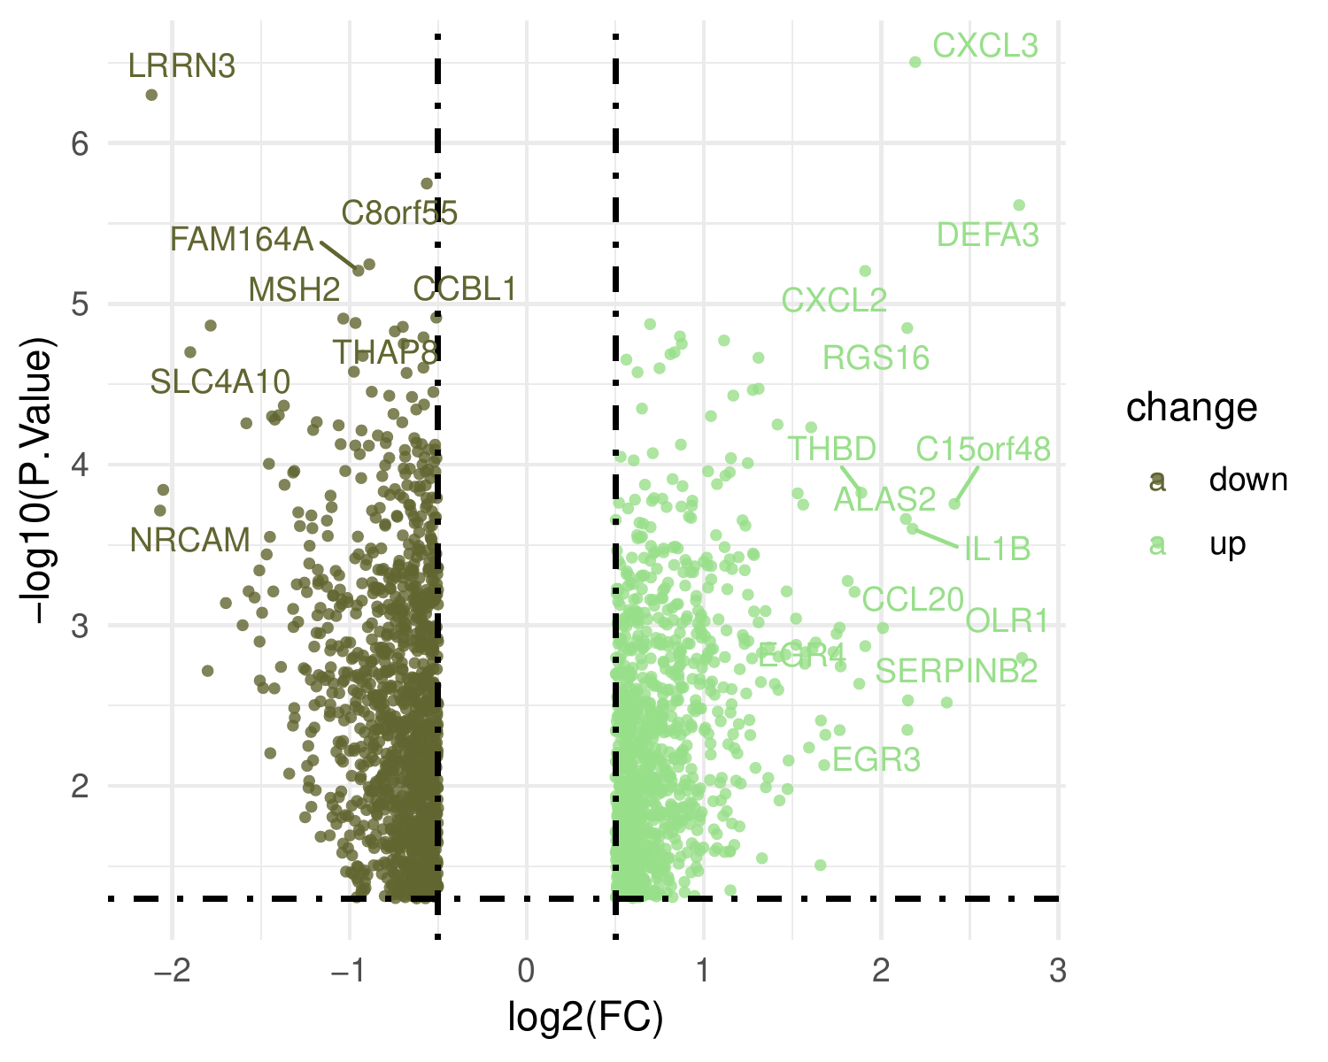

**Fig.** **2** DN diabetic nephropathy vs healthy control

**(File path: Figure+Table_support/3.3_Limma_差异分析_(DN)/DN-diabetic-nephropathy-vs-healthy-control.pdf)**

* P.Value cut-off: 0.05
* Log2(FC) cut-off: 0.5

**(See: Figure+Table_support/3.3_Limma_差异分析_(DN)/DN-diabetic-nephropathy-vs-healthy-control-content)**

**Tab.** **2** DN data diabetic nephropathy vs healthy control

| GENE SYMBOL | LogFC | P.Value | Rownames | ID |
| --- | --- | --- | --- | --- |
| CXCL3 | 2.191 | 3.133e-07 | A 24 P183150 | A 24 P183150 |
| LRRN3 | -2.117 | 5.019e-07 | A 24 P187766 | A 24 P187766 |
| C8orf55 | -0.5642 | 1.785e-06 | A 23 P257057 | A 23 P257057 |
| DEFA3 | 2.778 | 2.433e-06 | A 23 P31816 | A 23 P31816 |
|  | -0.8883 | 5.681e-06 | A 24 P560431 | A 24 P560431 |
| ... | ... | ... | ... | ... |

**(File path: Figure+Table_support/3.3_Limma_差异分析_(DN)/DN-data-diabetic-nephropathy-vs-healthy-control.tsv)**

## 3.4 GeneCards 基因获取 (AUTO)

从 GeneCards 搜索 Mitochondrial autophagy, 获取对应靶点数据，统计为 Protein Coding (n=91) , RNA Gene (lncRNA) (n=5) , RNA Gene (miRNA) (n=3) , RNA Gene (tRNA) (n=1) 。共 100 个靶点。 Tab. **3**

**Tab.** **3** AUTO disease related targets from GeneCards

| Symbol | Description | Category | UniProt ID | GIFtS |
| --- | --- | --- | --- | --- |
| PRKN | Parkin RBR E3 Ubi... | Protein Coding | O60260 | 62 |
| RNF185 | Ring Finger Prote... | Protein Coding | Q96GF1 | 42 |
| DNM1L | Dynamin 1 Like | Protein Coding | O00429 | 61 |
| PINK1 | PTEN Induced Kina... | Protein Coding | Q9BXM7 | 60 |
| BNIP1 | BCL2 Interacting ... | Protein Coding | Q12981 | 46 |
| ... | ... | ... | ... | ... |

**(File path: Figure+Table_support/3.4_GeneCards_基因获取_(AUTO)/AUTO-disease-related-targets-from-GeneCards.xlsx)**

* The GeneCards data was obtained by querying: Mitochondrial autophagy
* Restrict (with quotes): TRUE
* Filtering by Score:: Score > 0

## 3.5 交集: Mitochondrial_autophagy + DN_DEGs + MEG3_regulation (TARGET)

以下取交集： - 基因集 (来自于GeneCards 基因获取[Section: AUTO]) - 基因集 (diabetic_nephropathy - healthy_control, 来自于Limma 差异分析[Section: DN]) - 基因集 (miR-21, NFKB1, TP53, …[n = 208], 来自于LncTarD LncRNA调控靶点[Section: MEG3])

Fig. **3** 将Mitochondrial_autophagy, DN_DEGs, MEG3_regulation 取交集。 Fig. **4** 基因 HIF1A, TNF, NFE2L2 表达水平，以及对应的 limma 差异分析显著水平。

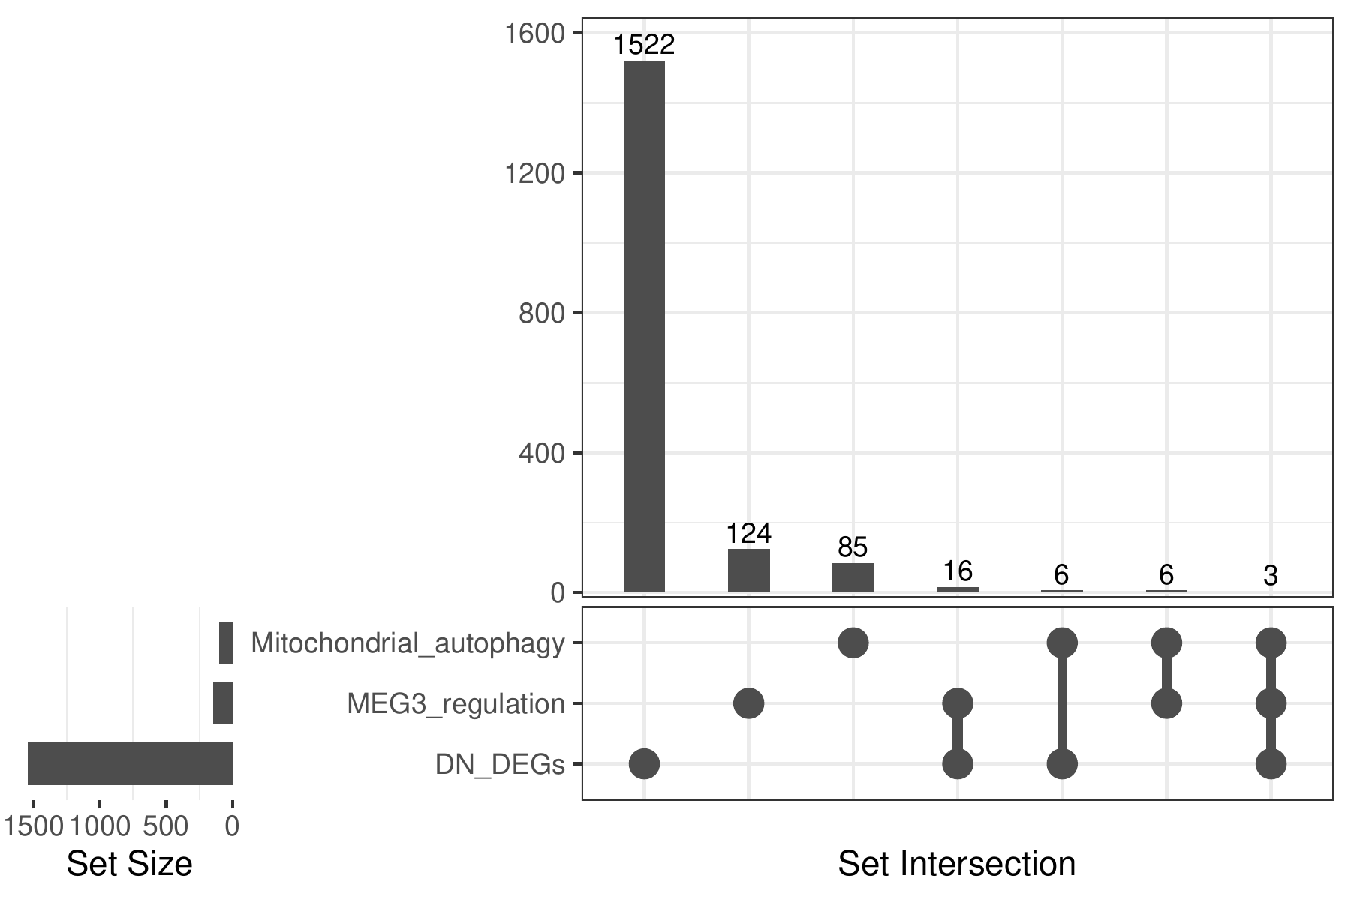

**Fig.** **3** Intersection of Mitochondrial autophagy with DN DEGs with MEG3 regulation

**(File path: Figure+Table_support/3.5_交集:_Mitochondrial_autophagy_+_DN_DEGs_+_MEG3_regulation_(TARGET)/Intersection-of-Mitochondrial-autophagy-with-DN-DEGs-with-MEG3-regulation.pdf)**

* All_intersection: HIF1A, TNF, NFE2L2

**(See: Figure+Table_support/3.5_交集:_Mitochondrial_autophagy_+_DN_DEGs_+_MEG3_regulation_(TARGET)/Intersection-of-Mitochondrial-autophagy-with-DN-DEGs-with-MEG3-regulation-content)**

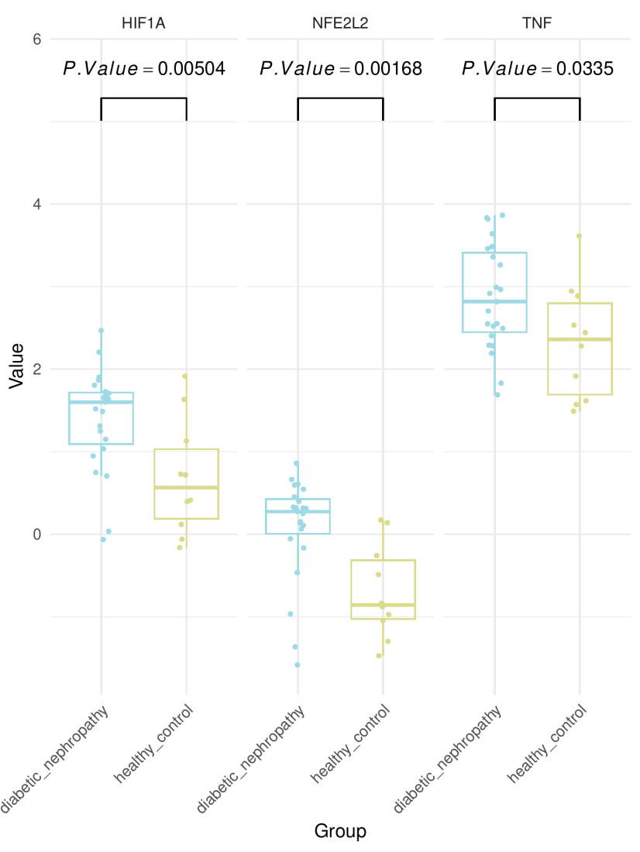

**Fig.** **4** DN Box Plot Of DEGs

**(File path: Figure+Table_support/3.5_交集:_Mitochondrial_autophagy_+_DN_DEGs_+_MEG3_regulation_(TARGET)/DN-Box-Plot-Of-DEGs.pdf)**

# 4 总结

筛选的 LncRNA MEG3 的调控 DEGs 为 HIF1A, TNF, NFE2L2，见 Fig. **3** , Fig. **4**

# Reference

1. Zhao, H. *et al.* LncTarD 2.0: An updated comprehensive database for experimentally-supported functional lncRNA-target regulations in human diseases. *Nucleic acids research* **51**, D199–D207 (2023).

2. Smyth, G. K. Limma: Linear models for microarray data. in *Bioinformatics and Computational Biology Solutions Using R and Bioconductor* (eds. Gentleman, R., Carey, V. J., Huber, W., Irizarry, R. A. & Dudoit, S.) 397–420 (Springer-Verlag, 2005). doi:[10.1007/0-387-29362-0_23](https://doi.org/10.1007/0-387-29362-0_23).

3. Stelzer, G. *et al.* The genecards suite: From gene data mining to disease genome sequence analyses. *Current protocols in bioinformatics* **54**, 1.30.1–1.30.33 (2016).