**生信分析报告**

**项目标题： 代谢组学数据分析流程 ;**

**单 号： BSJF240719 ;**

**分析人员： 黄礼闯 ;**

**分析类型： 模块开发 ;**

**委 托 人： ;**

**受 托 人： 杭州铂赛生物科技有限公司 .**

# 1 分析流程

## 1.1 思路

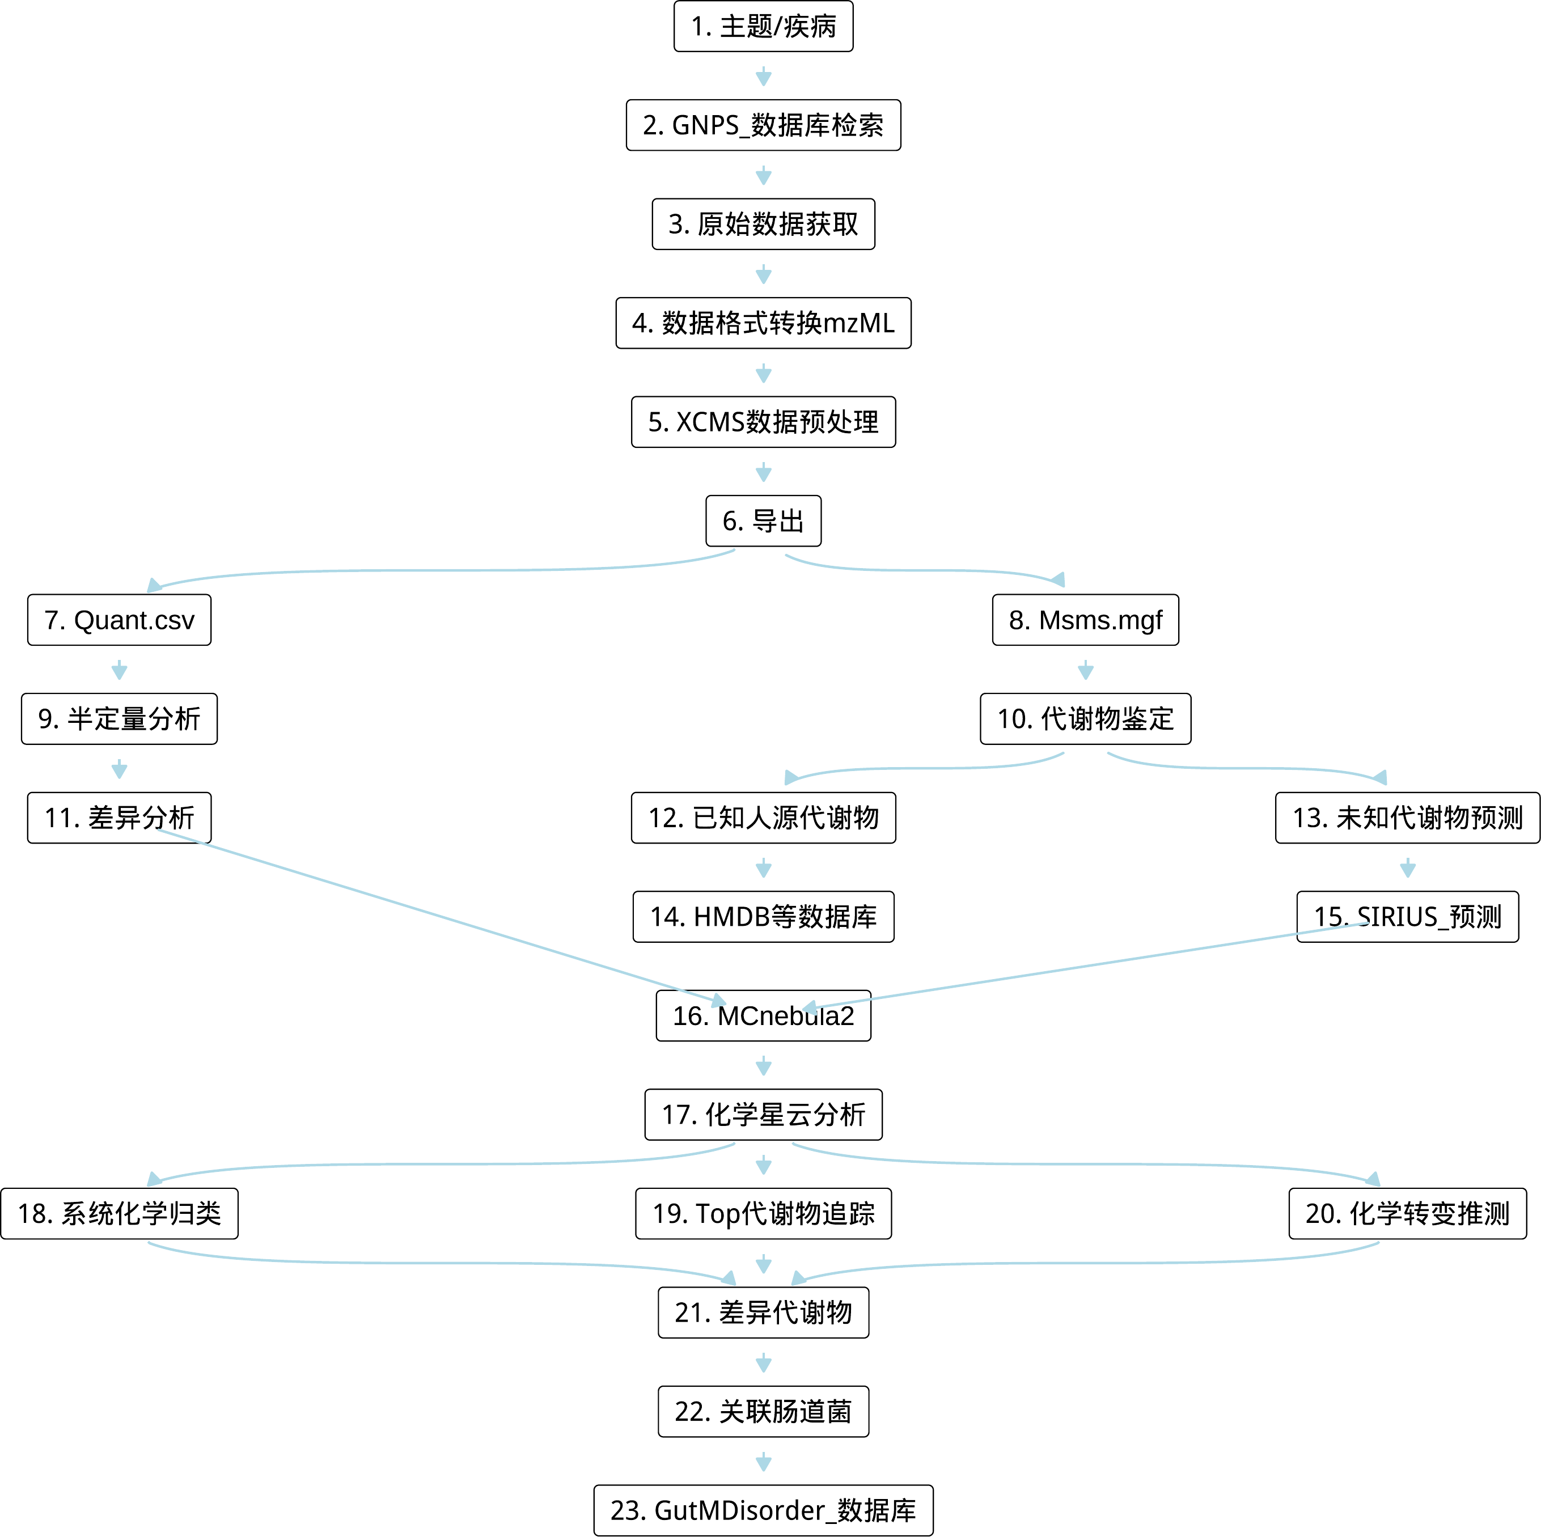

**Fig.** Route

* 参考 <https://mcnebula.org/>。
* <https://github.com/Cao-lab-zcmu/MCnebula2>
* (2023, **IF:6.7**, Q1, Analytical chemistry)1
* (2025, **IF:3.8**, Q1, Journal of chromatography. A)2
* (2025, Food research international (Ottawa, Ont.))3
* (2022, **IF:3.6**, Q2, Analyst)4

## 1.2 程序

<https://github.com/shaman-yellow/utils.tool/tree/master/R>

workflow_061_msconvert.R

workflow_062_xcms.R

workflow_063_sirius.R

# Reference

1. Huang, L. *et al.* MCnebula: Critical chemical classes for the classification and boost identification by visualization for untargeted lc-ms/ms data analysis. *Analytical chemistry* **95**, 9940–9948 (2023).

2. Chen, S. *et al.* Molecular network strategies combined with mcnebula2 identify potential active compounds from steamed polygonatum cyrtonema hua. *Journal of chromatography. A* **1746**, (2025).

3. Liu, R. *et al.* MCnebula analysis combined with alpha-glucosidase inhibitory screening reveals potential chemical contributors to efficacy enhancement of natural products after processing. *Food research international (Ottawa, Ont.)* **205**, (2025).

4. Lai, J. *et al.* A deep clustering-based mass spectral data visualization strategy for anti-renal fibrotic lead compound identification from natural products. *Analyst* **147**, 4739–4751 (2022).