plot(1:10)

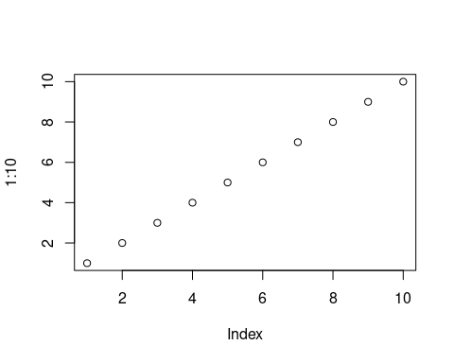

图

# 一、test

Article[5,4,3,2,1]

[1] Lai J, Huang L, Bao Y, 等. [A Deep Clustering-Based Mass Spectral Data Visualization Strategy for Anti-Renal Fibrotic Lead Compound Identification from Natural Products](https://doi.org/10.1039/D2AN01185A)[J]. The Analyst, 2022, 147(21): 4739–4751.

[2] Huang L, Lyu Q, Zheng W, 等. [Traditional Application and Modern Pharmacological Research of Eucommia Ulmoides Oliv.](https://doi.org/10.1186/s13020-021-00482-7)[J]. Chinese medicine, 2021, 16(1): 73.

[3] Huang L, Hu S, Shao M, 等. [Combined Cornus Officinalis and Paeonia Lactiflora Pall Therapy Alleviates Rheumatoid Arthritis by Regulating Synovial Apoptosis via AMPK-Mediated Mitochondrial Fission](https://doi.org/10.3389/fphar.2021.639009)[J]. Frontiers in Pharmacology, 2021, 12: 639009.

[4] Li Q, Hu S, Huang L, 等. [Evaluating the Therapeutic Mechanisms of Selected Active Compounds in Cornus Officinalis and Paeonia Lactiflora in Rheumatoid Arthritis via Network Pharmacology Analysis](https://doi.org/10.3389/fphar.2021.648037)[J]. Frontiers in Pharmacology, 2021, 12: 648037.

[5] Wang K, Xu X, Shan Q, 等. [Integrated Gut Microbiota and Serum Metabolomics Reveal the Protective Effect of Oleanolic Acid on Liver and Kidney-injured Rats Induced by *Euphorbia* *Pekinensis*](https://doi.org/10.1002/ptr.7673)[J]. Phytotherapy Research, 2022: ptr.7673.