officedown example

1.1

## Table of content

1.1. Table of content 1

1.2. List of figures 1

1.3. List of tables 1

1.4. A two columns section 1

1.5. Tables 1

1.6. Reference 2

1.7. figures 2

1.7.1. A boxplot 2

1.8. Landscape section 3

## List of figures

**Figure :** A boxplot 2

## List of tables

**Table :** caption 1 1

## A two columns section

Lorem ipsum dolor sit amet, consectetur adipiscing elit. Nulla eu pulvinar arcu, quis aliquam dui.

In at cursus ante.

Curabitur ligula quam, iaculis faucibus orci quis, vestibulum lobortis lectus.

Suspendisse fringilla nisl pulvinar, laoreet tellus sed.

## Tables

head(mtcars)

**Table** **:** caption 1

| mpg | cyl | disp | hp | drat | wt | qsec | vs | am | gear | carb |
| --- | --- | --- | --- | --- | --- | --- | --- | --- | --- | --- |
| 21.0 | 6 | 160 | 110 | 3.90 | 2.620 | 16.46 | 0 | 1 | 4 | 4 |
| 21.0 | 6 | 160 | 110 | 3.90 | 2.875 | 17.02 | 0 | 1 | 4 | 4 |
| 22.8 | 4 | 108 | 93 | 3.85 | 2.320 | 18.61 | 1 | 1 | 4 | 1 |
| 21.4 | 6 | 258 | 110 | 3.08 | 3.215 | 19.44 | 1 | 0 | 3 | 1 |
| 18.7 | 8 | 360 | 175 | 3.15 | 3.440 | 17.02 | 0 | 0 | 3 | 2 |
| 18.1 | 6 | 225 | 105 | 2.76 | 3.460 | 20.22 | 1 | 0 | 3 | 1 |

## Reference

see figure and table !

## figures

### A boxplot

boxplot(1:8)

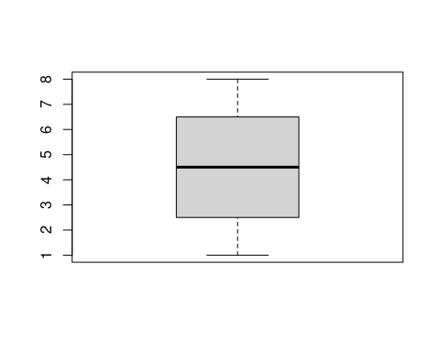

**Figure** **:** A boxplot

## Landscape section

