

***Report on***

**“Early Pest Detection using Image Processing”**

*Submitted in partial fulfilment of the requirements for* ***Sem IV***

**IMAGE PROCESSING AND DATA VISUALIZATION USING MATLAB**

**Bachelor of Technology**

**in**

**Computer Science & Engineering**

***Submitted by:***

|  |  |
| --- | --- |
| **Neha B**  **Serena A Gomez**  **Shamanth N Chitturi** | **PES2UG19CS252**  **PES2UG19CS372**  **PES2UG19CS374** |

*Under the guidance of*

|  |
| --- |
| **<Prof. Swati Pratap Jagdale>**  <Assistant Professor>  PES University, Bengaluru |

**January – May 2021**

**DEPARTMENT OF COMPUTER SCIENCE AND ENGINEERING**

**PES UNIVERSITY**

(Established under Karnataka Act No. 16 of 2013)

100ft Ring Road, Bengaluru – 560 085, Karnataka, India

**TABLE OF CONTENTS**

|  |  |  |
| --- | --- | --- |
| **Chapter No.** | **Title** | **Page No.** |
|  | **Abstract** |  |
|  | **Problem Statement** |  |
|  | **Module Description** |  |
|  | **High Level Design/Architecture** |  |
|  | **Implementation (Algorithm, platform, s/w, tools used etc…)** |  |
|  | **Result snapshots** |  |

# Abstract

One of the most important fields in Agricultural Research is – Pest detection & control. This has a direct impact on the agriculturalist’s livelihood - profit, productivity and food quality. A lot of research is focused on the use of non-chemical pest control methods. Today, the primary method to detect pests in plants is manual – which is time consuming & error prone. Once the onset of the pest is detected early in its lifecycle – it is possible to control the spread effectively.

In our project we perform pest detection in a rice field. One of the major causes of pest infestation of rice crops are Planthoppers. Images taken from the field are sent as input test images to detect whether a planthopper is present or not, and if present we detect what stage of life it is in.

This information is useful to the farmer as he will know what type of pesticide he needs to use. If the test image is identified as a phase 1 planthopper, it would mean that the pest is still in the early stages therefore destroy the plant faster. Hence a stronger pesticide must be used in the area where the pest was found as soon as possible; and if the test image is identified as a phase 2 planthopper, it would mean that the pest is in a mature stage and can hence fly and reach further areas and reproduce. Hence the pesticide can be weaker but must be applied in and around the area where the pest was found.

# Problem Statement

The primary objective of this project is to rapidly detect planthoppers – from images obtained using cameras or scanners in the field. These images are processed by image processing methods to interpret the image contents and to detect the planthopper infestation and its extent.

# Module Description

## Train_Presence.m

In this module we are training to check for the presence of a pest which results in a pest detection training model.

## Train_Phase.m

In this module we are training to find the phase of the insect that is found which results in a phase detection training model.

## Test_Presence.m

In this module, we take an input test image and classify it as ‘pest detected’ or ‘pest not detected’ using the pest detection training model.

## Test_Phase.m

In this module, if pest is detected we classify it as ‘Phase 1 Planthopper’ or ‘Phase 2 Planthopper’ using the phase detection training model.

# High Level Design/Architecture

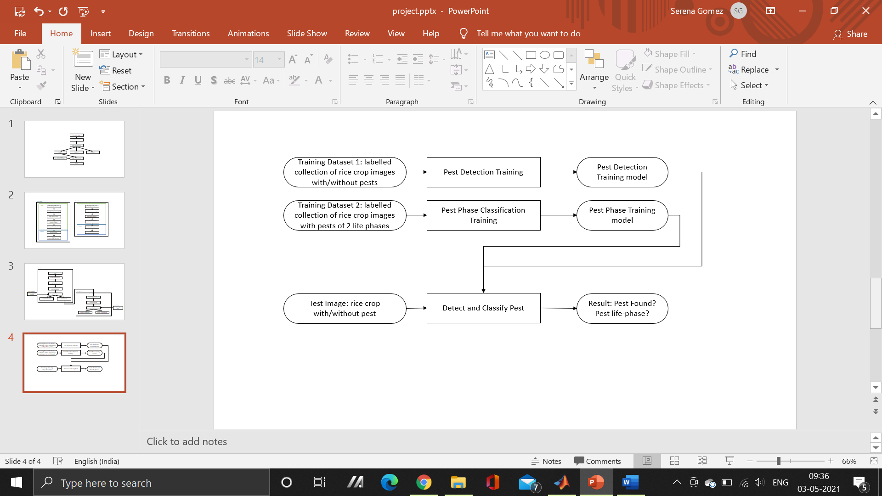

# Implementation

**TRAINING**

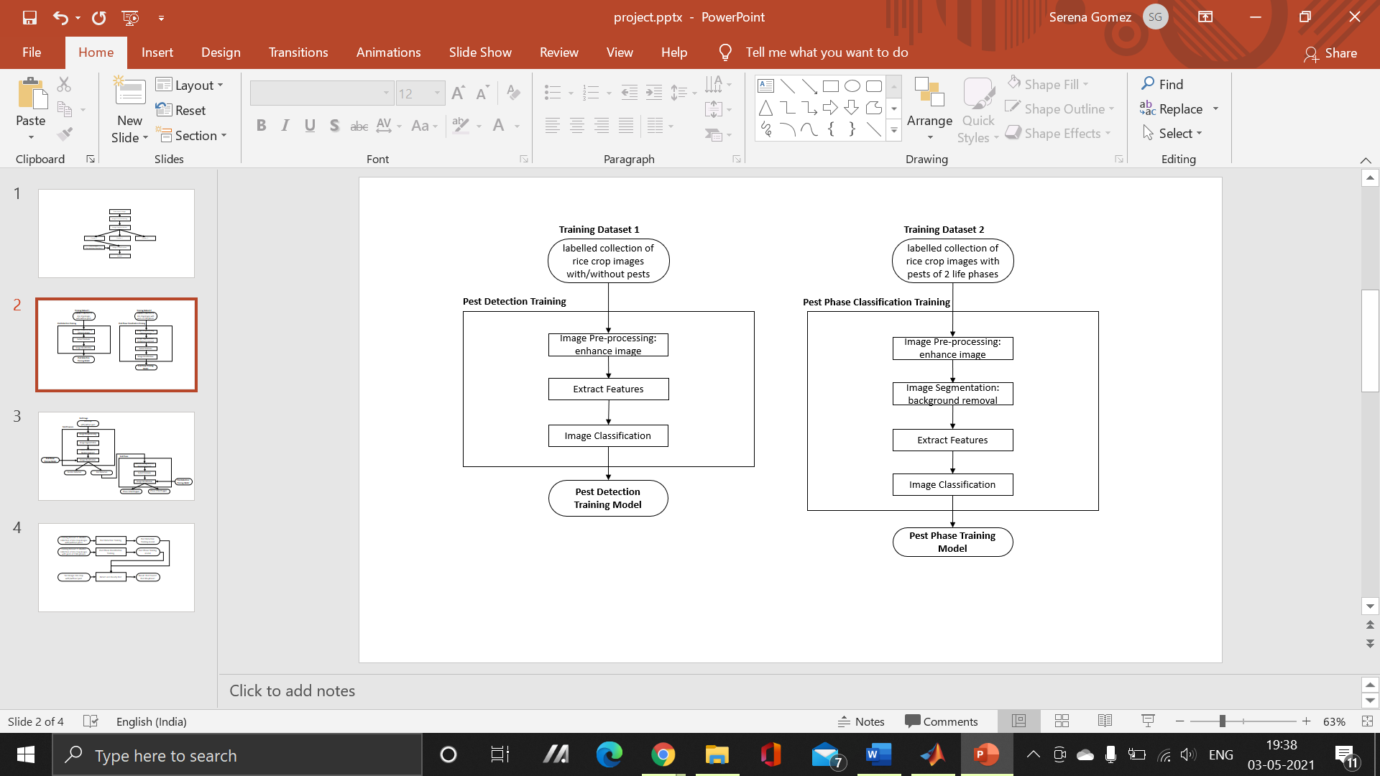

**TESTING**

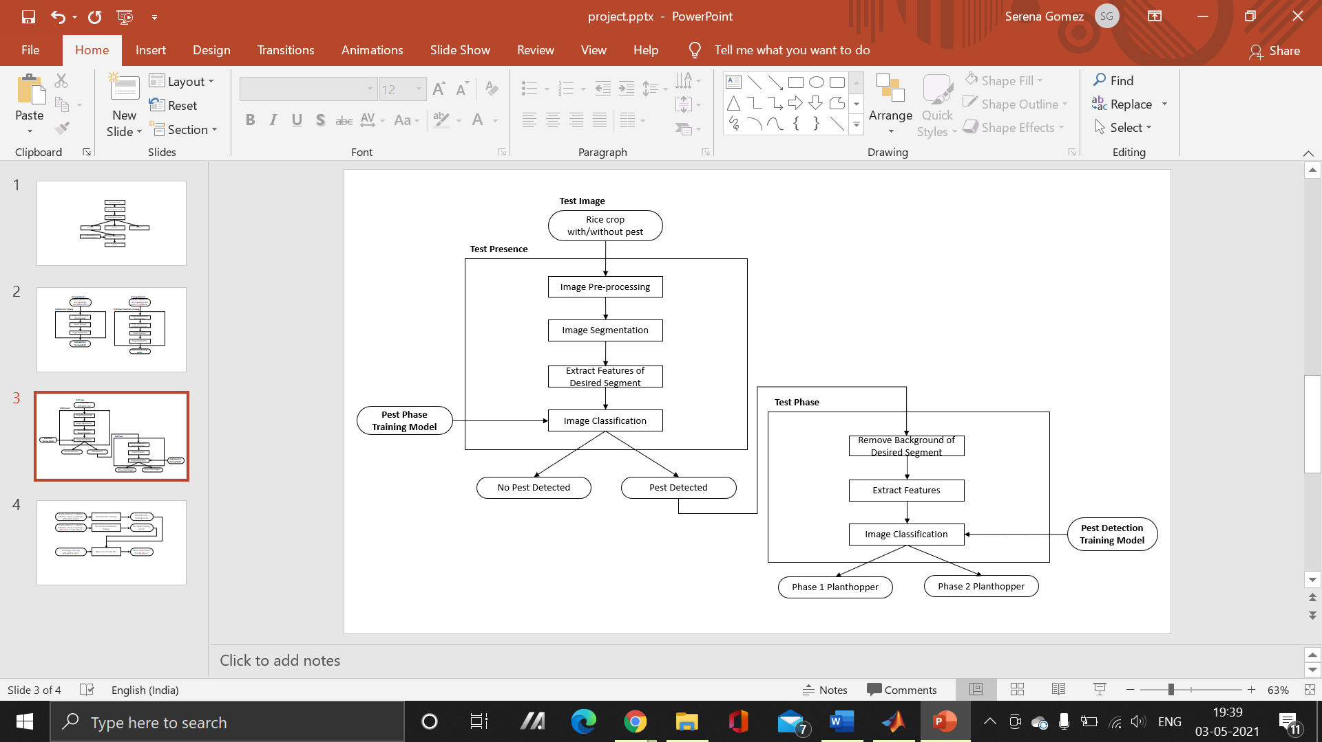

## Image Pre-processing

The crop image will be read and the following pre-processing functions will be applied:

* Resize
* Adjust
* Enhance contrast

## Image Segmentation

The goal of segmentation is to divide the image into meaningful sections. The result of image segmentation is a set of segments that collectively cover the entire image. Each of the pixels in a region is similar with respect to some characteristic or computed property such as colour, intensity, or texture.

For example, a pre-processed crop image can be divided into three segments - the background and the pest.

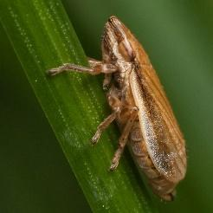 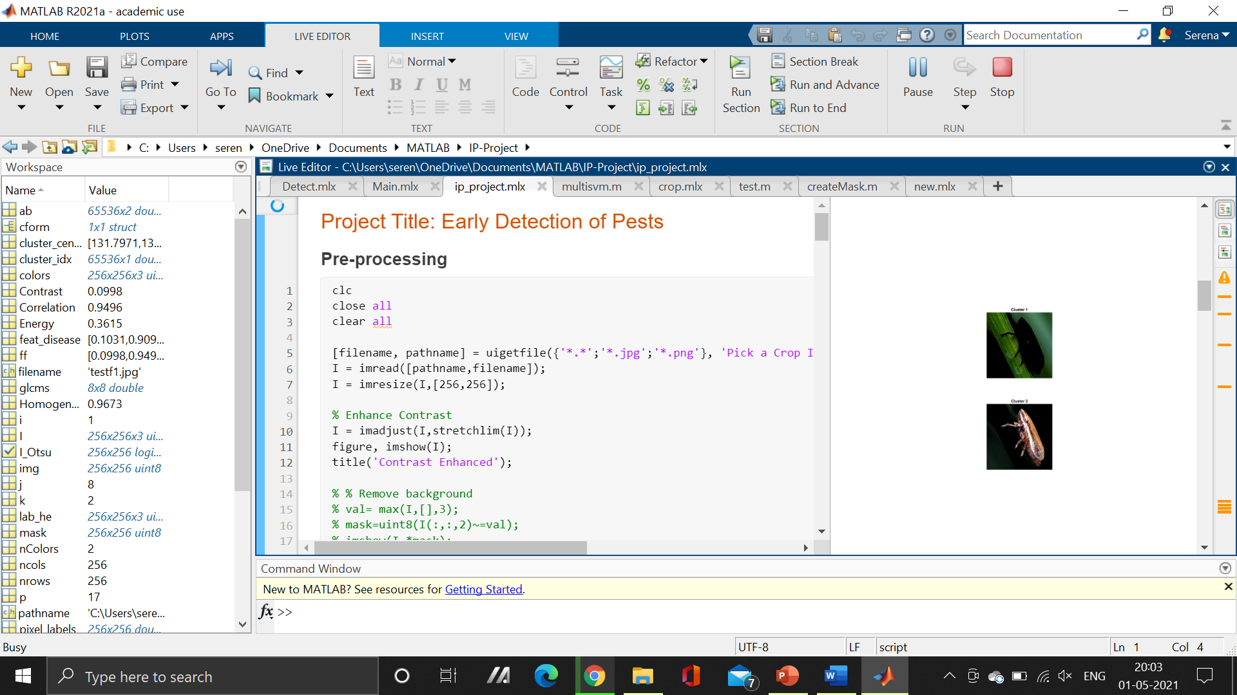 

#### Algorithm used: K-means Clustering

*k-means clustering*, or Lloyd’s algorithm, is an iterative, data-partitioning algorithm that assigns *n* observations to exactly one of *k* clusters defined by centroids, where *k* is chosen before the algorithm starts.

The algorithm proceeds as follows:

1. Choose *k* initial cluster centres (*centroid*).
2. Compute point-to-cluster-centroid distances of all observations to each centroid.
3. There are two ways to proceed:
   1. Batch update — Assign each observation to the cluster with the closest centroid.
   2. Online update — Individually assign observations to a different centroid if the reassignment decreases the sum of the within-cluster, sum-of-squares point-to-cluster-centroid distances.
4. Compute the average of the observations in each cluster to obtain *k* new centroid locations.
5. Repeat steps 2 through 4 until cluster assignments do not change, or the maximum number of iterations is reached.

## Image Classification

### Training

A set of training images go through the following processes:

* Image acquisition & pre-processing
* Image Segmentation
* Saving desired segment into a folder as .png file

The images in the new folder are then processed to extract some of its features (Contrast, Correlation, Energy and Homogeneity). The values of these features are being saved into a .mat file.

### Testing

The input image is classified using the SVM Classifier as: Pest not Detected or Pest Detected; and if the pest is detected it is classified as: Phase 1 Planthopper or Phase 2 Planthopper.

#### Algorithm Used: SVM Classification

An SVM (support vector machine) classifies data by finding the best hyperplane that separates all data points of one class from those of the other class.

fitcsvm Implementation: For binary classification, if you do not set a fraction of expected outliers in the data then the default solver is Sequential Minimal Optimization (SMO). SMO minimizes the one-norm problem by a series of two-point minimizations. During optimization, SMO respects the linear constraint , and explicitly includes the bias term in the model. SMO is relatively fast.

# Result Snapshots -- TODO

By using different image processing techniques to detect and extract the pests in the captured image, an efficient non-chemical pest control system is designed.

**input images predicted outputs**

**phase-1**

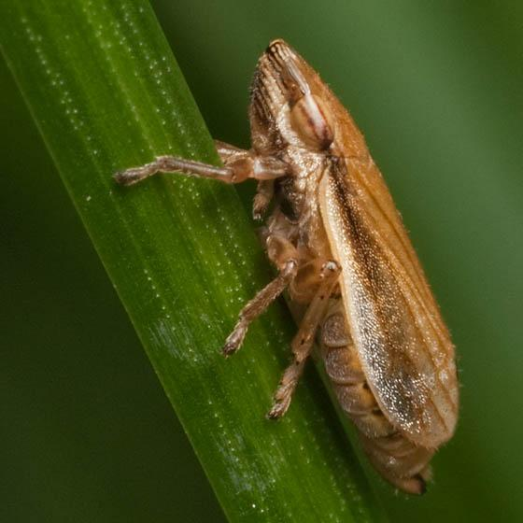 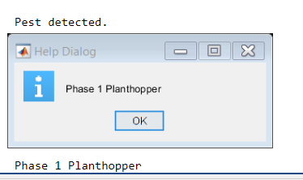

**phase-2**

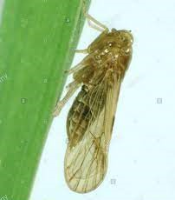 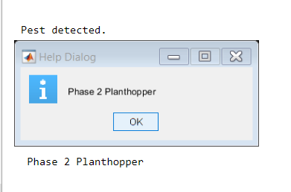

**phase-3**

 