OpenGL Notes
Table of Contents
Graphics pipeline 2
1. Vertex Shader 2
2. Shape Assembly 3
3. Geometry Shader 3
4. Rasterization 3
5. Fragment Shader 3
6. Testing and Blending 3
Setting up pipeline 3
1. Vertex Shader 3
2. Fragment Shader 4
3. Shader Program 5
4. Linking vertex attributes 6
5. Rending the vertex attributes 7
OpenGL Shader Language (GLSL) 7
Data types 8
Ins and outs 9
Uniform 9
Textures 9
1. Texture wrapping 10
2. Texture filtering 10
3. Mipmaps 11
Filtering options 11
4. stb_image.h 11
5. Generating texture 11
Transformation 12
1. Vector rotation 12
2. GLM 13
Coordinate system 13
1. Global picture 13
Orthographic projection matrix 15
Perspective matrix 15
Putting together 16
2. Creating 3D objects 16
Camera 17
1. Camera space 17
2. Look at 17
3. Euler angles 18
Lighting 18
1. Colors 18
2. Basic lighting 18
Phong light model 18
Ambient lighting 19
Diffuse lighting 19
Normal matrix 20
Miscellaneous 20
Coordinates convention 20
Normalized Device Coordinates (NDC) 20
Check (Shader) compilation status 20

Graphics pipeline

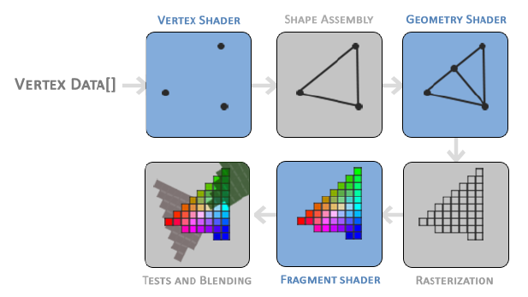
The sections where we can inject our own shader (marked in blue):
- Vertex shader
- Geometry shader
- Fragment shader

Vertex Shader
Vertex’s data is represented with vertex attributes that can contains any data we like.
Ex: 3D co-ordinates, color value
Vertex data is sent to the vertex shader storing it in the GPU memory, configure how OpenGL will be interpret this memory and specify how to send this data to GPU. The memory on the GPU is managed via vertex buffer objects (VBO) that store a large number of vertices in the memory.

unsigned int VBO; // Buffer ID
glGenBuffer(1, &VBO); // Buffer is generated
glBindBuffer(GL_ARRAY_BUFFER, VBO); // Define that the buffer is of type array
glBufferData(GL_ARRAY_BUFFER, sizeof(vertices), vertices, GL_STATIC_DRAW)

glBufferData is used to copy the vertex data to the GPU. Its arguments are follows:
- buffer type
- size of the input data (in bytes)
- the data
- Denotes how we want the GPU to manage the data
  - GL_STREAM_DRAW: The data is set only once and used few times
  - GL_STATIC_DRAW: The data is set only once and used many times
  - GL_DYNAMIC_DRAW: the data is changes a lot and used many times

Shape Assembly
The primitive assembly stage take vertices has input from the vertex shader to assemble all the points in to a primitive shape.
Primitive shapes includes – GL_POINTS, GL_TRIANGLES, GL_LINE_STRIP

Geometry Shader
The vertices that forms primitive shapes from the primitive assembly stage is processed by the geometry shader to generate other shapes (if required) by emitting new vertices to form new (or other) primitive(s).

Rasterization
The rasterization stage maps the output of the geometry shader to the corresponding pixels on the final screen. It will also performs clipping, where all the fragments outside the view is removed.

Fragment Shader
Calculates the final color of the pixel. The calculation can include the interference by the 3D scene – lighting, shadow, color of the light, etc.

Testing and Blending
This stage checks the depth (and stencil) value of the fragment and checks if fragment is in front or back of other fragments and will be discarded accordingly.
In modern OpenGL, we need to define vertex shader and fragment shader. As there is no default shaders are this stages.

Setting up pipeline

Vertex Shader
Defined with GLSL. We declare all the input vertex attribute with in keyword. To set the output of the vertex shader we have to assign the position data to the predefined gl_Position variable which is a vec4, which the 4 coordinates are x, y, z and w. w is perspective division.
Sample simple vertex shader

const char* vertexShaderSource = "#version 330 core\n"
"layout (location = 0) in vec3 aPos;\n"
"void main() {\n"
" gl_Position = vec4(aPos.x, aPos.y, aPos.z, 1.0);\n"
"}\0";

The shader source is compiled during run time. For this the shader object is created as follows:

unsigned int vertexShader;
vertexShader = glCreateShader(GL_VERTEX_SHADER);

Next we attach the shader source code and compile it:

glShaderSource(vertexShader, 1, &vertexShaderSource, NULL);
glCompileShader(vertexShader);

glShaderSource arguments:
- vertex shader object’s ID
- Number of the shader source (1 in this case)
- shader source code
- Set to NULL

Fragment Shader
The colors RGBA will have values between 0.0 to 1.0.
Here we define the version number and the core profile functionality. Then 1 output value with out keyword.
Sample simple fragment shader

const char* fragmentShaderSource = "#version 330 core\n"
"out vec4 FragColor;\n"
"int main() \n"
"{\n"
" FragColor = vec4(1.0f, 0.5f, 0.3f, 1.0f);\n"
"}\0";

And compile the shader as follows:

unsigned int fragmentShader;
fragmentShader = glCreateShader(GL_FRAGMENT_SHADER);
glShaderSource(fragmentShader, 1, &fragmentShaderSource, NULL);
glCompileShader(fragmentShader);

Shader Program
The shader program is the final linked version of the multiple shaders combined. To use the recently compiled shaders we have to link them to the shader program object and then activate this shader program when rendering objects.
When linking the shaders in to a program it links the output of each shader to the inputs of the next shader.
Creating shader program:

unsinged int shaderProgram;
shaderProgram = glCreateProgram();

Next attach all the shaders and then link them to the program.

glAttachShader(shaderProgram, vertexShader);
glAttachShader(shaderProgram, fragmentShader);
glLinkProgram(shaderProgram);

The shader program is then activated:

glUseProgram(shaderProgram);

Finally, delete the shader objects

glDeleteShader(vertexShader);
glDeleteShader(fragmentShader);

Linking vertex attributes

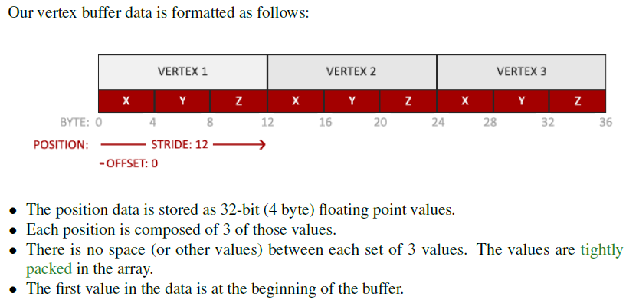
glVertexAttribPointer arguments:
- Denotes which vertex attribute we want to configure. In the vertex shader source, we defined the location = 0, therefore when this (first) argument is 0 the shader source defined above is called
- Denotes the size of the vertex attribute. In the vertex shader source, we have defined in vec3, therefore value = 3
- Specifies the type of data
- Specifies if we what to normalize the data.
- Also known as stride specifies the space between consecutive vertex attribute.
- This is the offset of where the position data begins in the buffer

glVertexAttribPointer(0, 3, GL_FLOAT, GL_FALSE, 3 * sizeof(float), (void*)0);
glEnableVertexAttribArray(0);

Vertex Array Object (VAO) – Attribute pointers are can be bounded to VAO. Any calls to the attribute calls will be stored in the VAO. VAO stores the following:
- Calls to glEnableVertexAttribArray and glDisableVertexAttribeArray.
- Vertex attributes configurations via glVertexAttribPointer
- VBO associated with vertex attributes via glVertexAttribPointer

usgined int VAO;
glGenVertexArrays(1, &VAO);
glBindVertexAraay(VAO);

Rending the vertex attributes

glUseProgram(shaderProgram);
glBindVertexArray(VAO);
glDrawArrays(GL_TRIANGLE, 0, 3);

Note: Code so far – \src\1.getting_started\2.1.hello_triangle\hello_triangle.cpp

Element Buffer Object (EBO) – is a buffer that store indices. Which is is used to tell OpenGL what to use as required. This way we avoid redefinition of the indices.

glGenBuffers(1, &EBO); // Similar to VBO, generate Buffer
glBindBuffer(GL_ELEMENT_ARRAY_BUFFER, EBO); // Similar to VBO bind the buffer
glBufferData(GL_ELEMENT_ARRAY_BUFFER, sizeof(indices), indices, GL_STATIC_DRAW); // Similar to VBO buffer the indices

// –- inside the rending loop --
glBindBuffer(GL_ELEMENT_ARRAY_BUFFER, EBO);
glDrawElements(GL_TRIANGLES, 6, GL_UNSIGNED_INT, 0); // Replace the glDrawArray

OpenGL Shader Language (GLSL)
Shader language used to define the shader. Each shader begin with of its version. (Ex: #version 330 core). We also mention that we are using core profile functionality

A typical shader structure

#version version_number
in type in_variable_name
in type in_variable_name

out type out_variable_name

uniform type uniform_name

void main() {
// process the input(s)
…
// set the output
output_variable_name = modified_update
}

In case of vertex shader, the maximum number of vertex attributes are limited by the hardware. OpenGL guarantees that there is always 16 4-component vertex always available. For given hardware, the maximum value can be queried using GL_MAX_VERTEX_ATTRIBUTES.

Int nAttributes;
glGetIntegerv(GL_MAX_VERTEX_ATTRIBUTES, &nAttributes);
std::cout << “Maximum nr of vertex attribute supported: ” << nAttributes << std::endl;

Data types
- int
- float
- double
- uint
- boo
- vectors
- matrices

Vectors
A vector in GLSL is a 1, 2, 3 or 4 component container of any of the basic types.
- vecn: default vector of n floats.
- bvecn: a vector of n booleans.
- ivecn: a vector of n integers.
- uvecn: a vector of n unsigned integers.
- dvecn: a vector of n double components.

We can use .x, .y, .z and .w to access 1st, 2nd, 3rd and 4th component
GLSL also allows rgba for color and stpq for texture coordinates

Swizzling: Allows the following operations
vec2 someVec;
vec4 differentVec = someVec.xyxx;
vec3 anotherVec = differentVec.yzw;
vec4 otherVec = someVec.xxxx + anotherVec.yxzy;

We can vector as arguments for different vector constructor calls
vec2 vect = vec2(0.5, 0.7);
vec4 result = vec4(vect, 0.0, 0.0);
vec4 otherResult = vec4(result.xyz, 1.0);

Ins and outs
Vertex shader requires layout specification for it’s inputs so we can link with vertex data.
Fragment shader required vec4 color output variable.

Uniform
Used to pass values from the application on the CPU to the shader in GPU
Uniform are global
Example:
Fragment Shader
#version 330 core
out vec4 FragColor;
uniform vec4 ourColor;
int main() {
FragColor = ourColor;
}
In the application
int timeValue = glfwGetTime();
float greenValue = (sin(timeValue) / 2.0f) + 0.5f;
int vertexColorLocation = glGetUnformLocation(shaderProgram, “outColor”);
glUseProgram(shaderProgram); // to active shader program
glUniform4f(vertexColorLocation, 0.0f, greenValue, 0.0f, 1.0f); // update the uniform value of type vec4

Textures
Texture coordinates range from 0 to 1. left-bottom is 0,0 and right-top is 1,1
Coordinate system – s, t and r is equivalent to x, y, and z.
Texture pixel is also called as texel

Texture wrapping
- GL_REPEAT: Default. Repeats the texture image
- GL_MIRRORED_REPEAT: same as GL_REPEAT, but mirrors the image with each repeat
- GL_CLAMP_TO_EDGE: Clams the coordinates between 0 and 1. The result is that the higher coordinates is clamped to the edge, resulting in a stretched edge pattern
- GL_CLAMP_TO_BORDER: Coordinate outside the range are no given user-specified border color
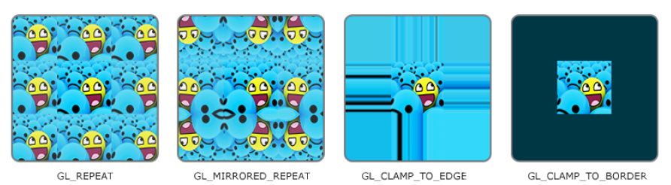
These options can be set per coordinate system
glTexParameteri(GL_TEXTURE_2D, GL_TEXTURE_WRAP_S, GL_MIRRORED_REPEAT);
glTexParameteri(GL_TEXTURE_2D, GL_TEXTURE_WRAP_T, GL_MIRRORED_REPEAT);

For GL_CLAMP_TO_BORDER:
float borderColor[] = {1.0f, 1.0f, 1.0f, 1.0f}
glTextParameterfv(GL_TEXTURE_2D, GL_TEXTURE_BORDER_COLOR, borderColor);

Texture filtering
When the coordinate is smaller than the pixel size (Ex: object is bigger than the texture’s resolution), texture filter is applied, i.e. OpenGL needs to figure out which pixel to use.
Filter options:
- GL_NEAREST (nearest neighbor or point filtering): Default. Chooses the pixel whose center is closest to the point of interest
- GL_LINEAR ((bi)linear filtering): takes interpolated value from the texture coordinate’s neighbor texels, approximating a color between the texel.
Texture filtering can be set for magnifying and minifying operations (when scaling up or downwards) so you could for example use nearest neighbor filtering when textures are scaled downwards and linear filtering for upscaled textures.

glTexParameteri(GL_TEXTURE_2D, GL_TEXTURE_MIN_FILTER, GL_NEAREST);
glTexParameteri(GL_TEXTURE_2D, GL_TEXTURE_MAG_FILTER, GL_LINEAR);

Mipmaps
Mipmaps is a collection of textures where subsequent texture is twice as small compared to the previous one.

Filtering options
- GL_NEAREST_MIPMAP_NEAREST: takes the nearest mipmap to match the pixel size and nearest neighbor interpolation for texture sampling
- GL_LINEAR_MIPMAP_NEAREST: takes the nearest mipmap to match the pixel size and linear interpolation for texture sampling
- GL_NEAREST_MIPMAP_LINEAR: linearly interpolates between 2 mipmap to match the pixel size and nearest neighbor interpolation for texture sampling
- GL_LINEAR_MIPMAP_LINEAR: linearly interpolates between 2 mipmap to match the pixel size and linear interpolation for texture sampling
glTexParameteri(GL_TEXTURE_2D, GL_TEXTURE_MIN_FILTER, GL_LINEAR_MIPMAP_LINEAR);
glTexParameteri(GL_TEXTURE_2D, GL_TEXTURE_MAG_FILTER, GL_LINEAR);
Note: texture magnification does not use mipmap and giving mipmap filter option will generate an OpenGL GL_INVALID_ENUM error code.

stb_image.h
stb_image.h is a library to load various image formats.
Source: www.github.com/nothings/stb/blob/master/stb_image.h

Generating texture
unsigned int texture;
glGenTextures(1, &texture); // number of textures, texture ID
glBundTextures(GL_TEXTURE_2D, texture);
glTexImage2D(GL_TEXTURE_2D, 0, GL_RBG, width, height, 0, GL_RGB, GL_UNSIGNED_BYTE, data);
glGenerateMipmap(GL_TEXTURE_2D);
stbi_image_free(data);

glTextImage2d
- The first argument specifies the texture target; setting this to GL_TEXTURE_2D means this operation will generate a texture on the currently bound texture object at the same target (so any textures bound to targets GL_TEXTURE_1D or GL_TEXTURE_3D will not be affected).
- The second argument specifies the mipmap level for which we want to create a texture for if you want to set each mipmap level manually, but we’ll leave it at the base level which is 0.
- The third argument tells OpenGL in what kind of format we want to store the texture. Our image has only RGB values so we’ll store the texture with RGB values as well.
- The 4th and 5th argument sets the width and height of the resulting texture. We stored those earlier when loading the image so we’ll use the corresponding variables.
- The next argument should always be 0 (some legacy stuff).
- The 7th and 8th argument specify the format and datatype of the source image. We loaded the image with RGB values and stored them as chars (bytes) so we’ll pass in the corresponding values.
- The last argument is the actual image data.

Transformation

Vector rotation
Rotation around x-axis:

Rotation around y-axis:

Rotation around z-axis:

To rotate wrt to unit vector
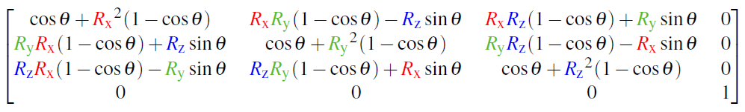
These formulas does not prevent gimbal lock. Quanternions are safer and computation friendly way to perform vector rotaion.
Note: Matrix multiplication must be done right-left when we have vector right most position.

GLM
Reference: www.glm.g-truc.net/0.9.8/index.html
Examples: C:/Users/shama/Documents/Learning/OpenGL/JoeyDeVriesOpenGL/test/testGLM.cpp

Updating the mat4 uniform:
glm::mat4 trans = glm::mat4(1.0f);
usgined int transformLoc = glGetUniformLocation(shader.ID, “transform”);
glUniformMatrix4fv(transformLoc, 1, GL_FALSE, glm::value_ptr(trans)); // Inputs: uniform location, number of matrices, traspose the matrix?, matrix data (translated so that OpenGL can understand)

Coordinate system
5 important coordinate system
- Local space (Object space)
- World space
- View space (eye space)
- Clip space
- Screen space

Global picture
Many transformations are performed. Important transformations are model, view and projection matrix.
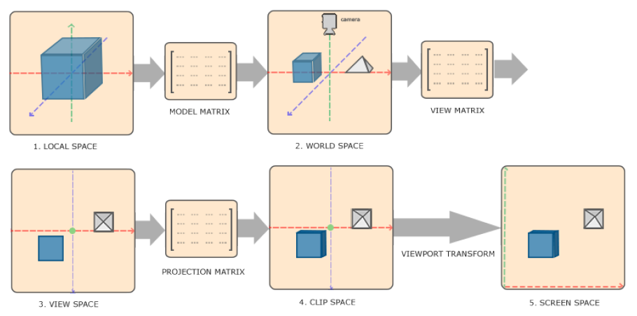
- Local coordinates are the coordinates of objects relative to its local origin.
- Local coordinates are transformed to world space coordinates which are coordinates in respect to the larger world. There coordinates are relative to the global origin where other objects exists wrt the global origin.
- World space is transformed to view space in such a way that each coordinate is as seen from the camera or viewer’s point of view
- View-space coordinate is transformed to clip coordinates range (-1 to 1). This determines which vertices will end on the screen. Projection to clip-space can also add perspective if using perspective projection.
- Lastly, clip-space coordinates is transformed to screen-space coordinates. Also called as viewport transform that transforms the coordinates to the range -1 to 1 defined my glViewport. The resulting coordinates are sent to the rasterizer to turn them to fragments. An orthographic projection matrix defines a cube like frustum box that defines the clipping space where each vertex outside this box is clipped.

Orthographic projection matrix
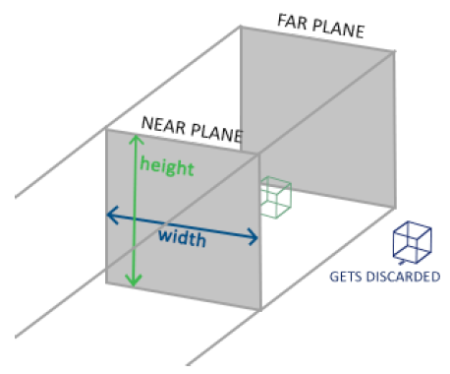
glm:ortho(0.0f, 800.0f, 0.0f, 600.0f, 0.1f 100.0f);
Parmaters:
- left coordinate
- right coordinate
- top coordinate
- bottom coordinate
- distance between the near plane
- distance between the far plane

Perspective matrix
Example of perceptive: far away objects appear smaller.
For info: www.songho.ca/opengl/gl_projectionmatrix.html
glm::mat4 proj = glm::perspective(glm::randians(45.0f), (float)width / (float)height, 0.1f, 100.0f);
Parameters:
- fov. Usually set to 45
- aspect ration of the screen. Width and height of glViewport is used here
- near distance
- far distance
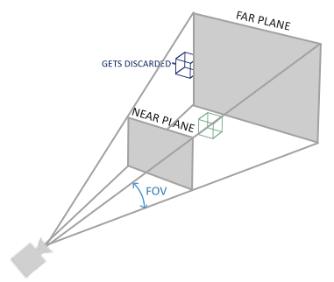
The perspective matrix creates frustum which looks like the image above.

Putting together

Note: the order of matrix multiplication is reversed here. This is assigned to gl_Position in the vertex shader.

Creating 3D objects
- Create model matrix
This contains for translation, rotation and the scaling of the object w.r.t. to the global view.
glm::mat4 model = glm::mat4(1.0f);
model = glm::rotate(model, glm::radians(-55.0f), vec3(1.0f, 0.0f, 0.0f));
- Create view matrix
glm::mat4 view = glm::mat4(1.0f);
view = glm::translate(view, vec3(0,0,-3.3f));
- Create projection matrix
glm::mt4 projection;
projection = glm::prespective(glm::randians(45.0f), 800.f/600.0f, 0.1f, 100f);
- Multiple the matrices: First we need to create uniforms in the vertex shader and the multiplication is done in the vertex shader.
#version core 330
…
uniform mat4 model;
uniform mat4 view;
uniform mat4 project;
int main()
{
gl_Position = project * view * model * vec4(aPos, 1.0f);
…
}
- z-buffer: OpenGL stores all the depth information in a z-buffer (depth buffer). This is disabled by default. To enable use glEnable(GL_DEPTH_TEST); (or glDisable(GL_DEPTH_TEST) if required)

Camera

Camera space
To define camera space, we need (all are glm::vec3):
- Camera position in the world space.
- camera’s direction it is looking at. glm::normalize(cameraPos – cameraTarget);
- a vector pointing to the right
glm::vec3 up = glm::vec3(0.0f, 1.0f, 0.0f);
glm::vec3 cameraRight = glm::normalize(glm::cross(up, cameraDirection));
- a vector pointing to the upwards from the camera. The cross product of x-axis (from the previous step) and z-axis (camera direction) gives the required y-axis
glm::vec3 cameraUp = glm::cross(cameraDirection, cameraRight);

Look at

where,
right vector (x-axis)
up vector (y-axis)
direction vector (z-axis)
Camera’s position vector in the world space
The left matrix acts like rotation matrix and right matrix acts like a translation matrix.
GLM actually performs all these transformation using the function call:
glm::mat4 view;
view = glm::lookAt(glm::vec3(0.0f, 0.0f, 3.0f), glm::vec3(0.0f, 0.0f, 0.0f), glm::vec3(0.0f, 1.0f, 0.0f));
- camera position
- camera target
- dummy up direction to get the right direction vector

Euler angles
Representation of rotation:
- pitch (along x-axis): used to see up/down
- yaw (along y-axis): used to see right/left. For yaw = 0, the camera must be looking at -ve z axis. Therefore, the default value = -90.0f
- roll (along z-axis): represent how much we roll in the space-flight camera
glm::vec3 direction;
direction.x = cos(glm::randians(yaw)) * cos(glm::randians(pitch));
direction.y = sin(glm::randians(pitch));
direction.z = sin(glm::randians(yaw)) * cos(glm::randians(pitch));

Lighting

Colors
Product of light color and object color gives the object’s color due to the light source.

Basic lighting

Phong light model
Components
- Ambient lighting: Constant color. Even in the dark there will be some color
- Diffuse lighting: simulated the directional impact a light source will have on an object.
- Specular lighting: simulates the bright spot of light that appear on shiny objects

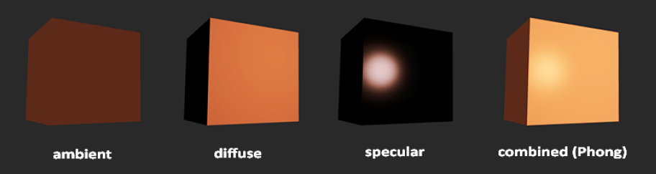

Ambient lighting
int main() {
float ambientStrength = 0.1;
vec3 ambient = ambientStrength * lightColor;
vec3 result = ambient * objectColor;
FragColor = vec4(result, 1.0f);
}

Diffuse lighting
Given the light source position, we first need to get the normal of the vertex (yellow line shown below). The difference between the light source position (in the world view) and fragment gives the light direction. The dot product of the normalize light direction and the fragment gives . Given that the light impact max at . The dot product is given the strength of the light impact. Therefore, multiplying the light vector with dot product gives the actual light reaching the fragment.
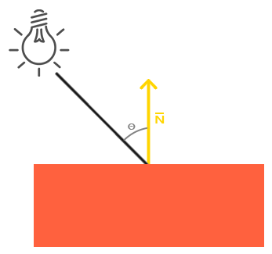
vec3 norm = normalize(Normal);
vec3 lightDir = normalize(lightPos - FragPos);
float diff = max(dot(norm, lightDir), 0.0);
vec3 diffuse = diff * lightColor;

vec3 result = diffuse * objectColor;
FragColor = vec4(result, 1.0);

Normal matrix
So far the object was not translated in accordance with the world view. When we do this, it will effect the normal vectors as well. Due to non-uniform scaling, the normal vector will be not normal (perpendicular) to the surface anymore. To avoid this and translate the normal vector to world view, we use normal matrix for the model transformation.
This normal matrix is the transpose of the inverse of the upper left 3x3 part of the model matrix.
Normal = mat3(transpose(inverse(model))) * aNormal;

Specular lighting
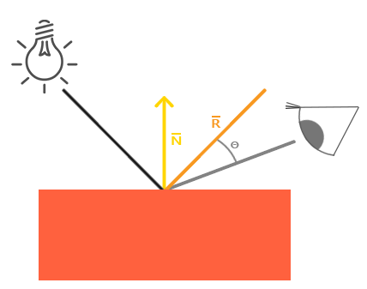
Similar to diffuse light, specular lighting calculated using light source position, normal to the fragment and the viewer’s location. Also, it depends on the reflective properties of the object. That is, we want the reflected light vector.
//specular
float specularStrength = 0.5;
vec3 viewDir = normalize(viewPos – FragPos);
// The reflect function expects the direction from light source to the fragment’s position. ReflDir is the Orange line
vec3 reflDir = reflect(-lightDir, norm);
float spec = pow(max(dot(viewDir, reflDir), 0.0), 32);
vec3 specular = specularStrength * spec * lightColor;
If this model was implemented in the vertex shader, then it’s called as Gauraud shading. Since the calculation is defined for only the vertices, the surrounding the fragment color is determined using interpolation which will look off.

Miscellaneous

Coordinates convention
OpenGL follows right handed system. Right hand’s pointing finger pointing up, thumb to the right and the middle finger to you.

Normalized Device Coordinates (NDC)
The coordinates (x, y and z) which lie in the range -1.0 to 1.0
The NDC will be converted to the screen coordinates based via viewport transform using the data provided in glViewport

Check (Shader) compilation status
Int success;
char infoLog[512];
glGetShaderiv(shaderID, GL_COMPILE_STATUS, &success);
if(!success) {
glGetShaderInfoLog(shaderID, 512, NULL, success);
std:cout << “ERROR::SHADER::COMPILATION_FAILED\n” << infoLog << std:endl;
}

