ID#: 2302648
Full Name: Shamari Haynes
Assignment #: IA#2
Day/Time of Class: Monday 5 -6 PM| Friday 11 – 1 PM
Module Name: Web Programming
Module Code: CIT2011

Business Description: This is an Ecommerce website that supplies quality cricketing gears to professional all around the world

Slogan: Your ultimate cricket destination, Where Champions Are Made!
Mission Statement: To empower every cricketer with access to premium, authentic cricket equipment while providing exceptional customer service and expert guidance. We strive to make quality cricket gear accessible to players across Jamaica and beyond, helping them perform at their best.
Vision Statement: To become the Caribbean's most trusted cricket equipment destination, fostering a vibrant community of cricket lovers and supporting the growth of the sport at all levels—from grassroots to professional cricket.

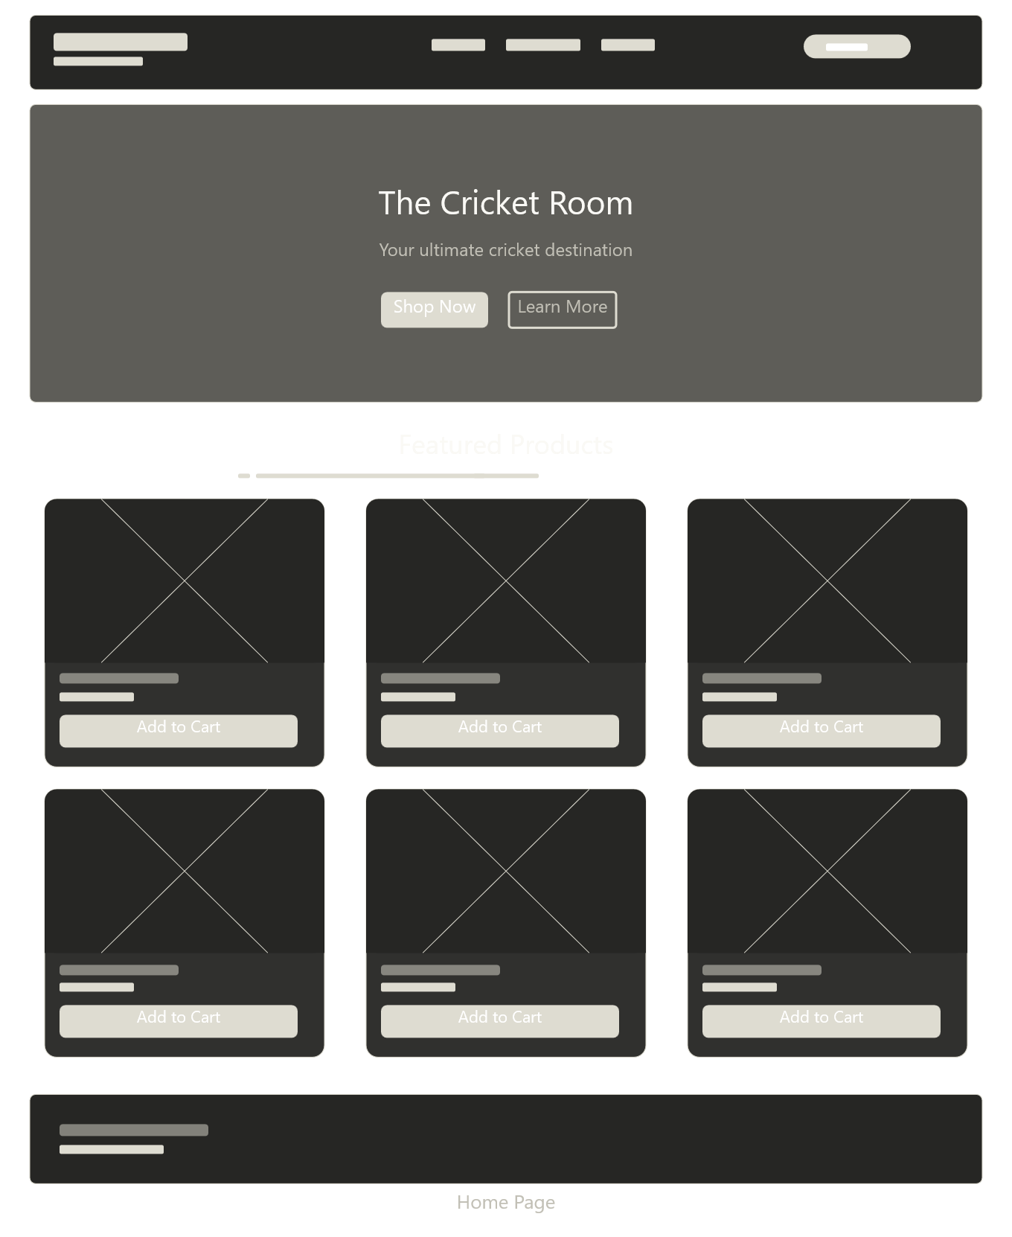
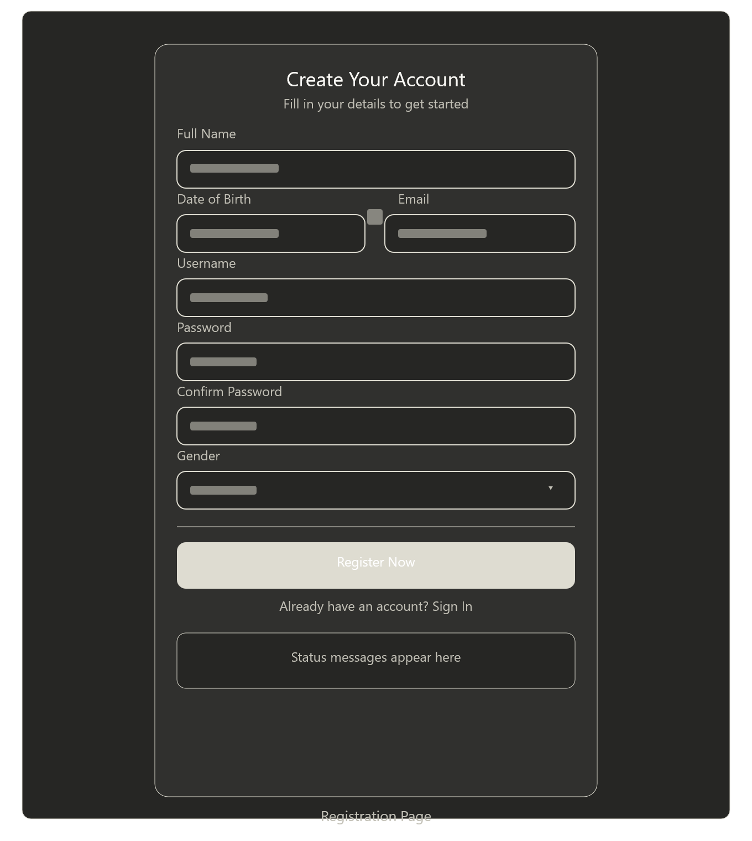
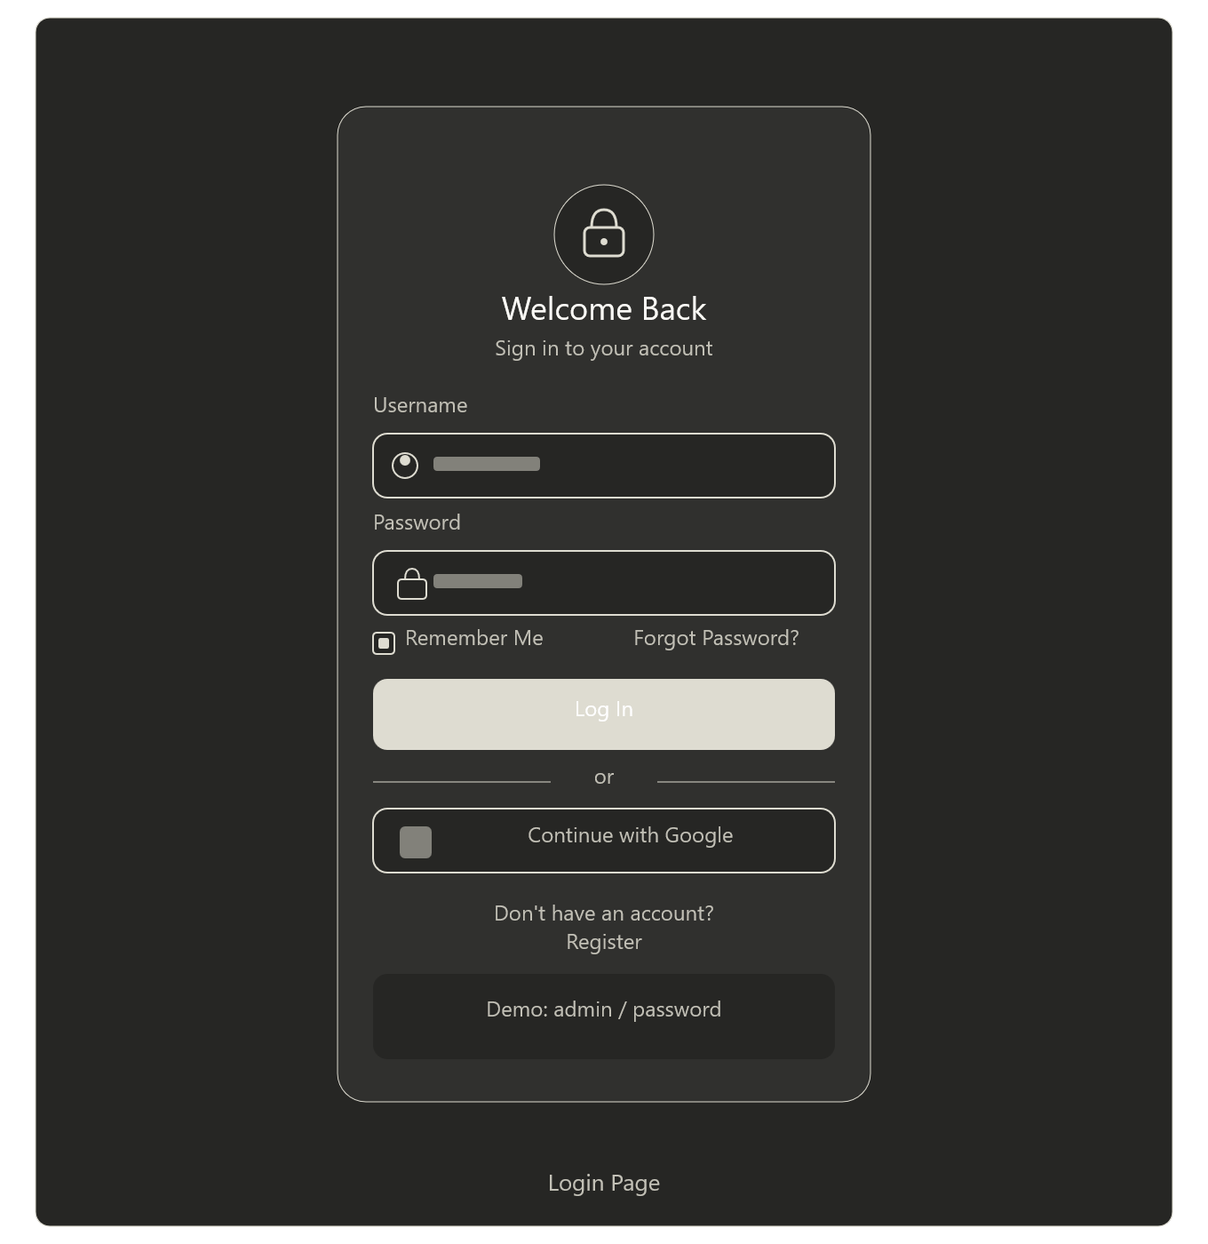
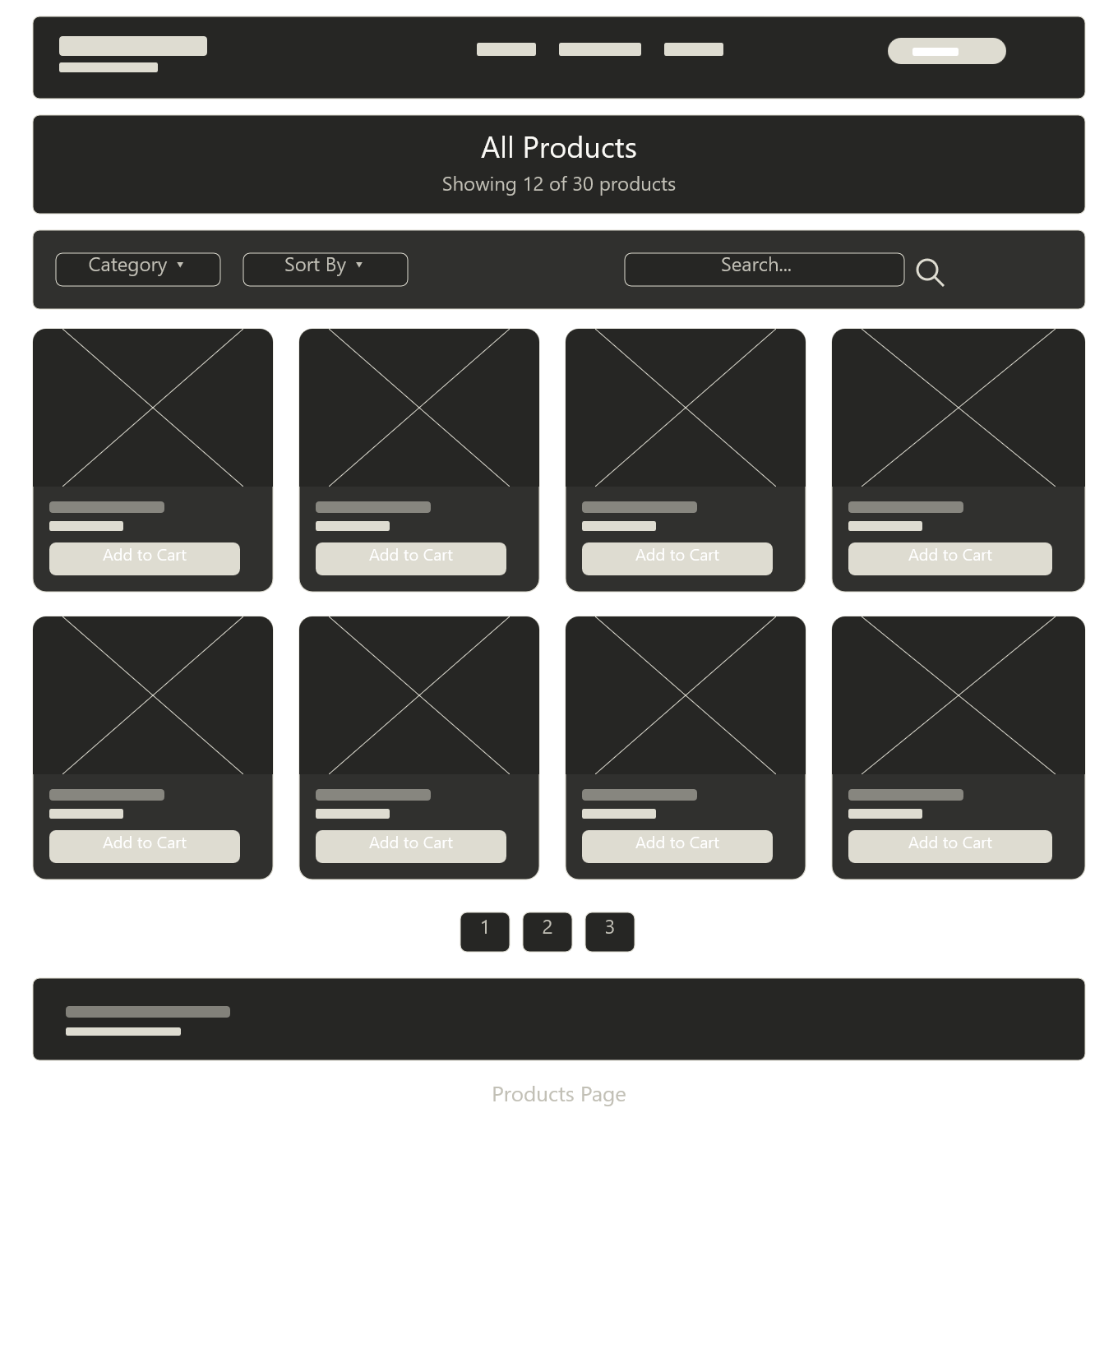

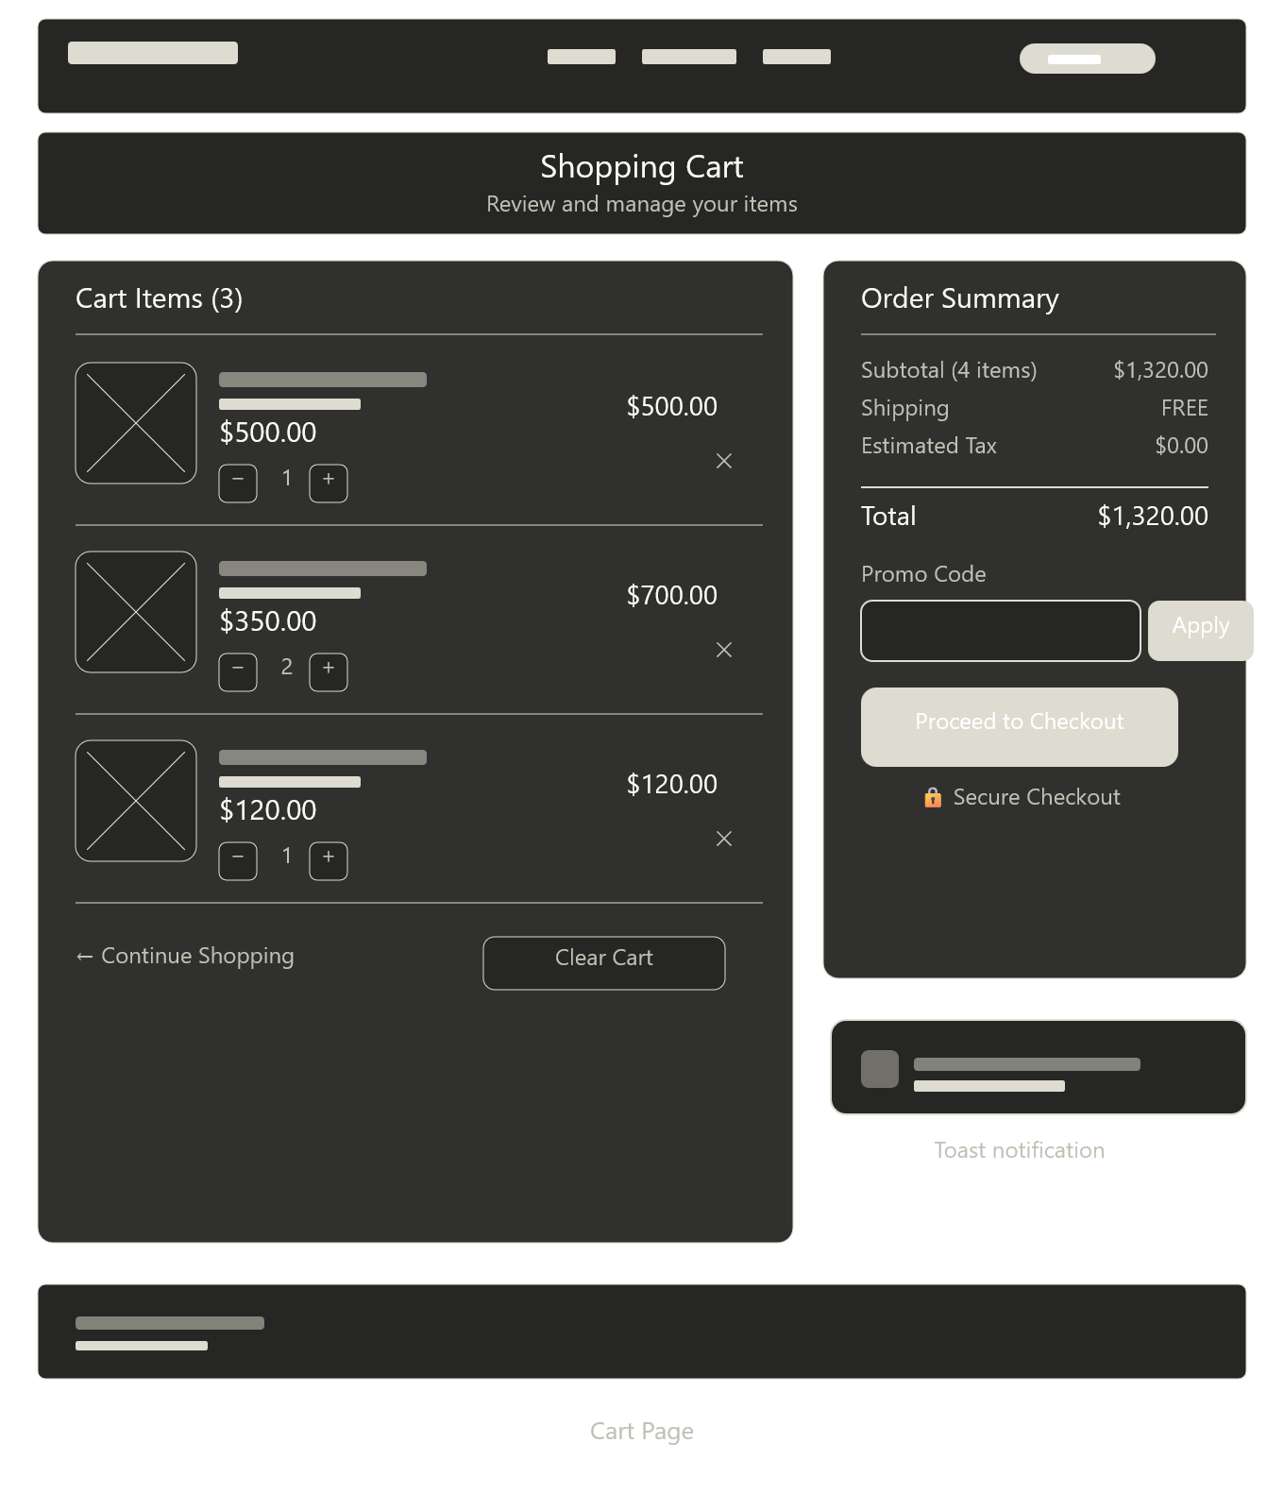

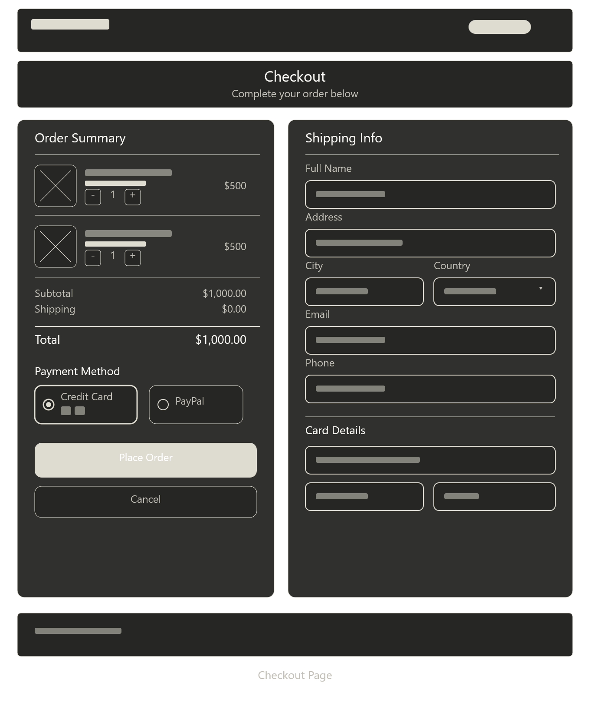
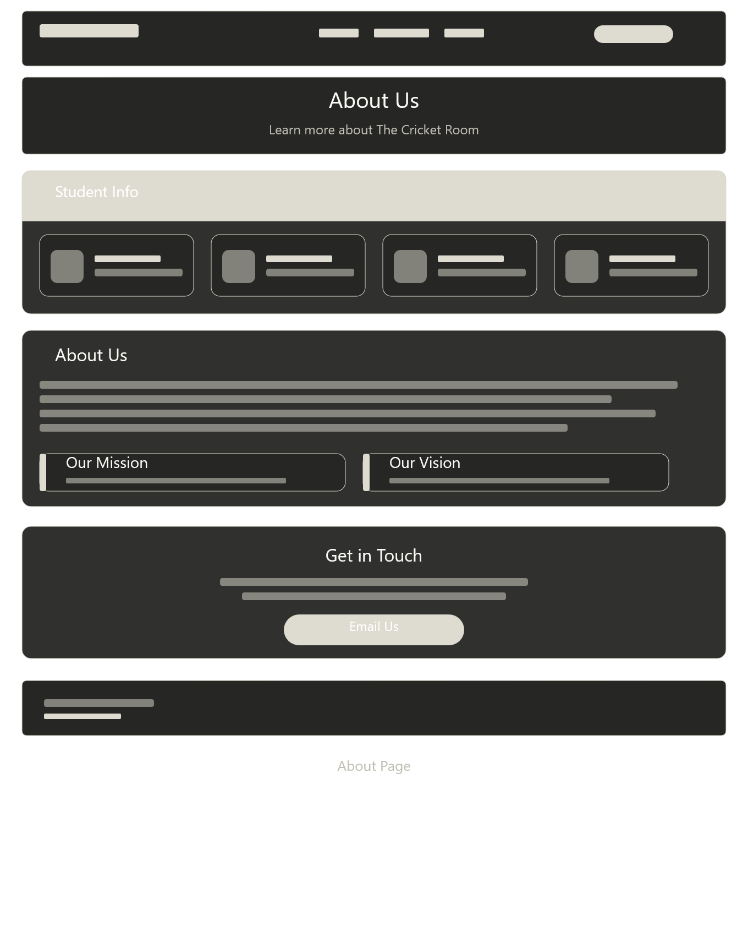

Reference
Cricket Store Online. (n.d.). A comprehensive cricket equipment name list with images: Your guide to the game's gear.
https://cricketstoreonline.com/blogs/articles/a-comprehensive-cricket-equipment-name-list-with-images-your-guide-to-the-games-gear
Cricket Direct. (n.d.). All about cricket equipment.
https://cricketdirect.co.uk/pages/all-about-cricket-equipment
Cricket Direct. (n.d.). Cricket Direct.
https://cricketdirect.co.uk/
Netlify. (n.d.). IA2 The Cricket Room deploys.
https://app.netlify.com/projects/ia2-thecricketroom/deploys
Free Hosting Link:
https://github.com/shamaricode/IA-2---THE-CRICKET-ROOM-.git
https://harmonious-frangipane-d3e8087.netlify.app/

