**Fergus Maripins Hotel \*\*\***

Occupying a prime beachfront location overlooking Malgrat de Mar’s golden beach, and a lively resort centre just a short stroll away. The hotel has a relaxed atmosphere and a great range of facilities.

50m from the nearest shops, bars and restaurants. 100m from the beach. 400m from the resort centre.

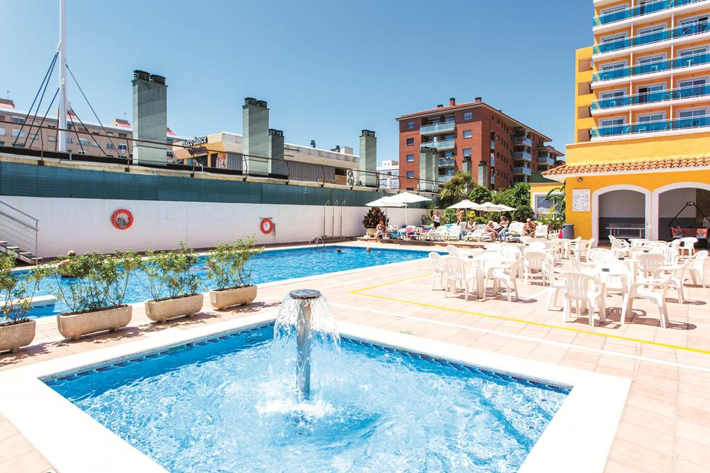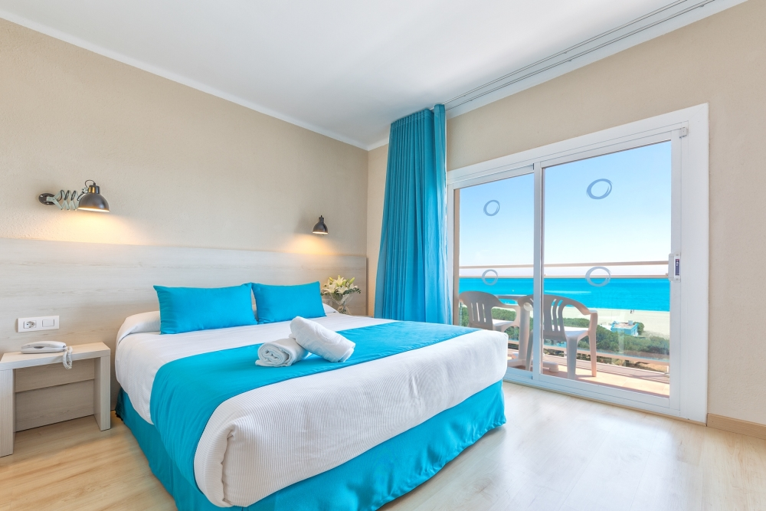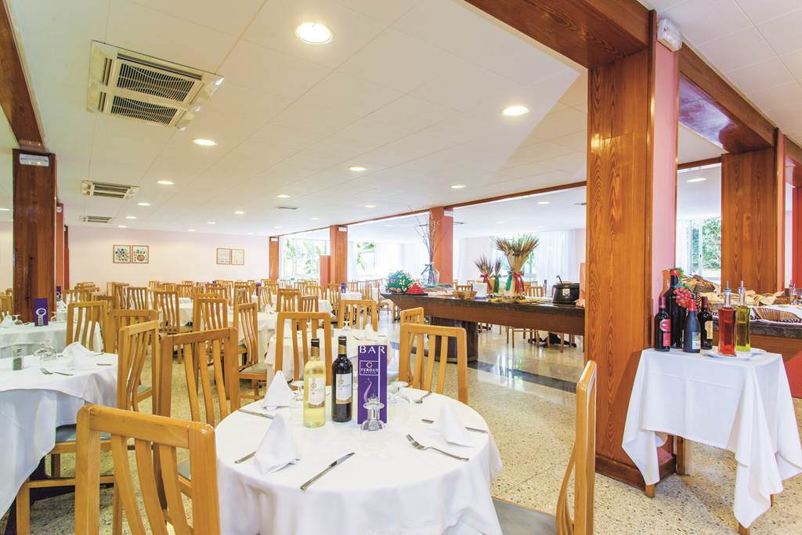

Twin rooms sleep up to 3 adults and have air-conditioning, satellite TV, full bathroom, hairdryer and balcony. Single rooms are also available at a supplement.

Outdoor swimming pool with sun terrace, lounges and umbrellas. Games room*. Internet WIFI Area*. TV Room*.

*Please note some features may be payable locally

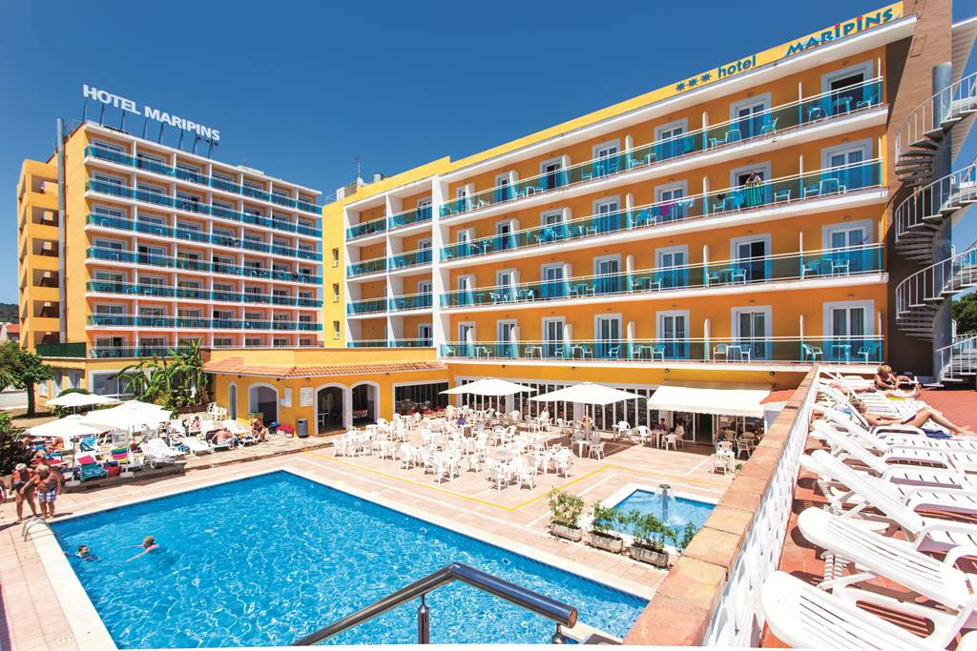[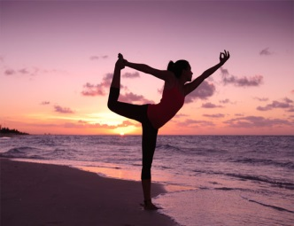](http://www.google.co.uk/url?sa=i&rct=j&q=&esrc=s&frm=1&source=images&cd=&cad=rja&docid=6divcHlyFUwrlM&tbnid=YLVbuKi-229J3M:&ved=0CAUQjRw&url=http://pollynoble.com/detox-retreats/raw-food-yoga-retreat-montenegro/&ei=wMMdUoqENMav0QXv_4DQDw&bvm=bv.51156542,d.ZG4&psig=AFQjCNFo0s1aTDXSjaS8F0XOadBMWcUTig&ust=1377767135244087)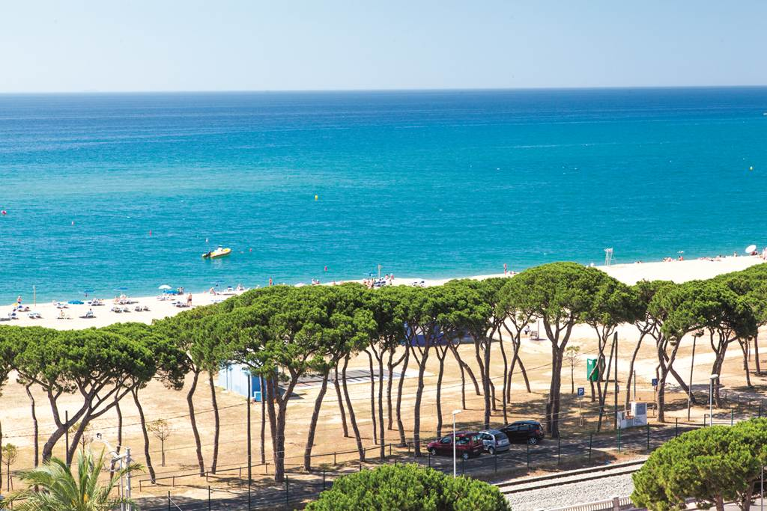

Contact **Adeona Travel** for Further details.

255 Fulwood Road, Broomhill, Sheffield, S10 3BD

0114 2684146 / [Sheffield@adeona.travel](mailto:Sheffield@adeona.travel)

*Terms and conditions apply. Based on group booking rates minimum of 10 passengers.

Price and availability are subject to change & cannot be guaranteed until deposits taken.

Package price includes the holiday cost payable to Adeona Travel & Yoga Classes / service of £100 per person payable to Steve Avian (Shama Yoga). [www.shamayoga.org.uk](http://www.shamayoga.org.uk)

Prices correct at time of print 21st April 2015.

For further information and bookings please call Steve on 07792557105

*Relax & Restore*

**Yoga Holiday**

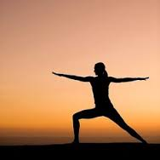

Your Package Includes:

FLIGHTS FROM MANCHESTER at 0815 Arrive 1145

THURSDAY 8TH OCTOBER 2015

4 Nights at the FERGUS MARIPINS HOTEL

In Malgarat De Mar - Costa Brava, SPAIN.

HALF BOARD with SHARED TRANSFERS.

RETURN MONDAY 12TH OCTOBER at 1330 Arrive 1510

Also enjoy…

TWICE DAILY YOGA & MORNING BEACH TAI CHI

DEPOSIT ONLY £60 per person!

BOOK EARLY TO SECURE THE BEST PRICE!

Single Room from **£439** per person*

Twin Share from **£389** per person*

Classes are suitable for all Yoga levels including little or no experience.

Non-Yoga Partner’s welcome at further discount.

*Price is based on 10kgs hand luggage & 22kgs hold luggage.

 [http://www.adeonatravel.co.uk/cgi-bin/artist?prot=1](http://www.google.co.uk/url?sa=i&rct=j&q=&esrc=s&frm=1&source=images&cd=&cad=rja&docid=ll6TP3l8mornlM&tbnid=E7KcyzX2J3yc8M:&ved=0CAUQjRw&url=http://www.adeonatravel.co.uk/&ei=huXnUd_BGc7_PPypgPAJ&bvm=bv.49478099,d.bGE&psig=AFQjCNHqITi8OBDXqkpfjrZN2GJkIxb2yA&ust=1374238412395728)

**Exclusive Bowls Package**

**To Cyprus!**

